|  |  |
| --- | --- |
| **PHÒNG GD&ĐT ...................**  **TRƯỜNG THCS ……………….** | **ĐỀ KIỂM TRA CUỐI HỌC KỲ II**  **NĂM HỌC 2024-2025**  MÔN: **Tiếng Anh - Lớp 9**  *Thời gian làm bài: 60 (Không kể thời gian giao đề)*  *(Đề bài gồm 04 trang)* |

**Họ và tên: Tạ Thị Vân Tên Zalo: Vanta**

**SĐT Zalo: 0916842841 Email: thds2.tavan@gmail.com**

**I. LISTENING**

***Part 1. Listen to 5 short conversations TWICE then choose the correct answer for each question. (1 point )***

**Question** 1. What must Michael paint first?

A. The wall B. The bicycle C. The chairs D. The table

**Question** 2. What must Michael wear?

A. Jeans B. Shorts C. Sweater D. Trousers

**Question** 3. What can Michael eat?

A. Bread and soup B. Chocolate biscuits C. Soup D. Rice

**Question** 4. Where’s the paint that Michael needs?

A. On the table B. In the cupboard C. In the kitchen D. on the wall

***Part 2. Listen to*** ***a conversation about the weekend*** twice ***then decide whether the statements are True (T) or False (F). (1 point)***

|  |  |
| --- | --- |
| **Statements** | **T/F** |
| **Question**.1 The class visit to Sunny Farm will be on Monday., |  |
| **Question** 2. The farmer grows flowers., |  |
| **Question** 3. The farm has thirty five fields., |  |
| **Question** 4. The children will draw vegetables during the visit., |  |

**II. IPRONUNCIATION**

**Choose the letter A, B, C, or D to indicate the word whose underlined part differs from the other three in pronunciation in each of the following questions**. **(0.5 point)**

**Question** **9**. A. affect B. habitat C. climate D. vitual

**Question** **10**. A. estimate B. exchange C. essential D. ecological

**Choose the letter A, B, C, or D to indicate the word that differs from the other three in the position of the primary stress in each of the following questions. (0.5 point)**

**Question** **11**. A. reserve B. glassland C. landform D. flora

**Question 12**. A. protect B. presuade C. cover D. observe

**III. GRAMMAR AND VOCABULARY**

**Choose the letter A, B, C, or D to indicate the correct answer to each of the following questions. (1.75 points)**

**Question 13.** Our teacher suggests that we _________ waste paper for the school’s recycling scheme.

|  |  |  |  |
| --- | --- | --- | --- |
| A. collected | B. collecting | C. should collect | D. to collect |

**Question 14**.The book ______ I read yesterday was written by Jack London.

|  |  |  |  |
| --- | --- | --- | --- |
| A. what | B. who | C. when | D. which |

**Question 15**: Pu Luong is a _______ in Viet Nam, It has beautiful limestone mountains with high biodiversity.

|  |  |  |  |
| --- | --- | --- | --- |
| A. grassland area | B. natural habitat | C. disaster area | D. nature reserve |

**Question 16**. You can carry your _______laptop with you from class to class because it's small and light.

|  |  |  |  |
| --- | --- | --- | --- |
| A. virtual | B. portable | C. aluminium | D. wireless |

**Question 17**. My father advised not ______ digital devices before bedtime

|  |  |  |  |
| --- | --- | --- | --- |
| A. to using | B. to use | C. used | D. using |

**Question 18**: Nobody could hear her_______ she spoke too quietly.

|  |  |  |  |
| --- | --- | --- | --- |
| A. although | B. because | C. because of | D. in spite of |

**Question 19**. I always wanted a _____ job because I think I would get bored if it wasn't.

|  |  |  |  |
| --- | --- | --- | --- |
| A. challenging | B. worrying | C. boring | D. tiring |

***Read the following advertisement/ announcement and mark the letter A, B, C, or D on your answer sheet to indicate the correct option that best fits each of the numbered blanks from 12 to 14. (0.75 points)***

|  |
| --- |
| **DREAM OF BECOMING A CHEF?**  Join our prestigious Culinary Institute and start your journey today! Our programs are designed for aspiring chefs of all levels. Discover the art **(20)** _____ cooking with expert chefs. Hands-on experience in a professional kitchen. Flexible schedules for **(21)** _________ busy learners. In addition, **(22)** _____ aid available for eligible students.  *For more information or to apply, contact us:*  Phone: 555-012  Email: info@culinaryinstitute.edu  Visit: 45 Gourmet Avenue, Flavor Town |

|  |  |  |  |  |  |
| --- | --- | --- | --- | --- | --- |
| **Question 20:** | A. of | B. on | C. in | | D. by |
| **Question 21:** | A. a | B. an | C. the | D.Ø (no article) | |
| **Question 22:** | A. Financial | B. Finance | C. [Financing](https://www.ldoceonline.com/dictionary/finance#finance__4) | | D. [Financially](https://www.ldoceonline.com/dictionary/financial) |

**IV. READING:**

**Read the following passage and choose the letter A, B, C, or D to indicate the correct option that best fits each of the numbered blanks from 23 to 27. (1.25 points)**

Television is an invention of the 20th century. It has been so popular that now we can’t imagine what life (23)______ like if there were no television. Television is a major (24)______ of communication and entertainment. It brings pictures and sounds from around the world into millions of homes. Television viewers can see and learn about people, places and things in far away lands. Television widens our knowledge by introducing us to new ideas (25)______ may lead us to new hobbies and recreations. In addition to the news, television provides us with a variety of programs that can satisfy every taste. Most people now seem to like (26)______ their evenings watching television. It is more convenient for them to stay at home watching television (27)______ to go out for amusement elsewhere.

**Question 23: A.** would be **B.** will be **C.** is **D.** was

**Question 24: A.** way **B.** kind **C.** mean **D.** sort

**Question 25: A.** whom **B.** which **C.** who **D.** what

**Question 26: A.** spent **B.** spending **C.** spend **D.**to spend

**Question 27: A.** than **B.** to **C.** as **D.** and

**Read the following passage and choose the letter A, B, C, or D to indicate the correct answer to each of the questions from 28 to 32. (1.25 points)**

The two main advantages of developed tourism industry are boost in country’s economy and a large number of new job openings for the local people. Firstly, tourists spend money on a wide range of services, including hotels, amusements, transportation, food and medical services. This way, tourism yields an additional income, greatly supporting the country’s economy. Secondly, tourism increases the level of employment by bringing new jobs. For instance, the influx of tourists results in a larger demand in restaurant workers, tour guides, hotel staff and employees of retail services, exhorting business owners to hire more people for these positions.

But tourism also has some major disadvantages like destruction of popular tourist destinations and development of illegal economic activities. Ancient buildings, temples and monuments struggle to **cope with** a vast amount of visitor’s traffic and get damaged. Also, the large number of tourists can cause environmental problems. For instance, when places of interest are overcrowded, natural resources often become overexploited. What’s more, the presence of a considerable number of tourists with a lot of money to spend, and often carrying valuables such as cameras and jewelry, increases the attraction for criminals and brings with it activities like robbery and drug dealing. However, proper hospitality management and correct usage of tourism revenue by the local government can eliminate these disadvantages.

**Question*****28***. What is the passage about?

A. The advantages of tourism. B. The disadvantages of tourism.

C. The advantages and disadvantages of tourism. D.Environmental problems.

**Question*****2***9 How many main advantages does the writer mention?

A. three B. two C. five D. four

**Question*****30*.** Which following word has the closest meaning to “**cope with**”?

A. put off B. turn down C. deal with D. take off

**Question*****31***. Which following information in the passage is **not true**?

A. Tourism provides a large number of new jobs for the local people.

B. Tourism can increase the attraction for criminals.

C. Tourists spend money on a wide range of services, including hotels, amusements, transportation, food and medical services.

D. The local government can never eliminate these disadvantages of tourism.

**Question*****32****.* Based on the passage, which of the following is a way tourism can negatively impact popular tourist destinations?

A. Increased job opportunities for local people

B. Boost in the country’s economy

C. Development of illegal economic activities

D. Additional income from tourists spending money

**V. WRTING**

**Choose the letter A, B, C, or D to indicate the sentence that best combines each pair of sentences in the following questions. (0.5 point)**

**Question** **33**. People live in Scotland. They are called Scots.

A. People live in Scotland who are called Scots.

B. People live in Scotland whom are called Scots.

C. People whom are called Scots, live in Scotland.

D. People who are called Scots, live in Scotland.

**Question** **34**. “You should take better care of your health,” said Tom’s mother.

A. Tom’s mother promised to take better care of his health.

B. Tom’s mother suggested he take better care of his health.

C. Tom’s mother required him to take better care of his health.

D. Tom’s mother advised him to take better care of his health.

***Write a paragraph (70- 80 words) about what your favorite electronic device can do now and what it will be able to do in the future. Using the questions below: (1.5 points)***

- What is your favorite electronic device?

- What can it do for you now?

- What will it be able to do for you in the future?

**------ The end -----**

**VI. SPEAKING (2.0 points)**

(Time allowed: 8🡪 10 minutes/ a student)

**I. Introduce yourself** (0.5 pt)

*Introduce yourself with basic information (name, class, age, hobby, family, etc.)*

*(at least 4 sentences)*

**II. Present one of the 6 topics chosen.** (1.5 pts)

***Topic 7. Talking about a natural wonder.***

* Name of the natural wonder
* Location
* Reasons for choosing the place
* Tourists’ activities
* Comments and feelings about the place

***Topic 8. Talking about your travel experience.***

* Where did you go?
* Which tour did you take: package or self-guided?
* How did you travel?
* Where did you stay?
* What did you do and see?

***Topic 9. Talking about some ways to improve English learning.***

* How long have you been learning English?
* How can you improve your English (inside/ outside class)?
* How often do you improve your English?
* Why are you interested in learning English now?
* What will you use English for in the future?

***Topic 10. Talking about threats to flora and fauna and how to protect them.***

* What are the threats to plants and animals?
* How can we protect plants and animals?

***Topic 11. Talking about an electronic device which is important to you.***

* What electronic device is important to you?
* How long have you had it?
* What does it look like?
* When do you use it?
* Why is it important to you?

***Topic 12. Talking about the job you want to do in the future.***

* What is the job?
* Where do you hear it from?
* What qualifications do you need for this job?
* Explain why you think it is perfect.

*(Chú ý: Phần kiểm tra nói các thầy cô có thể để học sinh tự chọn hình thức trình bày theo nhóm, cặp hoặc cá nhân. GV cũng có thể sử dụng bài project, bài thực hành nói, thuyết trình để đánh giá lấy điểm kiểm tra nói của học sinh.)*

|  |
| --- |
| **HƯỚNG DẪN CHẤM ĐỀ KIỂM TRA CUỐI HỌC KÌ II**  **NĂM HỌC: 2024-2025**  **MÔN: TIẾNG ANH- LỚP 9**  **Hướng dẫn chấm gồm 01 trang** |

**A. LISTENING**

**I. (1.0 p) 0.25 for each correct answer**

1C 2B 3B 4A

**II. (1.0 p) 0.25 for each correct answer**

1. T 2. T 3. F 4. T 5. T

**B. LANGUAGE (3.5 points )**

**0.25 for each correct answer**

1B 2A 3A 4C 5C 6D 7D

8B 9D 10B 11 A 12C 13D 14A

**C. READING**

**I. ( 1.25 p) 0.25 for each correct answer**

1. A 2. C 3. B 4. B 5. A

**II. ( 1.25 p) 0.25 for each correct answer**

1. C 2. B 3. C 4. D 5. C

**D. WRITING**

**I. (0.5 p) 0.25 for each correct answer**

1D 2D

**III. (1.5 p)** Ss’ answer:

- correct form: 0.4 p - reasonable ideas: 0.3 p

- accurate grammar: 0.3 p - appropriate vocabulary: 0.3 p

- good linking of sentences: 0.2 p

*(Chú ý: Tổng điểm bài kiểm tra trên giấy là 8.0 điểm)*

**Tapescrips Listening test**

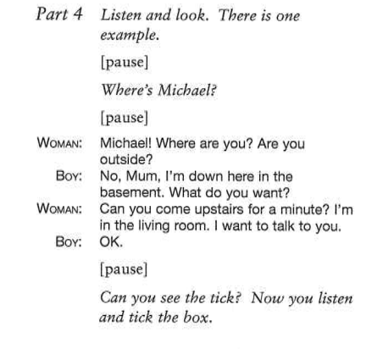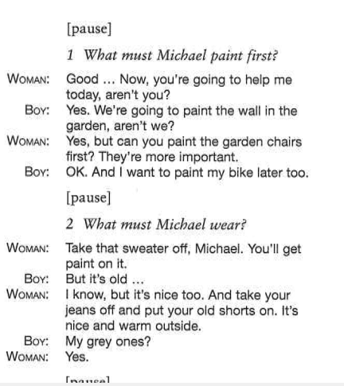

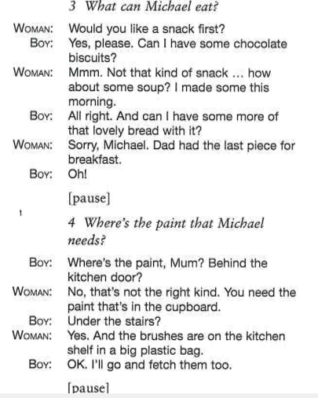

**Part 2**

