Period
LESSON PLAN
TIẾNG ANH 10 FRIENDS GLOBAL
UNIT 4: OUR PLANET
LESSON 4D: GRAMMAR – SUPERLATIVE ADJECTIVES,
TOO AND ENOUGH
By the end of the lesson, Ss will be able to:
1. Knowledge:
- Understand and use different structures to make comparisons
- Grammar: superlative adjectives, too and enough
- main skills: listening and speaking skills
- sub skills: reading and writing skills
- Use superlative adjectives properly in exercises and daily conversation
3. Quality:
- Have positive attitude in English language learning so that they can participate enthusiastically in all classroom activities, especially with the topic conducted by the teacher
- Know how to use different structures to make comparisons in different situations
II. TEACHER AIDS AND LEARNING MATERIALS:
Lesson plan, PPT slides, student’s book, workbook, notebook, personal computer (if any), projector/TV, speakers, IWB software.
III. PROCEDURES:
A. Warm-up (10’)
a) Objective: Introduce the new lesson and set the scene for Ss to acquire new language; get students' attention at the beginning of the class by means of enjoyable and short activities as well as to engage them in the steps that followed.
b) Content: Game “HOW?”, task 1 & 2 page 50
c) Outcomes: Students can gain more confidence and interest in the lesson.
d) Competence: communication, collaboration, critical thinking
e) Organisation of the activity:

TEACHER’S ACTIVITIES | STUDENT’S ACTIVITIES | CONTENTS
WARM-UP. T-Ss/ S-S/ Indiv  GAME “HOW DID THIS HAPPEN?”  Activity 1 (3’)  - Ask students to choose and read out loud the suitable explanation for each picture  Activity 2 (2’): Task 1 page 50  - Ask students to describe the photo using the words given  Activity 3 (5’): Task 2 page 50  - Ask students to read the text and check the answers from exercise 1  - Then underline all the structures that have superlative adjectives and enough  - Use the structure appeared in the text to lead in the lesson | - Volunteer to answer. With one correct answer, that student can get one bonus.  - Volunteer to answer.  - Read the text and check answer with the teacher  - Listen to the teacher and take notes  - Open the course book page 50 | 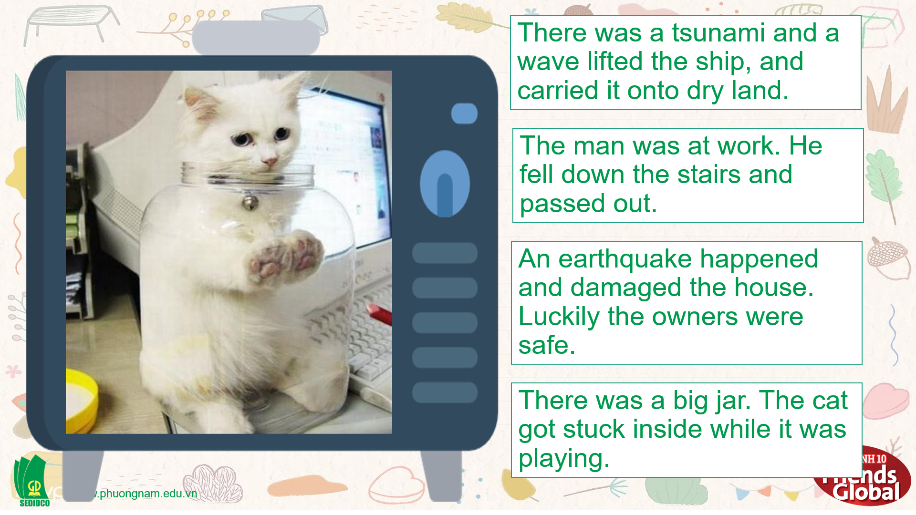  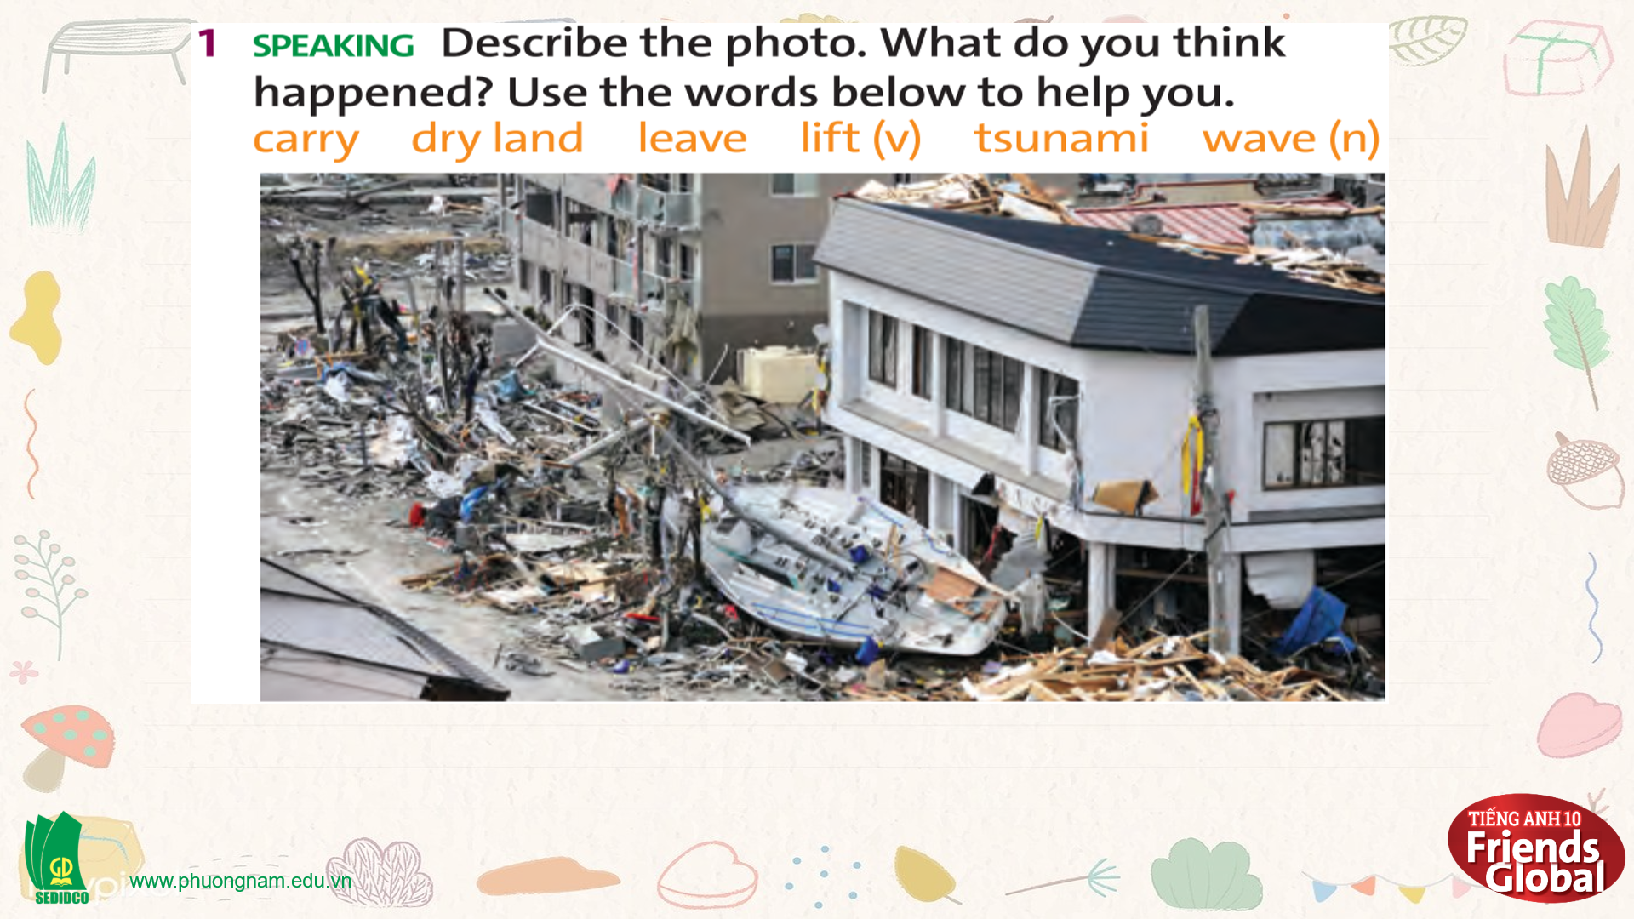  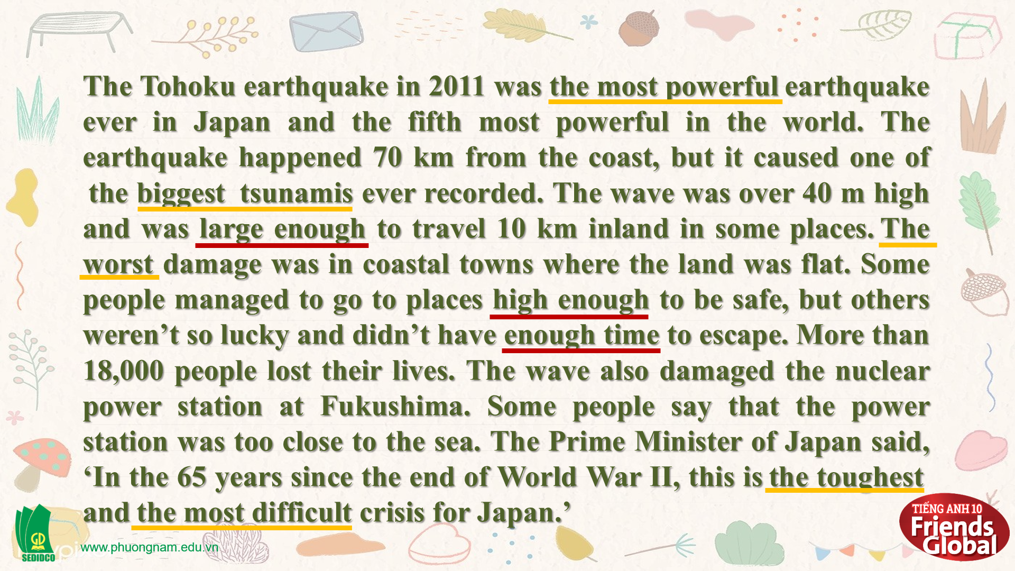  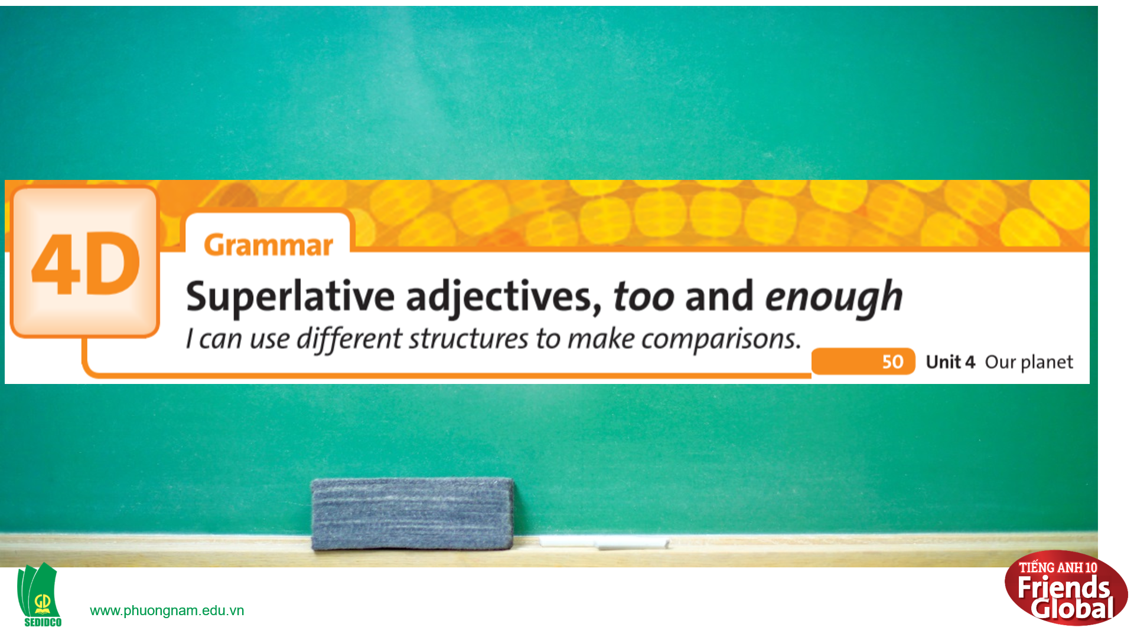
B. New lesson (30’)
- Activity 1: Presentation (5’)
a) Objective: Present to students the rules of superlative adjectives and help students to understand them

b) Content:
Listening
Grammar
c) Outcomes: Students can apply the useful language in everyday conversations.
d) Competence: communication, presentation, presentation
e) Organisation of the activity:

TEACHER’S ACTIVITIES | STUDENT’S ACTIVITIES | CONTENTS
PRESENTATION. T-Ss/ S-S/ Indiv.  Task 3 page 50  - Ask students to read the Learn this! box and highlight some main ideas  - Ask students to work in pairs and complete the task  - Check the answers | - Read the Learn this! box and highlight some main ideas  - Work in pairs to complete the task  - Check the answers with the teacher and take notes | 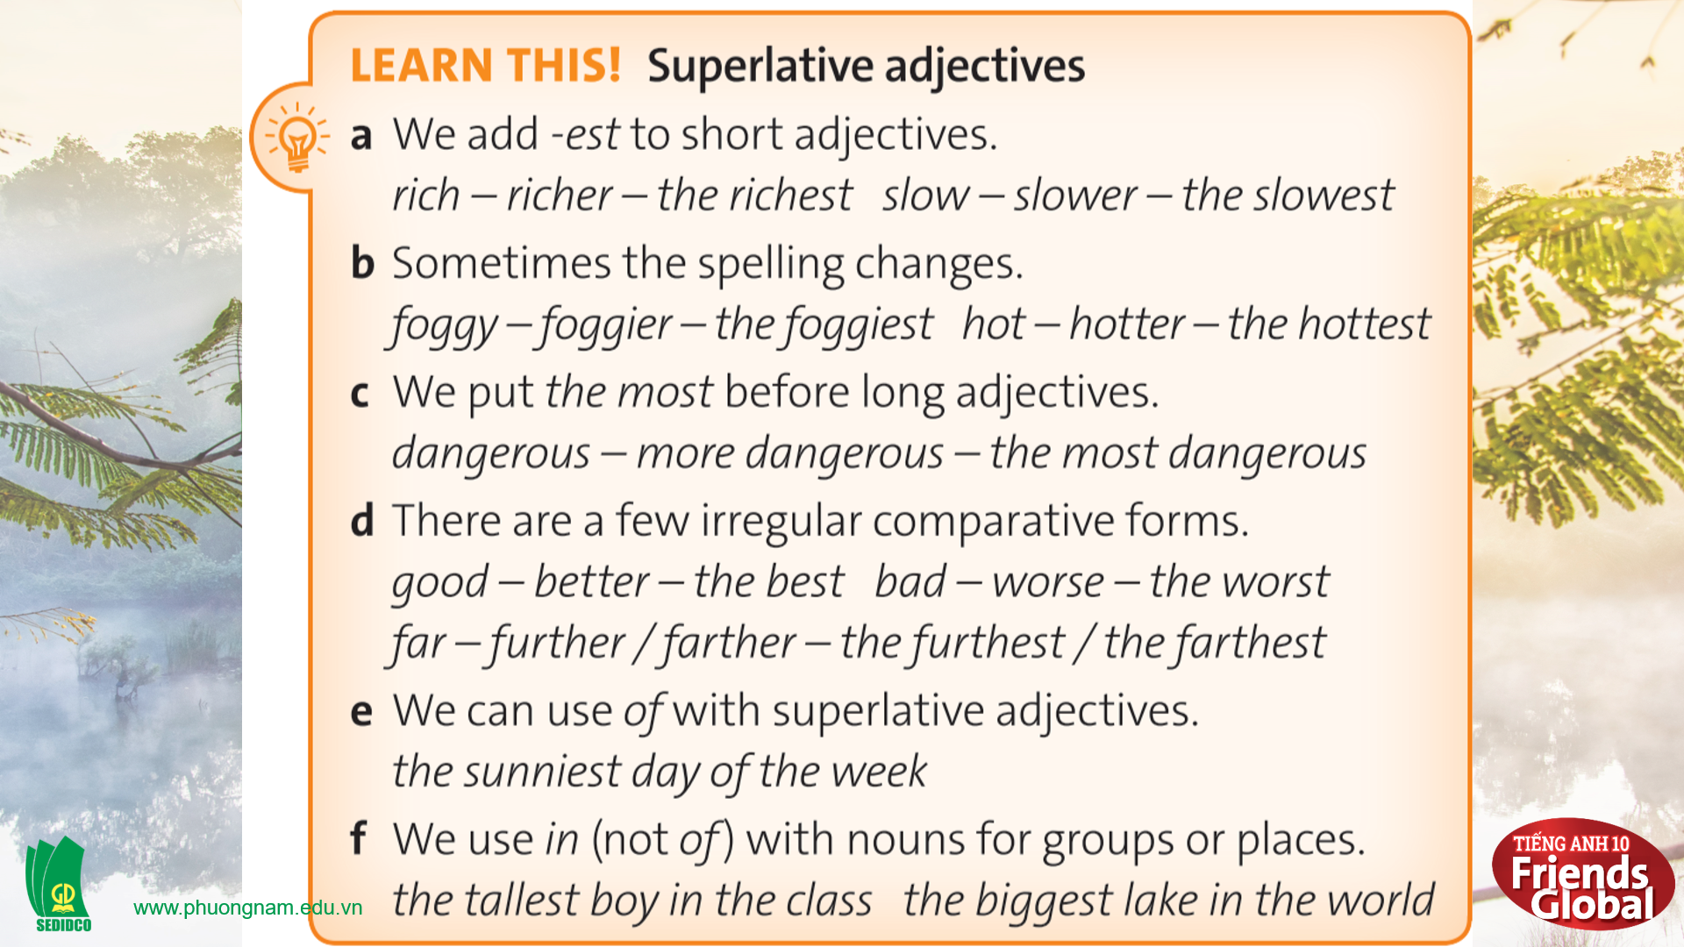  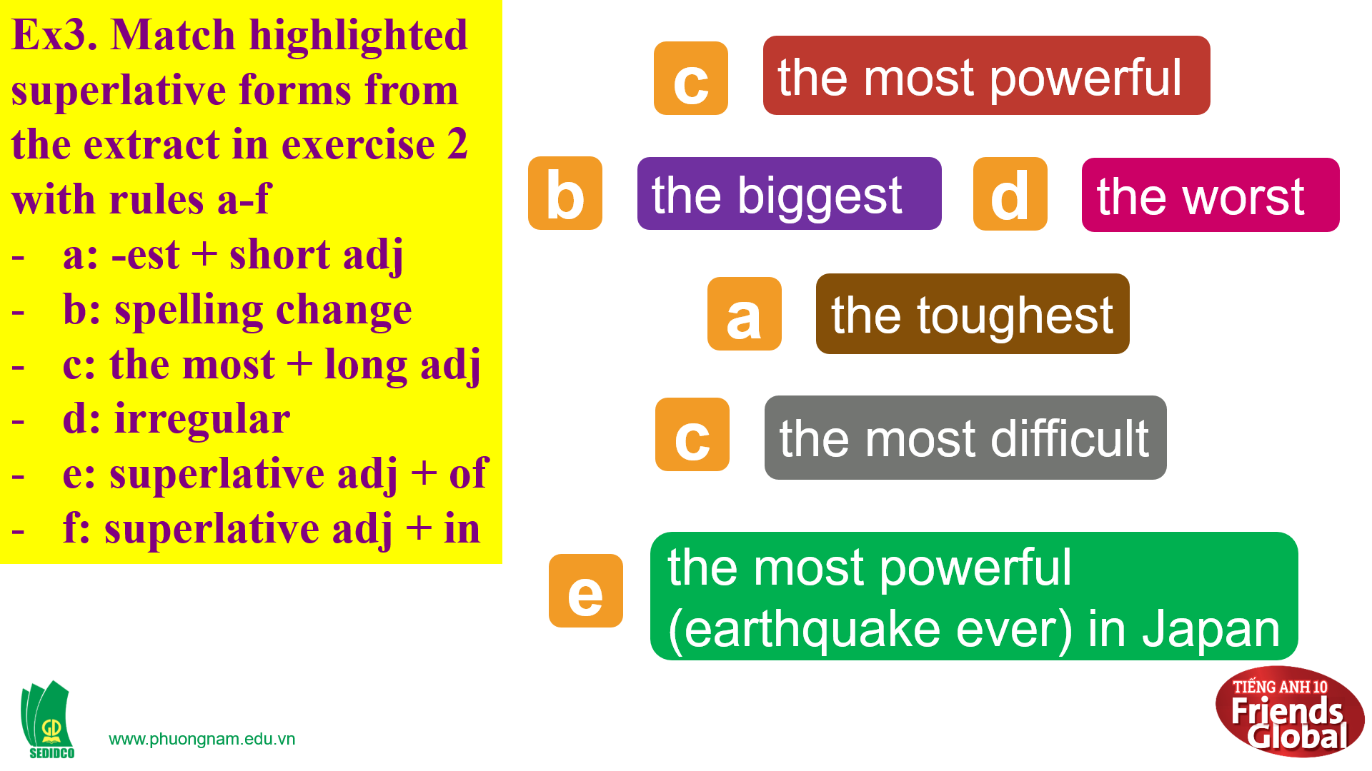  Answers:  A. the toughest  B. the biggest  C. the most powerful  D. the worst  E. the most powerful (earthquake ever) in Japan
- Activity 2: Practice (15’)
a) Objective: Students know more about superlative adjectives and how to use them properly
b) Content:
Speaking
Grammar
c) Outcomes: Students know how to use superlative adjectives to make comparisons in different everyday conversations.
d) Competence: communication, collaboration, presentation
e) Organisation of the activity:
TEACHER’S ACTIVITIES | STUDENT’S ACTIVITIES | CONTENTS
PRACTICE. T-Ss/ S-S/ Indiv.  Activity 1 (5’): Task 4 page 50  - Ask students to complete the task using the superlative form of the adjectives in brackets  - Check the answers  Activity 2 (5’): Task 5 page 50  - Ask students to read the Learn this! box and fill in the blanks  - Explain more if needed  Activity 2 (5’): Task 6 page 50  GAME “WHALE RESCUE STORY”  - Ask students to use the adjective in brackets and rewrite the sentences  - Check the answer | - Complete the task  - Check the answers with the teacher  - Read the Look out! box and complete the task  - Listen to the teacher  - Volunteer to answer  - Check the answers with the teacher | 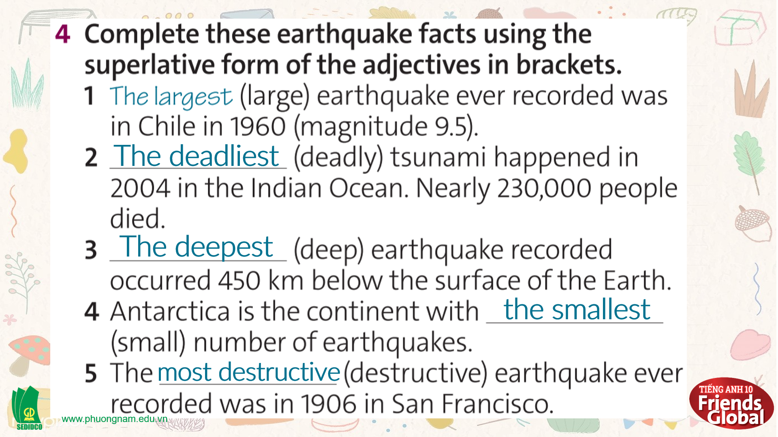  Answers:  2. The deadliest 3. The deepest  4. the smallest 5. the most destructive  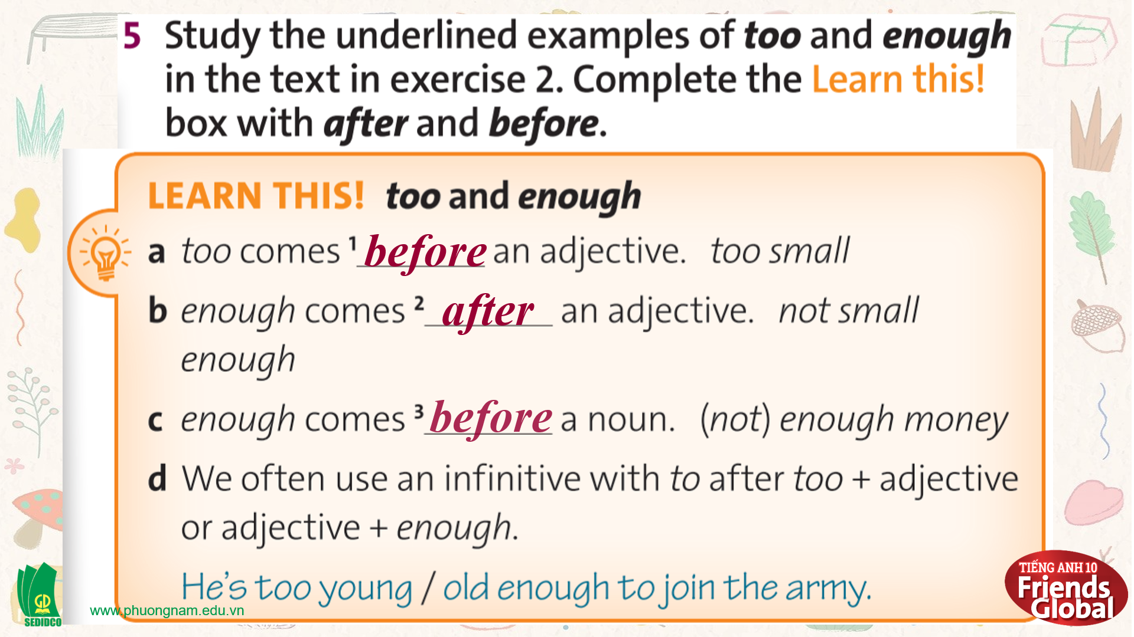  Answers:  a. before b. after c. before  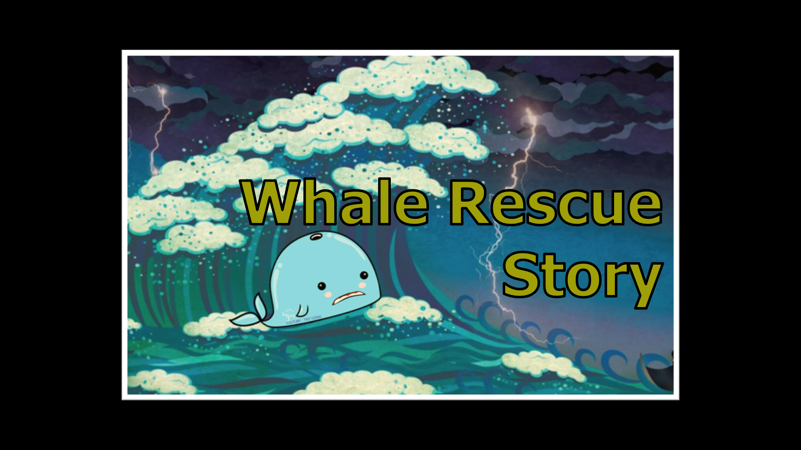  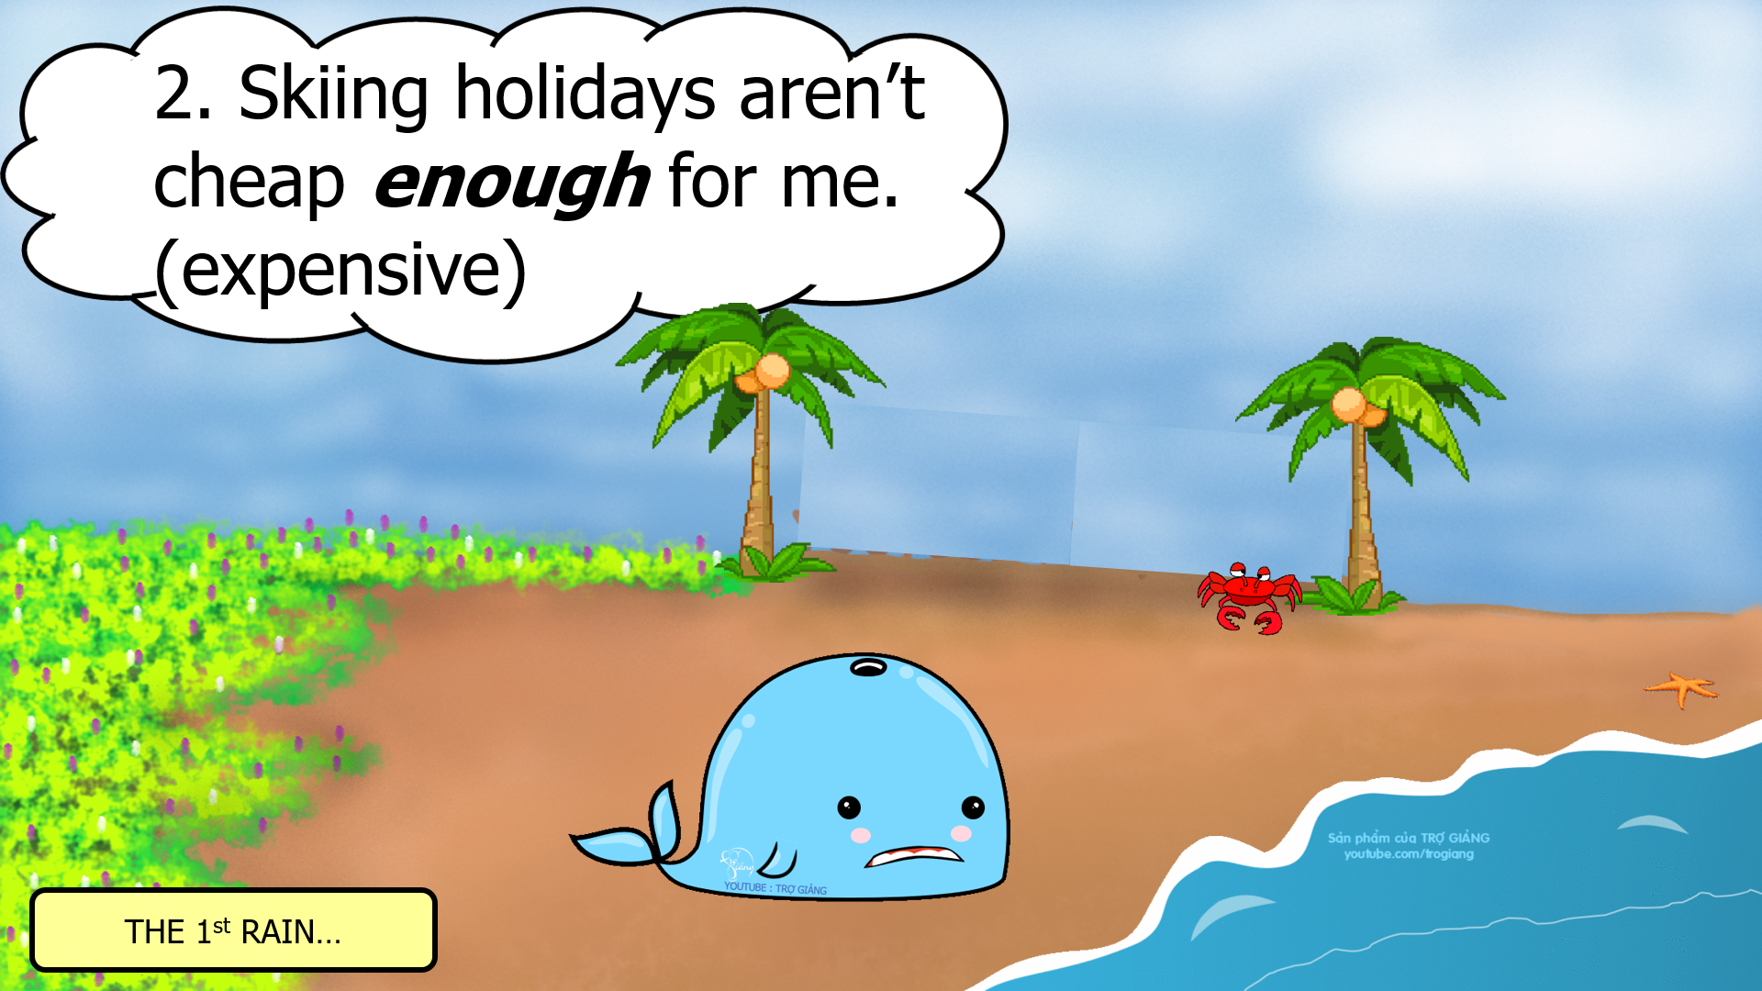
- Activity 3: Outcomes (10’)
a) Objective: Students work in pairs, take turns to ask and answer questions using the superlative form of adjectives. Communication is also be practiced.
b) Content: Task 7 page 50
c) Outcomes: Ss speak and listen mutually, they can apply the structure they have learnt to their conversations.
d) Competence: Presentation, communication, guessing
e) Organisation of the activity:
TEACHER’S ACTIVITIES | STUDENT’S ACTIVITIES | CONTENTS
PRODUCT. T- Ss/ S-S/ Indiv  Exercise 7 page 50: Speaking  - Go through the instructions together and make sure students understand what they have to do  - Monitor and help with grammar and vocabulary where necessary  - Give students some examples  - Encourage students to talk more | - Listen to the instruction  - Work in pairs, take turns to ask and answer  - Practice speaking more | 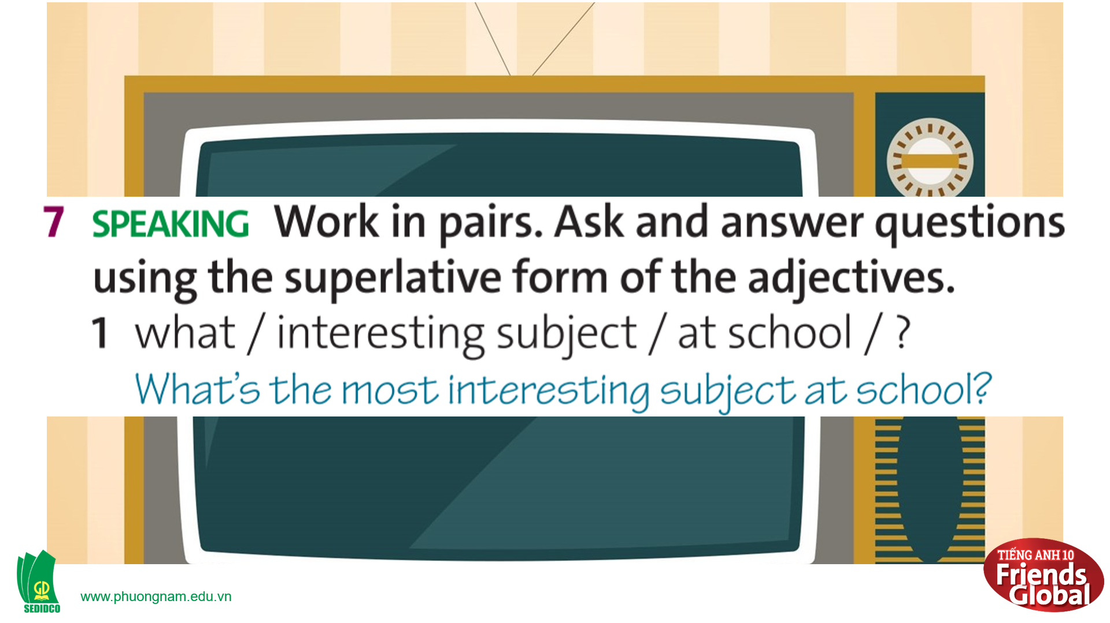  
C. Consolidation (3’)
Grammar: Use superlative adjectives to make comparisons
D. Homework (2’)
- Learn by heart the superlative rules
- Do exercise
- Prepare: Unit 3E: Work skills (page 51 – SB)

