

Tiết thứ ....
UNIT 7: TRAFFIC
Lesson 2: A closer look 1

Class | Date of teaching | Attendence
7A | ..../09/2022
7B | ..../09/2022
7C | ..../09/2022
I. OBJECTIVES: By the end of this unit, students will be able to gain the following things:
1. Knowledge:
- Vocabulary about the verbs to use means of transport
- Vocabulary to read the road signs.
- Pronunciation: /aɪ/ and /eɪ/
+ Pronunciation: - Pronunciation: /aɪ/ and /eɪ/
+ Vocabulary: Use the words about means of transport.
- road sign (n.phr.) /ˈrəʊd saɪn/: biển báo giao thông
- cycle lane (n.phr.) /ˈsaɪkl leɪn/: đường đi riêng cho xe đạp
- traffic light (n.phr.) /ˈtræfɪk laɪt/: đèn giao thông
+ Grammar:
2. Competence:
a) General competencies:
- Students will be able to know more words and phrases about means of transport.
- Develop communication skills and cultural awareness
- Be collaborative and supportive in pair work and teamwork
- Actively join in class activities
b) Specific competencies:
- Group work and independent working, pair work, linguistic competence, cooperative learning and communicative competence.
- Sts can introduce themselves or one another fluently.
3. Qualities: The love of traffic; The awareness about importance of trafffic; Be ready to talk about means of transport; Know some daily activities in the street.
- Develop self-study skills.
II. PREPARATIONS
Teacher: Grade 7 text book, laptop, TV, pictures and realia, Computer connected to the Internet, Sach mem.vn
Students: Text books, pencils, pics, blank papers, realia,….
III. PROCEDURE:
In each activity, each step will be represented as following:
* Task delivering
** Task performance
*** Report and discussion
 Judgement
Activity 1. WARM UP (5’-IW, GW)
* Aim:
- To activate students’ knowledge on the topic of the unit
- To enhance students’ skills of cooperating with team mates
* Content: JUMBLED WORDS
* Product: Having a chance to speak English and focus on the topic of the lesson.
* Implementation: Teacher’s instructions…
Teacher’s & Student’s activities | Content
JUMBLED WORDS  * Teacher gives instructions  ** In groups of 5, Ss will be given a small white board and marker.  - Teacher show the jumbled words onto the screen one by one  - Students work in groups to make the correct words and write down onto the small boards. When they finish, they hold it up to show their answers to teacher.  - take turns to write until finish all the words.  1- otba ->  2- itanr ->  3- npeilapra ->  4- rsotrpca ->  5- otmiroekb ->   Teacher checks and corrects if Ss write the words incorrectly. | JUMBLED WORDS  Answers:  1- otba -> boat  2- itanr -> train  3- npeilapra -> airplane  4- rsotrpca -> sport car  5- otmiroekb -> motorbike
Activity 2. KNOWLEDGE FORMATION (15'- PW, IW)
* Aim:
To help students use key language more appropriately
* Content: Teach some new words, some action verbs go with nouns.
* Product: Ss learn how to use them.
* Implementation: Teacher’s instructions…
Teacher’s & Student’s activities | Content
Vocabulary  * T asks Ss to look at the photos and answer the question  1. What are they?  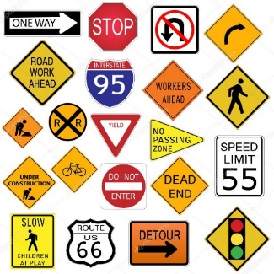  2. What is this?  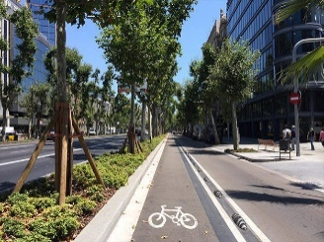  3. What is this?  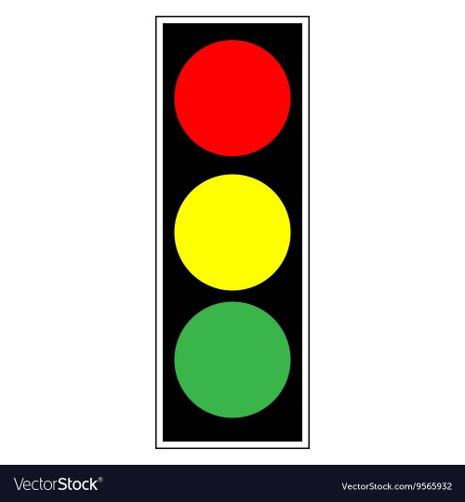  ** Ss say the words.  *** Other Ss correct if the previous answers are incorrect.   Teacher shows and says the words aloud and asks Ss to repeat them.  * Teacher asks Ss to translate the word into English  ** Ss says the word | Vocabulary  - road sign (n.phr.) /ˈrəʊd saɪn/: biển báo giao thông  - cycle lane (n.phr.) /ˈsaɪkl leɪn/: đường đi riêng cho xe đạ  - traffic light (n.phr.) /ˈtræfɪk laɪt/: đèn giao thông
Activity 3. PRACTICE (15’-IW, PW, GW)
* Aim:
- To practise identifying the meanings of road signs.
- To develop Ss' knowledge of vocabulary.
- To help Ss deeply understand how to read the road signs
- To practise the targetted language in life context.
* Product: Students’ answers.
* Implementation:
Teacher’s Student’s activities | Content
Task 2: Exercise 3 (p.74): Look at these road signs. Then write the correct phrases under the signs.  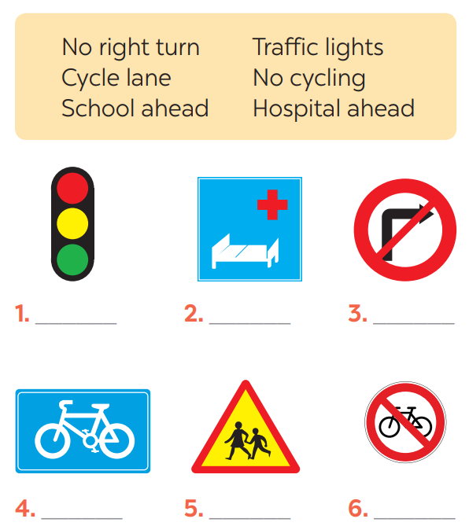  * Teacher asks Ss to look at the road signs and guess their meanings. Then work and share their answers with their partners who sit next to them. (peer check)  ** Ss do exercise 3 in pairs.  *** Ss share and discuss with their partners to write all words/ phrases down on the books.   Teacher corrects their answers as a class. | Task 2: Exercise 3 (p.74): Look at these road signs. Then write the correct phrases under the signs.  Answers  1. traffic lights 2. Hospital ahead 3. No right turn  4. cycle lane 5. School ahead 6. No cycling
Task 3: Work in pairs. Take turns to say which of the signs in 2 you see on the way to school.  * Teacher gives suggestions and asks students to share their sentences.  *** Teacher nominates Ss to say the sentences aloud   Teacher checks and gives the corrections if they have mistakes. | Task 3: Work in pairs. Take turns to say which of the signs in 2 you see on the way to school.  A: On the way to school, there are many bicycles on the roads, so I see a “Cycle lane” sign.  B: On the way to school, I see a “school ahead” sign.  A: On the way to school, there is no bicycle on the road, so I see a “No cycling” sign.  B: On the way to school, I see in a traffic light a “not turn right” sign.
Activity 4. APPLICATION (7’-IW, PW, GW)
* Aim:
- To help Ss identify the and classify the sounds
- To give students authentic practice in using pronouncing sounds in common words
* Content: using pronouncing sounds in common words
* Product: Students’work.
* Implementation: Teacher’s instructions
Task 4: Listen and repeat. Pay attention to the sounds /aɪ/ and /eɪ/.  * Teacher gives Ss time to listen and practice pronouncing the sounds individually and words.  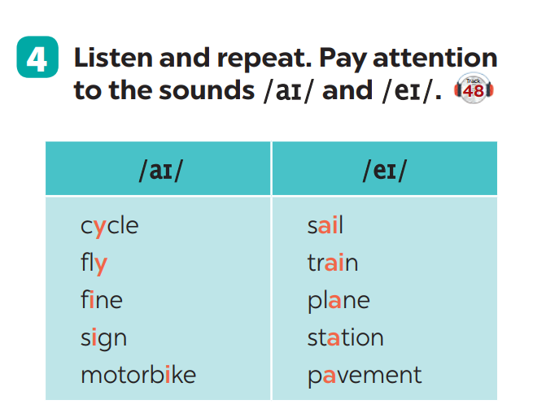  Task 5: Underline the words with the sound /aɪ/ and circle the words with the sound /eɪ/. Then listen, check and repeat  ** Ss do as instructed   Teacher gives Ss feedback.  - choose some common mispronounced words that contain the sounds and suggest students practise using them.  - choose some typical errors and correct as a whole class. | Task 4: Listen and repeat. Pay attention to the sounds /aɪ/ and /eɪ/.  /aɪ/ /eɪ/  cycle /ˈsaɪ.kəl/ fly /flaɪ/ fine /faɪn/ sign /saɪn/ motorbike /ˈməʊ.tə.baɪk/ sail /seɪl/ train /treɪn/ plane /pleɪn/ station /ˈsteɪ.ʃən/ pavement /ˈpeɪv.mənt/  Task 5: Underline the words with the sound /aɪ/ and circle the words with the sound /eɪ/. Then listen, check and repeat  Lời giải chi tiết:  1. The bus station is far from my house  2. Remember to ride your bike carefully.  3. We must obey traffic rules for our safety.  4. You have to get there in time for the train.  5. Don't ride on the pavement.  /aɪ/ /eɪ/  my /maɪ/ ride /raɪd/ bike /baɪk/ time /taɪm/ obey /əʊˈbeɪ/ station /ˈsteɪ.ʃən/ pavement /ˈpeɪv.mənt/
* Wrap up  To help Ss memorise the target language and skills that they have learned  * Homework:  - Exercises in the workbook | * Wrap up  - Vocabulary of verbs and road signs  - Pronuciation : /aɪ/ and /eɪ/  - Scanning  * Homework:  - Exercises in the workbook
V. FEEDBACK:
With 7A ……………………………………………………………………………..…
With 7B …………………………...……………………………………..……………
With 7C ………………………………………………………………………….……

