Full name: ……………………………………………….  Class: …………………………………………………….  School: …………………………………………………... | Mark:

SPEAKING TEST 1 (UNITS 1 – 3)

TASK 1 |  |  | Let’s talk about how you keep a healthy lifestyle.  The following questions may help you.
 | 1. | What kinds of food and drink do you often have?
 | 2. | What kind of exercise do you often do to keep fit?
 | 3. | How long have you started working out?
 | 4. | What should we eat to keep a healthy lifestyle?
 | 5. | What is the most important factor in keeping a healthy lifestyle?

TASK 2 | Work in pairs. Each of you receives a card. Use the clues on your card to make questions about your friend’s picture. Use the picture on your card to answer your friend’s questions.

CARD A
The digital infrastructure for smart future city
Ask your friends about his/ her picture. Listen to his/ her answers

1. | What/ the photo/ illustrate?
2. | How important/ this kind of infrastructure/ future city? | 
3. | What/ key factor/ this infrastructure?
4. | What/ advantage(s)/ this infrastructure?
5. | What/ disadvantage(s)/ this infrastructure?
 |  | Answer your friend’s questions about this picture.

CARD B
The green infrastructure for smart future city
Ask your friends about his/ her picture. Listen to his/ her answers.

1. | What/ the photo/ illustrate? | 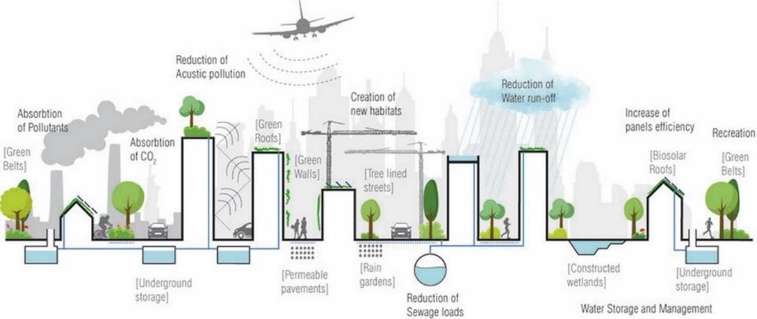
2. | How important/ this kind of infrastructure/ future city?
3. | What/ key factor/ this infrastructure?
4. | What/ advantage(s)/ this infrastructure?
5. | What/ disadvantage(s)/ this infrastructure?
 |  | Answer your friend’s questions about this picture.

