WEEK 5
Class | Date of teaching
4A | October 07th, 2025
4B | October 08th, 2025
PERIOD 17
UNIT 3: MY WEEK
LESSON 1 (1-3)
A. OBJECTIVES:
By the end of the lesson, pupils will be able to:
1. Knowledges:
- Understand and correctly repeat the sentences in two communicative contexts (pictures) in which pupils ask and answer questions about the days of the week.
- Correctly say the words and use What day is it today? – It’s _____. to ask and answer questions about the days of the week.
- Enhance the correct use of What day is it today? – It’s _____. to ask and answer questions about the days of the week in a freer context.
2. Skills: Listening and speaking
3. Attributes:
- Show their pride in their personal information and
- Communication and collaboration: work in pairs and groups to complete the learning tasks
- Self-control & independent learning: perform listening tasks.
4. Digital Competence (1.3CB2b): Identify where data is organized (specifically the days of the week) on digital interfaces such as a digital calendar or an online school timetable.
B. INSTRUCTIONAL RESOURCES
- Student’s book: Page 22
- Audio tracks 26, 27
- Teacher’s guide: Pages 43, 44, 45
- Flash cards/ pictures and posters (Unit 3)
- Hoclieu.vn
- Computer, projector
C. LEARNING PLAN:
Teacher’s activities | Student’s activities
1. Warm up (5’)  Greet the class.  - Have the whole class sing the song What time do you go to school? (ppt)  2. Presentation (10’)  Activity 1-Vocabulary  * Goals: Ss will be able to know the day of the week, before starting the new lesson.  * Procedure:  - T elicits the new words  + week : tuần lễ (picture)  + Monday : thứ hai (picture)  + Tuesday : thứ ba (picture)  + Wednesday : thứ tư (picture)  + Thursday : thứ năm (picture)  + Friday : thứ sáu (picture)  + Saturday : thứ bảy (picture)  + Sunday : chủ nhật (picture)  - T models (3 times).  - T writes the words on the board.  - Checking: Rub out and remember  - The disabled: Practice reading vocab.  - Digital Competence (1.3CB2b): T shows a digital calendar (e.g., Google Calendar or the Windows taskbar calendar) on the screen.  Activity 2-1. Look, listen and repeat.  * Goals: To understand and correctly repeat the sentences in two communicative contexts (pictures) in which pupils ask and answer questions about the days of the week.  * Procedure:  - Have pupils look at Pictures a and b and identify the characters in the pictures.  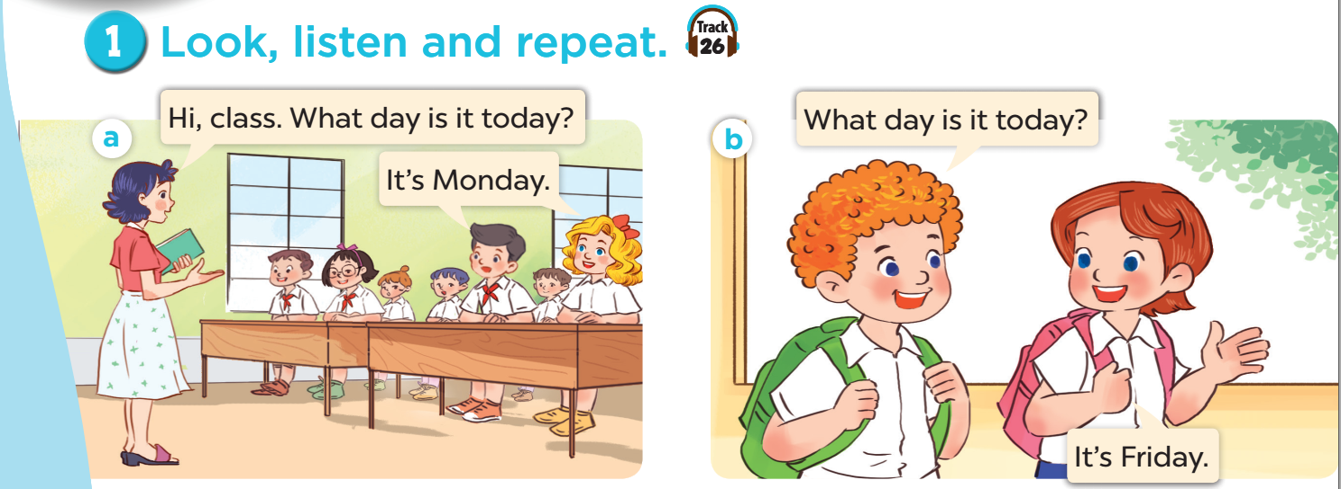  - Ask pupils to look at Picture a. Play the recording for them to listen. Play the recording again, sentence by sentence, for pupils to listen and repeat. Repeat the same procedure with Picture b. Correct their pronunciation where necessary.  - Play the recording again for pupils to listen and repeat in chorus sentence by sentence.  - Digital Competence (1.3CB2b): In Picture a, point to the calendar on the classroom wall. Ask: "In our e-book, how is this information arranged?" (In a list or grid).  - Invite a few pairs to the front of the classroom to listen to and repeat the sentences in the recording.  - Draw their attention to the question What day is it today? and the answer It's Monday. and It’s Friday.  - Tell pupils that they have a question and answers about the days of the week.  Extension: Invite a few pairs of pupils to ask and answer about the days of the week.  3. Practice (15’)  Activity 3-2. Listen, point and say.  * Goals: To correctly say the words and use What day is it today? – It’s _____. to ask and answer questions about the days of the week.  * Procedure:  - Have pupils look at the pictures and elicit the days of the week.  - Digital Competence (1.3CB2b): T uses the e-book tools to highlight the specific cells where the words "Monday", "Tuesday", etc., are stored. This helps Ss recognize the structured placement of data.  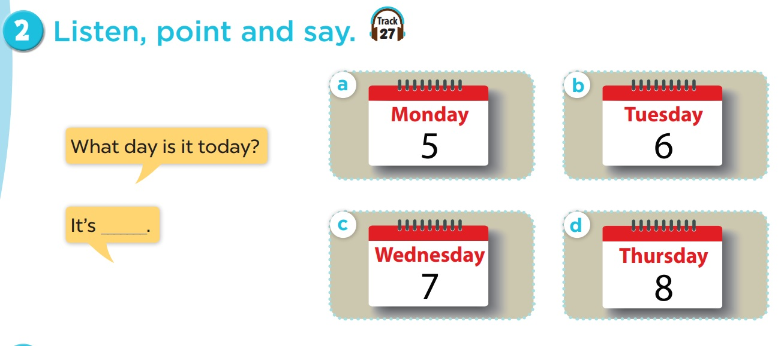  - Have pupils point at Picture a, listen to the recording and repeat the word (Monday). Repeat the same procedure with the other three pictures. Have the class repeat the words a few times.  - Point at the bubbles and Picture a and have pupils listen to and repeat after the recording (What day is it today? – It’s Monday.). Repeat the same procedure with the other three pictures (b, c, d). Have the class repeat the questions and answers a few times.  - Have pairs practise asking and answering the question What day is it today? – It’s _____.  - Invite a few pairs to point at the pictures and say the questions and answers in front of the class.  – Picture cues:  a. Monday b. Tuesday c. Wednesday d. Thursday  – Speech bubbles: What day is it today? – It’s _____.  Audio script:  a. Monday b. Tuesday c. Wednesday d. Thursday  a. A: What day is it today?  B: It’s Monday.  b. A: What day is it today?  B: It’s Tuesday.  c. A: What day is it today?  B: It’s Wednesday.  d. A: What day is it today?  B: It’s Thursday.  Activity 4-3. Let’s talk.  * Goal: To enhace the correct use of What day is it today? – It’s _____. to ask and answer questions about the days of the week in a freer context.  * Procedure  - Draw pupils’ attention to the picture. Ask questions to help them identify the context.  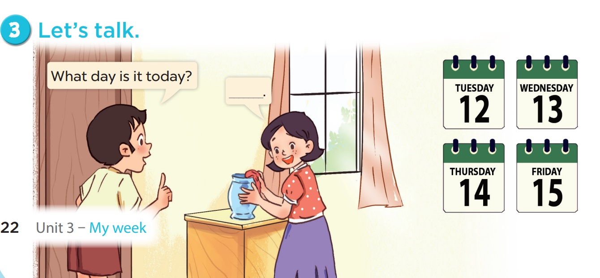  - Put pupils into pairs and encourage them to ask and answer questions about the days of the week. Go around the classroom to offer support.  - Invite a few pairs to the front of the class to ask and answer questions about the days of the week using What day is it today? – It’s _____. and the picture cue. Praise pupils if they perform well.  Game: Racing horses  - Divide children into groups of four.  - Give each group one paper dice.  - Race to find the winner.  4. Consolidation (3’)  - Ask students to answer the following question:  What have you learnt from the lesson today?  (- Use the words Monday, Tuesday, Wednesday, Thursday, Friday in relation to the topic My week to talk about the days of the week.  - Use sentence patterns What day is it today? – It’s _____. to ask and answer questions about the days of the week.)  * Preparation for the project:  Tell pupils about the project on page 27, Lesson 3, Activity 6. Ask them to take notes of weekend activities at home and present them to the class at Project time.  5. Homework (2’)  - Learn the vocab about the days of the week at home.  - Prepare the new lesson: Lesson 1 (4,5,6) of Unit 3 | - Listen to the techer  Whole class/ Individual work  - Ss listen and repeat  + Choral repetition (3 times).  + Individual repetition (3 ss)  - Ss take note  - Ss look, remember and write  - Whole class/Individual work  - Listen to the T's instruction  - Listen to the recording  - Individual work  - Listen and repeat  - Whole class/Pair work  - Listen to the T's instruction  - Individual work  - Listen to the teacher  Whole class/ Individual work  - Listen and repeat  - Listen to the teacher  - Pair work  - Whole class  - Practice in front of class  - Listen to the T's instruction.  - Play game in group  - Whole class/ Individual work
D. Recommendation
………………………………………………………………………………………….…..……………………………………………………………………………...………………………………………….…..………………………………………………

WEEK 5
Class | Date of teaching
4A | October 07th, 2025
4B | October 08th, 2025
PERIOD 18
UNIT 3: MY WEEK
LESSON 1 (4-6)
A.OBJECTIVES:
By the end of the lesson, pupils will be able to:
1. Knowledges:
- Listen to and understand two communicative contexts about the days of the week and tick the correct pictures.
- Complete four gapped exchanges with the help of picture cues.
- Revise target words about the days of the week by playing the game Slap the board.
2. Skills: Listening and speaking
3. Attributes:
- Show their responsibility by noticing the day of the week.
4. Digital Competency (3.2CB2a): Select ways to modify and refine information (weekly schedule): Pupils learn how to identify, select, and update correct information in a digital weekly schedule context when presented with incomplete or incorrect data.
B. INSTRUCTIONAL RESOURCES
- Student’s book: Page 23
- Audio tracks 29
- Teacher’s guide: Pages 45, 46, 47
- Hoclieu.vn
- Flash cards/ pictures and posters (Unit 3)
- Computer, projector
C. LEARNING PLAN:
Teacher’s activities | Student’s activities
1. Warm up (5’)  Greet the class.  - Spend a few minutes revising the previous lesson by asking the question What day is it today? and have a few pupils answer the question. Have the class give comments.  2. Practice (25’)  1-4. Listen and tick.  * Goals: To listen to and understand two communicative contexts about the days of the week and tick the correct pictures.  * Procedure  - Draw pupils attention to Pictures 1a and 1b. Ask questions to help them identify the days of the week.  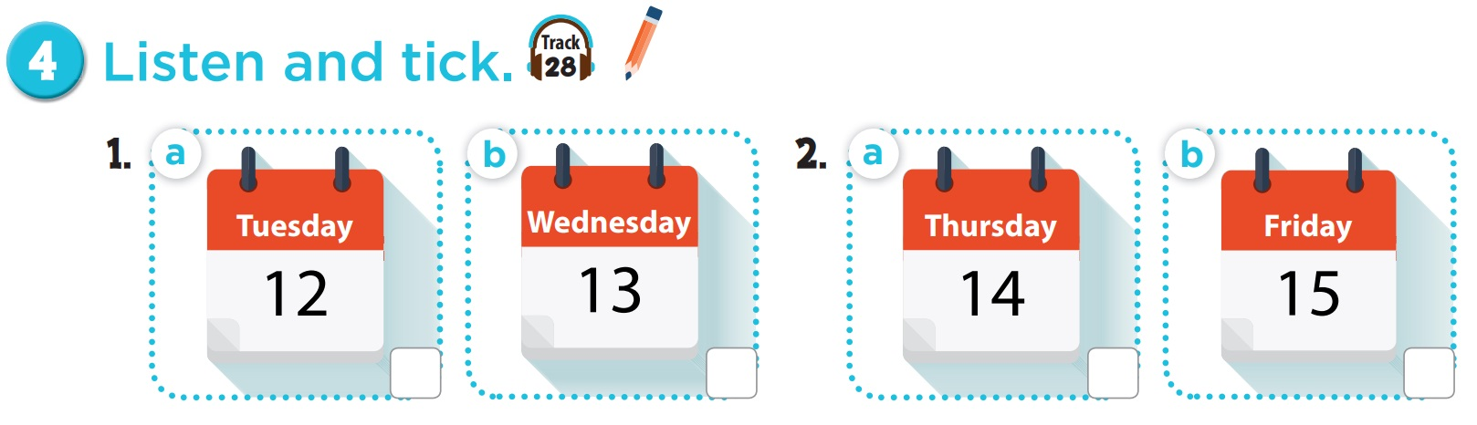  - Play the recording for Question 1 for pupils to listen. Then play the recording again for pupils to listen and tick the correct picture.  - Repeat Steps 1 and 2 for Pictures 2a and 2b.  - Tell pupils to swap books with a partner, then check answers together as a class. Write the correct answers on the board. Play the recording again for pupils to double- check their answers.  Extension: If time allows, play the recording, sentence by sentence, for the class to listen and repeat in chorus. Correct their pronunciation where necessary.  Picture cues:  1a. Tuesday 12 1b. Wednesday 13  2a. Thursday 14 2b. Friday 15  Audio script:  1. Ms Hoa: Hello, Nam.  Nam: Hello, Ms Hoa.  Ms Hoa: What day is it today?  Nam: It’s Wednesday.  Ms Hoa: OK.  2. Mr Long: Hello, Mai.  Mai: Hello, Mr Long.  Mr Long: What day is it today?  Mai: It’s Thursday.  Mr Long: Good.  Key: 1. b 2. a  Activity 2-5. Look, complete and read.  * Goal: To complete four gapped exchanges with the help of picture cues.  * Procedure  - Have pupils look at the pictures. Get them to identify the days of the week in the pictures.  - Digital Task (3.2CB2a): Tell pupils: "Imagine you are an editor for a digital calendar. This planner has missing days. You need to choose the correct day to 'refine' and complete the schedule."  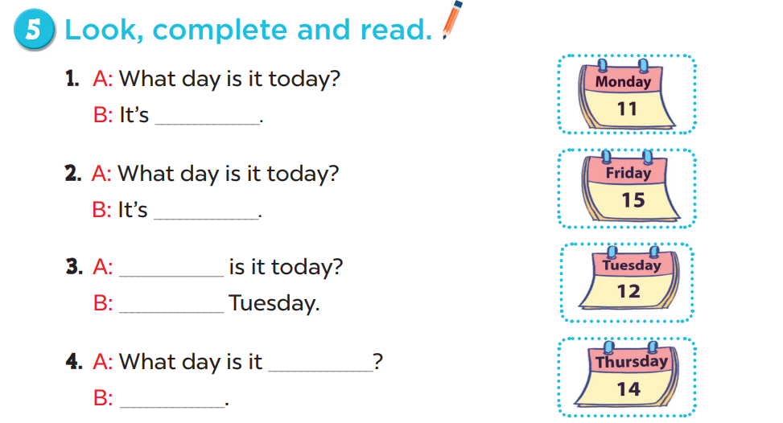  - Have pupils look at the gapped exchanges. Draw their attention to the missing words in the questions and answers.  - Model Picture 1. Have pupils look at the answer. Ask them what word is missing in the answer (Monday). Then have pupils complete it (It’s Monday.). Repeat the same procedure with Pictures 2, 3 and 4.  - Have pupils complete the gapped exchanges individually and ask a few pairs to read them aloud.  Key: 1. Monday 2. Friday 3. What day; It’s 4. today; It’s Thursday.  Activity 3. Let’s play.  * Goal: To revise target words about the days of the week by playing the game Slap the board.  * Procedure  - Tell pupils that they are going to listen to and slap the correct words as quickly as possible. Have them look at the days of the week on the board to recall the days of the week (as in Input).  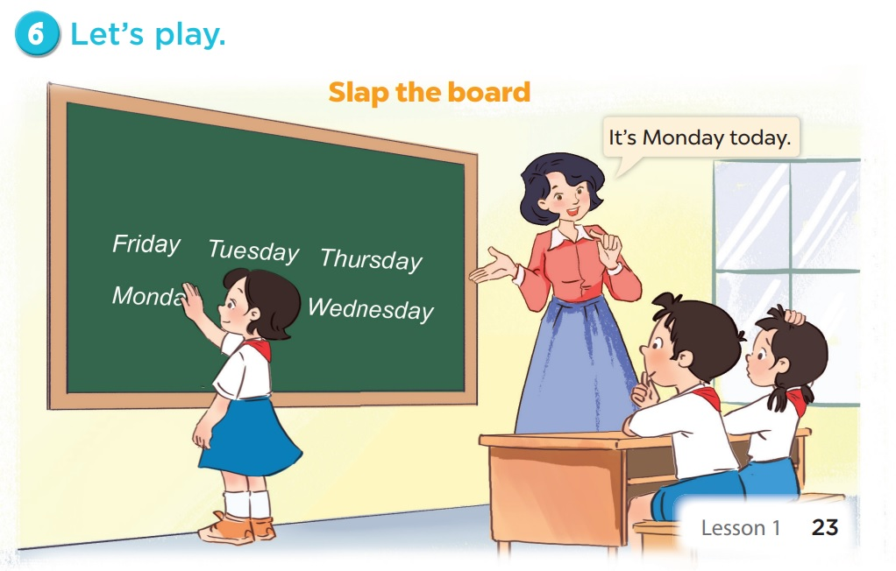  - Call two pupils to the front. Get them to stand at a certain distance from the board.  - Say a day of the week using It’s ____. with one of the words on the board, for example, It’s Monday. The pupil who is the quickest to slap the right word (Monday) gets one point. The pupil who slaps the most words is the winner.  - Invite a few pairs to the front of the class to play the game. Praise pupils if they perform well.  - The disabled: Play a game: Slap the board with the classmates.  3. Consolidation (3’)  - Ask students to answer the following questions:  1. What have you learnt from the lesson today?  Memory game https://www.eslgamesplus.com/days-of-the-week-esl-vocabulary-game/  4. Homework (2’)  - Review the vocab about the days of the week at home.  - Do parts A, B in the workbook.  - Prepare the new lesson: Lesson 2 (1,2,3) of Unit 3 | - Listen to the techer  Whole class/ Individual work  - Whole class/Individual  work  - Listen to the T's instruction  - Listen to the recording  - Individual work  - Listen and tick  - Whole class/Pair work  - Listen to the T's instruction  - Individual work  - Pair work  - Listen to the teacher  - Group work  - Listen to the T's instruction.
D. Recommendation
………………………………………………………………………………………….…..……………………………………………………………………………...………………………………………….…..………………………………………………
WEEK 5
Class | Date of teaching
4A | October 09th, 2025
4B | October 10th, 2025
PERIOD 19
UNIT 3: MY WEEK
LESSON 2 (1-3)
A. OBJECTIVES:
By the end of the lesson, pupils will be able to:
1. Knowledges:
- Understand and correctly repeat the sentences in two communicative contexts focusing on asking and answering questions about what someone does on certain days of the week.
- Correctly say the phrases and use What do you do on _____? – I _____. to ask and answer questions about what someone does on certain days of the week.
- Enhance the correct use of What do you do on _____? – _____. to ask and answer questions about what someone does on certain days of the week in a freer context.
2. Skills: Listening and speaking
3. Attributes:
- Show their responsibility by noticing the day of the week.
4. Digital Competency 2.1CB2a: Interact by asking and answering questions about weekly activities using digital tools (e.g., interactive software, Hoclieu.vn) at a basic level.
B. INSTRUCTIONAL RESOURCES
- Student’s book: Page 24
- Audio tracks 29, 30
- Teacher’s guide: Pages 47, 48, 49
- Flash cards/ pictures and posters (Unit 3)
- Hoclieu.vn
- Computer, projector
C. LEARNING PLAN:
Teacher’s activities | Student’s activities
1. Warm up (5’)  Greet the class.  Listen and guess  - Spell the first letter of any day/ spell any letter in a day, pupils guess.  - Flash the cards to consolidate pupils’ pronunciation and spelling.  2. Presentation (10’)  Activity 1-Vocabulary  * Goals: Ss will be able to know the day of the week, before starting the new lesson.  * Procedure:  - T elicits the new words  + study at school: học ở trường (picture)  + go to school : đi học (picture)  + do housework : làm việc nhà (picture)  + listen to music: nghe nhạc (picture)  - T models (3 times).  - T writes the words on the board.  - Checking: Rub out and remember  - The disabled: Practice reading vocab.  Activity 2-1. Look, listen and repeat.  * Goal: To understand and correctly repeat the sentences in two communicative contexts focusing on asking and answering questions about what someone does on certain days of the week.  * Procedure:  - Have pupils look at Pictures a and b and identify the characters in the pictures.  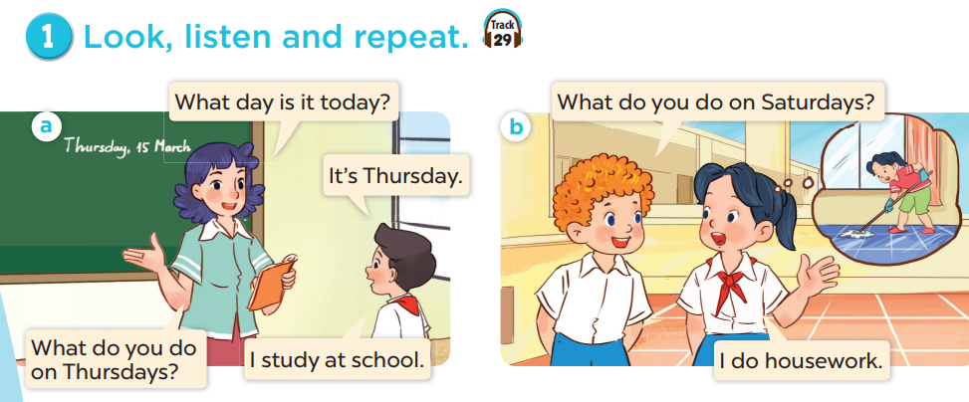  - Ask pupils to look at Picture a. Play the recording for them to listen. Play the recording again, sentence by sentence, for pupils to listen and repeat. Repeat the same procedure with Picture b. Correct their pronunciation where necessary.  - Play the recording again for pupils to listen and repeat in chorus sentence by sentence.  - Digital Integration (2.1CB2a): Use the interactive software to "click" on characters to hear them ask/answer. Ask pupils to predict the "digital response" before clicking.  - Invite a few pairs to the front of the classroom to listen to and repeat the sentences in the recording.  - Draw their attention to the questions What do you do on Thursdays / Saturdays? and the answers I study at school and I do housework. Tell pupils  hat they are questions and answers about what someone does on certain days of the week.  3. Practice (15’)  Activity 3-2. Listen, point and say.  * Goal: To correctly say the phrases and use What do you do on _____? – I _____. to ask and answer questions about what someone does on certain days of the week.  * Procedure:  - Have pupils look at the pictures and elicit the activities and the days of the week.  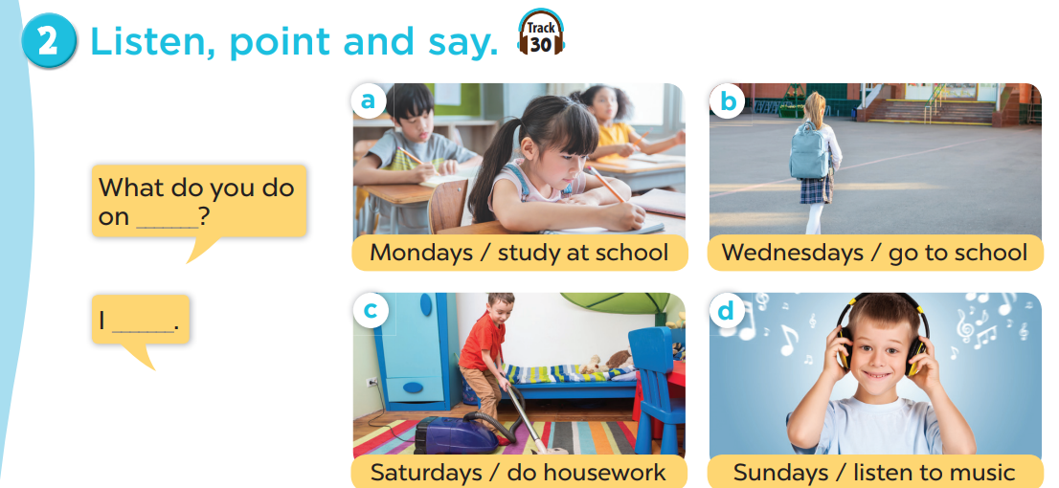  - Have pupils point at Picture a, listen to the recording and repeat the phrase (Mondays / study at school). Repeat the same procedure with the other three pictures. Have the class repeat the phrases a few times.  - Point at the bubbles and Picture a, then have pupils listen to and repeat after the recording (What do you do on Mondays? – I study at school.). Repeat the same procedure with the other three pictures b, c and d.  - Have pairs practise asking and answering the question What do you do on _____? – I _____.  - Invite a few pairs to point at the pictures and say the questions and answers in front of the class.  – Picture cues:  a. a girl studying at school b. a girl going to school  c. a boy doing housework d. a boy listening to music  – Speech bubbles: What do you do on _____? – I _____.  Audio script:  a. Mondays / study at school b. Wednesdays/ go to school  c. Saturdays / do housework d. Sundays/ listen to music  a. A: What do you do on Mondays?  B: I study at school.  b. A: What do you do on Wednesdays?  B: I go to school.  c. A: What do you do on Saturdays?  B: I do housework.  d. A: What do you do on Sundays?  B: I listen to music.  Activity 4-3. Let’s talk.  * Goal: To enhance the correct use of What do you do on _____? – _____. to ask and answer questions about what someone does on certain days of the week in a freer context.  * Procedure:  - Draw pupils’ attention to the picture. Ask questions to help them identify the context (see Input).  - Digital Competency Focus (2.1CB2a): Use the "Interacting" feature on the projector. Invite a student to come up and "interact" with a digital friend on the screen (using Hoclieu.vn or a digital puppet) to ask: What do you do on Sundays?  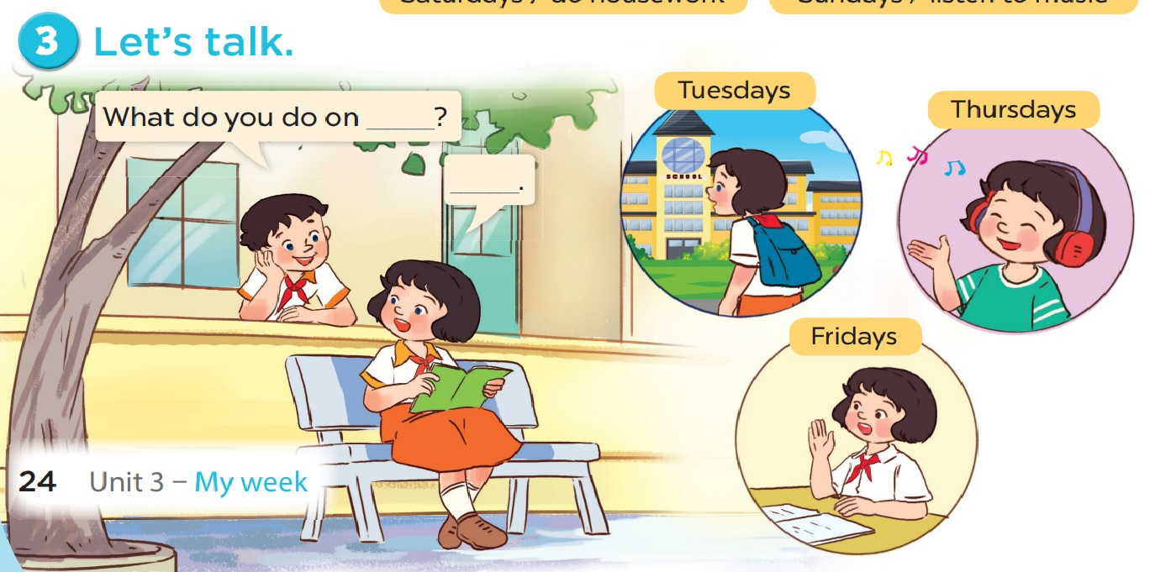  - Put pupils into pairs and encourage them to ask and answer questions about what someone does on certain days of the week. Go around the classroom to offer support.  - Invite a few pairs to the front of the class to perform their conversations.  - Invite a few pairs to practise asking and answering questions about what they do on certain days of the week. Praise pupils if they perform well.  Game: Spelling game  - Teacher says: Can you spell - pause - pretends to think, then say Mondays, waits for pupils to spell, shows the word  - Have Ss repeat with others.  - can play in two groups, the fastest gets one sticker.  4. Consolidation (3’)  - Ask students to answer the following questions:  1. What have you learnt from the lesson today?  5. Homework (2’)  - Learn the vocab by heart at home.  - Prepare the new lesson: Lesson 2 (4,5,6) of Unit 3 | - Listen to the techer  Whole class/ Individual work  - Ss listen and repeat  + Choral repetition (3 times).  + Individual repetition (3 ss)  - Ss take note  - Ss look, remember and write  - Listen to the T's instruction  - Individual work  - Whole class/Pair work  - Listen and repeat  - Listen to the T's instruction  - Repeat  - Individual work  - Listen to the teacher  - Whole class/ Individual work  - Listen to the teacher  - Listen to the T's instruction.  - Play in group  - Whole class/ Individual work
D. Recommendation
………………………………………………………………………………………….…..……………………………………………………………………………...………………………………………….…..…
WEEK 5
Class | Date of teaching
4A | October 09th, 2025
4B | October 10th, 2025
PERIOD 20
UNIT 3: MY WEEK
LESSON 2 (4-6)
A. OBJECTIVES:
By the end of the lesson, pupils will be able to:
1. Knowledges:
- Listen to and understand four communicative contexts about days of the week and what someone does on certain days of the week and number the correct pictures.
- Complete four gapped exchanges with the help of picture cues.
- Sing the song My week with the correct pronunciation, rhythm and melody.
2. Skills: Listening and speaking
3. Attributes:
- Show their responsibility by noticing the day of the week.
4. Digital Competence 5.2CB2c: Choose simple ways to adjust listening exercises. Pupils learn to interact with digital audio (pausing, repeating, or adjusting speed) to improve comprehension.
B. INSTRUCTIONAL RESOURCES
- Student’s book: Page 25
- Audio tracks 31, 32
- Teacher’s guide: Pages 50, 51, 52
- Flash cards/ pictures and posters (Unit 3)
- Hoclieu.vn
- Computer, projector
C. LEARNING PLAN:
Teacher’s activities | Student’s activities
1. Warm up (5’)  Greet the class.  - Spend a few minutes revising the previous lesson by getting a few pairs to ask and answer questions about what they do on certain days of the week.  2. Practice (25’)  Activity 1-4. Listen and number.  * Goal: To listen to and understand four communicative contexts about days of the week and what someone does on certain days of the week and number the correct pictures.  * Procedure:  - Draw pupils’ attention to the pictures. Elicit the activities and the days of the week.  - Integration of 5.2CB2c: Before playing the audio, T asks: "If the recording is too fast, what should we do?" (Slow it down/Pause). T shows how to use the playback bar on hoclieu.vn or the media player.  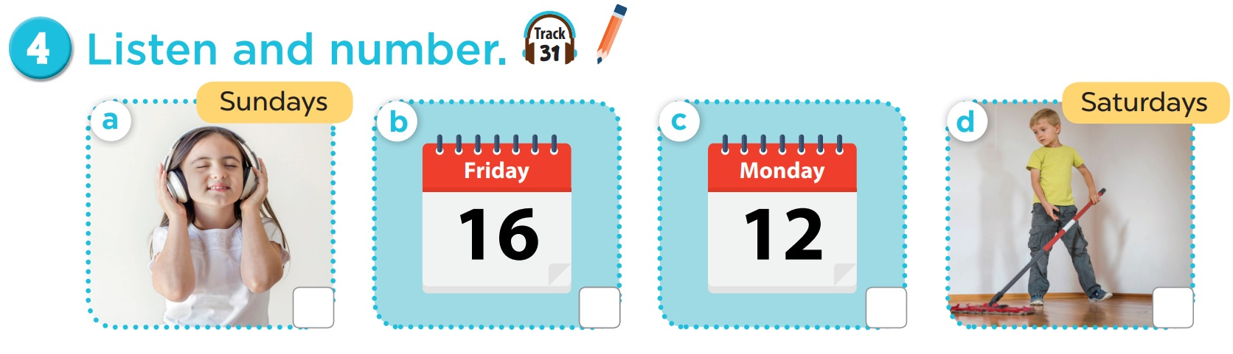  - Play the recording for pupils to do the task by numbering the pictures. Play the recording again to give pupils another listening opportunity.  - Check answers together as a class. Play the recording a third time for pupils to double-check their answers and correct their answers in pairs.  Extension: If time allows, play the recording, sentence by sentence, for the class to listen and repeat in chorus. Correct their pronunciation where necessary.  - The disabled: Do Ex.4.  Picture cues:  a. a girl listening to music on Sundays  b. a calendar: Friday  c. a calendar: Monday  d. a boy doing housework on Saturdays  Audio script:  - A: What day is it today?  B: It’s Monday.  - A: What do you do on Saturdays?  B: I do housework.  - A: What day is it today?  B: It’s Friday.  - A: What do you do on Sundays?  B: I listen to music.  Activity 2-5. Look, complete and read.  * Goal: To complete four gapped exchanges with the help of picture cues.  * Procedure:  - Have pupils look at the pictures. Get them to identify the days of the week and the activities in the pictures.  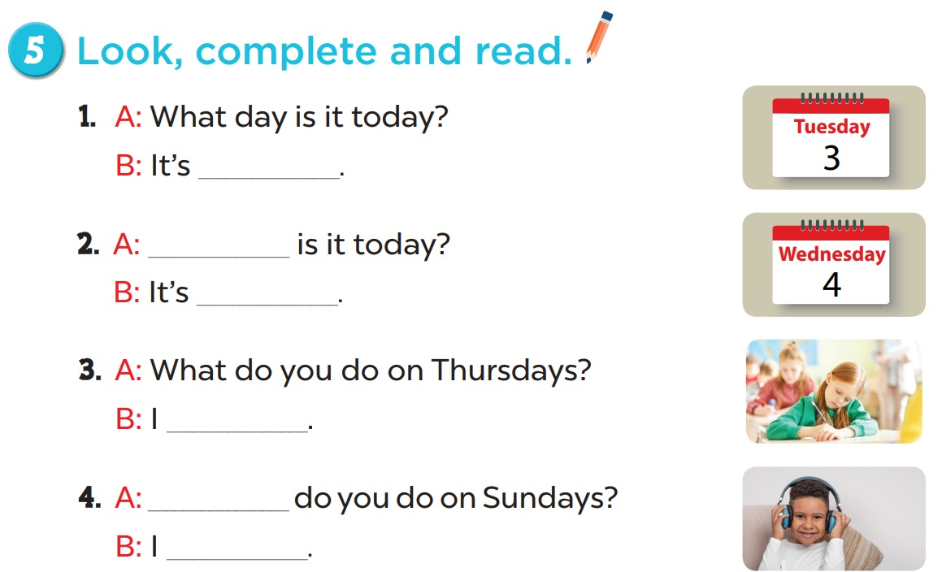  - Have pupils look at the four gapped exchanges. Draw their attention to the missing words in the questions and answers.  - Model Picture 1. Have pupils look at the answer. Ask them what word is missing (Tuesday). Then have them complete the answer (It’s Tuesday.). Repeat the same procedure with Pictures 2, 3 and 4.  - Have pupils complete the gaps individually and ask a few pairs to read the four completed exchanges aloud.  Key:  1. Tuesday  2. What/Wednesday  3. I go to school on Thursdays.  4. What/I listen to music on Sundays.  Activity 3-6. Let’s sing.  * Goals: To sing the song What day is it today? with the correct pronunciation, rhythm and melody.  Draw pupils’ attention to the title and lyrics of the song. Encourage them to point at the characters’ activities to reinforce their understanding.  * Procedure:  - Play the recording all the way through for pupils to listen to the whole song. Encourage them to listen carefully to the pronunciation, rhythm and the melody.  - Integration of 5.2CB2c: T encourages pupils to request a "replay" of difficult lines to catch the rhythm.  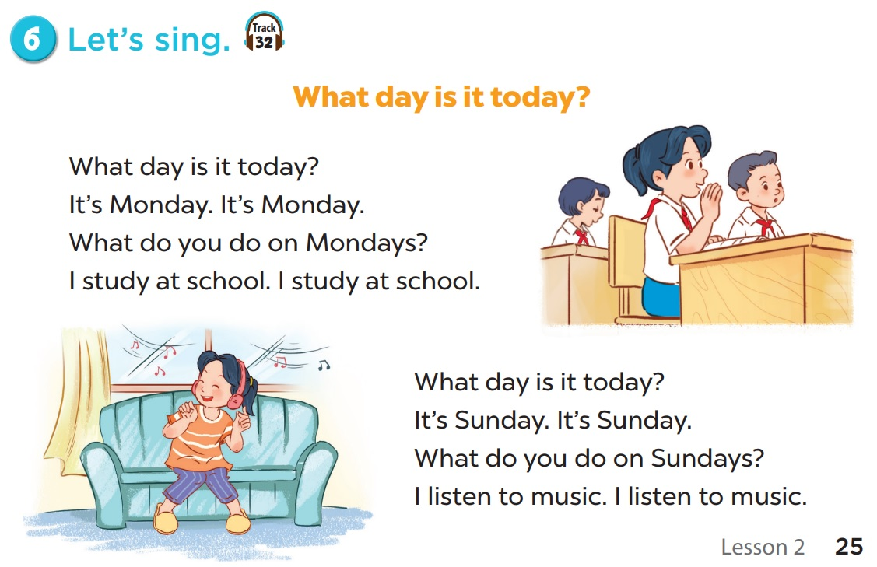  - Play the recording line by line for pupils to listen and repeat. Correct their pronunciation where necessary.  - Play the recording all the way through for pupils to sing along.  - Play the recording again for pupils to sing and clap along with the recording. Pupils can sing the song What day is it today? with the correct pronunciation, rhythm and melody.  3. Consolidation (3’)  - Sing the song Seven days of the week with TPR technique  https://www.youtube.com/watch?v=lPgTdgvj_jc  - Let pupils listen to the song several times, sing along and act together.  4. Homework (2’)  - Learn the sing by heart at home.  - Do parts C, D in the workbook.  - Prepare the new lesson: Lesson 3 (1,2,3) of Unit 3 | - Listen to the techer  Whole class/ Individual work  - Whole class/Individual work  - Listen to the T's instruction  - Individual work  - Whole class  - Listen to the T's instruction  - Whole class/ Individual work  - Individual work  - Listen to the teacher  - Group work  - Sing and clap along with the recording  - Whole class/ Individual work
D. Recommendation
WEEK 6
Class | Date of teaching
4A | October 14th, 2025
4B | October 15th, 2025
PERIOD 21
UNIT 3: MY WEEK
LESSON 3 (1-3)

A. OBJECTIVES:
By the end of the lesson, pupils will be able to:
1. Knowledges:
- Correctly repeat the sounds of the letter u in isolation, in the word music (/ju/) as in the sentence I listen to music on Saturdays, and the word Sunday (/ʌ/) as in I do housework on Sundays.
- Identify the target words music and Sunday while listening.
- Say the chant with the correct pronunciation and rhythm.
2. Skills: Listening and speaking
3. Attributes:
- Show their responsibility by noticing the day of the week.
4. Digital Competence (1.1CB2c): Identify and use the interactive audio icons on the digital textbook (hoclieu.vn) to access the specific sounds of the letter u.
B. INSTRUCTIONAL RESOURCES
- Student’s book: Page 26
- Audio tracks 33, 34, 35
- Teacher’s guide: Pages 51, 52, 53
- Flash cards/ pictures and posters (Unit 3)
- Hoclieu.vn
- Computer, projector
C. LEARNING PLAN:
Teacher’s activities | Student’s activities
1. Warm up (5’)  Greet the class.  - Have pupils answer the questions then sing the song What day is it today? (ppt)  2. Presentation (10’)  Activity 1-1. Listen and repeat.  * Goals: To correctly repeat the sounds of the letter u in isolation, in the words music and Sunday, and in the sentences I listen to music on Saturdays. and I do housework on Sundays. with the correct pronunciation and intonation.  * Procedure:  - Draw pupils’ attention to the letter u, the word music and the sentence I listen to music on Saturdays. Play the recording and encourage pupils to point at the letter, the word, and the sentence while listening.  - Digital Competence (1.1CB2c): T points to the speaker icons next to the letter 'u'. T asks: "If you want to hear this sound again at home, where do you click?"  - Play the recording again and encourage pupils to listen to and repeat the sound, the word and the sentence. Do this several times until pupils feel confident. Correct their pronunciation where necessary.  - Repeat Steps 1 and 2 for the same letter u, the word Sunday and the sentence I do housework on Sundays.  - Have pupils work in pairs or groups, pronouncing the sounds, saying the words and reading the sentences until they feel confident.  3. Practice (15’)  Activity 2-2. Listen and circle.  * Goals: To identify the target words music and Sunday while listening.  * Procedure:  - Tell pupils that they are going to listen to the recording and circle the correct options. Get them to read the options and guess the sentences they may hear in the recording.  - Digital Competence (1.1CB2c): Invite a pupil to the board to access the digital audio by clicking the play button for the class.  - Play the recording for pupils to listen. Play the recording again for pupils to listen and circle the correct options.  - Tell pupils to swap books with a partner, then check the answers together as a class. Write the correct answers on the board.  - Play the recording again for pupils to double-check their answers.  Extension: Invite one or two pupils to stand up, listen to and repeat the sentences.  Audio script:  1. I listen to music.  2. I study at school.  Activity 3-3. Let’s chant.  * Goal: To say the chant with the correct pronunciation and rhythm.  * Procedure:  - Draw pupils’ attention to the lyrics of the chant. Check their comprehension.  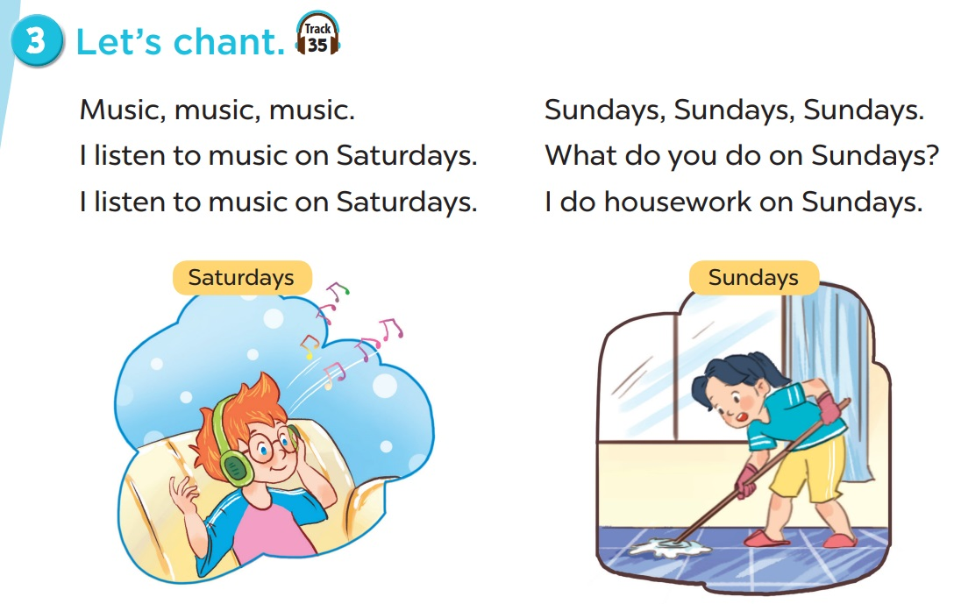  - Play the recording all the way through for pupils to listen to the whole chant. Encourage them to listen carefully to the rhythm and pronunciation. Draw pupils’ attention to the sounds of the letter u in the words music and Sunday.  - Play the recording, line by line, for pupils to listen and repeat. Correct their pronunciation where necessary.  - Play the recording all the way through for pupils to chant along. Encourage them to clap along while chanting.  Extension: Divide the class into two groups to take turns listening to and repeating the chant, while the rest of the class claps along. Praise pupils if they perform well.  Miming Game  - Mime to show the subject or activities pupils often do on each day at school or at home. It can be played in groups or the whole class.  - Award pupils stickers for their correct answer.  4. Consolidation (3’)  1. What have you learnt from the lesson today?  2. What are the core values of the lesson?  5. Homework (2’)  - Practice reading the sounds u by heart at home.  - Prepare the new lesson: Lesson 3 (3,4,5) of Unit 3 | - Listen to the techer  Whole class/ Individual work  - Whole class  - Listen to the T's instruction  - Listen and repeat  - Whole class/  - Pair work  - Listen and repeat  - Listen to the T's instruction  - Repeat  - Individual work  - Listen to the teacher  - Whole class/ Individual work  - Clap along while chanting  - Listen to the T's instruction.  - Play in group  - Whole class/ Individual work
D. Recommendation
………………………………………………………………………………………….…..……………………………………………………………………………...………………………………………….…..………………………………………………

WEEK 6
Class | Date of teaching
4A | October 14th, 2025
4B | October 15th, 2025
PERIOD 22
UNIT 3: MY WEEK
LESSON 3 (4-6)
A.OBJECTIVES:
By the end of the lesson, pupils will be able to:
1. Knowledges:
- Read and show understanding of a text and complete a table about Nam’s week.
- Complete a paragraph about what pupils do on certain days of the week by writing the target words in the gaps.
- Draw two pictures about weekend activities at home and present them to the class by using the target language.
2. Skills: Reading and writing
3. Attributes:
- Show their responsibility by noticing the day of the week.
4. Digital Competency (2.4CB2a): Select simple digital tools for group collaboration: Pupils work in groups to choose a digital template/table to organize and present their group’s weekly or weekend activities.
B. INSTRUCTIONAL RESOURCES
- Student’s book: Page 27
- Teacher’s guide: Pages 53, 54
- Hoclieu.vn
- Flash cards/ pictures and posters (Unit 3)
- Computer, projector
C. LEARNING PLAN:
Teacher’s activities | Student’s activities
1. Warm up (5’)  - Greet the class and encourage pupils to respond to the greeting.  - Spend a few minutes revising the previous lesson by having pupils answer the questions by using sentence patterns they have learned. (ppt)  2. Practice (25’)  Activity 1-4. Read and complete.  * Goals: To read and show understanding of a text and complete a table about Nam’s week.  * Procedure:  - Draw pupils’ attention to the words provided in the table and the four gaps about Nam’s activities on some days of the week.  - Ask pupils to read the text and complete the table with the missing words.  - Set a time limit for pupils to read the text again and look for specific information to fill in the gaps in the table. Go around the classroom to monitor their reading task.  - Tell pupils to swap their answers with a partner, then check answers together as a class. Write the answers on the board.  Key:  1, 2. go to school  3. do housework  4. watch TV  Activity 2-5. Let’s write.  * Goals: To complete a paragraph about what pupils do on certain days of the week by writing the target words in the gaps.  * Procedure:  - Ask pupils to read the gapped text and fill in the gaps with their own information. Tell pupils that the gaps in the text should focus on their activities and the days on which they do the activities. Check comprehension.  - Have pupils do the first gapped sentence together as an example. Ask them to read the sentence and elicit the names. Then have them write their names in the gap, e.g. I am Lan.  - Give pupils time to complete the text independently. Go around the classroom and offer help where necessary.  - Get pupils to swap their books with a partner and check their answers before checking as a class.  Extension: Invite a few pupils to read their completed texts in front of the class.  Suggested answer:  I am Tram. I go to school school on Modays, Tuesdays, Wednesdays, Thursdays, and Fridays. I do housework on Saturdays. On Sundays, I listen to music. What do you do at the weekend?  Activity 3-6. Project  * Goals: To tell sts’weekend activities.  * Procedure:  - Digital Task (2.4CB2a): Show 2-3 simple digital schedule templates on the projector. Ask groups: "Which tool do you want to use to show your group's activities?"  - Tell pupils the goal of the activity. Explain that they have to look at the pictures they have prepared at home and present them to the class.  - Have pupils work in groups of five or six. Each pupil looks at his / her pictures and tells the group about what he / she does on Saturdays and Sundays.  - Invite a few pupils to look at their pictures and tell the class about them, e.g. On Saturdays, I play football. or On Sundays, I do housework.  - The disabled: Say their weekend activites.  Game: Touching the wall  - Give each pair something to stick the cards on the wall with. Ask everyone to randomly stick the cards all over the walls around the room. Then bring everyone into the middle of the room. Shout out Monday and everyone has to race over to a Monday card and touch it. Then Tuesday and so on (in the correct order) until you make it through all the weekdays. Play another round, this time faster!  3. Consolidations (3’)  - Ask students to answer the following questions:  1. What have you learnt from the lesson today?  2. What are the core values of the lesson?  4. Homework (2’)  - Redo Ex.4, 5 at home.  - Do parts E, F in the workbook.  - Prepare the new lesson: Lesson 1 (1,2,3) of Unit 4 | - Listen to the techer  Whole class/ Individual work  - Whole class/Individual work  - Listen to the T's instruction  - Individual work  - Whole class/  - Do the task independently  - Listen to the T's instruction  - Individual work  - Listen to the teacher  - Work in groups of five or six  - Listen to the T's instruction.  - Play in group  - Whole class/ Individual work
D. Recommendation
………………………………………………………………………………………….…..……………………………………………………………………………...………………………………………….…..………………………………………………

WEEK 6
Class | Date of teaching
4A | October 16th, 2025
4B | October 17th, 2025
PERIOD 23

UNIT 4: MY BIRTHDAY PARTY
LESSON 1 (1-3)
A. OBJECTIVES:
By the end of the lesson, pupils will be able to:
1. Knowledges:
- Understand and correctly repeat the sentences in two communicative contexts focusing on asking and answering questions about birthdays.
- Correctly say the words and use When’s your birthday? – It’s in _____. to ask and answer questions about someone’s birthday.
- Enhance the correct use of When’s your birthday? – It’s in _____. to ask and answer questions about someone’s birthday in a freer context.
2. Skills: Listening and speaking
3. Attributes:
- Show pride in the date of birth of themselves and others’ and respect to their parents for their presence.
4. Digital Competency 1.1CB2b: Identify and find date/month data using an electronic calendar (on a computer or smartphone) to serve the purpose of asking and answering about birthdays.
B. INSTRUCTIONAL RESOURCES
- Student’s book: Page 28
- Audio tracks 36, 37
- Teacher’s guide: Pages 55, 56, 57
- Hoclieu.vn
- Flash cards/ pictures and posters (Unit 4)
- Computer, projector
C. LEARNING PLAN:
Teacher’s activities | Student’s activities
1. Warm up (5’)  Greet the class.  - Spend a few minutes revising Unit 3 by asking the class to do the project in Lesson 3 or to sing the song What day is it today? on page 25 and clap hands.  - Ask pupils to open their books at page 28 and look at Unit 4, Lesson 1, Activity 1. Get pupils to look at the title of the unit and check comprehension. Have them repeat it once or twice. Tell pupils what they will learn in this lesson.  2. Presentation (10’)  Activity 1-Vocabulary  * Goals: Ss will be able to know the day of the week, before starting the new lesson.  * Procedure:  - T elicits the new words  + birthday party: bữa tiệc sinh nhật (picture)  + month : tháng (picture)  + Juanuary : tháng 1 (picture)  + February : tháng 2 (picture)  + March : tháng 3 (picture)  + April : tháng 4 (picture)  + May : tháng 5 (picture)  + June : tháng 6 (picture)  + July : tháng 7 (picture)  + August : tháng 8 (picture)  + September : tháng 9 (picture)  + October : tháng 10 (picture)  + November : tháng 11 (picture)  + December : tháng 12 (picture)  - T models (3 times).  - T writes the words on the board.  - Checking: Rub out and remember  - The disabled: Practice reading vocab.  Activity 2-1. Look, listen and repeat.  * Goals: To understand and correctly repeat the sentences in two communicative contexts focusing on asking and answering questions about birthdays.  * Procedure:  - Have pupils look at Pictures a and b and identify the characters in the pictures.  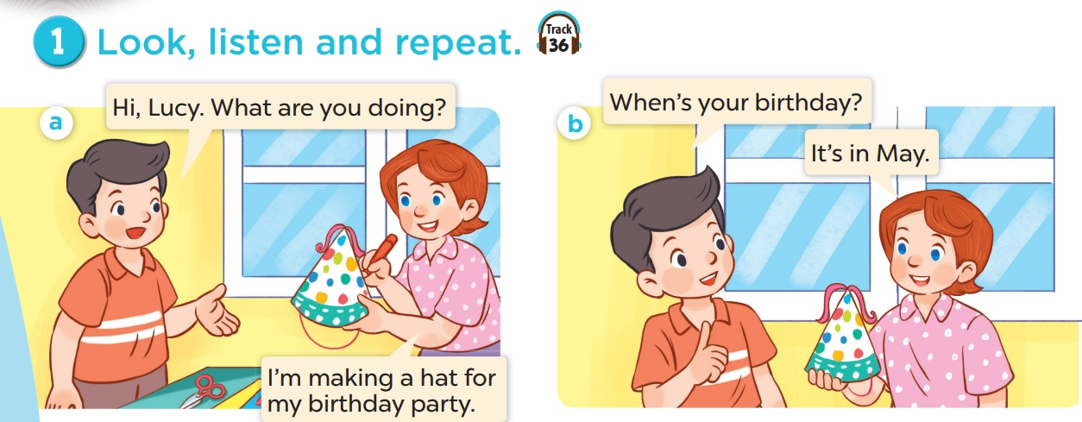  - Ask pupils to look at Picture a. Play the recording for them to listen. Play the recording again, sentence by sentence, for pupils to listen and repeat. Repeat the same procedure with Picture b. Correct their pronunciation where necessary.  - Play the recording again for pupils to listen and repeat in chorus, sentence by sentence.  - Invite a few pairs to the front of the classroom to listen to and repeat the sentences in the recording.  - Draw their attention to the question When’s your birthday? and the answer It’s in May. Tell pupils that these are a question and an answer about someone’s birthday.  3. Practice (15’)  Activity 3-2. Listen, point and say.  * Goals: To correctly say the words and use When’s your birthday? – It’s in _____. to ask and answer questions about someone’s birthday.  * Procedure:  - Have pupils watch a video about months of the year, then introduce the five first months by having them look at the pictures and elicit the names of the months. Have them repeat the word a few times.  - Digital Competency Integration (1.1CB2b): T projects a digital calendar (from the laptop taskbar). Ask: "If I want to find which month my birthday is in on this computer, where should I click?" T demonstrates how to scroll through months on the digital calendar.  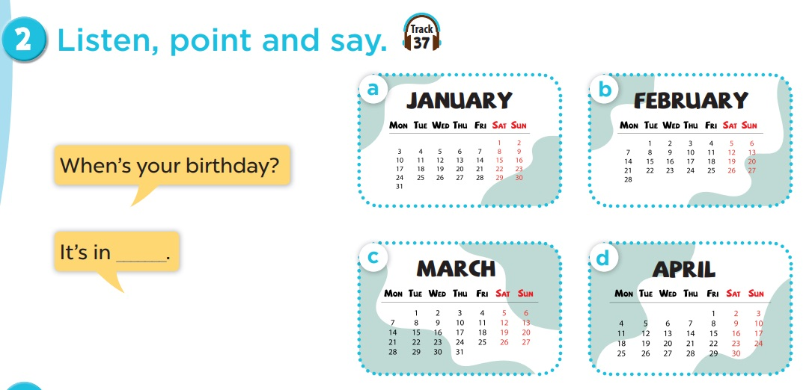  - Teacher may also let them play the Board Race game to consolidate the new words (Teacher says the months, pupils race to the board to write the corresponding numbers).  - Have pupils open the book at page 28, point at Picture a, listen to the recording and repeat the word (January). Repeat the same procedure with the other three pictures.  - Point at the bubbles and have pupils listen to and repeat after the recording (When’s your birthday? – It’s in January.). Point at Picture a and have pupils listen to and repeat the sentences until they feel confident. Repeat the same procedure with Pictures b, c, and d.  - Have pupils work in pairs and practise asking and answering the question When’s your birthday? – It’s in _____. using the speech bubbles and the pictures.  ﻿﻿﻿– Picture cues:  a. a calendar showing January  b. a calendar showing February  c. a calendar showing March  ﻿d. a calendar showing April  ﻿– Speech bubbles: When’s your birthday? – It’s in _____.  ﻿Audio script:  a. January b. February c. March d. April  a. A: When’s your birthday?  B: It’s in January.  b. A: When’s your birthday?  B: It’s in February.  c. A: When’s your birthday?  B: It’s in March.  d. A: When’s your birthday?  B: It’s in April.  Activity 3. Let’s talk.  * Goals: To enhance the correct use of When’s your birthday? – It’s in _____. to ask and answer questions about someone’s birthday in a freer context.  * Procedure:  - Draw pupils’ attention to the picture. Have them say the names of the months in the picture. Ask questions to help them identify the context (see Input).  - Digital Competency Focus (1.1CB2b): Invite a student to come to the laptop. T says: "Find the month of March on this digital calendar." Once found, the student asks a friend: "When's your birthday?"  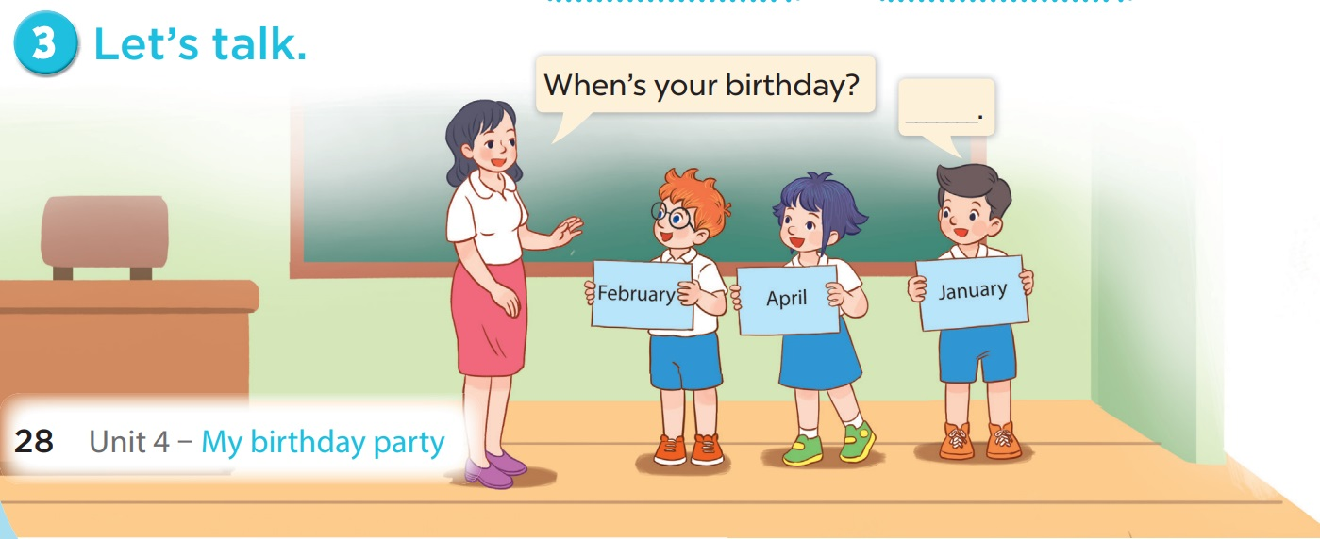  - Elicit the missing words in the speech bubble and write them on the board. Get pupils to say the completed sentences.  - Have pupils look at the bubbles to understand how the sentence pattern is used. Have pupils role-play to practise asking the questions and giving their answers in pairs, using picture cues. Make sure pupils understand the structure and say them with the right pronunciation and intonation. Go around to observe and provide help.  - Invite some pupils to practise asking and answering questions in front of the class. Praise them if they perform well.  Extension: For a more able class, have pupils ask and answer questions about their birthdays, using the structures learnt.  Game: SpongeBob  - Divide the class into 3 teams.  - Pupils from each team take turns to choose a letter and answer a question.  - Pupils answer correctly to get some points corresponding to the number of hamburgers.  4. Consolidation (3’)  - Ask students what they have learnt through the lesson  (Correctly say the words and use When’s your birthday? – It’s in _____. to ask and answer questions about someone’s birthday.)  * Preparation for the project: Tell pupils about the project on page 33. Ask them to prepare for it at home by making birthday party invitations. Remind them to bring the invitations to class to present them at Project time.  5. Homework (2’)  - Learn the vocab by heart at home.  - Prepare the new lesson: Lesson 1 (4,5,6) of Unit 4 | - Listen to the techer  Whole class/ Individual work  - Whole class/Individual work  - Ss listen and repeat  + Choral repetition (3 times).  + Individual repetition (3 ss)  - Ss take note  - Ss look, remember and write  - Listen to the T's instruction  - Listen to the recording  - Individual work  - Listen and repeat  - Whole class/  - Pair work  - Listen to the T's instruction  - Individual work  - Listen to the teacher  Whole class/ Individual work  - Listen and repeat  - Group work  - Listen to the teacher  - Group work  - Whole class  - Practice in front of class  - Some pupils to practise asking and answering questions in front of the class  - Listen to the T's instruction.
D. Recommendation
………………………………………………………………………………………….…..……………………………………………………………………………...………………………………………….…..………………………………………………

WEEK 6
Class | Date of teaching
4A | October 16th, 2025
4B | October 17th, 2025
PERIOD 24

UNIT 4: MY BIRTHDAY PARTY
LESSON 1 (4-6)
A. OBJECTIVES:
By the end of the lesson, pupils will be able to:
1. Knowledges:
- Listen to and understand four communicative contexts in which pupils ask and answer questions about their birthdays and number the correct pictures.
- Complete four target gapped exchanges with the help of picture cues.
- Sing the song When's your birthday? with the correct pronunciation, rhythm and melody.
2. Skills: Listening and writing
3. Attributes:
- Show pride in the date of birth of themselves and others’ and respect to their parents for their presence.
4. Digital Competence 4.2CB2a: Choose ways to protect personal data (birthdate). Pupils learn to distinguish between safe environments (classroom, party with friends) and unsafe ones (public websites, strangers) for sharing their personal information.
B. INSTRUCTIONAL RESOURCES
- Student’s book: Page 29
- Audio tracks 39, 40
- Teacher’s guide: Pages 57, 58, 59, 60
- Hoclieu.vn
- Flash cards/ pictures and posters (Unit 4)
- Computer, projector
C. LEARNING PLAN:
Teacher’s activities | Student’s activities
1. Warm up (5’)  Greet the class.  - ﻿Spend a few minutes revising the previous lesson. Get a few pupils to ask and answer questions about birthdays in front of the class. Have the class give comments.  2. Practice (25’)  Activity 1-4. Listen and number.  * Goals: To listen to and understand four communicative contexts in which pupils ask and answer questions about their birthdays and number the correct pictures.  * Procedure:  - Draw pupils’ attention to the pictures. Elicit the name of the month in each picture.  - Integration of 4.2CB2a: While checking answers, T asks: "In the audio, the characters are friends. Is it okay for them to tell each other their birthdays?" (Yes).  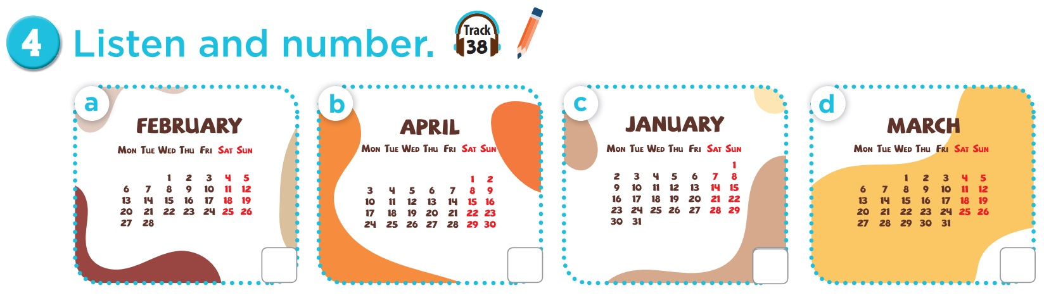  - Play the recording all the way through so that pupils can become familiar with the characters’ voices. Then play the recording for them to listen and number the pictures.  - Play the recording again for pupils to do the task. Play the recording a third time to give pupils another listening opportunity.  - Check answers as a class. Play the recording again for pupils to double-check their answers and correct their answers in pairs.  Extension: If time allows, play the recording, sentence by sentence, for the class to listen and repeat in chorus. Correct their pronunciation where necessary. If they repeat well, praise them.  Picture cues:  a. a calendar showing February b. a calendar showing April  c. a calendar showing January d. a calendar showing March  Audio script:  ﻿1. A: When’s your birthday?  B: It’s in April.  2. A: When’s your birthday?  B: It’s in February.  3. A: When’s your birthday?  B: It’s in March.  A: Thank you.  4. A: When’s your birthday?  B: It’s in January.  A: My birthday’s in January too.  Activity 2-5. Look, complete and read.  * Goals: ﻿To complete four target gapped exchanges with the help of picture cues.  * Procedure:  - Have pupils look at the pictures. Have them identify the birthdays (months) in the pictures.  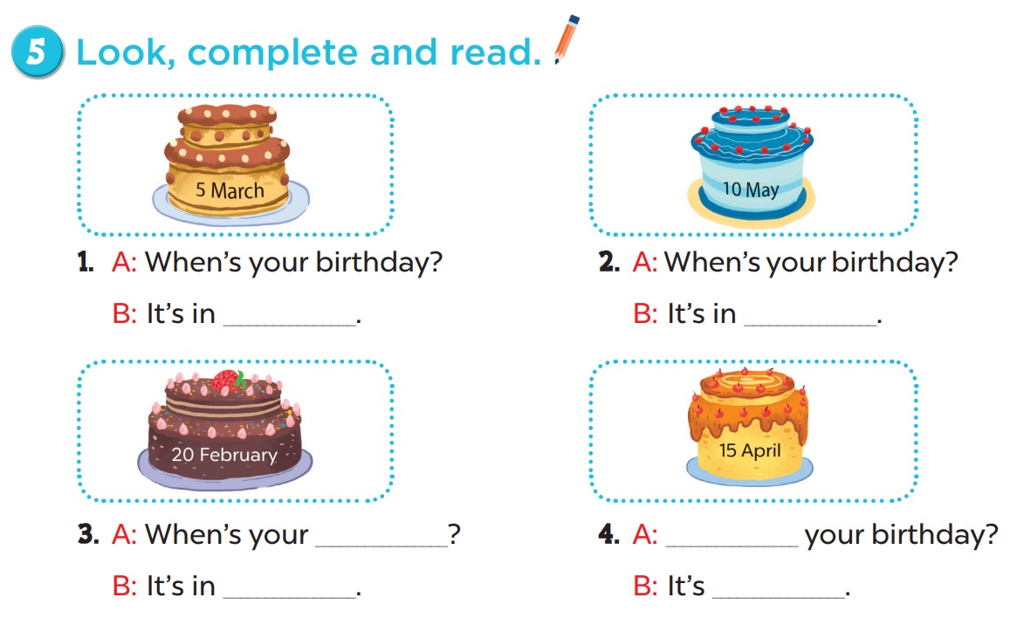  - Have pupils look at the four incomplete dialogues. Draw their attention to the missing words in the sentences.  - Integration of 4.2CB2a (Core Activity): T poses a situational question: "Imagine a stranger on an online game asks: 'When is your birthday? What is your full name?'. Should you tell them?" T guides pupils to choose the correct action: Only share birthdates with trusted people (family/teachers) and never type full birthdates on public internet forms without permission.  ﻿- Model Picture 1. Have pupils look at the dialogue. Then have them look at the picture and identify the month. Ask them what is missing in the answer (March). Ask them to complete the gap (When’s your birthday? – It’s in March.). Repeat the same procedure with Pictures 2, 3 and 4.  - Have pupils complete the dialogues individually and nominate a few pairs to read them aloud. Correct their pronunciation where necessary, praise the readers, and get the class to clap or cheer if their pronunciation is good.  Key:  1. March  2. May  3. birthday/February  4. When/in April  Activity 3-6. Let’s sing.  * Goals: To sing the song When's your birthday? with the correct pronunciation, rhythm and melody.  * Procedure:  - Draw pupils’ attention to the title and lyrics of the song. Encourage them to point at the pictures to reinforce the understanding.  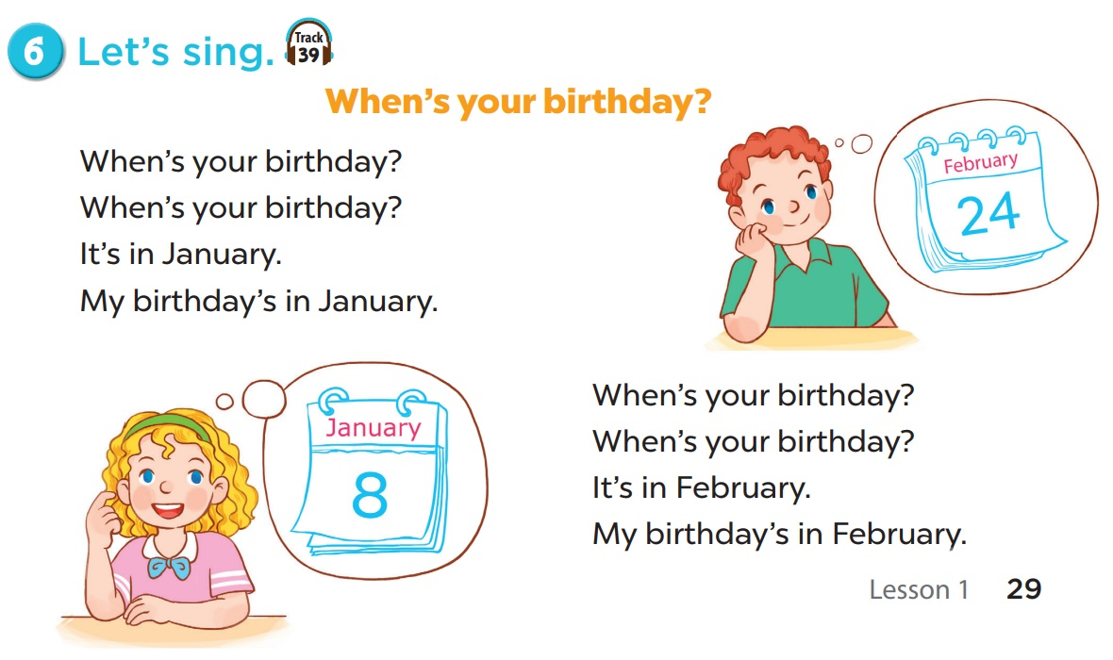  - Play the recording all the way through. Encourage them to listen carefully to the pronunciation and melody.  - Play the recording line by line for pupils to listen and repeat. Correct their pronunciation where necessary.  - Play the recording all the way through and have pupils sing along.  - The disabled: Practice singing a song: When’s your birthday?.  Extension: Put pupils into groups to make up their own actions for the song. Invite groups to the front of the class to perform, while the rest of the class sings and / or claps along. Encourage the class to praise or cheer the performers.  3. Consolidation (3’)  - Ask students about what they have learnt from the lesson.  4. Homework (2’)  - Sing the song When's your birthday?  - Redo Ex.4, 5.  - Do parts A, B in the workbook.  - Prepare the next lesson: Lesson 2 (1,2,3). | - Listen to the techer  Whole class/ Individual work  - Whole class/Individual work  - Listen to the T's instruction  - Listen to the recording  - Individual work  - Listen and repeat  - Whole class/Pair work  - Listen to the T's instruction  - Individual work  - Listen to the teacher  Whole class/ Individual work  - Listen and repeat  - Listen to the teacher  - Group work  - Group work/Whole class  - Pair work  - Listen to the T's instruction.  - Whole class/ Individual work
D. Recommendation
………………………………………………………………………………………….…..……………………………………………………………………………...………………………………………….…..………………………………………………

Tổ Trưởng ký duyệt Giáo viên Thực hiện

Nguyễn Thị Thu Hiền Nguyễn Thị Thu Hà

