PHÒNG GD-ĐT THẠCH HÀ  Đề 01 | ĐỀ KHẢO SÁT CHẤT LƯỢNG ĐẦU NĂM  NĂM HỌC 2022 - 2023  MÔN: Tiếng Anh 6  Thời gian làm bài: 60 phút
Điểm của toàn bài thi |  | Giám khảo (Ký và ghi rõ họ tên) | Số phách (do Ban phách ghi)
(Bằng số) | (Bằng chữ) | …..……………………………………….
Nhận xét:……………………………………..…
………………………….…………………..…….
…………………….…………………………..…

A. LISTENING: I. Listen and match. There is one example (0).
  A. |  | 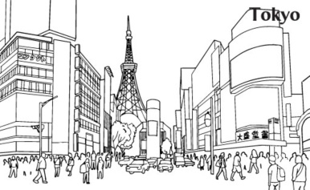  D.
  B. |  |   E.
  C. |  | 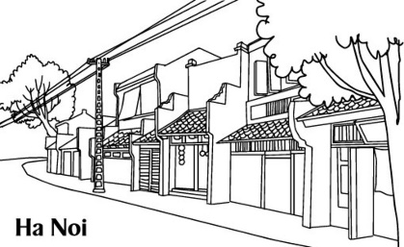  F.
II. Listen and tick  the correct pictures. There is one example.
Example:
What does she do in her free time?
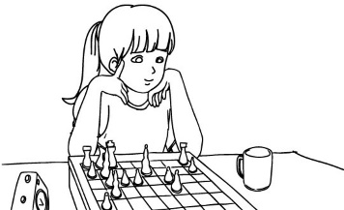 | 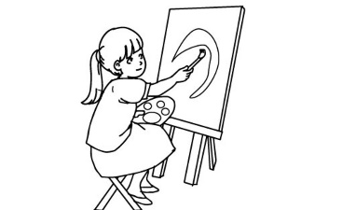 | 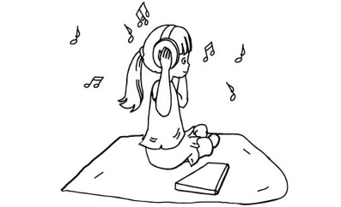
A.  | B. | C. 
- What does he do in his free time?

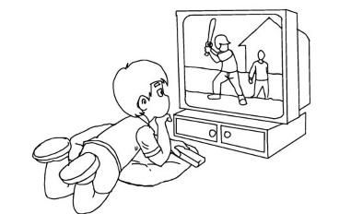  A. | 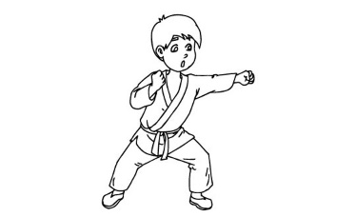  B. | 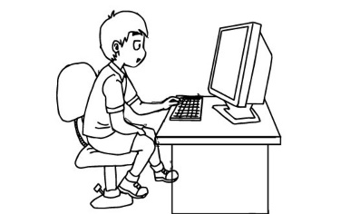  C.

2. What does his father often do in his free time?

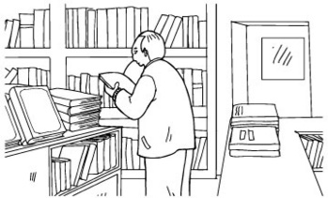  A. | 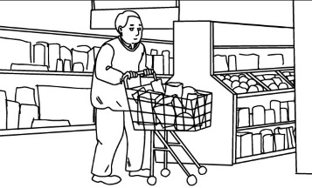  B. | 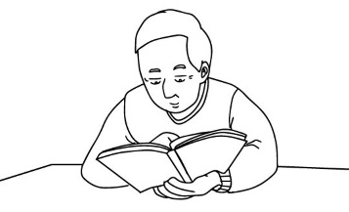  C.

3. What do they often do at the English club?

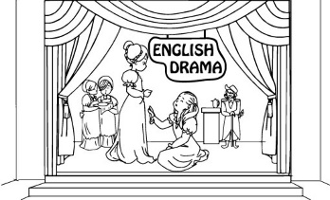  A. | 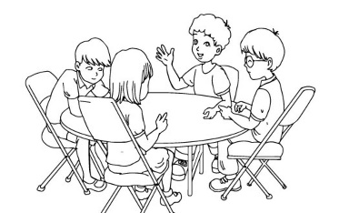  B. | 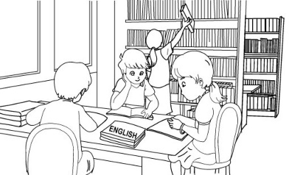  C.

4. What does Lan do in her free time?

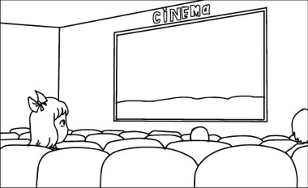  A. | 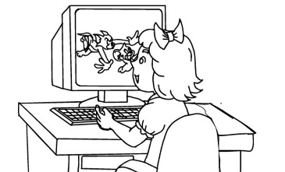  B. | 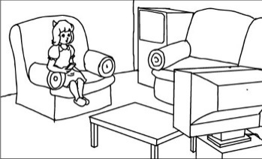  C.

5. What’s his favourite programme?

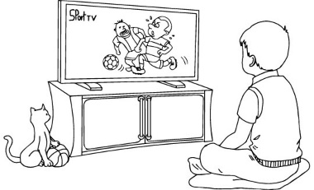  A. | 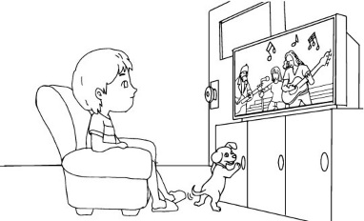  B. | 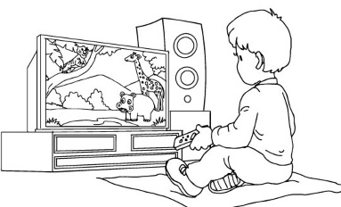  C.
B. READING
III. Read and tick True or False. There is one example (0).
My name’s Akiko. I’m from Japan. I’m in Grade Five. At school, I like studying English and Music. In my free time, I often read stories in English, listen to English songs, and write e-mails to my English penfriends. I’d like to be a teacher in the future. I think it’s an interesting and exciting job. I’d like to teach English for children in my hometown. I hope my dream will come true one day.
 | True | False
0. Akiko is Japanese. |  | 
1. She’s in Grade 4.
2. Her favourite subjects are English and Music.
3. She talks with her pen friends in her free time.
4. She’d like to be a nurse in the future.
5. She’d like to teach English for children in her hometown.
IV. Read and match. There is one example
0. What do you do in the evening? A. By train.
1. What did you see at the zoo? B. Yes, I do
2. How did you get to Sa Pa? C. I saw a baby elephant.
3. Do you like reading comic books? D. I usually do my homework.
4. Why do you learn English? E. I will swim in the sea.
5. What will you do at the beach? F. Because I want to watch English cartoon.
Answer: | 0-D | 1……… | 2……… | 3……… | 4……… | 5………
C. WRITING
V. Look and write ONE WORD for each gap. There is one example.
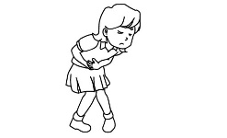 | 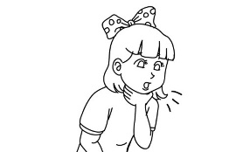 | 
0. She has a stomach ache. | 1. She has a _____________ throat. | 2. Mai has a toothache. She should see the __________.
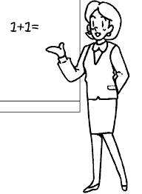 | 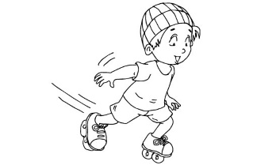 | 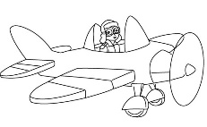
3. She’d like to be a ______________ in the future. | 4. My brother goes ___________ every Sunday. | 5. He would like to be a ______________.

VI. Order the words. There is one example.
Example: watch / in / I / my / time / free / TV
I watch TV in my free time.
1. I / English /four times / have / a week. /
→ ................................................................................................................................
2. What / of/ do / Snow White? / you think/
→ ................................................................................................................................
3. to eat? /What/ you/ would/ like/
→ ................................................................................................................................
4. to /should/ go / He / the dentist. /
→ ................................................................................................................................
5. English / Do / speak / you / class / always/ in?
→ ................................................................................................................................
D. GRAMMAR
VII. Odd one out. There is one example.
0. A. mountain | B. pretty | C. island | D. city
1. A. coffee | B. water | C. pizza | D. milk
2. A. usually | B. soccer | C. badminton | D. volleyball
3. A. winter | B. foggy | C. sunny | D. cloudy
4. A. pagoda | B. museum | C. bridge | D. visit
5. A. doctor | B. worker | C. fever | D. teacher
VIII. Choose the best answer. There is one example.
0. I………….. to Ha Noi last week.
A. go | B. goes | C. went | D. going
1. What’s the matter ……………. you? - I have a cold.
A. to | B. with | C. from | D. in
2. ........... do you play badminton? - Three times a week.
A. How often | B. Why | C. Where | D. What
3. Is she going to the party tomorrow? - Yes, she.............
A. is | B. do | C. did | D. can
4. My sister likes........... books.
A. read | B. to read | C. reading | D. to reading
5. How many....................... are there in your bag? – There are two.
A. book | B. book’s | C. a book | D. books
-- The end –

PHÒNG GD-ĐT THẠCH HÀ  Đề 02 | ĐỀ KHẢO SÁT CHẤT LƯỢNG ĐẦU NĂM  NĂM HỌC 2022 - 2023  MÔN: Tiếng Anh 6  Thời gian làm bài: 60 phút
Điểm của toàn bài thi |  | Giám khảo (Ký và ghi rõ họ tên) | Số phách (do Ban phách ghi)
(Bằng số) | (Bằng chữ) | …..……………………………………….
Nhận xét:……………………………………..…
………………………….…………………..…….
…………………….…………………………..…

A. LISTENING
I. Listen and match. There is one example (0).
A. |  | D.
B. |  | E.
C. |  | F.
II. Listen and tick the correct pictures. There is one example.
Example: What does she do in her free time?
A. | B. | C.
- What does he do in his free time?

A. | B. | C.

2. What does his father often do in his free time?

A. | B. | C.

3. What do they often do at the English club?

A. | B. | C.

4. What does Lan do in her free time?

A. | B. | C.

5. What’s his favourite programme?

A. | B. | C.
B. READING
III. Read and tick True or False. There is one example (0).
Hi. My name is Tuan. I'm a worker. I work in a big factory. I get up early in the morning. I go to work at six thirty. I have lunch in the canteen. I always have rice and fish for lunch. I don't like bread and eggs. I always play sports after work. I go home at six p.m. I often stay at home in the evening. I usually watch TV or read newspapers. At the weekend, I often play with my children. We go to bed at ten thirty p.m.
 | True | False
0. Tuan is a worker.
1. He works in a small factory.
2. He doesn’t like bread and eggs.
3. He goes home at seven p.m.
4. In the evening, he often stays at home.
5. He often plays with his children at the weekend.
IV. Read and match. There is one example
0. Don’t ride your bike too fast!  1. What will the weather be like tomorrow?  2. What’s the matter with him?  3. Did you go to your hometown last summer?  4. How often do you have English?  5. What would you like to be in the future? |  |  |  | A. Yes, I did  B. I’d like to be a pilot.  C. I have it three times a week.  D. Ok, I won’t. Thanks  E. He has a headache.  F. It’ll be hot and sunny.
Answer: | 0-d | 1……… | 2……… |  | 3……… | 4……… | 5………
C. WRITING
V. Look and write one word for each gap. There is one example.
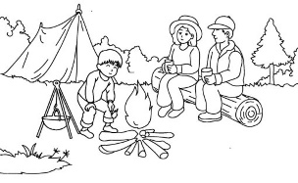 | 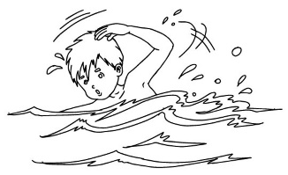 | 
0. We often go camping in summer. | 1. I like __________ | 2. Mr Smith often surfs the ______________ in the evening.
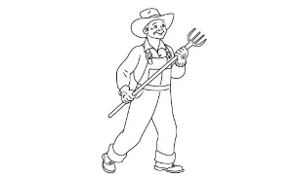 | 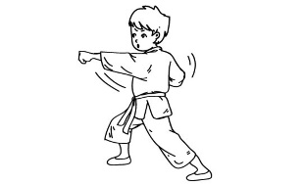 | 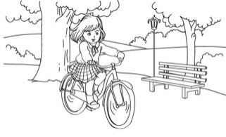
3. He’d like to be a_______________. | 4. I often do ____________ in the gym. | 5. I ride my _____________ in the park every Sunday.

VI. Order the words. There is one example.
Example: watch / in / I / my / time / free / TV
I watch TV in my free time.
1. will/ What/ be like/ the weather / tomorrow? /
→ ................................................................................................................................
2. you? /matter / with / What’s / the/
→ ................................................................................................................................
3. to/ walk / school /every morning / often. / I
→.................................................................................................................................
4. I’d/ a doctor/ to be / like / in the future.
→ ...............................................................................................................................
5. in / go fishing / my / free time. / I often/
→ ................................................................................................................................
D. GRAMMAR
VII. Odd one out. There is one example.
0. A. first | B. second | C. ten | D. third
1. A. badminton | B. football | C. chess | D. Sports Day
2. A. zoo | B. crocodile | C. monkey | D. elephant
3. A. kind | B. red | C. clever | D. hard-working
4. A. danced | B. stayed | C. listened | D. song
5. A. headache | B. sore throat | C. doctor | D. earache
VIII. Choose the best answer. There is one example.
0. I………….. to Ha Noi last week.
A. go | B. goes | C. went | D. going
1. I sometimes go ………….. in the winter.
A. fish | B. to fish | C. fishing | D. a fish
2. There are four ………….. in my country: spring, summer, autumn and winter.
A. season | B. seasons | C. students | D. people
3. ……….. are you going this summer holiday? _ I’m going to Phu Quoc Island.
A. How | B. What | C. Where | D. Who
4. Peter likes listening____________ music every morning.
A. to | B. at | C. by | D. on
5. Is Linda a primary student? Yes, _______________.
A. you are | B. fine | C. it is | D. she is
-- The end –

PHÒNG GD-ĐT THẠCH HÀ | ĐỀ KHẢO SÁT CHẤT LƯỢNG ĐẦU NĂM  NĂM HỌC 2022 - 2023  MÔN: Tiếng Anh 6  Thời gian làm bài: 60 phút
Số phách (Do Trưởng Ban phách ghi)

Họ và tên học sinh: ……………………………..…………..…………..
Ngày tháng năm sinh: ……………………..……….Lớp…..…………….
Số báo danh: ……………………… Phòng thi: ……………………...

Họ tên, chữ ký giám thị 1  ……………………..…………………… | Họ tên, chữ ký giám thị 2  …………………………………………

PHÒNG GD-ĐT THẠCH HÀ | ĐỀ KHẢO SÁT CHẤT LƯỢNG ĐẦU NĂM  NĂM HỌC 2022 - 2023  MÔN: Tiếng Anh 6  Thời gian làm bài: 60 phút
Số phách (Do Trưởng Ban phách ghi)

Họ và tên học sinh: ……………………………..…………..…………..
Ngày tháng năm sinh: ……………………..……….Lớp…..…………….
Số báo danh: ……………………… Phòng thi: ……………………...

Họ tên, chữ ký giám thị 1  ……………………..…………………… | Họ tên, chữ ký giám thị 2  …………………………………………

PHÒNG GD-ĐT THẠCH HÀ | ĐỀ KHẢO SÁT CHẤT LƯỢNG ĐẦU NĂM  NĂM HỌC 2022 - 2023  MÔN: Tiếng Anh 6  Thời gian làm bài: 60 phút
Số phách (Do Trưởng Ban phách ghi)

Họ và tên học sinh: ……………………………..…………..…………..
Ngày tháng năm sinh: ……………………..……….Lớp…..…………….
Số báo danh: ……………………… Phòng thi: ……………………...

Họ tên, chữ ký giám thị 1  ……………………..…………………… | Họ tên, chữ ký giám thị 2  …………………………………………

