SPEAKING TEST ENGLISH 7
UNIT 3: COMMUNITY SERVICE
A. Introduction: (0.4 pt)
B. Pictures Cue (Vocabulary): 1.0 pt (5 questions):
  1  2  3  4  5  6  7  9  10  11  12  8 | 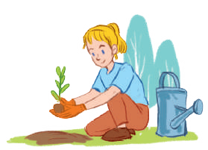 |  | 
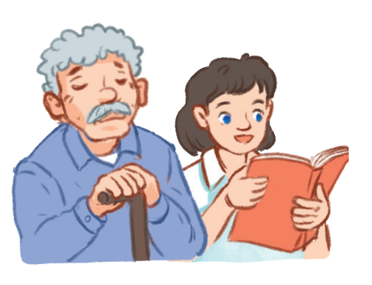 | - What’s this?/What are these? (1,6,9)  - What does she /he like doing? (2,7,3)  - What activities can you do to help the community?(4,5,10)  - It’s an activity that helps the old people relax?(12)  - It’s an activity that helps the street children to learn?(11)  - It’s a verb that means giving gift to old people/poor children. 8 |  | 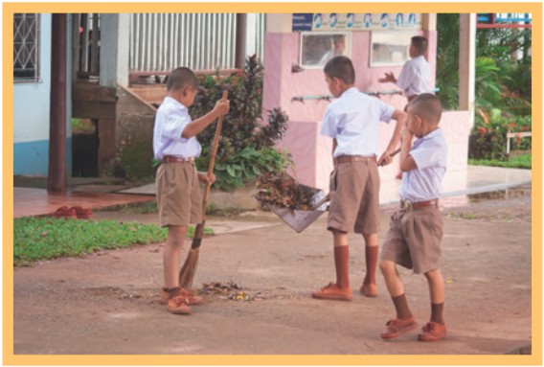
 |  |  | 
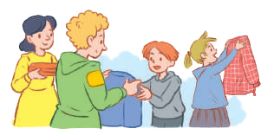 |  |  | 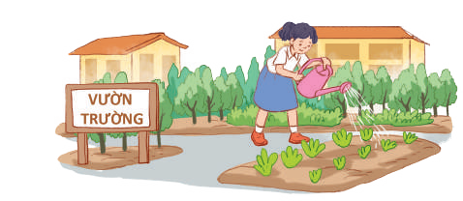

C. Interview/ Role-play:
Questions
- What do you often do in your free time?
- Which activities do you take part in to help community?
- Who do you often work with in this activity /these activities?
4. How often do you do this activity?
5. When did you last join this activity?
6. Why do you want to join this activity?

ANSWER KEYS:
B. Pictures Cue (Vocabulary):
1. Litter/ rubbish/ trash
2. Planting trees
3. Exchanging used paper to/for notebooks
4. Singing and dancing with the old people
5. Cleaning the playground
6. Tutor
7. Watering the vegetables in the school garden
8. Donate
9. Clothes
10. Donating clothes to poor people
11. Tutoring the street children
12. Reading books to the elderly people.
C. Interview/ Role-play:
Suggested answers
1.Listening to music/ Doing gardening/ Watching TV….
2.Donating books/ clothes/ food…to the street children.
Planting trees.
Watering flowers in the school yard.
Cleaning the playground.
Collecting the rubbish/ litter on the street/ the beach.
3.With my classmates/ my sister/ my brother…..
4.Sometimes/ often/ once a month…..
5.Last summer/ 3 weeks ago……
6 . To help people/ keep our environment clean- green – beautiful….

