Họ tên thí sinh: .................................................................
Số báo danh: ......................................................................
Mã Đề: 022.
Câu 1. Why is the Chess club changing its meeting location?
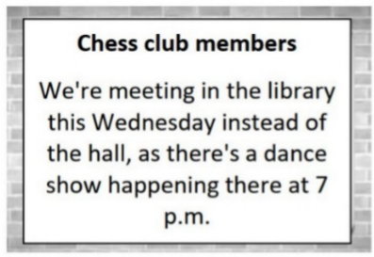
A. There's a dance show in the hall B. The chess tables are in the library
C. The hall is being renovated D. The library is more spacious
Câu 2. Look at the signs. Choose the best answer for the question.
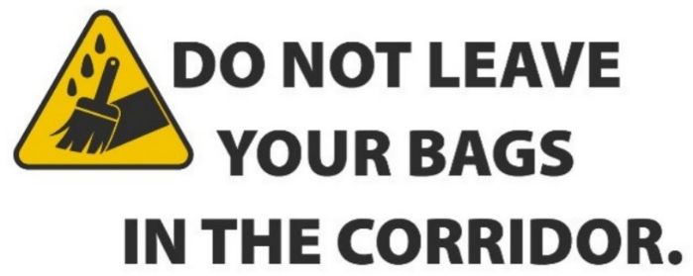
A. Bags will be removed from the corridor.
B. Don’t forget to put your bags out in the corridor.
C. Keep the corridor clear of bags.
D. If you leave your bags, it will be kept in the corridor.
Câu 3. What can be inferred about the new location of the post office?
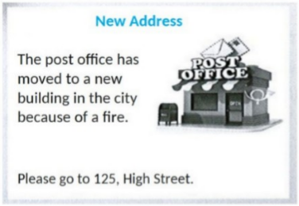
A. It's in a rural area B. It's on High Street in the city
C. It's in a residential neighborhood D. It's in a shopping mall
Câu 4. What does the sign say?
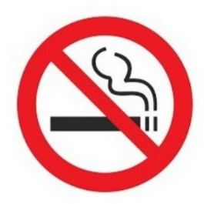
A. Smoking is useful here. B. Smoking is not permitted here.
C. Smoking is compulsory here. D. Smoking is optional here.
Câu 5. Look at the signs. Choose the best answer for the question.
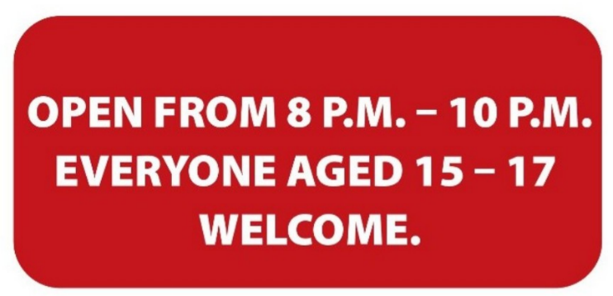
A. Only teenagers who are over 15 are allowed to enter this place.
B. Only 15-17 people can enter the place from 8 p.m. to 10 p.m.
C. Teenagers aged 15-17 can visit the venue from 8 p.m. to 10 p.m.
D. The venue is open to all teenagers under the age of 17.
Câu 6. Which day is the City Zoo closed?
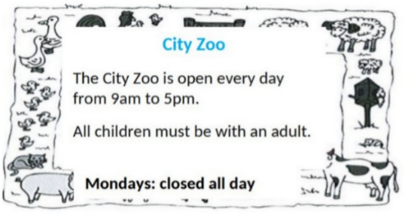
A. Monday B. Saturday C. Friday D. Sunday
Câu 7. What caused damage to the library?
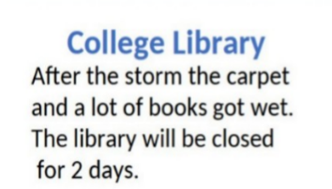
A. A fire B. A storm C. Vandalism D. Renovation work
Câu 8. Look at the signs. Choose the best answer for the question.
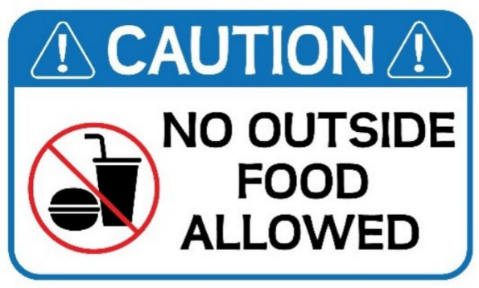
A. Food and drink are not allowed in this place.
B. Do not bring food or drink from outside into this place.
C. Be careful when eating and drinking outside this place.
D. Do not eat or drink anything outside this place.
Câu 9. Look at the signs. Choose the best answer for the question.
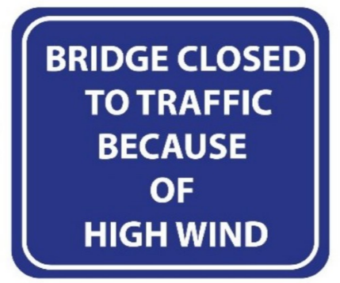
A. Be careful when using the bridge on windy days.
B. High traffic stopped people from using the bridge.
C. High wind prevented the bridge to be finished.
D. You cannot cross the bridge because the wind is so strong.
Câu 10. What made Michael send this message to Arthur?
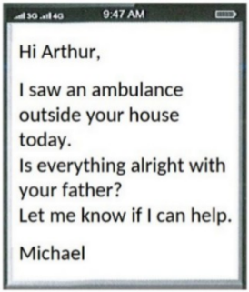
A. Arthur called him about an emergency B. He saw an ambulance outside Arthur's house
C. He heard about Arthur's father being ill D. He received a message from Arthur's father
----HẾT---

