SỞ GD&ĐT BẮC GIANG  TRƯỜNG THPT TÂN YÊN SỐ 2  (Đề thi có 04 trang) | ĐỀ KIỂM TRA ĐỊNH KÌ GIỮA HỌC KÌ 1  NĂM HỌC 2023 - 2024  MÔN: TIẾNG ANH -LỚP 10  Thời gian làm bài: 60 phút, không kể thời gian giao đề
 |  | Mã đề thi: 372
Lưu ý: - Thí sinh làm trực tiếp vào đề, tô phần trắc nghiệm vào phần phiếu trả lời trắc nghiệm
- Phần NGHE bắt đầu từ câu 26 đến câu 35
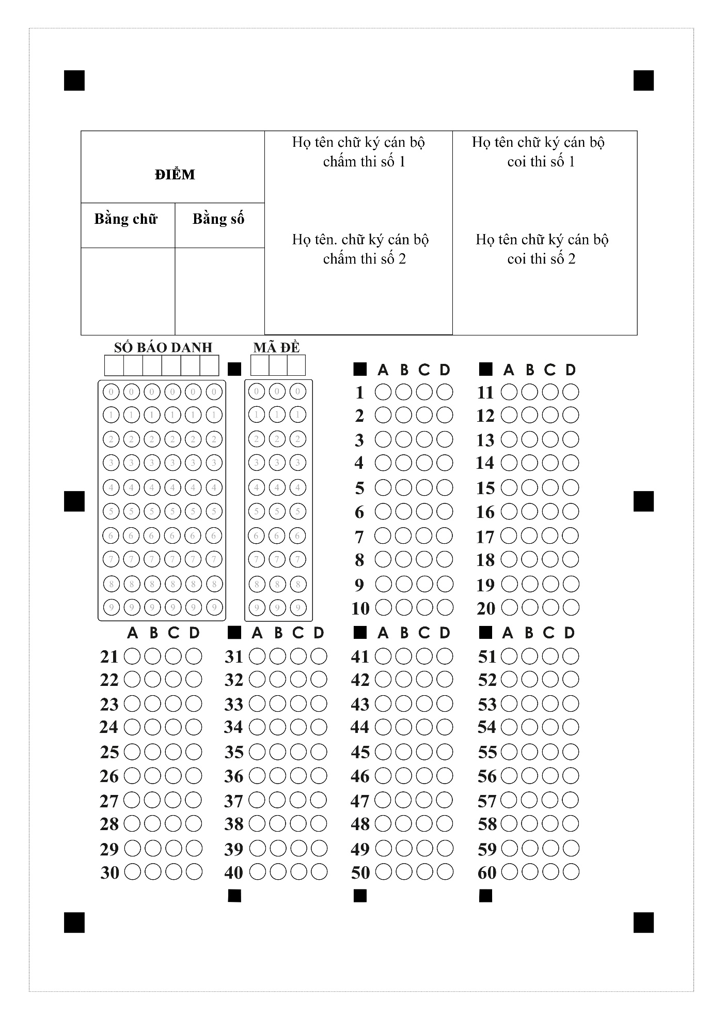
Họ tên: ……………………….….. Lớp: ……… SBD: ………….

I. PHẦN TRẮC NGHIỆM (6,0 điểm):
Mark the letter А, B, C, or D on your answer sheet to indicate the word whose underlined part differs from the other three in pronunciation in each of the following questions.
Question 1. A. develops B. excepts C. stays D. hates
Question 2. A. involved B. impressed C. organized D. carried
Question 3. A. gas B. activity C. average D. carbon
Mark the letter A, B, C, or D on your answer sheet to indicate the word that differs from the other three in the position of stress in each of the following questions.
Question 4. A. hobby B. perform C. boring D. duty
Question 5. A. perform B. student C. combine D. depend
Mark the letter A, B, C or D on your answer sheet to indicate the correct answer to each of the following questions.
Question 6. I’m responsible for cooking dinner as my mother usually ____late.
A. works B. working C. worked D. work
Question 7. You can go to the movies with me, ____ you can go to the concert alone.
A. and B. or C. but D. so
Question 8. He refused______me any money.
A. lent B. to lend C. lend D. lending
Question 9. More and more people _______a green lifestyle which is good for themselves and the environment.
A. increase B. reduce C. adopt D. raise
Question 10. In developed countries, many tall buildings are built from eco-friendly_____________
A. materials B. ways C. ingredients D. methods
Question 11. Putting out the_________ in the early morning is a part of my daily routine.
A. groceries B. rubbish C. energy D. laundry
Question 12. Don’t___________used items because we can recycle them to make new products
A. clean up B. throw away C. break down D. set up
Mark the letter A, B, C, or D on your answer sheet to indicate the option that best completes each of the following exchanges.
Question 13. Ann and Tim are talking about housework.
Ann: “ Do you think that we should divide the household chores equally?”
Tim: “Yes,_____________doing household chores helps everyone learn to take responsibility.”
A. You’re welcome B. I’m sure that C. That’s right D. Not at all
Mark the letter A, B, C, or D to indicate the word CLOSEST in meaning to the underlined word in each of the following questions.
Question 14. I want to express my gratitude to you because for valuable help
A. regret B. happiness C. thanks D. sadness
Mark the letter A, B, C, or D to indicate the word OPPOSITE in meaning to the underlined word in each of the following questions.
Question 15. He is a talented singer and has received some awards such as Grammy and Billboard Music.
A. bright B. brilliant C. gifted D. skilless
Read the passage and choose the best answer for each of the numbered blanks.
What are the benefits of a green lifestyle?
In addition to the health benefits already mentioned, such as increased exercise, healthier eating and better breathing, a green lifestyle has been shown to have a positive (16) _______ on mental health. A green lifestyle can foster people’s need for a closer connection to nature, (17) ______stimulating positive emotions, leading to a lighter and happier mood. This closer connection to nature, such as through increased outdoor activities, can actually help people suffering from mental health issues find comfort: A report conducted by Natural England concluded that people (18) ______ participate in nature-based activities suffer less stress, anxiety and depression. When a more (19) _______lifestyle leads to losing excess weight or simply getting in better shape, it can also lead to stronger self-esteem in addition to physical health. Consuming less, reusing and recycling more, while raising (20) __________ of important climate changes can help prioritize. Gaining this awareness, taking responsibility for our environment.
Question 16. A. affect B. chance C. choice D. impact
Question 17. A. yet B. or C. but D. so
Question 18. A. whom B. where C. which D. who
Question 19. A. action B. acttively C. activity D. active
Question 20. A. price B. salary C. awareness D. hand
Read the following passage and choose the most suitable answer.
Plastic and the environment
Plastic is a material we use every day. The first plastics were made more than 100 years ago from parts of plants. Plastics are now made from oil, coal and natural gas. We are using up these things so fast that the Earth’s supplies may run out. Because of this, scientists are investigating new ideas for making plastics from plants such as sweet potato, bamboo and flax.
Things made from plastic can be useful for people but bad for the planet. Some plastics can last for a long time without wearing out, and can be difficult to get rid of when they are not needed. They can remain in rubbish dumps called landfill sites for hundreds of years. Landfills can be smelly, ugly, and harmful to our planet.
Recycling is a good way to get rid of unwanted plastics. Recycled waste materials can be used again to make new products. This can be difficult as different types of plastic need to be recycled in different ways. Some kinds of plastics can be melted down and used to make new things such as bags and bottles. Others can be made into fibres (strands of material) for clothing.
Another way to protect the environment is to use canvas bags for shopping rather than plastic ones. A lot of plastic objects can also be reused. Plastic bottles can be refilled many times, rather than throwing them away once they are empty. Unwanted plastic goods such as CDs and toys can be sold or given away to charity shops.
Question 21. What is the passage mainly about?
A. Plastic: effects and solutions to the problem.
B. The history of plastic and its usefulness..
C. Materials that plastic is made of..
D. The ways to reduce the harm of plastics on the environment
Question 22. The phrase “get rid of” in paragraph 2 is closest in meaning to ________.
A. remove B. make C. keep D. create
Question 23. According to the passage, things made from plastic are bad for our environment because ______.
A. plastics can exist for a long time without decomposing.
B. they are a danger to marine life such as whales, turtles and so on.
C. people reuse plastic objects before recycling them.
D. they are very convenient for people to use in different purposes.
Question 24. The word “They” in paragraph 2 refers to ________.
A. things B. plastics C. people D. rubbish dumps
Question 25. According to the passage, which of the following is TRUE?
A. Plastics and plastic objects can be recycled or reused.
B. The history of plastic and its usefulness.
C. Some kinds of plastics can be melted down, then released into the river.
D. Plastic objects are useful for people without negative impacts.

Listening
Part 1: Listen to the recording and mark the letter A, B, C or D on your answer sheet to indicate the appropriate answer. You will listen TWICE.
Question 26. Duncan stayed in a hotel ________.
A. by the river B. in a town C. near the sea D. in the mountain
Question 27. What is his teacher's nationality?
A. Canadian B. Scott C. English D. French
Question 28. How much did Duncan pay for the course?
A. £185 B. £250 C. £265 D. £205
Question 29. What did he buy himself before the course?
A. shoes B. clothes C. ball D. racket
Question 30. What did you do in the evening?
A. watching football matches B. dancing and singing
C. watching TV D. playing tennis

II. PHẦN TỰ LUẬN (4,0 điểm):
Listening
Part 2: You will hear a woman giving information on the radio about a theatre school. Listen and fill in the blanks.
Information about the theatre school
- Every week courses for children between (31) ___________ and 16 years old.
- It costs (32) £ ______________ for children over 14.
- The special show takes place on (33) ______________ afternoon.
- The first summer course starts on July (34) _______________.
- The phone number for booking form: (35) _______________.
Give the correct tense/ form of the verbs in the brackets.
Question 36. She (do)_________________the laundry at the moment.
Question 37. There is someone at the door, I (open)_______________it.
Question 38. He has made a reservation, he (have)____________dinner at the Korean restaurant nearby.
Question 39. His friends promised (give) __________________ him a surprise present on his birthday.
Question 40. Her parents made her (study) ____________________ harder to prepare for the final exams.
Complete the second sentence so that it means the same as the sentence provided.
Question 41. She usually bakes delicious cookies for our family.
Delicious cookies ___________________________________________________________
Question 42. The company will recycle plastic bottles in the future.
Plastic bottles ______________________________________________________________
Question 43. Her parents don’t let her watch TV after 10pm.
Her parents don’t allow ______________________________________________________.
Question 44. Her parents don’t allow her to watch such TV shows.
Her parents don’t let ________________________________________________________.
Question 45. You can do this exercise at home. You can do it when you attend the class. (OR)
_________________________________________________________________________.

Write a short paragraph (about 70 words) about a music event you attended to share your experience.
_________________________________________________________________________________________________________________________________________________________________________________________________________________________________________________________________________________________________________________________________________________________________________________________________________________________________________________________________________________________________________________________________________________________________________________________________________________________________________________________________________________________________________________________________________________________________________________________________________________________________________________________________________________________________________________________________________________________________________________________________________________________________________________________________________________________________________________________
-------------- THE END --------------

