**SPEAKING**

**1. Introduction:**

**Introduce yourself with basic information (name, class, age, hobby, family, etc.) (0.5 point)**

**2. Each of you will now receive a card. On the card there is a picture and you can speak about this place. (0.5 point)**

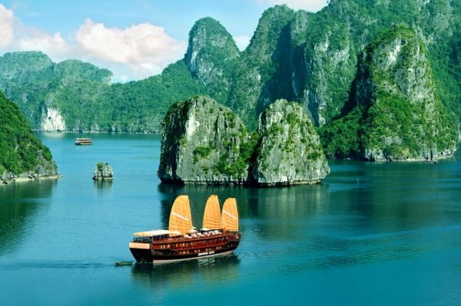

* Ha Long Bay - one of seven new world heritage sites by UNESCO
* located in Quang Ninh province in the northeast of Vietnam
* an area of over 1500 sq km, includes over 1600 islands and islets
* Bo Hon island the home of a variety of flora and fauna, Yen Tu mountain, Surprise Cave or Kissing rocks.

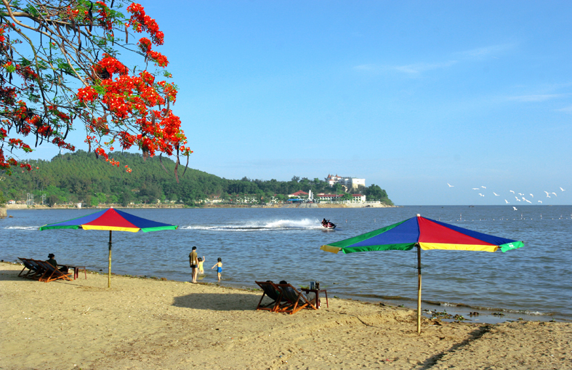

* Do Son beach - 22.5 kilometers in length between the Lạch Tray and Văn Úc Rivers
* Miniature Da Lat
* Hon Dau Island
* Ho Chi Minh road on the sea

**3. Answer further questions (1 point)**

- How many places have you traveled to?

- Who do you usually go with?

- What is your favourite tourist attraction?

- What language do you use when traveling?

- What do you do during your trip?

- What do you usually bring when you travel?