**LỚP HỌC THẦY (CÔ) ___________________________** **ĐỀ ÔN TẬP: READING SIGNS/ NOTICES – A2**

**Test 19**

*Thời gian làm bài: [Time]*

Họ và tên: ________________________________________________ Lớp: 9/___

**Question 1:** What does this sign indicate?

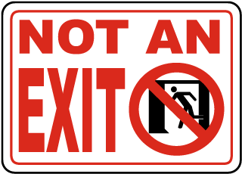**A.** This door leads to the exit.

**B.** You must not go through without permission.

**C.** You must not go through this door.

**D.** This is not an exit.

**Question 2:** What does the message mean?

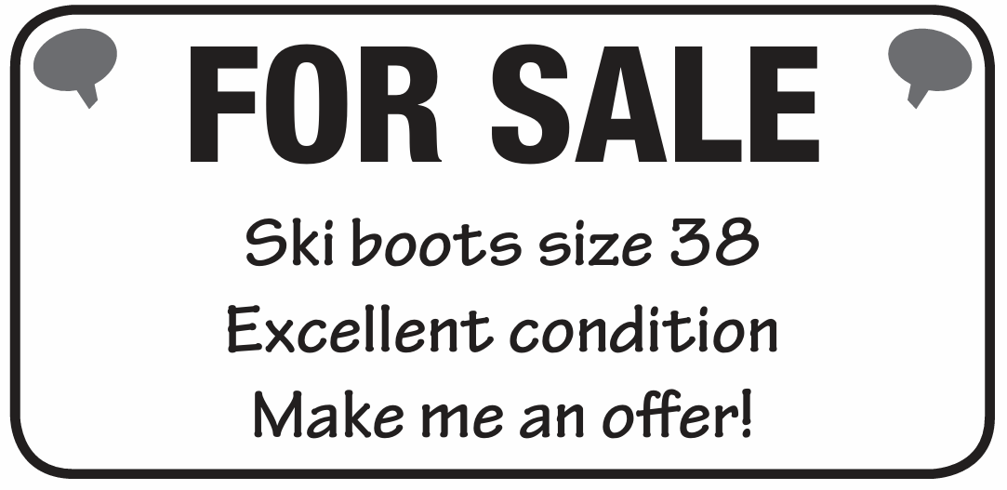

**A.** The ski boots are for sale; you can suggest a price.  
**B.** The ski boots are free.  
**C.** The ski boots are not for sale.  
**D.** The ski boots are only for kids.

**Question 3:** What does this sign indicate?

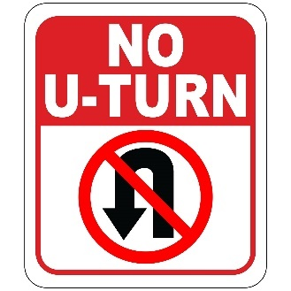**A.** U-turns are allowed here.

**B.** Only straight-ahead driving is allowed here.

**C.** U-turns are allowed during certain hours.

**D.** U-turns are allowed with caution.

**Question 4:** What does the message mean?

**New message**

**From: School secretary**

**To: All students**

**Please remember that you have to return all borrowed books to the school library before Friday, the last day of term.**

**A.** You must return all library books before Friday.  
**B.** You can return library books any time after Friday.  
**C.** You do not need to return library books.  
**D.** You must return the books after Friday.

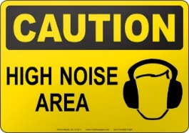**Question 5:** What does this sign indicate?

**A.** This area is quiet.

**B.** Expect high noise levels in this are**a.**

**C.** Noise is prohibited in this are**a.**

**D.** Noise levels are moderate.

**Question 6:** What does the message mean?

**New message**

**From: Daniel**

**To: Jake**

Jake

Hi Jake Great news! I don't have to go to the shops this afternoon, so shall we see that film? I can meet you outside the cinema at 2.30.

Daniel

**A.** Daniel is going to the shops and will meet Jake later.  
**B.** Daniel wants to see a film with Jake and can meet at 2:30.  
**C.** Daniel cannot meet Jake this afternoon.  
**D.** Daniel wants to see the film alone and will not meet Jake.

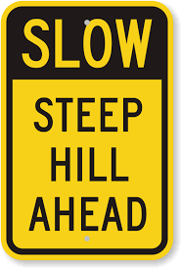**Question 7:** What does this sign indicate?

**A.** No need to be cautious, the hill is not steep.

**B.** Be cautious, the hill is steep.

**C.** The hill is flat.

**D.** The hill is closed to vehicles.

**Question 8:** What does the message mean?

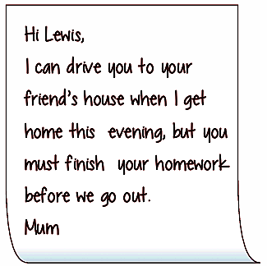

**A.** Mum will drive you if you finish your homework first.  
**B.** Mum will drive you anytime, no need to do homework.  
**C.** You can go out before doing your homework.  
**D.** Mum cannot drive you to your friend's house.

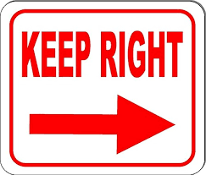**Question 9:** What does this sign indicate?

**A.** Stay on the left side.

**B.** Keep to the right side.

**C.** Right side is close**d.**

**D.** Both sides are open.

**Question 10:** What does the message mean?

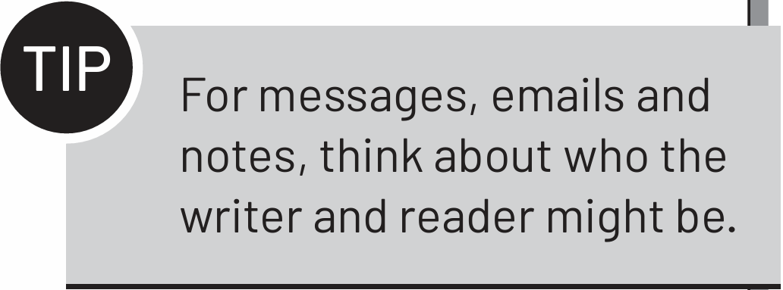

**A.** Think about who is sending and receiving the message.  
**B.** Only send messages to yourself.  
**C.** Don’t worry about who is reading the message.  
**D.** Write messages only in formal language.

**[HẾT]**