**BẢNG SỐ ĐẾM**

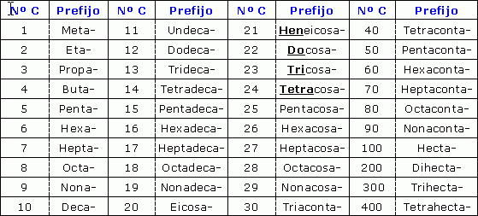

**ANKAN - **

**Tên gọi:** Số phân tử C (*bỏ chữ a cuối*) + an

|  |  |  |  |  |  |  |  |  |  |
| --- | --- | --- | --- | --- | --- | --- | --- | --- | --- |
|  |  |  |  |  |  |  |  |  |  |
| Metan | Etan | Propan | Butan | Pentan | Hexan | Heptan | Octan | Nonan | Decan |

**ANKEN - **

**Tên gọi:** Số phân tử C (*bỏ chữ a cuối*) + en

|  |  |  |  |  |  |  |  |  |  |
| --- | --- | --- | --- | --- | --- | --- | --- | --- | --- |
|  |  |  |  |  |  |  |  |  |  |
|  | Eten | Propen | Buten | Penten | Hexen | Hepten | Octen | Nonen | Decen |

**ANKIN - **

**Tên gọi:** Số phân tử C (*bỏ chữ a cuối*) + in

|  |  |  |  |  |  |  |  |  |  |
| --- | --- | --- | --- | --- | --- | --- | --- | --- | --- |
|  |  |  |  |  |  |  |  |  |  |
|  | Etin | Propin | Butin | Pentin | Hexin | Heptin | Octin | Nonin | Decin |

**ANCOL - **

**Tên gọi:** Số phân tử C (*bỏ chữ a cuối*) + anol

|  |  |  |  |  |  |  |  |  |  |
| --- | --- | --- | --- | --- | --- | --- | --- | --- | --- |
|  |  |  |  |  |  |  |  |  |  |
| Metanol | Etanol | Propanol | Butanol | Pentanol | Hexanol | Heptanol | Octanol | Nonanol | Decanol |