UNIT 11: TRAVELLING IN THE FUTURE

Lesson 6: Skills 2

I. OBJECTIVES
By the end of this lesson, Ss will be able to gain:
1. Knowledge
+ Listening
listen for general and specific information about some future means of transport;
+ Writing: write about the advantages of a future means of transport.
2. Core competence
- Develop communication skills
- Be collaborative and supportive in pair work and team work
- Actively join in class activities
3. Personal qualities
Be benevolent and responsible

II. PREPARATIONS
1. Teacher
- Grade 7 textbook, laptop, TV/Projector/ pictures and cards, speakers, lesson plan, sachmem.vn…
2. Students
- Grade 7 textbook, notebooks, school things….
III. TEACHING PROCEDURES
Notes
In each activity, each step will be represented as following
* Deliver the task
** Implement the task
*** Discuss
 Giving comments or feedback
ACTIVITY 1 – WARM – UP & INTRODUCTION (5’)
a) Aims:
- To prepare Ss for the listening by focusing them on some words / phrases
- To lead in the new lesson.
b) Contents: Make a discussion
c) Products: Ss’ answers
d) Teaching steps:
Teacher’s and students’ activities | Content
* Teacher asks Ss to look at the words or phrases in Ex 1 (p. 121) and think of which ones are used to describe the future means of the transport.  ** Ss thinks of it individually, then discuss with their partners. Teacher encourages Ss to give reasons for their answers.  *** Teacher calls some students to give their answers.   Teacher listens and give comments.  -Teacher introduces students the content of the lesson: “In the lesson today, we are going to listen to a talk between Mr. Ha and his students about future means of transport.” | DISCUSSION  Task 1. Circle the words/ phrases that you think are used to describe the future means of transport

ACTIVITY 2 – PRESENTATION (7’)
a) Aims:
- To provide students with some lexical items before listening the text
- To activate Ss’ knowledge of the topic of the listening text
-- To improve Ss’ skills of listening for general information
b) Contents:
- Teach vocabularies
- Listen to a talk between Mr Ha and his students. How many means of transport are they talking about? Circle the correct answer.
c) Products:
- List of vocabularies
- Answer key
d) Teaching steps:
Teacher’s and students’ activities | Content
*-Teacher introduces the vocabulary by:  + Providing the synonym or antonym of the words.  + Providing the pictures of the words.  + Providing the definition of the words.  Concept check: Rub out and Remember  * Teacher asks students to read through the statements, have a guess before they listen to the recording the second time and write their guesses on the board.  ** Teacher plays the recording again. Ask students to listen and choose the correct answer.  *** After listening once, T calls on some Ss to give their answer.   Teacher plays the recording again and confirms the correct answer. | LISTENING  *Vocabulary  1. bullet train (n) [visual + explanation]    2. (to) use up [visual + explanation]  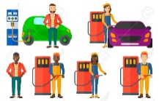  3. comfortable (a) [visual + explanation]    Task 2: Listen to a talk between Mr Ha and his students. How many means of transport are they talking about? Circle the correct answer. (Ex 2, p. 121 - cont)  Answer key: C
ACTIVITY 3 – PRACTICE (23’)
a) Aims:
- To improve Ss’ listening comprehension and note taking skills.
- To check Ss’ memory about what they have listened.
- To prepare Ss for the writing activity
- To help Ss practise writing.
b) Contents:
- Listen to the talk again and complete each sentence with ONE word.
- Choose one future means of transport in 3 and tick the words and phrases that describe its advantages. Can you add more words and phrases?
- Write a paragraph of about 70 words about the advantages of the means of transport you’ve chosen.
c) Products:
- Answer key
-Ss’ writings
d) Teaching steps:
Teacher’s and students’ activities | Content
* Teacher asks Ss to read the sentences and to predict the words they need to fill in each blank.  ** Ss works in pairs to do the task. Then teacher plays the recording for Ss to listen and fill in the blank.  *** Teacher calls on some Ss to give theirs answers and writes them on the board.   Teacher plays the recording again as many times as needed for Ss to check their answers and clearly understand the conversation.  Audio script – Tracks 80 + 81:  - Mr Ha: Now, let’s turn to future means of transport. How do you think people will travel in 2050, Tom?  - Tom: I think people will use bullet trains. Bullet trains will be faster and safer than cars and they can help avoid traffic accidents.  - Lan: I think skyTrans will also be popular, too. They will not use up much space and will be safe because they run on autopilot. - Tom: But skyTrans may be too expensive for students to use. Bamboo-copters will be cheaper and easier for them to use. They will just put on their bamboo-copters and fly to school.  - Mr Ha: Sounds interesting. How about travelling on sea?  - Lan: I think people will use solar-powered ships to travel on sea. They will be eco-friendly and comfortable …  *Teacher asks Ss to choose a future means of transport in Ex 3 and discuss with their partner by ticking the boxes or add as many words/ phrases as possible.  ** Ss do the task in pairs.  *** Teacher calls on some Ss to read out loud and encourages Ss to make sentences with the words/ phrases.   Teacher corrects and confirms.  * Teacher tells Ss that they are going to write about the advantages of the means of transport they ‘ve chosen. Teacher reminds them to start their writing as shown below.  ** Ss do the task independently.  *** Teacher allows students to cross check first.   Teacher gives feedback. | Task 3: Listen to the talk again and  complete each sentence with ONE word.  (Ex 3, p. 121)  Answer key:  1. accidents  2. autopilot  3. expensive  4. Bamboo-copters  5. eco-friendly  Task 4: Choose one future means of transport in 3 and tick the words and phrases that describe its advantages. Can you add more words and phrases? (Ex 4, p. 121)  Suggested answers: economical, carrying many passengers, avoiding traffic jams, having an autopilot function, driverless, etc.  Task 5: Write a paragraph of about 70 words about the advantages of the means of transport you’ve chosen. (Ex 5, p. 121)  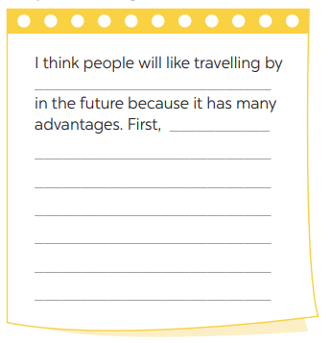
ACTIVITY 4 – PRODUCTION (7’)
a) Aims:
- To peer check, cross check and final check students’ writing.
b) Contents:
- Give peer-reflection & evaluation
c) Products:
- Ss’ writing
d) Teaching steps:
Teacher’s and students’ activities | Content
* Teacher asks students read their “production”.  ** Students listen to each other’s work.  *** Students then give comments to each other.   Teacher then gives feedback as a class discussion. | 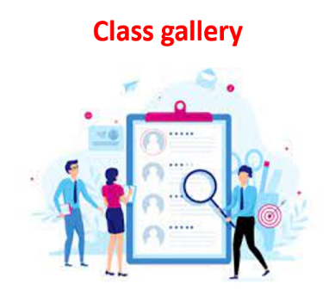  Task 6:  Class gallery
IV. WRAP-UP & HOMEWORK (3’)
- Teacher has Ss summarise what they have learnt in the lesson with the two skills.
If there is time, have them draw a mind map to summarise the main points of the lesson.
- Teacher asks Ss to rewrite the emails on their notebook.
- Teacher asks Ss to prepare the next lesson “Unit 11 – Looking back & project”
V. FEEDBACK

……………………….…, ngày………….tháng…………..năm 2022
Duyệt của Tổ chuyên môn

