READING
PART 1
Look at the picture. Read the words. Which words go with the picture? Fill in the correct circles on your answer sheet.
1.

(A) The boy is drawing a picture. | (B) The boy is taking a photo. | (C) The boy is talking on the phone.
The answer is “B”. Fill in “B” on your answer sheet.
2.
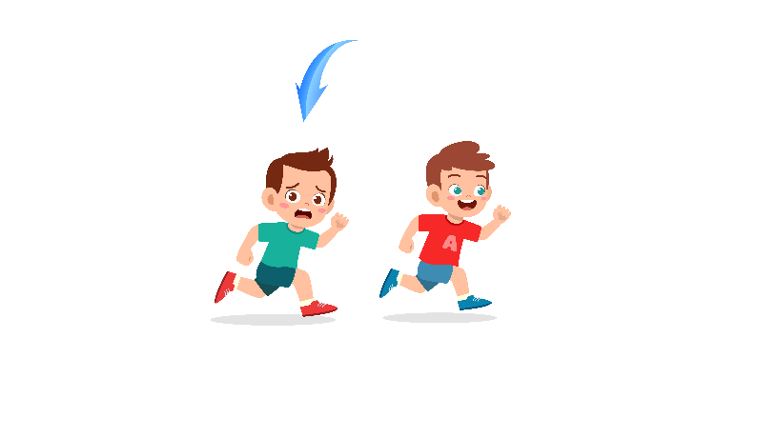
What does the arrow show?
The boy with the arrow is ahead of the other boy.
(A) Ahead | (B) Beside | (C) Under
The answer is “A”. Fill in “A” on your answer sheet.

3.

(A) Toy car | (B) Toy train | (C) Robot
4.
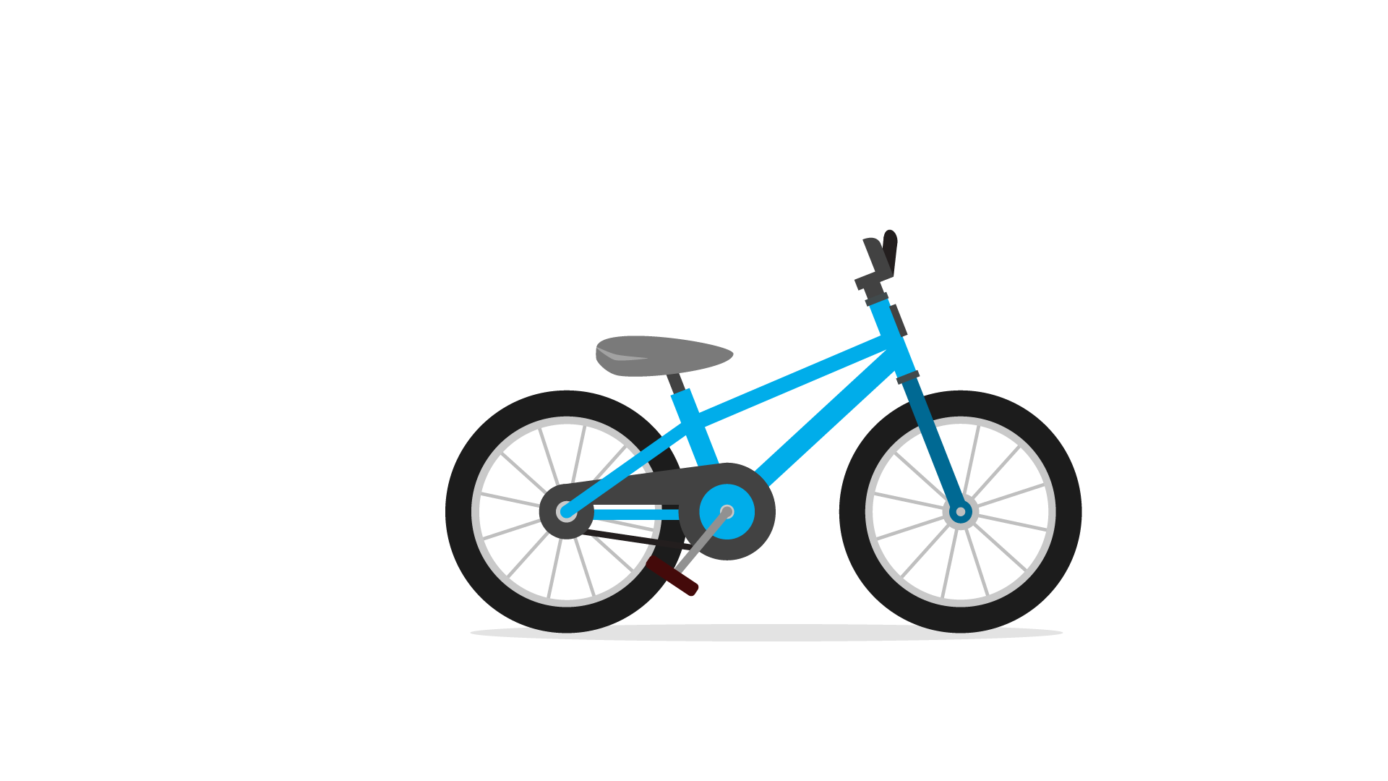
(A) Boat | (B) Bike | (C) Plane
5.
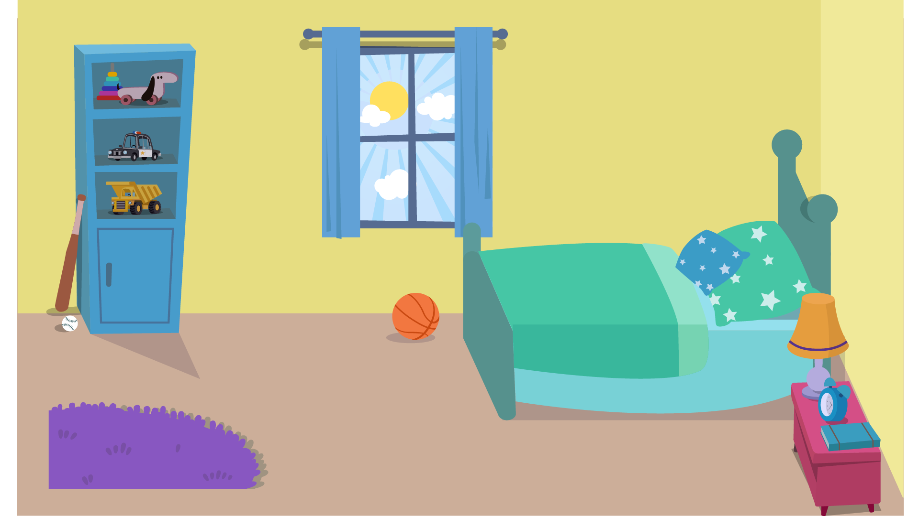

(A) Bathroom | (B) Bedroom | (C) Dining room
6.
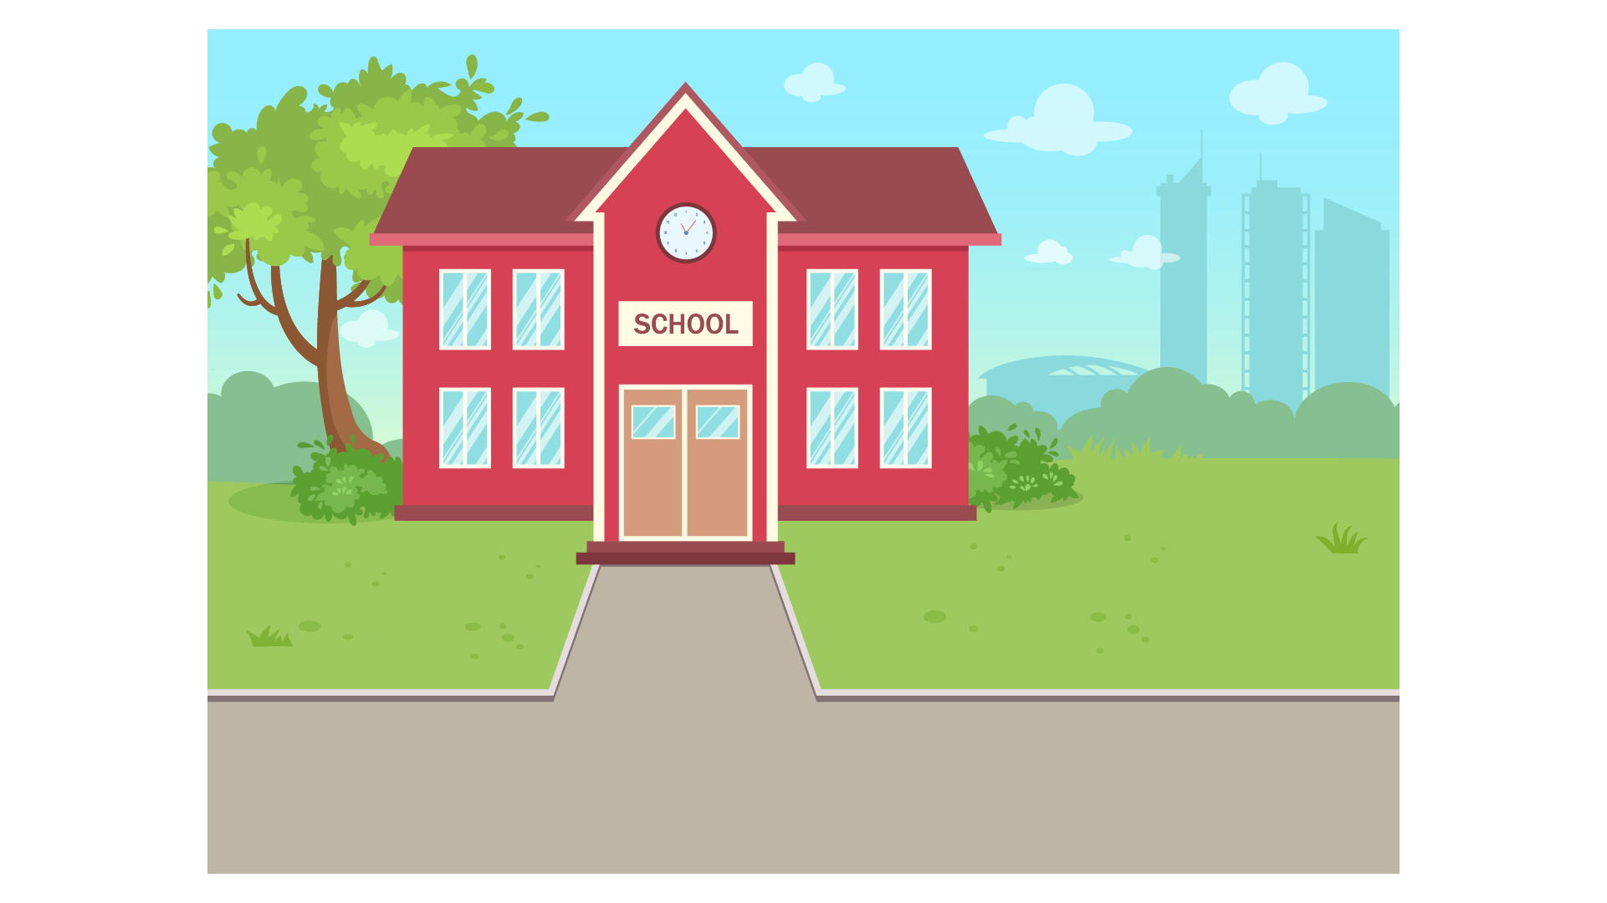
(A) School | (B) Bank | (C) Cafe
7.

(A) Sad | (B) Happy | (C) shy
8.

(A) Pear | (B) Grapes | (C) Apple
9.
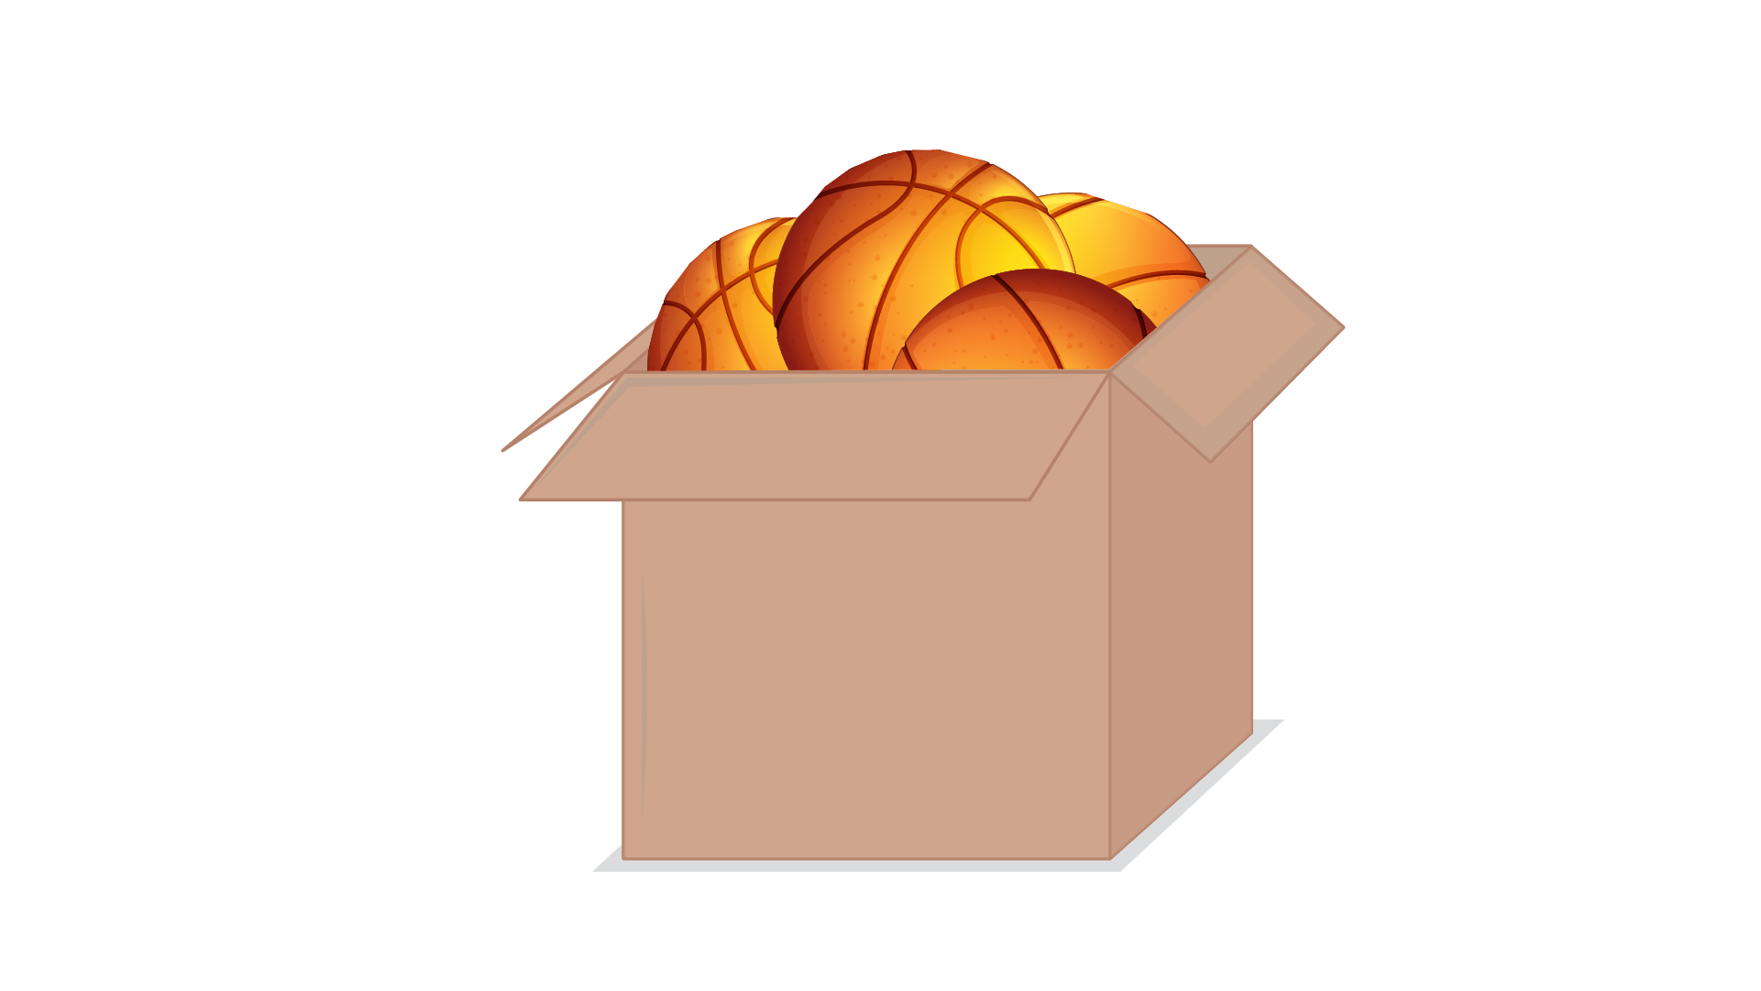
(A) Inside | (B) Outside | (C) Back
10.
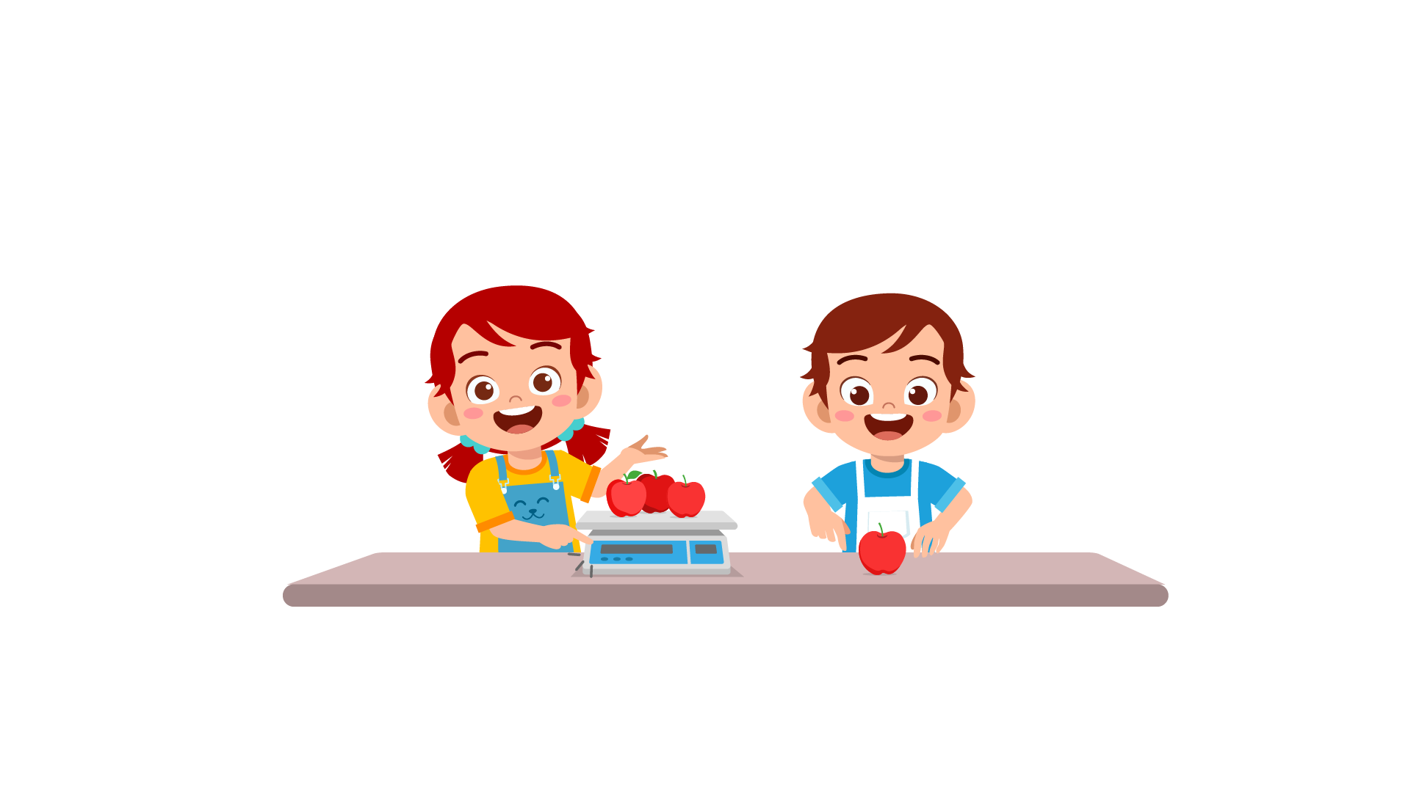
(A) They are selling apples. | (B) They are picking apples. | (C) They are making apple pies.
11.
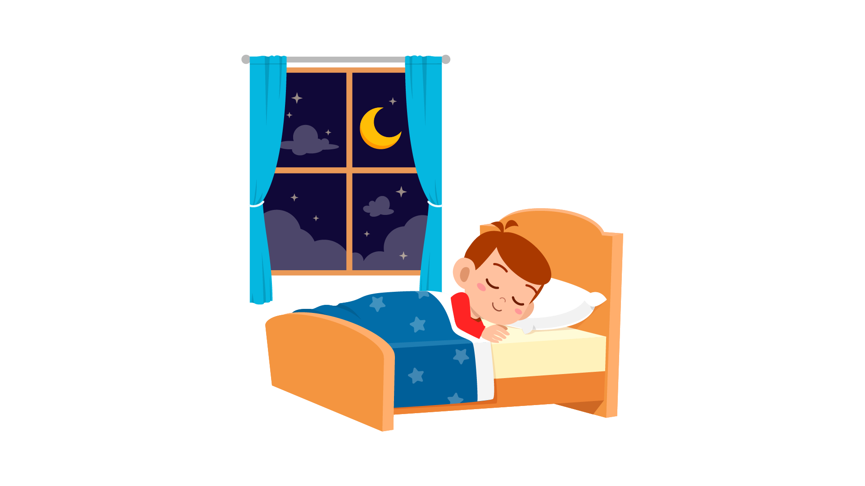
(A) The boy is drinking | (B) The boy is studying. | (C) The boy is sleeping.
12.
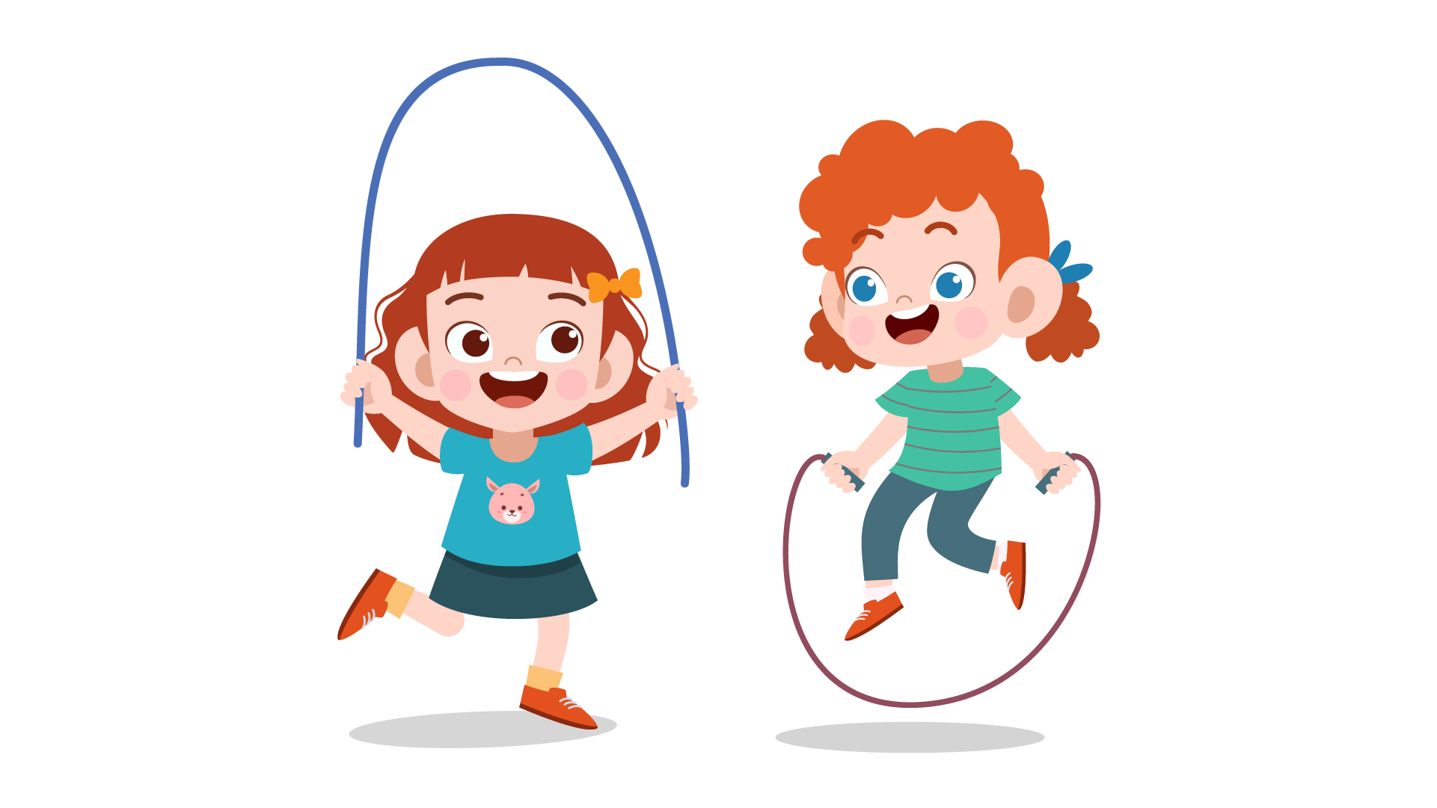
(A) The girls are jumping rope. | (B) The girls are baking. | (C) The girls are sitting.
13.

(A) The car is going up the hill. | (B) The car is at the foot of the hill. | (C) The car is going down the hill.
14.
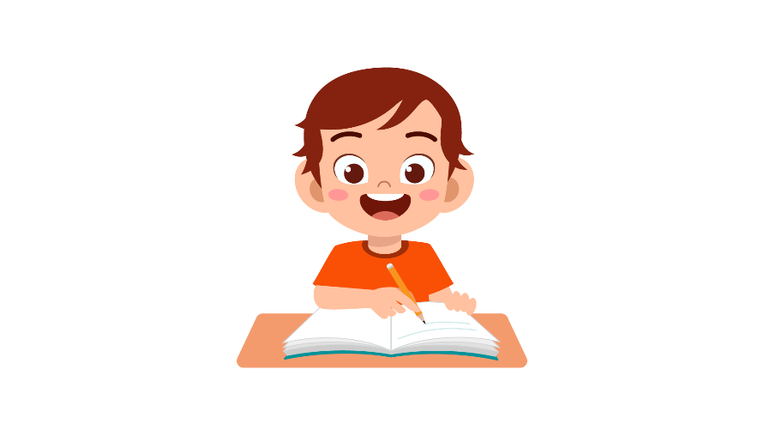
(A) The boy is raising his hand. | (B) The boy is sitting quietly. | (C) The boy is taking  notes.
15.
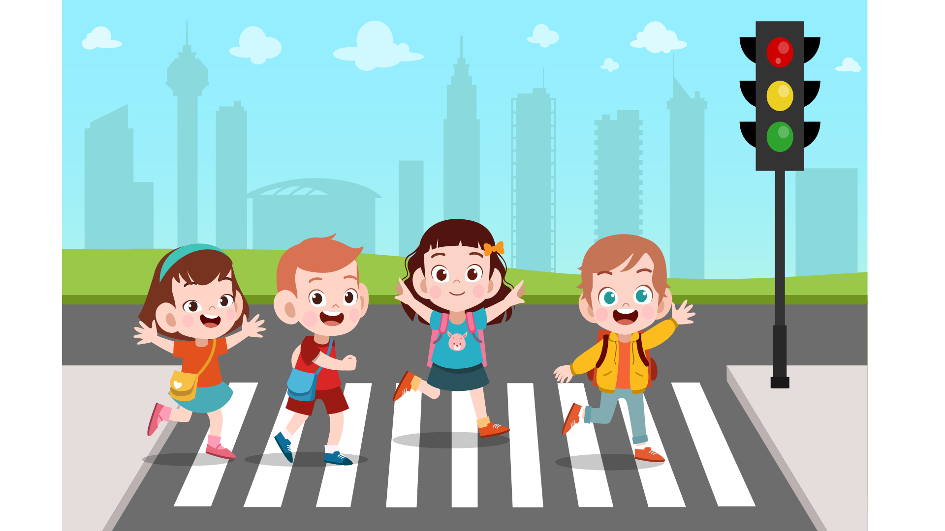
(A) They are crossing the roads. | (B) They are stopping at the bus stop. | (C) They are running at full speed.
16. | 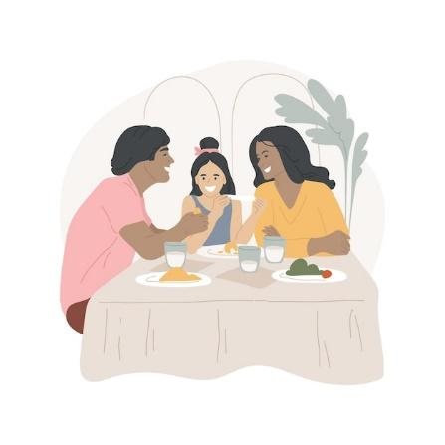
(A) The family ate cookies. | (B) The family bought fruit. | (C) The family went shopping.
17. | 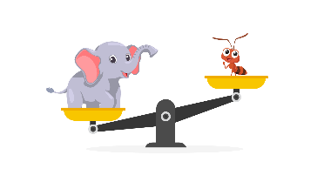
(A) The elephant is lighter than the ant. | (B) The elephant is heavier than the ant. | (C) The ant is heavier than the elephant.

PART 2
Read and find the answer.
Fill in the correct circles on your answer sheet.
Let’s do an example.
- Students go to class here. Teachers work here. It has many desks. What is it?
  - (A) A house
  - (B) A school
  - (C) A bank
The correct answer is a school. Fill in "B" on your answer sheet.

- It is a big place. It is the place where people grow food. It has many animals and trees.
Where is it?
(A) A farm
(B) A factory
(C) A library

- This is a school object. You use it to write notes. You use ink with it.
What is it?
(A) A pencil
(B) A pen
(C) A ruler

- This takes people from one place to another. You need tickets for it. This travels on land.
(A) A car
(B) A plane
(C) A bus

- You feel sick. Your body is hot. You need to drink medicine. You have _________.
(A) a fever
(B) toothache
(C) red eyes

- You do this when you want to know the sounds. You use your ears.
You _________ .
(A) listen
(B) read
(C) watch

- You go outside and it is winter. It is very cold. It is _________.
(A) windy
(B) sunny
(C) snowy

- There is no noise. People stop talking. It is __________.
(A) noisy
(B) beautiful
(C) quiet

PART 3
Read the sign. Answer questions 26 to 29.
Fill in the correct circles on your answer sheet.
Dane, Elena, Freud and Tom go to the school festival. They read this sign at the gate.
Guide to the Shopping Festival

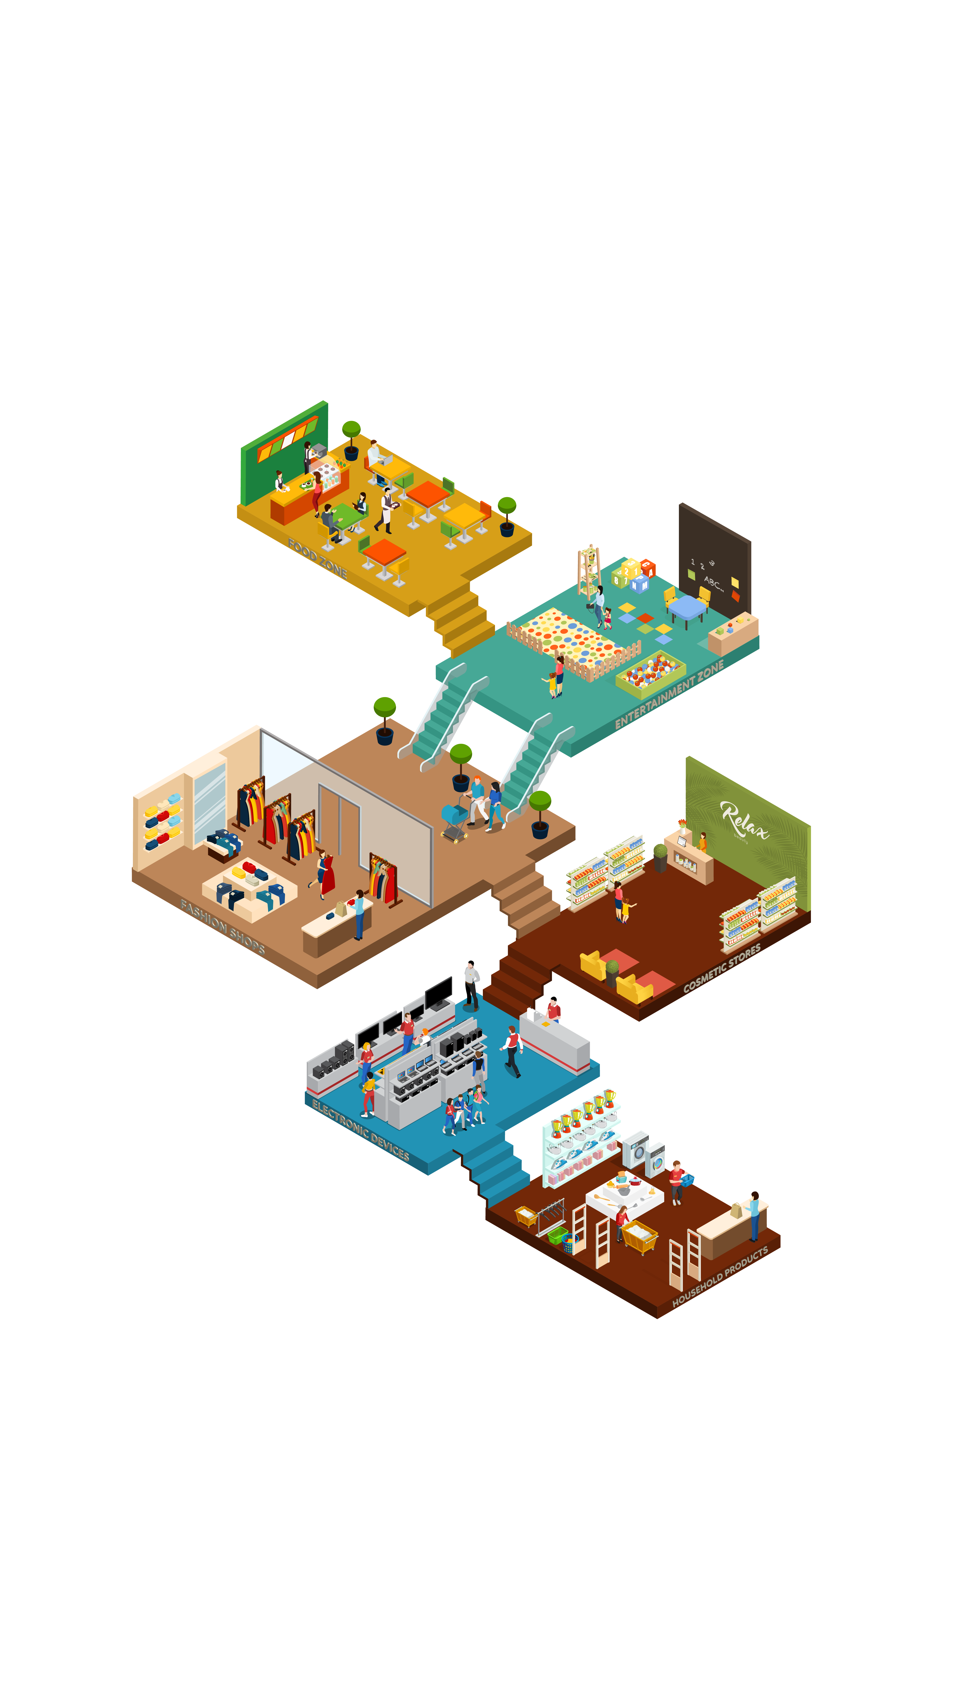

26. Dane want to buy tickets. He goes to ____________.
(A) ground floor
(B) 1st floor
(C) 2nd floor

27. Elena likes books a lot. She goes to ____________.
(A) 3rd floor
(B) 4th floor
(C) Balcony

28. Freud enjoys playing exciting things. He goes to ____________.
(A) ground floor
(B) 4th floor
(C) 2nd floor

29. Peter goes to the balcony. There is a ____________.
(A) souvenir shop
(B) costume trying
(C) flower showcase

Read the cinema timetable. Answer questions 30 to 33.
 | Monday | Tuesday | Wednesday
Doraemon | 2 p.m | 7 a.m | X
The secrets of a bumblebee | 2 p.m | X | 7 p.m
Home alone | X | 7 p.m | 7 a.m

30. Which movie does the cinema show at 7 p.m Wednesday?
(A) Doraemon
(B) The secrets of a bumblebee
(C) Home alone

31. When does the cinema show “The secrets of a bumblebee”?
(A) Tuesday
(B) Wednesday
(C) Friday
32.When does the cinema show “Doraemon” on Tuesday?
(A) 7 a.m
(B) 2 p.m
(C) 7 p.m
33.Which day doesn’t the cinema show “Home alone”?
(A) Monday
(B) Tuesday
(C) Wednesday
Read the letter. Answer questions 34 to 35.

Dear Mrs. Oakland,
This is Tom. I am writing this to let you know that we are visiting your place this summer vacation. Our family is really excited to visit you again. You are our favorite relatives in London.
I remember your beautiful three-story house, surrounded by fields of lavender. It smells great all year. The kitchen is huge. You always bake us many desserts after the meals. I can’t wait to see you this summer.
Sincerely,
Tom

34. Why does Tom write to Mrs. Oakland?
(A) To ask her about her new house
(B) To talk about his new classes
(C) To tell her the news about his family’s visiting

35. What does Tom say about Mrs. Oakland’s house?
(A) It is a four-story house.
(B) It smells bad.
(C) It has a huge kitchen.

Read the email. Answer questions 36 to 37.
To: Mr. Black
From: Jane
Subject: The ruler accident

Dear Mr. Black. This is Jane. This email is to apologize for the class ruler. I broke it this morning but I didn’t tell you that I did it. I felt really sad when I came back home. My mother told me to write to you. I’m very sorry for what I did. I promise that I will buy a new ruler for the classroom. I hope you can forgive me.

Your student,
Jane

36. Why does Jane write to Mr. Black?
(A) To tell him about her classroom
(B) To apologize him for the ruler
(C) To give him a story.

37. What is probably true about Jane?
(A) She was sad.
(B) She was happy.
(C) She was tired.

Read the information on the ID card. Answer questions 38 to 39.

STUDENT ID CARD
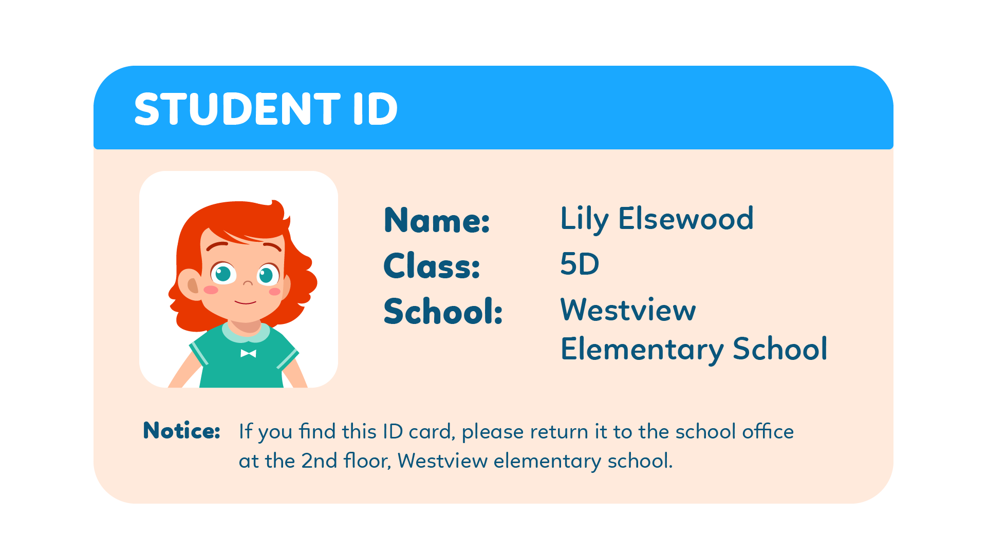

38. What is Lily’s school?
(A) Westlake elementary school.
(B) Westham elementary school.
(C) Westview elementary school.
39. Where do we return the ID card if we find it?
(A) nursing room
(B) principal office
(C) school office

You finished the reading test.
LISTENING
PART 1
Listen to the words. Look at the pictures.
Fill in the correct circles on your answer sheet.
1.
 | 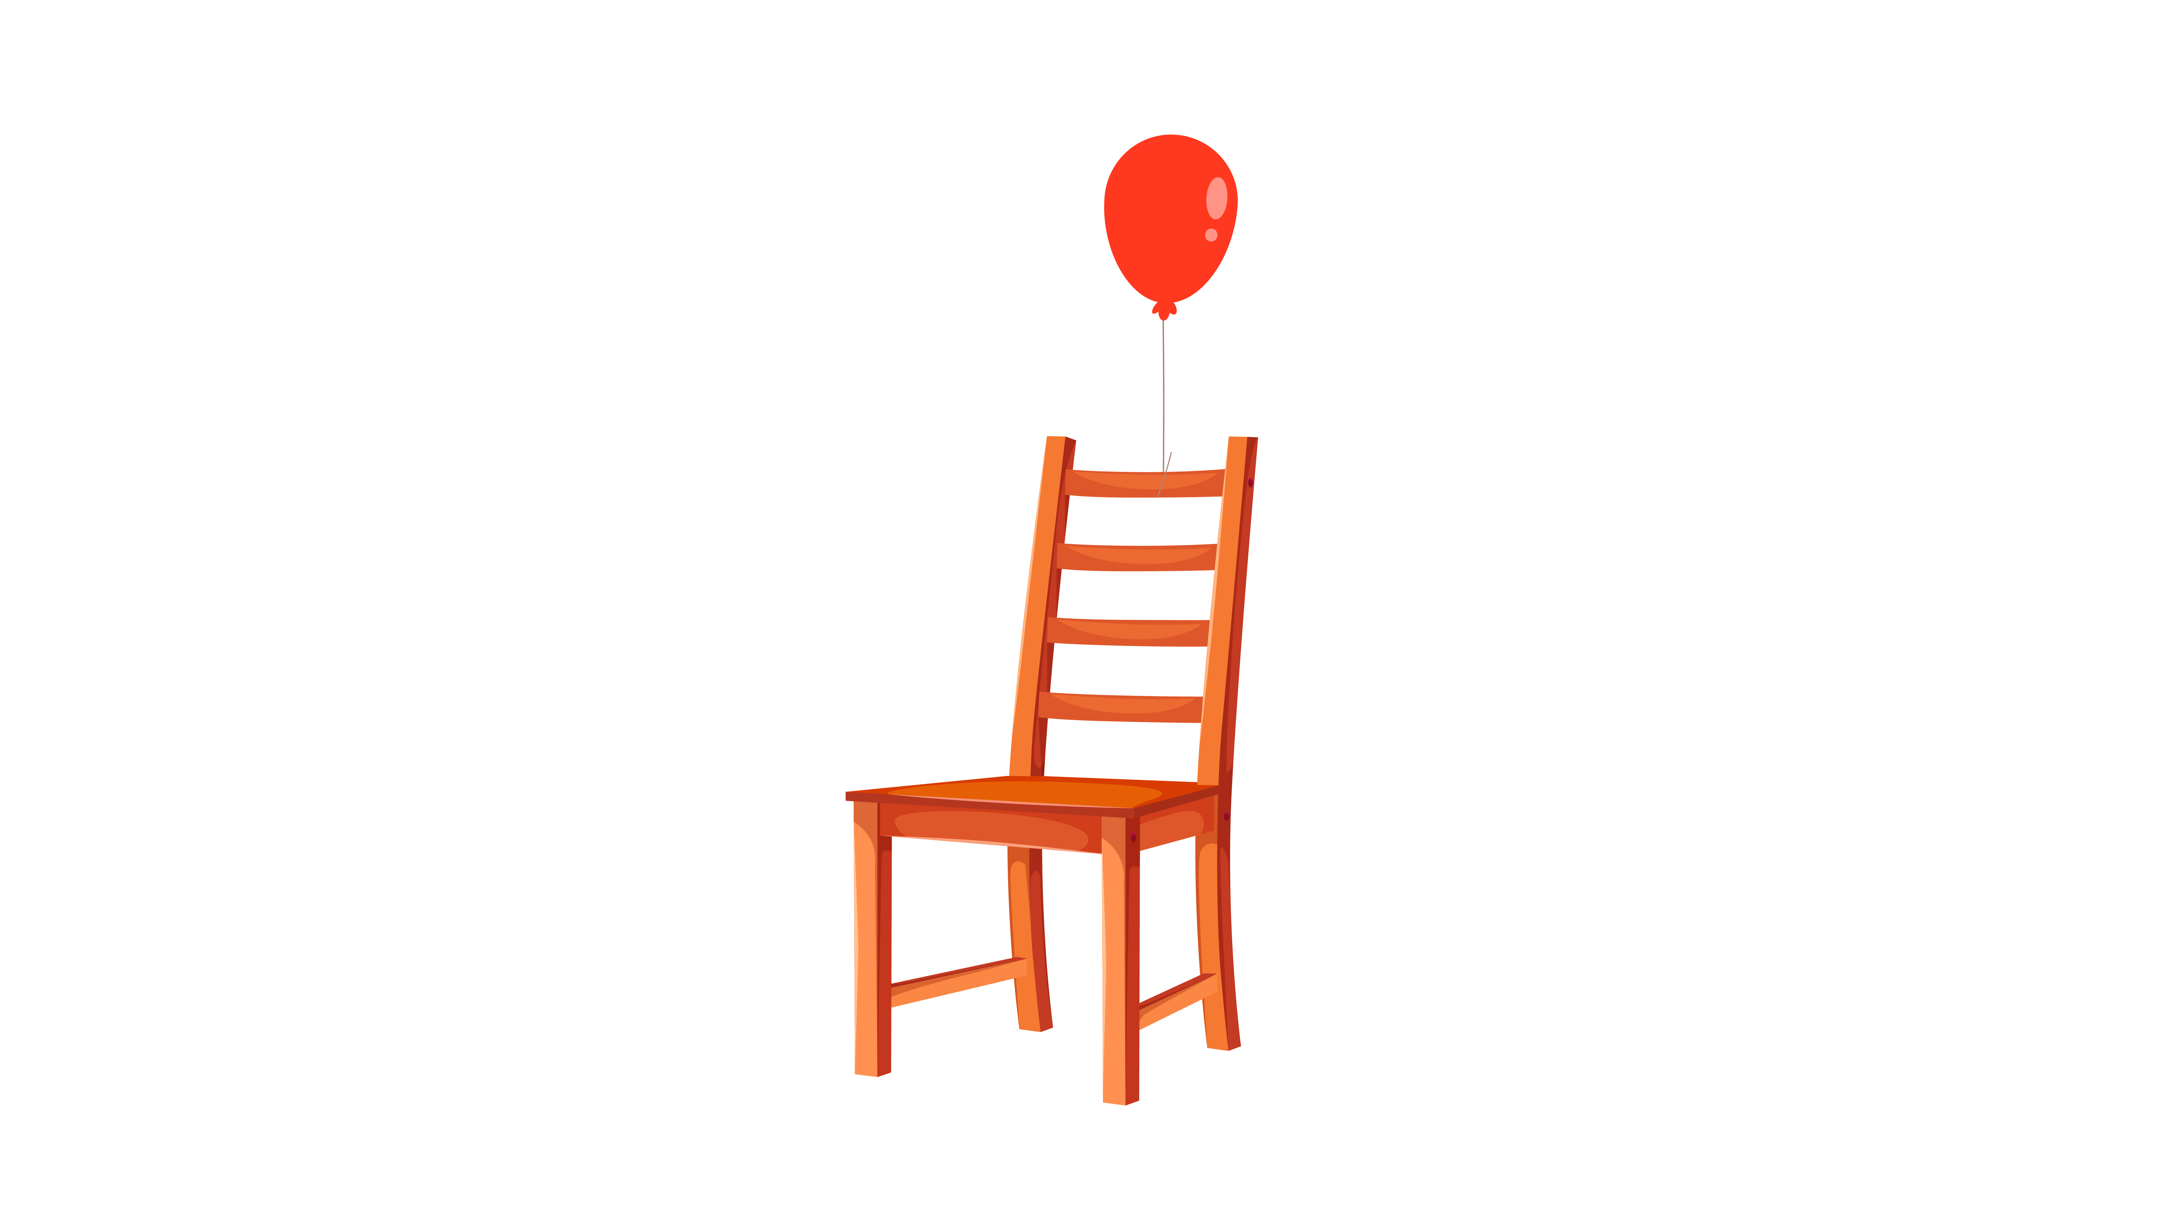 | 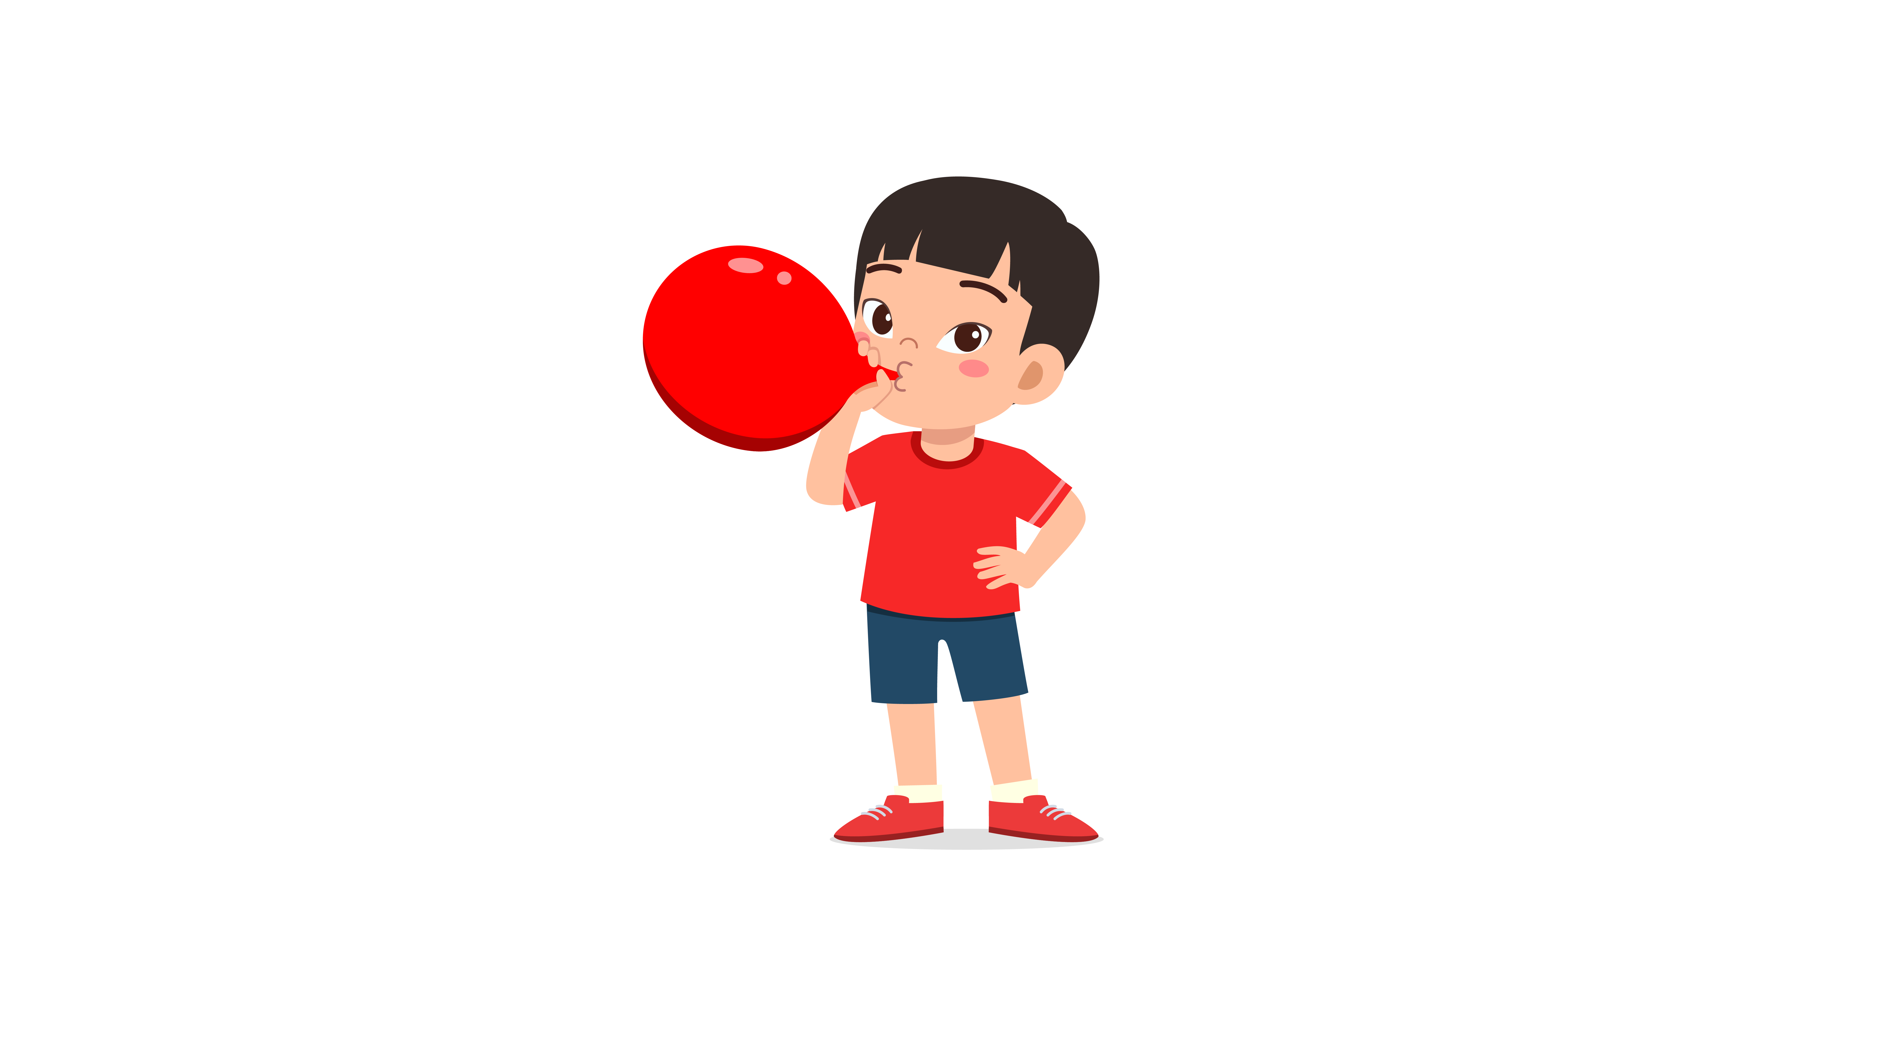
(A) | (B) | (C)
2.
 |  | 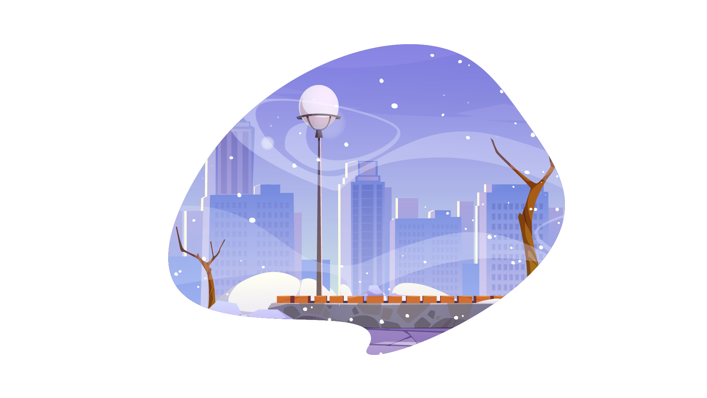
(A) | (B) | (C)
3.
 | 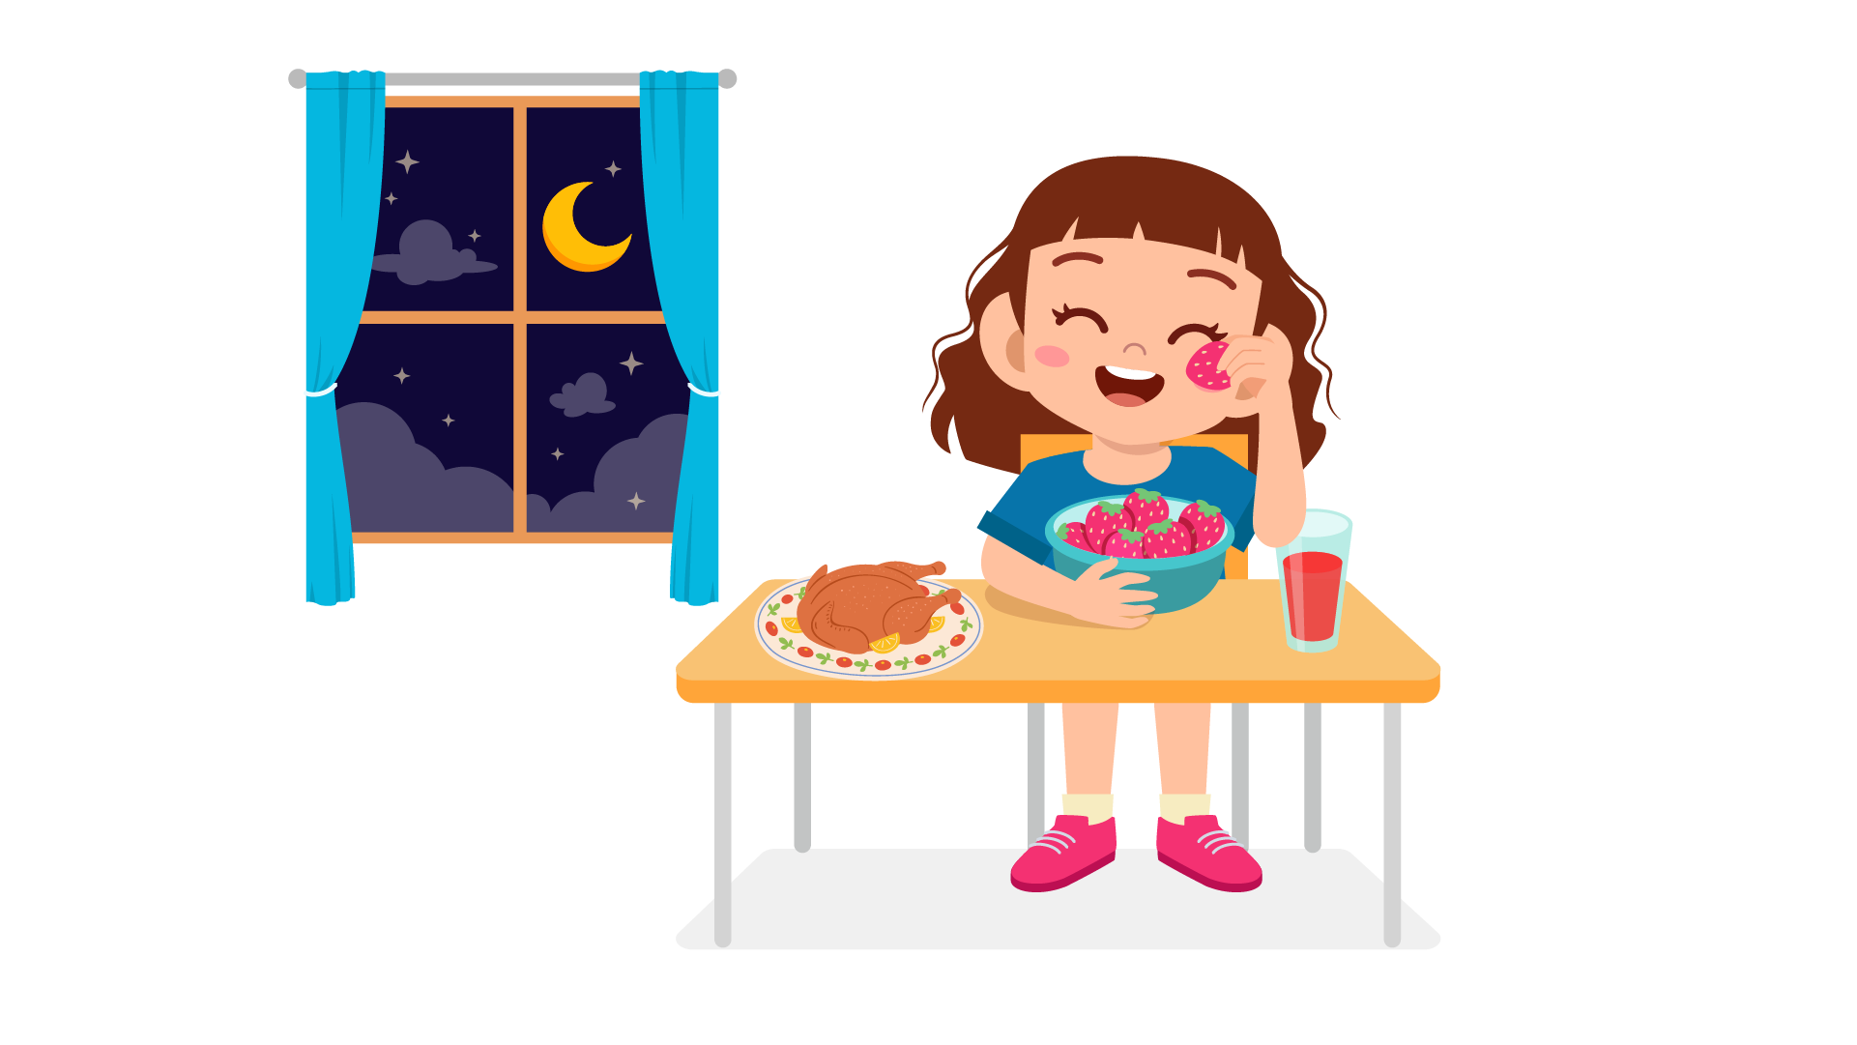 | 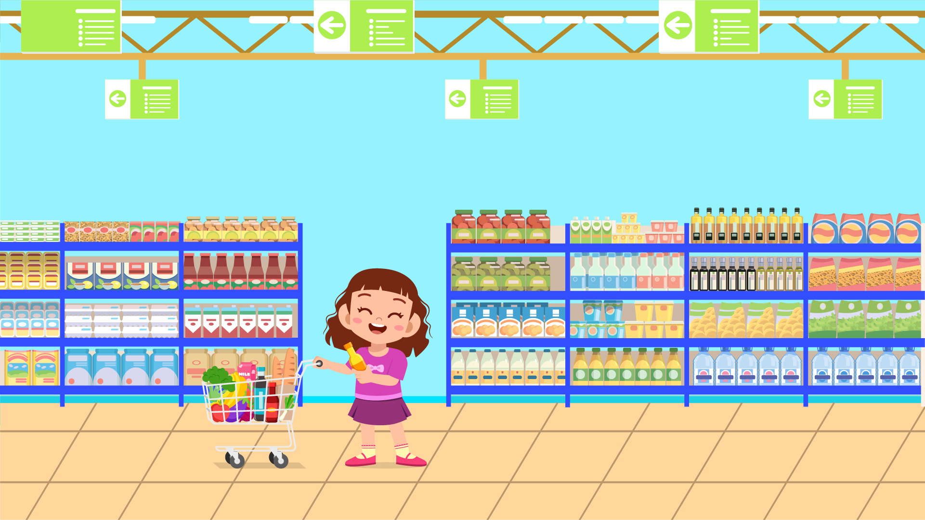
(A) | (B) | (C)
4.
 | 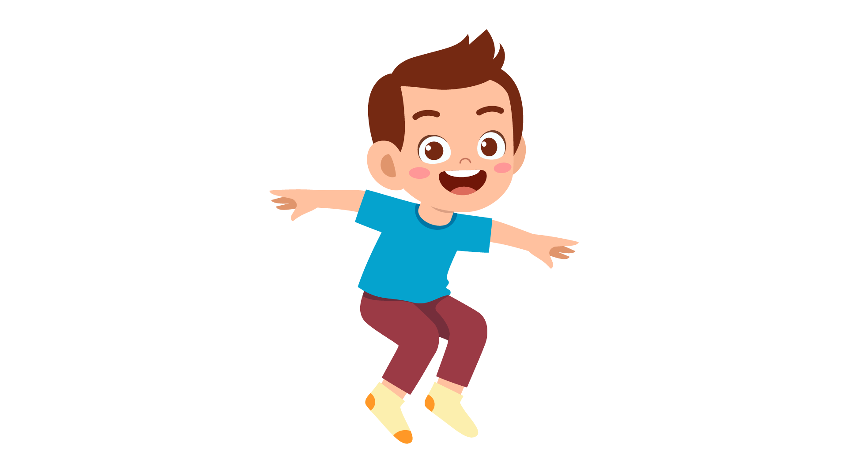 | 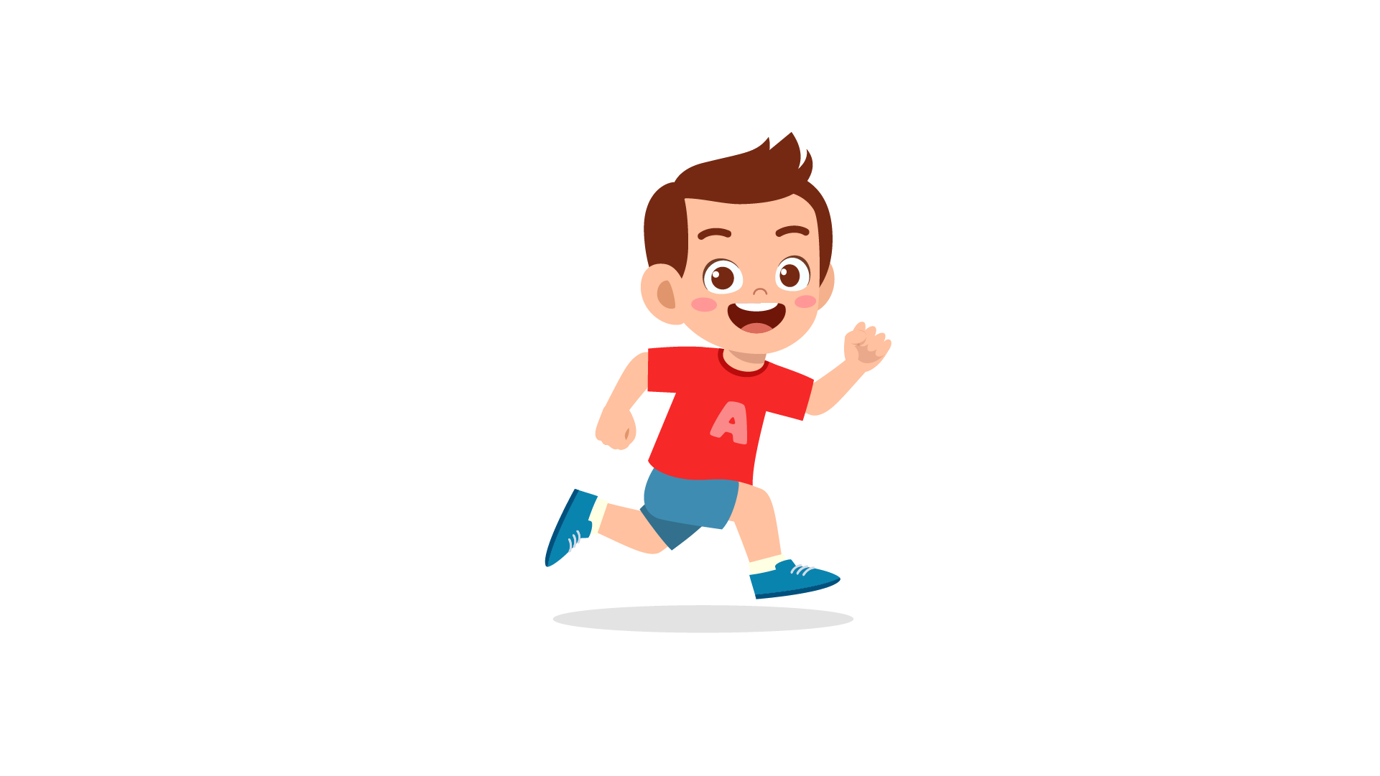
(A) | (B) | (C)
5.
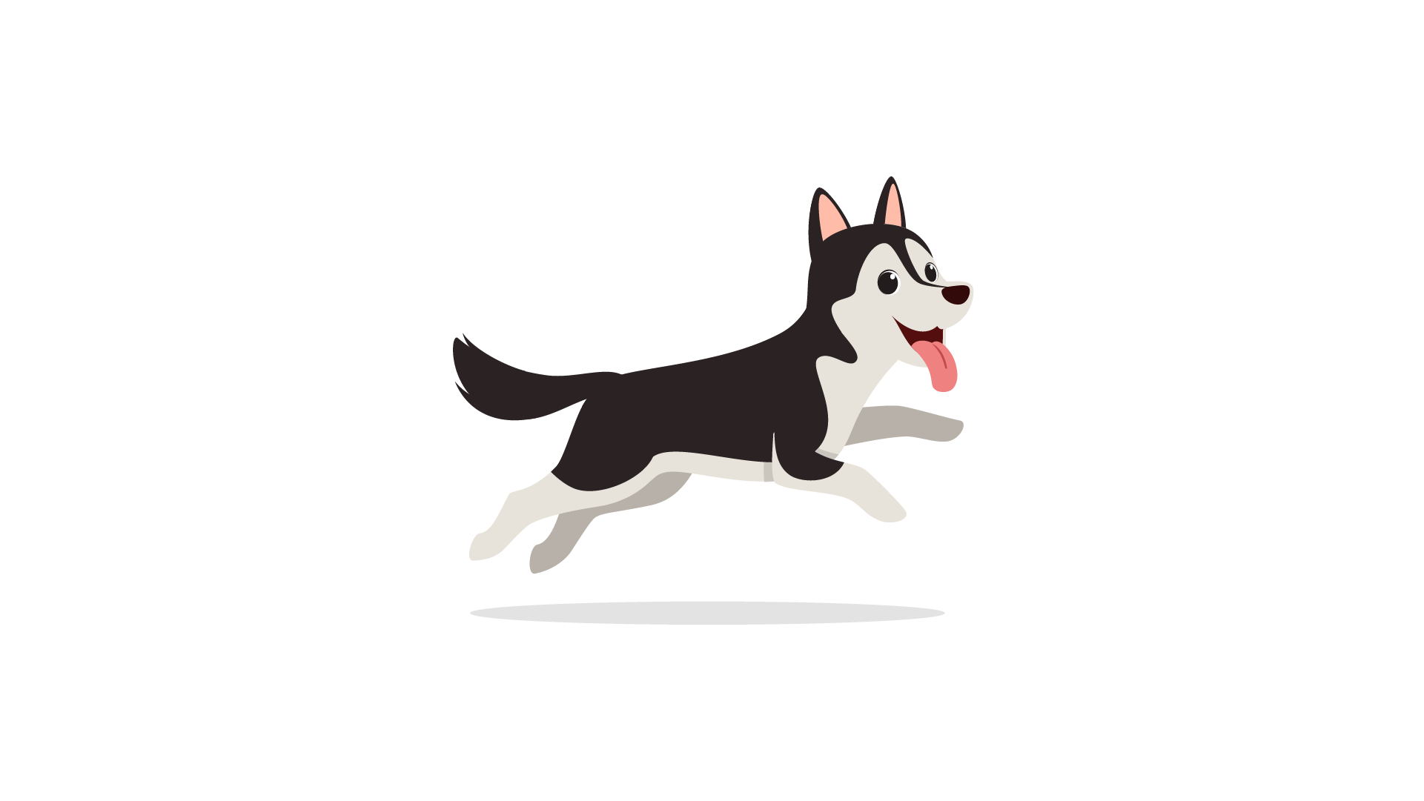 | 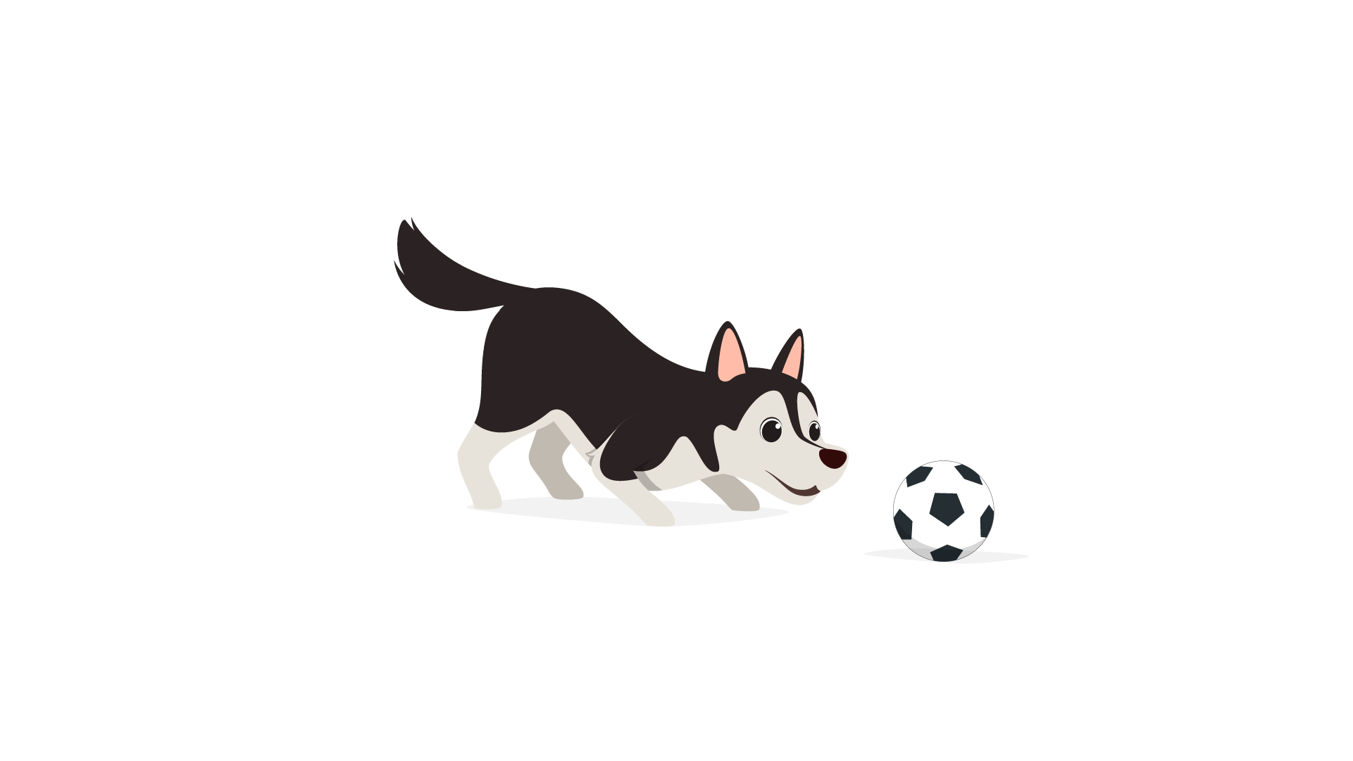 | 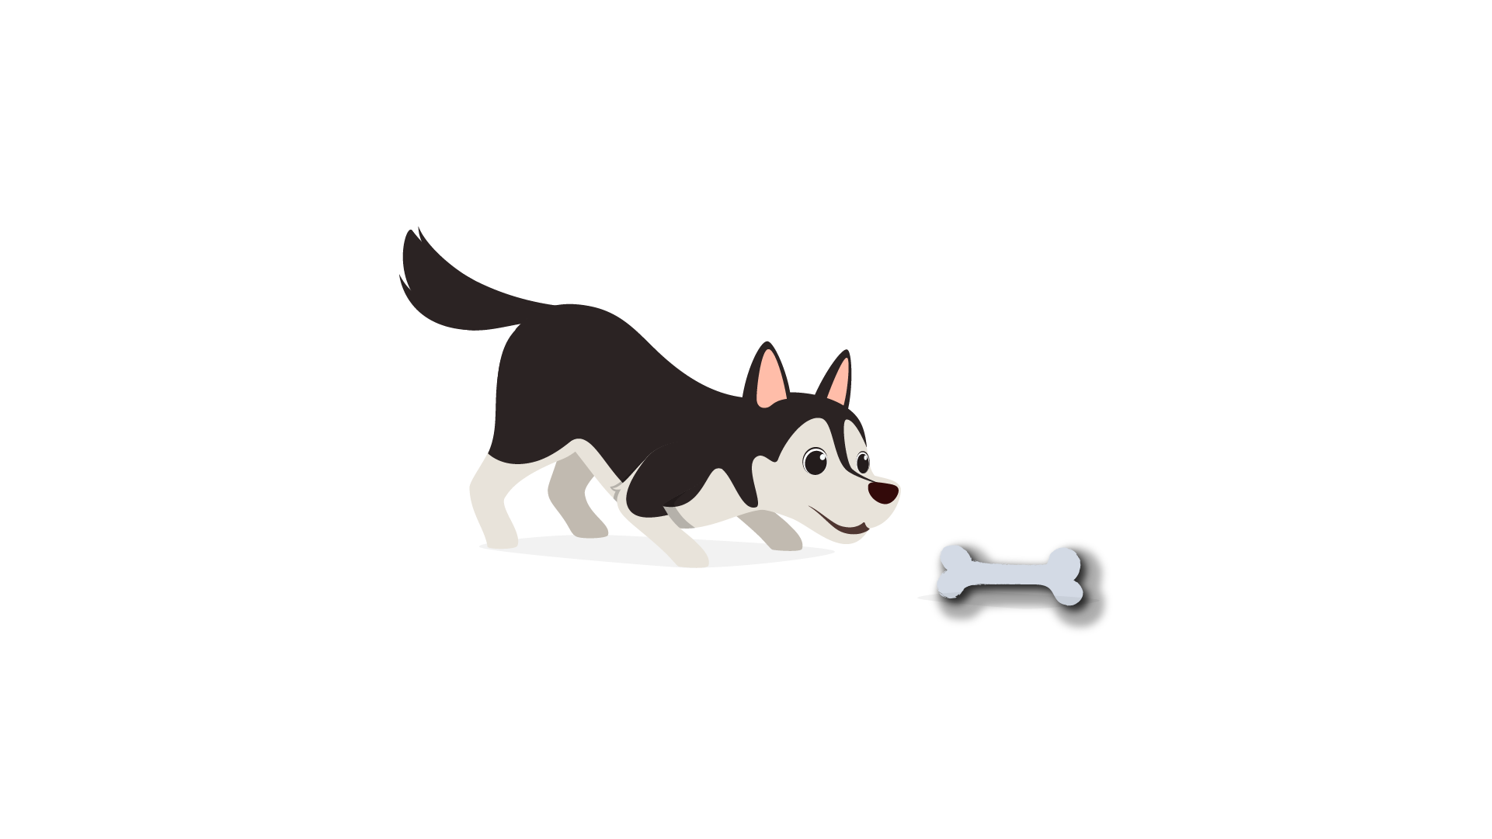
(A) | (B) | (C)
6.
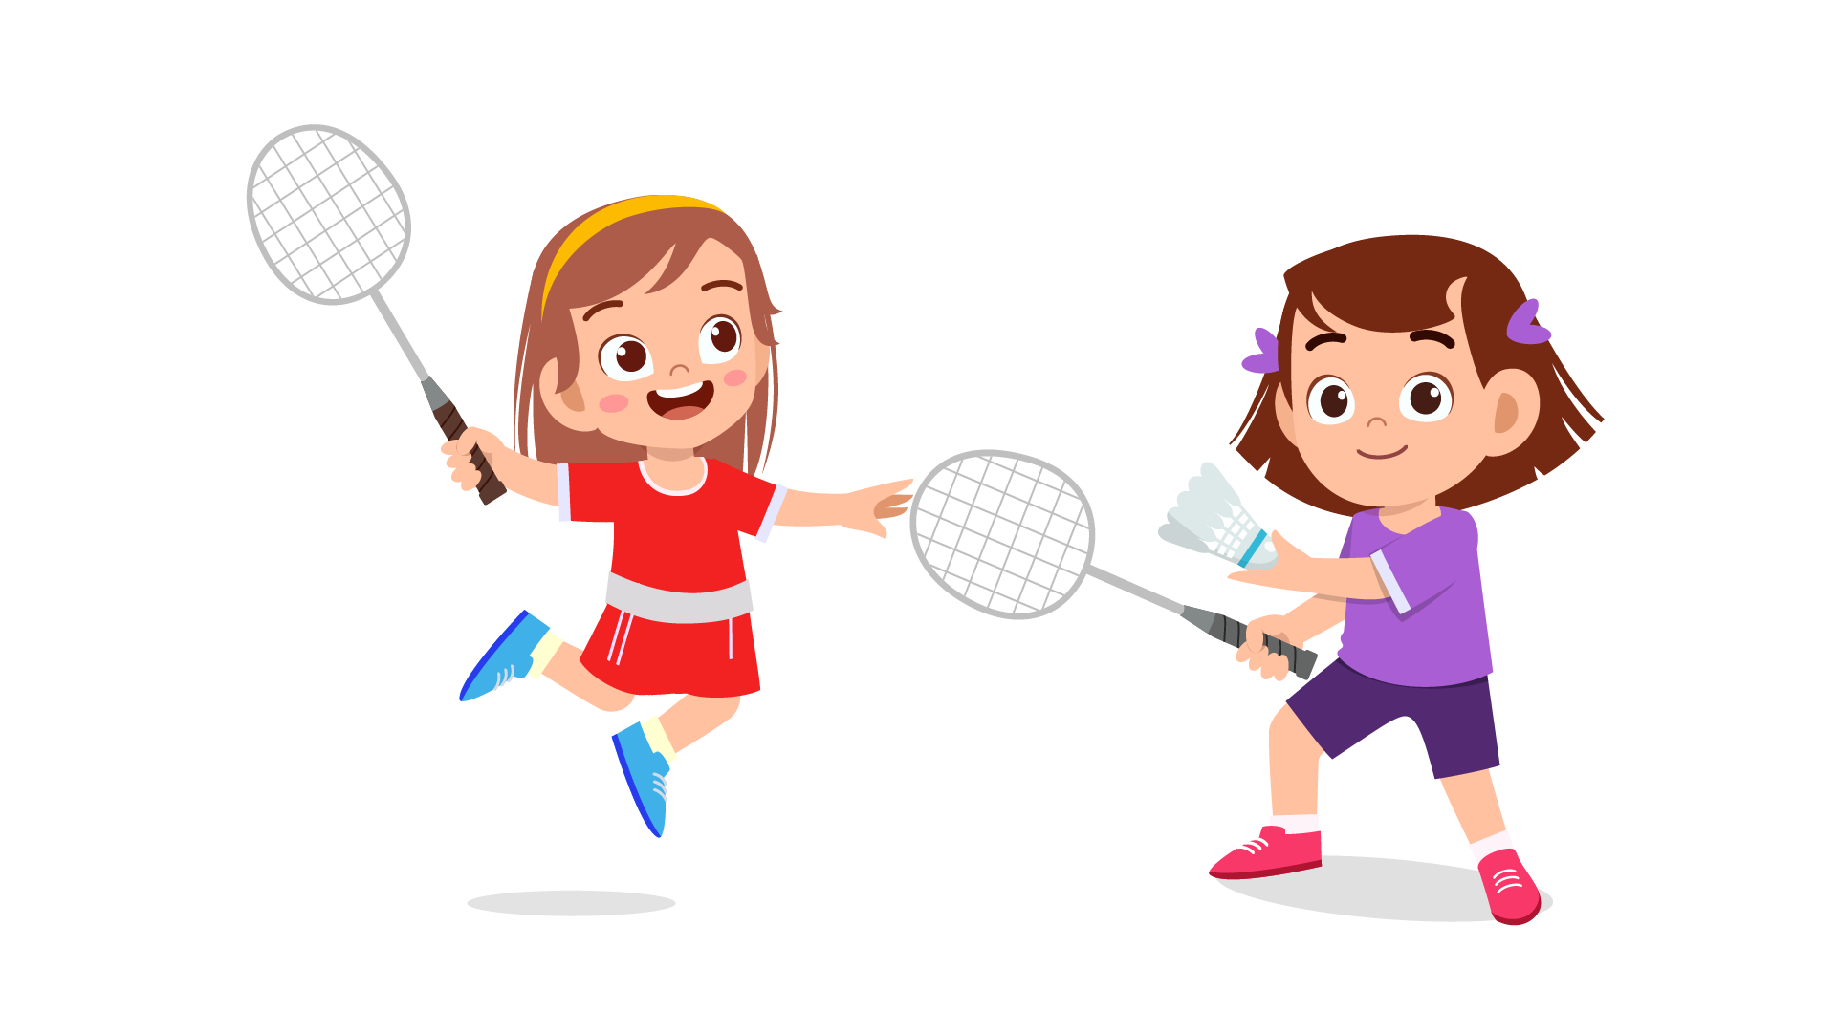 | 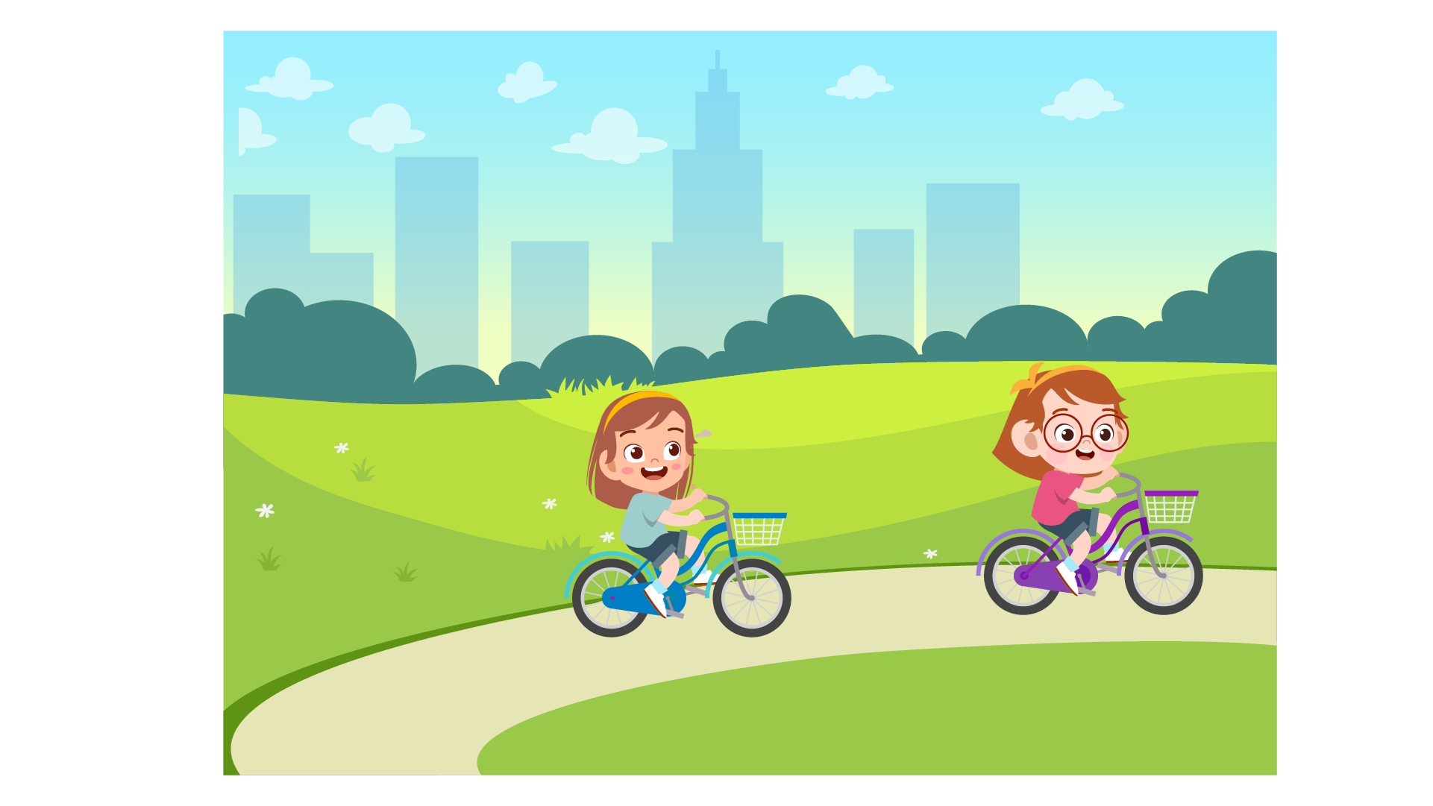 | 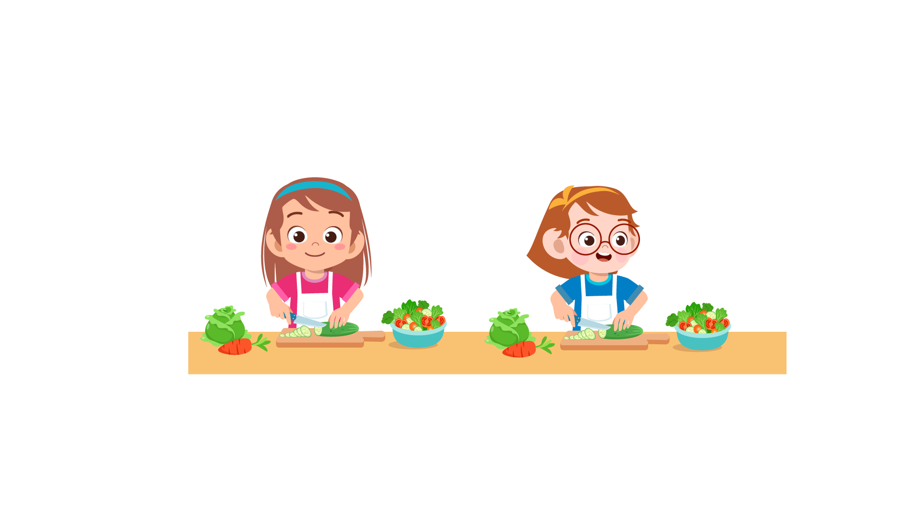
(A) | (B) | (C)
7.
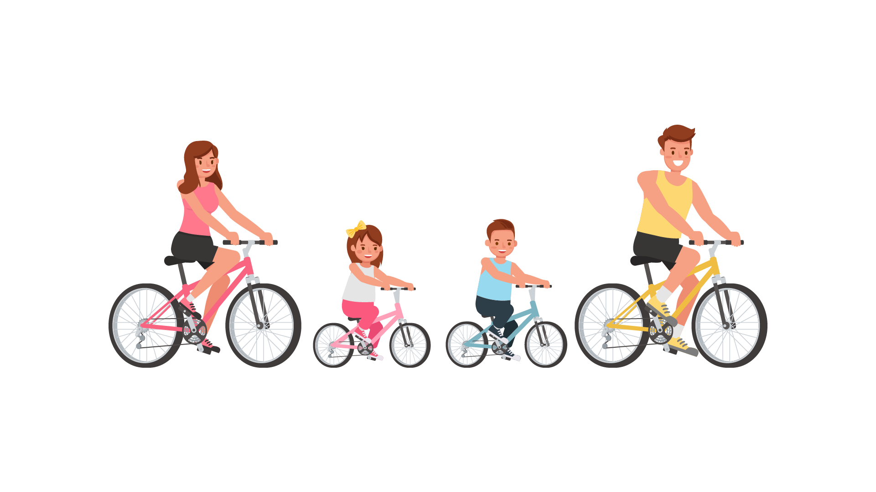 | 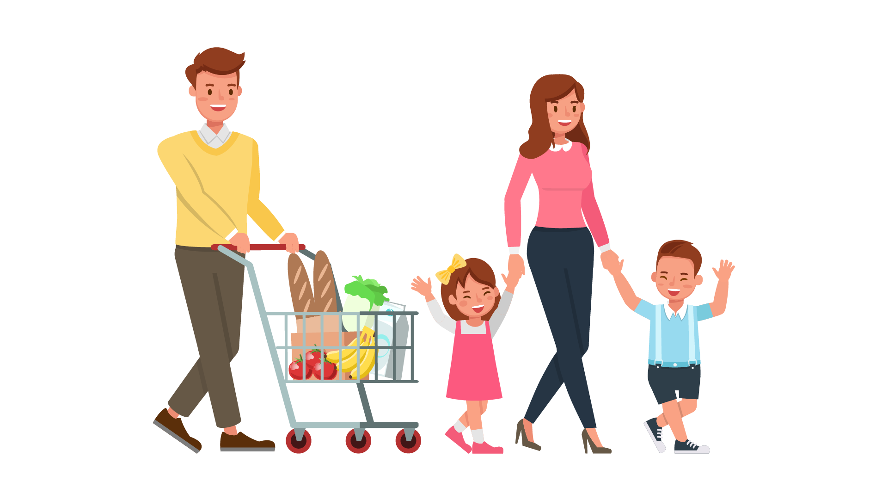 | 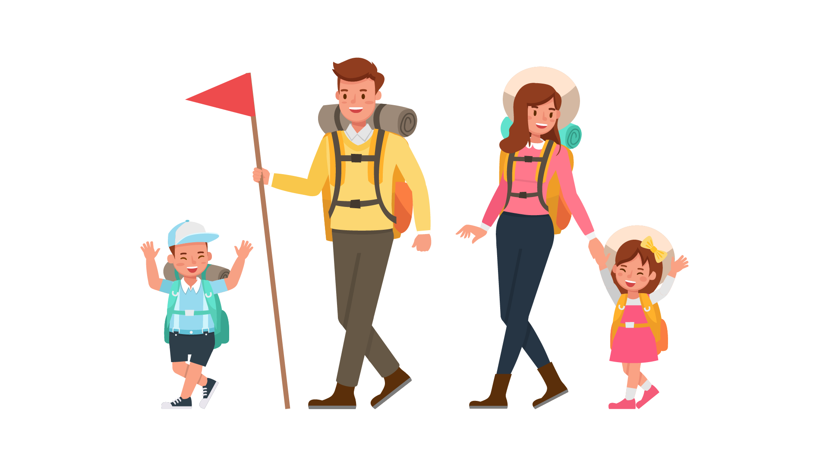
(A) | (B) | (C)
8.
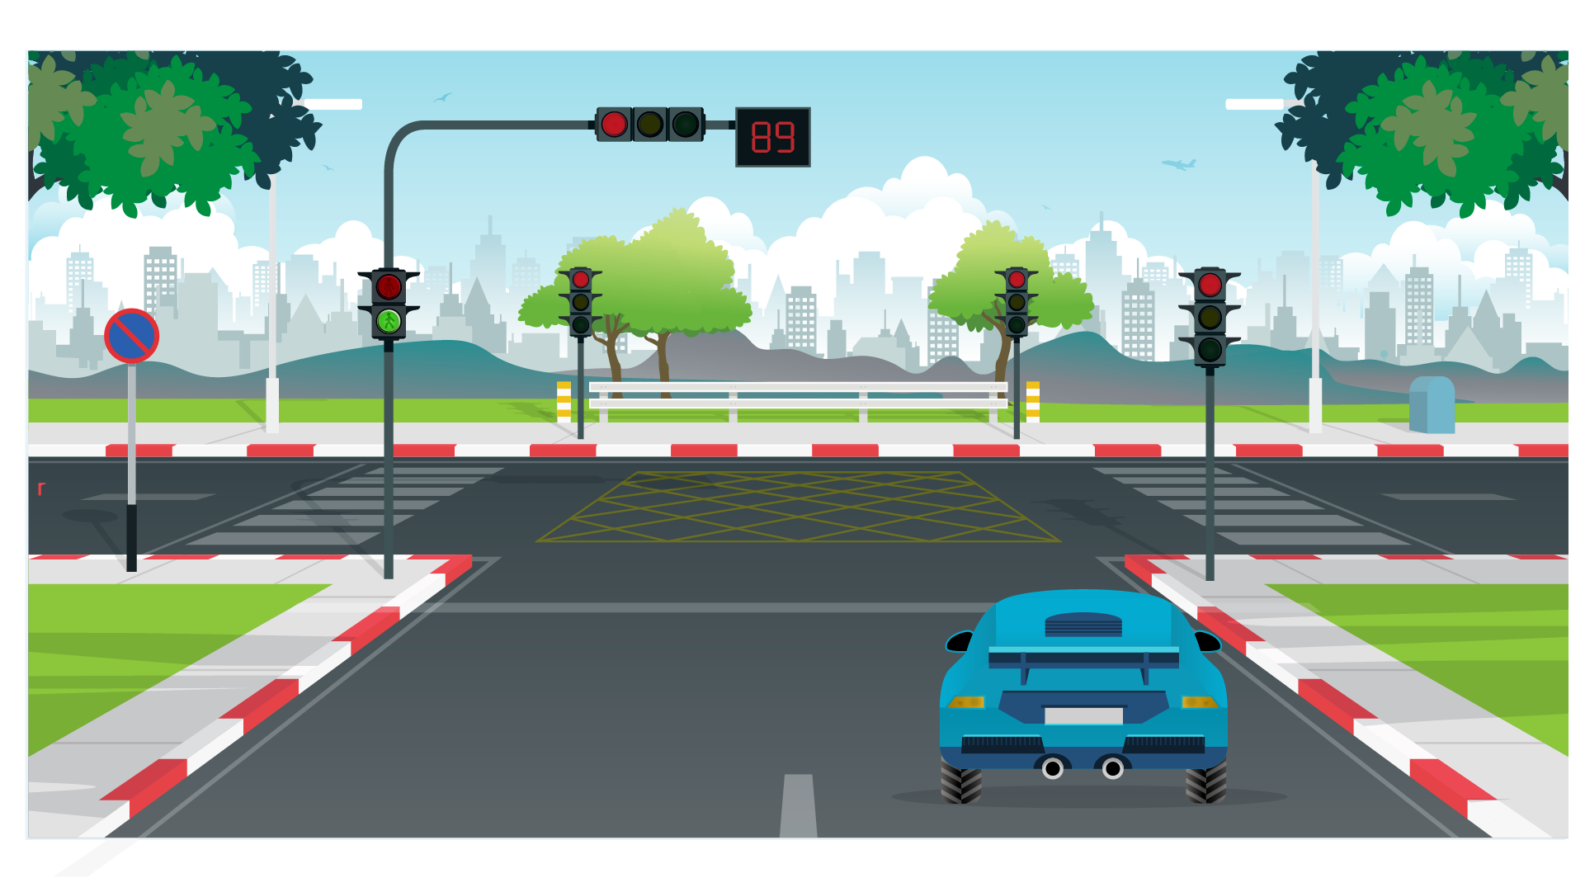 | 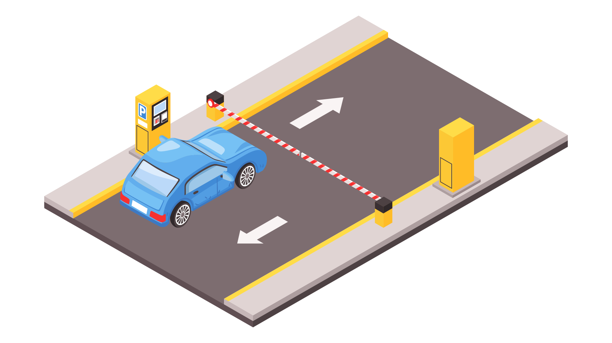 | 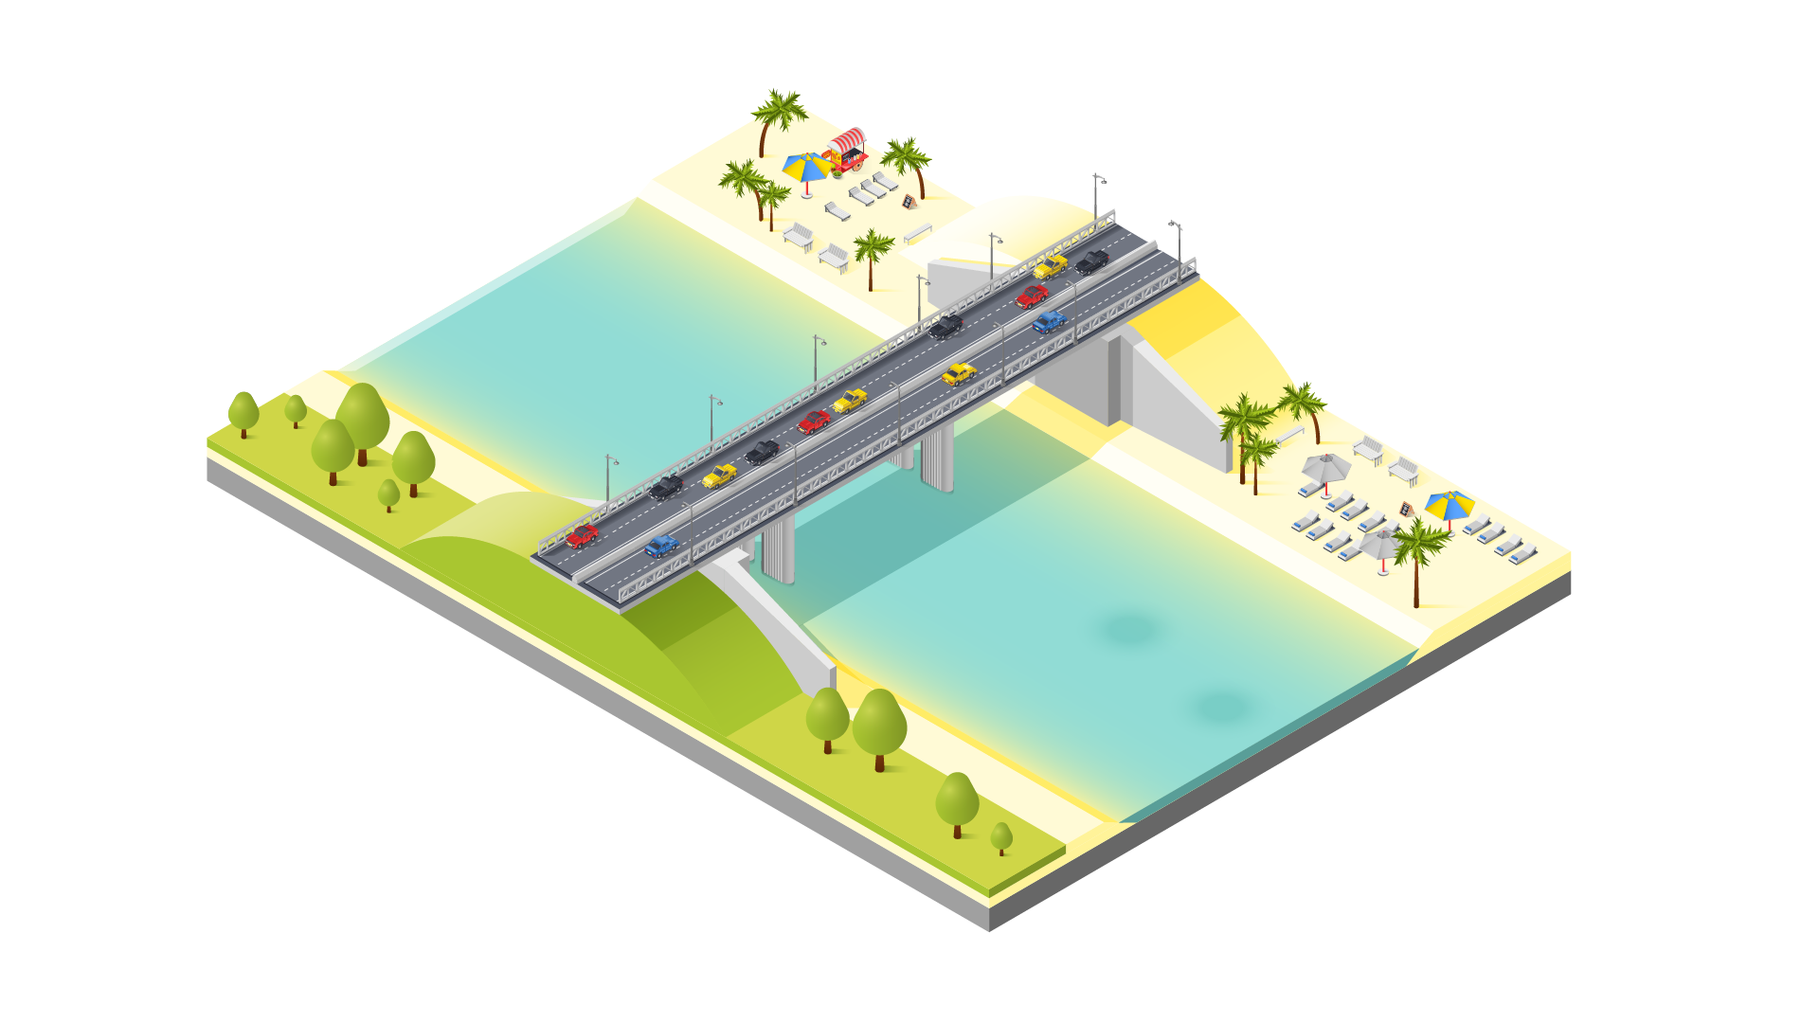
(A) | (B) | (C)

PART 2
Fill in the correct circles on your answer sheet.
9.
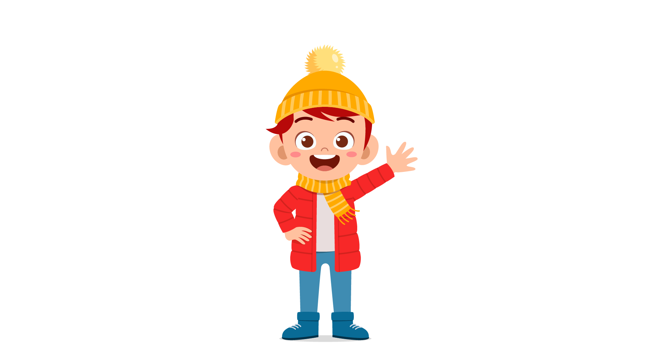 | 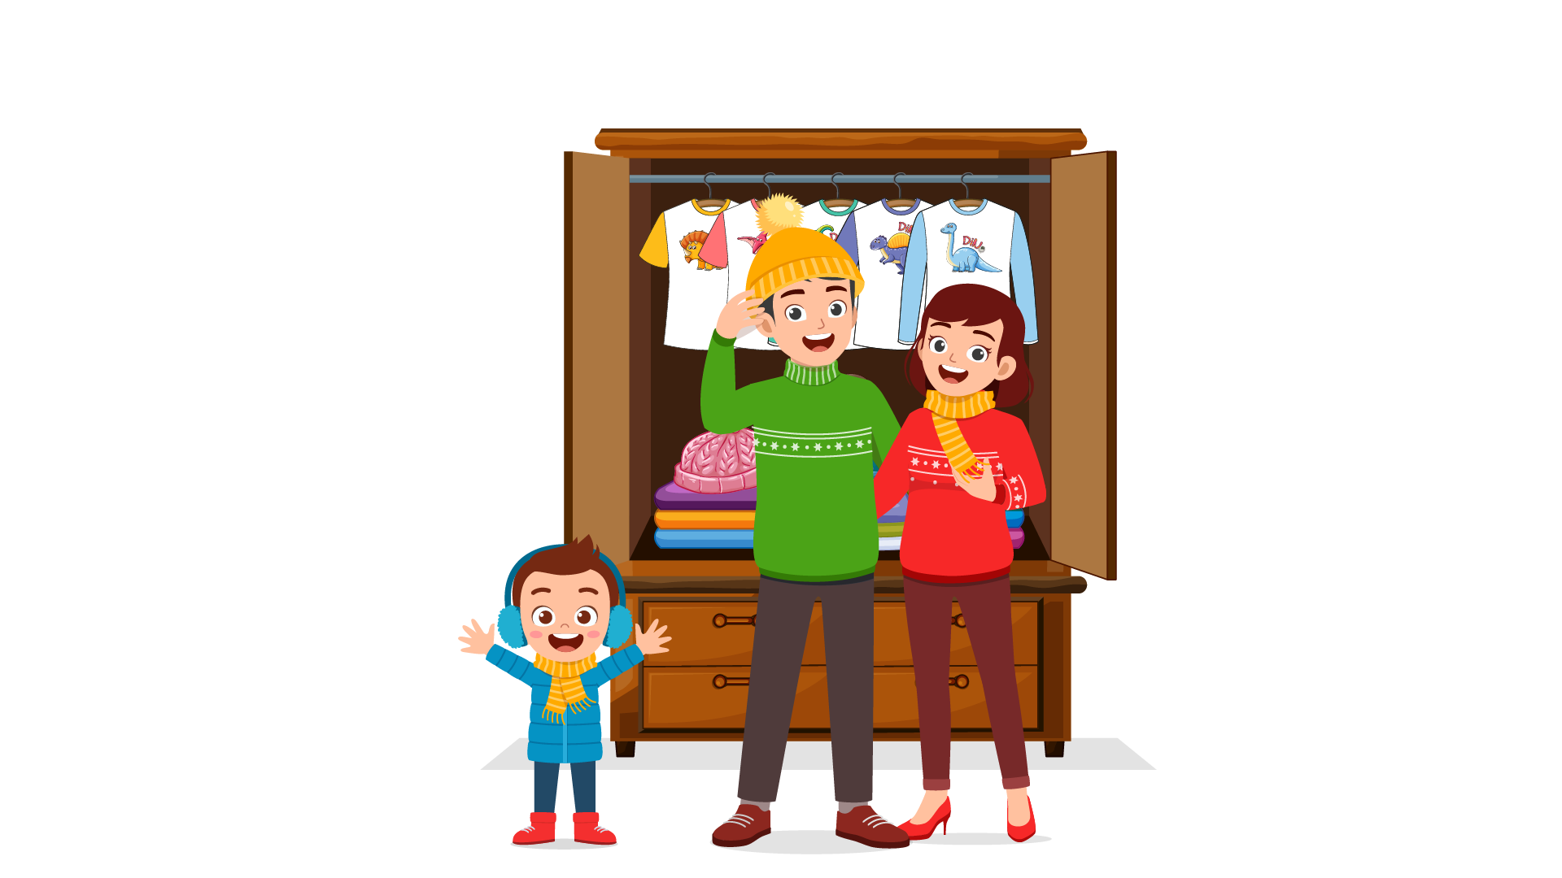 | 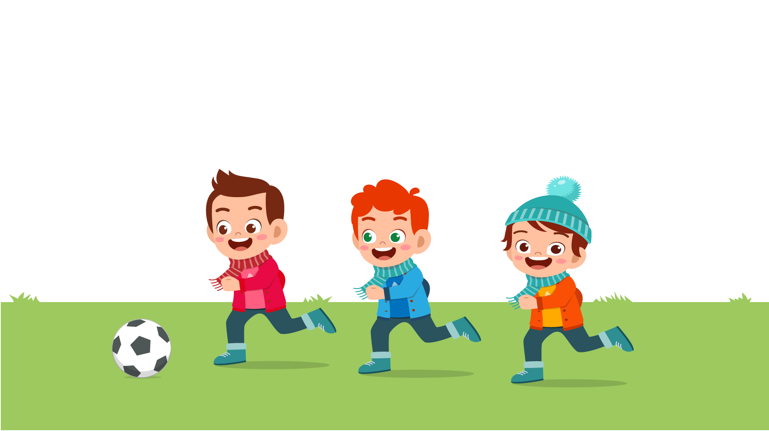
(A) | (B) | (C)
10.
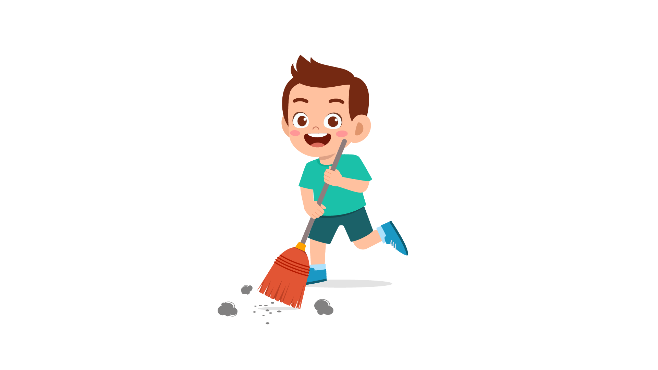 | 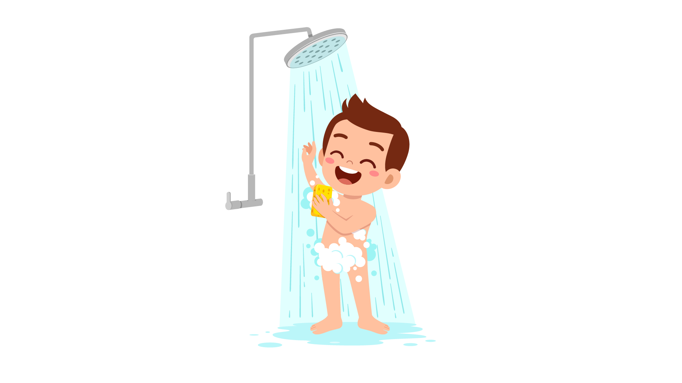 | 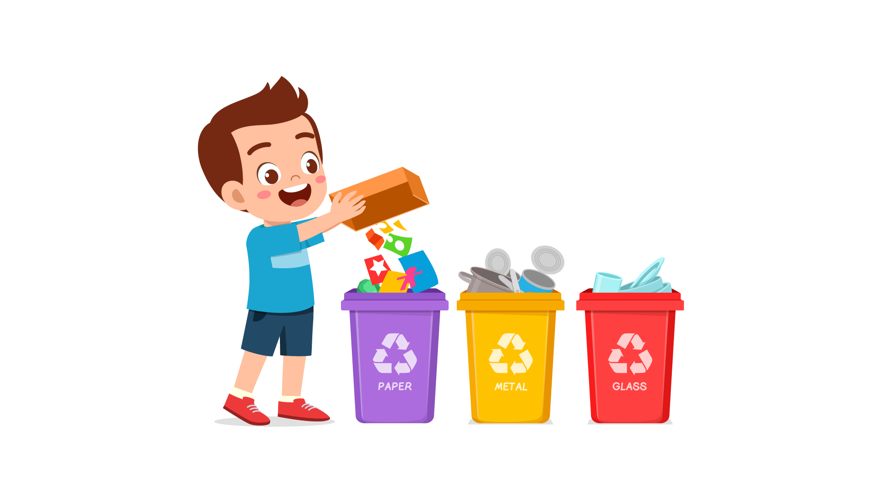
(A) | (B) | (C)
11.
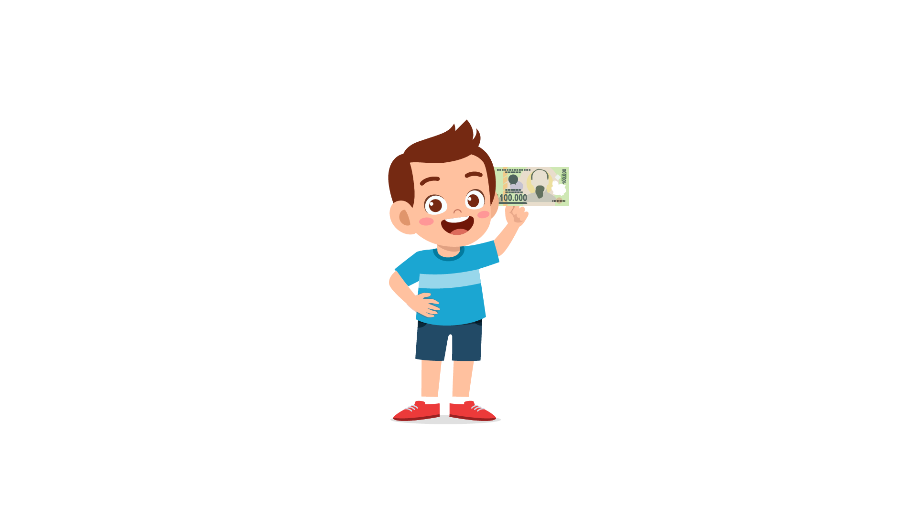 | 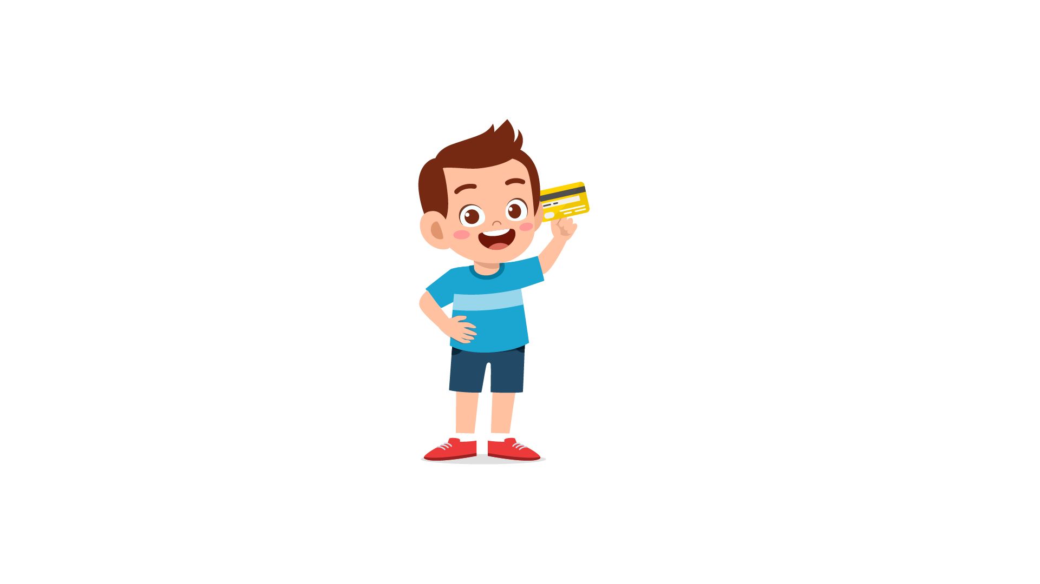 | 
(A) | (B) | (C)
12.
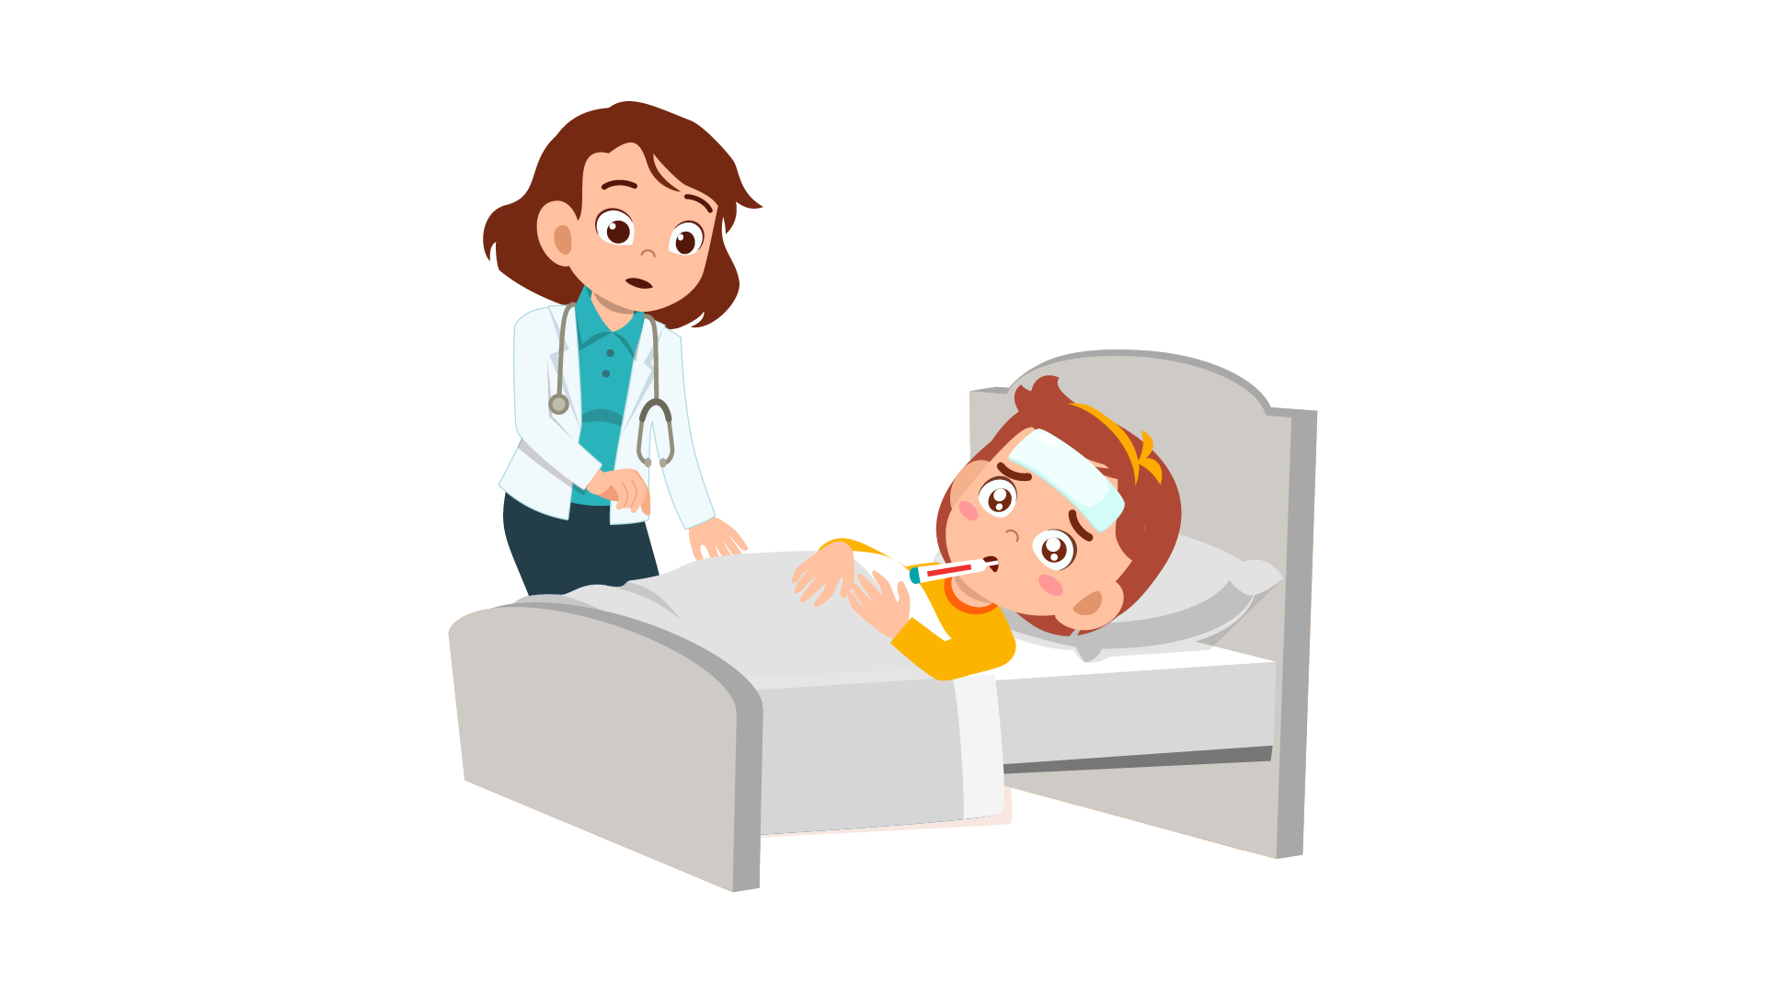 | 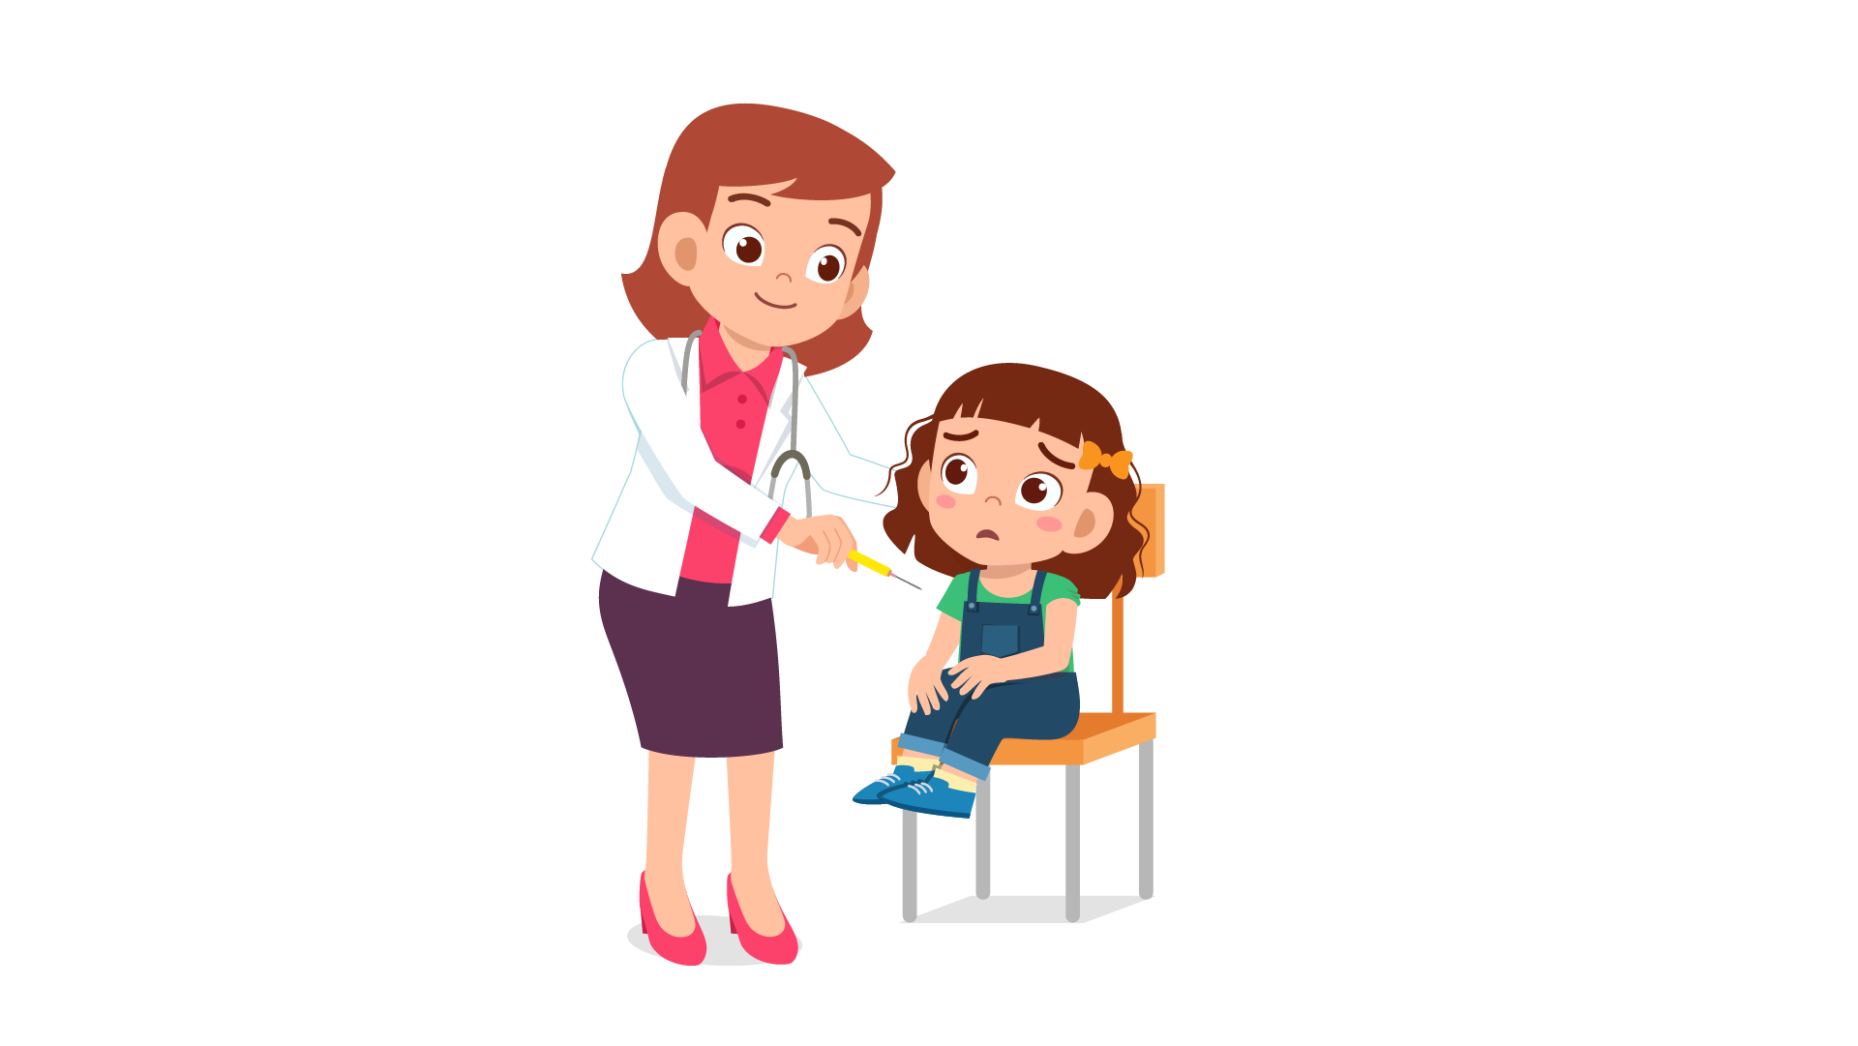 | 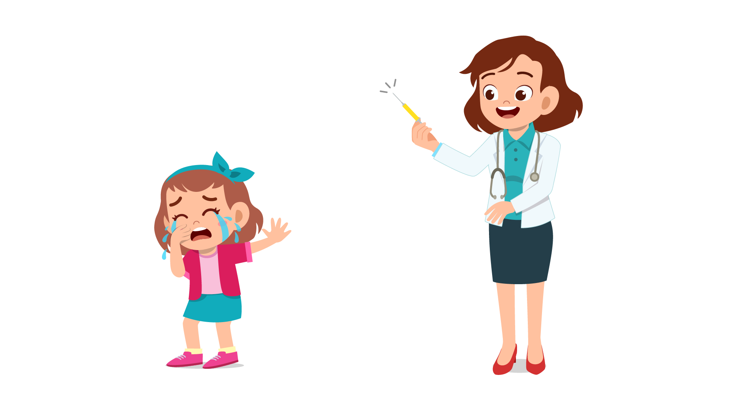
(A) | (B) | (C)
13.
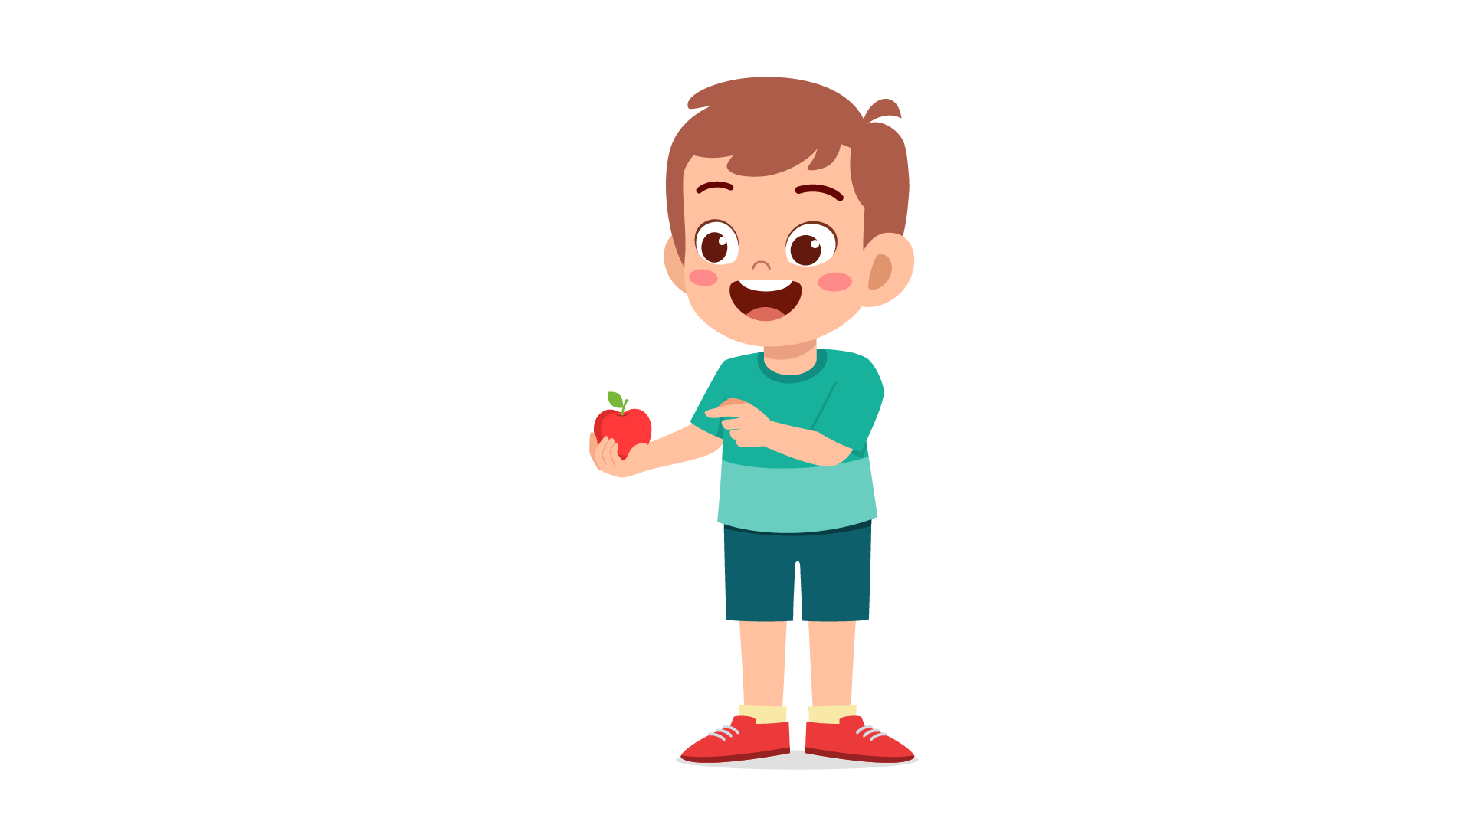 | 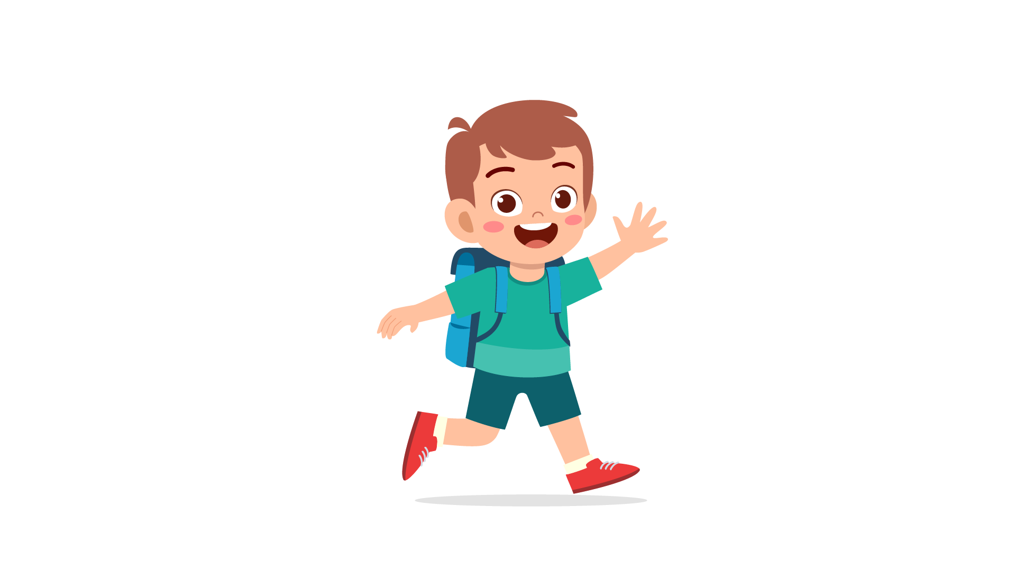 | 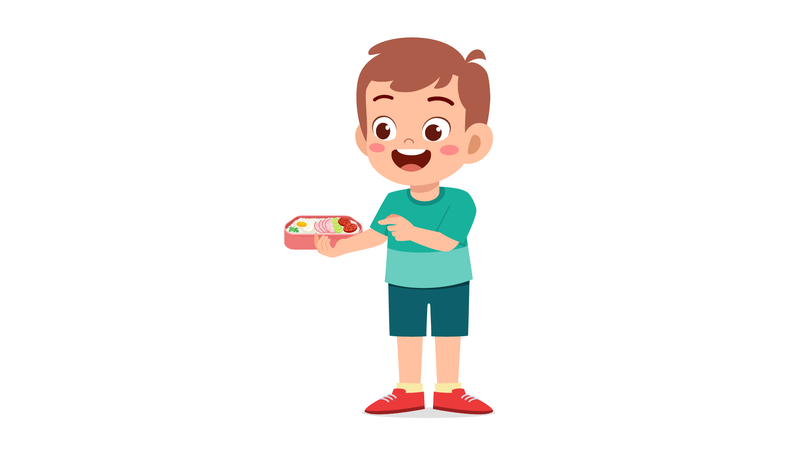
(A) | (B) | (C)
14.
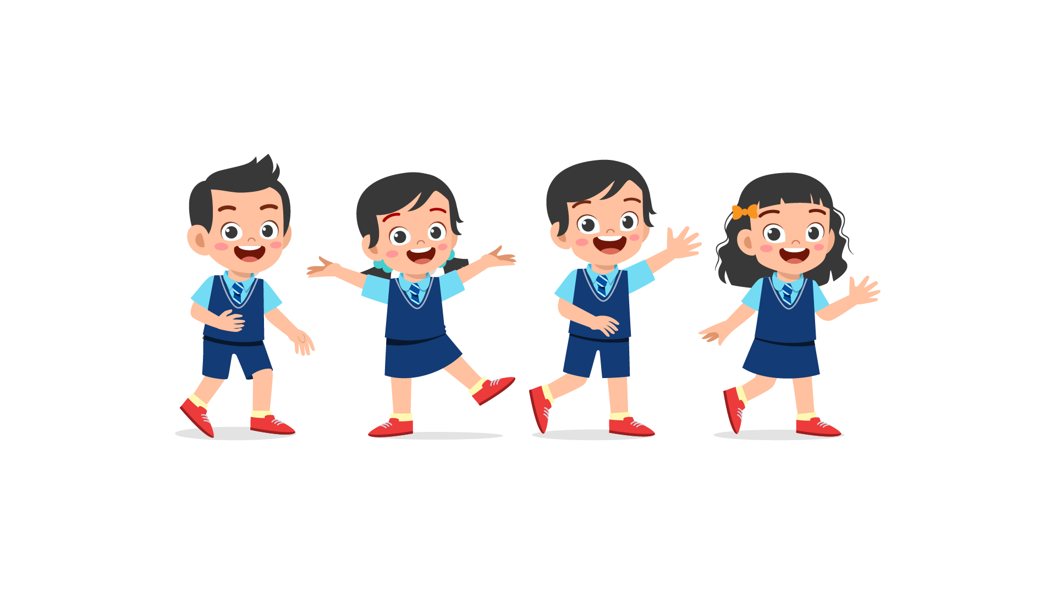 | 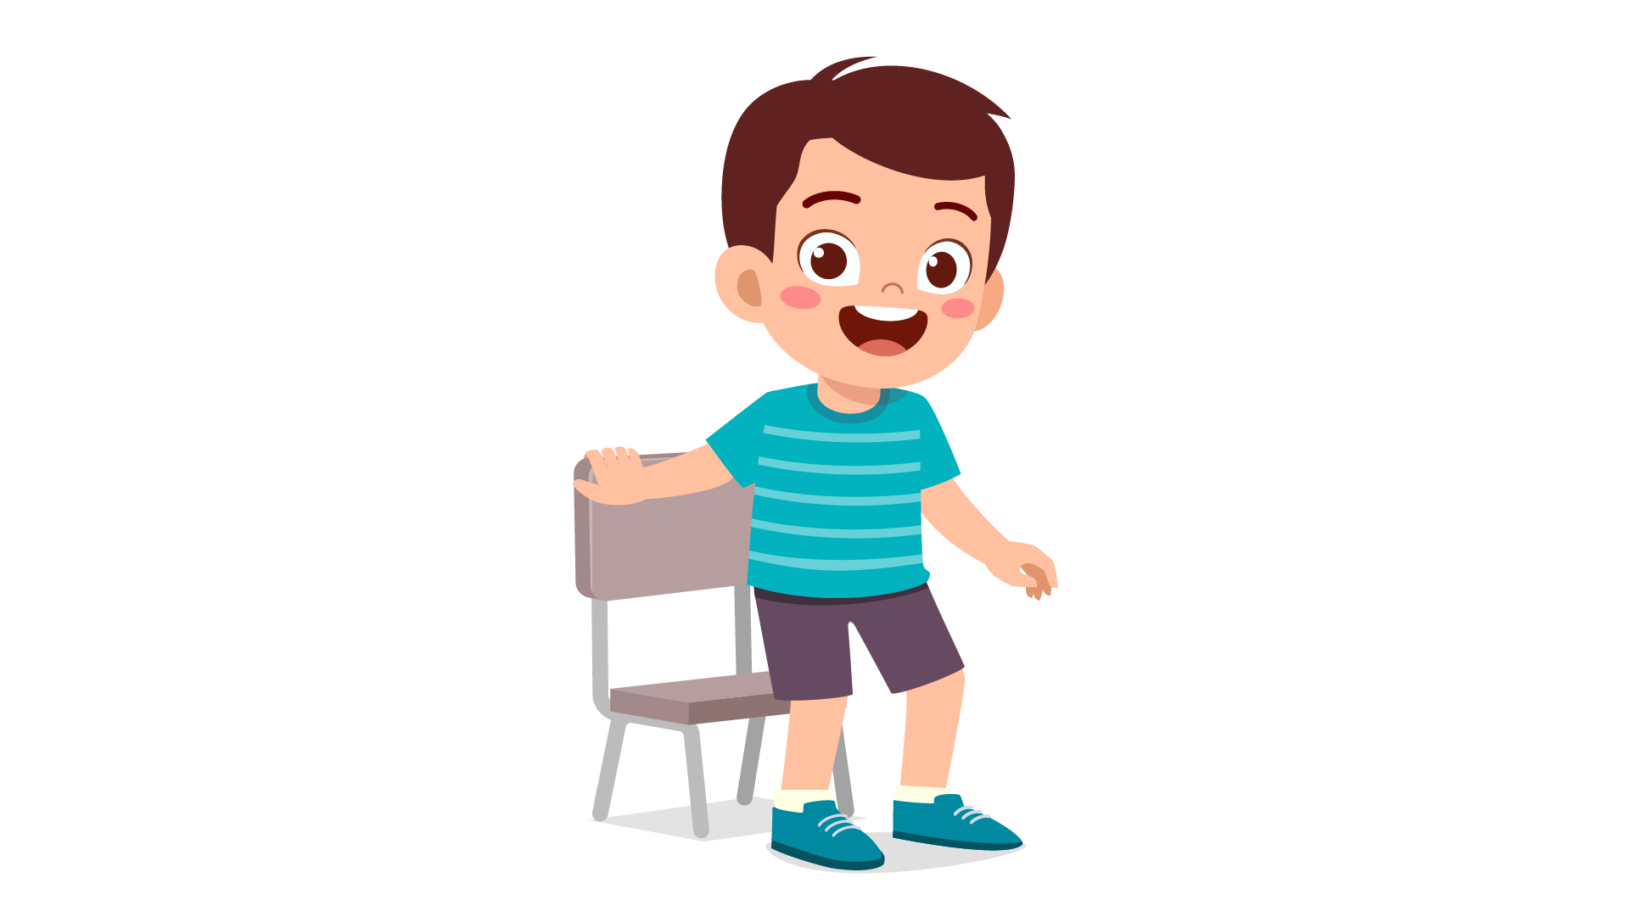 | 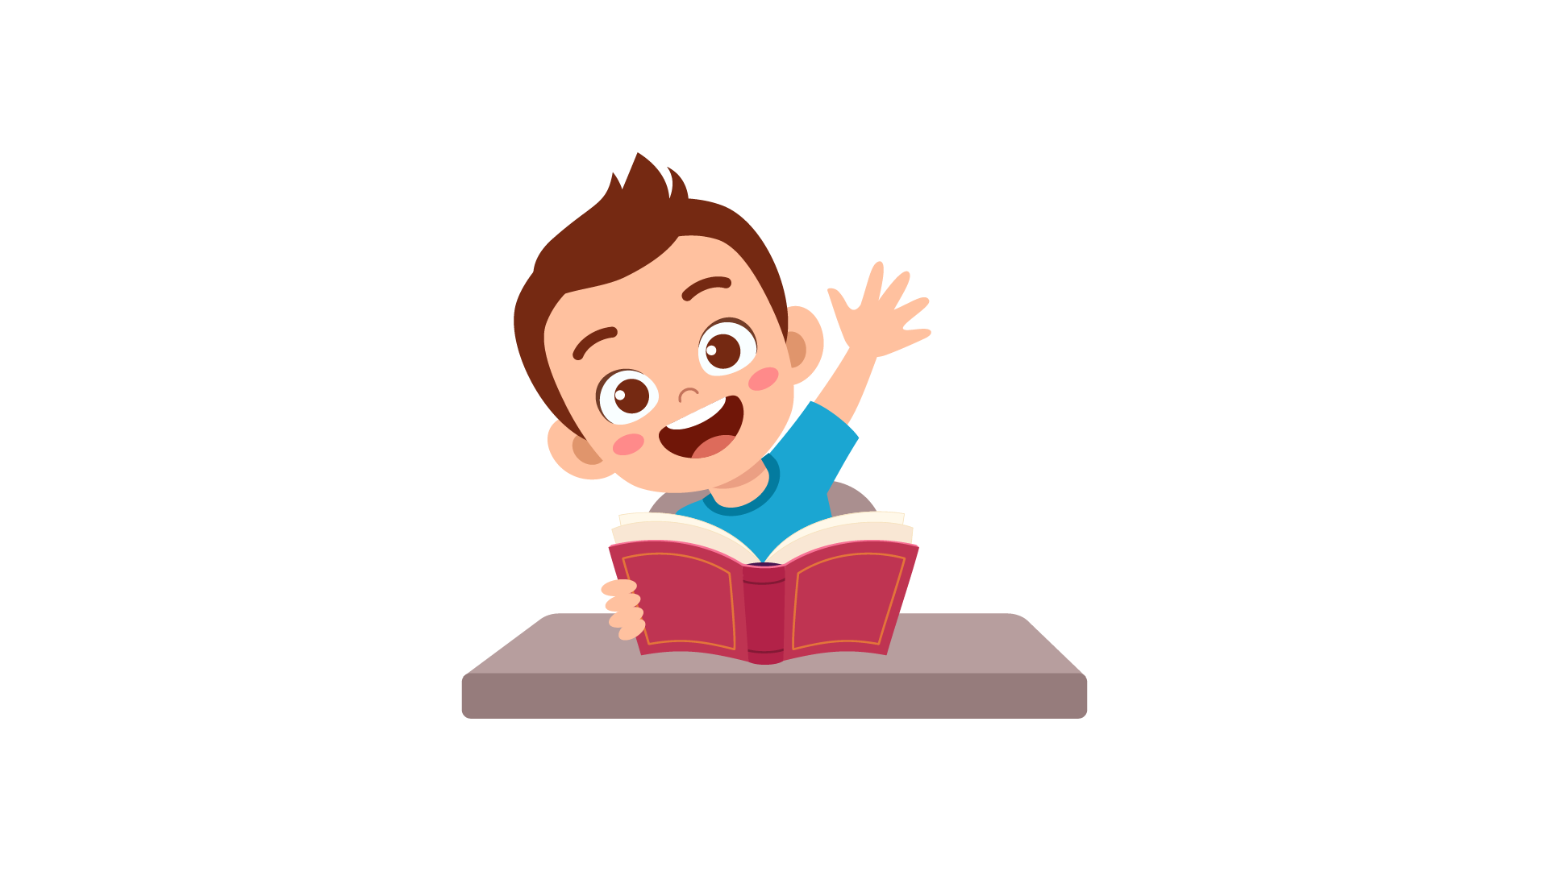
(A) | (B) | (C)
15.
 | 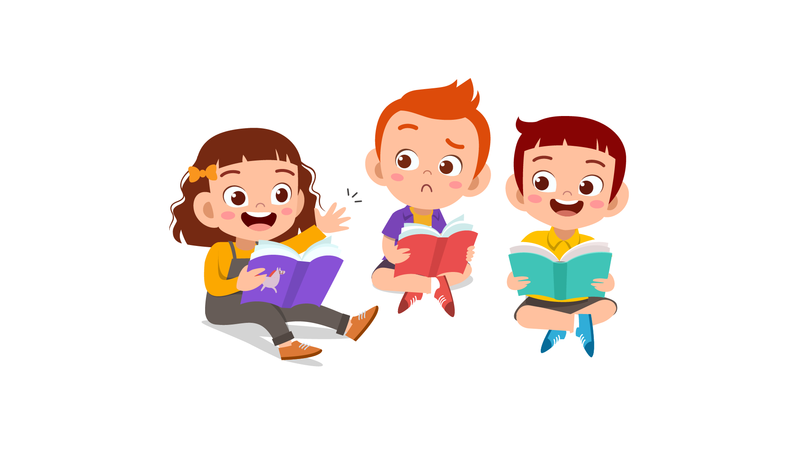 | 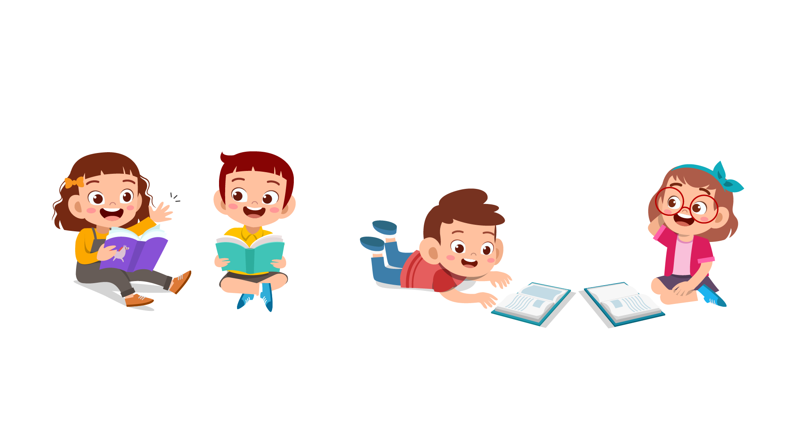
(A) | (B) | (C)
16.
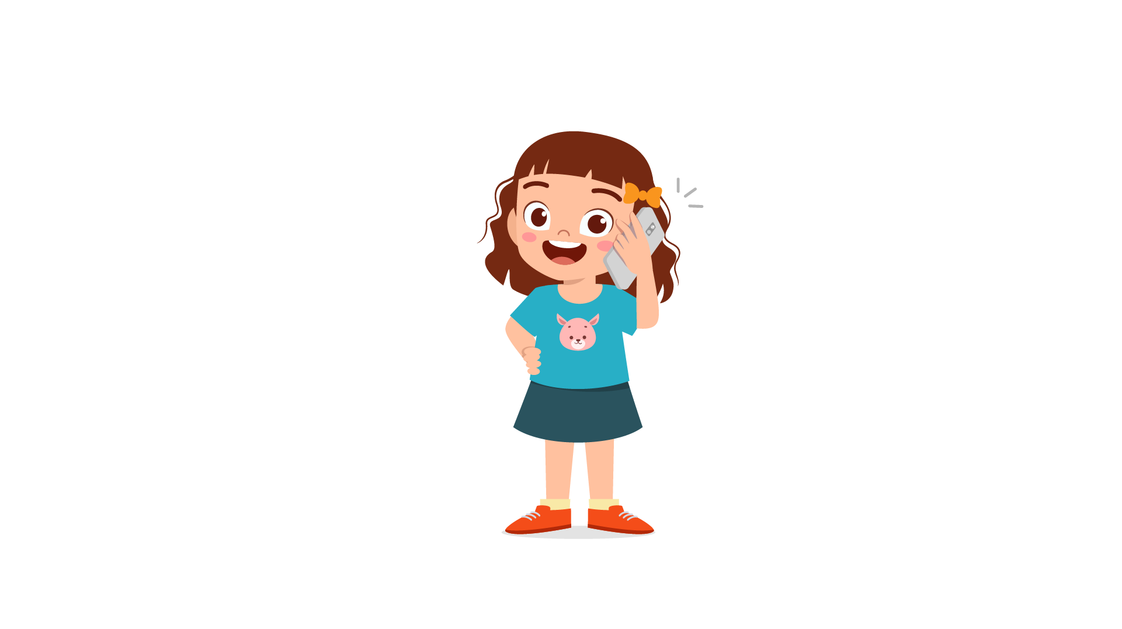 | 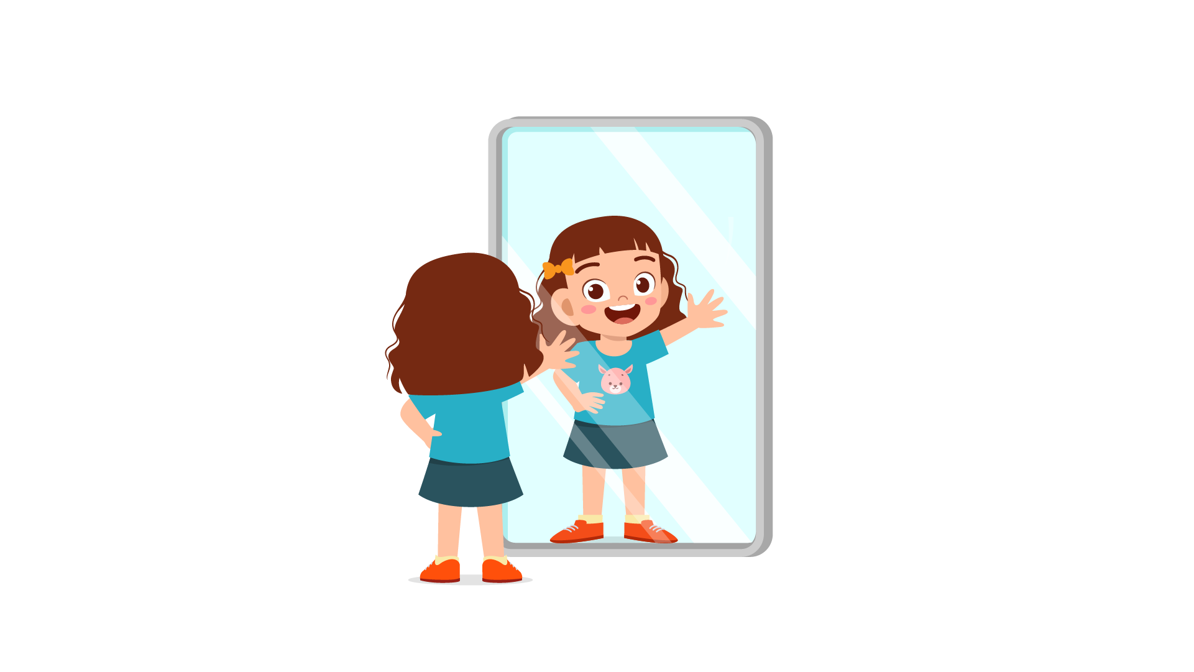 | 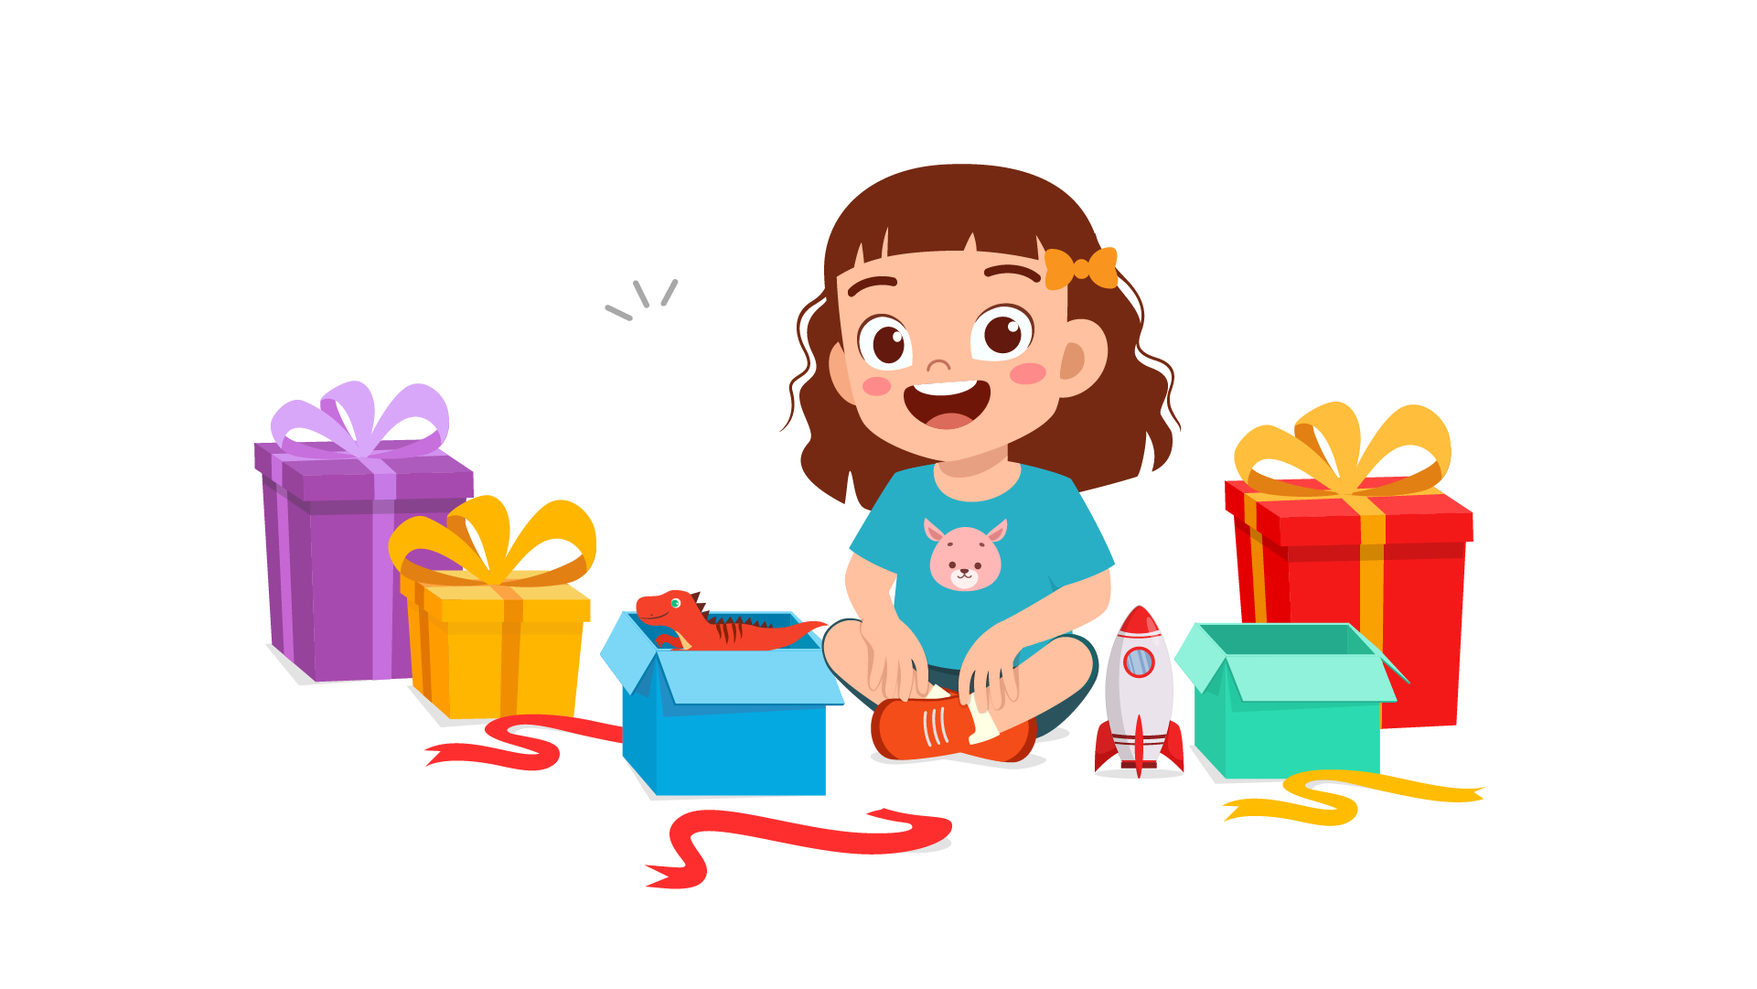
(A) | (B) | (C)
17.
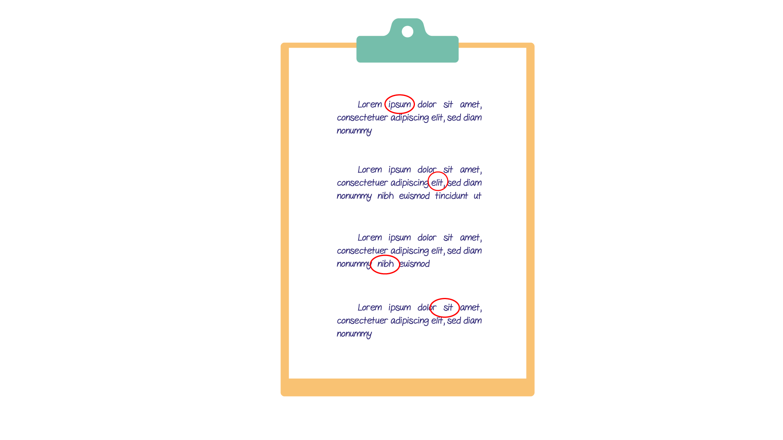 | 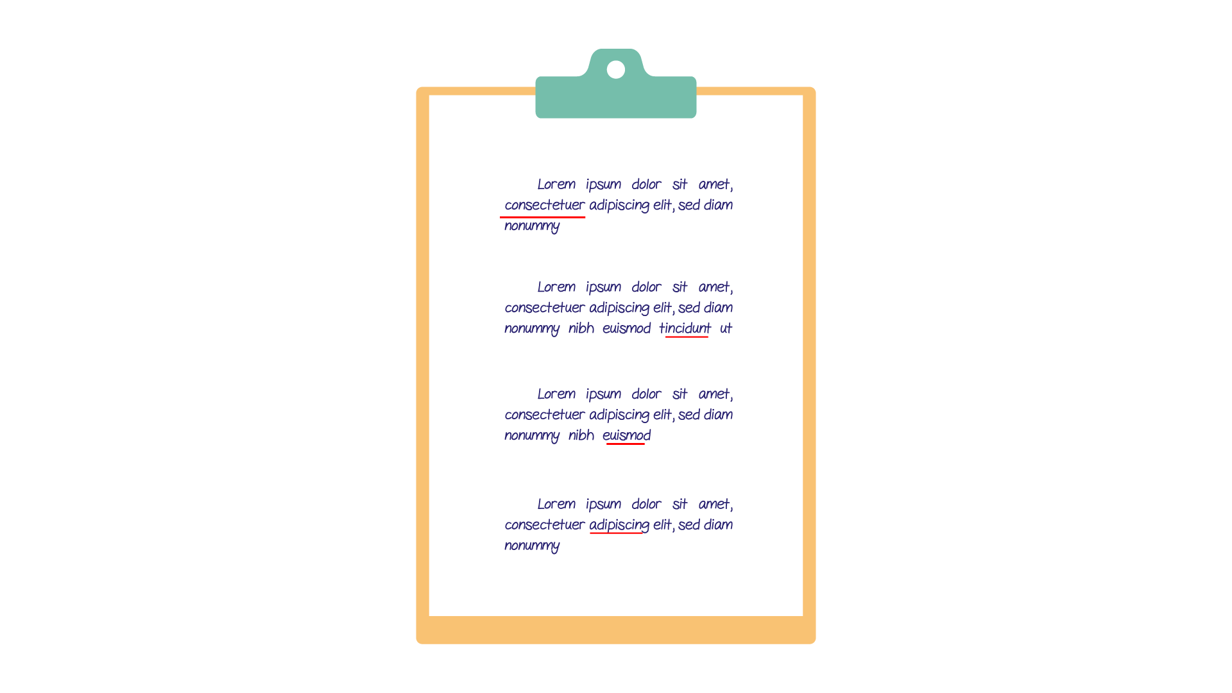 | 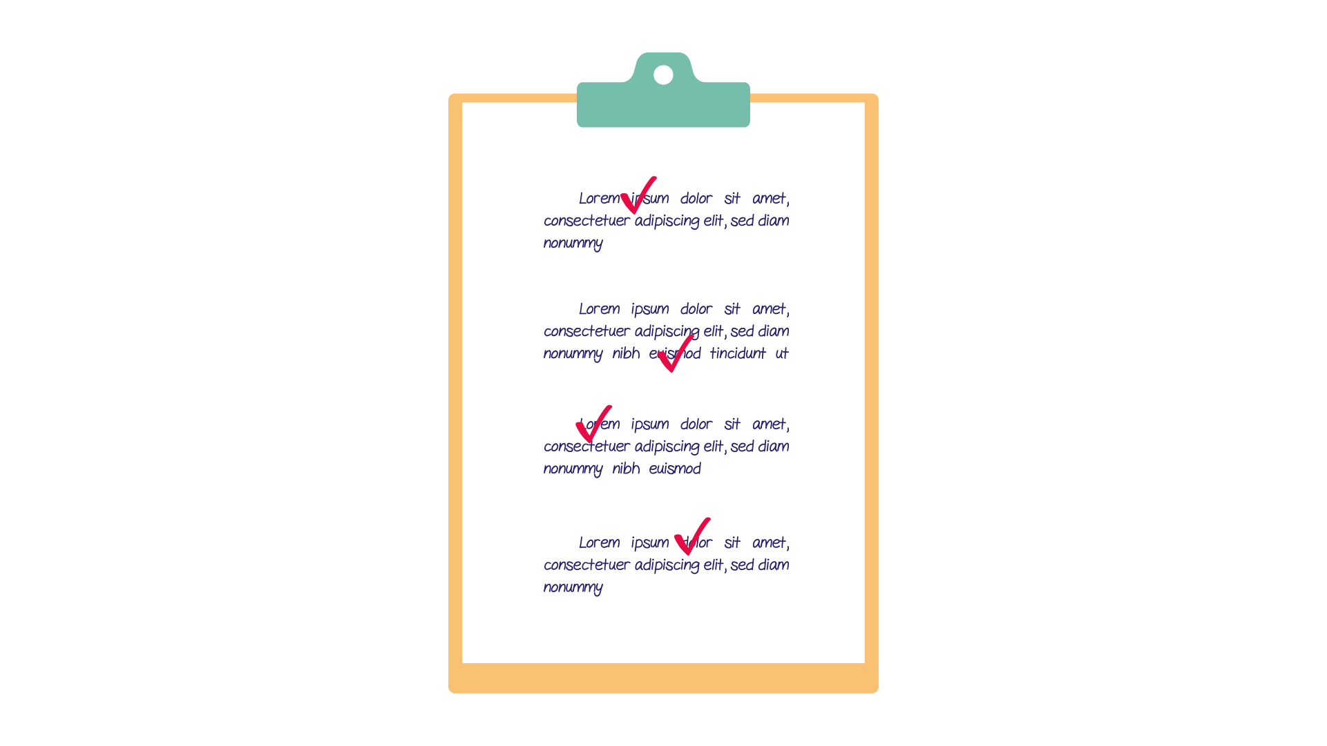
(A) | (B) | (C)

PART 3
Fill in the correct circles on your answer sheet.
Look at your answer sheet. Listen to a conversation. Which conversation sounds correct?
Let’s do an example.
(Narrator): A
(Boy): Hello. What’s your name?
(Girl): I’m fine, thanks.
(Narrator): B
(Boy): How are you today?
(Girl): I’m six years old.
(Narrator): C
(Boy): Nice to meet you!
(Girl): Nice to meet you, too!
The answer is "C." Fill in "C" on your answer sheet. Now, you do it.
18.
(A) | (B) | (C)
19.
(A) | (B) | (C)
20.
(A) | (B) | (C)
21.
(A) | (B) | (C)
22.
(A) | (B) | (C)
23.
(A) | (B) | (C)
24.
(A) | (B) | (C)
25.
(A) | (B) | (C)
26.
(A) | (B) | (C)
27.
(A) | (B) | (C)

PART 4
Listen to a conversation and answer the question. Fill in the correct circle on your answer sheet.
Let’s do an example.
28. When is the girl's party?
(A) Tonight
(B) Next week
(C) This weekend
The answer is "C." Fill in "C" on your answer sheet. Now, you do it.
29. What does the girl do in her free time?
(A) Chat with her friends online
(B) Draw paintings
(C) Play with friends outside
30. What do they want to buy?
(A) Some pens
(B) Some papers
(C) Some color papers
31*. How do they go to school?
(A) By car
(B) By bus
(C) On foot

32*. Who is Jim talking to?
(A) A teacher
(B) A cousin
(C) A classmate
33. What is the girl trying to do?
(A) ask for a pair of shoes
(B) stay at home
(C) think of the answers
34*. What are the friends planning to do?
(A) finish homework
(B) play tennis
(C) go to the cinema

PART 5
Listen and answer the question.
Fill in the correct circle on your answer sheet.
Let’s do an example.
- What did Mike call about?
(A) Homework
(B) A movie
(C) A library book
The answer is "B." Fill in "B" on your answer sheet. Now, you do it.

36. Why did Madeline call?
(A) To ask about the English classes
(B) To tell him she can’t join the meeting
(C) To remind him about the club meeting
37. Why did Helena call?
(A) To invite her friend to the music concert
(B) To sing a song for her friend
(C) To buy tickets for the music concert
38. Why did the neighbor call?
(A) To inform about the mail
(B) To ask for the name
(C) To invite their neighbor over
39. Why did the teacher call?
(A) To tell Lan’s father about the new teacher
(B) To speak with Lan’s father
(C) To ask Lan’s father about her grades
40*. Why did the shop assistant call?
(A) To tell the customer about the grand opening
(B) To sell desserts online to the customer
(C) To give information about the baking process
41*. Why did Tim’s father call?
(A) To thank Jim for his kindness
(B) To ask Jim to come to their house
(C) To give Jim an apology

