SỞ GIÁO DỤC VÀ ĐÀO TẠO | KỲ THI TUYỂN SINH LỚP 10 THPT
PHÚ THỌ | NĂM HỌC 2025 - 2026
ĐỀ CHÍNH THỨC | Môn thi: TIẾNG ANH
ĐỀ CHÍNH THỨC | Thời gian làm bài: 60 phút  ( Đề thi này gồm 4 trang)

I. Chọn một phương án A, B, C, hoặc D ứng với từ có phần gạch chân được phát âm khác với các từ còn lại. (1,0 điểm)
1. A. shops B. books C. lifts D. roads
2. A. carried B. enjoyed C. finished D. traveled
3. A. poster B. picture C. autumn D. curtain
4. A. happy B. basic C. native D. crazy
II. Chọn một phương án A, B, C, hoặc D ứng với từ/ cụm từ thích hợp để hoàn thành câu. (3,0 điểm)
5. Teenagers can find a lot of career advice on ______ Internet.
A. a B. an C. the D. ∅
6. Would you like to join our party ______ Saturday night?
A. on B. about C. in D. to
7. Sa Pa is famous for its ______ landmarks such as Fansipan Mountain, Tả Phìn Village and Mường Hoa Valley.
A. attract B. attractive C. attraction D. attractively
8. Although plastic bags are convenient, they are ______ to the environment.
A. polite B. modern C. friendly D. harmful
9. When riding a bike, you should wear ______ equipment such as helmets and knee pads.
A. fashion B. art C. safety D. gym
10. She tried hard so that she ______ win a scholarship to study abroad.
A. ought to B. could C. had to D. may
11. We love the song “Viết tiếp câu chuyện hòa bình” ______ its meaningful lyrics.
A. because of B. despite C. because D. although
12. The test was ______ that many students could finish it in only a few minutes.
A. too easy B. so easy C. easy enough D. such easy
13. We should plan a menu before shopping and ______ healthy food choices.
A. make B. do C. take D. get
14. Wait a second! I need to ______ my running shoes before we go for a run.
A. get off B. go out C. look up D. put on

15. What does the sign show? Choose the best option.  A. A place to take a rest.  B. A place to book rooms.  C. A place to wash your hands.  D. A place to buy food and drinks. | 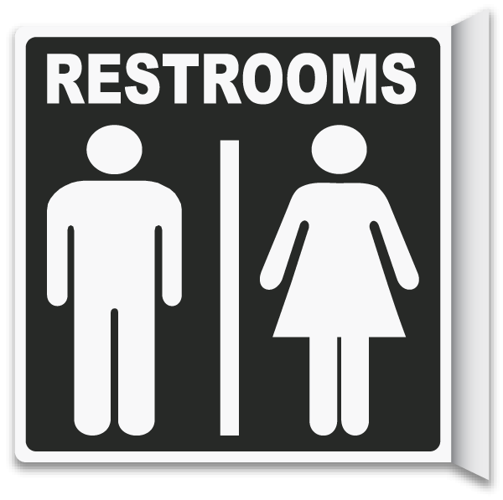
16. What does the notice say? Choose the best option.  A. Security cameras are only in use in special cases.  B. Security cameras are watching and recording in this area.  C. Security cameras are only active during the night.  D. There are no security cameras around this building now. | 

III. Viết dạng đúng của động từ trong ngoặc để hoàn thành câu. (1,0 điểm)
17. Sarah (wait) ______ for me when I arrived at the airport yesterday.
18. Linda (go) ______ to the cooking class every Thursday evening.
19. Children should avoid (spend) ______ too much screen time.
20. Don’t forget (buy) ______ some sugar. We haven’t got any now.
IV. Chọn một phương án A, B, C, hoặc D để điền vào chỗ trống trong đoạn văn sau. (1,0 điểm)
Our school library is a wonderful resource for all students. It’s usually a very quiet place (21) _______ people can focus on studying or reading without too many distractions. The librarian, Mrs. Evans, is incredibly helpful and always ready to assist students in finding the materials they need. The library has an impressive (22) ______ of books covering various subjects, from science and history to fiction and poetry. I often go there during my lunch break to finish homework or just relax with a good book. You can borrow most items for two weeks, (23) ______ you need to remember to return them on time. It’s important to (24) ______ attention to the library rules to keep it a pleasant space for everyone.
21. A. which B. who C. when D. where
22. A. collect B. collective C. collection D. collectively
23. A. or B. but C. although D. because
24. A. get B. make C. pay D. do
V. Đọc văn bản sau và chọn câu trả lời đúng cho các câu hỏi. (1,0 điểm)
MUSIC IN OUR LIVES
Music plays an important role in many people’s lives, often forming the soundtrack to our daily activities and special moments. It has the power to change our mood, help us relax after a long day, or give us a needed burst of energy. People listen to music in different ways — perhaps hearing their favorite tune on the radio, choosing songs through streaming services, or experiencing the excitement of live concerts.
There are many genres of music, such as pop, rock, classical, jazz, and country, offering something for nearly every taste. Everyone has their own preferences, of course. Some people enjoy listening to upbeat music with a strong beat when they exercise, finding it motivating, while others prefer calming melodies without lyrics when they study or work to help them focus. Beyond individual enjoyment, music can also bring people together, strengthening bonds when people share experiences like singing songs around a campfire or dancing together at a party. It’s often called a universal language precisely because it can evoke emotions and be enjoyed by anyone anywhere.
25. What is the main idea of the passage?
A. Different ways of listening to music B. The history of some genres of music
C. The importance and variety of music D. Favorite places to listen to live music
26. According to the passage, what can music help people do?
A. Change mood, relax, or get energy B. Lose focus on studying or working
C. Bring people together and weaken bonds D. Choose songs through streaming services
27. The word their in paragraph 1 refers to ______.
A. ways B. activities C. moments D. people
28. The word preferences in paragraph 2 is closest in meaning to ______.
A. problems B. likes or choices C. instruments D. skills and abilities
VI. Đọc văn bản sau và trả lời các câu hỏi. (1,0 điểm)
Many of us know it can be difficult to achieve our health goals. Dr. Wombat shares his suggestions for setting the right goals.
Set real-life goals and not wishes
Sometimes we want to do too difficult things. Most people set New Year’s Eve health goals that they never achieve. It’s important to set real goals.
Don’t give up if you make a mistake
If your health improvements aren’t going as quickly as you expected, don’t give up. If you ate something unhealthy or didn’t go for a run, it’s OK. Keep trying to achieve your goals, and you will see a difference.
Find support from friends or family
Find people with similar goals. These could be friends or family. It’s much easier to reach your goals when you have help from others that care.
Focus on one goal at a time
If you try to exercise, lose weight, and stop playing video games at the same time, you will risk failing. Pick one goal that is important to you — something you really want to improve. Set one goal and go after it.
Note down important information in a diary
Write things down to help you check progress. You can write down any information that you think you need to keep checking to help you achieve your goal.
29. What do most people never achieve?
30. Should you set new goals or continue with the same plan if you make a mistake?
31. Who can help you with health goals?
32. Is noting down important information in a diary a good way to achieve your goal?

VII. Chọn một phương án A, B, C, hoặc D ứng với câu viết đúng nhất từ những từ cho sẵn. (0,5 điểm)
33. They/ use/ go/ school/ bike/ when/ they/ young.
A. They used to go to school by bike when they were young.
B. They used to going to school by bike when they were young.
C. They used to go to school by bike when they were young.
D. They used to go to school by a bike when they are young.
34. Doctors/ suggest/ eat/ healthy diet/ help/ organs/ stay/ strong.
A. Doctors suggest to eat healthy diet to help your organs to stay strong.
B. Doctors suggest eating a healthy diet to help your organs stay strong.
C. Doctors suggest eating healthy diet to help your organs to stay strong.
D. Doctors suggest eat a healthy diet to help your organs staying strong.
VIII. Hoàn thành câu thứ hai sao cho nghĩa không thay đổi so với câu đã cho. (1,5 điểm)
35. “Why do you want to participate in this charity event?” Tom said to me.
→ Tom asked _____________________________________________________
36. The new smartwatch is so expensive that he cannot buy it. (too)
→ The new smartwatch ______________________________________________
37. Don’t be lazy, or you will get bad results in the coming exam.
→ If you _________________________________________________________
38. Anna doesn’t often visit her grandparents.
→ Anna wishes she ________________________________________________
40. She doesn’t sing as beautifully as Hoà Minzy.
→ Hoà Minzy _____________________________________________________
41. Because of knowing that smoking is very harmful, he decides to give it up.
→ Because he ____________________________________________________

----HẾT---

