READING
PART 1
Look at the picture. Read the words. Which words go with the picture? Fill in the correct circles on your answer sheet.
1.

- (A) The boy is drawing a picture.
- (B) The boy is taking a photo.
- (C) The boy is talking on the phone.
The answer is "B." Fill in "B" on your answer sheet.
2.
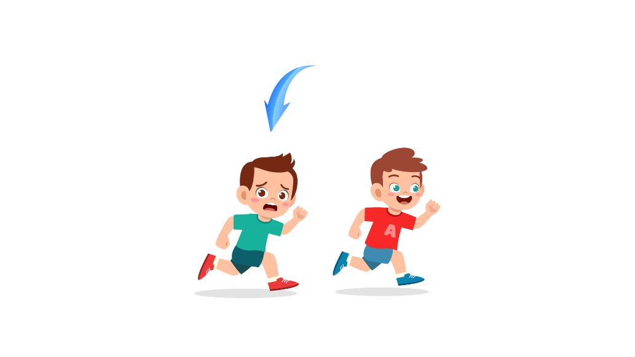
What does the arrow show?
The boy with the arrow is ahead of the other boy.
- (A) Ahead
- (B) Beside
- (C) Under
The answer is "A." Fill in "A" on your answer sheet.

3.
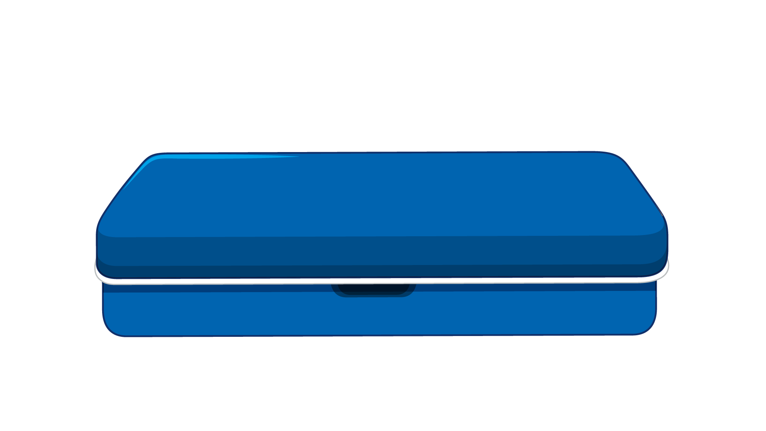
(A) Book | (B) Notebook | (C) Pencil case
4.
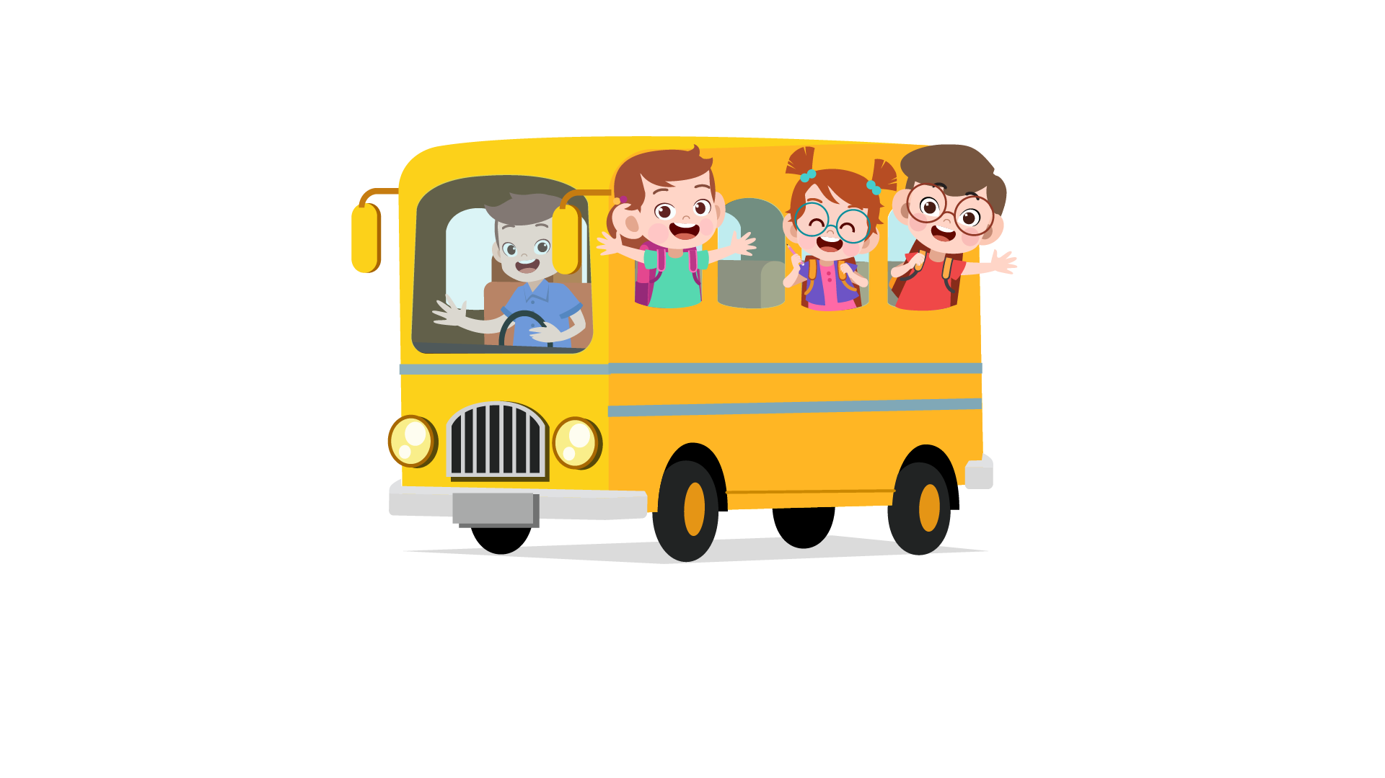
(A) Ferry | (B) Tram | (C) Bus

5.
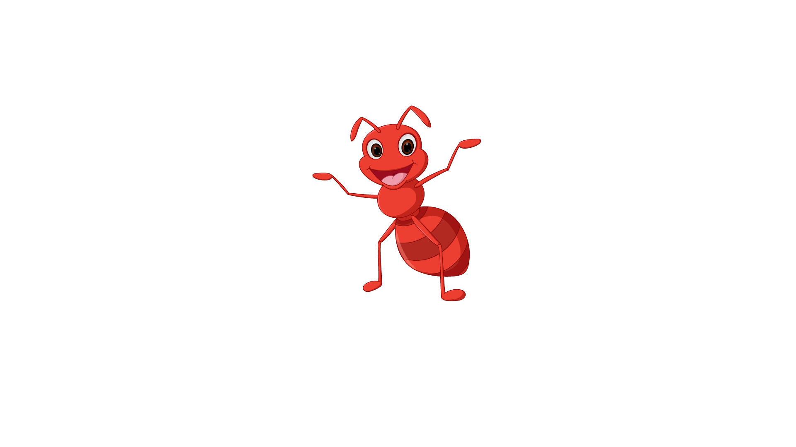
(A) Kangaroo | (B) Ant | (C) Snail

6.

(A) Banana | (B) Papaya | (C) Plum
7.
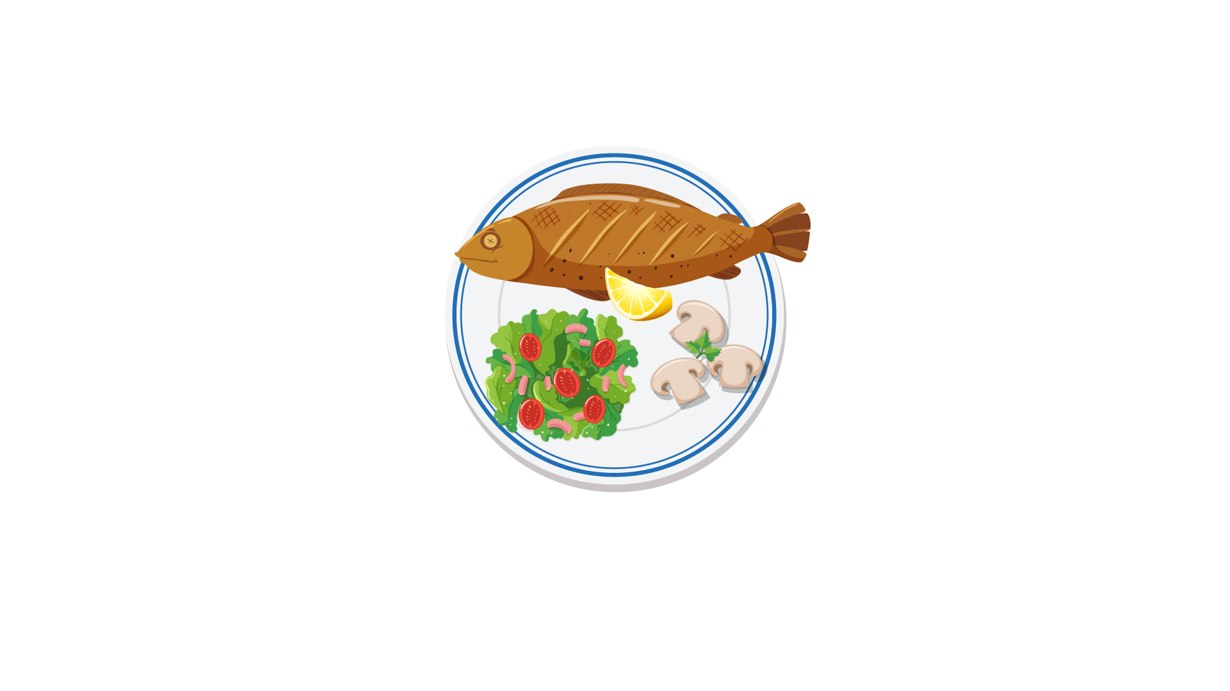

(A) Fish | (B) Chicken | (C) Meat
8.

(A) beard | (B) mustache | (C) hair
9.
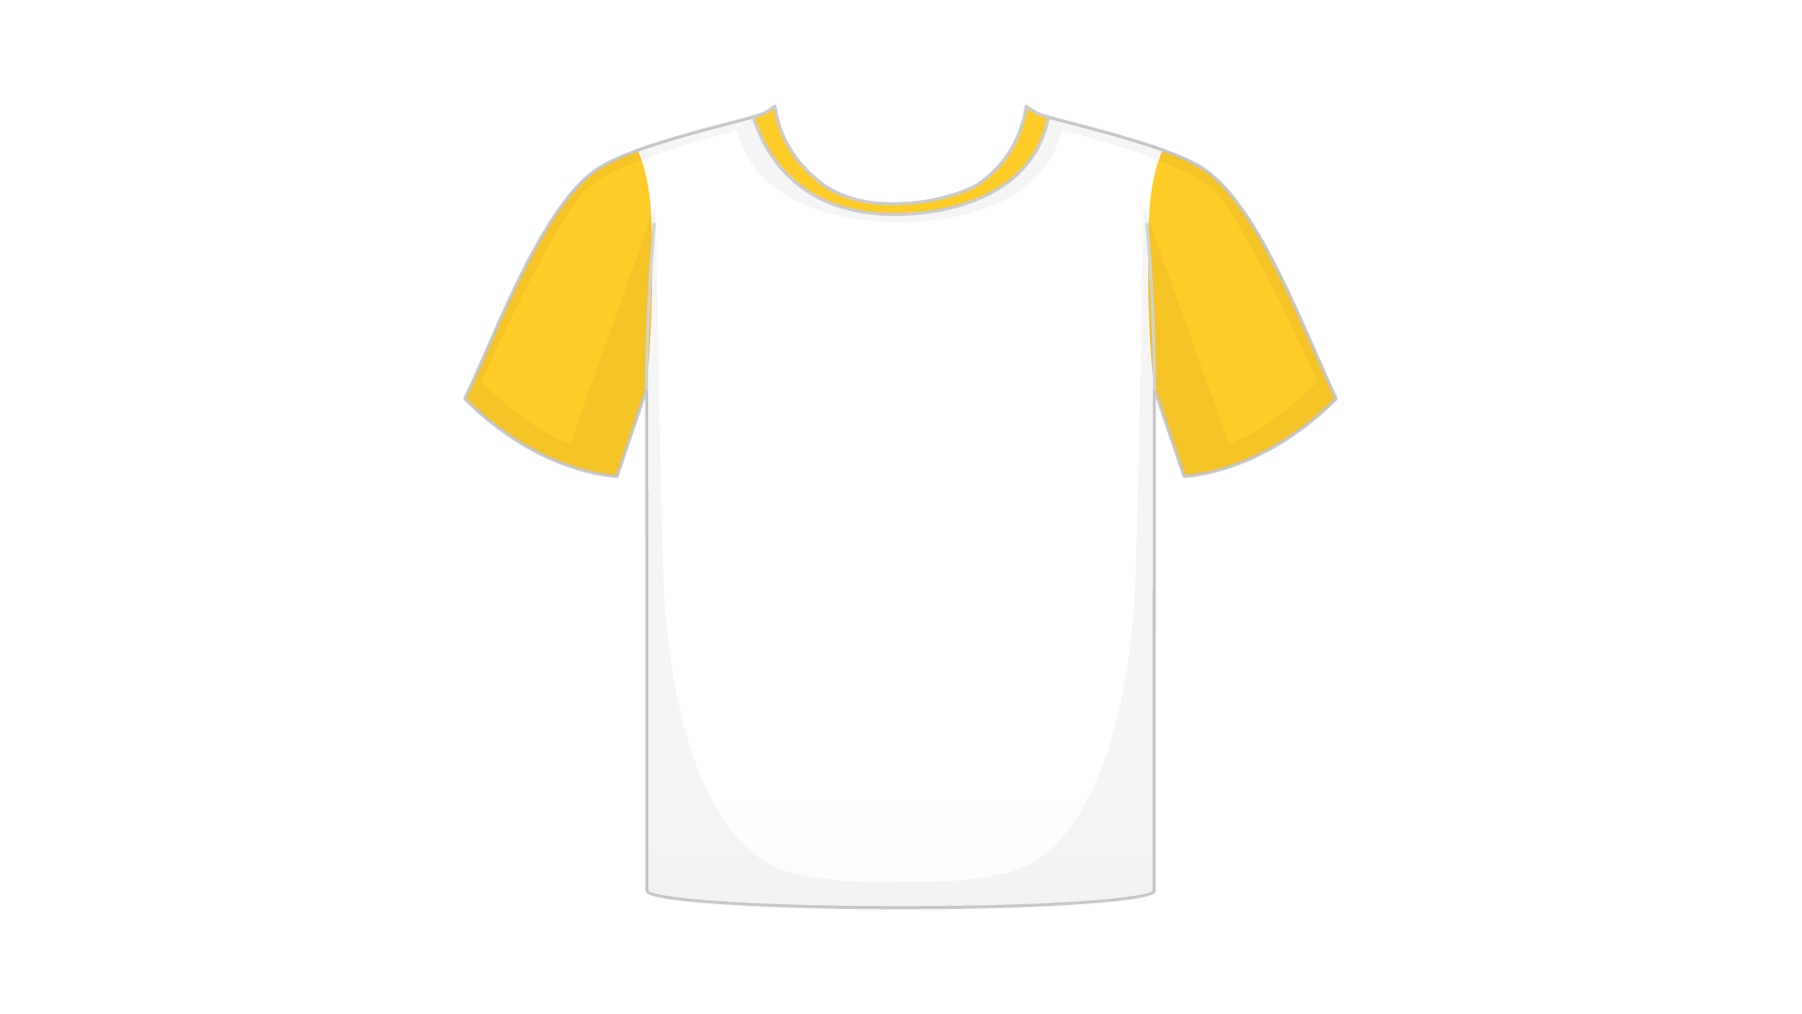
(A) Shirt | (B) Jacket | (C) T-shirt
10.
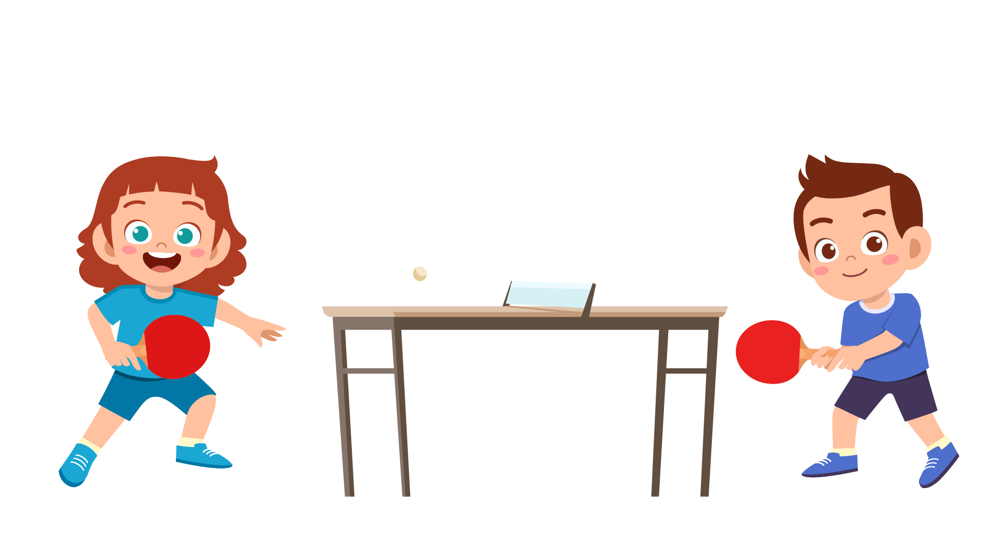
(A) They are playing soccer. | (B) They are playing table tennis. | (C) They are playing basketball.
11.
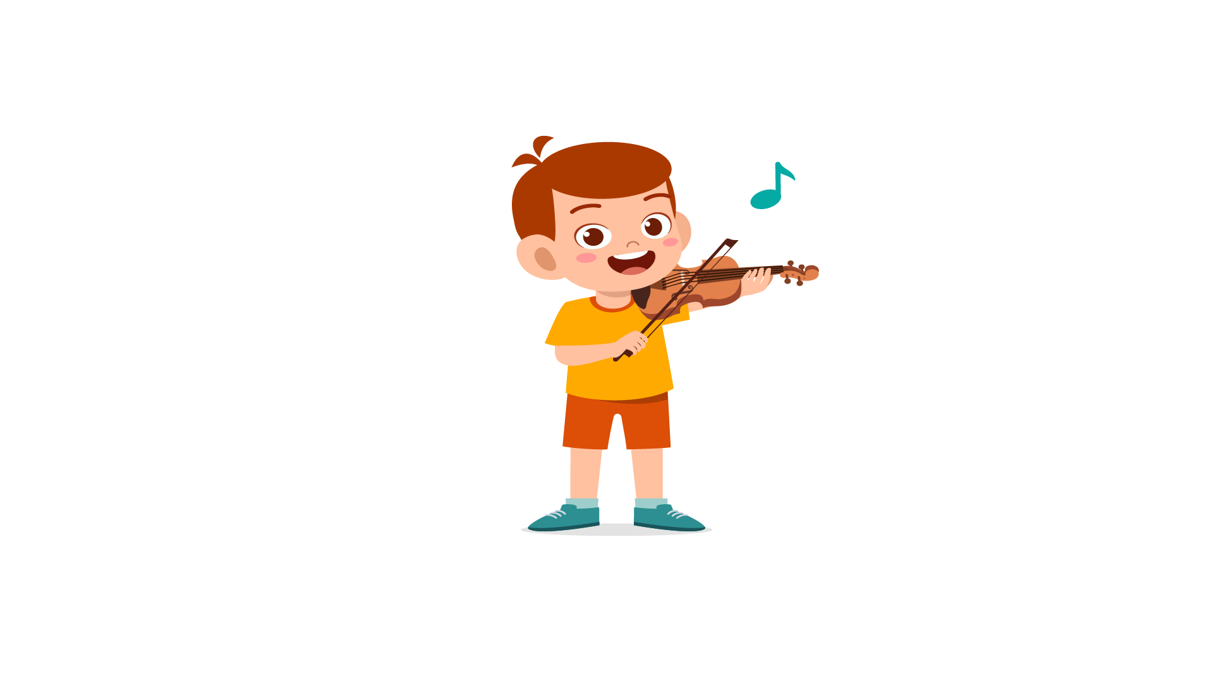
(A) The boy is playing the piano. | (B) The boy is playing the violin. | (C) The boy is playing the guitar.
12.
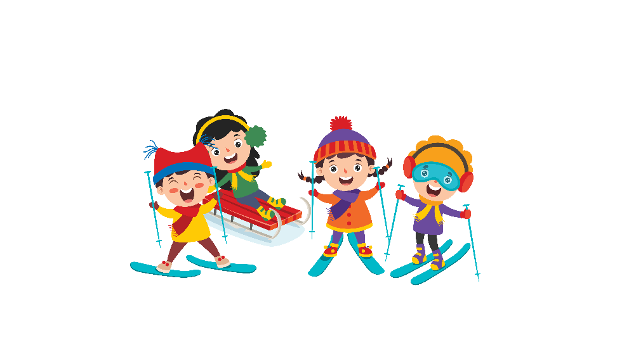
(A) They are going swimming. | (B) They are going skiing. | (C) They are going skateboarding.
13.
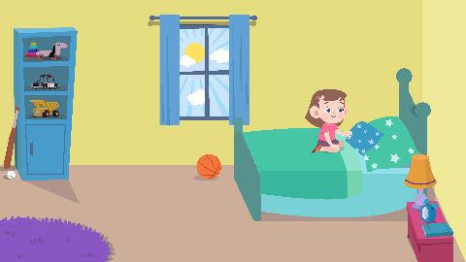

(A) She is sweeping the floor. | (B) She is making the bed. | (C) She is washing dishes.
14.
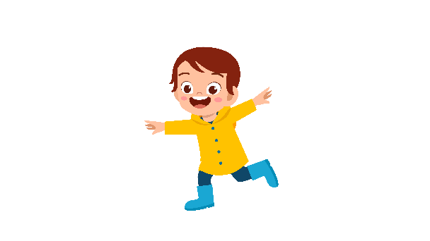
(A) The boy wears a raincoat. | (B) The boy takes a hat. | (C) The boy wears boots.
15.
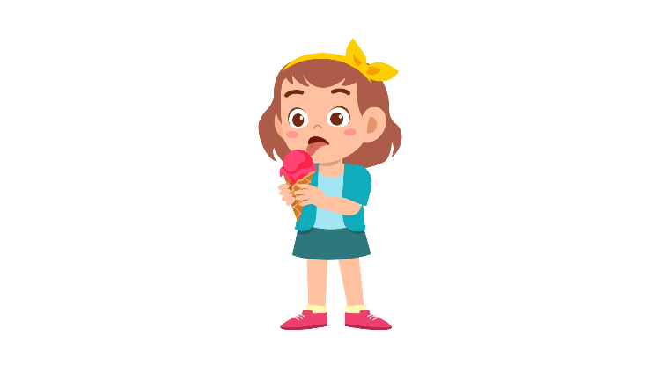
(A) She is eating ice cream. | (B) She is eating bread. | (C) She is eating fries.
16.
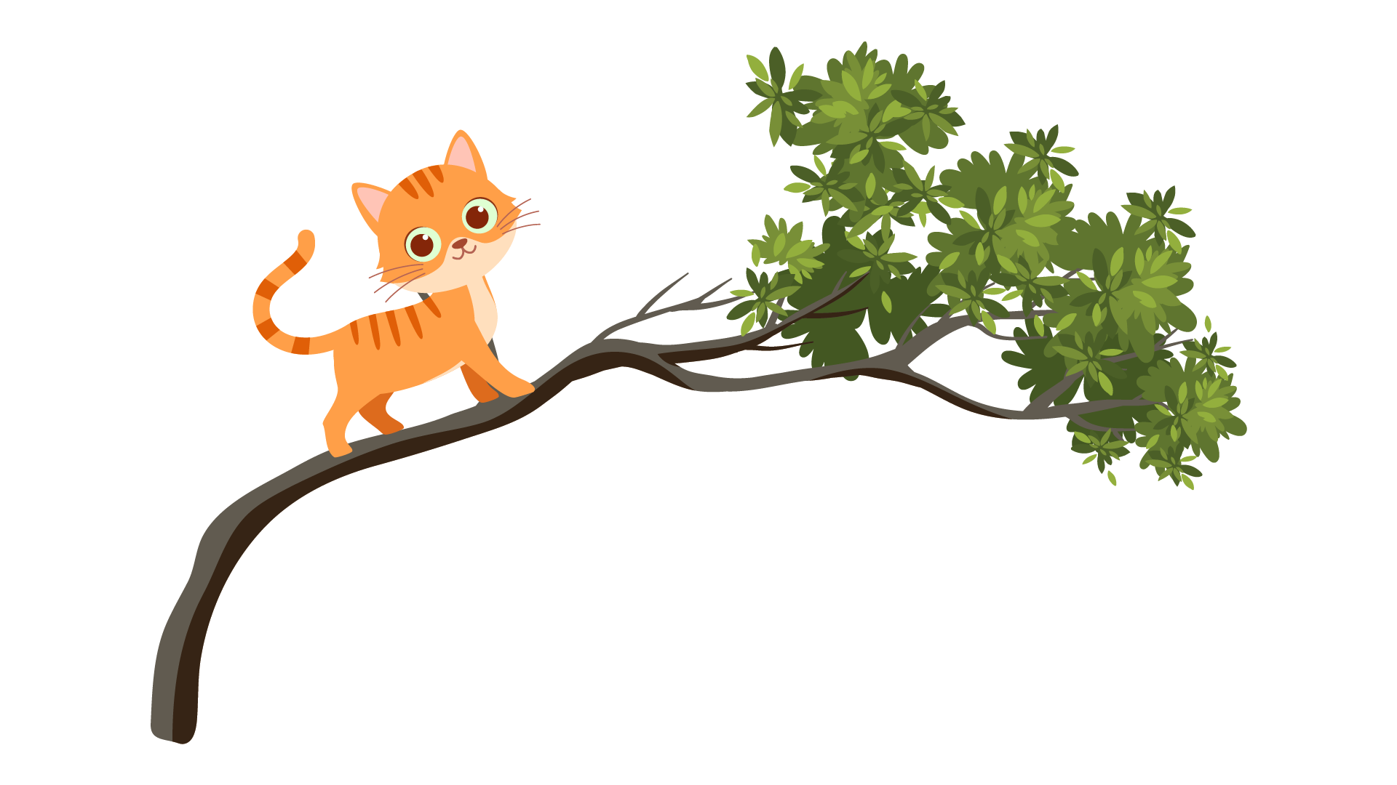
(A) The cat is chasing a mouse. | (B) The cat is climbing tree. | (C) The cat is eating fish.
17.


(A) The supermarket is larger than the post office. | (B) The post office is larger than the super market. | (C) The supermarket is smaller than the post office.

PART 2
Read and find the answer.
Fill in the correct circles on your answer sheet.
Let’s do an example.
- Students go to class here. Teachers work here. It has many desks. What is it?
  - (A) A house
  - (B) A school
  - (C) A bank
The correct answer is a school. Fill in "B" on your answer sheet.

- It is a place. People go there to borrow books. Where is it?
(A) A laboratory
(B) A library
(C) A bookstore

- This is an object. It is a pair of narrow sticks. People use it to eat food. What is it?
(A) A knife
(B) A scissor
(C) A chopstick

- Peter wants to fly a plane. He wants to be ________________ in the future.
(A) a passenger
(B) a pilot
(C) a traveller

- You feel pain as something goes wrong with one of your teeth. You may have a/an _________.
(A) eyesore
(B) toothache
(C) stomachache

- Your watch does not move anymore. It ________.
(A) runs
(B) dies
(C) stops

- Musa is going out. She wears a raincoat. It is ______________ outside.
(A) sunny
(B) rainy
(C) windy

- When going home, Maria just wants to rest or sleep because she is ______________.
(A) excited
(B) tired
(C) hungry

PART 3
Read the sign. Answer questions 26 to 29.
Fill in the correct circles on your answer sheet.
Jay, Alex, Janice, Kelly and Ana go to the animal museum. They read this sign at the museum.

Guide to the animal museum

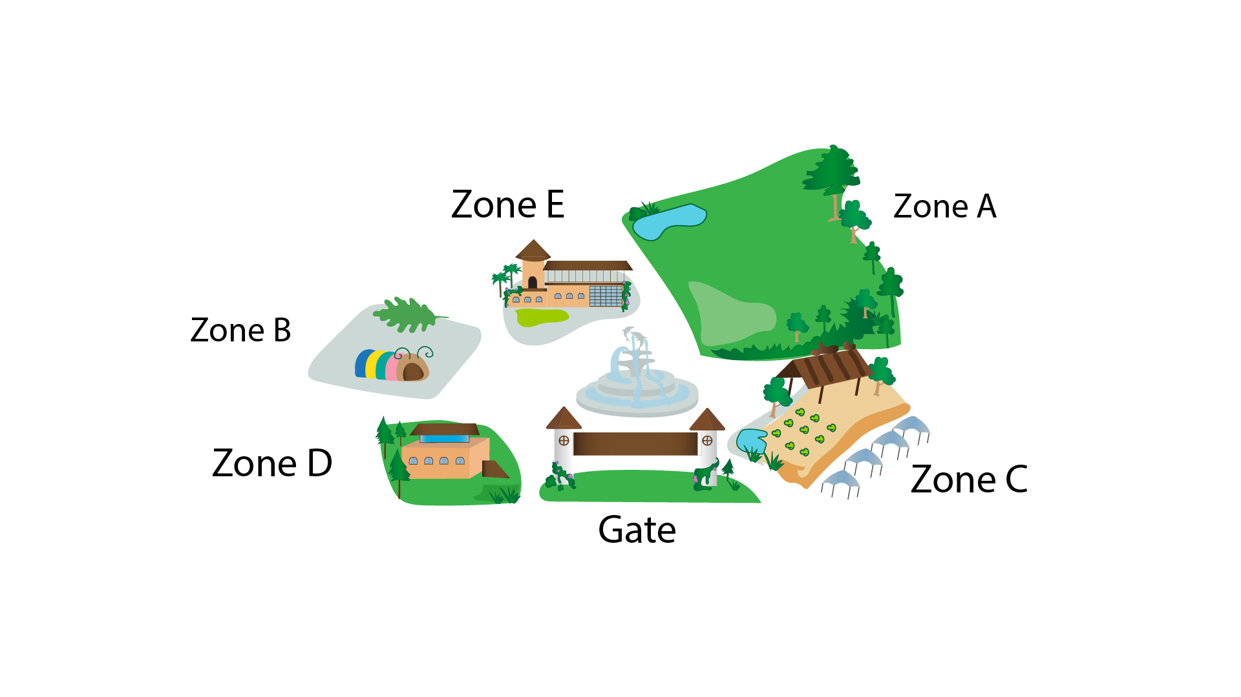

- Janice wants to buy ticket. She goes to ____________.
(A) zone D
(B) zone A
(C) the gate

- Ana needs to see some dinosaurs. She goes to ____________.
(A) zone A
(B) zone C
(C) zone E

- Jay wants to learn about ants. He goes to ____________.
(A) zone B
(B) zone C
(C) zone D

29. Kelly wants to study the cows. She goes to ____________.
(A) the gate
(B) zone B
(C) zone C

Read the timetable of Isabella. Answer questions 30 to 33.

 | Tuesday | Wednesday | Thursday
Science | x | x | v
Music | v | x | x
Art | x | v | x
30. What subject does Isabella have on Tuesday?
(A) Science
(B) Music
(C) Art

31. When does Isabella have Science?
(A) Tuesday
(B) Wednesday
(C) Thursday

32. What subject does Isabella have on Wednesday?
(A) Science
(B) Music
(C) Art

33. When does Isabella have Music ?
(A) Tuesday
(B) Wednesday
(C) Thursday

Read the email. Answer questions 34 to 35.

Hi Sira,
I'm really happy that we'll see each other next weekend! A friend of mine plays in a band and they're going to play a small concert on Friday evening. Would you like to go and see my friend playing with her group?

We need to decide what to do on Saturday. We could either take a trip down the River Clyde in a boat (I'm sure you'd love the beautiful scenery) or we could go and see a football match. Can you tell me which activity you'd rather do?

Just one final thing. You told me in your last message that you have a new skateboard. Could you bring it with you to Scotland? I'd love to have a go on it.

All the best,
Chris

34. Why does Chris write to Sira?
(A) To ask about her hobby
(B) To discuss their weekend activities
(C) To borrow her skateboard

35. What activity is in the plan?
(A) watching a concert
(B) playing football
(C) travelling by a ship

Read the letter. Answer questions 36 to 37.
Dear Jack,

I am writing this letter to thank you for coming to my birthday party last night. Thank you so much for spending your time coming to my party. Also, thanks for the wonderful gift that you brought. It was so pretty.

I hope you liked the food, the music and the activities at the party. I hope that you enjoy all of these. I am sorry if anything was not as good as you want.

Thank you again for coming and making my day more special. Give my love to uncle and aunty.

Yours Lovingly,
Rose

36. Why does Rose write to Jack?
(A) To thank him for joining the party
(B) To talk about childhood memories
(C) To ask whether he liked the party

37. According to the letter, what is true about the birthday party?
(A) Something went wrong.
(B) Rose prepared for the party carefully.
(C) Jack gave Rosie a gift.
Read the email. Answer questions 38 to 39.
To: francois.dupont192@me-mail.com
Subject: Saturday
Dear Jack,
Thanks for your message. I’m looking forward to your visit to Dublin. I’ll come to the airport with my father to collect you on Saturday. What time does your flight arrive?
I think you’ll like Dublin. We live about 5km from the city centre but there are buses that go into the city all the time. When you’re here there are lots of things we can do. We can go to the water park at the city center and we can ride our bikes around Phoenix Park. If you like horror stories, we can visit Dracula’s Castle and we can watch a film there too. And of course, you’ll meet all my friends and we can play football together.
You should bring a coat and a jacket. The weather here is usually cold!
See you on Saturday.
Tim
38. Why does Tim write to Jack?
(A) To introduce his city
(B) To talk about one future plan
(C) To ask about his schedule

39. What does Tim say in the email?
(A) They will play football in the rain.
(B) They will go from the airport to city center by bus.
(C) They can go around Phoenix Park by bike.

You finished the reading test.
LISTENING
PART 1
Listen to the words. Look at the pictures.
Fill in the correct circles on your answer sheet.
1.
 | 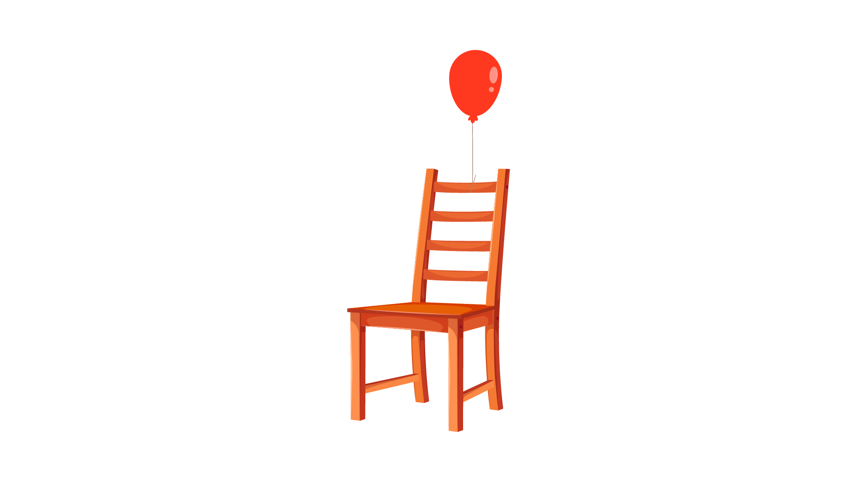 | 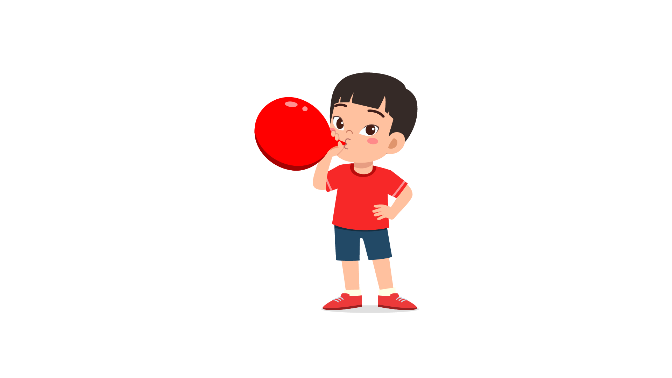
(A) | (B) | (C)
2.
 |  | 
(A) | (B) | (C)
3.
 |  | 
(A) | (B) | (C)
4.
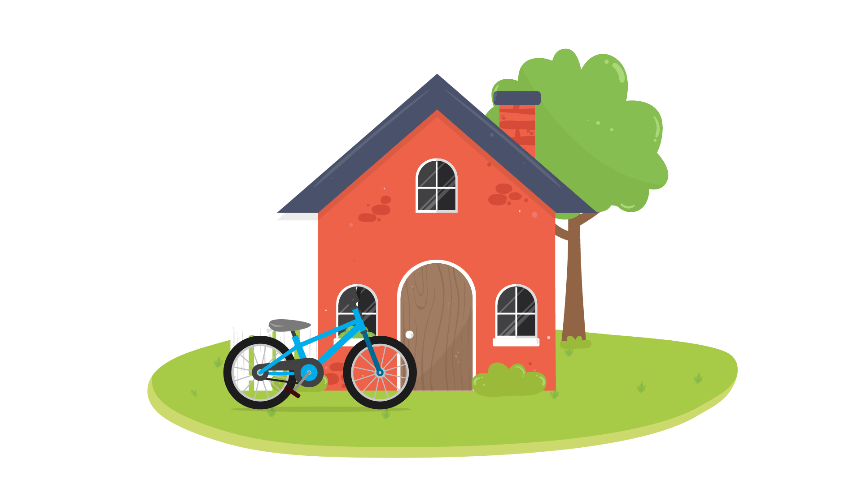 | 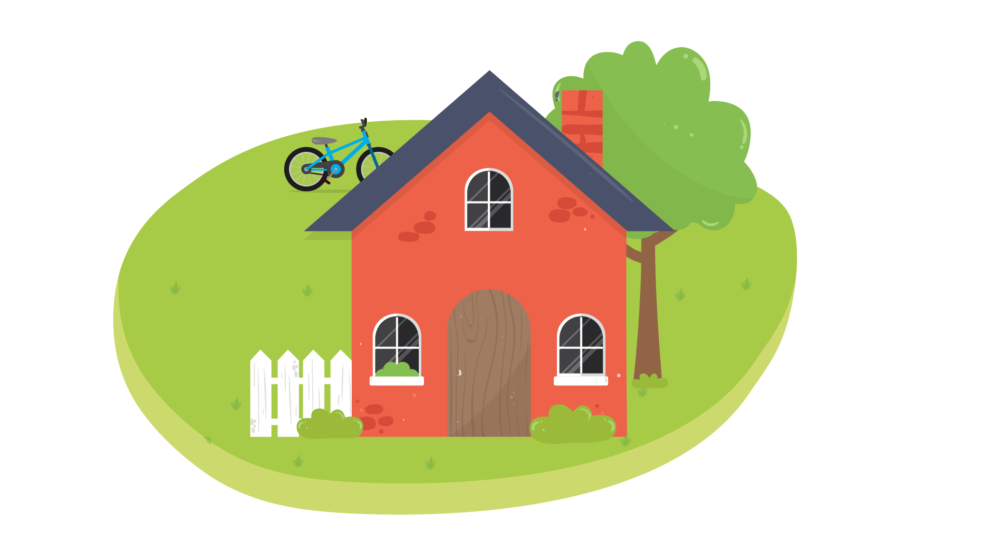 | 
(A) | (B) | (C)
5.
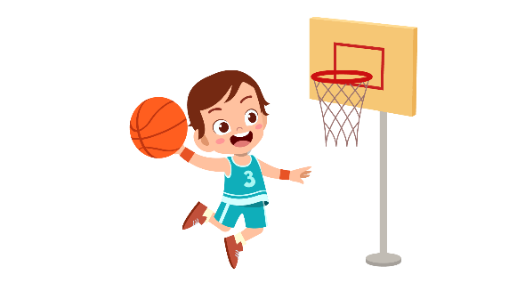 | 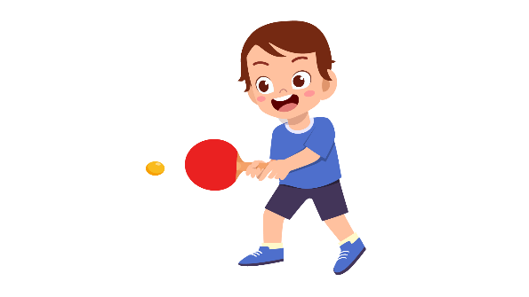 | 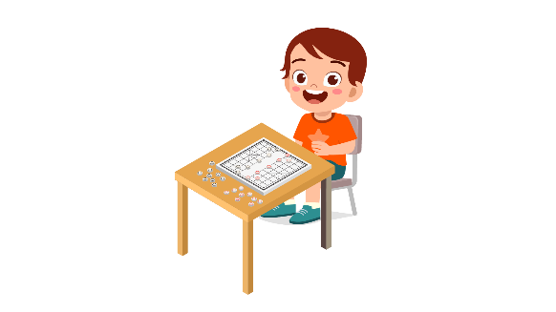
(A) | (B) | (C)
6.
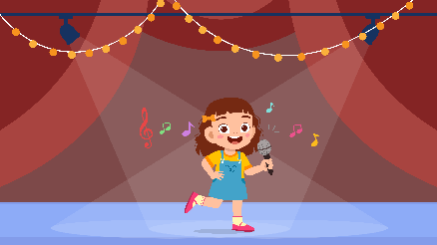 | 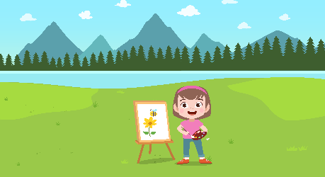 | 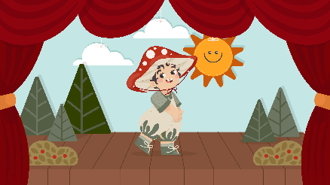
(A) | (B) | (C)
7.
 |  | 
(A) | (B) | (C)
8.
 | 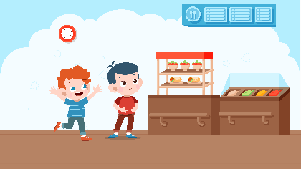 | 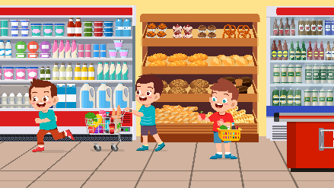
(A) | (B) | (C)

PART 2
Fill in the correct circles on your answer sheet.

9.
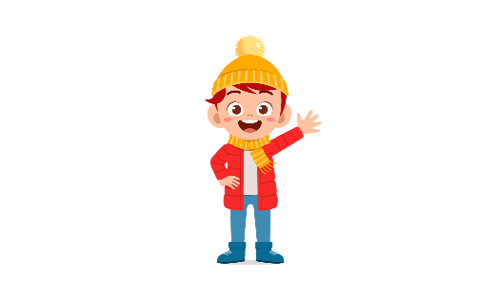 | 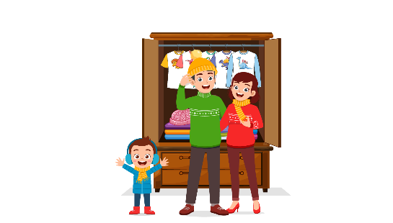 | 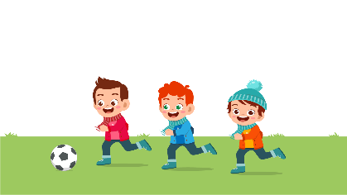
(A) | (B) | (C)
10.
 |  | 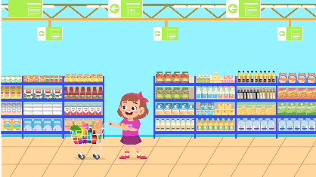
(A) | (B) | (C)
11.
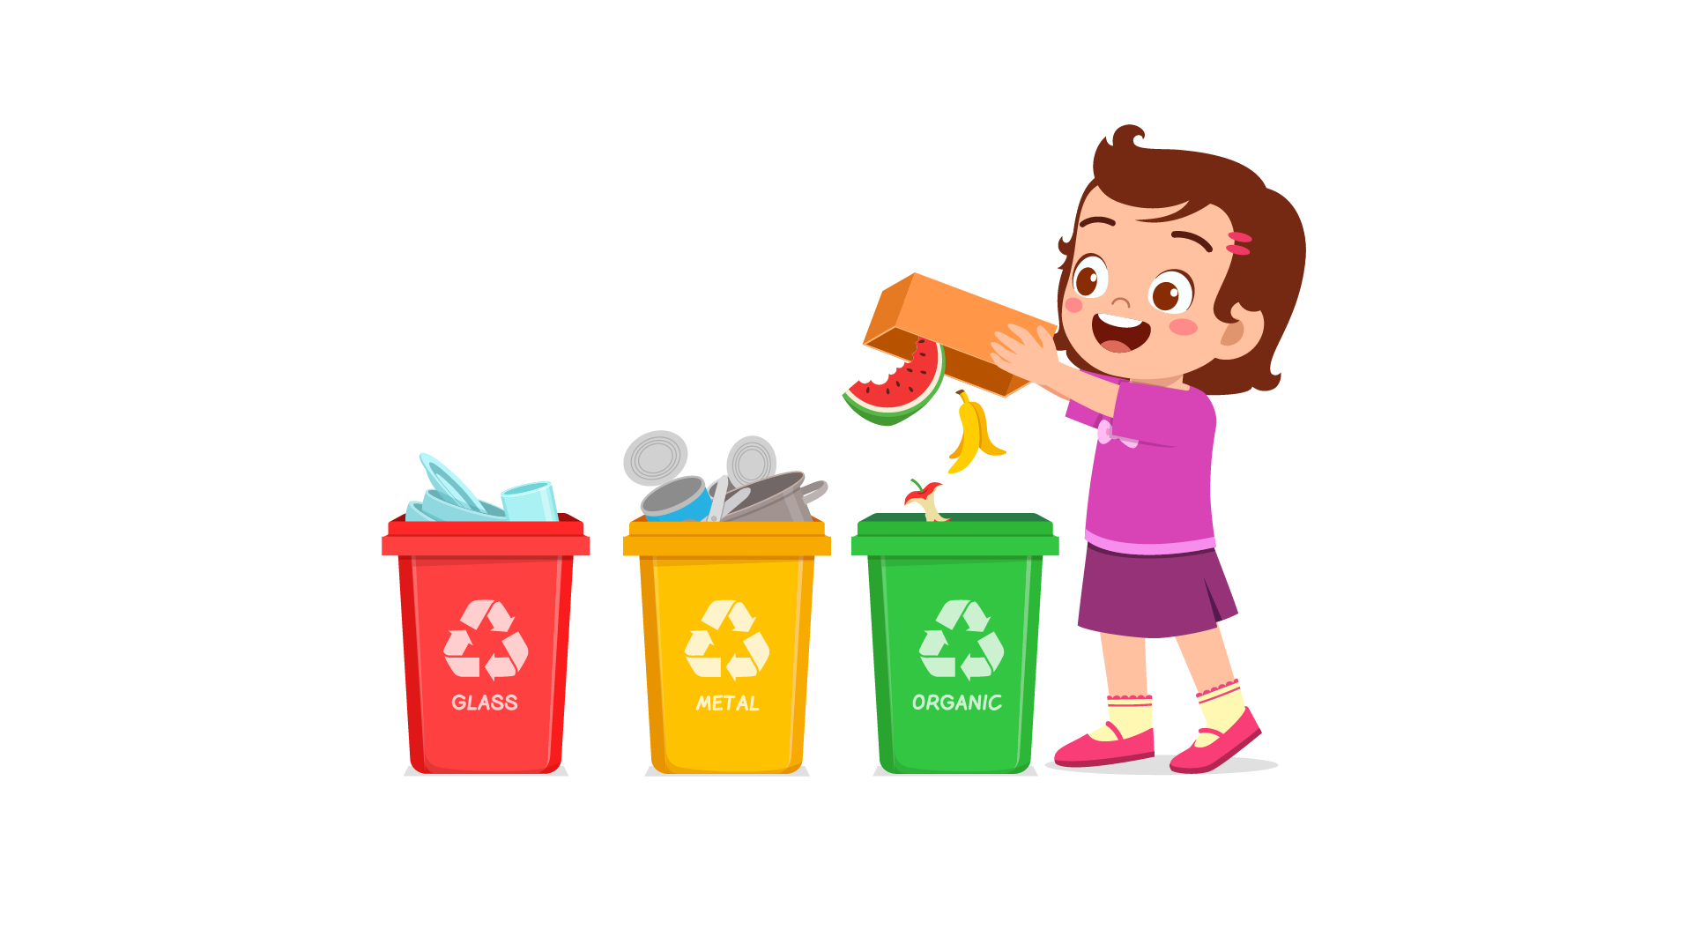 | 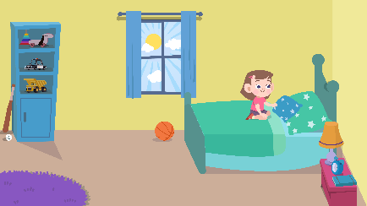 | 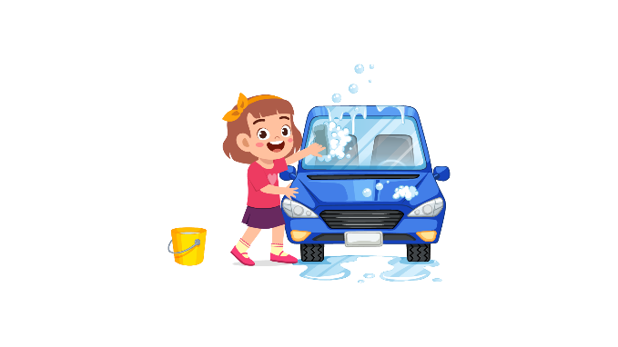
(A) | (B) | (C)
12.
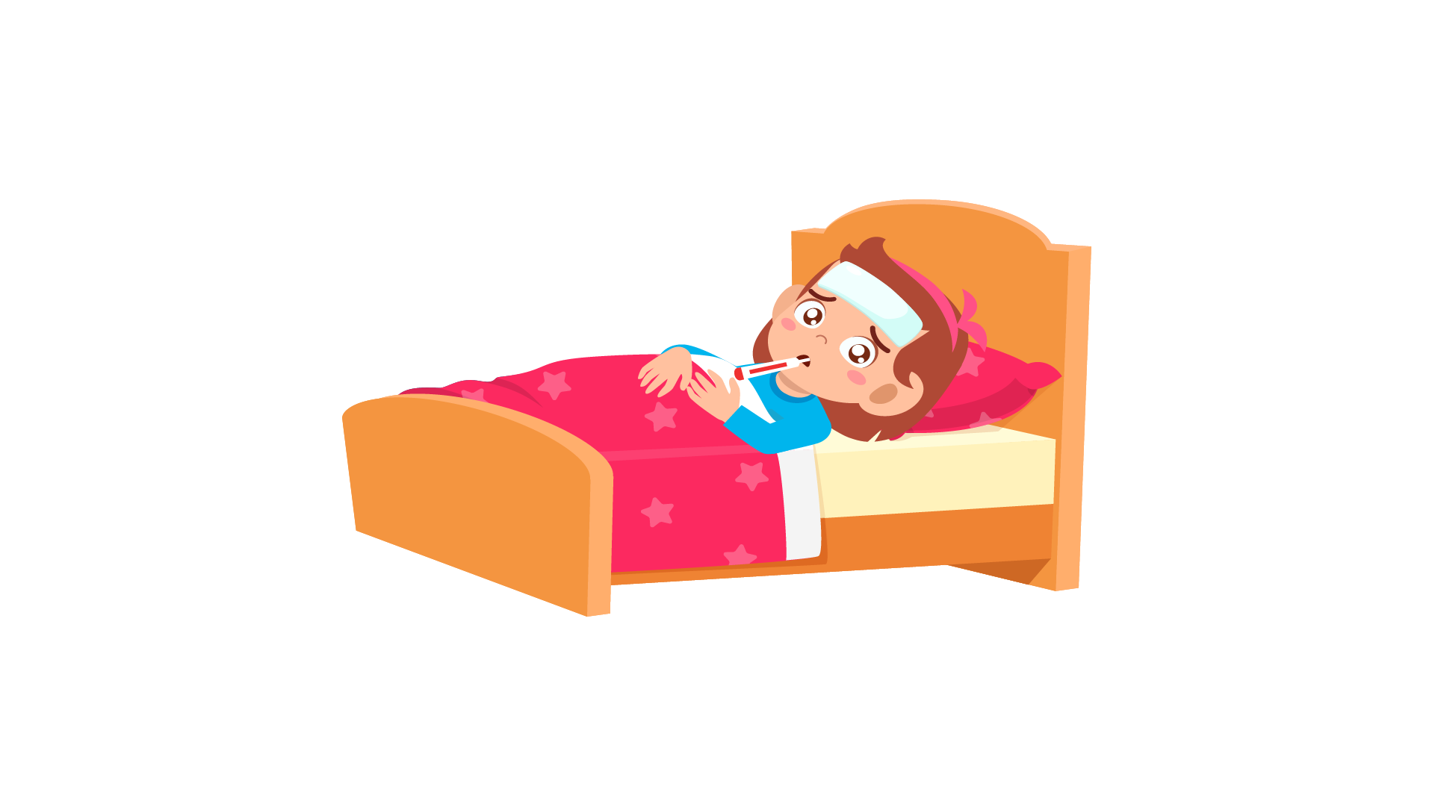 | 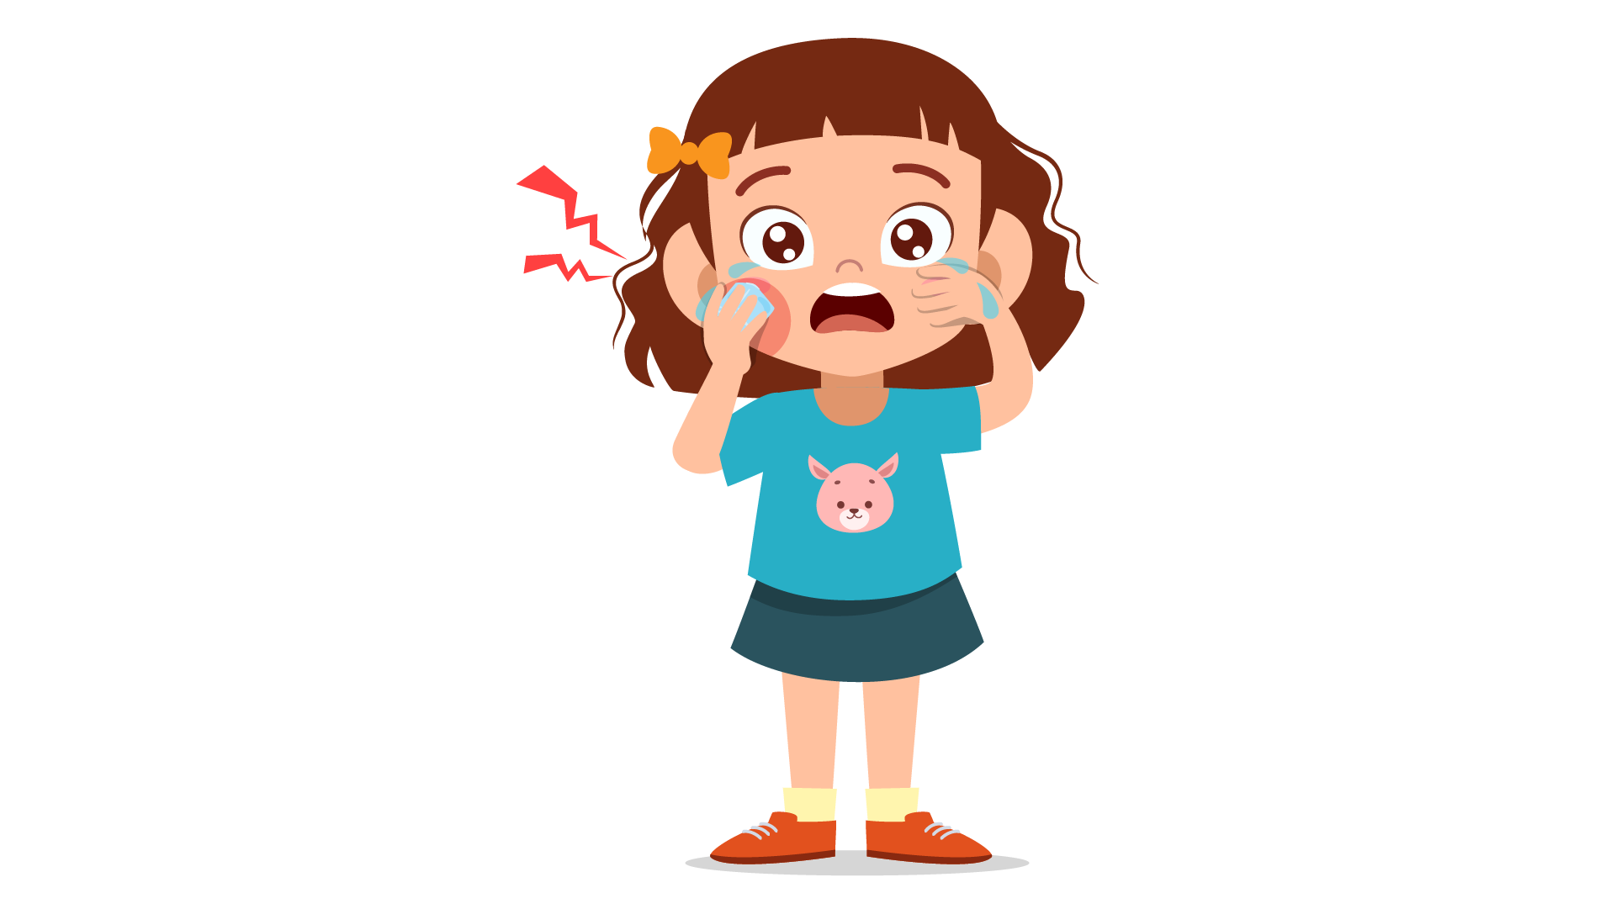 | 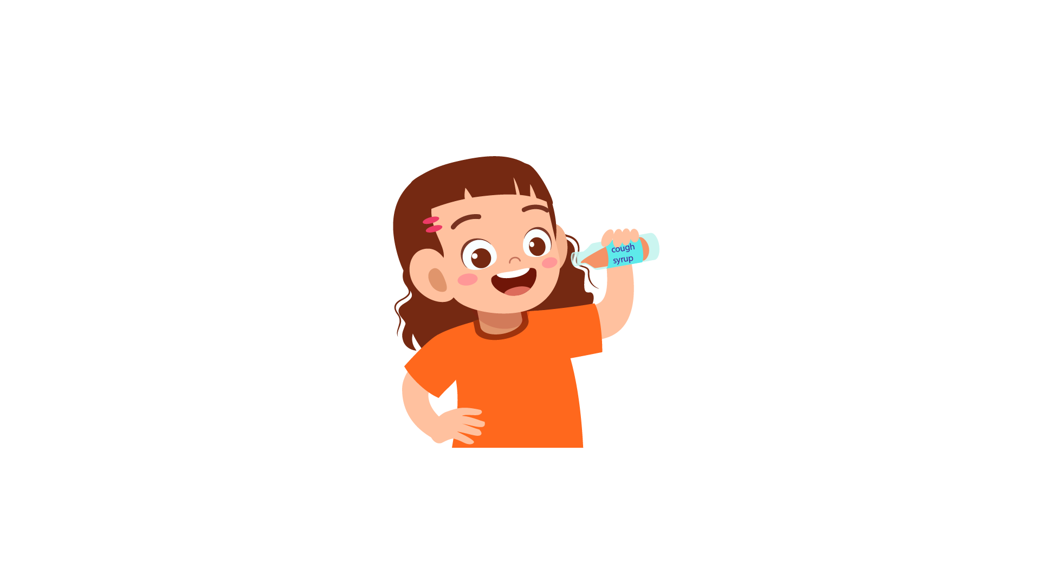
(A) | (B) | (C)
13.
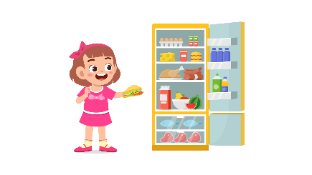 | 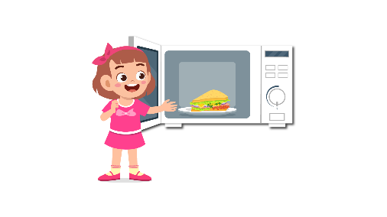 | 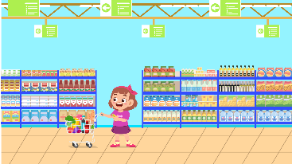
(A) | (B) | (C)
14.
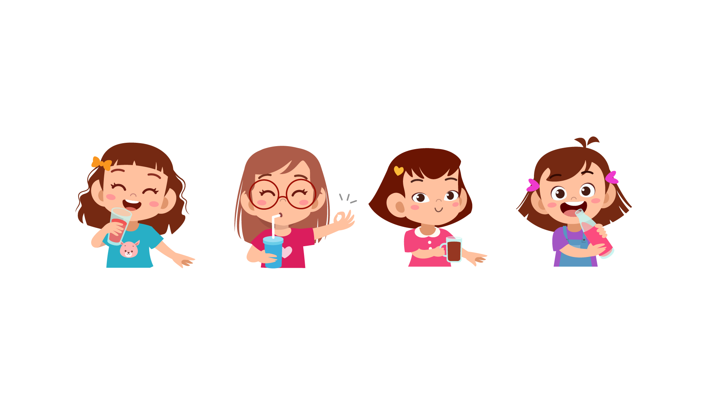 | 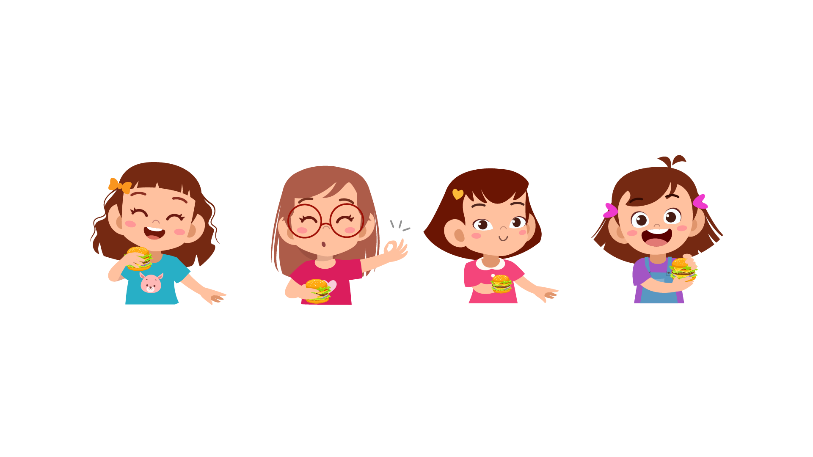 | 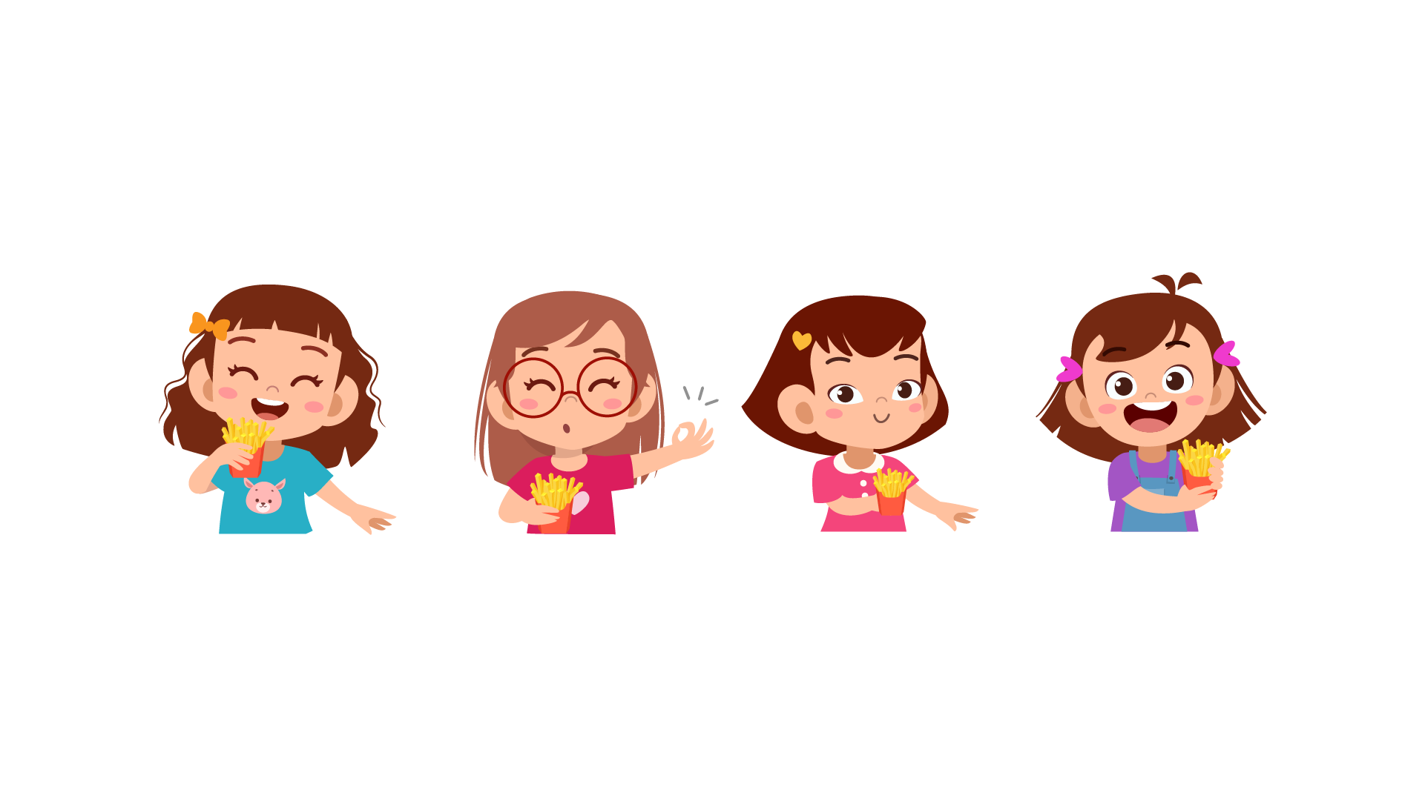
(A) | (B) | (C)
15.
 |  | 
(A) | (B) | (C)
16.
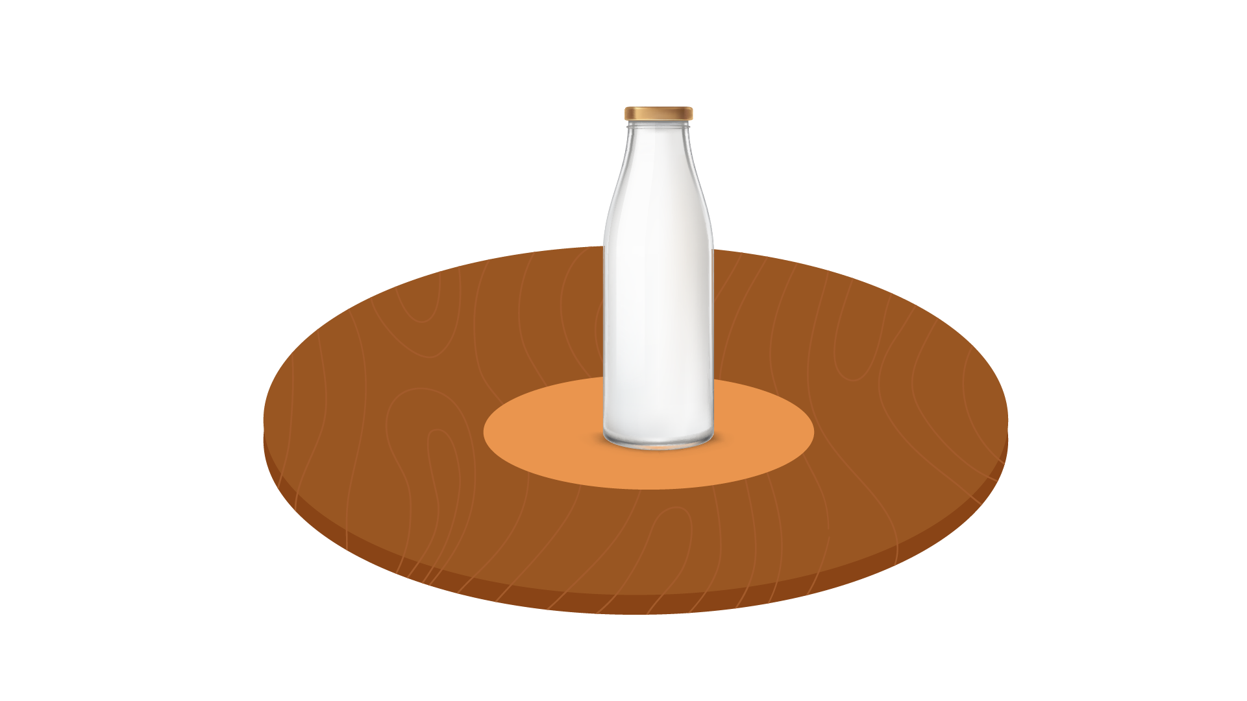 |  | 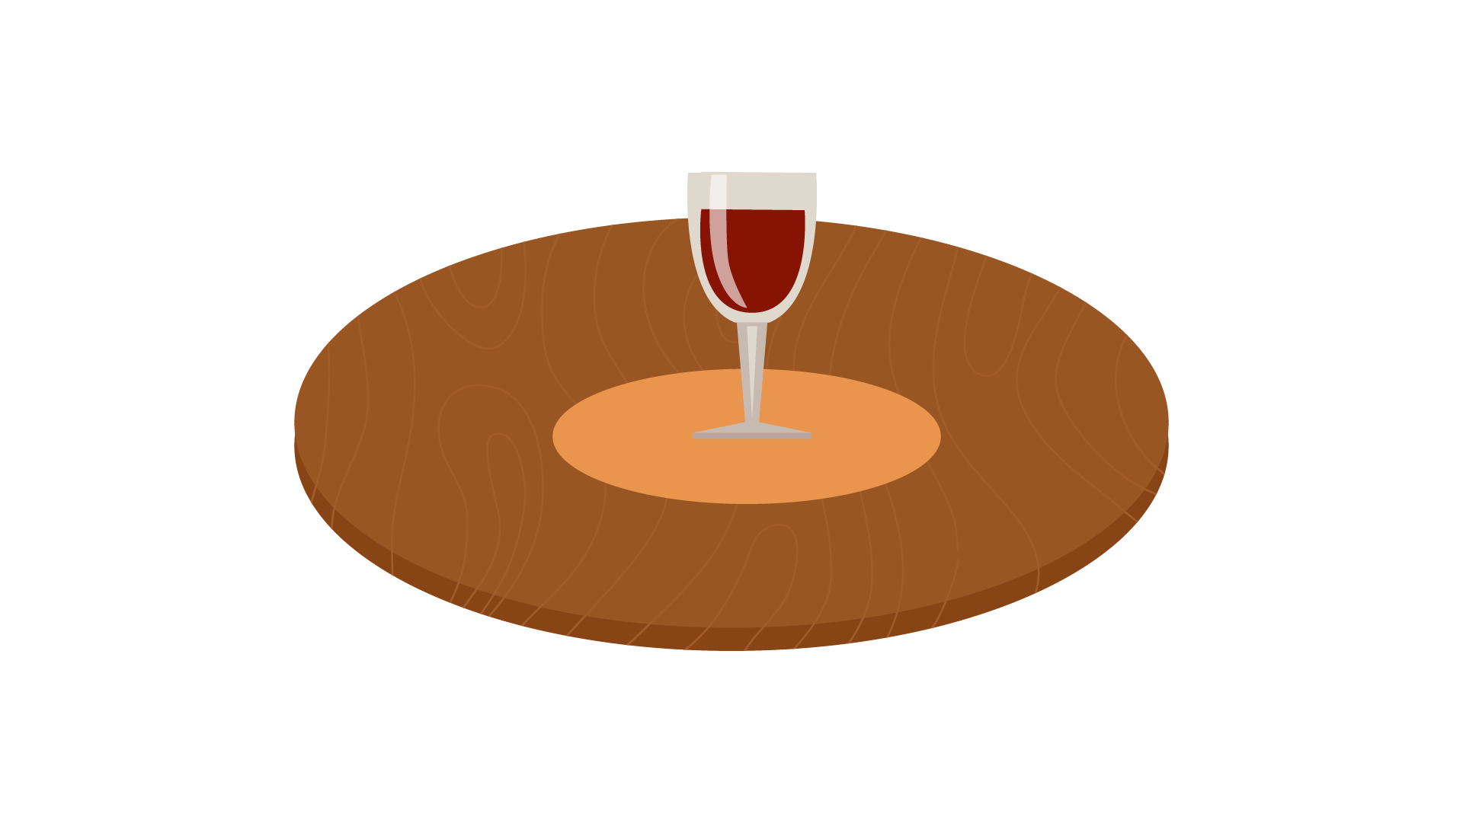
(A) | (B) | (C)
17.
 | 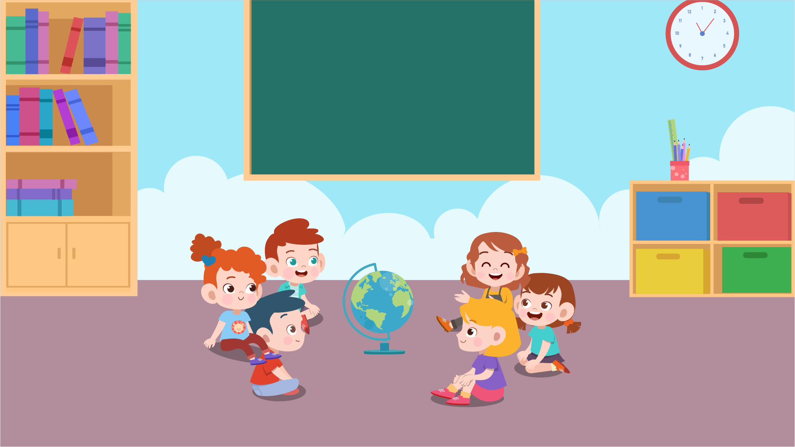 | 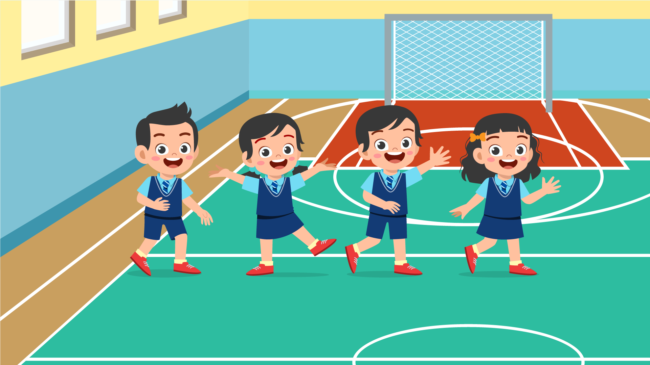
(A) | (B) | (C)
PART 3
Fill in the correct circles on your answer sheet.
Look at your answer sheet. Listen to a conversation. Which conversation sounds correct?
Let’s do an example.
(Narrator): A
(Boy): Hello. What’s your name?
(Girl): I’m fine, thanks.
(Narrator): B
(Boy): How are you today?
(Girl): I’m six years old.
(Narrator): C
(Boy): Nice to meet you!
(Girl): Nice to meet you, too!
The answer is "C." Fill in "C" on your answer sheet. Now, you do it.
18.
(A) | (B) | (C)
19.
(A) | (B) | (C)
20.
(A) | (B) | (C)
21.
(A) | (B) | (C)
22.
(A) | (B) | (C)
23.
(A) | (B) | (C)
24.
(A) | (B) | (C)
25.
(A) | (B) | (C)
26.
(A) | (B) | (C)
27.
(A) | (B) | (C)

PART 4
Listen to a conversation and answer the question. Fill in the correct circle on your answer sheet.
Let’s do an example.
28. When is the girl's party?
(A) Tonight
(B) Next week
(C) This weekend
The answer is "C." Fill in "C" on your answer sheet. Now, you do it.
29. What did the boy do last weekend?
(A) Stay at home
(B) Visit another country
(C) Go camping
30. What does the customer buy?
(A) A shirt
(B) A blouse
(C) A jacket
31. What will the boy do this summer holiday?
(A) go to the beach
(B) climb a mountain
(C) go camping
32. What does the teacher tell the boy to do?
(A) write an essay
(B) make a presentation
(C) read books
33. What does the girl need to do?
(A) make cakes
(B) decorate the cakes
(C) decorate the party
34. What do the friends want to do?
(A) go to the park
(B) go skiing
(C) go skateboarding
PART 5
Listen and answer the question.
Fill in the correct circle on your answer sheet.
Let’s do an example.
- What did Mike call about?
(A) Homework
(B) A movie
(C) A library book
The answer is "B." Fill in "B" on your answer sheet. Now, you do it.

36. Why did Lisa’s mother call?
(A) To ask her to cook dinner
(B) To ask her to check the ingredient
(C) To tell her to buy some food
37. Why did Santra call?
(A) To remind about the homework
(B) To tell about her sending email
(C) To share a new idea
38. Why did Camilla call?
(A) To confirm one previous decision
(B) To tell about her piano class
(C) To change the plan
39. Why did the teacher call?
(A) To invite Lucy to the gallery
(B) To borrow her pictures
(C) To ask Lucy to draw pictures
40. Why did the shop assistant call?
(A) To notify Maria of a change
(B) To ask about Maria’s available time
(C) To confirm the order
41. Why did Ariel call?
(A) To get information about the topic
(B) To ask about the deadline
(C) To ask for related materials

