UNIT 12: LIFE ON OTHER PLANETS
(CUỘC SỐNG TRÊN CÁC HÀNH TINH KHÁC)
A. VOCABULARY
New words | Meaning | Picture | Example
aeronautical  [,eərə'nɔ:tikəl] adj | thuộc hàng không |  | Mr. Smith is an aeronautical engineer.  Ông Smith là một kĩ sư hàng không.
alien  ['eiljən] (n) | người ngoài hành tinh | 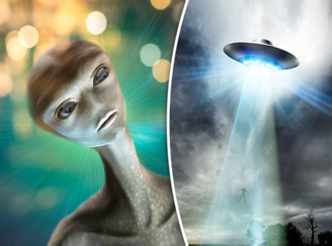 | Do you think that aliens really exist?  Bạn có nghĩ rằng người ngoài hành tinh thực sự tồn tại không?
astronaut  ['æstrənɔ:t] (n) | phi hành gia | 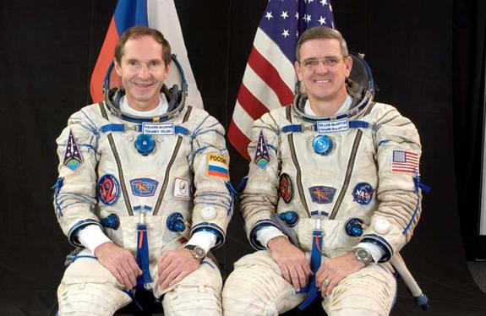 | They will send two astronauts into space this year.  Họ sẽ đưa hai phi hành gia lên vũ trụ năm nay.
captain  ['kæptin](n) | thuyền trưởng, đội trưởng |  | He was the captain of the football team at school.  Anh ấy là đội trưởng đội bóng ở trường.
crew  [kru:] (n) | đoàn, đội | 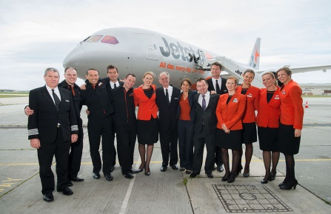 | My sister is one of the flight crew.  Chị tôi là một người trong phi hành đoàn.
Galaxy  ['gæləksi] (n) | Giải Ngân Hà |  | The galaxy contains our solar system.  Dải Ngân Hà chứa hệ mặt trời.
Jupiter  ['dʒu:pitə] (n) | sao Mộc | 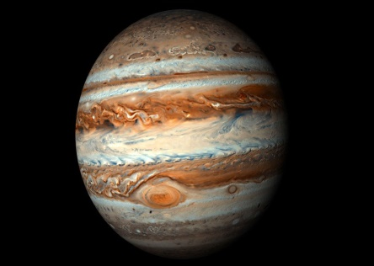 | Jupiter is the largest planet in the solar system.  Sao Mộc là hành tinh lớn nhất trong hệ mặt trời.
launch  [lɔ:nt∫] (v) | phóng, mở, khởi đầu |  | They launched a rocket last year.  Họ đã phóng một quả tên lửa năm ngoái.
Mercury  [ˈmɝːkjəri ] (n) | sao Thủy | 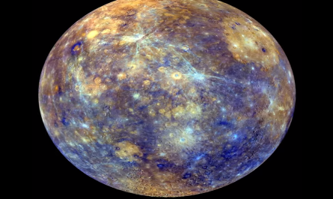 | Jupiter is the smallest planet in the solar system.  Sao Thủy là hành tinh bé nhất hệ mặt trời.
Neptune  ['neptju:n] (n) | sao Hải Vương |  | Neptune is not visible to the naked eye.  Sao Hải Vương không thể nhìn thấy bằng mắt thường.
notable  ['nəutəbl] (adj) | đáng chú ý |  | He made a notable success in the field of business.  Anh ấy làm nên thành công đáng chú ý trong ngành kinh tế.
outer space  [ˈaʊtər speɪs] | vũ trụ |  | Who was the first woman in outer space?  Ai là người phụ nữ đầu tiên trong không gian vũ trụ.
particular  [pə'tikjulə(r)] (adj) | cụ thể, riêng biệt |  | Is there a particular film you like?  Có bộ film cụ thể nào bạn thích không?
solar system  [ˌsəʊlə ˈsɪstəm] | hệ Mặt trời | 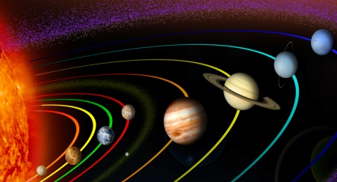 | There are eight planets in the solar system.  Có 8 hành tinh trong hệ Mặt trời.
UFO  [ju:ˌefˈoʊ ] | (Unidentified Flying Object)  vật thể bay không xác định |  | Do you believe in UFOs?  Bạn có tin vào những vật thể bay không xác định không?
Venus  ['vi:nəs] (n) | sao Kim | 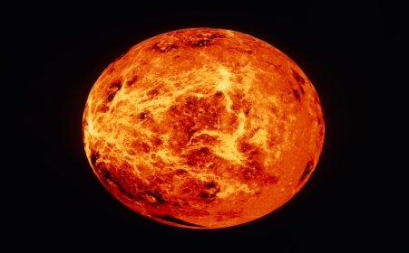 | Venus has the same size as the Earth.  Sao Kim có cùng độ lớn với địa cầu.
weightless  [ˈweɪtləs] (adj) | không trọng lực |  | Astronauts work in weightless conditions.  Phi hành gia làm việc trong môi trường không trọng lực.
witness  [ˈwɪtnəs] (n,v) | nhân chứng, chứng kiến | 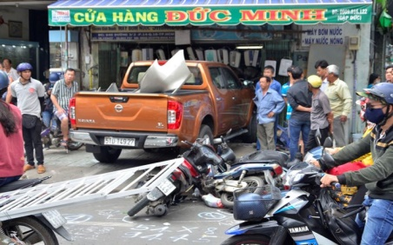 | No one witnessed the accident last night.  Không có ai chứng kiến vụ tai nạn tối qua.
B. GRAMMAR.
I. ÔN TẬP MAY VÀ MIGHT
Cách dùng | Ví dụ
- “May” và “might” được dùng để diễn đạt điều gì có khả năng xảy ra ở hiện tại hoặc tương lai.  - “might” diễn tả sự việc có khả năng xảy ra thấp hơn “may”. | - It may/might be a bomb. (Có thể đó là 1 quả bom)  - Where is Emma? I don’t know. She may/might be out shopping. (Có lẽ cô ấy đi mua sắm)  - I may go to London next month. (khả năng xảy ra 50%)  - I might go to London next month. (khả năng xảy ra 30%)
- “May” và “might” được dùng để xin phép, cho phép (có tính chất lễ phép, trang trọng hơn “can” và “could”).  - “May not” được dùng để từ chối lời xin phép hoặc chỉ sự cấm đoán. | - May I borrow your car? (xin phép lịch sự)  - Yes, of course you may./No, I’m afraid you may not. (từ chối lời xin phép)  - Students may not use the teachers’ car park. (cấm đoán)
- May được dùng trong những lời chúc mừng trang trọng (không dùng might). | May the New Year bring you all your heart desires. (Chúc bạn 1 năm mới vạn sự như ý!)
BÀI TẬP VẬN DỤNG CƠ BẢN
Bài 1: Hãy chỉ ra chức năng của hai động từ khuyết thiếu may và might trong những câu dưới đây. Viết Po vào ô trống bên cạnh nếu nó chỉ khả năng (Possibility), viết AP nếu nó chỉ lời xin phép (Asking for Permission), và viết PE nếu nó chỉ sự cho phép (Permission)
1. PO I may have lunch early I’m hungry.
2. AP May I come in now?
3. PO He might go abroad next month.
4. PO I may not have time to go out today.
5. AP May I borrow your book tomorrow?
6. PE You may not borrow the car until you can be more careful with it.
7. PE You may go camping with your friends if you get high marks in the next tests.
8. PO It’s quite bright. It might not rain today.
9. AP Might we just interrupt for a moment?
10. PO Jay may be coming to see us tomorrow.
Bài 2: Sắp xếp các từ đã cho thành câu đúng.
1. airport/He/be/the/waiting/us/may/at/for.
He may be waiting for us at the airport.
2. might/John/your/come/party/to.
John might come to your party.
3. room/I/the/May/leave?
May I leave the room.
4. your/I/May/eraser/use/,/please/?/Yes/,you/course/of/may.
May I use your eraser, please? Yes, of course you may.
5. that/touch/Don’t/ write/it/be/because/dangerous/might.
Don’t touch that wire because it might be dangerous.
6. is/No One/to/go/allowed/into/building/that/,/may/go/you/not/inside/.
No one is allowed to go into that building, you may not go inside.
7. applying/is/for/the/a/He/job/at/university/,/get/he/it/might
He is applying for a job at the university, he might get it.
8. yesterday/Sheila/go/sick/work/didn’t/,/to/she/be/might/.
Sheila didn’t go to work yesterday, she might be sick.
9. bomb/may/it/a/be
It may be a bomb.
10. put/I/the/May/on/TV?
May I put the TV on?
Bài 3: Dựa vào những từ gợi ý, dùng might/might not(mighn’t) để viết thành câu hoàn chỉnh.
1. I/go to the party.
I might go to the party.
2. She/not talk to him.
She might not talk to him.
3. They/lose the game.
They might lose the game.
4. Everybody/come to my concert.
Everybody might come to my concert.
5. The government/not win the election.
The government might not win the election.
6. The school/not win the competition.
The school might not win the competition.
7. The singer/become famous.
The singer might become famous.
8. He/not break a world record.
He might not break a world record.
9. My father/work in a different country
My father might work in a different country.
10. I /not become president of a country.
I might not become president of a country
II.CÂU HỎI GIÁN TIẾP (REPORTED QUESTIONS)
1. Các quy tắc khi chuyển câu hỏi trực tiếp sang câu hỏi gián tiếp
- Động từ tường thuật được sử dụng trong câu hỏi gián tiếp thường là: asked, required, wondered, wanted to know.
- Áp dụng qui tắc đổi đại từ nhân xưng, tính từ sở hữu, đại từ sở hữu giống câu trần thuật gián tiếp.
- Áp dụng qui tắc đổi thì của động từ giống câu trần thuật gián tiếp.
- Áp dụng qui tắc đổi các trạng từ chỉ thời gian, nơi chốn giống câu trần thuật gián tiếp.
- Câu hỏi chuyển sang câu gián tiếp phải được chuyển về dạng khẳng định và lược bỏ dấu hỏi chấm.
2. Các dạng câu hỏi gián tiếp.
Dạng | Cấu trúc
Câu hỏi Wh-Questions (Câu hỏi bắt đầu bằng các từ để hỏi như: What, Where, When, Why, How...) | S + asked/wondered/wanted to know + O + Wh + S + V...  He said to me, “Why did you go with her father last week?”  →He asked me why I had gone with her father the week before.
Câu hỏi Yes/No Questions: Dùng “If hoặc whether” để bắt đầu câu hỏi Yes/No gián tiếp. | S + asked/wondered/wanted to know + O + if/whether + S + V  Ví dụ:  He said to me, “Will you go with her father next week?”  → He asked me if/whether I would go with her father the following week.

BÀI TẬP VẬN DỤNG CƠ BẢN.
Bài 4: Sắp xếp các từ sau để tạo thành câu hỏi gián tiếp hoàn chỉnh.
1. asked/was/how much/that/Tom/computer
Tom asked how much that computer was.
2. had/to know/the officer/if/wanted/the keys/I
The officer wanted to know if I had the keys.
3. Ann/hadn’t come/why/to her party/asked/Sam/he
Ann asked Sam why he hadn’t come to the party.
4. asked/Jane/for her holidays/she/was going/he/where
He asked Jane where she was going for her holidays.
5. me/English/asked/I/spoke/He/if
He asked me if I spoke English.
6. old/asked/He/her/how/was/mother
He asked how old her mother was.
7. British/was/asked/whether/He/I/me/American/or
He asked me whether I was British or American.
8. Boy/The asked/the/where/lived/policeman/be
The policeman asked the boy where he lived.
9. Had/Bristol/She/I/been/asked/to/before/if
She asked if I had been to Bristol before.
10. The/asked/time/train/She/what/arrived.
She asked what time the train arrived.
Bài 5: Khoanh tròn vào phương án đúng.
1. Tourist: “Where is the post office?” A tourist asked me where ...............................
A. the post office has | B. the post office was
C. is the post office | D. was the post office
2. Mom: “It’s 2 a.m; what are you doing in the kitchen?” Mom wanted to know what ...................... in.
A. was I doing | B. I do | C. I was doing | D. am I doing
3. Dad: “Why did you come home so late last night?” Dad wanted to know ................ home very late the night before.
A.why did I come | B. if I come | C. if I came | D. why I had come
4. Jane: “Have you ever been to Australia?” Jane asked me .......................to Australia
A. if I’m ever going | B. if I’d ever been | C. have I ever been | D. had I ever been
5. Joe: “Could you sing when you were five?” He asked me.................when I was five
A. can I sing | B. if I can sing | C. could I sing | D. if I could sing
6. Mother: “When are you going to do your homework?” Mother asked me when ...........to do my homework.
A. was I going | B. I was going | C. am I going | D. I’ll be going
7. Allen: “How many songs had John Lennon written before he died?” Allen wanted to know how many songs .................. before his death.
A. John Lennon had written | B. John Lennon was writing
C. was John Lennon writing | D. had John Lennon written
8. Janet: “Were you working at 8p.m last night?” Janet asked me ................... at 8p.m the other night.
A. if I’m working | B. if I’d been working
C. was I working | D. had I been working
9. Dad: “Have you been attending classes regularly?” Dad asked me ...................attending classes regularly.
A. if I’d be | B. had I been | C. if I’d been | D. have I ben
10. Mario: “What should I do to improve my English?” Mario asked his teacher what ........... to improve his English.
A. he should do | B. he would do | C. shall he do | D. should he do
11. Jim: “How much does your sister earn?” Jim wanted to know how much.................
A. my sister has earned | B. did my sister earn
C. does my sister earn | D. my sister earned
12. Joe: “Could you sing when you were five?” He asked me ....................when I was five.
A. can I sing | B. if I can sing | C. could I sing | D. if I could sing
13. Mary: “Are you able to swim?” Mary asked me ........................to swim.
A. if I have been able | B. am I able | C. if I was able | D. will be able
14. Tourist: “When was that castle built?” The tourist asked the guide when ...................
A. had the castle been built | B. the castle had been built
C. the castle was being built | D. was the castle built
15. Sue: “May I sleep at Lee’s house overnight?” Sue asked her mother ........................ at her friend’s house overnight
A. if she might sleep | B. could she sleep
C. can she sleep | D. if she had to sleep
Bài 6: Chuyển các câu hỏi trực tiếp dạng Yes-No questions dưới đây thành câu hỏi gián tiếp.
Ví dụ: “Is this my birthday cake?” →Peter asked Mary if that was his birthday cake.
1. “Will you send me an e-mail?” Marty to Kim
Marty asked Kim if she would send him an e-mail.
2. “Were you driving your car when you had an accident?” The police to Mr Lloyd
The police asked Mr. Lloyd if he was driving /had been driving his car when he had an accident
3. “Did you give up smoking last month?” The doctor to Mrs Smith
The doctor asked Mrs. Smith if she had given up smoking the previous month.
4. “Have you done the washing up?” Mum to me
Mum asked me if I had done the washing up.
5. “Can’t you phone your mother at home?” The teacher to him
The teacher asked Tim If he couldn’t phone his mother at home.
6. “Do you like sleeping? ” I to Greg
I asked Greg if he liked sleeping.
7. “Has your house been redecorated? ” My neighbour to me
My neighbour asked me if my house had been redecorated.
8. “Were you punished for being late? ” Mum to Ben
Mum asked Ben if he had been punished for being late.
9. “Do I have to move the lawn in our garden today? ” Tom to his wife
Tom asked his wife if he had to move the lawn in our garden that day.
10. “Are they taking the dog for a walk now? ” Kate to me
Kate asked me if they were taking the dog for a walk then.
Bài 7: Chuyển các câu hỏi trực tiếp dạng Wh-questions dưới đây thành câu hỏi gián tiếp.
Ví dụ: Who is this flower for? →Mary asks Peter who that flower is for.
1. “What’s your name? ” The officer to Sam
The officer asked Sam what his name was.
2. “How could you drive here in this storm?” Linda to the writer
Linda asked the writer how he could drive there in that storm.
3. “Why are you wearing this awful shirt?” The boss to Mr Grey
The boss asked Mr. Grey why he was wearing that awful shirt.
4. “When will the lunch be ready?” Tina to her mum
Tina asked her mum when the lunch would be ready.
5. “How did you try to cope with this problem? ” The psychologist to Sylvie.
The psychologist asked Sylvie how she had tried to cope with that problem.
6. “When did you find this great book? ” The teacher to Jack
The teacher asked Jack when he had found that great book.
7. “Where are you from? ” Mike to Sam
Mike asked Sam where he was from.
8. “How many apples have you eaten today?” Mum to Paul
Mum asked Paul how many apples he had eaten that day.
9. “What can I do for you? ” The greengrocer to Mrs Hill
The greengrocer asked Mrs Hill what she/he could do for her.
10. “Where is my tie? ” Dad to the children.
Dad asked the children where his tie was.
Bài 8: Chuyển các câu hỏi trực tiếp dưới đây thành câu hỏi gián tiếp.
1. “Have you done your homework yet, Peter?”
Mum wanted to know if Peter had already done his homework .
2. “Where are you going to spend your holiday this summer, Sue?”
Mary asked Sue where she was going to spend her holiday that summer
3. “Do you know how long it is from London to Cambridge?”
Tom asked me if I knew how long it was from London to Cambridge.
4. “Will you phone me as soon as you arrive in Oxford, Carol?”
Cindy asked Carol if she would phone her as soon as she arrived in Oxford
5. “Did the children play football in the park yesterday? ”
Grandma was interested in knowing if the children had played football in the park the previous day/the day before.
6. “How much does the ticket for the concert cost? ”
Father wanted to know how much the ticket for the concert cost.
7. “Can you help me with the housework tomorrow, Linda?”
He asked Linda if she could help him with the housework the next/following day.
8. “What time does the new TV series begin tonight?”
Terry asked what time the new TV series began that night.
9. “Are you going to buy a new computer next month, Lewis?”
I wanted to know if Lewis was going to buy a new computer the next/following month
10. “When has Tim started working this morning?”
Mr. Smith asked his secretary when Tim had started working that morning
11. “Is Sue coming to the library with you, Paul?”
Tina asked Paul if Sue was coming to the library with him.
12. “Why haven’t you sent me an email while you were in London?”
Dave wanted to know why I hadn’t sent him an email while I had been in London
13. “Could you swim when you were six, Tony? ”
The P.E teacher asked Tony if he was able to swim when he was six.
14. “What have you been doing at school this morning, Charles ?”
Dad was interested in knowing what Charles had been doing at school that morning
15. “Are you revising for tomorrow exam?”
The teacher asked the students if they were revising for the next/following day’s exam.
16. “How often do you play chess with your brother, Alice?”
Sam wanted to know how often Alice played chess with her brother.
BÀI TẬP TỔNG HỢP NÂNG CAO.
Bài 9: Chọn phương án đúng nhất.
1. “What has Daddy made for dinner ? ” asked Simon.
A. Simon asked what Daddy had made for dinner.
B. Simon asked what Daddy have made for dinner.
C. Simon asked what Daddy has made for dinner.
2. “Who won the match? ” asked Monica.
A. Monica asked who had won the match.
B. Monica asked who have won the match.
C. Monica asked who has won the match.
3. “Has Sarah ever been to Siena ? ” he asked.
A. He asked whether Sarah had never been to Siena.
B. He asked whether Sarah had ever been to Siena.
C. He asked whether Sarah has never been to Siena.
4. “Do you like fried eggs?”Anne asked David
A. Anne asked David whether he like fried eggs.
B. Anne asked David if he like fried eggs.
C. Anne asked David if he liked fried eggs.
5. “Can they play the piano?” she asked
A. She asked if they could play the piano.
B. She asked if they can play the piano.
C. She asked whether they can play the piano.
6. “Have you ever been to Lisbon? ”Luis asked Paul.
A. Luis asked Paul whether he has ever been to Lisbon.
B. Luis asked Paul whether he had ever been to Lisbon.
C. Luis asked Paul whether he had never been to Lisbon.
7. “Can I use your mobile, John? ” asked Sarah.
A. Sarah asked John if she can use his mobile.
B. Sarah asked John if she could use her mobile.
C. Sarah asked John if she could use his mobile.
8. “Are we going out tonight?” asked Bob.
A. Bob asked if/whether they were going out this night.
B. Bob asked whether they were going out that night.
C. Bob asked whether they are going out that night.
9. “Is the Pope a Catholic?” asked JK
A.JK asked whether the Pope be a Catholic
B. JK asked if the Pope be a Catholic
C. JK asked if the Pope was a Catholic
10. “Where do bears live?” asked George.
A. George asked where bears lived.
B. George asked where bears lives.
C. George asked where lived bears.
Bài 10. Đọc đoạn hội thoại dưới đây và tường thuật lại dưới dạng câu gián tiếp.
Mike: “What are you doing here, Liz? I haven’t seen you since June.”
Liz: “I’ve just come back from my holiday in Ireland”
Mike: “Did you enjoy it?”
Liz: “I love Ireland. And the Irish people were so friendly”
Mike: “Did you go to the Wicklow Mountains?”
Liz: “It was my first trip. I can show you some pictures. Are you doing anything tomorrow?”
Mike: “I must arrange a couple of things. But I am free tonight.”
Liz: “You might come to my place. What time shall we meet?”
Mike: “I’ll be there at eight. Is it all right?”
1. Mike asked Liz what she was doing there. And he said he had not seen her since June.
2. Liz explained that she had just come back from her holiday in Ireland.
3. Mike wondered if /whether she had enjoyed it
4. Liz told him that she loved Ireland and that the Irish people had been so friendly.
5. Mike wanted to know if/whether she had gone to Wicklow Mountains.
6. Liz said that it had been her first trip and that she could show him some pictures.
7. And then she asked him if he was doing something the next day/the following day.
8. Mike explained that he must/had to arrange a couple of things
9. But he added that he was free at night.
10. Liz suggested that he might come to her place and asked him what time they would meet.
11. Mike said he would be there at eight.
12. And then he asked if/whether it was all right.
Bài 11: Chọn dạng động từ đúng trong những câu trực tiếp dưới đây.
1. Helen asked me if I liked visiting old buildings.
‘Do you like/Did you like visiting old buildings?’ asked Helen.
2. Bill asked Mary if she had done anything the previous weekend.
‘Have you done anything/Did you do anything last weekend?’
3. The policeman asked me if the car belong to you me.
‘Does this car belong/Did this car belong to you?’asked the policeman.
4. Fiona asked me if I had seen her umbrella anywhere.
‘Did you see/Have you seen my umbrella anywhere ?’ asked Fiona.
5. Joe asked Tina when she would get back.
‘When will you get /have you got back?’asked Joe.
6. Eddie asked Steve who he had been to the cinema with.
‘Who did you go/had you been to the cinema with?’ asked Eddie.
7. My parents asked me what time I had got home the night before.
‘What time did you get/have you got home last night?’ my parents asked.
8. David asked a passer-by f it was the right road for Hastings.
Is this/Was this the right road for Hastings? Asked David.
Bài 12: Đọc kĩ đoạn văn dưới đây.
People used to think that there were six planets moving in a circle around the Sun. Mercury was the nearest to the Sun and Saturn was the furthest away. Most scientists knew that the Earth was the third nearest planet to the Sun, between Venus and Mars, and that Jupiter was between Mars and Saturn. We have now discovered that there are three more planets – Uranus, Pluto and Neptune. These others are farther from the Sun, and Pluto is the farthest one.
From its time of discovery in 1930 Pluto was considered to be the ninth planet in solar system. In 2006 the IAU (International Astronomical Union) changed the definition of ‘planet’, so that Pluto is not a planet, but the second largest dwarf planet in solar system. So there are eights planets, not six or nine and the largest is in the middle of them, the fifth away from the Sun.
Đánh dấu T (True) nếu câu đúng, F (False) nếu câu sai, NS (Not stated) nếu câu không được nói trong bài.
1. Mercury is the third nearest planet to the Sun. F
“Mercury was the nearest to the Sun and Saturn was the furthest away”
2. Venus is the brightest of the planets. NS
3. Pluto has been considered a planet for 76 years. T
“ From its time of discovery in 1930 Pluto was considered to be the ninth planet in solar system. In 2006 the IAU (International Astronomical Union) changed the definition of ‘planet’ ”
4. The International Astrological Union changed the definition of ‘planet’. T
“ In 2006 the IAU (International Astronomical Union) changed the definition of ‘planet’ ”
5. There are five dwarf planets in the solar system. NS
6. Jupiter is the largest planet in the solar system. T
“...the Earth was the third nearest planet to the Sun, between Venus and Mars, and that Jupiter was between Mars and Saturn.... So there are eights planets, not six or nine and the largest is in the middle of them”

