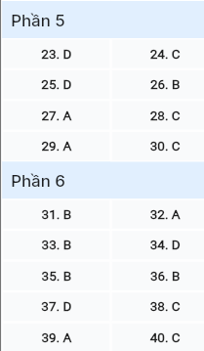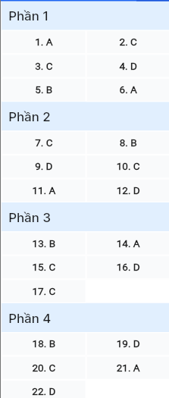**ĐỀ MINH HỌA SỐ 03**  
**KỲ THI TỐT NGHIỆP TRUNG HỌC PHỔ THÔNG NĂM 2025**  
(Đề thi có 08 trang)  
**Môn thi: TIẾNG ANH**  
**Thời gian làm bài: 50 phút, không kể thời gian phát đề**

**Read the following advertisement and mark the letter A, B, C or D on your answer sheet to indicate the option that best fits each of the numbered blanks from 1 to 6.**



**Wanderlust: Your Ultimate Adventure Awaits!**

Are you (1) ___ by endless options for your next holiday? Don’t worry! That’s about to change with ‘Wanderlust’. Our app is crafted to help you find the best travel experiences (2) ___ to your interests. Whether you crave exciting city adventures or (3) ___, “Wanderlust” has it all! Discover personalized itineraries designed just (4) ___ you. You can read fellow travellers’ reviews, gather insider tips, and (5) ___ reservations for flights and hotels in one click. Download Wanderlust today and turn your travel dreams into reality – we advise (6) ___ local attractions and discovering hidden gems along the way!

**Questions 1-6**

1. A. frustrated B. frustrating C. frustration D. frustrate



1. A. which tailor B. tailoring C. tailored D. are tailored

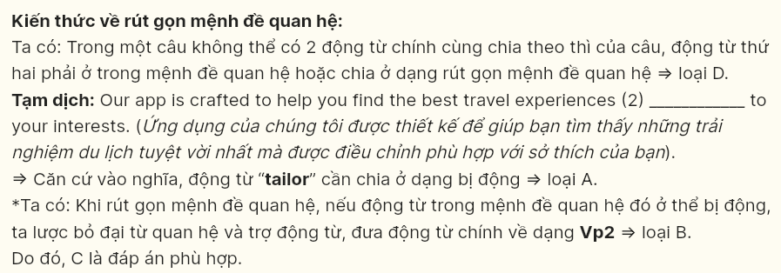

1. A. vacations relaxing beach B. beach vacations relaxing  
   C. relaxing beach vacations D. beach relaxing vacations



1. A. to B. with C. on D. for



1. A. take B. make C. put D. do



1. A. exploring B. to explore C. explored D. explore

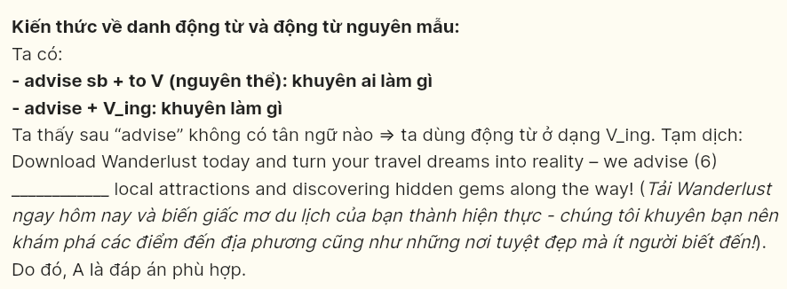

***Read the following leaflet and mark the letter A, B, C or D on your answer sheet to indicate the option that best fits each of the numbered blanks from 7 to 12.***

**

**Empower Your Mind: The Importance of Lifelong Learning**  
*Knowledge is a journey, not a destination!*

**The Value of Education**  
In today’s rapidly changing world, continuous learning is essential to (7) ________ with new developments and enhance our skills. Many people overlook opportunities to learn outside traditional settings, which can limit personal growth. Embracing education can open doors to new (8) _______ and opportunities.

**What We Can Do:**

* Take online courses. Explore various subjects and expand your skill set through accessible online (9) ____. This flexibility allows you to learn at your own pace and convenience.
* Join community classes. Participate in local workshops or courses to meet others and develop new interests, (10) _______ your current skill level. Engaging with a group can foster connections and provide support to (11) __________.
* Read regularly. Make it a habit to read books, articles, or blogs related to your interests. This not only (12) __________ your knowledge but also encourages critical thinking and reflection.

**Questions 7-12**

1. A. catch up B. put up C. keep up D. make up

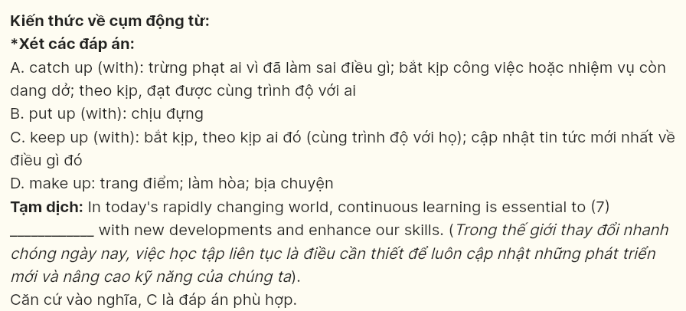

1. A. aspects B. experiences C. experiments D. qualifications

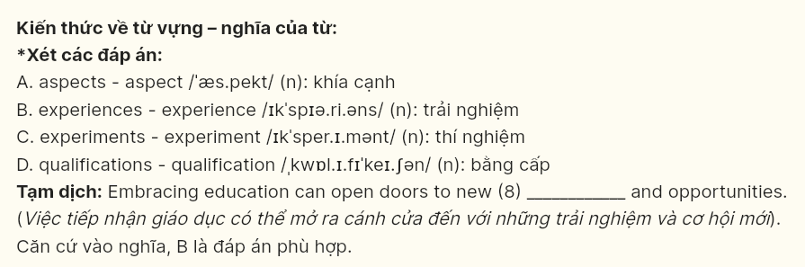

1. A. stations B. basements C. structures D. platforms

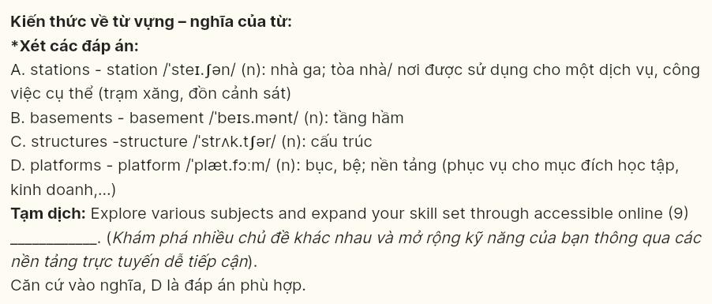

1. A. instead of B. on account of C. regardless of D. in addition to



1. A. others B. other C. the other D. another



1. A. advances B. promotes C. lengthens D. broadens

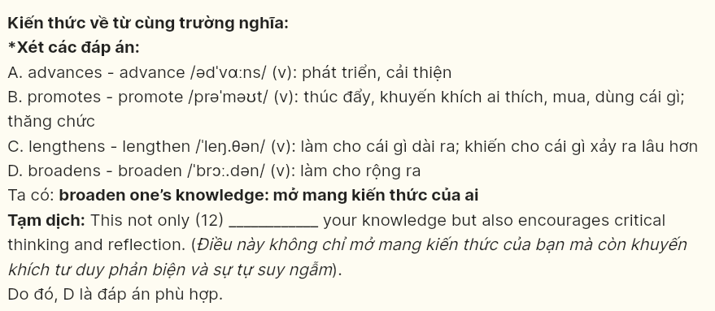

***Mark the letter A, B, C or D on your answer sheet to indicate the best arrangement of utterances or sentences to make a meaningful exchange or text in each of the following questions from 13 to 17.***

**Question 13**

a. Sarah: You should review your notes and take some practice tests!  
b. Sarah: Hi, Alex! Are you ready for the exam tomorrow?  
c. Alex: Not really, I still have a lot to study.

A. c-a-b B. b-c-a C. c-b-a D. a-c-b



**Question 14**

a. Daniel: Let’s make a list of what to buy and when to plant.  
b. Rachel: I’m thinking of planting vegetables in our backyard this spring.  
c. Daniel: Why not include some flowers for color?  
d. Daniel: How do you plan to start your gardening project?  
e. Rachel: That’s a good suggestion! I’ll pick some that attract butterflies.

A. d-b-c-e-a B. d-e-c-b-a C. c-b-a-e-d D. c-e-d-b-a



**Question 15**

Hi Lucy,

a. You will have to budget for flights, accommodations, and daily expenses.  
b. You should research affordable options and plan your itinerary wisely, and I can help you find some great deals!  
c. I heard you were thinking of visiting Italy this summer.  
d. However, traveling can be a rewarding experience that broadens your horizons.  
e. It sounds like a fantastic idea, but have you considered the costs involved in your trip?

Write back soon!  
James

A. c-a-d-e-b B. b-e-c-a-d C. c-e-a-d-b D. c-d-e-a-b



**Question 16 [696859]:**  
a. While it sometimes requires extra effort to shop sustainably and avoid convenience items, the positive impact is worth it.  
b. Over the past year, I've made an impact by reducing plastic use, recycling, and supporting local conservation projects.  
c. Living sustainably at home encourages me to find creative solutions to minimize waste.  
d. In conclusion, I'm incredibly proud of my eco-conscious lifestyle, as it aligns with my values of preserving the planet.  
e. My commitment to nature and sustainability inspired me to adopt eco-friendly habits in my daily life.

A. a-c-b-e-d B. c-b-e-a-d C. b-c-e-a-d D. e-b-c-a-d

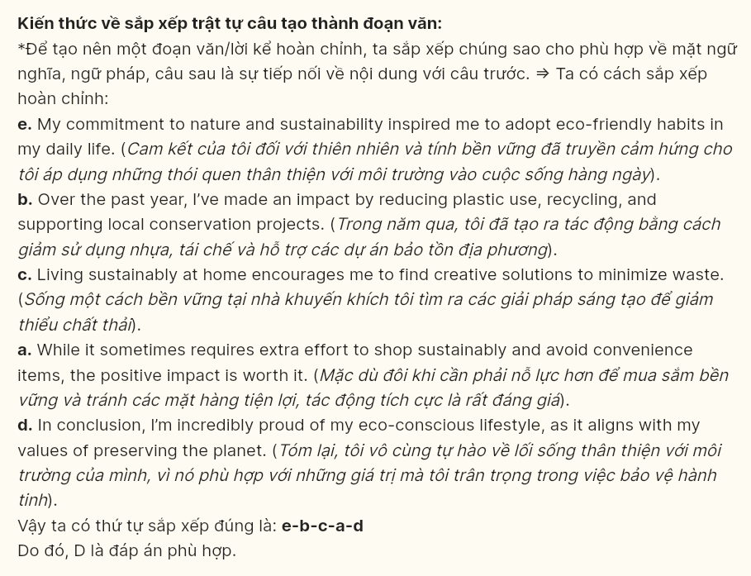

**Question 17 [696860]:**  
a. It originally offered only a limited selection of groceries, but the growing demand prompted the owner to expand the inventory to include fresh produce and household items.  
b. The shop now hosts regular promotional events, such as discounts and seasonal sales, which draw in more customers and create excitement within the community.  
c. Thanks to the owner’s unwavering dedication and commitment to quality service, the shop has become a beloved fixture in the neighborhood.  
d. The small local shop has undergone significant transformation over the years.  
e. After renovating the space to create a more inviting atmosphere, the shop successfully attracted a larger customer base, resulting in increased sales.

A. d-e-c-a-b B. d-c-a-b-e C. d-a-e-b-c D. d-b-c-a-e

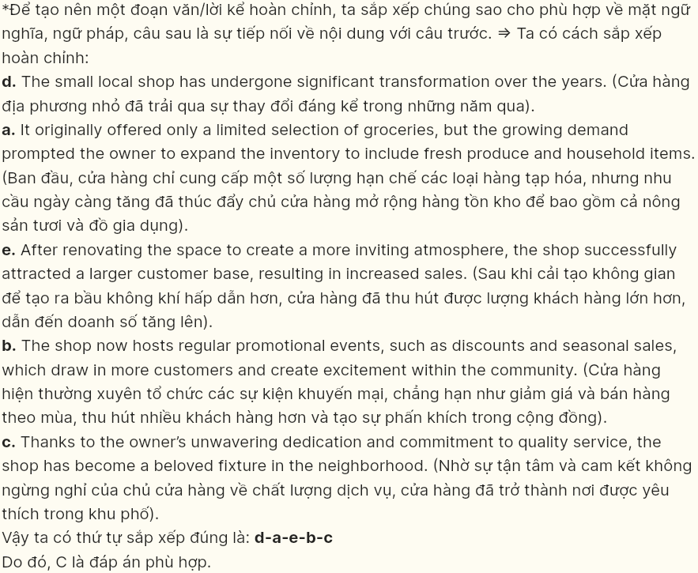

***Read the following passage about driverless cars and mark the letter A, B, C, or D on your answer sheet to indicate the option that best fits each of the numbered blanks from 18 to 22.***



Driverless cars, also known as autonomous vehicles, (18) ________. These vehicles rely on advanced artificial intelligence and sensor technologies to operate independently, without human intervention. This innovation not only minimizes accidents caused by human error but also optimizes traffic flow, reducing congestion in urban areas.

One significant feature (19) ________ and urban planners is their potential to communicate with other vehicles and infrastructure. This vehicle-to-everything (V2X) communication allows for a coordinated traffic system, where cars can anticipate and avoid obstacles, adjust speed, and even signal each other to ensure a smooth drive.

Despite these advantages, significant concerns remain about the safety and ethical implications of autonomous vehicles. Machines make complex decisions that raise questions about accountability in case of accidents. (20) ________.

Driverless car offer a safer, more efficient transportation experience. Promising transformative benefits to society, (21) ________. These vehicles still face significant regulatory, technical, and ethical challenges. (22) _______.

**Question 18 [696861]:**  
A. which are gradually becoming a prominent part of the future of modern transportation  
B. are gradually becoming a prominent part of the future of modern transportation  
C. of which has gradually become prominent in the future of modern transportation  
D. having gradually become a prominent part of the future of modern transportation

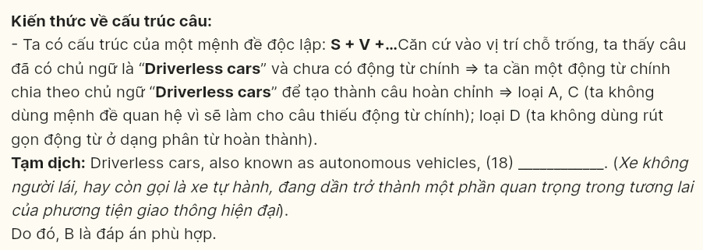

**Question 19 [696862]:**  
A. makes driverless cars especially appealing to modern consumers  
B. from which driverless cars are especially appealing to modern consumers  
C. turns driverless cars into a special appeal to modern consumers  
D. that makes driverless cars especially appealing to modern consumers

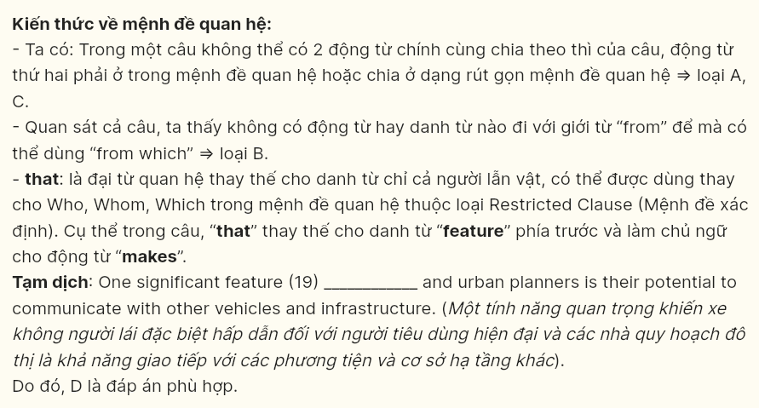

**Question 20 [696863]:**  
A. Expressing concerns about jobs for drivers, autonomous cars have their impact  
B. People believe autonomous cars will decrease numerous jobs for drivers  
C. The potential impact on jobs in driving-related industries is also a concern  
D. Autonomous cars reduce the urgent need for new driving-related jobs

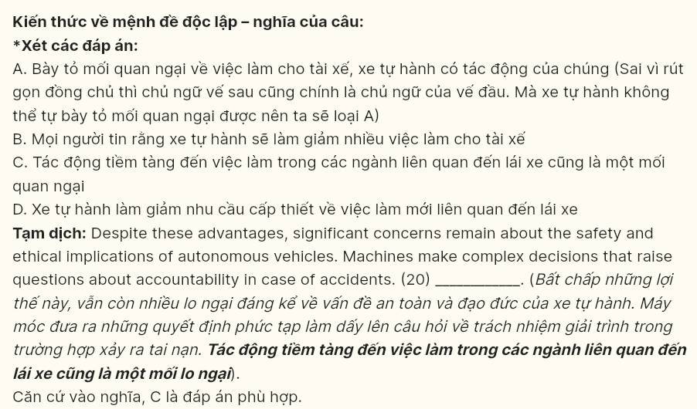

**Question 21 [696864]:**  
A. they are expected to play a crucial role in the future  
B. people expect them to play a crucial role in the future  
C. a crucial role in the future will be taken by these machines  
D. we expect them to take an important role in the future

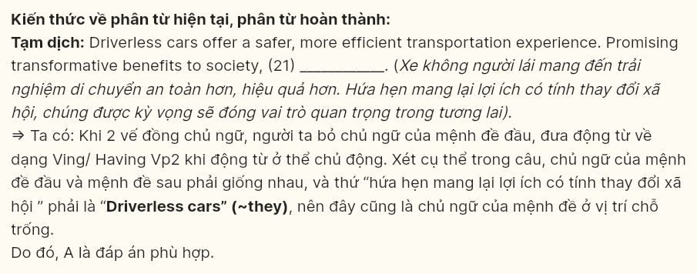

**Question 22 [696865]:**  
A. These challenges must be addressed so that full integration can be achieved  
B. Without solving these challenges, they can still achieve full integration  
C. Solving these challenges, these machines can achieve their full integration  
D. Overcoming these challenges is essential before they can achieve full integration

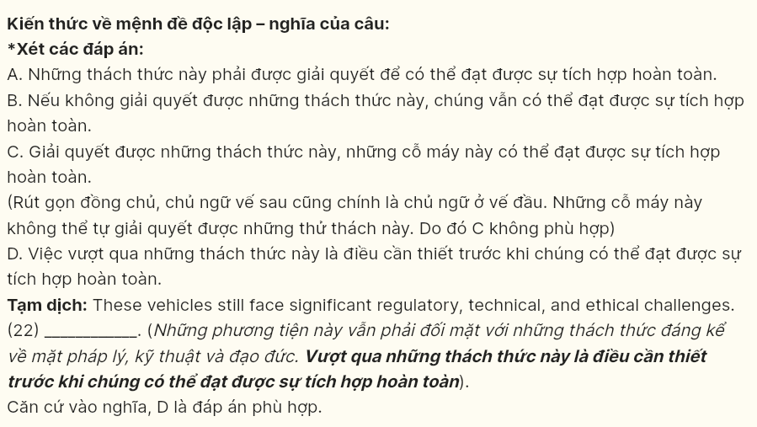

***Read the following passage about endangered languages and mark the letter A, B, C, or D on your answer sheet to indicate the best answer to each of the following questions from 23 to 30.***



Language is a powerful marker of cultural identity, yet many indigenous languages are at risk of extinction. In multicultural societies, minority languages often struggle to survive as dominant languages take precedence in education, media, and government. This linguistic shift can weaken community ties and **erode** cultural heritage. Efforts to preserve endangered languages are essential for maintaining cultural diversity.

Bilingual education programs are one way to promote language preservation. By integrating native languages into their curriculum, schools can foster a sense of pride among young speakers. Additionally, these programs encourage cross-cultural understanding among students from different backgrounds, helping **them** appreciate diverse perspectives. Bilingualism not only benefits individuals cognitively but also strengthens their cultural connections within society.

Digital platforms have become essential in the effort to preserve endangered languages**.** Language apps, online dictionaries, and social media are **conducive** to helping speakers of these languages share their knowledge widely, reaching audiences far beyond their own communities. Such tools enable younger generations to connect with and learn their ancestral languages, securing their survival. In this way, technology plays a vital role in sustaining minority languages in the digital era.

While there are challenges in preserving languages, every effort is valuable. **Language represents more than just words because it encapsulates traditions, wisdom, and worldview.** Protecting linguistic diversity in multicultural societies is crucial for fostering a world where every culture's voice is heard and valued.

**Question 23 (696866):** Which of the following is **NOT** mentioned as an area where dominant languages take precedence over minority languages in multicultural societies?  
A. education B. media C. government D. healthcare

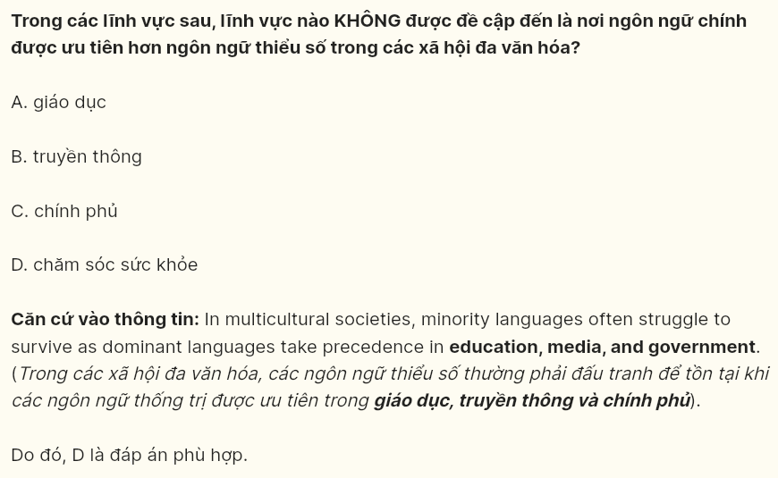

**Question 24 (696867):** The word **erode** in paragraph 1 is **OPPOSITE** in meaning to ______.  
A. diminish B. damage C. foster D. commence

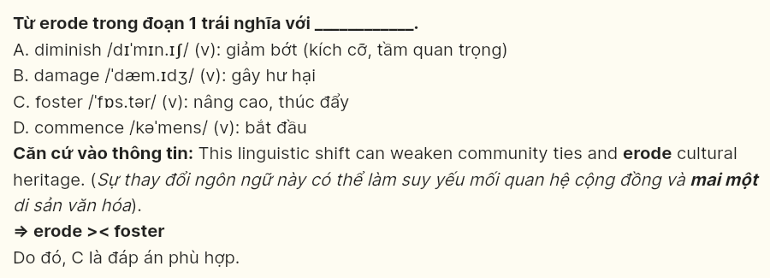

**Question 25 (696868):** The word **them** in paragraph 2 refers to ______.  
A. programs B. backgrounds C. perspectives D. students

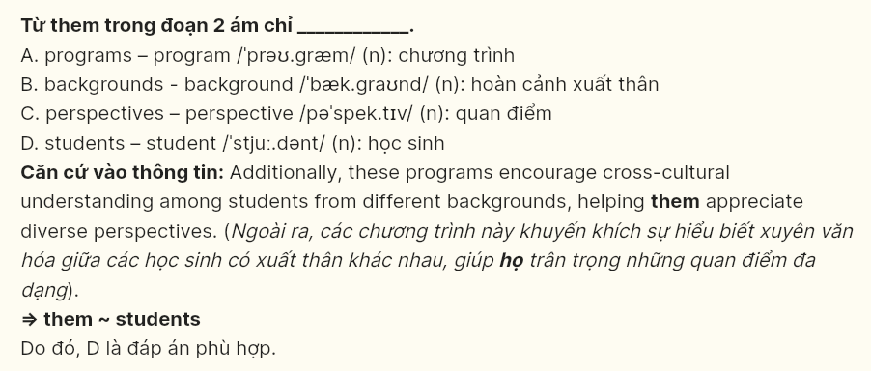

**Question 26 (696869):** The word **conducive** in paragraph 3 could be best replaced by ______.  
A. adverse B. beneficial C. convenient D. dangerous

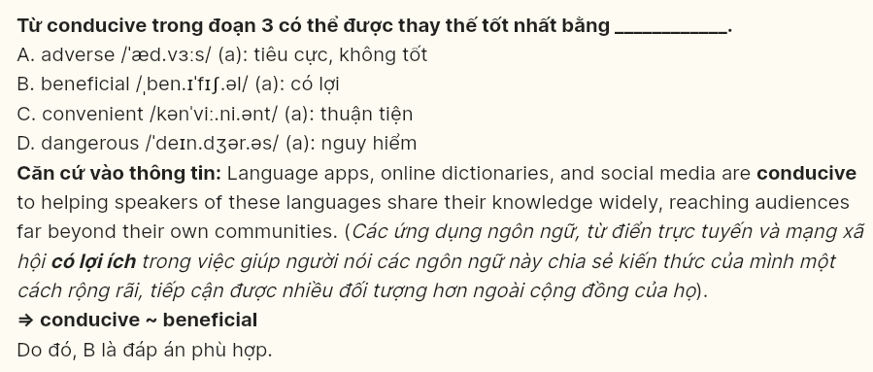

**Question 27 (696870):** Which of the following best paraphrases the underlined sentence in paragraph 4?  
A. Language reflects traditions, wisdom, and worldview, beyond simple communication.  
B. Language conveys simple ideas without carrying traditions, wisdom, and worldview.  
C. Language is a set of words and lacks traditions, wisdom, and worldview altogether.  
D. Language helps people communicate but excludes traditions, wisdom, and worldview.



**Question 28 (696871):** Which of the following is **TRUE** according to the passage?  
A. Dominant languages help preserve cultural heritage in multicultural societies.  
B. Bilingual education programs are designed to replace minority languages.  
C. Digital platforms can assist in sharing endangered languages with wider audiences.  
D. The survival of minority languages is guaranteed in the digital era.



**Question 29 (696872):** In which paragraph does the writer mention a causal relationship?  
A. Paragraph 1 B. Paragraph 2 C. Paragraph 3 D. Paragraph 4

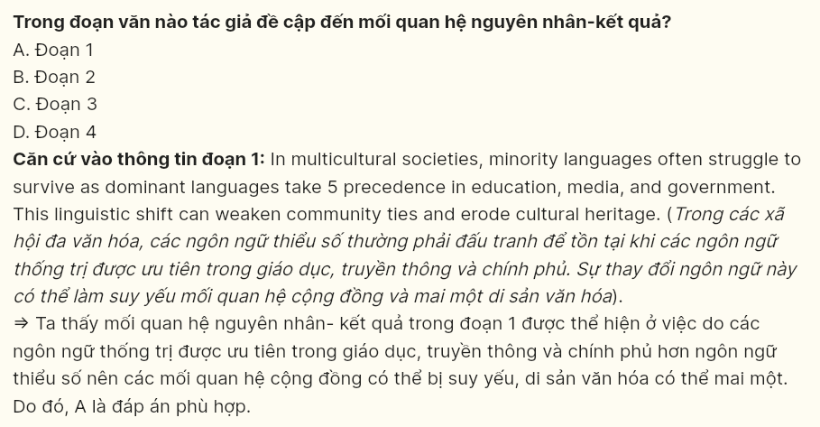

**Question 30 (696873):** In which paragraph does the writer emphasize modern methods for preserving cultural knowledge?  
A. Paragraph 1 B. Paragraph 2 C. Paragraph 3 D. Paragraph 4

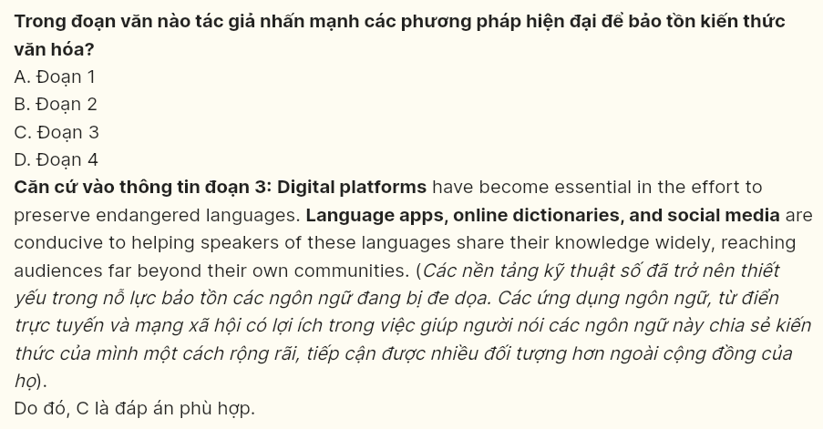

**Read the following passage and mark the letter A, B, C or D on your answer sheet to indicate the best answer to each of the following questions from 31 to 40.**



The rapid development of industry has been a driving force behind economic growth worldwide, providing employment and improving living standards. **[I]** From manufacturing to energy production, industries contribute significantly to modern society’s infrastructure. **[II]** Industrial activities release large amounts of greenhouse gases and pollutants, contaminate water sources, and contribute to deforestation. **[III]** The damage inflicted by industry is now a major concern for scientists and policymakers alike, as it endangers ecosystems and public health. **[IV]**

One of the most pressing issues linked to industrial growth is air pollution. Factories and power plants release vast quantities of carbon dioxide, sulfur dioxide, and other harmful emissions into the atmosphere, fueling climate change and contributing to respiratory diseases in humans. Water pollution is equally severe, with toxic industrial waste often dumped into rivers and oceans, damaging marine life and contaminating water supplies. Furthermore, the heavy reliance on non-renewable resources, such as coal and oil, **is taking a toll on** natural resources, intensifying environmental degradation. Combined, these factors underscore the urgent need to address the environmental repercussions of industrial activities.

To mitigate these effects, industries must adopt sustainable practices that reduce **their** environmental impact. One effective approach is the transition to clean energy sources, such as solar and wind, which produce **minimal** emissions compared to fossil fuels. Another solution is the implementation of stricter waste management practices to prevent hazardous materials from contaminating water bodies.

Additionally, investing in technology that improves energy efficiency in manufacturing processes can significantly reduce pollution. Governments can also enforce regulations that limit emissions and incentivize companies to adopt green practices, further promoting sustainable industrial development.

**While these changes require substantial investment and collective effort, they are essential for the long-term health of our planet.** By committing to sustainable practices, industries can balance growth with environmental responsibility, creating a future where both the economy and the natural world can thrive.

**Question 31 (696875):** Where in paragraph 1 does the following sentence best fit?  
**However, this progress has come at a high cost to the environment.**  
A. [I] B. [II] C. [III] D. [IV]

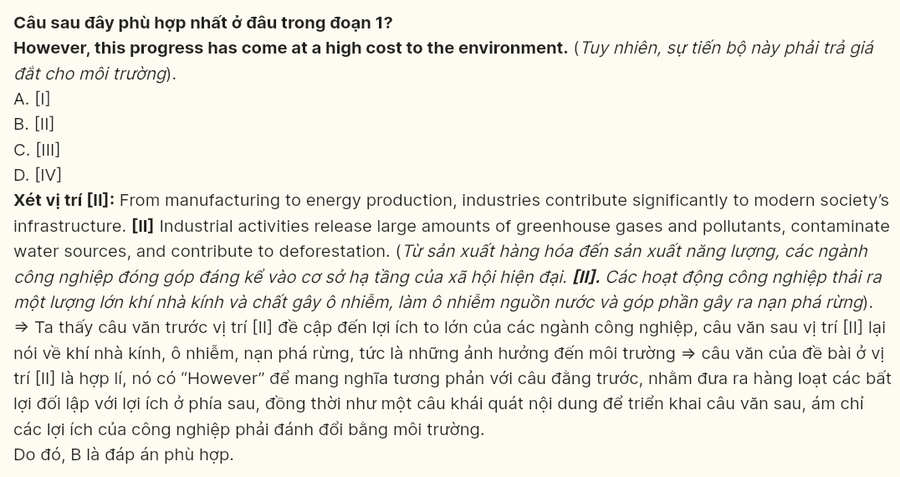

**Question 32 (696876):** The phrase **taking a toll on** in paragraph 2 could be best replaced by ______.  
A. causing damage to B. keeping track of  
C. taking advantage of D. making room for

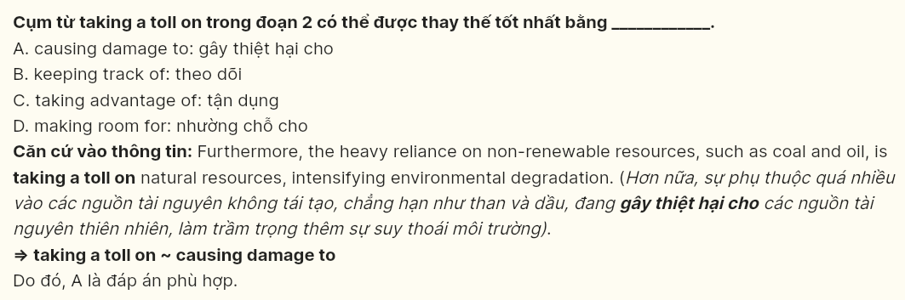

**Question 33 (696877):** The word **their** in paragraph 3 refers to ______.  
A. effects B. industries C. practices D. activities

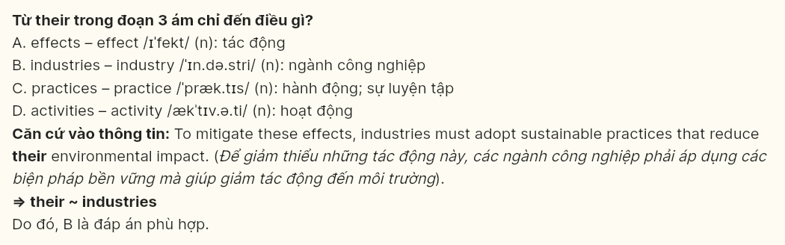

**Question 34 (696878):** According to paragraph 2, which of the following is **NOT** a consequence of industrial growth?  
A. an increase in respiratory health issues B. depletion of natural resources  
C. harm to marine ecosystems D. decline in urban safety

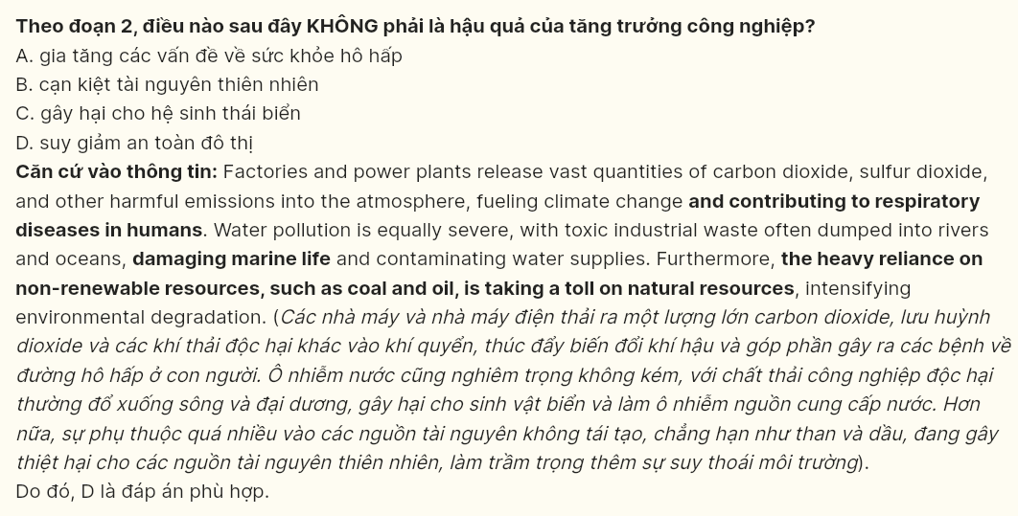

**Question 35 (696879):** Which of the following best summarises paragraph 3?  
A. Various industries produce more jobs, creating positive impacts on the economy, with minimal environmental effects if carefully managed.  
B. Implementing sustainable practices in industries, including clean energy and efficient technology, helps reduce pollution and environmental harm.  
C. Despite costly technology, industries’ focus on environmental policies increases pollution, challenging governments to control emissions and hazardous waste.  
D. Environmental benefits depend on switching to renewable energy sources and monitoring air pollution from industrial activities on a global scale.

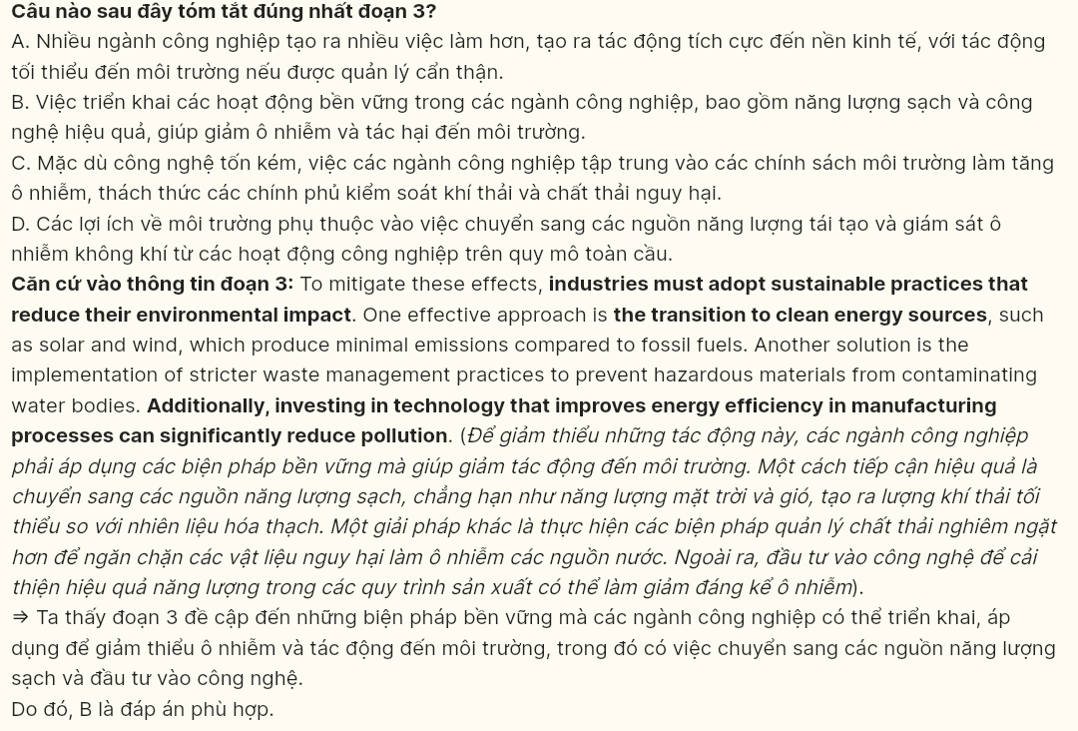

**Question 36 (696880):** The word **minimal** in paragraph 3 is **OPPOSITE** in meaning to ______.  
A. optional B. uttermost C. trivial D. adequate



**Question 37 (696881):** Which of the following is **TRUE** according to the passage?  
A. Industrial development has led to an overall decrease in water pollution worldwide.  
B. Scientists and policymakers see industrial emissions as an inevitable cost of economic growth.  
C. Non-renewable resources like coal and oil have a minor impact on environmental degradation.  
D. Governments are encouraged to implement policies that promote sustainable industrial practices.

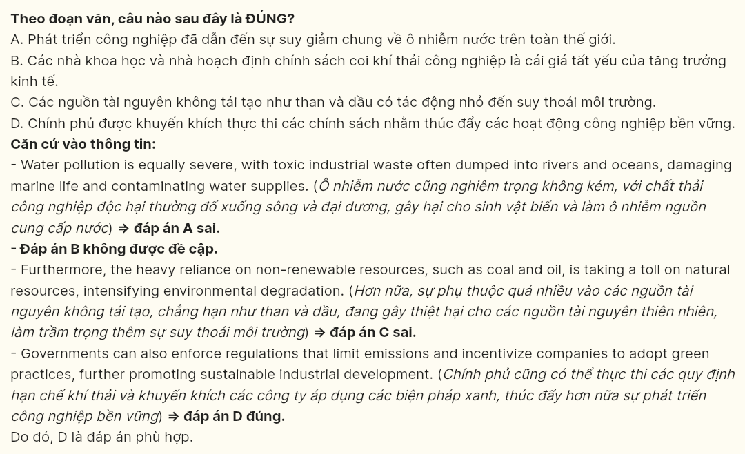

**Question 38 (696882):** Which of the following best paraphrases the underlined sentence in paragraph 4?  
A. Not until these changes are implemented will the long-term health of our planet be achieved in spite of the high cost and individual effort.  
B. Were these changes to be implemented for the long-term health of our planet, they would demand much investment or combined effort.  
C. These changes are important for the long-term health of our planet despite demanding significant investment and combined efforts.  
D. Because these changes are costly and require combined efforts, they are not vital for the long-term health of our planet.

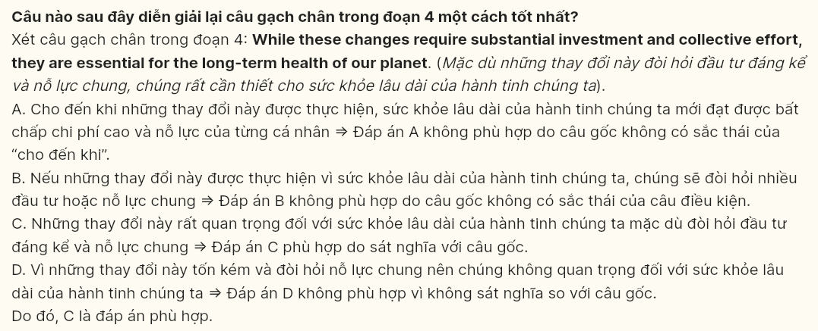

**Question 39 (696883):** Which of the following is **TRUE** according to the passage?  
A. Sustainable practices can enable industries to achieve both economic and environmental goals in the long term.  
B. Industrial development will have limited economic benefits if sustainable practices are widely implemented.  
C. The economy and the environment are unlikely to coexist if industries continue unsustainable practices.  
D. Industries will face fewer regulatory challenges if they prioritize economic growth over environmental health.

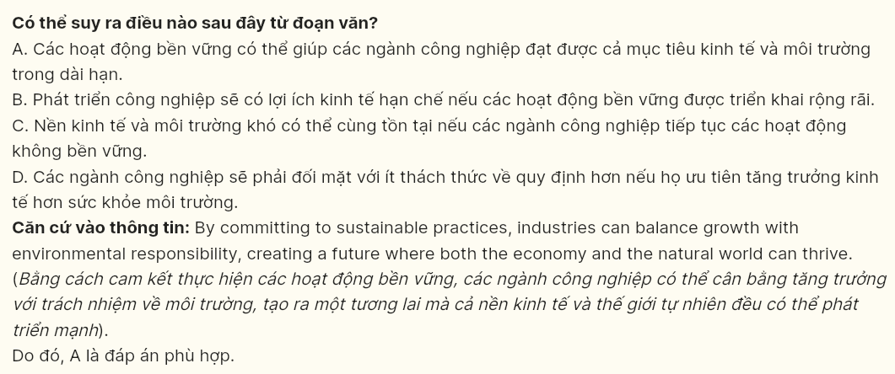

**Question 40 (696874):** Which of the following best summarises the passage?  
A. Industrial growth enhances the economy, but government regulation alone can solve environmental issues caused by resource depletion.  
B. Industrial activities have advanced the economy by creating jobs, yet these activities contribute heavily to pollution and resource depletion.  
C. Industrial growth has driven economic development but has also caused significant environmental damage, leading to calls for more sustainable practices.  
D. Industrial expansion has created opportunities for economic growth and better living standards, while environmentalists urge stricter pollution control.



