UNIT 3: COMMUNITY SERVICE
Lesson 1: GETTING STARTED p28-29

I. OBJECTIVES
.
By the end of this lesson, Ss will be able to gain:
1. Knowledge
- An overview about the topic “Community service”
- Lexical items related to community activities
2. Core competence
- Develop communication skills and enhance awareness of preserving the culture
- Be collaborative and supportive in pair work and teamwork
- Actively join in class activities
3. Personal qualities
- Develop self-study skills
- Raise students’ awareness of the need to keep their neighbourhood green

II. MATERIALS
- Grade 7 textbook, Unit 3: Getting Started
- Computer connected to the Internet
- Projector/ TV/ Pictures and cards
- sachmem.vn

Language analysis
Form | Pronunciation | Meaning | Vietnamese equivalent
1. community activity (n.phr.) | /kəˈmjuːnɪti ækˈtɪvɪti/ | doing things because we want to give back to our communities or help others | hoạt động cộng đồng
2. donate (v) | /dəʊˈneɪt/ | giving money or goods to help a person or organization | quyên góp, ủng hộ
3. nursing home (n.phr.) | /ˈnɜːsɪŋ həʊm/ | a place where very old people who are ill live and receive medical treatment and care | viện dưỡng lão
4. homeless (adj) | /ˈhəʊmləs/ | without a home | vô gia cư

III. PROCEDURE

TIME | T’S ANS SS’ ACTIVITIES | CONTENT
5’ | (group work)  * Teacher asks students to make a list of activities:  - T calls some to present.  - T gives feedback. | I. WARM-UP  *Warm-up  Community service Community activities  (work that people do without payment to help other people).
5’  5’  8’  6’  6’ | - T elicits new words, using some techniques (maybe definition, pictures)  T. asks Ss to copy down  T introduces the lesson, using picture  T. has Ss listen and read the conversation once.  Ss check their answers by themselves.  .  Tick  - Teacher asks students to work individually to complete the table.  - Students do the task individually.  - Teacher allows students to swap their textbooks to peer check first.  - Teacher confirms the answers and gives feedback, if necessary.  Gap - Fill  - Teacher asks students to work individually to complete each of the sentences with a suitable word / phrase from the box. All of these words / phrases have been learnt in.  - Students do the task individually.  - Teacher allows students to swap their textbooks to peer check first.  Teacher gives feedback.  Gap - Fill  - Teacher asks students to work individually to complete each of the sentences with a suitable word / phrase from the box. All of these words / phrases have been learnt in.  - Students do the task individually.  - Teacher allows students to swap their textbooks to peer check first.  Teacher gives feedback. | II. VOCABULARY  * Pre teach vocabulary:  - community activity /kəˈmjuːnɪti ækˈtɪvɪti/  (n.phr): hoạt động cộng đồng  - donate (v) /dəʊˈneɪt/ quyên góp  - nursing home (n.phr.)/ˈnɜːsɪŋ həʊm/ (n) viện dưỡng lão  - homeless (adj) /ˈhəʊmlɪs/ :trẻ em vô gia cư  III. TASKS  1. Listen and read. P28  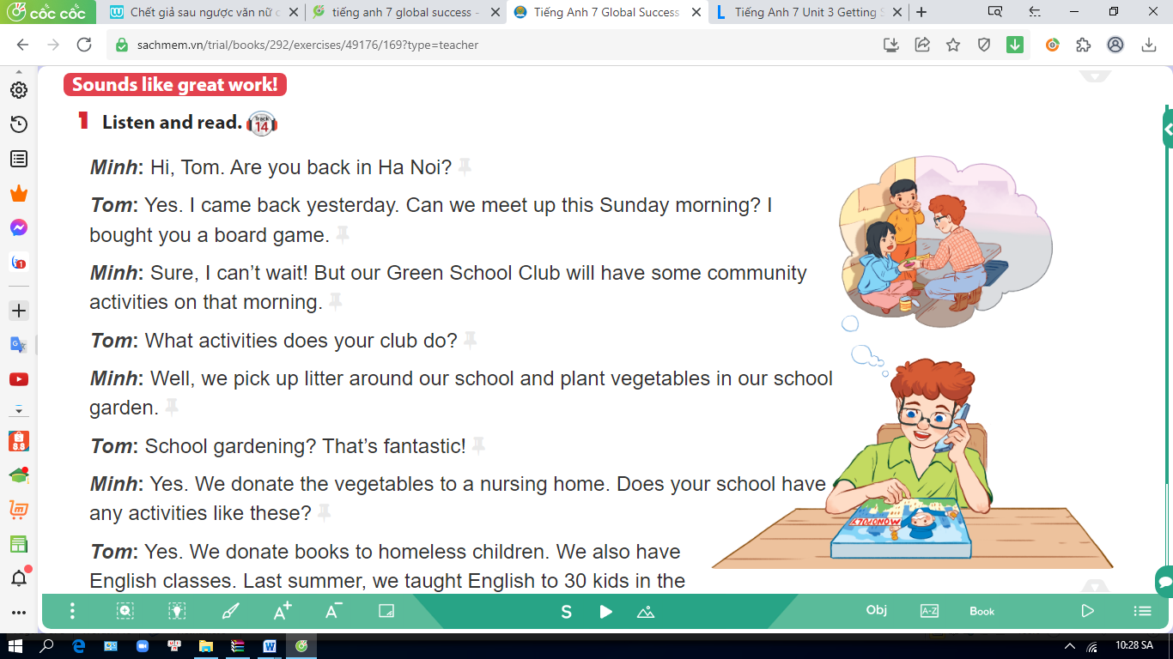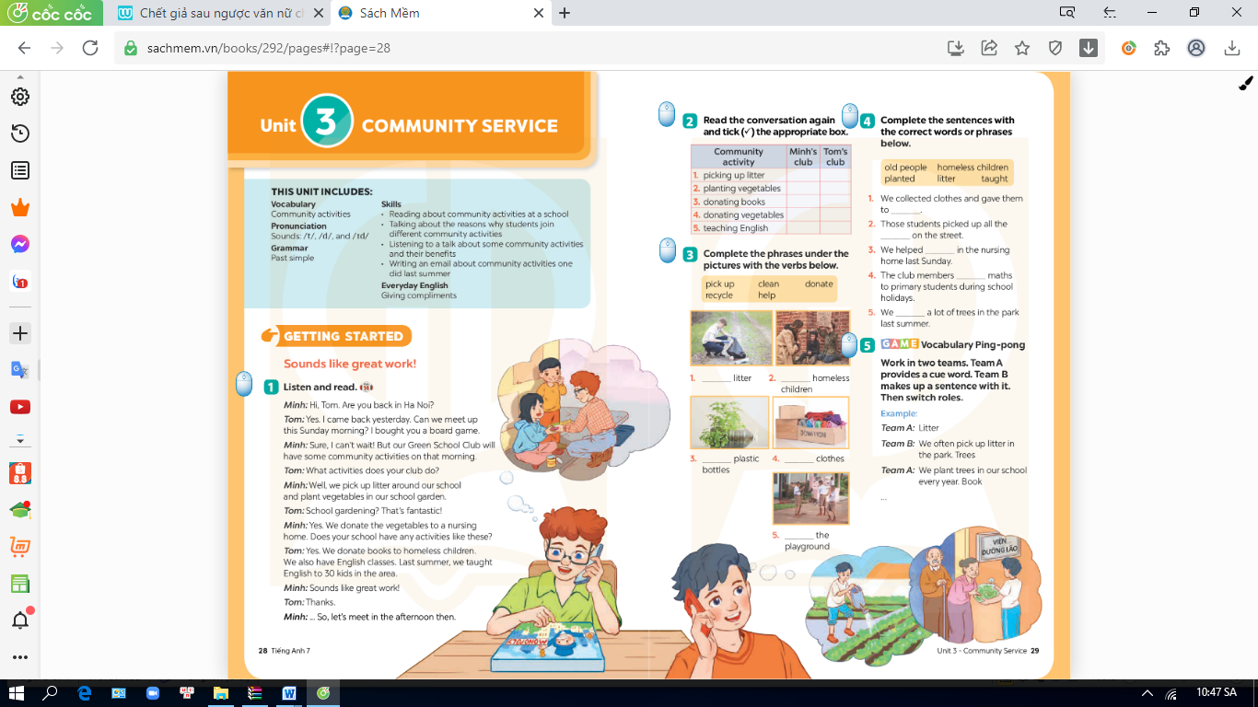  2. Read the conversation again and tick (✓) the appropriate box. P29  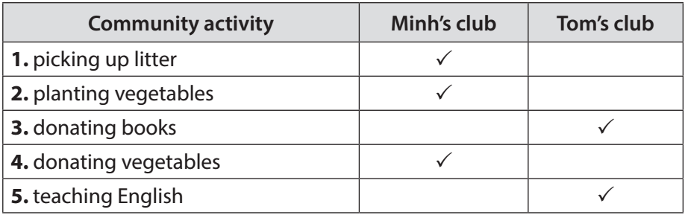  * 3. Complete the phrases under the pictures with the verbs below.  pick up clean doante  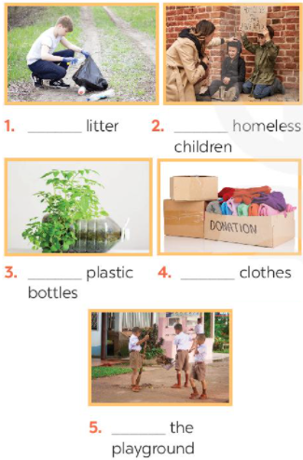  recycle help  *Answer Key  1. pick up litter (nhặt rác)  2. help homeless children (giúp đỡ trẻ vô gia cư)  3. recycle plastic bottles (tái chế chai nhựa)  4. donate clothes (quyên góp quần áo)  5. clean the playground (dọn dẹp khu vui chơi)  4. Complete the sentences with the correct words or phrases below.  old people homeless children  planted litter taught  1. We collected clothes and gave them to___________.  2. Those students picked up all the _________ on the street.  3. We helped ________ in the nursing home last Sunday.  4. The club members __________ maths to primary students during school holidays.  5. We _______ a lot of trees in the park last summer.  *Answer Key  1. homeless children  2. litter  3. old people  4. taught  5. planted
8’ | Work in two teams.  Team A provides a cue words.  Team B makes up a sentence with it. Then switch roles | * Task 5: GAME . Vocabulary Ping-Pong  Example:  Team A: Litter  Team B: We often pick up litter in the park. Trees.  Team A: We plan trees in our school every year. Book.
2’ | - Ss take notes and do at home. | IV. HOMEWORK  - Learn the vocabulary.  - Write at least 3 activities which you can do to make your neighborhood to be a greener place.  - Prepare Unit 3 (A Closer look 1 p30)  – Review community service activity
V. Teacher’s reflexion:
……………………………………………………………………………………………………………………………………………………………………………………………………

