UNIT 11: TRAVELLING IN THE FUTURE
Lesson 5: Skills 1

I. OBJECTIVES
By the end of this lesson, Ss will be able to gain:
1. Knowledge
+ Reading:
- read for general and specific information about a future car.
+ Speaking:
talk about why a means of transport will / won’t be popular
2. Core competence
- Develop communication skills
- Be collaborative and supportive in pair work and team work
- Actively join in class activities
3. Personal qualities
Be benevolent and responsible
II. PREPARATIONS
1. Teacher
- Grade 7 textbook, laptop, TV/Projector/ pictures and cards, speakers, lesson plan, sachmem.vn…
2. Students
- Grade 7 textbook, notebooks, school things….
III. TEACHING PROCEDURES
ACTIVITY 1 – WARM – UP & INTRODUCTION (5’)
a) Aims:
- To introduce the topic of reading.
- To enhance students’ skills of cooperating with team mates.
- To lead in the lesson about Skills 1.
b) Contents: Play the game “Networking”
c) Products: Suggested answers
d) Teaching steps:
Teacher’s and students’ activities | Content
* Teacher asks Ss to think of the forms of transport they have used and any that they would like to experience.  ** Ss in groups to share.  *** Teacher calls on groups to see how many different forms of transport they can list. The group which has more corrects ones will be the winner.   Teacher confirms and corrects.  -Teacher leads students into the lesson by telling what they are going to learn: “In the lesson today, we are going to read and find some information about a kind of means of transport.” | Game: NETWORKING  FORMS OF TRANSPORT  Suggested answers:  tank, hot-air balloon, helicopter, yacht, bicycle, horse and carriage, RollsRoyce, hang glider, mule, double – decker bus, elephant, spaceship, etc.
ACTIVITY 2 – PRESENTATION (10’)
a) Aims:
- To lead in the reading skills.
- To provide students with some lexical items before reading the text.
b) Contents:
-
- Work in pairs. Discuss the following questions.
- Read Phong’s blog. Match the underlined words in the text with their meanings.
c) Products:
- Lists of vocabularies
- Answer key
d) Teaching steps:
Teacher’s and students’ activities | Content
*-Teacher introduces the vocabulary by:  + Providing the synonym or antonym of the words.  + Providing the pictures of the words.  + Providing the definition of the words.  Concept check: Rub out and Remember | READING  * Vocabulary  a. (to) charge [ visual + explanation]  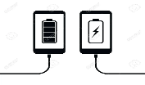  b. passenger (n) [ visual + explanation]  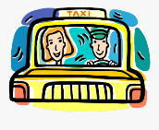  c. economical (a) [ visual + explanation]    d. autopilot (adj, n) [ visual + explanation]  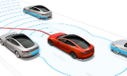  e. function (n) [ visual + explanation]  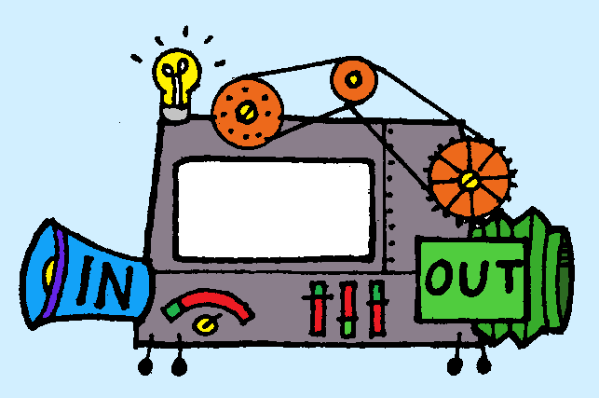  f. (to) run on [ visual + explanation]  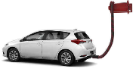  * BRAINSTORMING:  Task 1. Look at the picture and find the words or phrases to describe it. (Ex 1, p. 120)  Suggested answer:  The car: convenient, safe, comfortable, modern, automatic, automated, autopilot, etc.  The driver: relaxing / isn’t driving, etc.
ACTIVITY 3 – PRACTICE (20’)
a) Aims:
- To improve Ss’ skills of reading for the general idea.
- To improve Ss’ skills of reading for details.
- To check students’ reading comprehension.
- To enable Ss to ask and answer questions about a car company
b) Contents:
- Read the passage and answer the question.
- Read the passage again and complete the fact file with no more than two words or a number.
- Retelling
- Look at the fact file in 3 then ask and answer questions about it.
c) Products:
- Answer key
d) Teaching steps:
Teacher’s and students’ activities | Content
* Teacher tells Ss to read the text quickly and find out the main idea of the paragraph individually.  ** Ss work independently to read.  *** Some Ss read out their answer and explain their choices.   Teacher confirms, corrects, and explains that B and C are just facts.  * Teacher tells Ss that they are going to read to passage again to complete the table about the company and its car. Teacher also reminds Ss to look at the information on the left first before doing the task to guess what types of information they need to scan.  ** Ss work independently to do the task.  *** Teacher calls on some Ss to give their answers and points out where they can find the information.   Teacher corrects and confirms.  * Teacher asks Ss to close their books and just look at the table in task 2 to retell what they have read about “Roadrunner”.  ** Ss work on pairs, take turns to retell.  *** Some Ss retell all the information about “Roadrunner”.   Teacher listens and corrects if needed  * Teacher asks Ss to work in pairs to look at the table once more times to make questions about Roadrunner and its car based on the fact file in 3.  ** Ss work in pairs to make questions, then answer these questions.  *** Teacher calls on some pairs to role – play it in front of the class.   Teacher corrects Ss’ grammar and pronunciation mistakes if needed. | Task 2: Read the passage and answer the question. (Ex 2, p. 120)  Answer key: A  Task 3: Read the passage again and complete the fact file with no more than two words or a number. (Ex 3, p. 120)  Answer key:  * Retelling  SPEAKING  Task 4: Look at the fact file in 3 then ask and answer questions about it. (Ex 4, p. 120)  Suggested questions:  * When was Speed introduced? / When did they introduce Speed?  • What do you know about Safety? / What is special about Safety?  • What functions do these models have?  • What do these models run on?  • What can passengers do when they are travelling in the car?
ACTIVITY 4 – PRODUCTION (7’)
a) Aims:
- To help Ss practise reasoning skill
b) Contents:
- Discuss why Roadrunner’s cars will or won’t become popular in the near future. Report your reasons to the class.
c) Products:
- Ss’ reports
d) Teaching steps:
Teacher’s and students’ activities | Content
* Teacher writes on the board: “Why Roadrunner’s cars will or won’t become popular in the near future?” and asks Ss to work in groups to discuss it.  ** Ss work in groups to do the task. Teacher goes around to help them if needed.  *** Teacher invites one representative of each group to report the answers of their own group to the class | Task 5: Discuss why Roadrunner’s cars will or won’t become popular in the near future. Report your reasons to the class. (Ex 5, p. 120)  Suggested answers:  + Roadrunner’s cars will become popular in the near future, because they are fast / safe / comfortable /  modern.  + Roadrunner’s cars run on electricity, so they are eco-friendly / green / they do not pollute the  environment.  + Roadrunner’s cars have an autopilot function, so they are very comfortable and modern
IV. WRAP-UP & HOMEWORK (3’)
- Teacher has Ss summarise what they have learnt in the lesson with the two skills.
- read for general and specific information about a future car.
- talk about why a means of transport will / won’t be popular
- Teacher asks Ss to make a conversation, video and upload on given drive link.
- Teacher asks Ss to prepare the next lesson “Unit 11 – Skills 2”
V. FEEDBACK

……………………….…, ngày………….tháng…………..năm 2023
Duyệt của Tổ chuyên môn

