|  |  |
| --- | --- |
| UBND HUYỆN QUỲNH NHAI | **CỘNG HÒA XÃ HỘI CHỦ NGHĨA VIỆT NAM** |
| **PHÒNG GIÁO DỤC VÀ ĐÀO TẠO** | **Độc lập - Tự do - Hạnh phúc** |

SỐ BÁO DANH : …..........................

Họ và tên thí sinh dự thi :........................................................ Nam (Nữ) : ..............

Sinh ngày: Ngày ........ tháng ........ năm ..........

Nơi sinh : ..................................................................................................................

Học sinh trường : ....................................................................Học sinh lớp............

Hội đồng coi thi:……………………..........…………………………...…………..

|  |  |  |
| --- | --- | --- |
| **HỌ TÊN VÀ CHỮ KÝ CỦA GIÁM THỊ** |  | **Số phách**  *(do Trưởng ban phách ghi, thí sinh không được ghi vào ô này)* |
| Giám thị số 1 : .........................................................  Giám thị số 2 : .......................................................... | ..................................... |

**\* Chú ý :**

*- Thí sinh phải ghi đầy đủ các mục trên theo sự hướng dẫn của giám thị.*

*- Thí sinh không được ký tên hay dùng bất cứ kí hiệu gì để đánh dấu bài thi*

*(ngoài việc làm bài theo yêu cầu của giám thị).*

*- Bài thi không được viết bằng mực đỏ, bút chì, không viết bằng 2 thứ mực.*

*Phần viết hỏng ngoài cách dùng thước gạch chéo, không được tẩy xoá bằng*

*bất cứ cách gì khác (kể cả bút xoá).*

*- Trái với các điều trên, thí sinh sẽ bị loại./.*

|  |  |
| --- | --- |
| UBND HUYỆN QUỲNH NHAI  **PHÒNG GIÁO DỤC & ĐÀO TẠO**  **ĐỀ CHÍNH THỨC**  *(Đề thi có 10 trang)* | **ĐỀ THI GIAO LƯU HỌC SINH GIỎI 6,7,8 CẤP HUYỆN**  **NĂM HỌC 2022- 2023**  **Môn thi: TIẾNG ANH 6**  **Ngày thi: 20/4/2023**  *Thời gian làm bài: 120 phút không kể thời gian phát đề* |

|  |  |  |
| --- | --- | --- |
| **HỌ TÊN VÀ CHỮ KÝ CỦA CB CHẤM THI**  **CBChT số 1:**  **CBChT số 2:** | **SỐ PHÁCH**  ………………….  *(do Trưởng ban phách ghi, thí sinh không được ghi vào ô này)* | **SỐ ĐIỂM**  Bằng số:…………  Bằng chữ:……….  ………………….. |

**SECTION A: LISTENING**

***Part I. Listen and tick  the box. Then write A,B,C or D in the box below***

1.Where does her brother work?

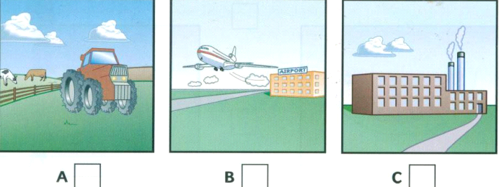

2. How does he go to work?

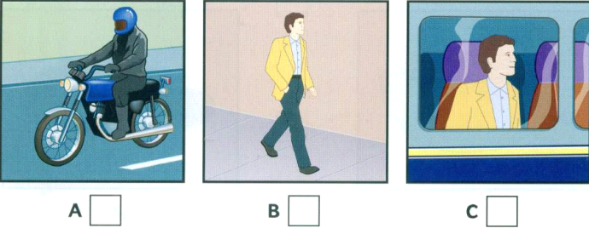

3. When does he start work?

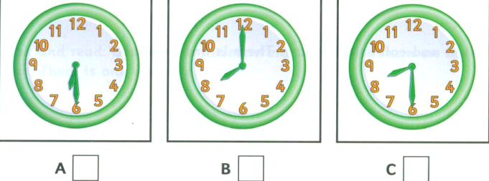

4. What does he do for lunch ?

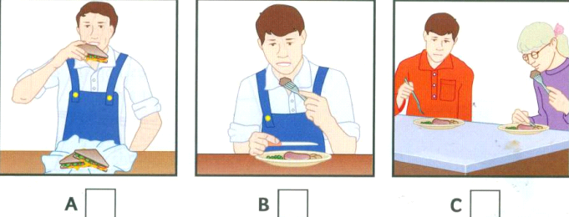

5. What did he do before he started this job?

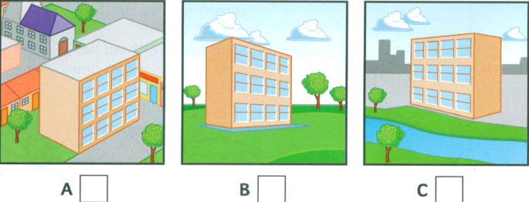

**Write your answer here:**

|  |  |  |  |  |
| --- | --- | --- | --- | --- |
| 1. | 2. | 3. | 4. | 5. |

***Part II.* Listen to a conversation and decide if the statements are true (T) or false (F).**

|  |  |  |
| --- | --- | --- |
|  | **T** | **F** |
| 1. Sarah is a teacher. |  |  |
| 2. She usually arrives at work at nine o’clock. |  |  |
| 3. Sarah always brings a sandwich from home. |  |  |
| 4. She often has work to do in the evening. |  |  |
| 5 She never goes out during the week. |  |  |

**Write your answer here:**

|  |  |  |  |  |
| --- | --- | --- | --- | --- |
| 1. | 2. | 3. | 4. | 5. |

***Part III. Listen and fill in the gaps in the table.***

|  |  |  |
| --- | --- | --- |
| **Student 1:**  Name: Celine **(0)**Poulain  Nationality: French  Age: 25  Job**:(1)**___________ | **Student 2:**  Name: Manuel Garcia  Nationality: **(2)** ___________  Age: 32  Job: Engineer | **Student 3:**  Name: Eva **(3)**___________  Nationality: Finnish  Age: **(4)** ___________  Job: **(5)** ___________ |

**Write your answer here:**

|  |  |
| --- | --- |
| ***1.*** | ***4.*** |
| ***2.*** | ***5.*** |
| ***3.*** |  |

***IV. Listen and choose the correct answer.***

1. Which sentence is TRUE?

A. Nam’s thinking about getting married.

B. Nam’s thinking about getting a new TV.

C. Nam’s thinking about getting a new apartment.

2. Trang _________________ watches television.

A. always B. usually C. rarely

3. What is Nam’s favorite TV program?

A. Music programs.

B. The news.

C. The sports.

4. When will they go to the show “Who wants to be a Millionaire?”?

A. On Friday night.

B. On Saturday night.

C. On Sunday night.

5. Why does Trang want to come back home?

A. Because she wants to see the game shows.

B. Because she wants to do her homework.

C. Because she wants to see the final episode of her favorite show.

**Write your answer here:**

|  |  |  |  |  |
| --- | --- | --- | --- | --- |
| 1. | 2. | 3. | 4. | 5. |

**SECTION B. PHONETICS, LEXICO AND GRAMMAR**

**Part I. Choose the word whose underlined part differs from the other three in pronunciation in each of the following questions**

1. A. armchair B. sandwich C. chocolate D. school

2. A. knee B. market C. know D. knife

3. A. travelled B. started C. decided D. visited

**Write your answer here:**

|  |  |  |
| --- | --- | --- |
| 1. | 2. | 3. |

**Part II. Choose the word that differs from the other three in the position of the main stress in each of the following questions.**

1. A. actor B. resort C. writer D. island

2. A. action B. fantasy C. adventure D. thriller

**Write your answer here:**

|  |  |
| --- | --- |
| 1. | 2. |

**Part III. Choose the best option (A, B, C or D) to complete each of the following questions.**

1. I don’t like beef. Don’t you have ................................?

|  |  |  |  |
| --- | --- | --- | --- |
| A. some chicken | B. no chicken | C. any chicken | D. a chicken |

2. Son La is famous for …………… beauty.

|  |  |  |  |
| --- | --- | --- | --- |
| A. it’s | B. its | C. it | D. their |

3. I drink ………….coffee than you.

|  |  |  |  |
| --- | --- | --- | --- |
| A. little | B. less | C. few | D. fewer |

4. It’s very hot. ..................... swimming?

A. Why don’t we go B. Let’s go C. What about go D. How to go

5. Minh’s father’s brother is his..................... .

     A. grandparents      B. grandfather  C. grandmother            D. uncle

6. This programme is very..................... .

|  |  |  |  |
| --- | --- | --- | --- |
| A. educate | B. education | C. aducational | D. educating |

7. If it ………………. This afternoon, we won’t go to the park.

A. will rain B. don’t rain C. rain D. rains

8. Who is ..................... of the two girls ?

A. tallest B. the tallest C. taller D. more tall

9. One of them ..................... a red car.

A. has B. having C. have D. had.

10. ……are you going to stay here? - ..................... about three days.

A. How long - For B. How far – For C. How long - At D. How long - From

11. When . . . . . to Quynh Nhai ? - In 2010

A. have you gone B. did you go C. do you go D. will you go

12. A: Would you like a glass of lemon juice? – B: ……………... I’m very thirsty

A. No, am not. B. No, I don’t like. C. No, thanks. D. Yes, please.

13. Lan hates playing football. .....................does Hoa.

A. So B. Too C. Neither D. Either

14. We ………………… cross the street outside the zebra crossing

A. should to B. Shouldn’t C. ought D. should

15. Tony plays badminton at ……………….. every Saturday morning.

A. a quarter to eight B. eight to a quarter C. eight quarter D. a quarter eight to

16. .....................is the capital of Great Britain.

A. Paris B. England C. New York D. London

17. Peter likes ……………………. weather because he can go swimming.

A. snowy B. foggy C. Hot D. cold

18. It is hot, I……………………. turn on the fan.

A. is going to B. am going to C. are going to D. will

19. Vivian can wait hours for her friends without getting angry. She is a………… girl.

A. hard-working B. free C. patient D. active

20. How was your holiday? - ...................... .

A. It was hot and sunny B. It was great

C. That sounds great. D. That’s a good idea

|  |  |  |  |  |
| --- | --- | --- | --- | --- |
| **1.** | **2.** | **3.** | **4.** | **5.** |
| **6.** | **7.** | **8.** | **9.** | **10.** |
| **11.** | **12.** | **13.** | **14.** | **15.** |
| **16.** | **17.** | **18.** | **19.** | **20.** |

**Part IV. Supply the correct tense or form of the verbs in brackets.**

1 you (watch) a film on TV last night?

1. If I finish my homework, I (come) with you.
2. My brother (not/listen) to rock music. He hates it.
3. If you want to lose weight, you should (do) some exercise.
4. They (learn) English since last year.

**Write your answer here:**

|  |  |  |
| --- | --- | --- |
| **1.** | **2.** | **3.** |
| **4.** | **5.** |  |

**Part V. There is one mistake in each sentence. Identify the mistake and write your answers in the space provided.**

1. I would liketo buya packet of tea and a bar of toothpaste.

A B C D

2. My classmatesalwayshave a picnictwo a year.

A B C D

3. It isexpensivestaying at Rocky Bay hotel.

A B C D

4. These color televisions are too expensive for we to buy at this time.

A B C D

5. We likes watching TV at night but our parents lovereading newspapers.

A B C D

**Write your answer here:**

|  |  |  |  |  |
| --- | --- | --- | --- | --- |
| 1. | 2. | 3. | 4. | 5. |

**Part VI. Give the correct form of the words in capital to complete the sentences.**

|  |  |
| --- | --- |
| 1. I have a sister. She is a ______________. | **POLICE** |
| 2. Paul turns out to be the _____________________student in our school. | **GOOD** |
| 3. Her birthday is on the____________of September. | **TWENTY** |
| 4. There are five____________in the kitchen. | **KNIFE** |
| 5. They often play sports. They are very______________ | **SPORT** |

**Write your answer here:**

|  |  |  |
| --- | --- | --- |
| **1.** | **2.** | **3.** |
| **4.** | **5.** |  |

**SECTION C. READING COMPREHENSION**

**Part I. Choose the word (A, B, C, or D) that best fits each of the blank spaces.**

We live in the suburbs, and it’s just too (1) ! There aren’t (2) shops, and there are certainly (3) clubs or theaters. (4) a lot of parks, good schools, and very (5) crime: but nothing ever really happens here. I would really love living downtown.

1. A. noisy B. noisily C. quiet D. quietly

2. A. much B. many C. more D. a lot of

3. A. not B. nothing C. none D. no

4. A. Has B. Having C. There is D. There are

5. A. little B. less C. many D. lots of

**Write your answer here:**

|  |  |  |  |  |
| --- | --- | --- | --- | --- |
| 1. | 2. | 3. | 4. | 5. |

**PartII. Read the passage below and choose the best answer from A, B, C, or D.**

Hi. My name is Anh. I am from Vietnam. **It** is a small and beautiful country in South-East Asia. I live in the north and it has four seasons: spring, summer, fall and winter. The weather is often warm in the spring. However, it sometimes rains and I don’t like rain at all. In the summer, it’s hot and sunny. A lot of people often go swimming, fly their kites or go to the beach in this season. It’s cool in the fall and it’s very cold and windy in the winter. Most people like fall because the weather is very pleasant and they can do a lot of activities outside like going fishing, jogging, sailing. However, my favorite season is winter. I like cold weather. When winter comes, I often go for a walk around the park near my house in the evening. Many people think that it’s crazy but I really feel relaxed and entertained. I sometimes go climbing in the winter because I like mountains. When it’s not very cold, I also like to ride my bike to the city center to watch movies or eat out with my friends. I don’t like hot weather so I hate summer. When it’s hot, I don’t like going out. I just want to stay home and watch football matches on TV.

1. What does the word “**It**” in line 1 mean?

A. Anh B. Vietnam C. Anh’s house D. the north

2. How many seasons are there in the north of Vietnam?

A. 2 B. 3 C. 4 D. 5

3. What’s the weather like in the spring?

A. It’s hot and rainy. B. It’s cold and sometimes rainy.

C. It’s warm and sometimes rainy. D. It’s cold.

4. What do people do when it’s hot and sunny?

A. They often go swimming and go to the beach. B. They often fly their kites.

C. They do nothing D. Both A and B are correct.

5. What’s the weather like in the winter?

A. I’s cold and windy. B. It’s cold and rainy.

C. It’s warm. D. It’s hot.

6. What weather does Anh like?

A. He likes cool weather. B. He likes cold weather.

C. He likes hot weather. D. He likes windy weather

7. What does Anh do when it’s not very cold?

A. He watches movies or eats out with his friends in the city. B. He goes hiking.

C. He goes swimming. D. He sleeps.

8. What does Anh do when it’s hot?

A. He plays football. B. He eats out with his friends.

C. He watches football matches on TV at home. D. He plays badminton

9. Why do most people like fall? – Because_________________.

A. they can stay at home. B. they can do a lot of activities

C. they can play chess D. they can watch TV

10. He doesn’t like summer because_____________.

A. it’s crazy B. he doesn’t like hot weather

C. he doesn’t like swim D. he doesn’t like going out.

**Part III. Read the passage and check T/ F for each statement below.**

Smoke and waste chemicals are polluting the air and our environment. We are wasting too much power. Smokes from cars, buses, trucks and motorbikes are very harmful. We are producing too much trash. This is polluting the land, the rivers and the oceans, too. What should we do to protect our environment? We should save water and electricity. We shouldn’t leave our trash in the country. We should collect used paper, bottles and cans. We can recycle them to save the natural resources.

**Statements**

1. Smokes from vehicles are harmful.

2. Waste chemicals pollute the air.

3. We aren’t wasting too much power.

4. We can’t recycle used bottles and cans.

5. We should save the natural resources.

**SECTION D. WRITING**

**Part I. Complete the second sentence so that it has the same meaning as the first one.**

1. No hotel on the street is newer than this hotel.

=> This hotel __________________________________________________.

2. I met Frank three years ago and we are still friends.

=> Frank and I have been ____________________________________________.

3. What is the price of a bowl of noodles?

=>How much ______________________________________________________?

4. Mrs. Brown wants twelve eggs.

=>Mrs. Brown wants a ___________________________________________.

5. This box has twelve packets of tea.

=>There ___________________________________________________________

**Part II. Arrange the words to make sentences.**

1. Lisa/ is/to /going / a sleepover / have / with/ school / her / friends.

=>___________________________________________________________

2. He/ picking / likes / up/ at / bargains / markets.

=>___________________________________________________________

3. We/travel /will / abroad/summer/this / if/enough / have/we / money.

=>___________________________________________________________

4. I/ enjoy/ because / documentaries/ watching / are / they / educational.

=>___________________________________________________________

5. You/ spend / can / the/ museums / at/ night / in/ real/ life.

=>___________________________________________________________

**Part III. Imagine you are going on holiday in a city. Now write a paragraph tell about it. Your writing should include:**

* **Where you are**
* **When you arrived**
* **Who you are with**
* **Where you are staying**
* **What you have done**
* **What you are doing tomorrow**
* **How you are feeling**

**Write about 60 words**

|  |
| --- |
|  |
|  |
|  |
|  |
|  |
|  |
|  |
|  |
|  |
|  |
|  |
|  |
|  |
|  |
|  |
|  |
|  |
|  |

**HƯỚNG DẪN CHẤM THI GIAO LƯU HSG 6,7,8**

**Năm học: 2022-2023**

**Môn: Tiếng Anh 6**

**SECTION 1: LISTENING. (20 points)**

***Part 1. Listen and tick  the box.***

***5 x 0,2 = 1 point***

|  |  |  |  |  |
| --- | --- | --- | --- | --- |
| 1. C | 2. A | 3. B | 4. A | 5. C |

***Part II.* Listen to a conversation and decide if the statements are true (T) or false (F).**

***5 x 0,2 = 1 point***

1. T 2 F 3. F 4. T 5. F

***Part III.* Listen to a school secretary talking to one of the teachers and fill in the gaps in the table.**

***5 x 0,2 = 1 point***

1. doctor 2. Mexican 3. Lipponen 4. twenty-one / 21 5. Artist

***Part IV. Listen and choose the correct answer.***

***5 x 0,2 = 1 point***

|  |  |  |  |  |
| --- | --- | --- | --- | --- |
| 1. B | 2. C | 3. A | 4. B | 5. C |

**SECTION B. PHONETICS, LEXICO AND GRAMMAR**

**Part I. Choose the word whose underlined part differs from the other three in pronunciation in each of the following questions**

**(3 x 0,2 = 0,6 points).**

|  |  |  |
| --- | --- | --- |
| 1. D | 2. B | 3. A |

**Part II. Choose the word that differs from the other three in the position of the main stress in each of the following questions**

**(2 x 0,2 = 0,4 points).**

|  |  |
| --- | --- |
| 1.B | 2.C |

**Part III. Choose the best option (A, B, C or D) to complete each of the following questions. (20 x 0,2 = 4 points).**

|  |  |  |  |  |
| --- | --- | --- | --- | --- |
| 1. C | 2. B | 3. B | 4. A | 5. D |
| 6. C | 7. D | 8. C | 9. A | 10. A |
| 11.B | 12.D | 13.A | 14.B | 15.A |
| 16.D | 17.C | 18.D | 19.C | 20.B |

**Part IV. Supply the correct tense or form of the verbs in brackets.**

***5 x 0,2 = 1 point***

|  |  |  |  |  |
| --- | --- | --- | --- | --- |
| 1. Did you watch | 2. will come | 3. doesn’t listen | 4. do | 5. have learned/ have learnt |

**Part V. There is one mistake in each sentence. Identify the mistake and write your answers in the space provided.**

***5 x 0,2 = 1 point***

|  |  |  |  |  |
| --- | --- | --- | --- | --- |
| 1. D | 2. D | 3. C | 4.C | 5. A |

**Part VI. Give the correct form of the words in capital to complete the sentences.**

***5 x 0,2 = 1 point***

|  |  |
| --- | --- |
| **1.Policewoman** | **2.best** |
| **3.twentieth** | **4.knives** |
| 1. **sporty** |  |

**SECTION C. READING COMPREHENSION**

**Part I. Choose the word (A, B, C, or D) that best fits each of the blank spaces.**

***5 x 0,2 = 1 point***

|  |  |  |  |  |
| --- | --- | --- | --- | --- |
| **1.C** | **2.B** | **3.D** | **4.D** | **5.B** |

**PartII. Read the passage below and choose the best answer from A, B, C, or D.**

***10 x 0,2 = 2 points***

|  |  |  |  |  |
| --- | --- | --- | --- | --- |
| 1. B | 2. C | 3. C | 4. D | 5. A |
| 6. B | 7. A | 8. C | 9. B | 10. B |

**Part III. Read the passage and check T/ F for each statement below.**

***5 x 0,2 = 1 point***

|  |  |  |  |  |
| --- | --- | --- | --- | --- |
| **1.T** | **2.T** | **3.F** | **4.F** | **5.T** |

**SECTION C. WRITING**

**Part I. Complete the second sentence so that it has the same meaning as the first one.**

***5 x 0,2 = 1 point***

1. This hotel is the newest hotel on the street.

2. Frank and I have been friends for three years.

3. How much does a bowl of noodles cost?/ How much is a bowl of noodles?

4. Mrs. Brown wants a dozen eggs

5. There are twelve packets of tea in this box.

**Part II. Arrange the words to make sentences**

***5 x 0,2 = 1 point***

1. Lisa is going to have a sleepover with her school friends.

2. He likes picking up bargains at markets.

3. We will travel abroad this summer if we have enough money.

4. I enjoy watching documentaries because they are educational.

5. You can spend the night at museums in real life.

**Part III. Imagine you are going on holiday in a city. Now write a paragraph tell about it. 2 points**

Đúng mẫu, từ vựng tốt 0,6 điểm

* **Where you are** 0,2 điểm
* **When you arrived** 0,2 điểm
* **Who you are with** 0,2 điểm
* **Where you are staying** 0,2 điểm
* **What you have done** 0,2 điểm
* **What you are doing tomorrow** 0,2 điểm
* **How you are feeling** 0,2 điểm

Cứ sai 1 lỗi ngữ pháp hoặc 2 lỗi chính tả trừ 0.05 điểm