|  |  |
| --- | --- |
|  | *Thời gian làm bài: 40 phút (Không kể thời gian giao đề)*  *-------------------------* |

**Họ tên thí sinh: .................................................................**

**Số báo danh: ......................................................................**

**Mã Đề: 011.**

**Câu 1.** How many students is the snack shop looking for?

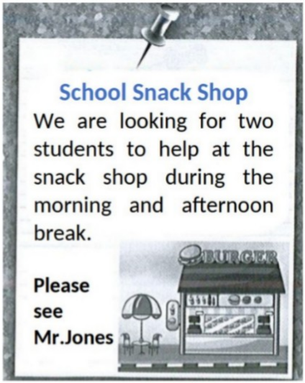

**A.** One  **B.** Two  **C.** Four  **D.** Three

**Câu 2.** **Look at the signs. Choose the best answer for the question.**

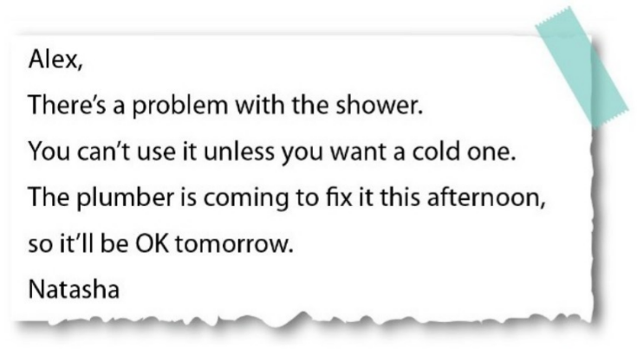

**A.** Alex can’t take a shower until tomorrow.

**B.** Alex prefers taking a cold shower today.

**C.** It is impossible to have a hot shower this morning.

**D.** The plumber will repair the shower tomorrow.

**Câu 3.** What is the main reason James cannot attend the concert?

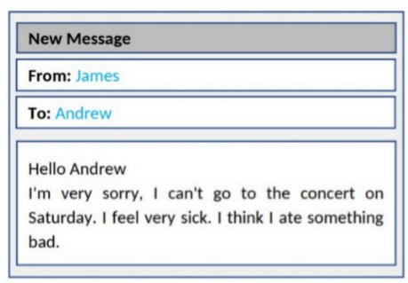

**A.** He is feeling unwell  **B.** He doesn't like the music

**C.** He has another commitment  **D.** He lost his ticket

**Câu 4.** What subject does John need help with?

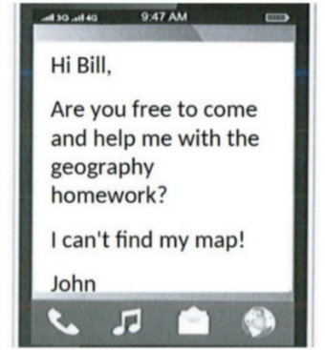

**A.** History  **B.** Math  **C.** Geography  **D.** English

**Câu 5.** What does Rachel offer to do?

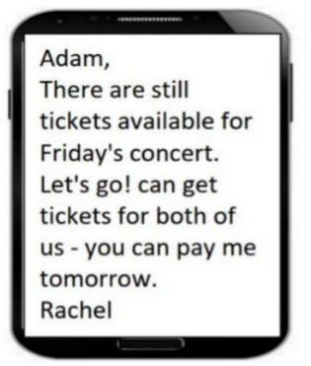

**A.** Reserve tickets for Adam  **B.** Get tickets for both of them

**C.** Buy tickets for Adam  **D.** Pay for both tickets

**Câu 6.** When can students receive a 20% discount at Sam's Café?

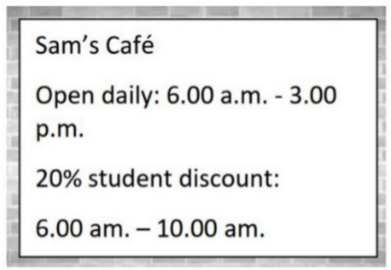

**A.** All day  **B.** From 6:00 a.m. to 10:00 a.m.

**C.** After 10:00 a.m.  **D.** From 6:00 a.m. to 3:00 p.m.

**Câu 7.** What activity is being proposed in the message?

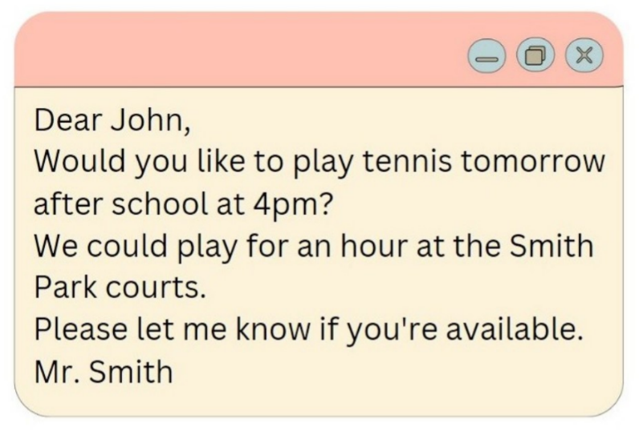

**A.** Playing tennis  **B.** Playing basketball  **C.** Going swimming  **D.** Going for a run

**Câu 8.** **Look at the signs. Choose the best answer for the question.**

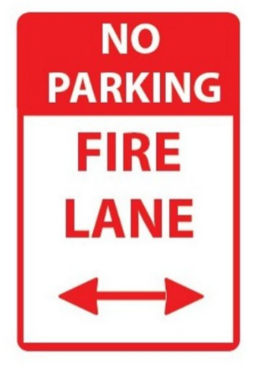

**A.** If there is a fire, park your vehicle in this area.

**B.** This area prevents your cars from fire.

**C.** You can’t park your car here when it is on fire.

**D.** You can’t park your car here because this area is for fire trucks.

**Câu 9.** **Look at the signs. Choose the best answer for the question.**

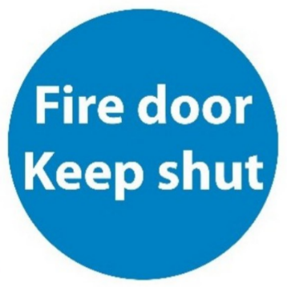

**A.** This door must remain closed to prevent the spread of fire.

**B.** You should only shut the door when it is on fire.

**C.** You mustn’t put the door on fire.

**D.** You should keep the door open unless there is a fire.

**Câu 10.** What are the things that Mom asked her kid to pick up?

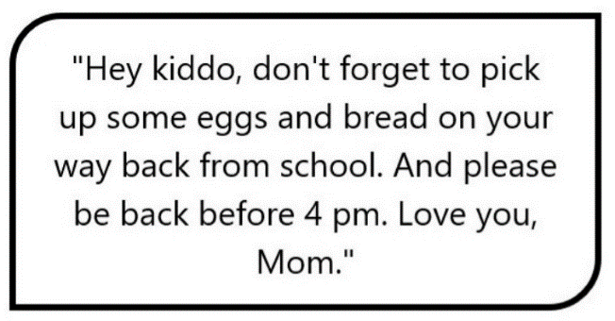

**A.** Eggs, bread, and milk  **B.** Eggs and milk

**C.** Bread and milk  **D.** Eggs and bread

**----HẾT---**