**LỚP HỌC THẦY (CÔ) ___________________________** **ĐỀ ÔN TẬP: READING SIGNS/ NOTICES – A2**

**Test 4**

*Thời gian làm bài: [Time]*

Họ và tên: ________________________________________________ Lớp: 9/___

**Nội dung:**

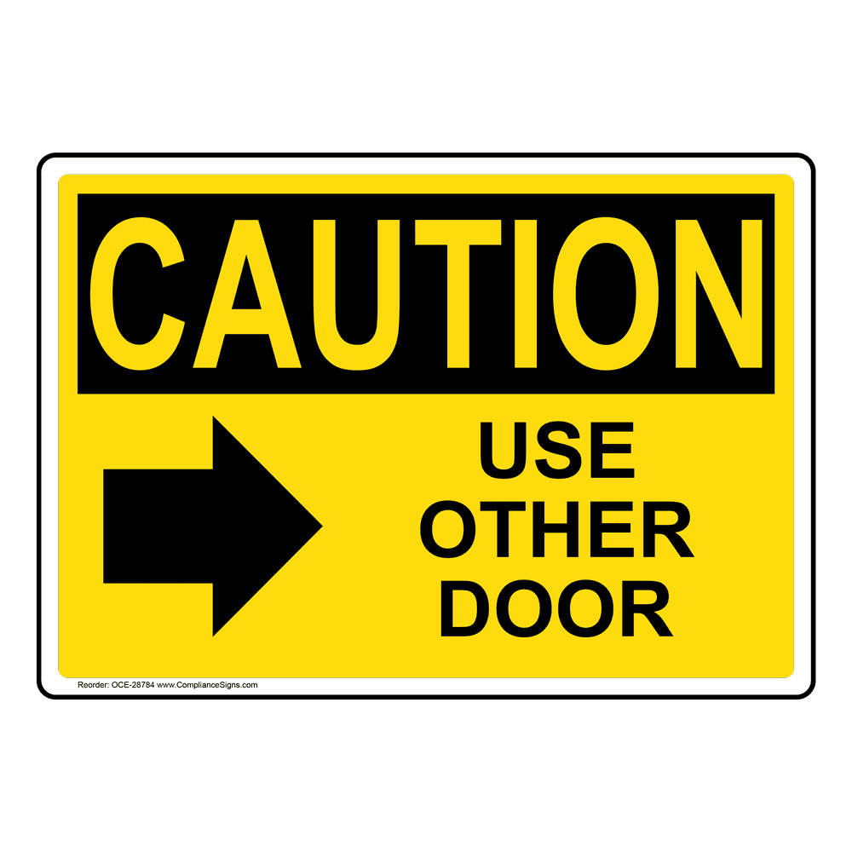**Question 1:** What does the sign say?

**A.** You should use this door if you want to enter.  
**B.** Please use a different door to go inside the building.  
**C.** This door can only be used for emergencies and is not for general use.  
**D.** This door cannot be opened because it is locked**.**

**Question 2:** What does the notice say?

**"The parking lot will be full on Saturday due to a big event. Please park on the street."**

**A.** Please don't park on Saturday, we have an event.

**B.** You can park in the parking lot on Saturday without any problems.

**C.** There will be more parking on Saturday.

**D.** There will be more cars in the parking lot on Saturday, park on the street.

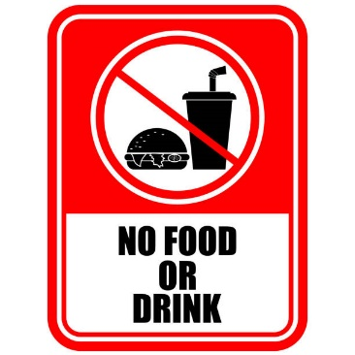**Question 3:** What does the sign say?

**A.** You are allowed to eat and drink here without any restrictions.  
**B.** Eating and drinking are not permitted in this area at all times.  
**C.** You can bring drinks but not food into this area**.**  
**D.** Food is permitted but drinks are not allowed in this area**.**

**Question 4:** What does the notice say?

**"The library will be closed on Sunday for cleaning. It will open again on Monday morning."**

**A.** The library will be open on Sunday for cleaning.

**B.** The library will be closed on Sunday and open again on Monday.

**C.** The library will close early on Sunday for cleaning.

**D.** The library will be closed all weekend**.**

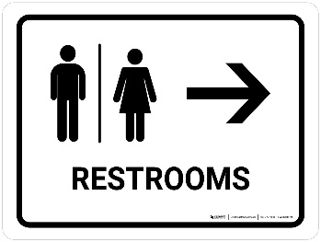**Question 5:** What does the sign say?

**A.** Restrooms are in the direction shown by this sign.  
**B.** The restroom is closed and you cannot use it now.  
**C.** There are no restrooms here or nearby.  
**D.** Restrooms are on the other side of this place.

**Question 6:** What does the notice say?

**Notice:**

**Students will have Tet holiday from February 8, 2025. They will return to school on February 15, 2025 to prepare for mid-term exams.**

**A.** Students will return to school after 8 days of holiday and prepare for exams.

**B.** Students' exams will come when they return to school.

**C.** Students will have to prepare for exams after the holiday.

**D.** Students will return to school after February 14 and prepare for exams.

**Question 7:** What does the sign say?

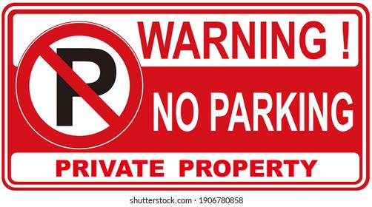**A.** You can park your car in any place here without rules.  
**B.** Do not park your car here; it is not allowed**.**  
**C.** Only customers can park in this area**.**  
**D.** You can park your car in any spot you like.

**Question 8:** What does the notice say?

**Note:** **"The post office will be closed on holidays. Check the calendar for the specific days the post office will be closed."**

**A.** The post office will be closed on public holidays.

**B.** Check the schedule to know the days the post office will be close**d.**

**C.** The post office will open later on public holidays.

**D.** The post office will close early on public holidays.

**Question 9:** What does the sign say?

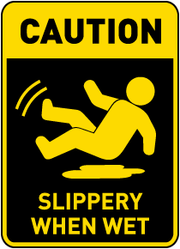**A.** The floor is safe and dry; there is no need to be careful.  
**B.** The floor becomes slippery when wet; you should be careful.  
**C.** The floor is always slippery and may be dangerous.  
**D.** The floor is clean and safe for walking at all times.

**Question 10:** What does the notice say?

**"The local farmers market will be open every Saturday from 8 AM to 2 PM. Fresh produce and local goods will be sold."**

**A.** The market will be open every Sunday from 8am to 2pm to sell local goods.

**B.** The farmers market will be open every Saturday from 8am to 2pm to sell fresh produce and local goods.

**C.** The market will only be open in the evening to sell local produce and local goods.

**D.** No local goods will be sold at the market.

**[HẾT]**