Full name: ……………………………………………….  Class: …………………………………………………….  School: …………………………………………………... | Mark:

SPEAKING TEST 4 (UNITS 9 – 10)

TASK 1 |  |  | Let’s talk about your experience of school bullying and how you overcame it.  The following questions may help you.
 | 1. | When did the incident happen?
 | 2. | Why were you bullied?
 | 3. | What kind of bullying did you face up to and what happened to you?
 | 4. | How did you feel while you were being bullied?
 | 5. | How did you overcome it?

TASK 2 | Work in pairs. Each of you receives a card. Use the clues on your card to make questions about your friend’s picture. Use the picture on your card to answer your friend’s questions.

CARD A
How to conserve wildlife
Ask your friends about his/ her picture. Listen to his/ her answers. |  | 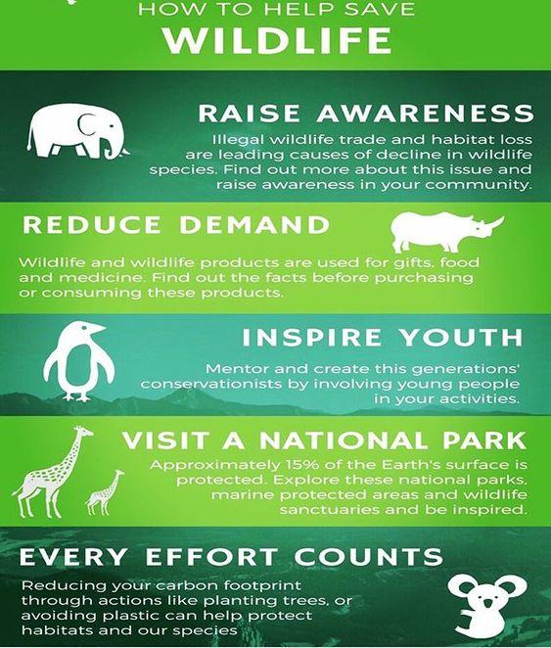
1. | What/ the purpose/ notice?
2. | How many/ ways/ we/ help/ conserve/ wildlife?
3. | Why/ we/ need/ follow/ these ways?
4. | What way(s)/ students/ do/ protect/ these wildlife animals?
5. | Which one/ the most important? Why?
 |  | Answer your friend’s questions about this picture.

CARD B
How to conserve wildlife
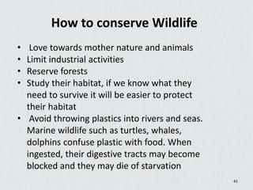
Ask your friends about his/ her picture. Listen to his/ her answers.
1. | What/ the purpose/ notice?
2. | How many/ ways/ we/ help/ conserve/ wildlife?
3. | Why/ we/ need/ follow/ these ways?
4. | What way(s)/ students/ do/ protect/ these wildlife animals?
5. | Which one/ the most important? Why?
 |  | Answer your friend’s questions about this picture.

