|  |
| --- |
| ***Chu Van An* Primary School**  **Class: ……………..**  **Name: …………………………………….** |

Page1

**THE MID SEMESTER TEST**

**SUBJECT: ENGLISH – Grade 3**

**Time alloted: 40 minutes**

|  |  |  |  |  |  |  |  |  |  |  |  |
| --- | --- | --- | --- | --- | --- | --- | --- | --- | --- | --- | --- |
| **MARKS** | Listening | | | | | Reading | | Writing | |  | **Total** |
| Q1 | Q2 | Q3 | Q4 | Q5 | Q6 | Q7 | Q8 | Q9 | Q10 |  |
|  |  |  |  |  |  |  |  |  |  |

**Part 1: Listening ( 20 minutes )**

***Question 1: Listen and number ( 1m )***

|  |  |  |  |
| --- | --- | --- | --- |
|  |  |  |  |
|  |  |  |  |

***Question 2: Listen and tick (*** ***) ( 1m )***

|  |  |
| --- | --- |
|  |  |

***Question 3: Listen and match ( 1m )***

1. **A**: Who’s that?

**B**: It’s Tony.



1. **A**: Who’s that?

**B**: It’s Mr. Loc.

***Question 4: Listen and tick ( 1m )***

|  |  |
| --- | --- |
|  |  |

***Question 5: Listen and write ( 1m )***

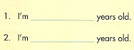

Page 2

**Part 2: Reading and Writing ( 20 minutes )**

http://www.mechanical-engineering-group.org.nz/Content/black-cross-md.png**Question 6: read and tick**  **or in the box ( 1m )**

|  |  |
| --- | --- |
| 1. This is my friend. |  |
| 1. Is that Tony?  * No, it isn’t. |  |
| 1. How do you spell your name?  * L_I_N_D_A. |  |
| 1. How old are you?  * I’m 8 years old. | **8** |

**Question 7: Read and write ( 1m )**

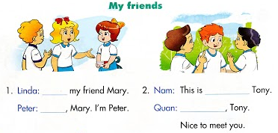

**Question 8: Read and match ( 1m )**

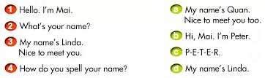

**Question 9: Read and complete ( 1m )**

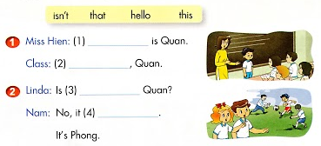

**Question 10: Read and tick ( 1m )**

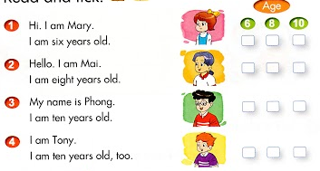

**THE END**

**ANSWER KEY**

( The mid semester test )

**Part 1: Listening ( 20 minutes )**

**Question 1: Listen and number ( 1m ) –** *Unit 2 / L 2 (4 ) page 15*

1. C

2. B

3. D

4. A

**Question 2: Listen and tick ( ) Yes or No ( 1m ) –** *Unit 3 / L 1 ( 4 ) page 19*

1. A

2. B

**Question 3: Listen and match ( 1m ) –** *Unit 4 / L1 ( 1 ) page 24*

1. B
2. A

**Question 4: Listen and tick ( 1m ) –** *Unit 4 / L1 ( 4 ) page 25*

1. B
2. A

**Question 5: Listen and write ( 1m ) –** *Unit 4 / L 3 ( 2 ) page 28*

1. five
2. six

**Part 2: Reading and Writing ( 20 minutes )**

http://www.mechanical-engineering-group.org.nz/Content/black-cross-md.png **Question 6: read and tick(  ) in the box ( 1m )**

1. http://www.mechanical-engineering-group.org.nz/Content/black-cross-md.png
2. 
3. http://www.mechanical-engineering-group.org.nz/Content/black-cross-md.png
4. 

**Question 7: Read and write ( 1m** **)**

1. This / Hi ( Hello )
2. my friend / Hi ( Hello )

**Question 8: Read and match ( 1m )**

1. B
2. D
3. A
4. C

**Question 9: Read and complete ( 1m )**

1. This
2. Hello
3. that
4. isn’t

**Question 10: Read and tick ( 1m )**

1. 6
2. 8
3. 10
4. 10