HỘI CÁC TRƯỜNG THPT CHUYÊN KHU VỰC DH VÀ ĐB BẮC BỘ  THPT Chu Văn An – Hà Nội    ĐÁP ÁN ĐỀ THI ĐỀ XUẤT | ĐỀ THI CHỌN HỌC SINH GIỎI KHU VỰC  DUYÊN HẢI VÀ ĐỒNG BẰNG BẮC BỘ NĂM 2023  MÔN THI: ANH - LỚP: 11  (Thời gian làm bài 180 phút không kể thời gian giao đề)
I. LISTENING (50 points)
PART 1. Listen to a talk about the world's cleanest cities and decide whether the following statements are True (T), False (F), or Not Given (NG) according to what you hear. (10 points)
1. TRUE | 2. TRUE | 3. FALSE | 4. NOT GIVEN | 5. FALSE

https://www.youtube.com/watch?v=YSew_OnDEFE

(Q1) In December 2015 China issued a “red alert” warning for their capital, Beijing. Smog and air particle levels were ten times higher than the World Health Organization’s safety standards. The alert shut down schools and stopped construction, reflecting China’s ongoing issues with pollution. At that same time, the rest of the world was meeting in Paris for the United Nations Climate Change convention, in an attempt to tackle growing environmental concerns. So, while Beijing is covered in smog, we want to know: what are the cleanest cities in the world?
A 2012 Green City Index report by the Economist Intelligence Unit examined each major world region to determine which global factors contribute to cleanliness.
In Europe, many of the top spots were captured by Nordic countries, with Copenhagen in Denmark as the cleanest city overall. Zurich, Switzerland also received high points for lowest CO2 emissions.
(Q2) Both countries have strict limits on high polluting vehicles, but there is also a societal push to use public transit, bicycling, and walking. Even the 2009 Copenhagen Accord saw the world’s major economies come together for the first time to lower global emissions.
(Q3) In Latin America, a clear and repeat winner for cleanest city has been Curitiba, in Brazil. The city was the first to introduce bus rapid transit in 1974, and has continued the trend of working with its citizens to provide environmental benefits. A recycling program called, “Garbage? That’s not garbage!” has led to about ¾ of the city’s trash recycled by residents. Other programs, like one which trades bus tokens for recycling, shows how effective communal and government efforts can be.
(Q4) Another top recycler, this time in Asia, is the city-state of Singapore. On average, they generate less trash per person than the rest of the continent. But they also keep the city clean through high-density planning, and infrastructure investment. Recycling and water treatment plants are state-of-the-art, and designed around supplying the uniquely compact city.
With so many people living so close together, it is very important to produce as little waste as possible.
Over in North America, it’s health conscious San Francisco that takes the lead. According to the GCI, San Francisco recycles as much as 77% of their waste, which is more than any European city besides Leipzig, Germany. Another reason is that SF requires that commercial building owners submit regular energy usage reports, leading to considerably lower usage.
This, coupled with a sharing economy, high quality public transit, and marginal environmental tax benefits, makes SF incredibly clean.
Lastly, and unfortunately, no cities score “well above average” in Africa. The highest ranked, Accra in Ghana, is not necessarily the cleanest. But they get major points for having a direct bureaucratic link with the national government concerning the environment.
This helps not only in monitoring, but also action, and is found lacking in most African cities profiled.
(Q5) Overall, the most consistent aspect of environmental friendliness seemed to be based on society’s willingness to take part. Mass transit and recycling help bring down emissions, as does efficient city planning and government policy. But it should come as no surprise that without the support of the people, there is little that can be done to save the earth.
While it is nice to live in a city with no pollution, much of the world does not have that luxury. To find out what pollution actually does to your body, check out this video by DNews. Thanks for watching Test Tube News! Please like and subscribe and we’ll keep making videos for you every day.
PART 2. Listen to a talk about the future fuel and answer the questions. Write NO MORE THAN THREE WORDS taken from the recording for each answer. (10 points)
1. (the) linchpin | 2. fracking | 3. energy self-efficiency | 4. (the) Middle East | 5. shared electricity grids

How to fuel the future
https://www.youtube.com/watch?v=_d325ohXLxE
Oil moves the world around and creates powerful countries. Oil is such a vital commodity that it provoked wars throughout the 20th century. The few countries that produce it try to keep control of it to ensure its riches stay at home.
Those who do not have it, strive to get it. In the 1930s, Saudi Arabia was one of the poorest countries in the world. But the discovery of oil transformed it and Saudi Arabia has amassed $515.6 billion in sovereign wealth funds. It has become the (Q1) linchpin of a powerful cartel that sometimes rations oil to push up prices.
The United States is now the biggest producer of oil and gas, owing to it's shale revolution. It has tapped abundant reserves through (Q2) fracking. A technology that uses high pressure water and sand to fracture rock deep below the ground to extract hydrocarbons. This shale revolution has helped the United States become less dependent on oil imported from Saudi Arabia, Venezuela, Iraq and other OPEC countries.
More oil and gas on global markets has also benefited the world's energy consumers by pushing down costs. Oil still remains the primary fuel, supplying almost a third of the world's energy. But its heyday may soon be over, despite growing demand.
By 2040 the world's global energy use is set to increase by 30%. That energy must be much cleaner, if the world wants to prevent catastrophic global warming. In the past, coal and gas were less expensive than renewable technologies, but their costs have come down dramatically. There is now a race among some nations to create more efficient renewable technologies to reduce pollution and be more energy self-sufficient. China is the world's largest consumer of coal and the second largest of oil. But it also now leads the world in clean energy. One third of the world's new wind power and solar panels is installed in China and it sells more electric cars than any other country. The quest for (Q3) energy self-sufficiency is a big motivation for many countries. China is moving fast. And America, under President Donald Trump, is securing it's energy independence with oil and gas. But unlike oil and gas, renewables will not increase global warming. The long-term transition to clean energy will throw up new global challenges. It will create tensions in unstable parts of (Q4) the Middle East as oil revenue starts to dry up. Another challenge is that wind and sun are intermittent. Renewables may require vast (Q5) shared electricity grids spanning borders to make them more efficient. To stop global warming, the world needs a huge collaboration over our shared energy future. If we fail, wars over scarce resources could be even worse in the 21st century, than in the 20th.
Why is the transition to renewable energy such as wind and sun a challenge?

PART 3. You will hear Alice Brown interviewing Professor Robert Atkins about health scares. For questions 1-5, choose the answer (A, B, C, D) which fits best according to what you hear. (10 points)
1. B | 2. D | 3. C | 4. A | 5. C

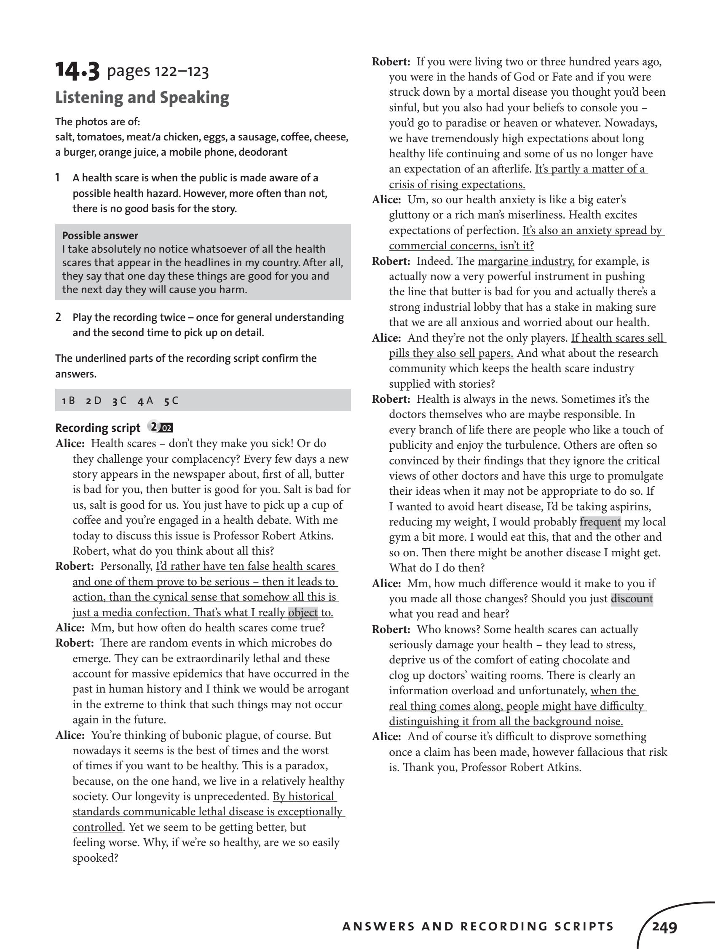

PART 4. Listen to the news about materialism and write NO MORE THAN THREE WORDS taken from the recording to complete each sentence. (20 points)
1. bombarded | 2. conceivable space | 3. commercialization and consumerism | 4. aspirations and goals | 5. a seesaw
6. empathic, generous, cooperative | 7. ecologically beneficial activities | 8. intrinsic values | 9. immunize | 10. sense of connection

https://www.youtube.com/watch?v=oGab38pKscw&t=107s
(5'36'')
Every day, Americans are (1) bombarded with hundreds of messages suggesting that “the good life” is attainable through “the goods life” by making lots of money and spending it on products that claim to make us happy, loved, and esteemed. On the news shows, we hear a near-constant refrain from economists and politicians about the importance of consumer spending and economic growth. And around $150 billion are spent most years to embed consumer messages in every (2) conceivable space from TV shows and websites to public bathrooms and escalator handrails. Lately, marketers have even been paying actors to drop sales pitches into conversations in bars and city parks.
But (3) commercialization and consumerism also reach deeper, worming their way into people’s psyches and encouraging them to organize their lives around higher salaries and owning more “stuff.”
Unfortunately, this can come at a high price for the well-being of both people and the planet. Research consistently shows that the more that people value materialistic (4) aspirations and goals, the lower their happiness and life satisfaction and the fewer pleasant emotions they experience day to day. Depression, anxiety, and substance abuse also tend to be higher among people who value the aims encouraged by consumer society. Strong materialistic values also influence our social relationships, and thereby affect other people’s well-being. Scientists have found that materialistic values and pro-social values are like (5) a seesaw as materialistic values go up, pro-social values tend to go down. This helps explain why people act in less (6) empathic, generous, and cooperative ways when money is on their minds. When people are under the sway of materialism, they also focus less on caring for the Earth. The same type of see-saw is at work here as materialistic values go up, concern for nature tends to go down. Studies show when people strongly endorse money, image, and status they are less likely to engage in (7) ecologically beneficial activities like riding bikes, recycling, and re-using things in new ways. Clearly, if we hope to have a happier, more socially just, and more ecologically sustainable world then we need to develop ways to diminish the power of materialistic values in our personal lives and in society. Two basic principles for change can help frame the way forward. First, we need to understand what causes people to prioritize materialistic values. For instance, studies show that people focus more on material things when they feel insecure. So, instead of buying a new handbag or power tool the next time you’ve had a blow to your self-esteem, consider a different coping strategy like spending time with friends or taking a walk outside.
Scientists also know that the more that people are exposed to the media, the more they prioritize materialistic values. A couple of ways to diminish the onslaught of consumer messages are to use Ad-Block to hide ads on the Internet, or to hit “mute” when commercials play on TV.
But these steps can only take us so far. We also need to get active and start to remove advertising from public spaces and from our children’s schools so that people aren’t exposed to materialistic messages so often. The second principle for change involves promoting intrinsic values for growing as a person, being close to one’s family and friends, and improving the broader world. The research shows that (8) intrinsic values not only promote personal, social and ecological well-being, but can also act to (9) immunize people against materialism. It’s that see-saw again as intrinsic values go up, materialistic values tend to go down. So part of the trick is to build a life that expresses your intrinsic values. That might involve spending more time with people you care about, finding meaningful work, even if it pays less and taking part in volunteer opportunities for causes you care about. But, again, changing our lifestyles is not enough. We also need to advocate for policies that promote intrinsic values. For example, countries like France and Bhutan have recognized that they can’t only focus on GDP and other measures of economic growth. Now they are starting to regularly assess citizens’ well-being and (10) sense of connection to their communities so as to develop policies that truly encourage these intrinsic values. Similar efforts are underway in some parts of the United States, but they need more support. The grip that consumerism and commercialism have on our world can seem inescapable, and there are certainly powerful forces that push materialistic values on us. But by making changes in our personal lives, and by working for broader societal changes, we can break the hold of materialism and be freer to live our intrinsic values. That, in turn, would help us take important steps toward greater personal well-being, a more humane society, and a more sustainable world.

II. GRAMMAR AND LEXICOLOGY (30 points)
1. Choose the best answer. (20 points)
1. B | 2. B | 3. A | 4. C | 5. C
6. B | 7. D | 8. C | 9. D | 10. B
11. C | 12. D | 13. C | 14. C | 15. A
16. B | 17. B | 18. C | 19. B | 20. B

2. Complete these sentences, using the suitable form of the given words in brackets. (10 points)
1. warpath | 2. unpasteurised/ unpasteurized | 3. photovoltaic | 4. uprisings | 5. molten
6. irrespective | 7. far-flung | 8. innermost | 9. unattributable | 10. superannuated

III. READING (60 points)
Part 1. Complete the following passage by filling each blank with ONE suitable word. (15 points)
ADOPTED CHILDREN
1. no | 2. withhold | 3. sooner | 4. accepted | 5. arise
6. fit | 7. case | 8. fish | 9. available | 10. whatever

Part 2. Read the passage below and answers the questions (10 points)
Coffee and Climate Change
1. D | 2. C | 3. C | 4. B | 5. B
6. D | 7. A | 8. C | 9. C | 10. A, D, E

Part 3. Read the passage and do the tasks below. (13 points)
1. vi | 2. v | 3. viii | 4. iii | 5. i
6. ix | 7. TRUE | 8. FALSE | 9. TRUE | 10. FALSE
11. NOT GIVEN | 12. FALSE | 13. TRUE

Part 4: In the passage below, seven paragraphs have been removed. For questions 1-7, read the passage and choose from the paragraphs A-H the one which fits each gap. There is ONE extra paragraph which you do not need to use. (7 points)
1. F | 2. D | 3. B | 4. H | 5. C | 6. A | 7. G

Part 5. You are going to read an extract from an article about paintings. For questions 1–10, choose from the sections (A–E). The sections may be chosen more than once. (15 points)
1. D | 2. B | 3. E | 4. A | 5. C
6. B | 7. C | 8. D | 9. A | 10. C

IV. WRITING (60 points)
Part 1. (15 points)
Read the following article about stress and biological age. You should write a paragraph of between 100 and 120 words.
- Extract from "Stress Increases Biological Age, But Recovery Can Revert It"
by Alejandra Manjarrez, PhD - The Scientist - April 2023

Assessment criteria | Marking
- Task fulfillment:  - Meeting the word limit requirements.  - PLAGIARISM: Not being able to paraphrase in the summary. | (3 pts)  3 pts  Trừ 1
- Summary: Being able to clearly summarise the main ideas:  - Stressful stimuli accelerate cellular aging and reversibility of the effect  - Experiments in mice and analysis in humans and variability in outcomes  - Potential of DNA methylation clocks | (9 pts)  3 pts  3 pts  3 pts
- Vocabulary and sentence structure:  - Being able to use a wide range of vocabulary, appropriate word formation naturally, appropriately and accurately.  - Being able to use a variety of grammatical sentence structures. | (3 pts)  1.5 pts  1.5 pts

Part 2. (15 points)
The chart and table below give information about tourists at a particular holiday resort in Australia.
Summarize the information by selecting and reporting the main features and make comparisons where relevant.
Write at least 150 words.
1. Contents (10 pts)
The report MUST have at least 2 paragraphs covering the following points:
- Introduce the charts (2 points) and state the overall trends & striking features (2 points)
- Describe main features with relevant data from the charts and make relevant comparisons (6 points)
The report MUST NOT contain personal opinions (A penalty of 1 point to 2 points will be given to personal opinions found in the answer)
2. Language Use (5 pts)
The report:
- Should demonstrate a wide variety of lexical and grammatical structures.
- Should have correct use of words (verb tenses, word forms, voice, ...) and mechanics (spelling, punctuations, ...)

Part 3. (30 points)
Many people worry that innovative technology will supplant humans in all future workplaces, whether industrial, administrative or creative. Others, however, insist that while technology is an invaluable tool, it could never replace people.
Discuss both views and present your opinion. Give reasons for your answer and include any relevant examples from your own knowledge or experience.
Write an essay of at least 350 words.
Assessment criteria | Marking
- Task fulfillment:  - Being able to present an argumentative essay with an introduction, body and conclusion,  - Meeting the word limit requirements. | (5 pts)  3 pts  2 pts
- Arguments, ideas and evidence:  - Being able to present a clear position with a logical, well-supported argument; organise and link his/her relevant ideas and opinions; develop these into a well-supported argument/ opinion  - Being able to support his/her argument with specific reasons, examples, his/her own ideas and experience to support the answer.  - Being able to focus on the topic and not include anything irrelevant.  - Being able to write fluently enough to make his/her message clear to the reader. | (20 pts)  5 pts  5 pts  5 pts  5 pts
- Vocabulary and sentence structure:  - Being able to use a wide range of vocabulary naturally, appropriately and accurately.  - Being able to use a variety of grammatical sentence structures. | (5 pts)  3 pts  2 pts

THE END

GV ra đề: Thái Thị Phương Nga - THPT Chu Văn An, Hà Nội - 0946061199

