Period
LESSON PLAN
TIẾNG ANH 10 FRIENDS GLOBAL
UNIT 2: ADVENTURE
LESSON 2H: WRITING- AN INVITATION
I. OBJECTIVES:
By the end of the lesson, Ss will be able to:
1. Knowledge:
- Vocabulary: abseiling, jet-skiing, orienteering, quad biking
- review some outdoor activities, know some email phrases, write an invitation and a reply
2. Ability:
- main skills: reading and writing skills
- sub skills: listening and speaking skills
- write an invitation to a party
3. Quality:
- have positive attitude in English language learning so that they can participate enthusiastically in all classroom activities, especially with the topic conducted by the teacher
- keen on studying English
II. TEACHER AIDS AND LEARNING MATERIALS:
Lesson plan, PPT slides, student’s book, workbook, notebook, personal computer (if any), projector/TV, speakers, IWB software.
III. PROCEDURES:
A. Warm-up (5’)
a) Objective: Introduce the new lesson and set the scene for Ss to acquire new language; get students' attention at the beginning of the class by means of enjoyable and short activities as well as to engage them in the steps that followed.
b) Content: Game ‘Choosing Right Rocket’ – Outdoor activities
c) Outcomes: Students can gain more confidence and interest in the lesson.
d) Competence: communication, collaboration, guessing
e) Organisation of the activity:
TEACHER’S ACTIVITIES | STUDENT’S ACTIVITIES | CONTENTS
WARM-UP. T-Ss/ S-S/ Indiv  Game ‘Choosing Right Rocket’  - Divide class into groups. Students look at the photo in each question and choose the correct answer. If students get it correct, they will hear the sound ‘Correct’. If student don’t get it, the wrong rocket will disappear.  - Encourage students to play. | - Play in groups and choose the correct answers for the photos.  - Volunteer to play. With one correct answer, that group can get bonus. | 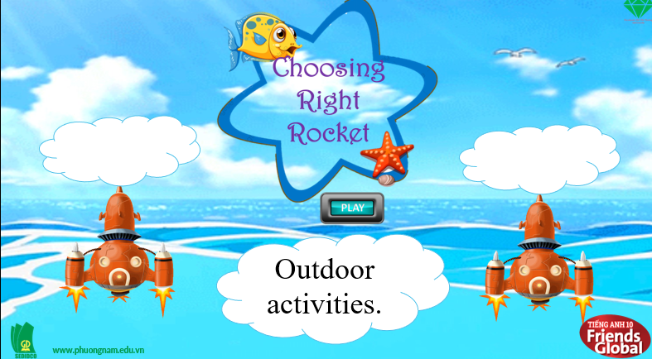  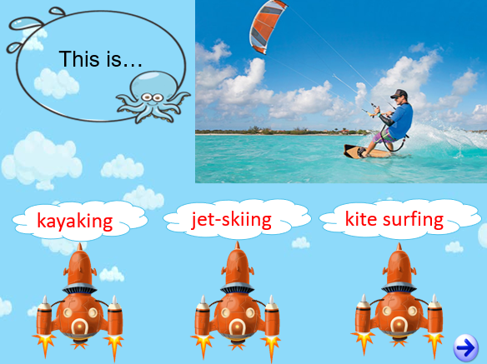

B. New lesson (36’)
- Activity 1: Presentation (13’)
a) Objective: Students review some phrases and structures they learnt to describe the photos and learn some new words.
b) Content: Task 1 page 31
c) Outcomes: Students know how to pronounce words correctly.
d) Competence: communication, presentation
e) Organisation of the activity:

TEACHER’S ACTIVITIES | STUDENT’S ACTIVITIES | CONTENTS
PRESENTATION. T-Ss/ S-S/ Indiv  Activity 1 (3’): Describe the photos A and B using structures and strategy in lesson 2G.  - Ask students to describe the photos A and B with structures and strategy in lesson 2G.  - Show students the strategy and some phrases to describe a photo.  - Invite some students to share their opinions.  - Correct students’ pronunciation.  Activity 2 (7’): Teach new words.  - Use pictures and explanation to present new words.  - Have students practice their pronunciation drills.  New words:  Abseiling (n)  Jet-skiing (n)  Orienteering (n)  Quad biking (n)  Activity 3 (3’): Task 2 page 31.  - Ask student which outdoor activities from the list would they like/dislike. Ask students to give reasons.  - Encourage students to speak out. | - Describe the photo using the structures and strategy on the screen.  - Volunteer to answer.  - Look, listen, and repeat in chorus and individuals.  - Answer the question and give reasons.  - Volunteer to share ideas. | 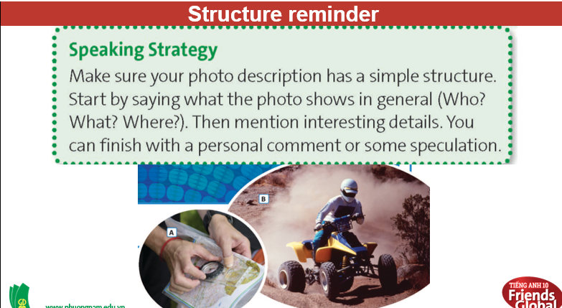  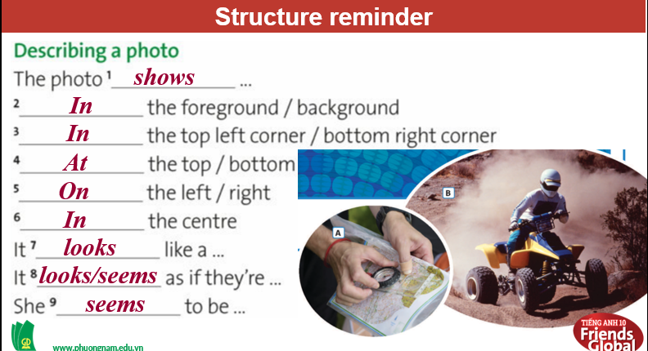  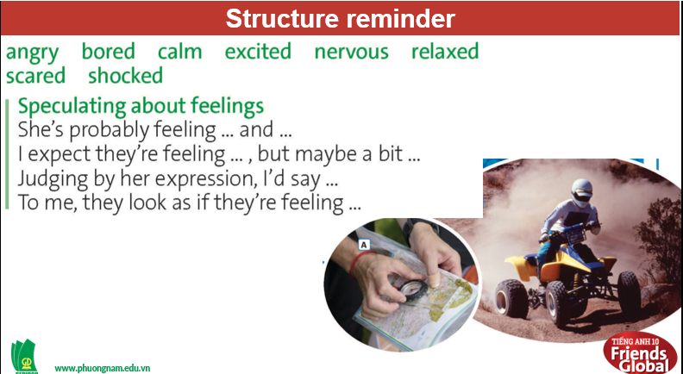  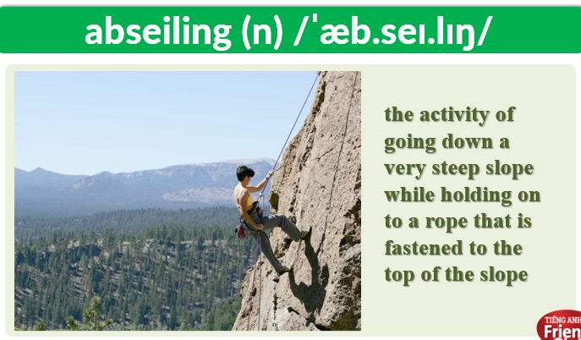  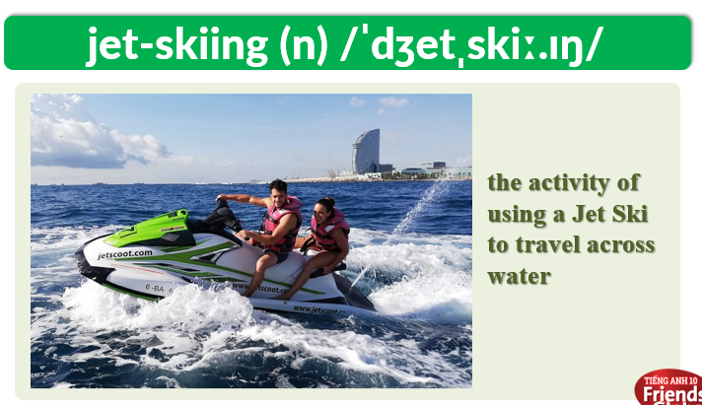  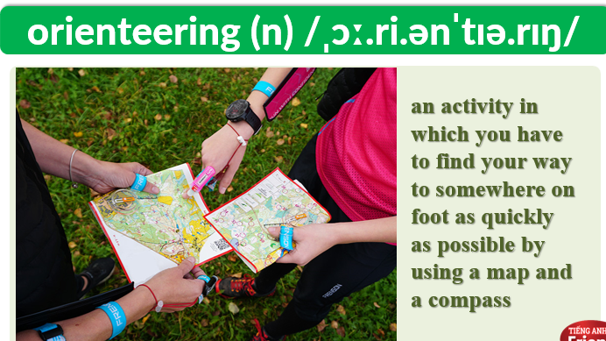  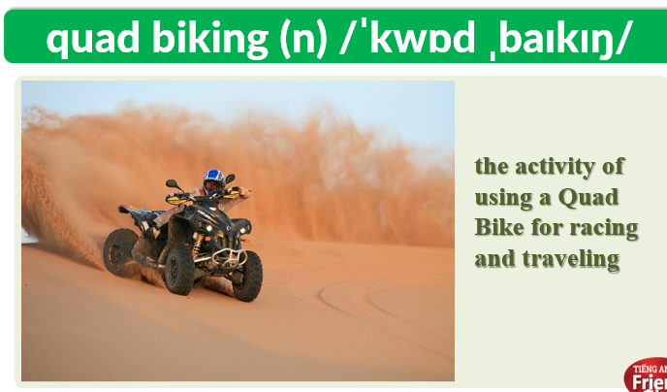  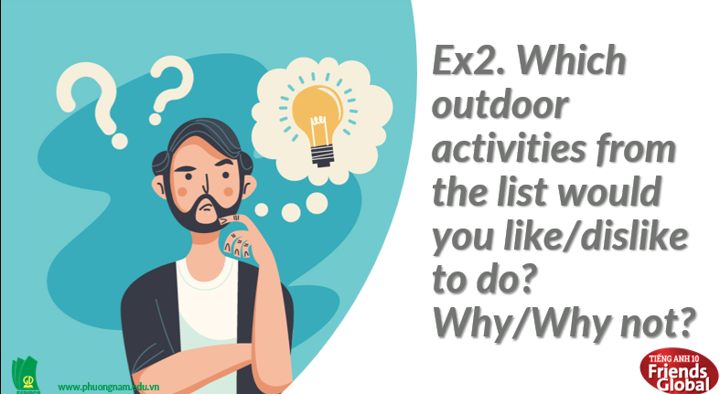
- Activity 2: Practice (13’)
a) Objective: Students can answer the questions to critical thinking, and they can finish the tasks in the textbook. Critical thing skills (guessing/ reasoning) and communication can also be practiced.
b) Content: Students read and find the meanings of some abbreviations, match phrases and rearrange the text.
c) Outcomes: Student know some abbreviations and know the structure to write an invitation.
d) Competence: communication, collaboration, presentation
e) Organisation of the activity:
TEACHER’S ACTIVITIES | STUDENT’S ACTIVITIES | CONTENTS
PRESENTATION. T-Ss/ S-S/Indiv  Activity 1 (4’): Task 3 page 31.  - Ask students to read the invitation and reply and answer the questions.  - Check answers as a class.  Activity 2 (3’): Task 4 page 31.  - Ask students to read the key phrases and to find two more in the reply.  - Check answers and the meaning of the phrases as a class.  - Encourage students to think of alterative endings for Why don’t we…?(optional)  Activity 3 (3’): Task 5 page 31.  - Go through the Writing Strategy together.  - Ask students to find three abbreviations in the invitation and to use the context to work out the meaning. Click ‘Check All’ to eliminate 3 words which are not in the invitation.  - Check answers as a class.  - Ask students if they know any other common abbreviations.  Activity 4 (3’): Prepare for task 6.  - Ask students to match the phrases on the left columns with the correct expressions on the right columns.  - Check answers as a class.  - Ask them to rearrange the texts into the correct order.  - Give answers to the class. | - Read the invitation and reply. Then, answer the questions.  - Check answers with teacher.  - Read the key phrases and find two more in the reply in exercise 3.  - Listen to the teacher carefully.  - Find three abbreviations in the invitation.  - Check answers with teacher.  - Complete the task.  - Check answers with teacher.  - Rearrange the texts. | Answers:  1. The party begins at 3p.m.  2. The first activities are jet-skiing and kite surfing.  3. Lisa suggests that Bess doesn’t have to bring anything.  Answers:  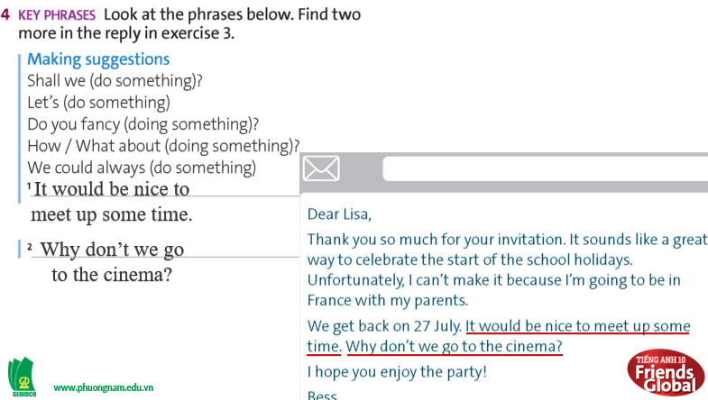  1. It would be nice to up some time.  2. Why don’t we go to the cinema?  Answers:  BBQ  p.m.  PS  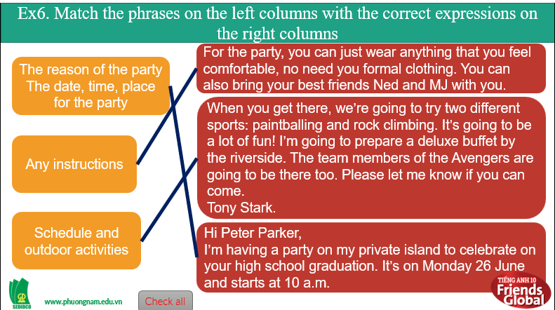  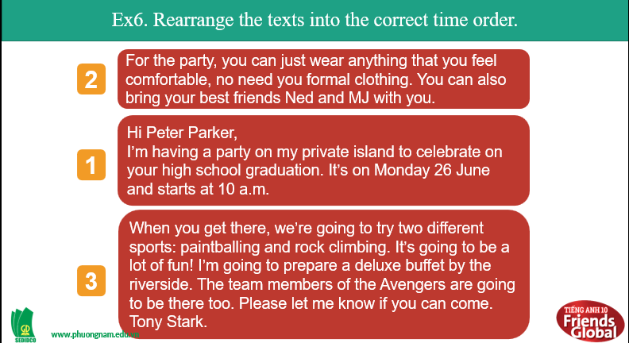

- Activity 3: Outcomes (10’)
a) Objective: Students know how to write an invitation to a party that includes outdoor activities.
b) Content: Students write an invitation (100-120 words) to a party that includes outdoor activities.
c) Outcomes: Students apply what they learnt to write an invitation.
d) Competence: Collaboration, presentation, comprehension
e) Organisation of the activity:
TEACHER’S ACTIVITIES | STUDENT’S ACTIVITIES | CONTENTS
PRODUCT. T-Ss/ S-S/ Indiv  Activity 1 (5’): Write an invitation.  - Ask students to write an invitation to a party just like the sample above.  - Go around to assist students.  Activity 2 (5’): Work in pairs.  - Ask students to work in pairs and to swap the invitations.  - When students finish swapping, ask them to write a reply in the following instructions.  - Students swap their replies and check that their partner has included all of the information. | - Write an invitation.  - Swap the invitations.  - Write a reply making sure that they include all of the points. | 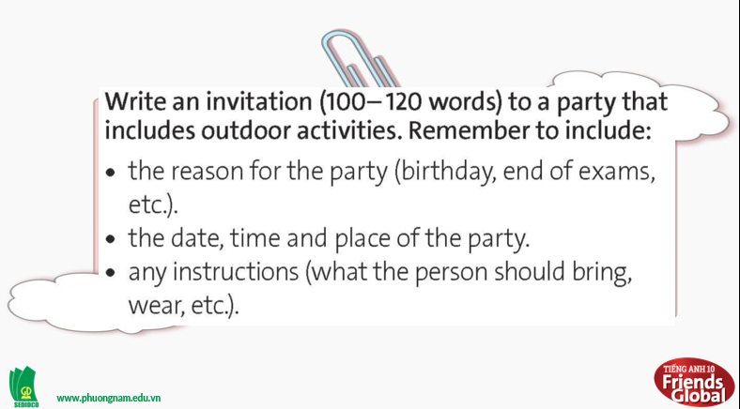  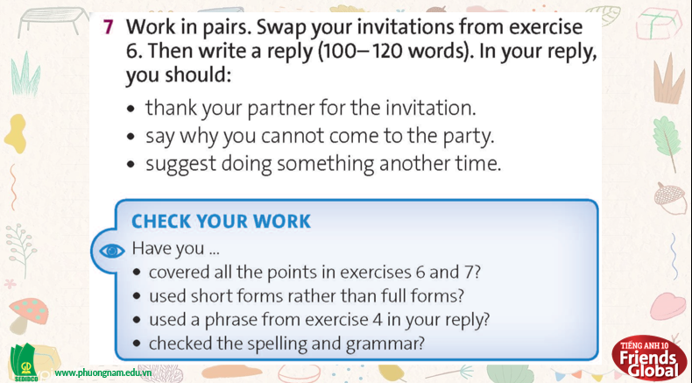
C. Consolidation (2’)
- Vocabulary: abseiling, jet-skiing, orienteering, quad biking
- Know how to write an invitation to a party.
D. Homework (2’)
- Learn by heart new words.
- Do exercise
- Prepare: Unit 2 – I- (page 32 – SB)

