
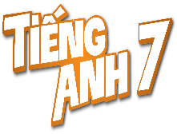
Tiết thứ ....
UNIT 7: TRAFFIC
Lesson 4: Communication

Class | Date of teaching | Attendence
7A | ..../09/2022
7B | ..../09/2022
7C | ..../09/2022
I. OBJECTIVES: By the end of this unit, students will be able to gain the following things:
1. Knowledge:
- Learn how to ask and answer about means of transport and some strange traffic rules.
- Practise using some grammar points and vocabulary related to the topic.
+ Pronunciation:
+ Vocabulary: Use the words about means of transport.
+ Grammar:
2. Competence:
a) General competencies:
- Students will be able to know more words and phrases about means of transport.
- Develop communication skills and cultural awareness
- Be collaborative and supportive in pair work and teamwork
- Actively join in class activities
b) Specific competencies:
- Group work and independent working, pair work, linguistic competence, cooperative learning and communicative competence.
- Sts can introduce themselves or one another fluently.
3. Qualities: The love of traffic; The awareness about importance of trafffic; Be ready to talk about means of transport; Know some daily activities in the street.
- Develop self-study skills.
II. PREPARATIONS
Teacher: Grade 7 text book, laptop, TV, pictures and realia, Computer connected to the Internet, Sach mem.vn
Students: Text books, pencils, pics, blank papers, realia,….
III. PROCEDURE:
In each activity, each step will be represented as following:
* Task delivering
** Task performance
*** Report and discussion
 Judgement
Activity 1. WARM UP (5’-IW, GW)
* Aim:
To introduce the lesson.
To lead in the lesson.
* Content: BRAINSTORMING
* Product: Having a chance to speak English and focus on the topic of the lesson.
* Implementation: Teacher’s instructions…
Teacher’s & Student’s activities | Content
Game: BRAINSTORMING  HOW DO YOU GO TO SCHOOL?  * Teacher divides class into 2 teams and asks them to think of “MEANS OF TRANSPORTS” (even the strangest ones).  ** Ss have 1 min to think of the words related to the topic or they can discuss with their partners.  *** Each member from each team turn by turn run to the board and write one word.   Teacher corrects their answers.  - The team which has more correct words will be the winner.  - Teacher leads students into the lesson by telling what they are going to learn: “We are going to learn how to ask and answer about means of transport and some strange traffic rules”. | Suggested answers:  Motorbike, bicycle, train, bus, plane, helicopter,…
Activity 2. KNOWLEDGE FORMATION (15'- PW, IW)
* Aim:
To let students know the structure to ask and answer about means of transport.
* Content: * EVERYDAY ENGLISH - Ask and answer about means of transport.
* Product: Ss learn how to use them.
* Implementation: Teacher’s instructions…
Teacher’s & Student’s activities | Content
Task 1: Listen and read the conversation, paying attention to the highlighted parts.  * Teacher plays the record for SS to listen and read the conversation about means of transport. .  ** Ss listen and practice saying with their partners.  *** Teacher calls some pairs to read aloud.   Teacher corrects pronunciation if needed.  * Teacher asks Ss to pay attention to the highlighted parts and asks them some questions to elicit the new structure:  - Which tense do we use to ask and answer?  - Which question word do we use?  - …..  ** Ss answer teacher’s questions to find out new structure to ask anad answer about means of transport to travel to places  *** Some students give the new structure to the teacher.   Teacher corrects and writes on the board. | Task 1: Listen and read the conversation, paying attention to the highlighted parts.  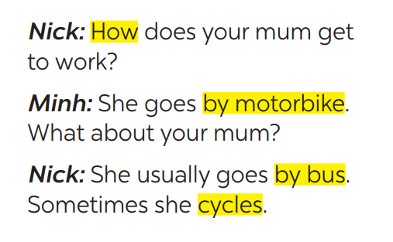  - Structure:  to ask:  - How do/does + S + go to …?  to answer:  - S + go/goes by …  - S + V
Activity 3. PRACTICE (15’-IW, PW, GW)
* Aim:
To help students practise on how to ask and answer about means of transport.
To provide students with more knowledge about strange traffic rules and help them practice the skill of listening for details.
* Product: Students’ answers.
* Implementation:
Teacher’s Student’s activities | Content
Task 2: Work in pairs. Take turns to ask and answer about the means of transport your family members use every day.  * Teacher has SS look at the situation in Ex 2 to make similar dialogue:  ** Ss work in pairs to make similar dialogue.  *** Teacher calls some pairs to present it in front of the class.   Teacher gives feedback and some comments. | Task 2: Work in pairs. Take turns to ask and answer about the means of transport your family members use every day.  Suggested answers:  A: How does your father go to school?  B: He usually drives his car but sometimes he goes by bus. How about your father?  A: He walks because we live near his office.
* STRANGE TRAFFIC RULES  Task 3: Which countries below keep to the left? Tick the correct answers.  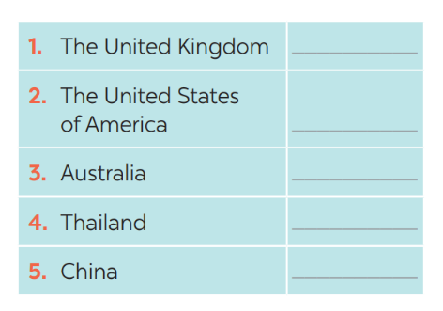  * Teacher asks Ss to discuss in pairs and tick.  ** Ss so the task in pairs  Task 4: Listen and check your answers in 3. Then listen again and complete the sentence with no more than THREE words.  * Teacher plays the recording twice.  *** Teacher calls some Ss to give their answer and explain it.   Teacher let Ss listen and confirms the correct answers.  Answer key: - United Kingdom, Australia  - same traffic rules/regulations | * STRANGE TRAFFIC RULES  Task 3: Which countries below keep to the left? Tick the correct answers.  1. The United Kingdom v  2. The United States of America  3. Australia v  4. Thailand v  5. China  Task 4: Listen and check your answers in 3. Then listen again and complete the sentence with no more than THREE words.  Answer key:  - United Kingdom, Australia  - same traffic rules/regulations
Activity 4. APPLICATION (7’-IW, PW, GW)
* Aim:
To help students know more about traffic rules around the world.
* Content: Discuss which one do is the strangest rule?
* Product: Students’work.
* Implementation: Teacher’s instructions
Task 5: Read, discuss which one do is the strangest rule?  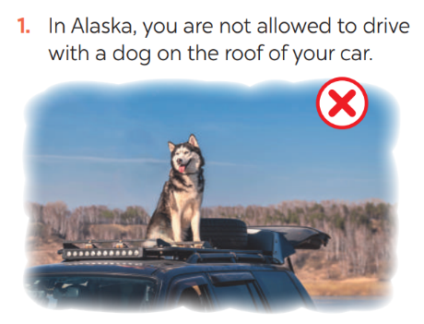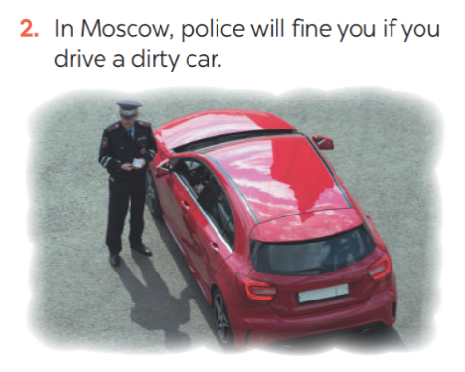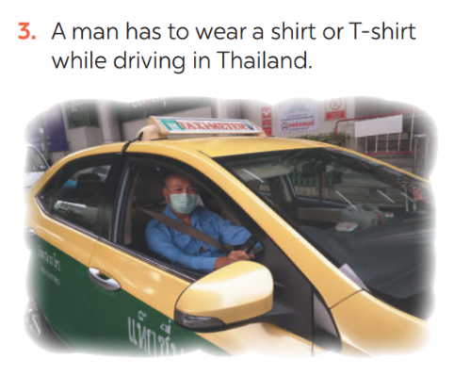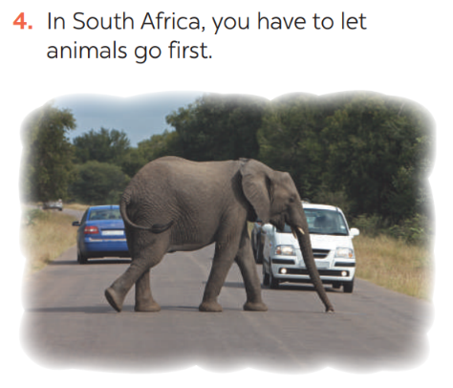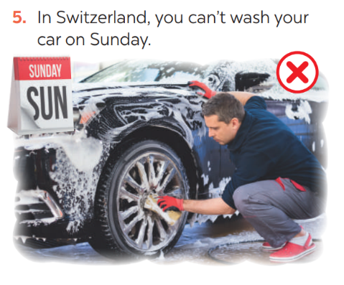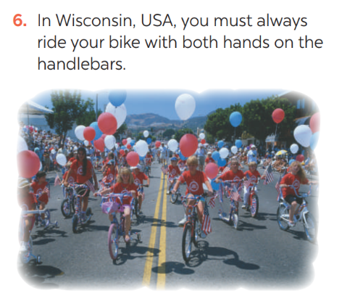  * Teacher has students work in groups to discuss which one they find strangest.  ** Ss work in groups.  *** 2-3 groups share their ides   Teacher encourages students to add more if they know. | Task 5: Read, discuss which one do is the strangest rule?  In my opinion, the strangest traffic rule is a man in Thailand has to wear a shirt or T-shirt while driving I just can't figure out why people have set that rule.  I know another strange traffic rule which prevents you from driving on Mondays if your number plate ends in a 1 or 2 in Manila, Philippines.
* Wrap up  - To consolidate what students have learnt in the lesson.  * Homework:  - Exercises in the workbook.  - To prepare for the next lesson:  Skills 1. | * Wrap up  Teacher asks students to talk about what they have learnt in the lesson.  * Homework:  - Exercises in the workbook  - To prepare for the next lesson:  Skills 1.
V. FEEDBACK:
With 7A ……………………………………………………………………………..…
With 7B …………………………...……………………………………..……………
With 7C ………………………………………………………………………….……

