UNIT 3: COMMUNITY SERVICE
Lesson 1: GETTING STARTED p36-37

I. OBJECTIVES
.
By the end of this lesson, Ss will be able to gain:
1. Knowledge
- Review the vocabulary and grammar of Unit 3
- Apply what they have learnt (vocabulary and grammar) into practice through a project
2. Core competence
- Develop communication skills and creativity
- Develop presentation skill
- Develop critical thinking skill
- Be collaborative and supportive in pair work and team work
- Actively join in class activities
3. Personal qualities
- Be more creative when doing the project
- Develop self-study skills
- Raise students’ awareness of the need to keep their neighbourhood green.

II. MATERIALS
- Grade 7 textbook, Unit 3, Looking back & Project
- Computer connected to the Internet
- Pictures, A0 paper
- Projector / TV
- sachmem.vn
Assumptions

Anticipated difficulties | Solutions
1. Students may not have sufficent speaking, writing and  co-operating skills when doing the project | - Encourage students to work in pairs, in groups so that they can help each other.  - Provide feedback and help if necessary.
2. Some students may excessively talk in the class. | - Define expectation in explicit detail.  - Have excessive talking students practise.  - Continue to define expectations in small chunks (before every activity).

III. PROCEDURE

TIME | T’S ANS SS’ ACTIVITIES | CONTENT
5’ | * Teacher asks students to make a list of activities:  - T calls some to present.  - T gives feedback. | I. WARM-UP  Community service Community activities  (work that people do without payment to help other people).  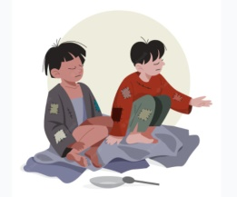  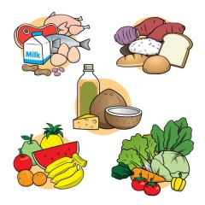
5’  5’  10’  10’ | Gap - Fill  - Teacher asks students to work individually to complete each of the sentences with a suitable word / phrase from the box. All of these words / phrases have been learnt in.  - Students do the task individually.  - Teacher allows students to swap their textbooks to peer check first.  Teacher gives feedback.  Gap - Fill  - Ss use words in 1 to complete  - Students do the task individually.  - Teacher allows students to swap their textbooks to peer check first.  Teacher gives feedback.  Gap – Fill  - T asks SS to remind Simple Past  - Students do the task individually.  - Teacher allows students to swap their textbooks to peer check first.  Teacher gives feedback.  Write  - T asks Ss to write using Simple Past  - Students do the task individually.  -Teacher gives feedback. | II. LOOKING BACK  Vocabulary  1. Complete the table with the words and phrases from the box.  Help Pick up Donate  Homeless children The elderly Litters bottles Books food  2. Complete each sentence with one phrase from 1. Remember to use the correct forms of the verbs.  1. The club ______ to some poor farmers last week.  2. Yesterday, we _______ around our area and recycled them.  3. We ______ summer. do the cleaning last.  4. Last month, our club to the community library.  5. In our recent project, we ______ learn to read and write.  *Answer Key  1. donated food  2. picked up litters  3. helped the elderly  4. donated books  5. helped homeless children  Grammar  *Thì quá khứ đơn, dạng khẳng định:  - Động từ có quy tắc: Ved  - Động từ bất quy tắc: V2 (cột thứ 2 của bảng động từ bất quy tắc)  3. Use the correct form of the verbs from the box to complete the passage.  donate collect have sell go  Warm Clothes is a famous volunteer group in Viet Nam. Its members are both parents and their children. Last year, they (1) ________ many activities to help their community. The group (2) _______ clothes and sent them to poor people in rural areas. The parents taught their children to make things from bamboo and bottles. They then (3) ________ these to buy books, and (4) _________ them to village children. They also (5) ________ to the villages and tutored small kids there. They really brought love to those small villages.  *Answer Key  1-had 2-collected 3-sold 4-donated 5-went  4. Write full sentences about the activities the students did to help their community last year.  1. Mi: singing and dancing for the elderly at a nursing home  2. Mark and his friends: collecting books and setting up a community library  3. Lan and Mai: growing and donating vegetables to a primary school  4. Minh and his friends: giving food to young patients in a hospital  5. Tom: making and sending postcards to the elderly at Christmas  *Answer Key  1. Mi sang and danced for the elderly at a nursing home.  2. Mark and his friends collected books and set up a community library.  3. Lan and Mai grew and donated vegetables to a primary school.  4. Minh and his friends gave food to young patients in a hospital.  5. Tom made and sent postcards to the elderly at Christmas.
8’ | Work in groups  1. Think about some environmental problems in your neighborhood  2. Discuss and find the answers to the questions  . What problems can you find?  . What do you want to do to solve the problems?  . How are you going to do them?  3. Present them to your class | III. PROJECT  Our green neighbourhood  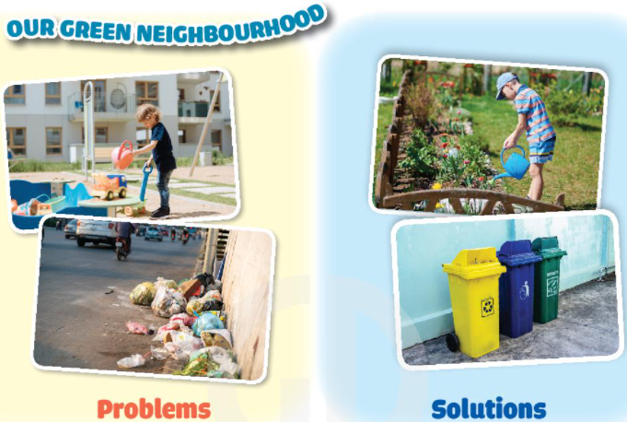
2’ | - Ss take notes and do at home. | IV. HOMEWORK  - 5. Write problem you can find and your solutions which you can do to make your neighborhood to be a greener place.  – Review Vocabulary + Simple Past  - Prepare Unit 3 REVIEW Unit 1-3 (p38)
V. Teacher’s reflexion:
……………………………………………………………………………………………………………………………………………………………………………………………………

