Chương II | ĐỌC ĐIỀN BẢNG THÔNG TIN, QUẢNG CÁO, THƯ, HƯỚNG DẪN AN TOÀN

I. HƯỚNG DẪN LÀM BÀI [5744]
Xem nội dung này ở Chương V. ĐỌC ĐIỀN TỪ, CỤM TỪ VÀO ĐOẠN VĂN
Read the following announcement/letter/instruction/advertisement and mark the letter A, B, C or D on your answer sheet to indicate the correct option that best fits each of the numbered blanks.
Exercise 1. Tra ID Đề [5506] - Tra ID Video [5507]
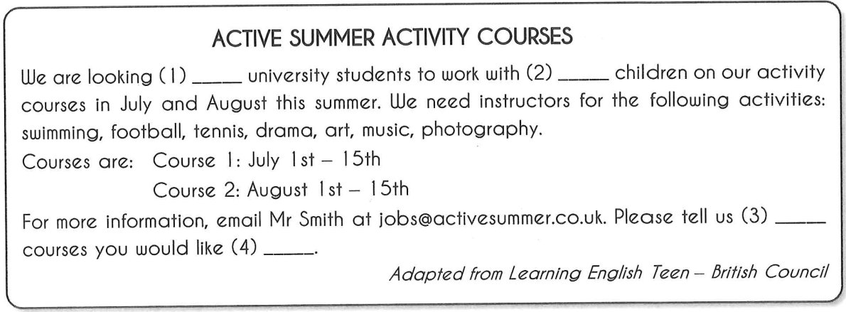
Question 1: A. up B. in C. for D. to
Question 2: A. a B. an C. the D. ∅
Question 3: A. who B. whom C. which D. where
Question 4: A. teaching B. to teach C. teach D. teacher
Exercise 2. Tra ID Đề [5508] - Tra ID Video [5509]
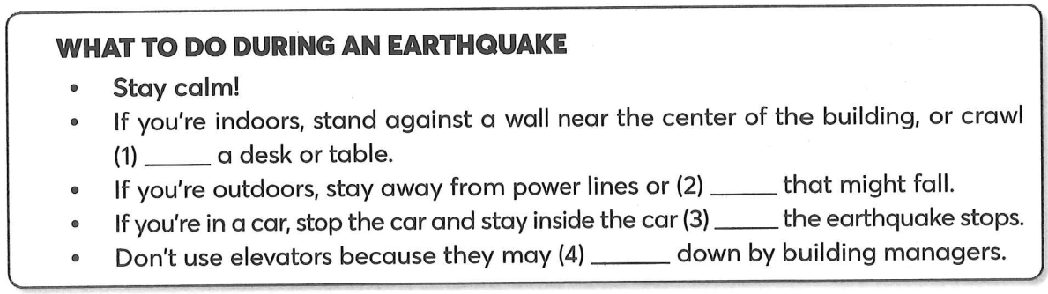
Question 1: A. under B. behind C. on D. above
Question 2: A. nothing B. everyone C. anything D. something
Question 3: A. as soon as B. until C. while D. when
Question 4: A. shut B. be shut C. shutting D. shuts

Exercise 3. Tra ID Đề [5510] - Tra ID Video [5511]
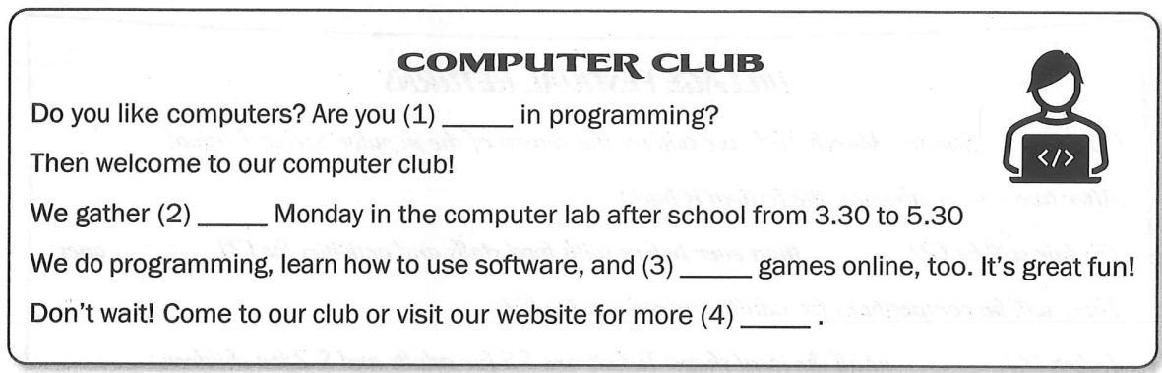
Question 1: A. keen B. fond C. interested D. love
Question 2: A. all B. one C. some D. every
Question 3: A. playing B. plays C. play D. played
Question 4: A. informed B. informative C. information D. inform
Exercise 4. Tra ID Đề [5512] - Tra ID Video [5513]
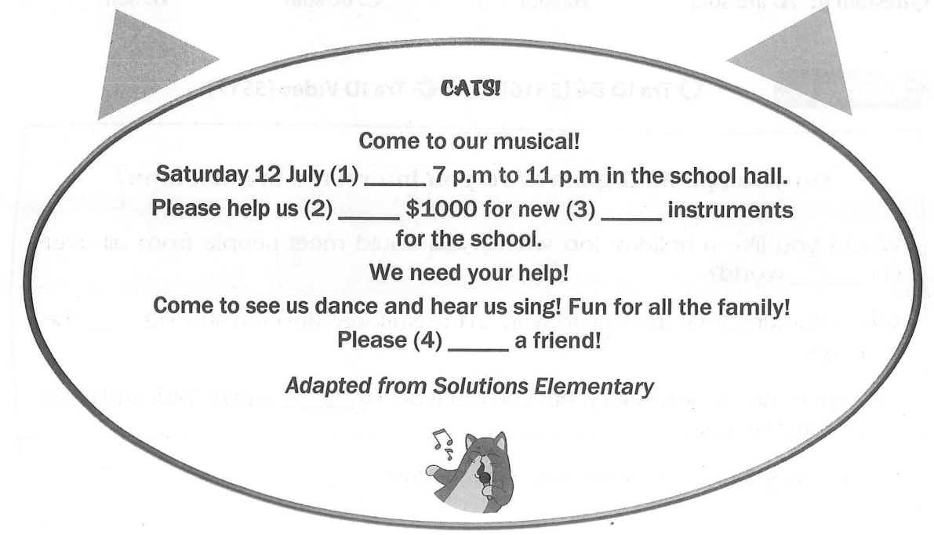
Question 1: A. from B. between C. at D. on
Question 2: A. raising B. to raise C. rising D. to rise
Question 3: A. music B. musician C. musical D. musics
Question 4: A. make B. do C. come D. bring

Exercise 5. Tra ID Đề [5514] - Tra ID Video [5515]
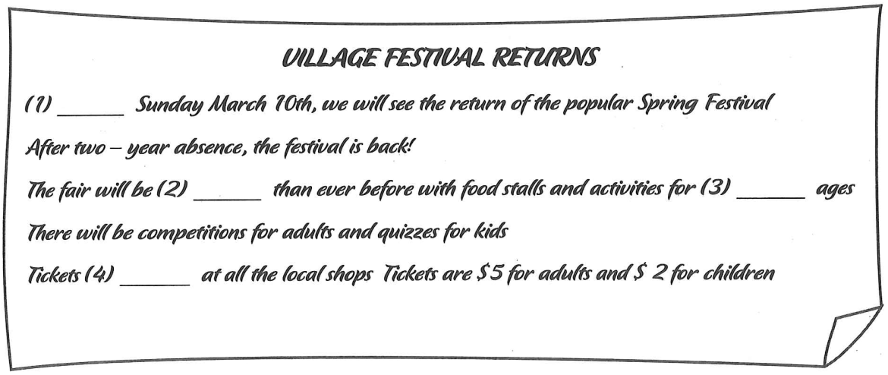
Question 1: A. At B. On C. In D. About
Question 2: A. big B. the bigger C. bigger D. the biggest
Question 3: A. each B. all C. every D. other
Question 4: A. are sold B. sold C. be sold D. sell
Exercise 6. Tra ID Đề [5516] - Tra ID Video [5517]
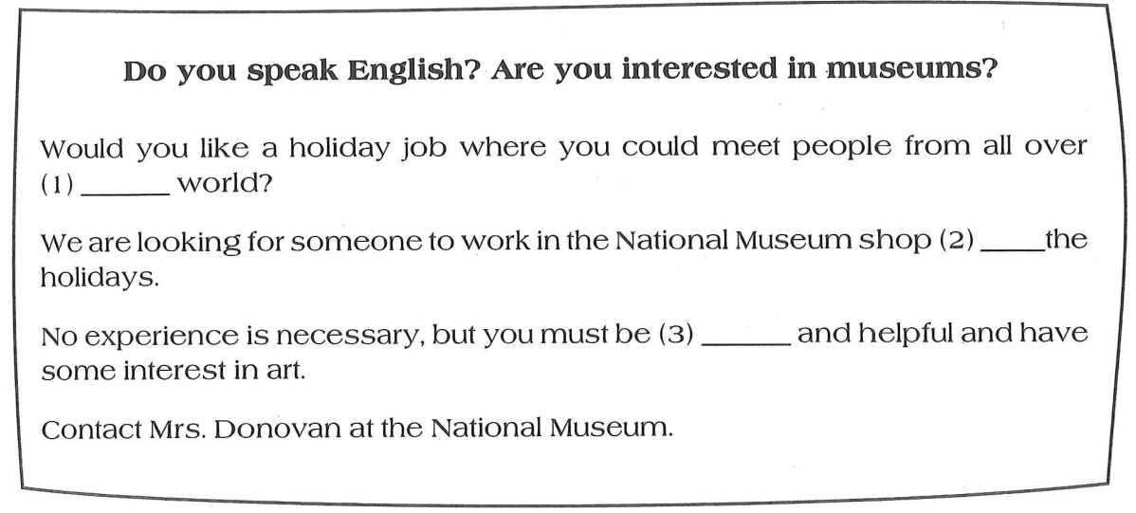
Question 1: A. a B. an C. the D. ∅
Question 2: A. during B. at C. since D. in
Question 3: A. friend B. friendship C. friendliness D. friendly

Exercise 7. Tra ID Đề [5518] - Tra ID Video [5519]
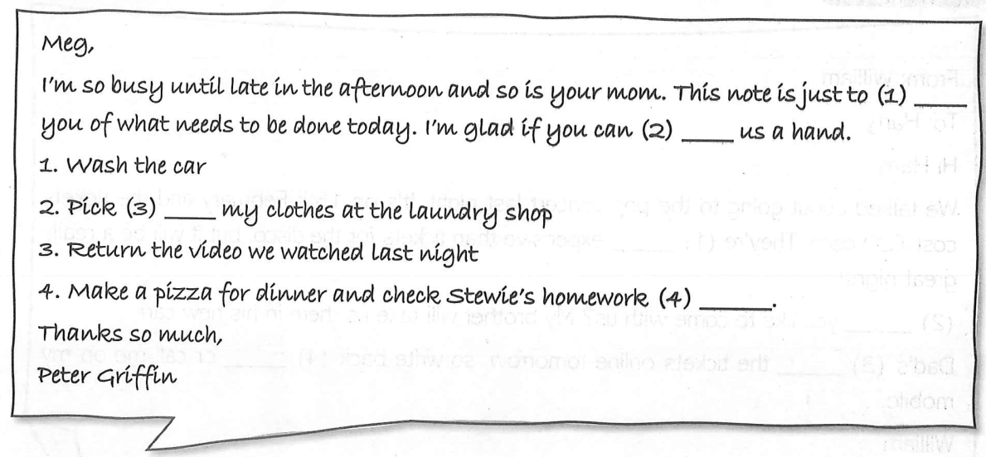
Question 1: A. remember B. reduce C. regret D. remind
Question 2: A. take B. give C. make D. do
Question 3: A. off B. on C. up D.in
Question 4: A. careful B. carefully C. careless D. carelessly
Exercise 8. Tra ID Đề [5520] - Tra ID Video [5521]
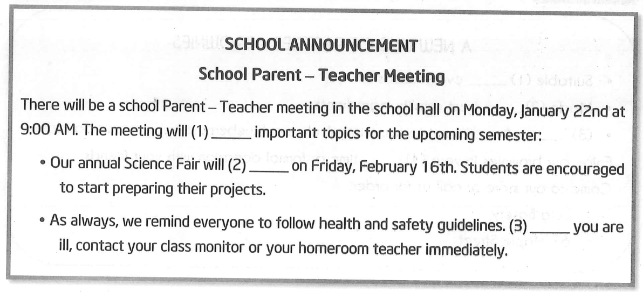
Question 1: A. make B. talk C. cover D. argue
Question 2: A. hold B. held C. be held D. holding
Question 3: A. Unless B. If C. While D. Because

Exercise 9. Tra ID Đề [5522] - Tra ID Video [5523]
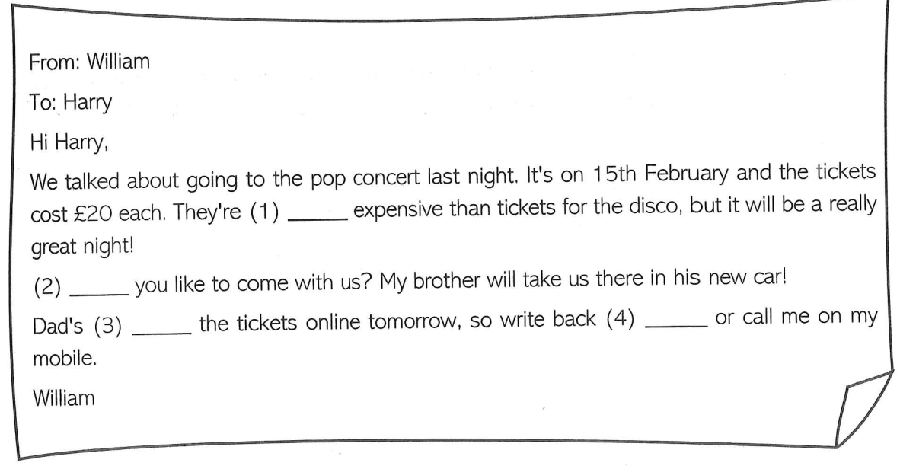
Question 1: A. most B. the most C. more D. the more
Question 2: A. Does B. Are C. Can D. Would
Question 3: A. been bought B. buying C. buy D. bought
Question 4: A. quick B. quicker C. quickly D. quickest
Exercise 10. Tra ID Đề [5524] - Tra ID Video [5525]
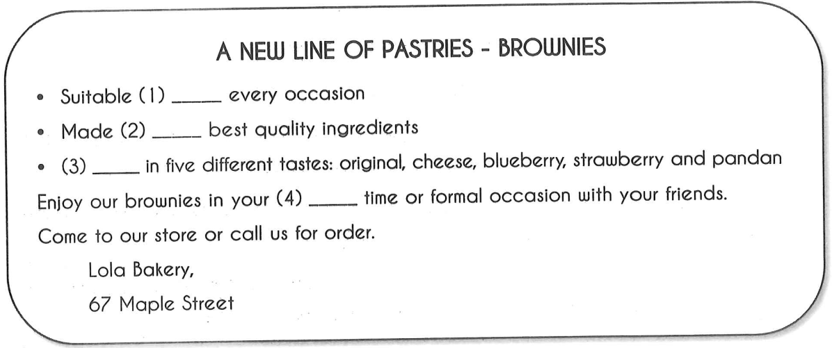
Question 1: A. with B. for C. on D. of
Question 2: A. from B. by C. in D. out
Question 3: A. Empty B. Available C. Covered D. Tasted
Question 4: A. freedom B. leisure C. closing D. freely

Exercise 11. Tra ID Đề [5526] - Tra ID Video [5527]
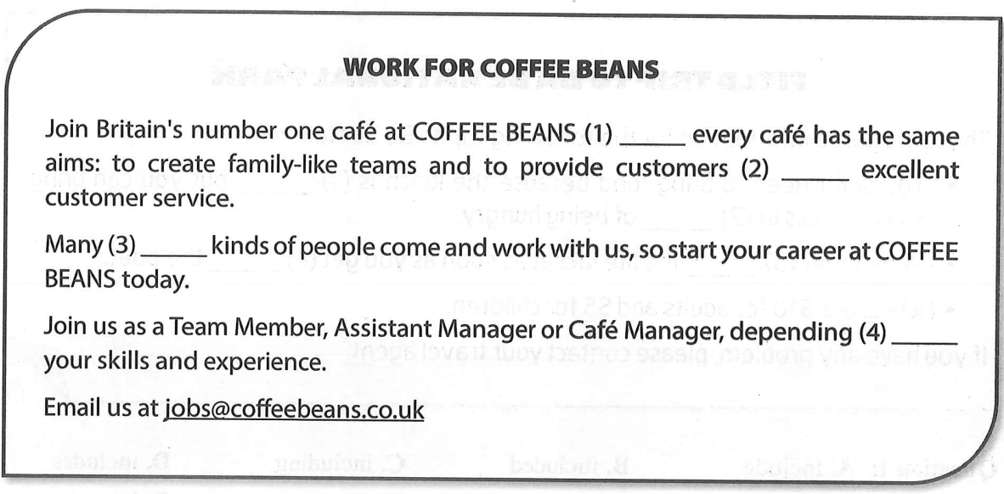
Question 1: A. which B. when C. where D. that
Question 2: A. with B. to C. about D. of
Question 3: A. different B. differently C. difference D. differ
Question 4: A. at B. with C. for D. on
Exercise 12. Tra ID Đề [5528] - Tra ID Video [5529]
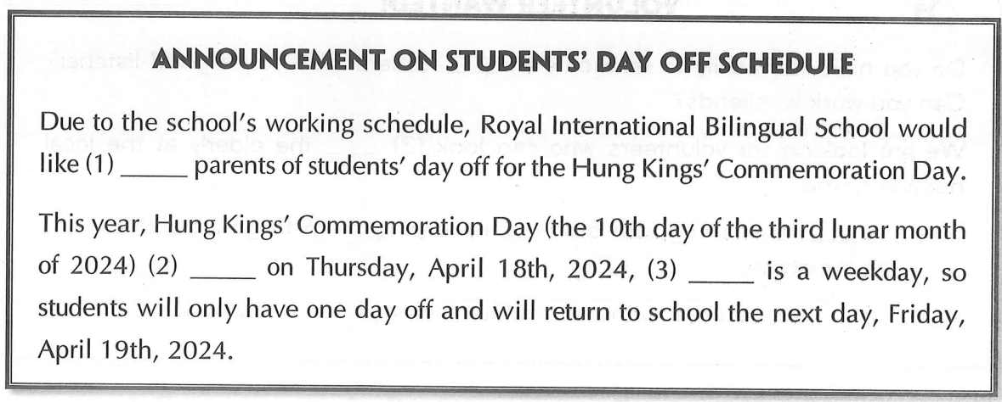
Question 1: A. inform B. to inform C. informing D. informed
Question 2: A. appears B. falls C. happens D. hold
Question 3: A. when B. which C. what D. who

Exercise 13. Tra ID Đề [5530] - Tra ID Video [5531]
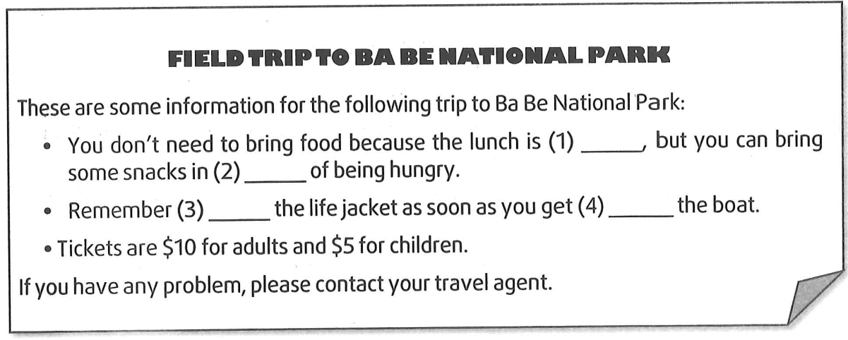
Question 1: A. include B. included C. including D. includes
Question 2: A. instead B. because C. case D. lots
Question 3: A. wear B. wearing C. wore D. to wear
Question 4: A. in B. off C. on D. under
Exercise 14. Tra ID Đề [5532] - Tra ID Video [5533]
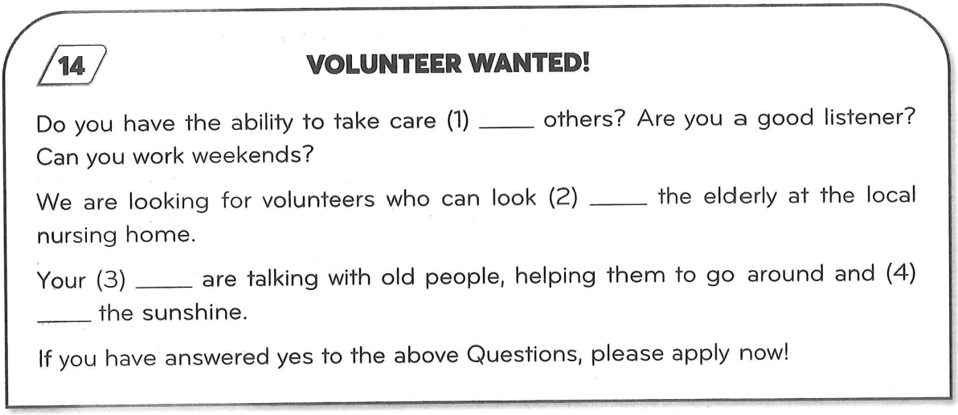
Question 1: A. up B. on C. of D. to
Question 2: A. on B. up C. for D. after
Question 3: A. responses B. responsibilities C. responsible D. respond
Question 4: A. enjoying B. enjoy C. enjoyed D. enjoys

Exercise 15. Tra ID Đề [5534] - Tra ID Video [5535]
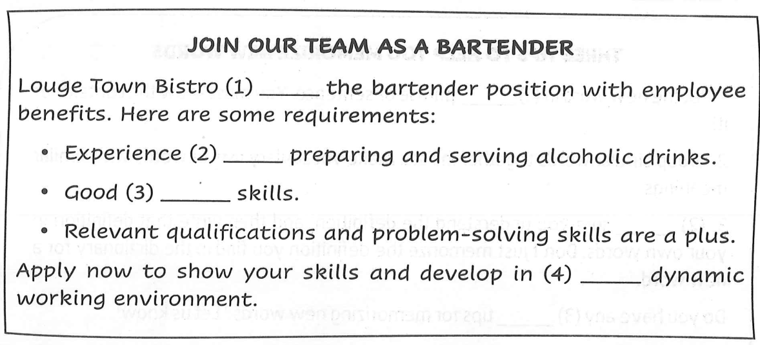
Question 1: A. offers B. applies C. introduces D. invites
Question 2: A. on B. for C. in D. of
Question 3: A. communicate B. communication C. communicated D. community
Question 4: A. a B. an C. the D. ∅
Exercise 16. Tra ID Đề [5536] - Tra ID Video [5537]
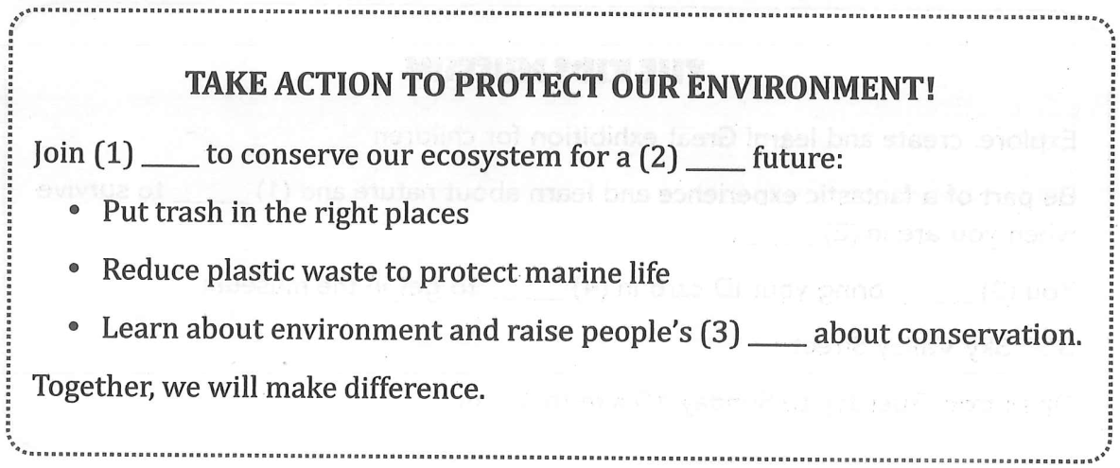
Question 1: A. eyes B. mouth C. heads D. hands
Question 2: A. brightest B. brightly C. brighter D. brightless
Question 3: A. awared B. awareness C. aware D. awaring

Exercise 17. Tra ID Đề [5538] - Tra ID Video [5539]
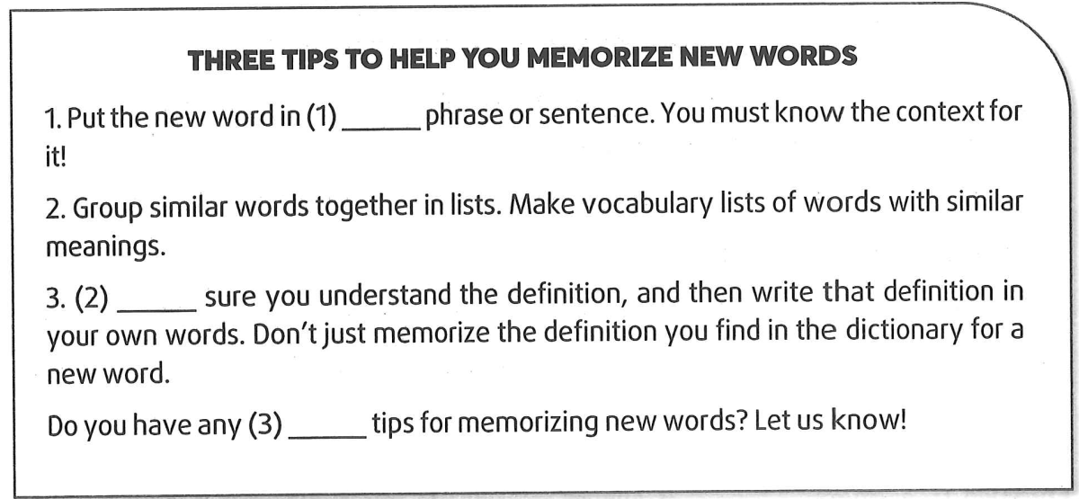
Question 1: A. a B. an C. the D. ∅
Question 2: A. Take B. Have C. Make D. Come
Question 3: A. another B. other C. the other D. others
Exercise 18. Tra ID Đề [5540] - Tra ID Video [5541]
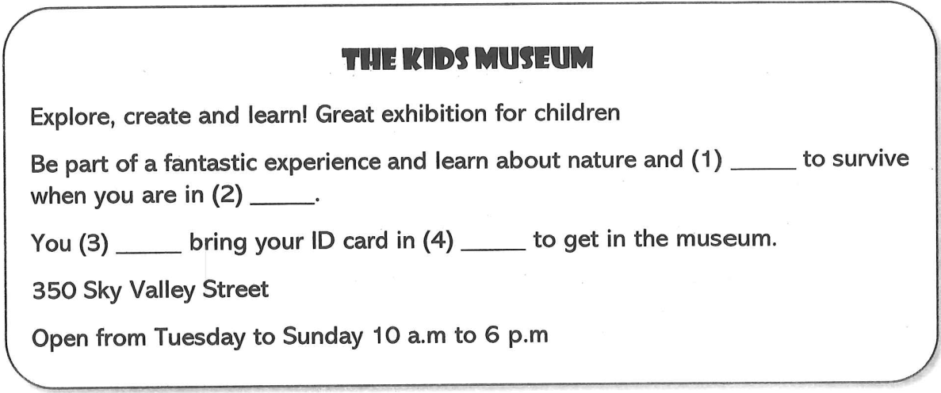
Question 1: A. why B. who C. how D. which
Question 2: A. dangerous B. danger C. dangerously D. endanger
Question 3: A. should B. have to C. can D. ought to
Question 4: A. stead B. front C. pair D. order

Exercise 19. Tra ID Đề [5542] - Tra ID Video [5543]
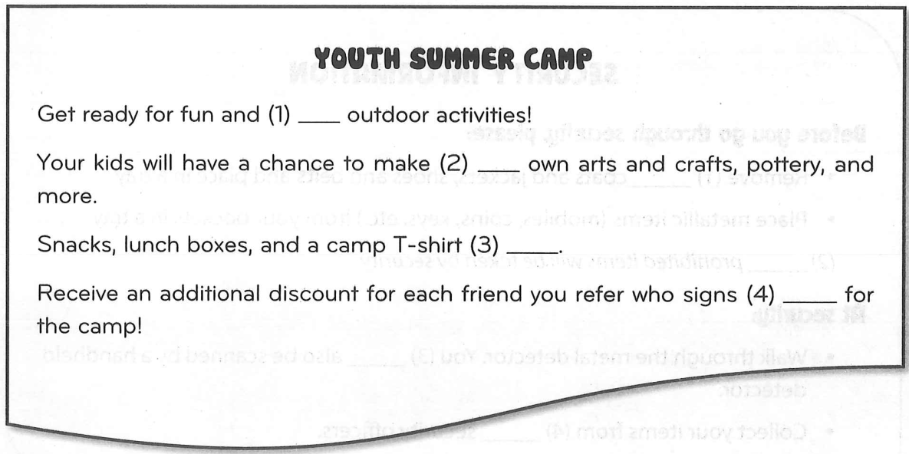
Question 1: A. creative B. created C. creation D. creativity
Question 2: A. them B. themselves C. theirs D. their
Question 3: A. includes B. including C. are included D. included
Question 4: A. down B. up C. out D. on
Exercise 20. Tra ID Đề [5544] - Tra ID Video [5545]
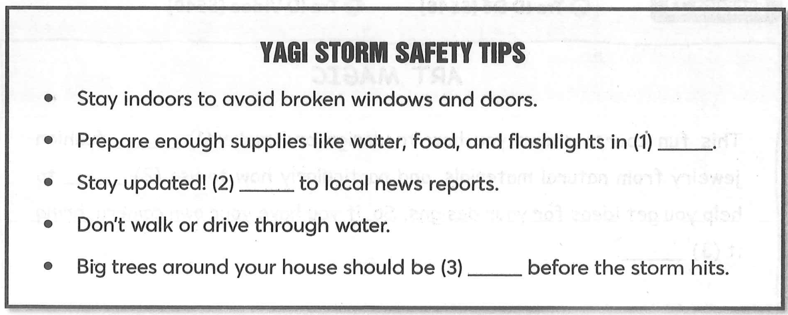
Question 1: A. peace B. exchange C. advance D. return
Question 2: A. watch B. wait C. listen D. hear
Question 3: A. strong B. strength C. strengthened D. stronger

Exercise 21. Tra ID Đề [5546] - Tra ID Video [5547]
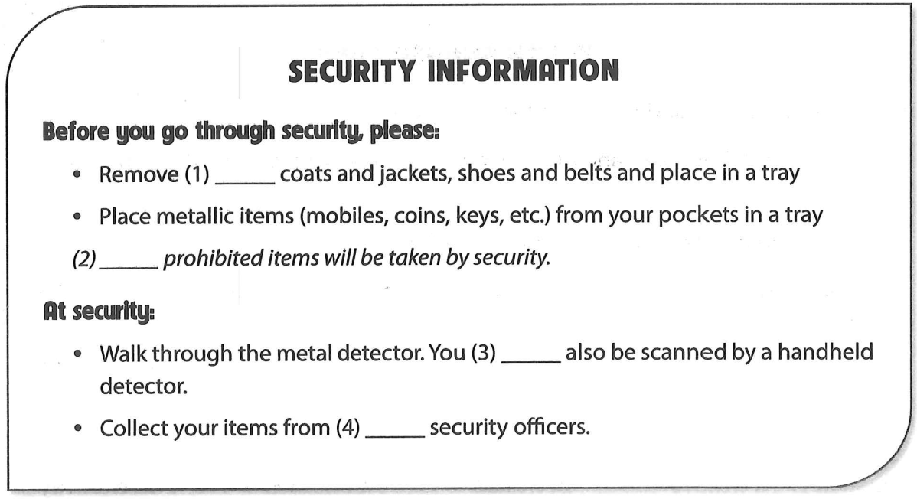
Question 1: A. every B. all C. each D. other
Question 2: A. Some B. Any C. No D. Few
Question 3: A. are B. have C. may D. had
Question 4: A. a B. an C. the D. ∅
Exercise 22. Tra ID Đề [5548] - Tra ID Video [5549]
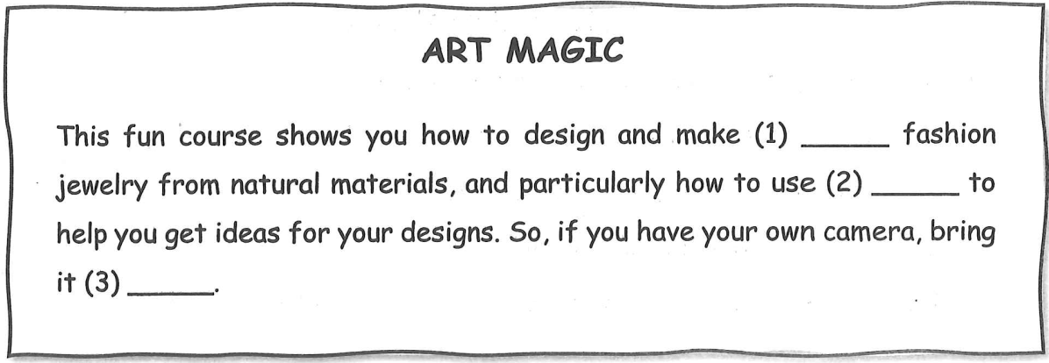
Question 1: A. a B. an C. the D. ∅
Question 2: A. photography B. photograph C. photographer D. photogenic
Question 3: A. in B. about C. up D. along

Exercise 23. Tra ID Đề [5550] - Tra ID Video [5551]
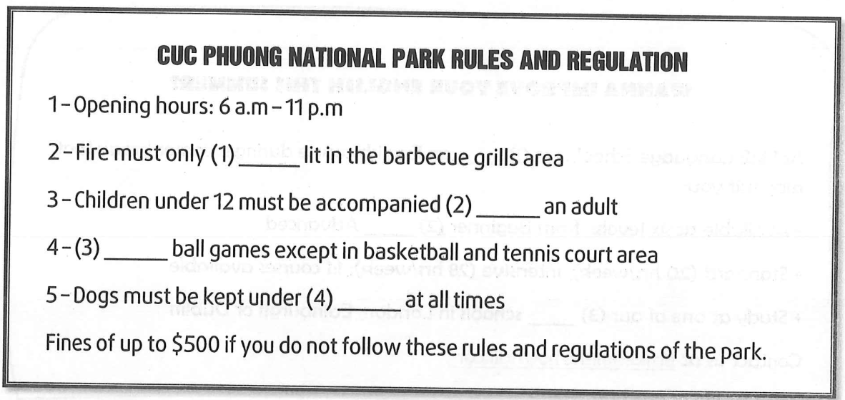
Question 1: A. be B. are C. is D. have
Question 2: A. for B. by C. of D. in
Question 3: A. Some B. None C. Not D. No
Question 4: A. pressure B. control C. stress D. influence
Exercise 24. Tra ID Đề [5552] - Tra ID Video [5553]
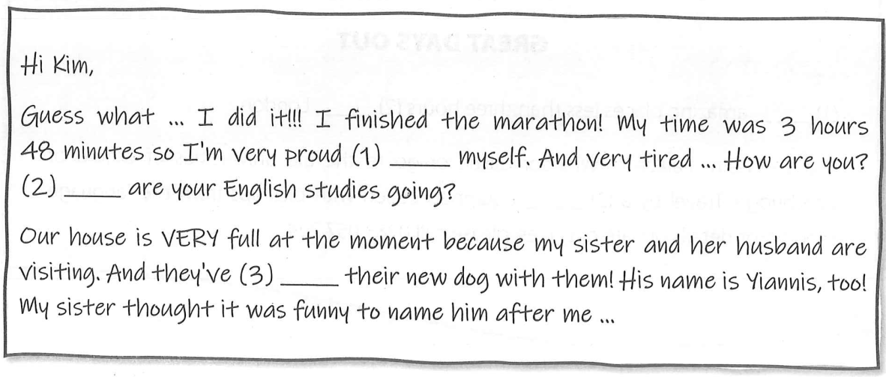
Question 1: A. in B. for C. on D. of
Question 2: A. How B. When C. Where D. What
Question 3: A. bring B. been brought C. bringing D. brought

Exercise 25. Tra ID Đề [5554] - Tra ID Video [5555]
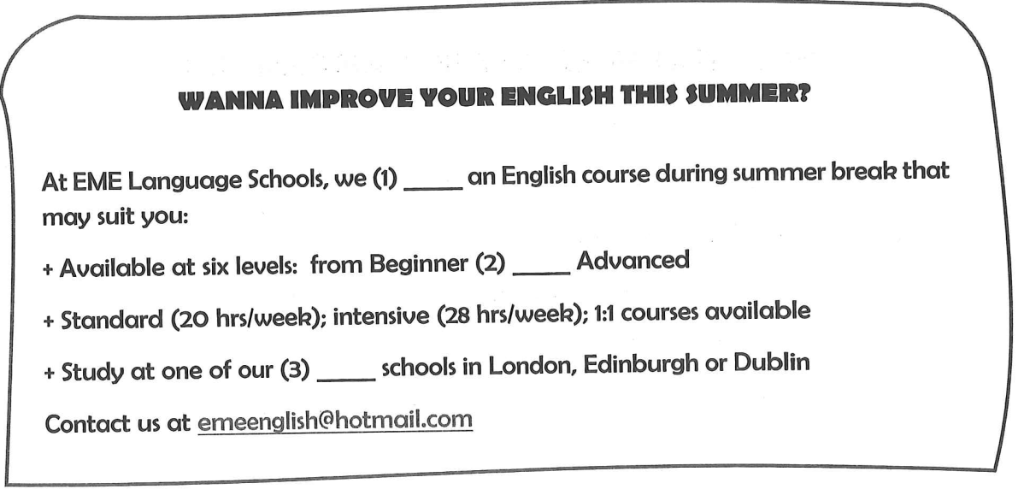
Question 1: A. require B. happen C. offer D. advertise
Question 2: A. and B. to C. for D. in
Question 3: A. fascinating B. fascination C. fascinated D. fascinate
Exercise 26. Tra ID Đề [5556] - Tra ID Video [5557]
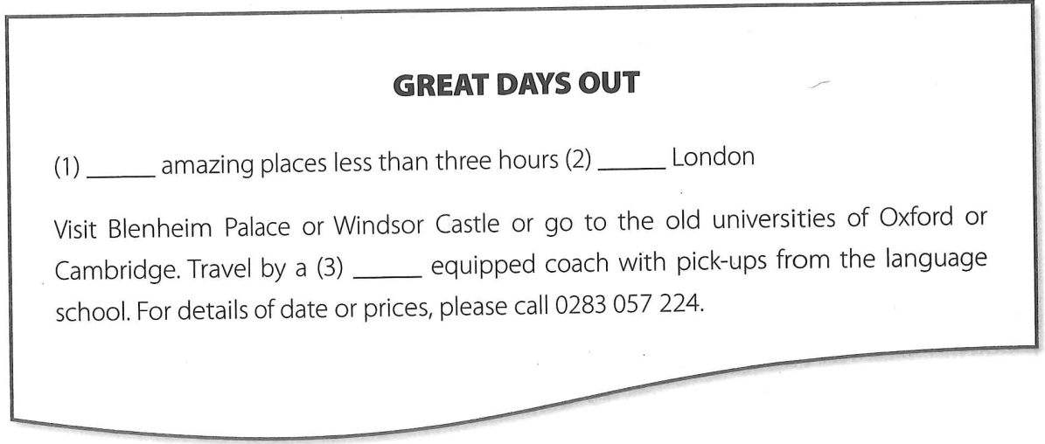
Question 1: A. Explore B. Discover C. Adventure D. Find
Question 2: A. in B. to C. at D. from
Question 3: A. full B. fully C. fuller D. unfull

Exercise 27. Tra ID Đề [5558] - Tra ID Video [5559]
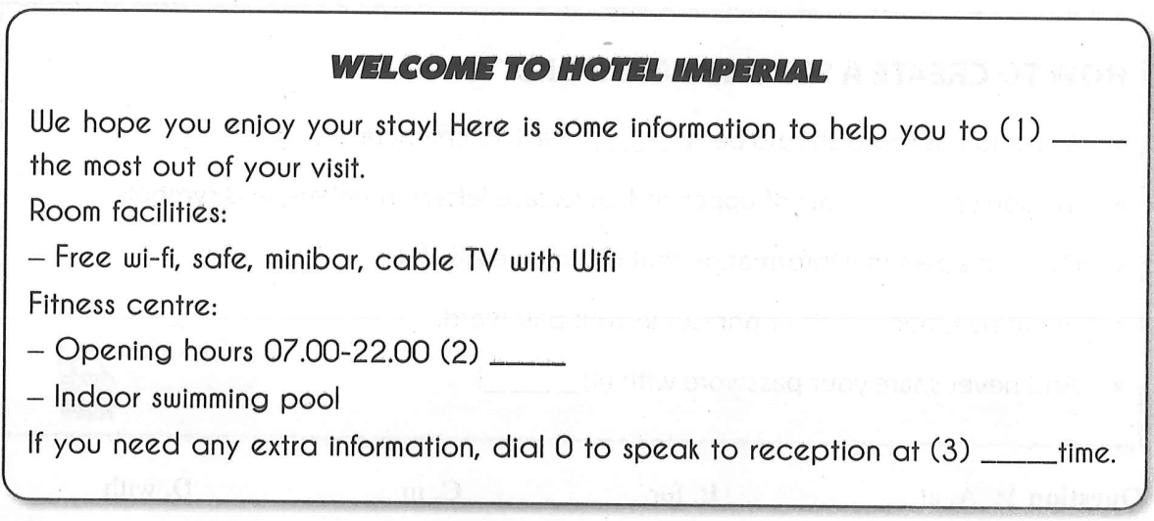
Question 1: A. bring B. have C. get D. buy
Question 2: A. date B. daily C. annually D. days
Question 3: A. some B. any C. each D. many
Exercise 28. Tra ID Đề [5560] - Tra ID Video [5561]
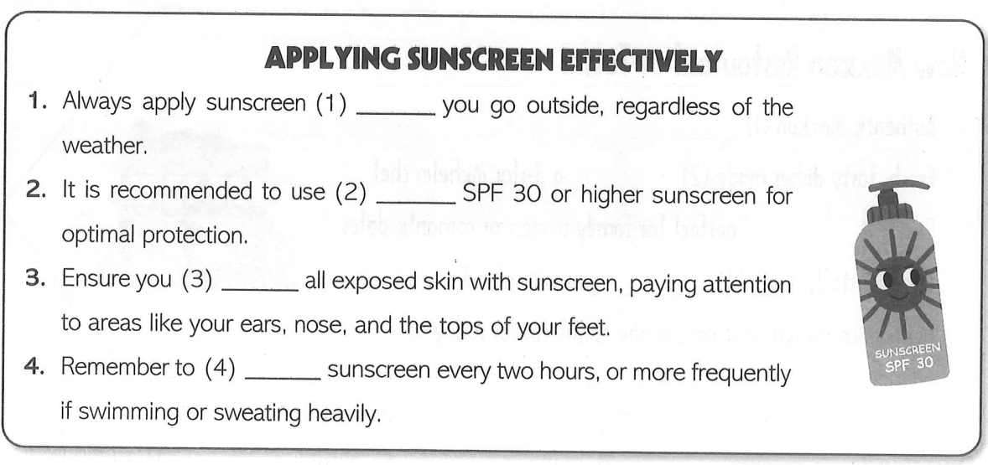
Question 1: A. while B. before C. during D. after
Question 2: A. a B. an C. the D. ∅
Question 3: A. protect B. cover C. leave D. moisturize
Question 4: A. reapply B. replace C. redo D. repeat

Exercise 29. Tra ID Đề [5562] - Tra ID Video [5563]
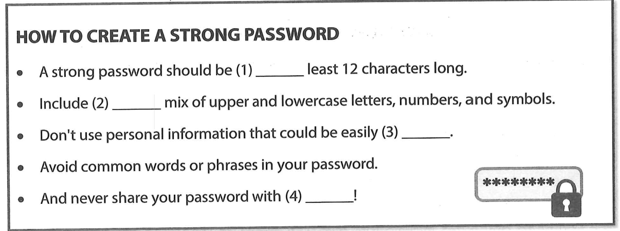
Question 1: A. at B. for C. in D. with
Question 2: A. a B. an C. the D. ∅
Question 3: A. guess B. guessing C. guessed D. to guess
Question 4: A. anyone B. everyone C. no one D. someone
Exercise 30. Tra ID Đề [5564] - Tra ID Video [5565]
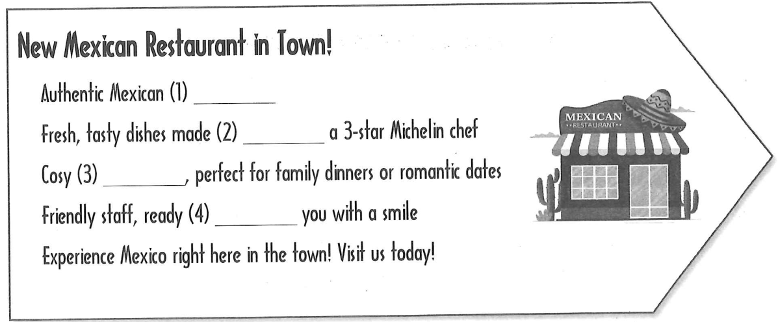
Question 1: A. cuisine B. manner C. habit D. lifestyle
Question 2: A. of B. from C. by D. in
Question 3: A. air B. temperature C. atmosphere D. emotion
Question 4: A. serving B. to serving C. serve D. to serve

Exercise 31. Tra ID Đề [5566] - Tra ID Video [5567]
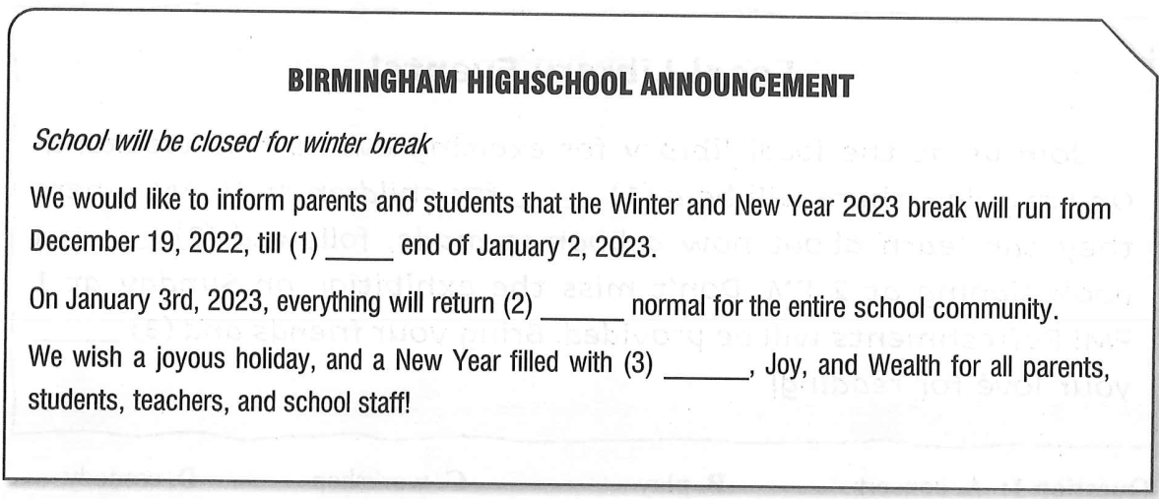
Question 1: A. a B. an C. the D. ∅
Question 2: A. on B. in C. at D. to
Question 3: A. Unhealthy B. Healthily C. Health D. Healthy
Exercise 32. Tra ID Đề [5568] - Tra ID Video [5569]
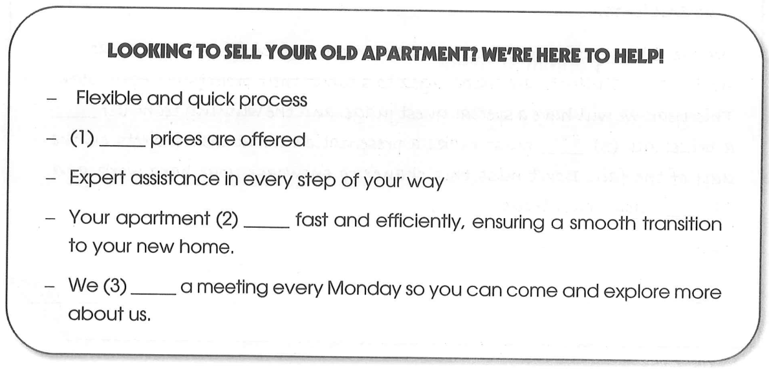
Question 1. A. Competitively B. Competition C. Competitive D. Compete
Question 2. A. will be sold B. sells C. was sold D. sold
Question 3. A. invent B. take place C. occur D. create

Exercise 33. Tra ID Đề [5570] - Tra ID Video [5571]
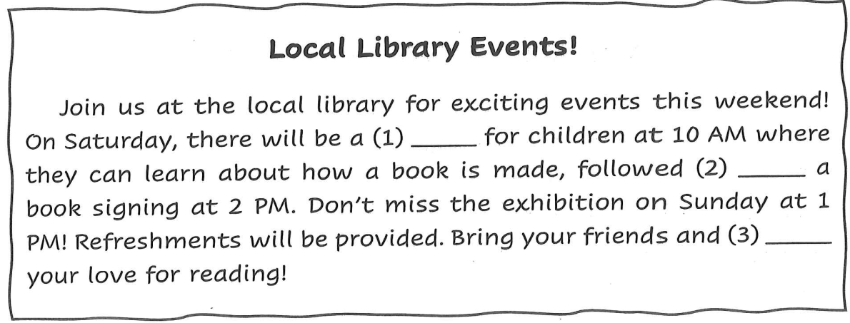
Question 1: A. concert B. play C. workshop D. comedy
Question 2: A. by B. with C. in D. on
Question 3: A. tell B. say C. share D. perform
Exercise 34. Tra ID Đề [5572] - Tra ID Video [5573]
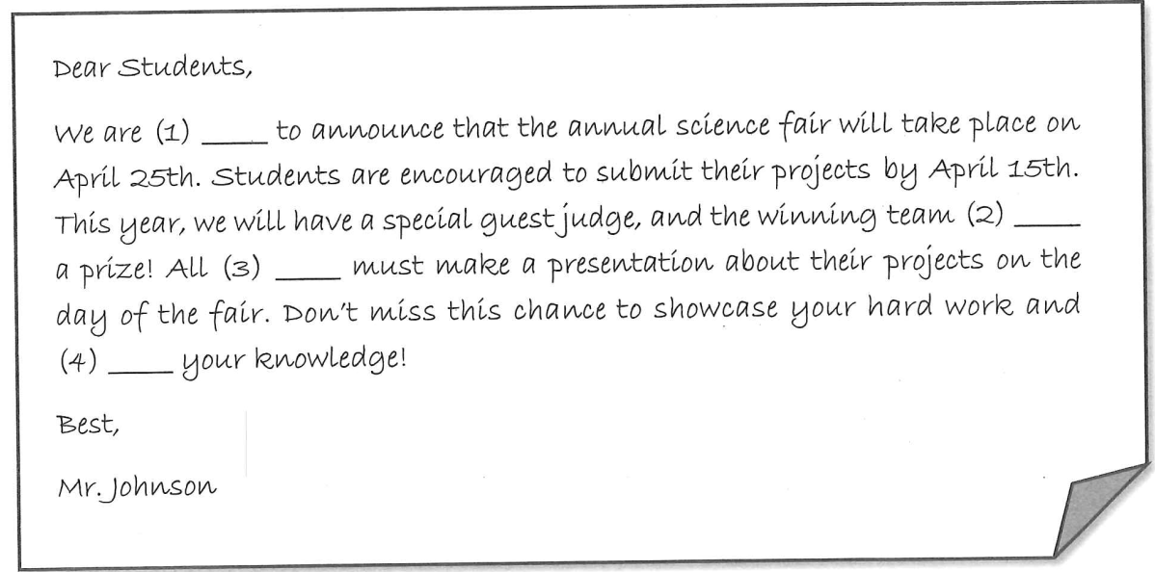
Question 1: A. excite B. excitement C. exciting D. excited
Question 2: A. has received B. received C. will receive D. receives
Question 3: A. participants B. supporters C. players D. applicant
Question 4: A. share B. sharing C. shared D. share

Exercise 35. Tra ID Đề [5574] - Tra ID Video [5575]
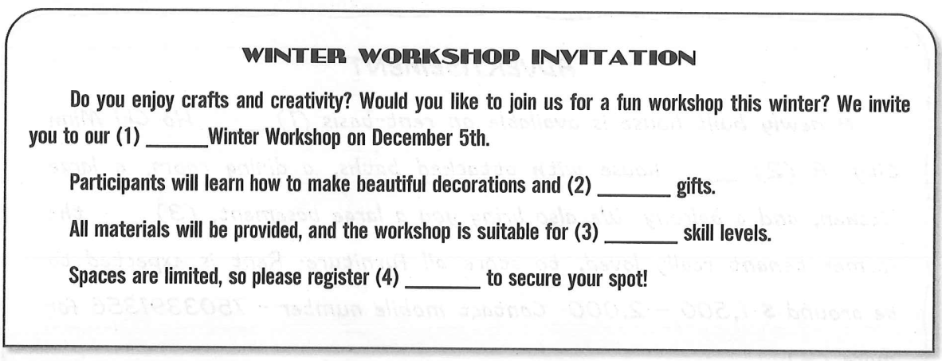
Question 1: A. exciting B. excite C. excitement D. excited
Question 2: A. handmade B. handmake C. hand D. hands
Question 3: A. any B. every C. all D. much
Question 4: A. early B. late C. quick D. later
Exercise 36. Tra ID Đề [5576] - Tra ID Video [5577]
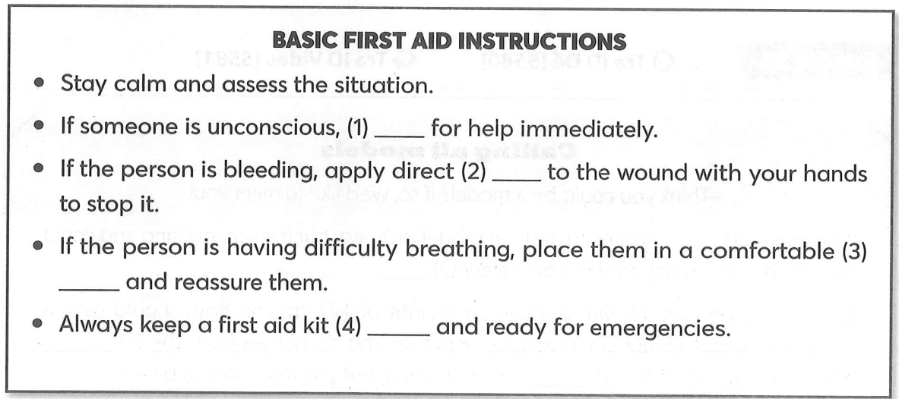
Question 1: A. call B. shout C. wave D. send
Question 2: A. breath B. force C. heat D. ice
Question 3: A. position B. destination C. place D. style
Question 4: A. closed B. open C. next D. far

Exercise 37. Tra ID Đề [5578] - Tra ID Video [5579]
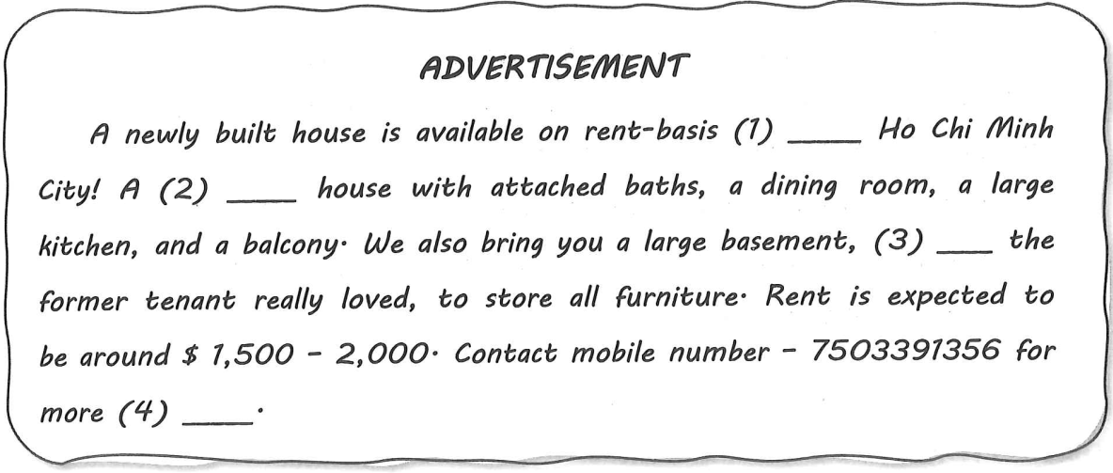
Question 1: A. in B. on C.at D. to
Question 2: A. four bedrooms B. four – bedrooms
C. four – bedroom D. fours bedroom
Question 3: A. where B. which C. when D. who
Question 4: A. informatively B. information C. informative D. inform
Exercise 38. Tra ID Đề [5580] - Tra ID Video [5581]
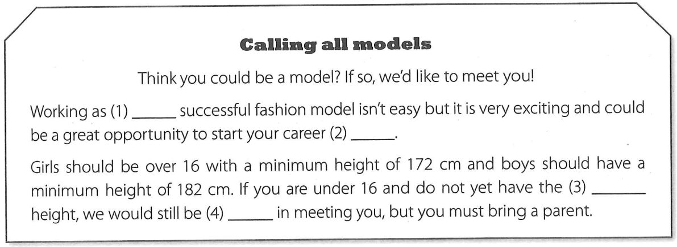
Question 1: A. a B. an C. the D. ∅
Question 2: A. way B. road C. street D. path
Question 3: A. required B. requiring C. requirement D. require
Question 4: A. keen B. fond C. interested D. like

Exercise 39. Tra ID Đề [5582] - Tra ID Video [5583]
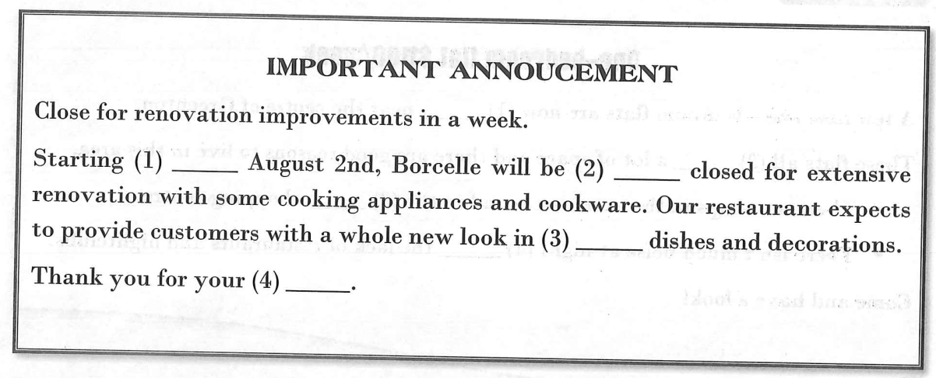
Question 1: A. in B. on C. at D. for
Question 2: A. permanently B. temporarily C. endlessly D. hopefully
Question 3: A. both B. neither C. every D. other
Question 4: A. patient B. patiently C. patients D. patience
Exercise 40. Tra ID Đề [5584] - Tra ID Video [5585]
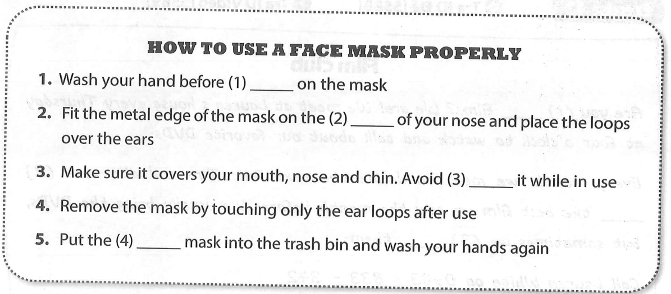
Question 1: A. wearing B. having C. taking D. putting
Question 2: A. bridge B. back C. wing D. holes
Question 3: A. touching B. to touch C. to touching D. touch
Question 4: A. using B. useful C. used D. uses

Exercise 41. Tra ID Đề [5586] - Tra ID Video [5587]
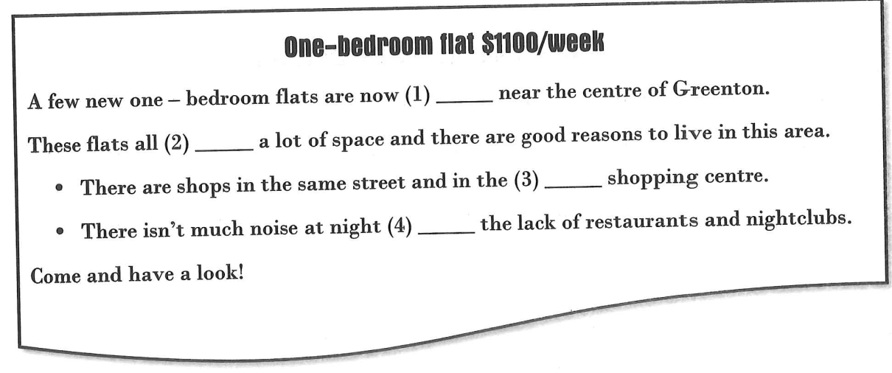
Question 1: A. suitable B. possible C. available D. incredible
Question 2: A. offer B. demand C. require D. ask
Question 3: A. by B. nearby C. faraway D. next to
Question 4: A. because B. despite C. in spite D. because of
Exercise 42. Tra ID Đề [5588] - Tra ID Video [5589]
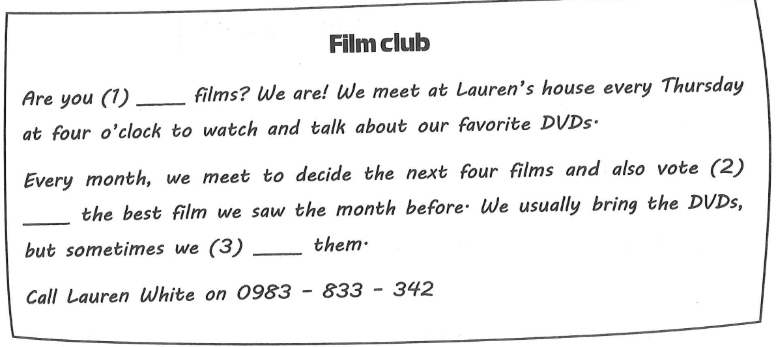
Question 1: A. like B. interested C. into D. keen
Question 2: A. by B. for C. to D. on
Question 3: A. rent B. hire C. lease D. owe

Exercise 43. Tra ID Đề [5590] - Tra ID Video [5591]
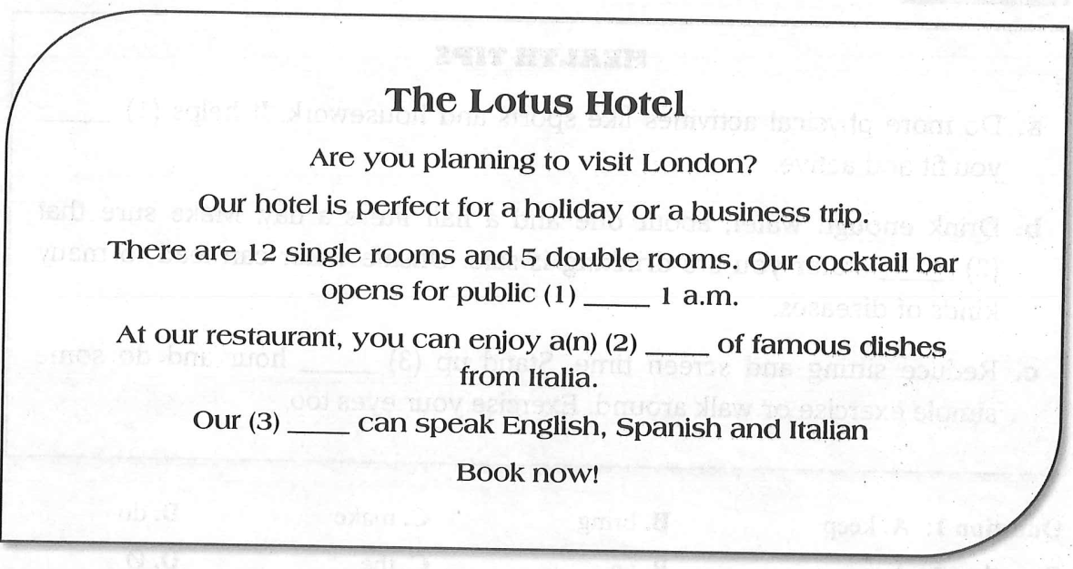
Question 1: A. until B. as soon as C. when D. while
Question 2: A. amount B. deal C. number D. plenty
Question 3: A. reception B. receptionists C. receive D. receptive
Exercise 44. Tra ID Đề [5592] - Tra ID Video [5593]
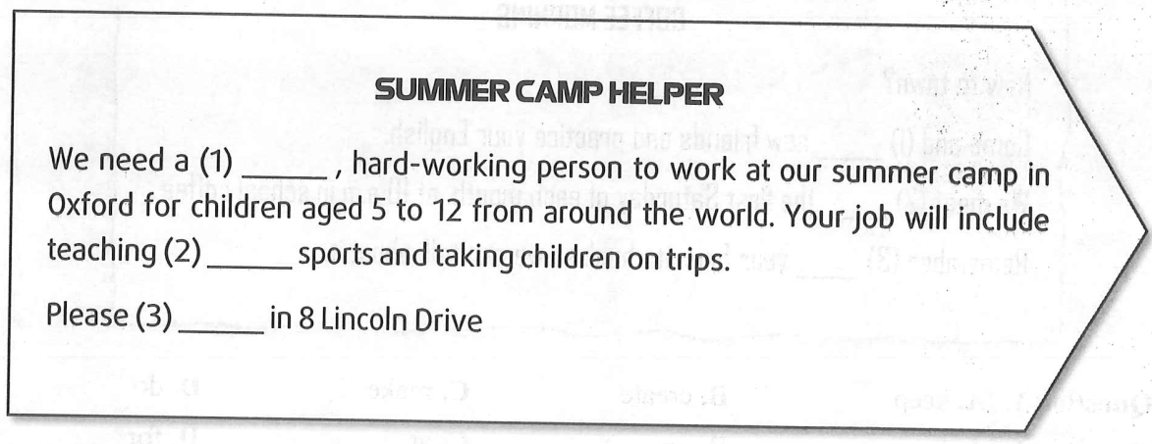
Question 1: A. rely B. reliable C. reliably D. reliance
Question 2: A. a B. an C. the D. ∅
Question 3: A. recruit B. apply C. hire D. compete

Exercise 45. Tra ID Đề [5594] - Tra ID Video [5595]
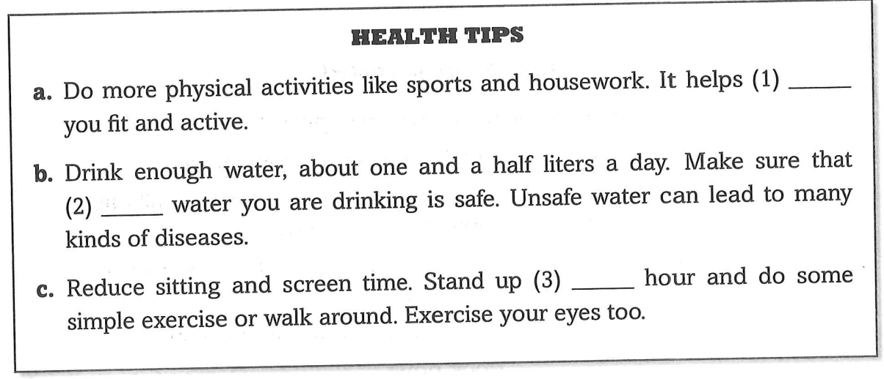
Question 1: A. keep B. bring C. make D. do
Question 2: A. a B. an C. the D. ∅
Question 3: A. a B. every C. most D. few
Exercise 46. Tra ID Đề [5596] - Tra ID Video [5597]
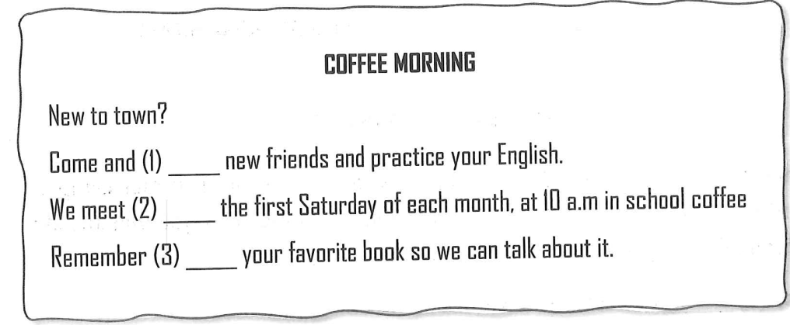
Question 1: A. keep B. create C. make D. do
Question 2: A. in B. on C. at D. for
Question 3: A. to bring B. bringing C. brought D. bring

Exercise 47. Tra ID Đề [5598] - Tra ID Video [5599]
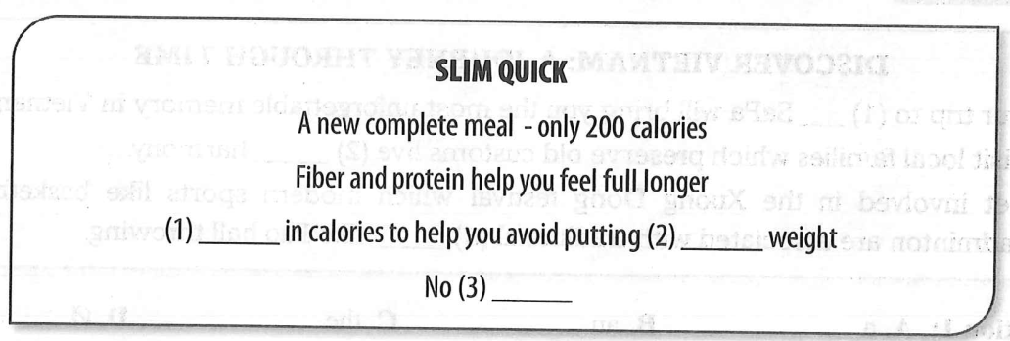
Question 1: A. low B. short C. high D. lack
Question 2: A. in B. on C. at D. for
Question 3: A. addition B. additives C. addict D. addicted
Exercise 48. Tra ID Đề [5600] - Tra ID Video [5601]
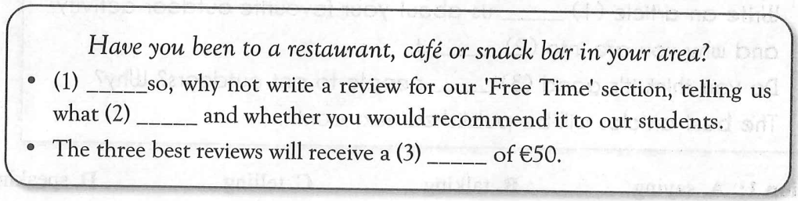
Question 1: A. Even B. If C. Like D. That
Question 2: A. it is like B. is it like C. does it like D. it likes
Question 3: A. money B. fine C. cost D. prize
Exercise 49. Tra ID Đề [5602] - Tra ID Video [5603]
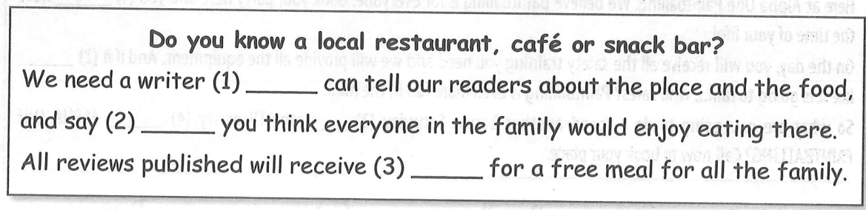
Question 1: A. which B. whom C. who D. whose
Question 2: A. whether B. where C. can D. should
Question 3: A. vouchers B. receipts C. bills D. paper

Exercise 50. Tra ID Đề [5604] - Tra ID Video [5605]
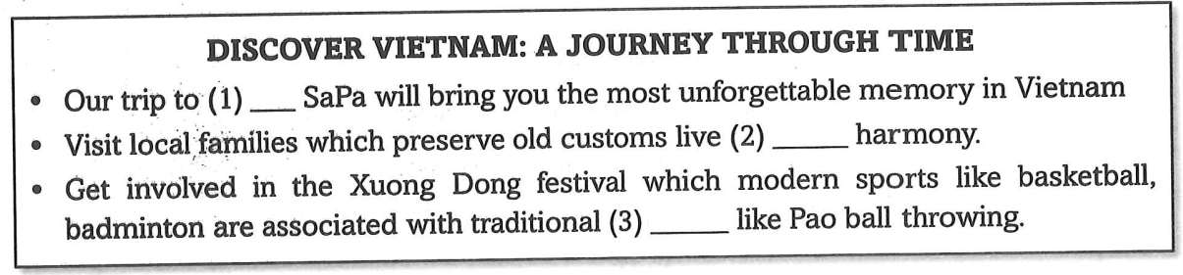
Question 1: A. a B. an C. the D. ∅
Question 2: A. in B. to C. at D. on
Question 3: A. educations B. differences C. types D. values
Exercise 51. Tra ID Đề [5606] - Tra ID Video [5607]
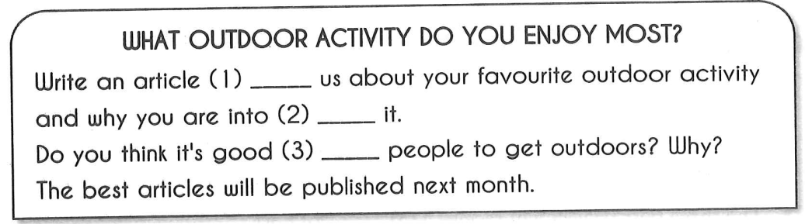
Question 1: A. saying B. talking C. telling D. speaking
Question 2: A. doing B. did C. to do D. do
Question 3: A. to B. for C. in D. at
Exercise 52. Tra ID Đề [5608] - Tra ID Video [5609]
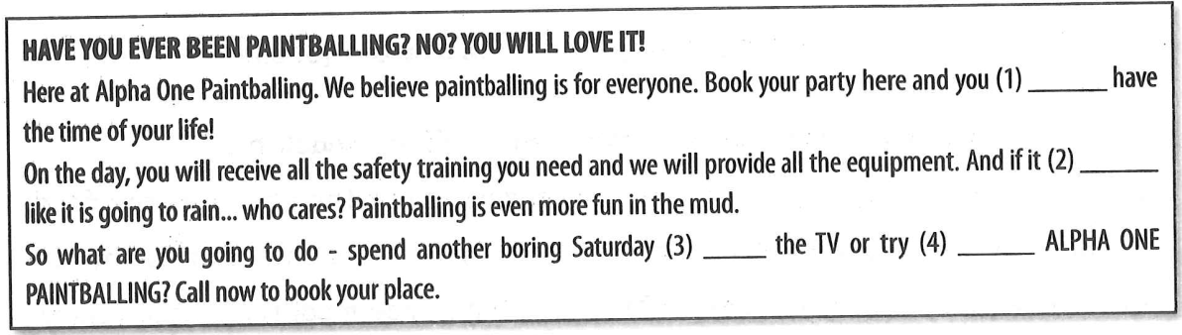
Question 1: A. are going to B. will C. have D. is
Question 2: A. smells B. sounds C. says D. looks
Question 3: A. behind B. besides C. in front of D. under
Question 4: A. in B. on C. out D. after

Exercise 53. Tra ID Đề [5610] - Tra ID Video [5611]
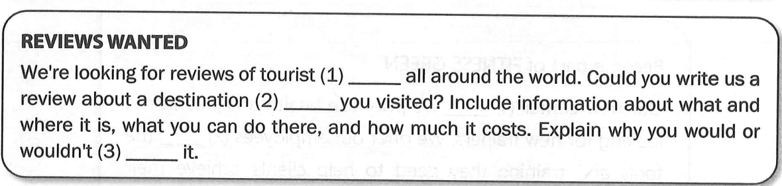
Question 1: A. attractions B. attract C. attractive D. attractant
Question 2: A. where B. which C. whom D. who
Question 3: A. recommend B. demand C. require D. invite
Exercise 54. Tra ID Đề [5612] - Tra ID Video [5613]
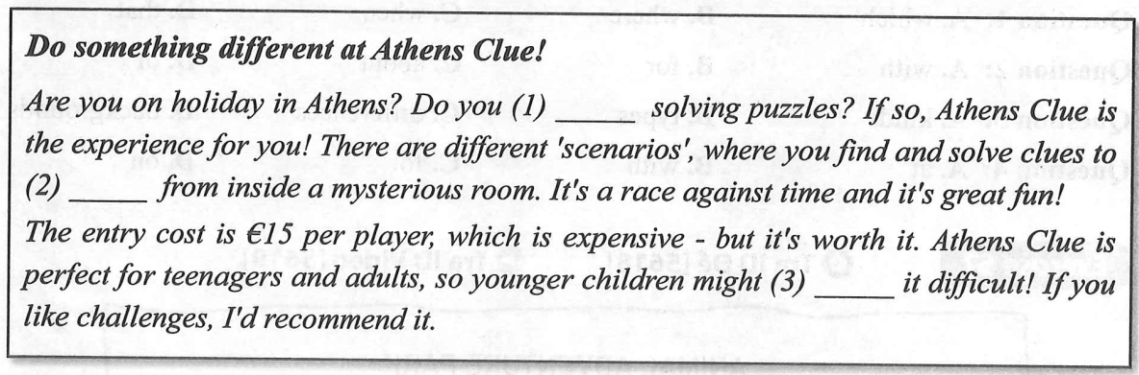
Question 1: A. interested B. keen C. fond D. fancy
Question 2: A. release B. escape C. eliminate D. emit
Question 3: A. look B. watch C. find D. make
Exercise 55. Tra ID Đề [5614] - Tra ID Video [5615]
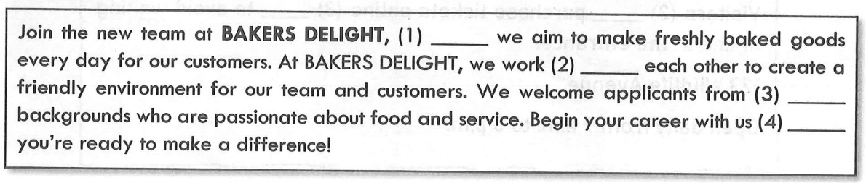
Question 1: A. when B. where C. that D. what
Question 2: A. with B. alongside C. to D. on
Question 3: A. various B. vary C. varying D. variation
Question 4: A. if B. unless C. while D. because

Exercise 56. Tra ID Đề [5616] - Tra ID Video [5617]
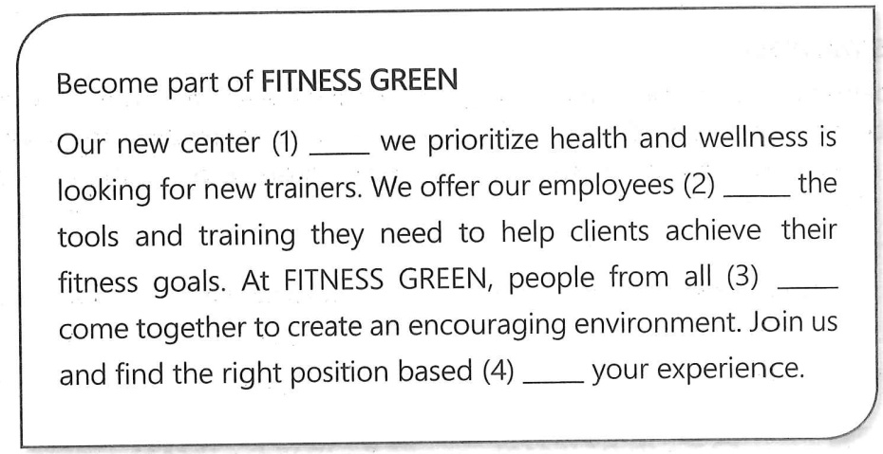
Question 1: A. which B. where C. when D. that
Question 2: A. with B. for C. about D. of
Question 3: A. kinds B. types C. differences D. backgrounds
Question 4: A. at B. with C. for D. on
Exercise 57. Tra ID Đề [5518] - Tra ID Video [5519]
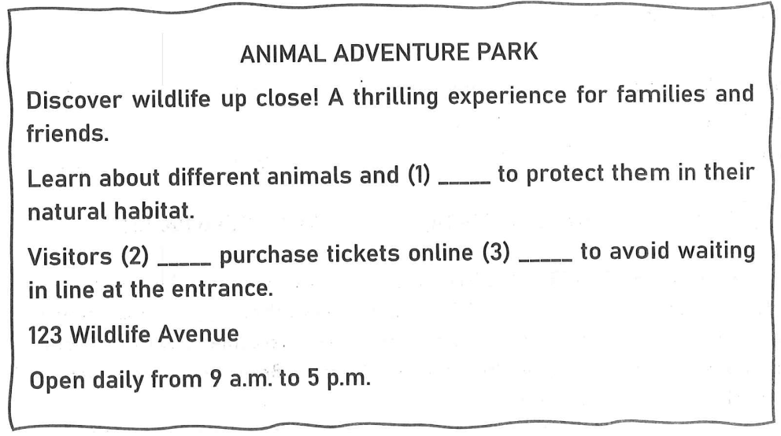
Question 1: A. why B. where C. when D. how
Question 2: A. have to B. could C. should D. might
Question 3: A. so B. in order C. for D. front
Exercise 58. Tra ID Đề [5620] - Tra ID Video [5621]
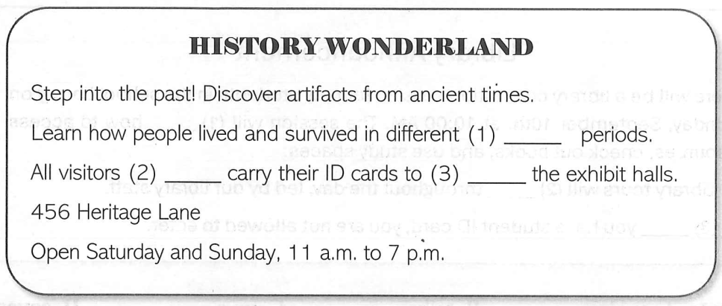
Question 1: A. history B. historic C. historical D. historian
Question 2: A. could B. have to C. can D. ought to
Question 3: A. enter B. go C. arrive D. come
Exercise 59. Tra ID Đề [5622] - Tra ID Video [5623]
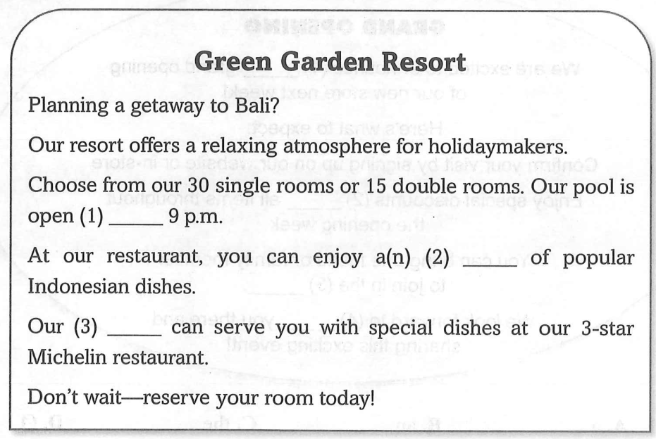
Question 1: A. through B. beyond C. until D. across
Question 2: A. variety B. portion C. number D. sample
Question 3: A. staff B. receptionists C. employees D. chefs
Exercise 60. Tra ID Đề [5624] - Tra ID Video [5625]
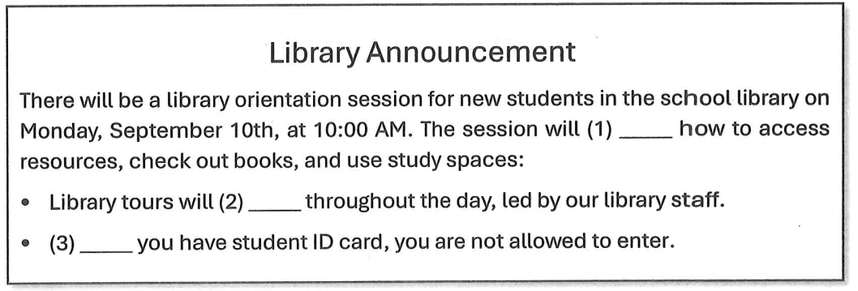
Question 1: A. explain B. talk C. give D. cover
Question 2: A. hold B. held C. be held D. holding
Question 3: A. When B. While C. If D. Unless
Exercise 61. Tra ID Đề [5626] - Tra ID Video [5627]
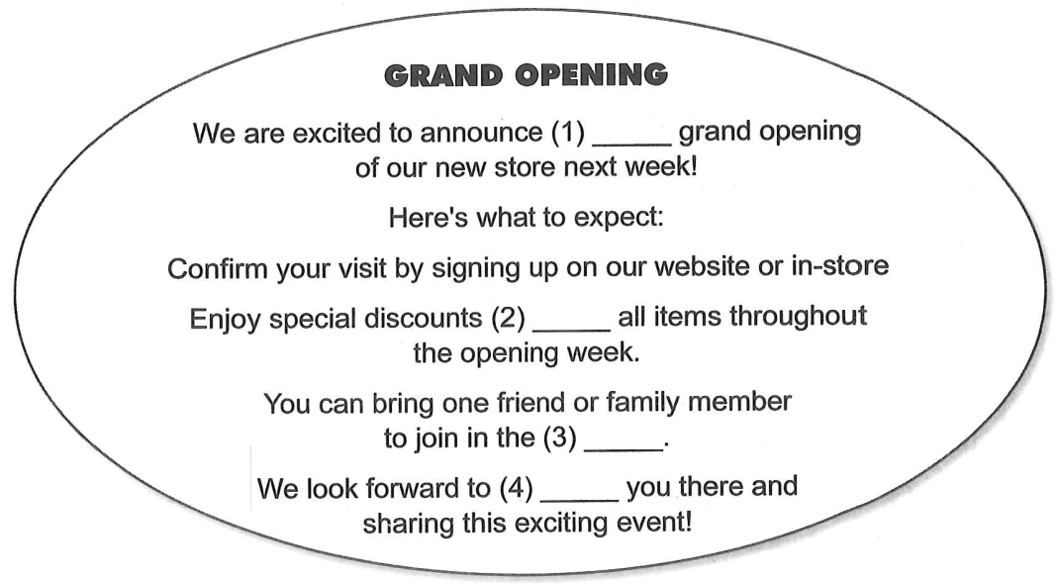
Question 1: A. a B. an C. the D. ∅
Question 2: A. on B. for C. with D. over
Question 3: A. celebrity B. celebrated C. celebration D. celebrate
Question 4. A. seeing B. avoiding C. chasing D. missing

Exercise 62. Tra ID Đề [5628] - Tra ID Video [5629]
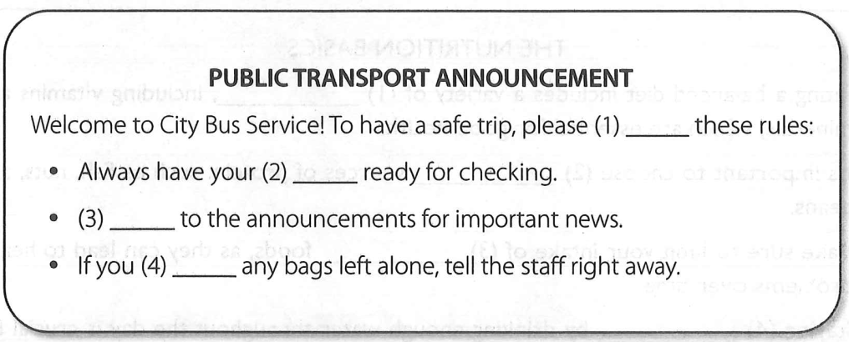
Question 1: A. ignore B. follow C. break D. forget
Question 2: A. bag B. money C. ticket D. map
Question 3: A. Shout B. Listen C. Speak D. Turn
Question 4: A. see B. hide C. lose D. want
Exercise 63. Tra ID Đề [5630] - Tra ID Video [5631]
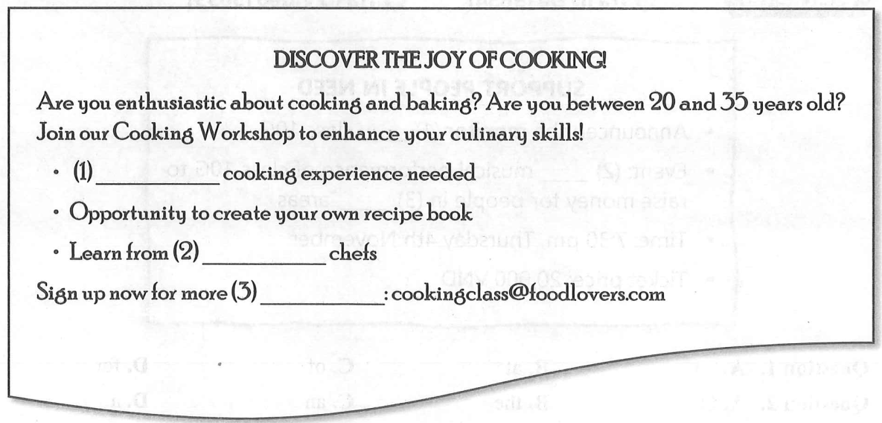
Question 1: A. Not B. No C. Never D. Neither
Question 2: A. professional B. professionally C. profession D. profiting
Question 3: A. updates B. updating C. updated D. update

Exercise 64. Tra ID Đề [5632] - Tra ID Video [5633]
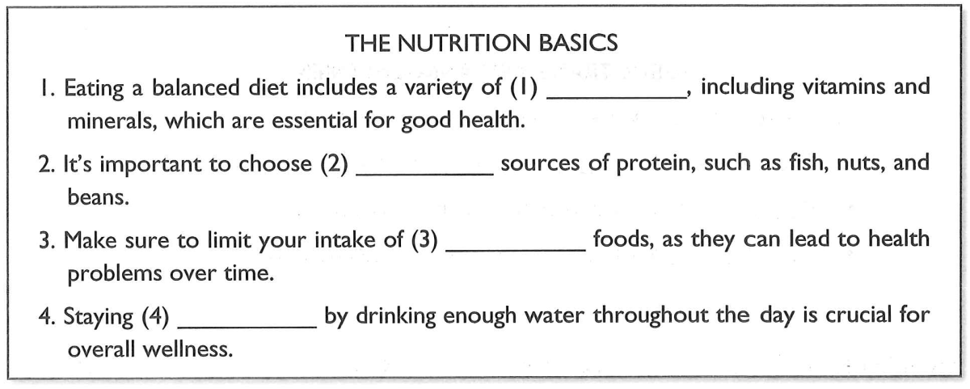
Question 1: A. fats B. nutrients C. snacks D. desserts
Question 2: A. processed B. sugary C. lean D. fatty
Question 3: A. whole B. fast C. low-calorie D. junk
Question 4: A. hydrated B. tired C. sleepy D. full
Exercise 65. Tra ID Đề [5634] - Tra ID Video [5635]
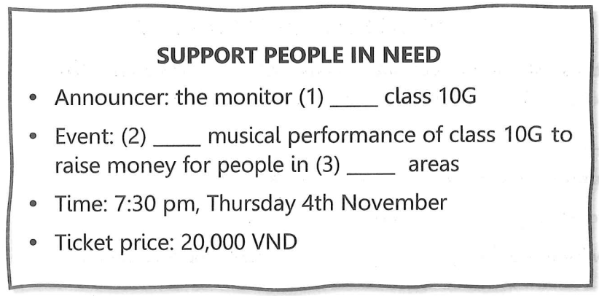
Question 1: A. on B. at C. of D. for
Question 2: A. ∅ B. the C. an D. a
Question 3: A. flooding B. floods C. flood D. flooded

