|  |  |
| --- | --- |
| **SỞ GD&ĐT VĨNH PHÚC**  TRƯỜNG THPT BÌNH SƠN  *Đề thi có 06 trang* | **KỲ THI CHỌN HSG LỚP 10, 11 CẤP TRƯỜNG**  **NĂM HỌC 2023-2024**  Môn: **TIẾNG ANH 10**  Thời gian làm bài: 90 phút (*không kể thời gian phát đề*) |

*Họ và tên: …………….…………………………………………………… Số báo danh:…………….…………*

**A. LISTENING**

**Section 1.**

**Questions 1-7**

**Complete the table below.**

**Write NO MORE THAN TWO WORDS AND/OR A NUMBER for each answer.**

**International Club**

|  |  |  |  |
| --- | --- | --- | --- |
| Event/Venue | Time/Dates | Fees | Notes |
| Library | Example: From 1 1 am to 6 pm | **(1)**…………..  Deposit: $ | Return the deposit if there is no damage |
| **(2)**…………centre | Open on (**3)** ………… | $3 | Bring one guest for free |
| Swimming | Starts on (**4)** ………… | $ (**5)** ………….. | Bring your own swimming  suit |
| Dance class | Open all day | $5 (**6** ………  included) | Bring enough water and food |
| **(7)** ……… | Open between 10:30 am and 3:30 pm (weekdays) | $3 | Replacement for the visit to Grand hotel |

**Questions 8 — 10**

**Choose THREE correct answers.**

**Which THREE events are held every month by the club?**

**A**. Lecture

**B**. Fil

**C**. Saturday

**D**. excursion

**E**. Culture evening

**F**. Night tour

**G**. Yoga classes

**8**………….

**9**………….

**10**………...

**Section 2.**

**Questions 11 — 15**

**Label the map below**

**Write the correct letter, A-I, next to Question 15-20**

**Map of Fitchton Railway Station**

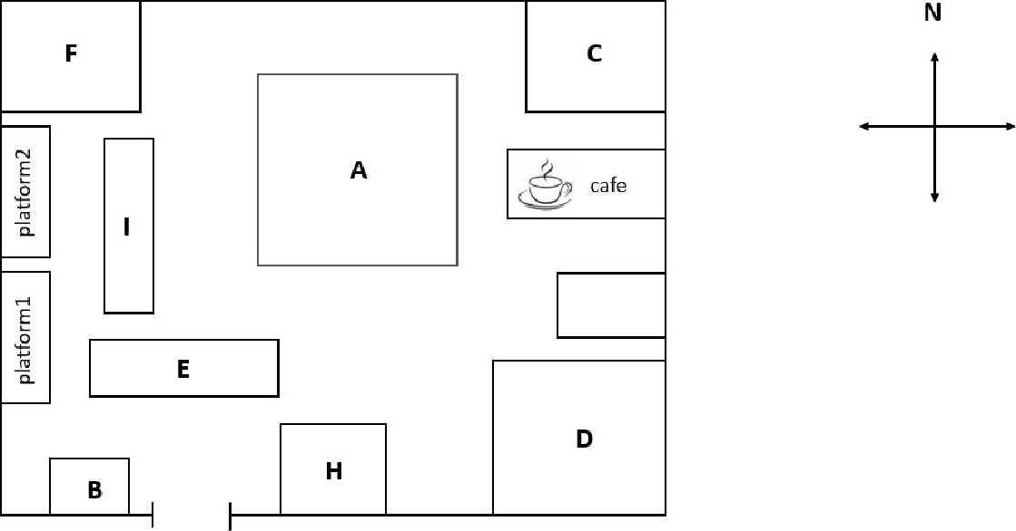

# **FITCHTON ROAD**

|  |  |  |
| --- | --- | --- |
|  | Taxi stop | **G** |

**11.** bike racks 

**12.** luggage lockers

**13.** chemist's

**14**. toilet 

**15.** news agency

**Questions 16-20**

**Choose the correct letter A, B or C**

**16.** Where could the passengers see the exhibition?

**A**. in the town library

**B**. in Fitchton college

**C**. in the station

**17**. What is the best gift for passengers to buy and bring home?

**A.** local food **B.** clothing **C.** jewelry

**18.** Where can passengers buy souvenir postcards?

**A.** in the museum **B.** in the shop **C.** in the college

**19.** What will the old cinema be converted to?

**A.** a housing area **B.** a new theatre **C.** a shop

**20.** Who is the statue in the train station modeled after?

**A.** a poet **B.** an engineer **C.** a politician

**B. LEXICO-GRAMMAR**

**Choose the best option (A, B, C or D) to complete each of the following sentences.**

**21.** - Adriana: “Don't forget to drop me a line when you settle down."

- Ryan: “_______.”

**A.** Oh, that's great! But I'm going to miss you. **B.** I look forward to hearing from you soon.

**C.** Trust me. I won't. I'll keep you posted. **D.** All right! Good luck!

**22.** You will have to ________ your holiday if you are too ill to travel.

**A**. put out **B**. put off **C**. put down **D**. put up

**23.** He’d hardly finished doing his homework when you arrived, __________?

**A**. would he **B**. had he **C**. didn’t you **D.** hadn’t he

**24.** His English teacher recommends that he _______ a regular degree program.

**A**. begin **B**. begins **C**. will begin **D**. is beginning

**25.** From an investor’s viewpoint, getting ______ advice is the key to making sound investment decisions.

**A.** unbiased **B.** inanimate **C.** unjudged **D.** impatient

**26.** _______ a scholarship, I entered one of the most privileged universities of the United Kingdom.

**A.** To award **B.** Being awarded

**C.** Having awarded **D.** Having been awarded

**27.** Fathers can _________ a good example to their children by helping with the household chores.

**A**. set  **B.** hold  **C.** raise  **D**. follow

**28.** . ________ you known he was a liar, would you have agreed to support him?

**A.** Had **B.** If **C.** Did **D.** Since

29. Jane likes watching films, but she is not _______keen on any kind.

**A**. specially **B**. certainly **C**. largely **D**. particularly

**30.** _______ finds the treasure is entitled to twenty five percent of it.

**A.** Who **B.** The person who **C**. Whoever **D**. Man who

**31.** The number of people traveling by air has been growing _______.

**A.** by leaps and bounds **B.** from time to time

**C.** slow but sure **D.** by hook or by crook

**32.** The children went ________ with excitement.

**A.** wild **B.** wildly **C.** wilderness **D.** wildlife

**33.** There are different kinds of music to _______ your taste.

**A**. miss **B**. fit **C.** tight **D**. suit

**34.** When his alarm went off, he shut it off and slept for ______15 minutes.

**A**. other **B**. others **C**. another **D**. the others

**35.** _______ the invention of the steam engine, most form of transport were horse-drawn.

**A.** Similar to **B.** Prior to **C.** In addition to **D.** With reference to

**C. READING**

**Section 1. Choose the correct answer A, B, C or D to complete the following passage.**

LEARNING TO MAKE A PERFECT PIZZA

According to the European Pizza-Makers’ Association, making a good pizza is not a straightforward skill to learn. The ingredients seem very simple: flour, yeast, water and a bit of salt. (36)______, water and flour can easily (37)______ a rather unappetizing gluey mix, and anyone who has eaten a (38)______ quality pizza will know how bad it can make your stomach feel.

“In Italy, 70 per cent of pizza makers could improve on their product, not to (39)______ all the pizza makers around the world who (40)______ uneatable meals,” says Antonio Primiceri, the Association’s founder. He has now started a pizza school in an attempt to (41)______ the reputation of this traditional dish. As part of an (42)______ course, the students at Mr Primiceri’s school are taught to (43)______ common mistakes, produce a good basic mixture, add a tasty topping and cook the pizza properly. “Test the finished pizza by breaking the crust,” advises Mr Primiceri. “If the soft (44)______ inside the pizza is white, clean and dry, it's a good pizza. If it is not like this, the pizza will upset your stomach. You will feel (45)______ full and also thirsty.”

**36. A.** However **B.** Despite **C.** Although **D.** Conversely

**37. A.** make out **B.** take up **C.** put out **D.** turn into

**38. A.** sad **B.** poor **C.** short **D.** weak

**39. A.** state **B.** mention **C.** remark **D.** tell

**40. A.** submit **B.** give **C.** provide **D.** deal

**41. A.** save **B.** hold **C.** deliver **D.** return

**42. A.** extensive **B.** extreme **C.** intensive **D.** intentional

**43. A.** pass **B.** escape **C.** miss **D.** avoid

**44. A.** spot **B.** part **C.** side **D.** slice

**45. A.** discouragingly **B.** tightly **C.** uncomfortably **D.** heavily

**Section 2. Fill in each of the numbered blanks in the following passage with ONE suitable word.**

**THE ROLE OF THE TEACHER**

There can be no doubt that teachers play a vital role in shaping students' lives. Today's educators are not (**46**)______responsible for their students' academic achievements, but also for their well-being outside the school environment. This could involve offering students valuable (**47**)______ of advice to help them handle personal problems, as young people today encounter many difficulties in their daily lives which may range (**48**)______ something minor, such as an argument with a friend, to something serious such as bullying and abuse. (**49**)______ the problem may be, teachers need to be there for their students. Teachers also take on the role of motivator. That's why they often enrol in special seminars (**50**)______ they are trained to encourage student motivation in the classroom. By putting this theory into (**51**)______ they can inspire students to view learning as an enjoyable process. (**52**)______, good teachers do not simply focus on testing or examinations, but make available resources, in the hope of maintaining student interest and ultimately preparing them for their future. All in all, the way a teacher treats a student can have a huge (**53**)______ on their character and future achievements. Encouraging students to set goals and stick (**54**)______ them is extremely important and it is such encouragement that eventually builds a solid relationship (**55)**______ teacher and student which will help them get on well with each other.

**Section 3. Read the following passage and choose the correct answer A, B, C or D to each of the questions.**

**DIET AND EXERCISE**

Many people seem to believe that there is a magic diet formula that will guarantee weight loss. [1] This is a fallacy. Most fad diet, if followed **conscientiously**, will result in weight loss due to the reduction in calories. [2] However, they are nearly always too monotonous and sometimes too unhealthy to be followed in the long term. [3] Worse, fad dieters who don't become physically active and learn to eat sensibly will eventually regain the weight they lost, and often even more. [4]

Some of the most popular fad diet in recent years have been low-carbohydrate programs, which work by making the body produce ketons. Ketons are normal and efficient source of energy for the human body. When the intake of carbohydrate is severely restricted, body fats are broken down into fatty acids that can be used as fuel. The fatty acids may be incompletely metabolised, yielding ketons. When your body is producing ketons, and using them as fuel, this is called ketosis. Most diets based on ketosis do not limit the consumption of protein, fat, or total calories. As a result, **their** fat content tends to be very high. Promoters claim that ketosis will lead to increased metabolism of unwanted fat, even if the calories are not reduced. This is not entirely true; calorie reduction is likely to occur because of the diet's lack of appealing foods. This **is not conductive to** forming sensible eating habits.

The major widely used low-carbohydrate diet is the one advocated by the late Robert Atkins M.D, of New York City. Under the Atkins program, the dieter is permitted to eat unlimited amounts of non-carbohydrate foods "when hungry". The American Medical Association and many individual experts have warned that the unlimited intake of saturated fat under Atkins food plan can increase the dieter's risk of heart disease. In 2000, researchers at the University of Kentucky did a computer analysis of a week's worth of sample menus and reported several alarming findings: the diet contained 59% fat; it provided fewer servings of grains, vegetables, and fruits than recommended by most nutritionists, and while it can produce short-term weight loss, long-term use is likely to increase the risk of both cardiovascular disease and cancer. The weight loss usually doesn't last, either. **As ketosis begins, weight will be shed quickly, giving the misleading impression that significant fat reduction is taking place**. In fact, most of the weight loss is water rather than fat; the lost water is regained quickly when a normal diet is resumed. Appetite, which is often reduced during ketosis, also returns.

Atkins advocated his diet for more than 30 years and claimed that more than 60,000 patients treated at his centre had used his diet as their primary protocol for losing weight. Yet he never published any study in which people who used this program were monitored over a period of several years. Besides the dubiousness of its effects in the long term, the Atkins diet shares another shortcoming of all fad diets: inflexibility. People are different, with different health problems and genetic characteristics, and no single diet is right for everyone.

An additional downside to the recent craze for low-carbohydrate diets is that **it** has encouraged food companies to market low-carbohydrate foods for people who want to "watch their carbs". Most of these foods are much higher in fat than the foods they are designed to replace. "Low carb" advertising is encouraging both dieters and non-dieters to eat high-fat foods, which is exactly the opposite of medical and nutrition authorities have been arguing for decades. Following a low-carbohydrate diet under medical supervision may make sense for some people, but a population-wide increase in fat consumption would be a public health disaster.

*(Source: tracnghiemtienganhthpt.vn/onthi/success/13118.html)*

**56.** What is the topic of the passage?

**A**. How to succeed with the Atkins Diet **B.** Weight loss through carbohydrate reduction

**C.** Problems with fad diets **D.** The dangers of a high-fat diet.

**57.** Which is the best place for the following sentence?

***"In order to lose weight you must eat less, or exercise more, or do both"***

**A**. [1] **B**. [2] **C**. [3] **D.** [4]

**58*.***It can be inferred from the passage that the author thinks fad diets in general ______.

**A**. are always bad for you because they contain too much fat.

**B.** can be unhealthy in the long term and have too little variety.

**C**. are effective and safe if used under a doctor's supervision .

**D**. usually result in long-term weight loss.

**59**. Which of the following is an effect of ketosis?

**A.** Long-term weight loss **B.** Loss of water from the body

**C**. Increase in appetite **D**. Greater energy

**60***.* The word “**their**” in paragraph 2 refers to ______.

**A.** diets **B**. ketons **C**. calories **D.** ketosis

**61**. The word “**conscientiously**” in paragraph 1 could be best replaced by ______.

**A**. consciously **B**. scientifically **C.** correctly **D.** severely

**62***.* The phrase “**is not conductive to**” in paragraph 2 is closest in meaning to ______.

**A**. does not prevent **B**. makes easier

**C**. is not consistent with **D.** does not encourage

**63**. It can be inferred that the author's biggest objection to the Atkins diet is that ______.

**A**. it has led to "low-carb" advertising **B.** (s)he believes it causes cancer

**C**. it leads to higher fat consumption **D.** it has not been thoroughly studied

**64.** The word “**it**” in paragraph 5 refers to ______.

**A**. downside **B.** craze **C.** diet **D.** food

**65*.*** Which of the following best expresses the essential information in the underlined sentence in the passage?

**A.** Ketosis causes weight loss at first, leading people to wrongly believe that they are losing fat.

**B**. Ketosis causes the rapid loss of fat at first, which leads to a false belief that the loss will be permanent.

**C.** The process of ketosis quickly misleads people into thinking that they are losing weight.

**D.** Ketosis causes rapid weight loss, but only in the early days of the diet.

**D. WRITING**

**Section 1. Rewrite each of the following sentences in such a way that it has a similar meaning to the original one.**

**66.** It is sad, but unemployment is unlikely to go down this year.

⇨ Sad

**67.** It is believed that his father died in a car accident .

⇨ His father

**68**. The book was so interesting that people couldn’t put it down.

⇨ It was

**69**. The noise next door continued until after midnight.

⇨It was not until

**70**. I’m sure he ate the cake because he was in the kitchen all that time.

⇨ He must

**Section 2. Complete each second sentence using the word given, so that it has a similar meaning to the first sentence. Write between TWO and SIX words in each gap.**

**71.** It’s no good persuading her to change her mind now. **(POINT)**

🡲 There ____________________________change her mind now.

**72.** I was not allowed to go to the party. (**PERMISSION)**

🡲I _________________________to the party.

**73**. She thought it was too difficult for her to come to the class on time. (**FOUND**)

🡪 She to the class on time.

**74**. You mustn’t start writing before the test has started. (**RULES**)

🡪 It is until the test has started.

**75.**“I promise I will never tell anyone about the missing files,” said Jenny. **(WORD)**

🡪 Jenny _____________________________________never tell anyone about the missing files.

**------------------- Hết -------------------**