School: ……………………………………….. | Date:……………………………………..
Class: ……………………………..................... | Period: 42

UNIT 4: NATURAL DISASATERS
Lesson 2.2 - Grammar, pages 39 & 40
1. Objectives
By the end of this lesson, students will be able to…
1.1. Language knowledge/ skills
- practice and use Preposition of place and movements correctly
1.2. Competences
- improve Ss’ communication, analytical, critical thinking skills.
1.3. Attributes
- talk about locations and movements correctly.
2. Teaching aids and materials
- Teacher’s aids: Student’s book and Teacher’s book, class CDs, DCR– Phần mềm tương tác trực quan, DHA – Ứng dụng trò chơi tương tác, projector / interactive whiteboard /TV (if any), PowerPoint slides.- Students’ aids: Student’s book, Workbook, Notebook.
3. Assessment Evidence
Performance Tasks | Performance Products | Assessment Tools
- Read about prepositions of place and movement, then fill in the blanks to complete a conversation.  - Read the notes and examples on the left,  then circle the correct words.  - Fill in the blanks with the words in the box.  - In pairs: Describe where things are in the classroom and where you can move classroom objects to. | - Ss’ answers.  - Ss’ answers.  - Ss’ answers.  - Ss’ answers. | - Observation.  - Observation.  - Observation.  - Observation.
4. Procedures
A. Warm up: 5’
a. Objective: to review vocabulary related to disasters.
b. Content: vocabulary game
c. Expected outcomes: Ss can list many words about leisure activities they have learned.
d. Organization
Teacher’s activities | Students’ activities
Word race  Complete the words with the vowels (a, e, i, o, u).  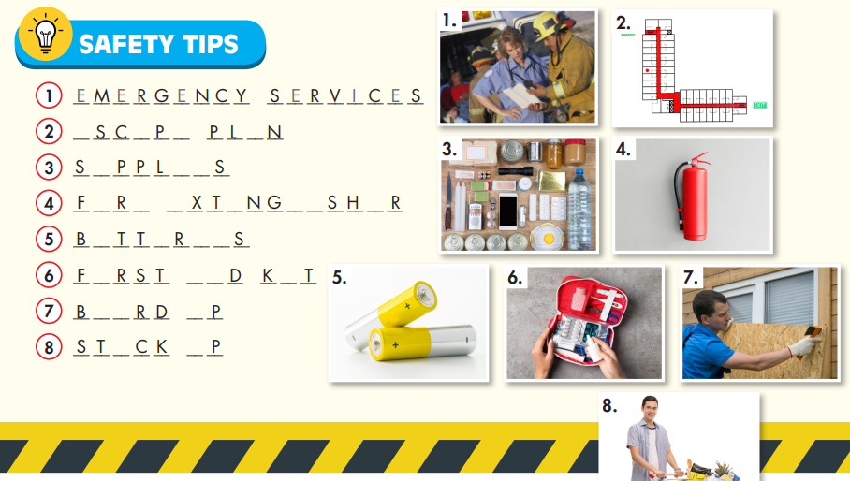  - Divide the class into two teams.  - Ask Ss to work in groups to complete these words in 2minutes (on a piece of paper)  - Check their answers and decide the winner with the most correct words. | Answer keys:  1. EMERGENCY SERVICES  2. ESCAPE PLAN  3. SUPPLIES  4. FIRE EXTINGUISHER  5. BATTERIES  6. FIRST AID KIT  7. BOARD UP  8. STOCK UP
B. New lesson (35’)
1. Presentation: 15’
a. Objective: to help Ss know how to use Preposition of place and movements correctly.
b. Content: tasks a & b.
c. Expected outcomes: Ss can use Preposition of place and movements correctly.
d. Organization
Teacher’s activities | Students’ activities
Prepositions of place  - Ask Ss to look at the pictures and label them with the correct prepositions: inside, outside, under, or near.    - Pick some Ss to give the answers.  - Check their answers.  - Introduce the use of prepositions of place: to show where something or someone is.  Prepositions of time  - Ask Ss to look at the pictures and label them with the correct prepositions: into or to.  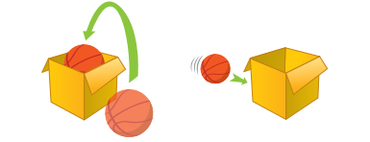  - Pick some Ss to give the answers.  - Check their answers.  - Introduce the use of prepositions of movement: to show movement from one place to another.  Task a: Read about prepositions of place and movement, then fill in the blanks.  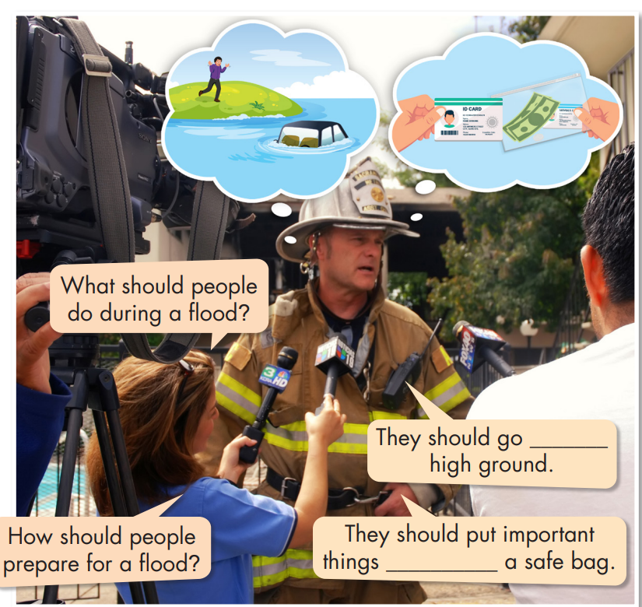  - Ask Ss to read about prepositions of place and movement, then fill in the blanks with appropriate prepositions.  - Get Ss to check with their partners.  - Pick some Ss to give their answers.  Task b. Listen and check your answers. Listen again and repeat.  - Ask Ss to listen and check.  - Pick some Ss to share their ideas.  - Check their answers.  - Ask Ss to listen again and repeat chorally.  - Pick some pairs to read the conversation again and check their pronunciation if necessary. | - look at the pictures and label them with the correct prepositions: inside, outside, under, or near.  Answer keys:  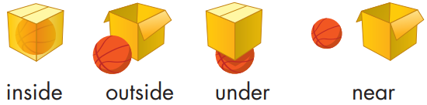  -Listen and take notes.  - Look at the pictures and label them with the correct prepositions: into or to.  Answer keys:  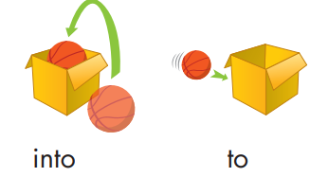  -Listen and take notes.  - Read about prepositions of place and movement, then fill in the blanks with appropriate prepositions.  - Check with their partners.  - Give their answers.  -Listen and check.  - Give their answers.  Answer keys:  to; into  -Listen and repeat.
2. Practice: 15’
a. Objective: to help Ss practice using preposition of place and movements correctly.
b. Content: tasks a, b, and c.
c. Expected outcomes: Ss can use preposition of place and movements correctly.
b. Content: tasks a, b.
d. Organization:
Teacher’s activities | Students’ activities
Task a: Read the notes and examples on the left, then circle the correct words.  1. Stock up on supplies and stay inside/under  your home.  2. In a flood, don't go outside/into the water.  3. Keep a phone near/to you and call  emergency services if you are in danger.  4. If there's a tsunami, move into/to higher  ground.  5. If there's an earthquake, get outside/under  a table.  6. Board up doors and windows, and don't go  near/outside of your house.  - Introduce the task.  - Ask Ss to read the sentences carefully and circle the correct words.  - Let Ss check with their partner.  - Pick some students to give their answers and give reasons.  - Check their answers. | - Read and circle the correct words.  - Check with their partner.  - Give their answers.  Answer Keys:  1. inside 2. Into 3. near  4. to 5. Under 6. outside
Task b: Fill in the blanks with the words in the box.  Inside to near outside in  Tips to Stay Safe in a Wildfire  • Have an escape plan. If the fire comes close, leave your home and follow your escape plan (1) _________ a safe place.  • Keep fire extinguishers and first aid kits (2) __________ a safe place.  • Move wooden outdoor furniture (3) _________ your house, to the center of rooms and away from windows.  • Keep a phone (4) _________ you and make sure your phone has enough battery.  • Make sure your car has enough gas.  • Stay inside your house during the fire. Close doors and windows to keep smoke (5) _________ of your house.  - Ask Ss to fill in the blanks with the words in the box.  - Let Ss check with their partner.  - Pick some Ss to give their answers.  - Check their answers. | - Fill in the blanks with the words in the box.  - Check with their partner.  - Give their answers.  Answer keys:  1. to 2. In 3. inside  4. near 5. outside
3. Production: 5’
a. Objective: to help Ss use the language in real situation.
b. Content: task c
c. Expected outcomes: Ss can use Preposition of place and movements to talk about locations and movements
d. Organization:
Teacher’s activities | Students’ activities
Task c: In pairs: Describe where things are  in the classroom and where you can move classroom objects to.  - Ask Ss to work in pairs to describe where things are in the classroom and where you can move classroom objects to.  - Pick some Ss to say their sentences.  - Give feedback. | -Work in pairs to describe where things are  in the classroom and where you can move classroom objects to.  -Say their sentences.  Sample answers:  My textbook is on my desk.  I put my book inside my bag.
C. Consolidation and homework assignments: 5’
- Grammar: Preposition of place and movements: inside, outside, under, near, into, to.
- Do exercises in workbook on page 23.
- Prepare the next lesson: Lesson 2.3 – Pronunciation & Speaking, pages 40 & 41
- Do the exercises in Tiếng Anh 8 i-Learn Smart World notebook (page 33).
5. Reflection

a. What I liked most about this lesson today:
…………………………………………………………………………………………
b. What I learned from this lesson today:
…………………………………………………………………………………………
c. What I should improve for this lesson next time:
…………………………………………………………………………………………

