





SPEAKING ASSESSMENT ENGLISH 6 UNIT 3: MY FRIENDS
- Introduction - 0.4 pt (~2 ideas):
Share something about your family, school, house, friends, neighborhood,…









- Topic Speaking (Cue pictures) – 1.0 pt (~4 questions):
1 | 2 | 3
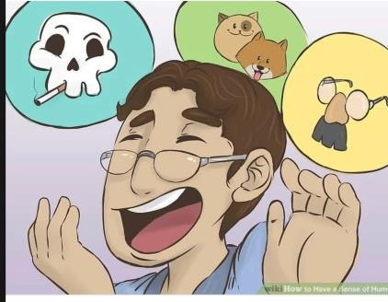  8 | - - What do you see in the picture?  - - How do you spell it?  - - What is he/she like?  - - He/ She always makes people laugh. What is he/ she like?  - When you would like to answer teacher’s question, you haveto raise it. What is it?  - She always does her homework before class. What is  shelike?  - He/ she has a lot of friends. What is he/she like? | 4
7 |  6 |  5

