**LỚP HỌC THẦY (CÔ) ___________________________** **ĐỀ ÔN TẬP: READING SIGNS/ NOTICES – A2**

**Test 12**

*Thời gian làm bài: [Time]*

Họ và tên: ________________________________________________ Lớp: 9/___

**Nội dung:**

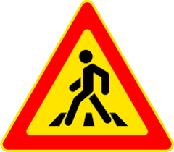Question 1: What does this sign say?

A. School ahead.

B. Road works ahead

C. Pedestrian crossing ahead.

D. Traffic light ahead.

**Question 2:** Correct information from the announcement?

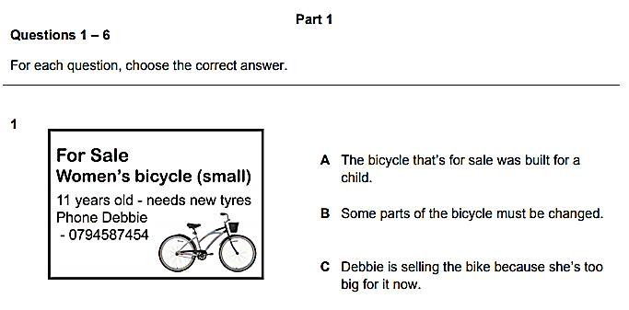

A. The bicycle that's for sale was built for a child.

B. Some parts of the bicycle must be changed.

C. Debbie is selling the bike because she's too big for it now.

D. The bike needs to be sold because the tyres are bad.

Question 3: What does this sign say?

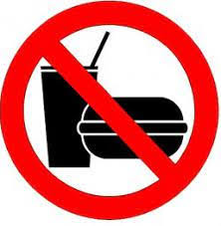A. You can have some drinks and food here.

B. Your breakfast is done.

C. No one helps you take food and drinks.

D. You can't drink and eat here.

**Question 4:** Correct information from the announcement?

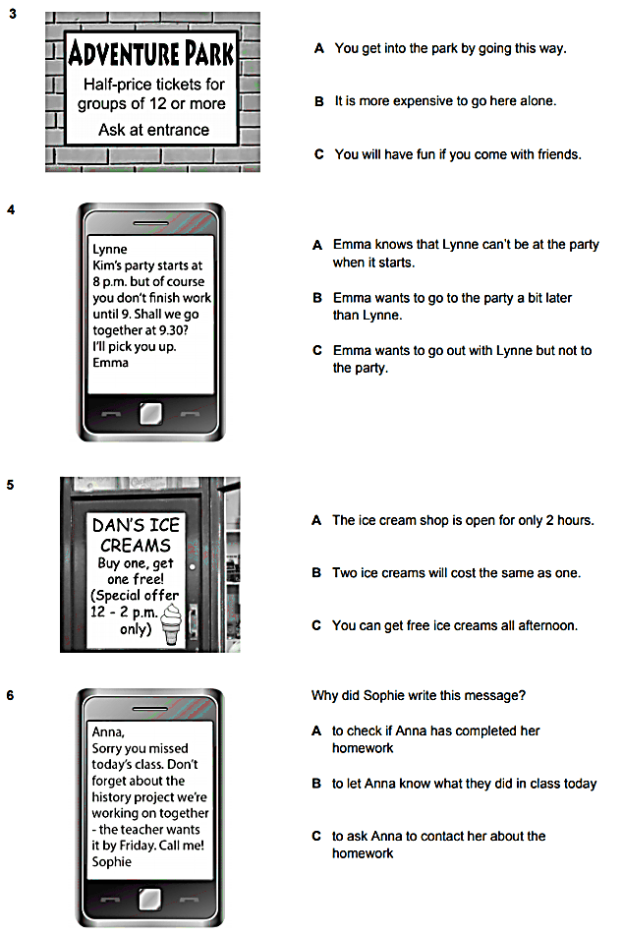

A Only discount for groups of 12. B Going alone will cost more.

C You will have more fun with friends D Going with a group of 12 will get a discount.

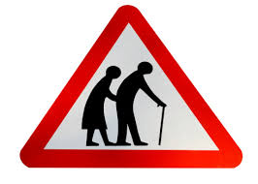Question 5: What does this sign mean?

A. Be cautious as elderly people may be crossing the road.

B. There are two old people here.

C. Be careless as elderly people may be crossing the road.

D. They are wearing traditional clothing.

**Question 6:** What are the things that Mom asked her kid to pick up?



A. Eggs and milk B. Eggs, bread, and milk C. Eggs and bread D. Bread and milk

Question 7: 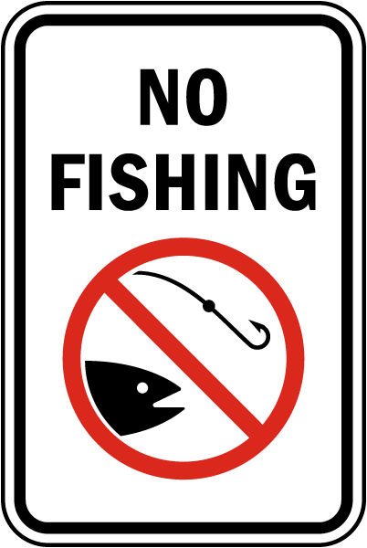What does this sign mean?  
A. Fishing is allowed here.  
B. Fishing is not allowed in this area.  
C. Fishing is only allowed with a permit.  
D. Fishing is encouraged.

**Question 8:** Why did Sophie write this message?



Anna, Sorry you missed today's class. Don't forget about the history project we're working on together the teacher wants it by Friday. Call me! Sophie

A. to check if Anna has finished her homework B. to let Anna know what they did in class today

C. to ask Anna to contact her about her homework D. to ask her if she has finished her homework

Question 9: 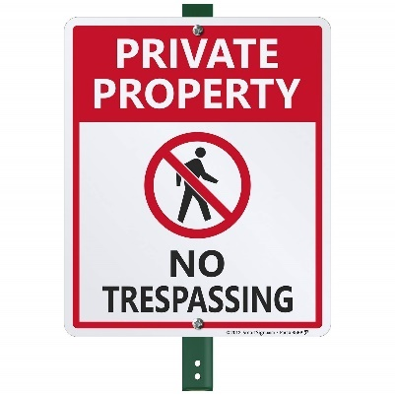What does this sign mean?  
A. Trespassing is allowed.  
B. Only specific times allow trespassing.  
C. Going in without permission is not allowed.

D. Trespassing is encouraged here.

**Question 10:** What activity is being proposed in the message?



Dear John,

Would you like to play tennis tomorrow after school at 4pm? We could play for an hour at the Smith Park courts.

Please let me know if you're available. Mr. Smith

A. Going swimming B. Playing football C. Playing tennis D. Going for a run

**[HẾT]**