|  |  |
| --- | --- |
| **………………… Primary School**  **Class:** 5.…  **Name:** ..…………………...... | **1st TERM TEST – GRADE 5**  **School year: 2021-2022**  Time allowed: **40 minutes** |

|  |  |
| --- | --- |
| **Marks** | **Comments** |
|  |  |

**PART 1: LISTENING**

**Q1. Listen and tick**

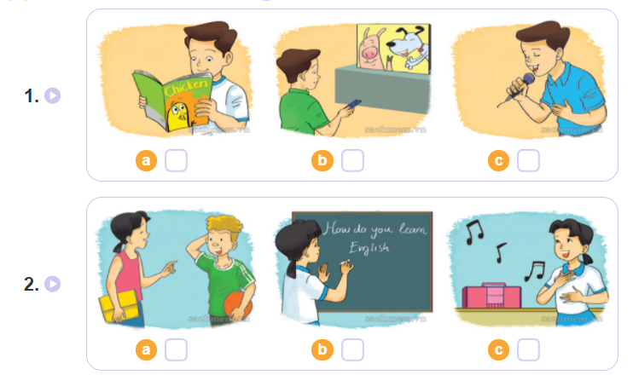

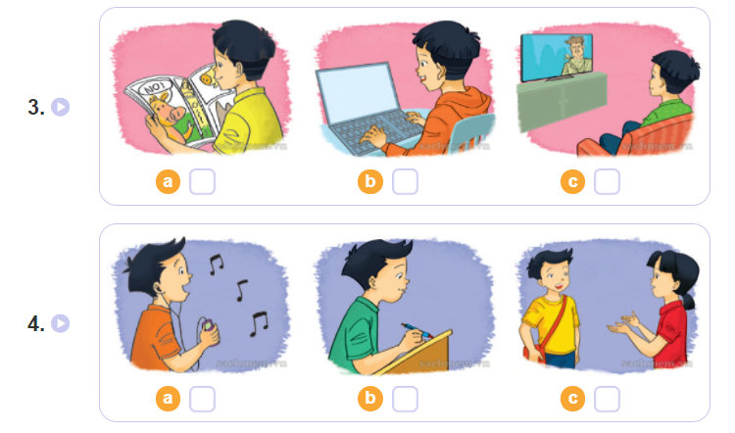

**Q.2. Listen and circle**

1. Mai has English ___________? **a.** four times a week **b.** every school day
2. Nam has ___________ today. **a.** four lessons **b.** no lesson
3. Akiko is ___________ today. **a.** at school **b.** on holiday
4. Quan has Maths ____________. **a.** every school day **b.** four times a week

**Q.3. Listen and write**

1. Tony: Hi, Mai. What are you doing?  
    Mai: I'm practising for the ………. contest.  
    Tony: When will it be?  
    Mai: It'll be on Independence Day.  
  
2. Tony: What are Tony and Phong doing?  
    Linda: They're playing table tennis.  
    Tony: Why are they playing table tennis now?  
    Linda: They're preparing for ……………..

**PART 2: READING**

**Question 4**. **Look and write the correct words. There is one example**

|  |  |  |  |  |
| --- | --- | --- | --- | --- |
| https://kiemtra.sachmem.vn/images/ta51/u3/media/image53.jpeg | https://kiemtra.sachmem.vn/images/ta51/u3/media/image54.jpeg | https://kiemtra.sachmem.vn/images/ta51/u3/media/image55.jpeg | https://kiemtra.sachmem.vn/images/ta51/u3/media/image56.jpeg | https://kiemtra.sachmem.vn/images/ta51/u3/media/image57.jpeg |
| train | motorbike | underground | ship | plane |

|  |  |  |  |  |  |  |  |  |  |  |  |  |  |  |  |
| --- | --- | --- | --- | --- | --- | --- | --- | --- | --- | --- | --- | --- | --- | --- | --- |
| |  |  |  |  |  | | --- | --- | --- | --- | --- | |  |  |  |  |  |  |  |  | | --- | --- | | *Example: It is long and it can go on the ground.* | train | | 1. It can fly in the sky. | _________ | | 2. It can go in the sea. | _________ | | 3. It is long. It can go under the ground. | _________ | | 4. You must wear a helmet when you ride it. | _________ | |

**Question 5. Look and read. Fill each gap with one word from the box. Write the word next to the number. There is one word that you do not need. There is one example (0).**

|  |  |  |  |  |
| --- | --- | --- | --- | --- |
| https://kiemtra.sachmem.vn/images/ta51/et1/image1.jpeg | https://kiemtra.sachmem.vn/images/ta51/et1/image2.jpeg | https://kiemtra.sachmem.vn/images/ta51/et1/image4.jpeg | https://kiemtra.sachmem.vn/images/ta51/et1/image5.jpeg | https://kiemtra.sachmem.vn/images/ta51/et1/image6.jpeg |
| summer | reading | home | books | bookshop |

|  |  |  |  |  |  |  |  |  |  |  |  |  |  |  |  |  |  |  |  |  |  |  |  |  |  |  |  |  |  |  |  |  |  |  |  |  |  |  |  |  |  |  |  |  |  |  |  |
| --- | --- | --- | --- | --- | --- | --- | --- | --- | --- | --- | --- | --- | --- | --- | --- | --- | --- | --- | --- | --- | --- | --- | --- | --- | --- | --- | --- | --- | --- | --- | --- | --- | --- | --- | --- | --- | --- | --- | --- | --- | --- | --- | --- | --- | --- | --- | --- |
| Hi Joe, Are you enjoying your (0) summer holiday? This summer I’m staying at (1) ................._. I’m (2) ............... a lot of story books. I didn’t have enough time to read them during the school year. Yesterday I went to the (3) …………….. and bought a lot of story books. The characters in these books are great people. I like them very much. I’ll write more about my (4)……………..in the next letter. Write and tell me about your summer. Hoa  **Question 6.** **Read and tick**https://s.sachmem.vn/public/sm-quizz/icons/checkbox-tick.png**True or False. There is one example (0).**   |  |  |  |  | | --- | --- | --- | --- | | After school, Bill often stays at home and reads books. He likes reading comic books. His favourite story is *Doraemon*. It is the name of a magic cat, the main character of the story. The cat has a lot of magical things in its pocket. It comes to Japan from the future to help Nobita and his friends. Bill likes the story very much because the magic cat is friendly and very intelligent. | | | | |  | **True** | **False** |  | | 0. After school, Bill often reads books in the library. |  | ✔ | | 1. He doesn’t like reading comic books. |  |  | | 2. A magic cat is the main character of the story *Doraemon*. |  |  | |  |  | | PART 3. WRITING  **Question 7. Look at the pictures. Read and write one word for each gap. There is one example.**     |  |  |  | | --- | --- | --- | | *Example:*   |  | | --- | | He usually plays computer games at the weekend. | | https://kiemtra.sachmem.vn/images/ta51/u2/media/image64.jpeg |  |  |  |  |  | | --- | --- | --- | --- | | |  |  |  | | --- | --- | --- | | 1 | My mother _­­­­_________gets up early in the morning. | https://kiemtra.sachmem.vn/images/ta51/u2/media/image65.jpeg | | | |  |  |  | | --- | --- | --- | | 2. | He often ___________ a bike to school. | https://kiemtra.sachmem.vn/images/ta51/u2/media/image66.jpeg | | | |  |  |  | | --- | --- | --- | | 3 | My friends goes to the library ___________ a week. | https://kiemtra.sachmem.vn/images/ta51/u2/media/image67.jpeg | | | |  |  |  | | --- | --- | --- | | 4. | I often __________ with a partner in class. | https://kiemtra.sachmem.vn/images/ta51/u2/media/image68.jpeg | |   **Question 8. Order the words. There is one example.**     |  |  |  |  | | --- | --- | --- | --- | | *Example:* | |  | | --- | | last / wonderful / a / he / trip / summer / had | | He had a wonderful trip last summer. | |  |  |  |  | | --- | --- | --- | | |  |  | | --- | --- | | 1. | you / go / did / where / weekend / last _________________________________? | | | | |
| 2. | you / what / day / going / sports / to / do / are / on __________________________________________________? |

|  |  |  |
| --- | --- | --- |
| 3. | the / character / who / main / is __________________________________? | |
| |  |  | | --- | --- | | 4 . | you / what / reading / are __________________________________? | | |

**Question 9. Order the letter and write**

1. 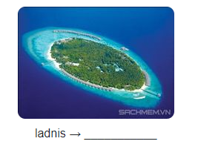 2. 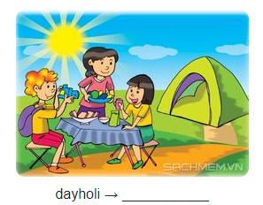

PART 4. SPEAKING (2.5)

**Part 1 – Questions 1-3: Interview.**

**Part 2 – Questions 4-7: Talk about future job.**

**Part 3 – Questions 8-10: Describing a picture.**

******************************************************************

ANSWER KEYS

Q1. Listen and tick

1.b 2.c 3.a 4b

1. Linda: How do you practise listening, Nam?  
    Nam: I watch English cartoons on TV.  
  
2. Linda: How do you learn English, Mai?  
    Mai: I sing English songs.  
  
3. Linda: How do you practise reading, Trung?  
    Trung: I read English comic books.  
  
4. Linda: How do you learn vocabulary, Quan?  
    Quan: I write new words in my notebook and read them aloud.

Q2. Listen and circle

1.a 2.a 3.b 4.a

1. Mai: How often do you have English, Akiko?  
    Akiko: I have it every day, Mai.  
    Mai: Do you like English?  
    Akiko: Yes, of course. How about you? How often do you have English?  
    Mai: I have it four times a week.  
  
2. Akiko: How many lessons do you have today, Nam?  
    Nam: I have four: Maths, Vietnamese, Music and PE. How about you? How many lessons do you have today?  
    Akiko: Oh, it's a holiday in Japan today.  
    Nam: Great! It's nice to have holidays!  
  
3. Mai: Hello, Akiko. It's nice to talk to you again.  
    Akiko: Nice to talk to you, too, Mai. Do you have school today?  
    Mai: Yes, but not now. I'll go to school in the afternoon. How about you?  
    Akiko: I'm on holiday. How many lessons do you have today?  
    Mai: Four: English, Vietnamese, Maths and Art.  
  
4. Tony: What subject do you like best, Quan?  
    Quan: I like Maths. How about you, Tony?  
    Tony: I like it, too. How often do you have Maths?  
    Quan: I have it every school day. And you?  
    Tony: Oh, I have it only four times a week.

Q3. Listen and write

1. singing 2. Teacher’s Day

1. Tony: Hi, Mai. What are you doing?  
    Mai: I'm practising for the singing contest.  
    Tony: When will it be?  
    Mai: It'll be on Independence Day.  
  
2. Tony: What are Tony and Phong doing?  
    Linda: They're playing table tennis.  
    Tony: Why are they playing table tennis now?  
    Linda: They're preparing for Teacher's Day.

|  |  |
| --- | --- |
| **Q4**. **Look and write the correct words.**  1. It can fly in the sky. | PLANE |
| 2. It can go in the sea. | SHIP |
| 3. It is long. It can go under the ground. | UNDERGROUND |
| 4. You must wear a helmet when you ride it. | MOTORBIKE |

**Q5. Look and read. Fill each gap with one word from the box**

(1)HOME (2) READING (3)BOOKSHOP (4) BOOKS   
**Q.6.** **Read and tick**https://s.sachmem.vn/public/sm-quizz/icons/checkbox-tick.png**True or False**

1. F 2. T

**Q7. Look at the pictures. Read and write one word for each gap.**

1. Always
2. Rides
3. Once
4. Study

**Q.8. Order the words.**

1. Where did you go last weekend?

2. What are you going to do on Sports Day?

3. Who is the main character?

4. What are you reading?

**Question 9. Order the letter and write**

1. Island 2. Holiday

**PART 4. SPEAKING**

**Part 1 – Questions 1-3: Interview. (**Mỗi câu trả lời đúng được 0,25 điểm ).

**Part 2 – Questions 4-7: Talk about future job. (**Mỗi câu trả lời đúng được 0,25 điểm )

**Part 3 – Questions 8-10:** Describing a picture .**(**Mỗi câu trả lời đúng được 0,25 điểm )

**MA TRẬN ĐỀ KIỂM TRA CUỐI HỌC KỲ 1 LỚP 5**

|  |  |  |  |  |  |  |
| --- | --- | --- | --- | --- | --- | --- |
| **Kỹ năng** | **Nhiệm vụ đánh giá/kiến thức cần đánh giá** | **Mức/Điểm** | | | | **Tổng số câu, số điểm, tỷ lệ %** |
| **Nghe** | **M1** | **M2** | **M3** | **M4** | 10 câu  2,5 điểm  25% |
| **Listen and tick** |  | 4  1đ |  |  |
| **Listen and circle** |  |  | 2  0,5đ | 2  0,5đ |
| **Listen and write** |  | 1  0,25đ | 1  0,25đ |  |
| **Đọc** | **Look and write the correct words** | 1  0,25đ | 3  0,75đ |  |  | 10 câu  2.5 điểm  25% |
| **Look and read. Fill each gap with one word from the box** |  | 2  0,5đ | 2  0,5đ |  |
| **Read and tick**https://s.sachmem.vn/public/sm-quizz/icons/checkbox-tick.png**True or False** |  | 1  0,25đ | 1  0,25đ |  |
| **Viết** | **Look at the pictures. Read and write one word for each gap.** |  | 2  0,5đ | 2  0,5đ |  | 10câu  2.5 điểm  25% |
| **Order the words** |  | 2  0,5đ | 2  0,5đ |  |
|  | **Order the letter and write** | 1  0,25đ | 1  0,25đ |  |  |
| **Nói** | **Interview** |  | 1  0,25đ | 1  0,25đ |  | 10câu  2.5 điểm  25% |
| **Talk about future job.** |  | 2  0,5đ | 2  0,5đ |  |
| **Describing a picture** | 1  0,25đ | 1  0,25đ | 1  0,25đ | 1  0,25đ |
| **Tổng** |  | 3-7.5  % | 20 –50% | 14 – 35% | 3 – 7,5% | 40 câu -  10 điểm  100% |