Period
LESSON PLAN
TIẾNG ANH 10 FRIENDS GLOBAL
UNIT INTRODUCTION
LESSON C: VOCABULARY
DESCRIBING PEOPLE
I. OBJECTIVES:
By the end of the lesson, Ss will be able to:
1. Knowledge:
- Get some more knowledge to talk about adjectives to describe hair
- Vocabulary: wavy, curly, fair, trousers, waistcoat
2. Ability:
- main skills: writing and speaking
- Using adjectives to describe hair
- Ask and answer about people’s appearance
3. Quality:
- have positive attitude in English language learning so that they can participate enthusiastically in all classroom activities, especially with the topic conducted by the teacher
- know how to describe people’s appearance, especially hair by using adjectives
II. TEACHER AIDS AND LEARNING MATERIALS:
Lesson plan, PPT slides, student’s book, workbook, notebook, personal computer (if any), projector/TV. Speakers, IWB software.
III. PROCEDURES:
A. Warm-up (5’)
a) Objective: Introduce the new lesson and set the scene for Ss to acquire new language; get students' attention at the beginning of the class by means of enjoyable and short activities as well as to engage them in the steps that followed.
b) Content: Warm-up game
c) Outcomes: Students can gain more confidence and interest in the lesson
d) Competence: communication, guessing, collaboration
e) Organisation of the activity:

TEACHER’S ACTIVITIES | STUDENT’S ACTIVITIES | CONTENTS
Warm-up T-Ss- T/ Ss – Ss  Game “GUESSING NAMES” (5’)  - Tells students what they need to  - Tells students that they have to answer three questions  - First, match name with the character  - Second, guess names of the actors or actresses  - Third, which films do the actors or actresses appear in  - Shows the answers on the screen | - Listen to the teacher carefully  - Look at the three questions on the screen  - Work in groups and find out the answers of the questions  - Write down the answers | 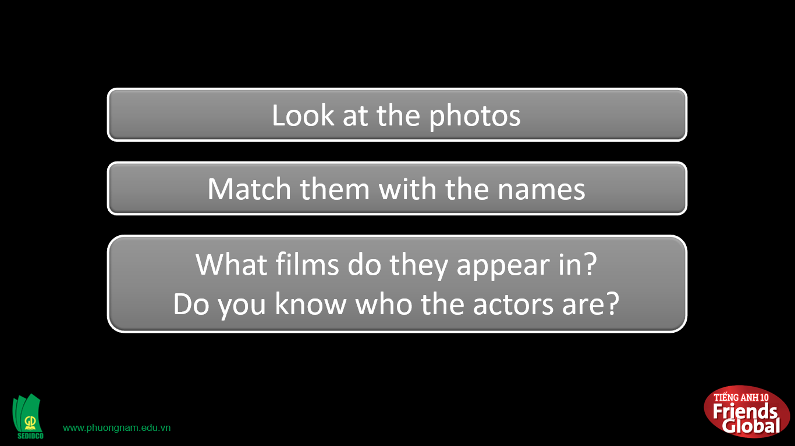  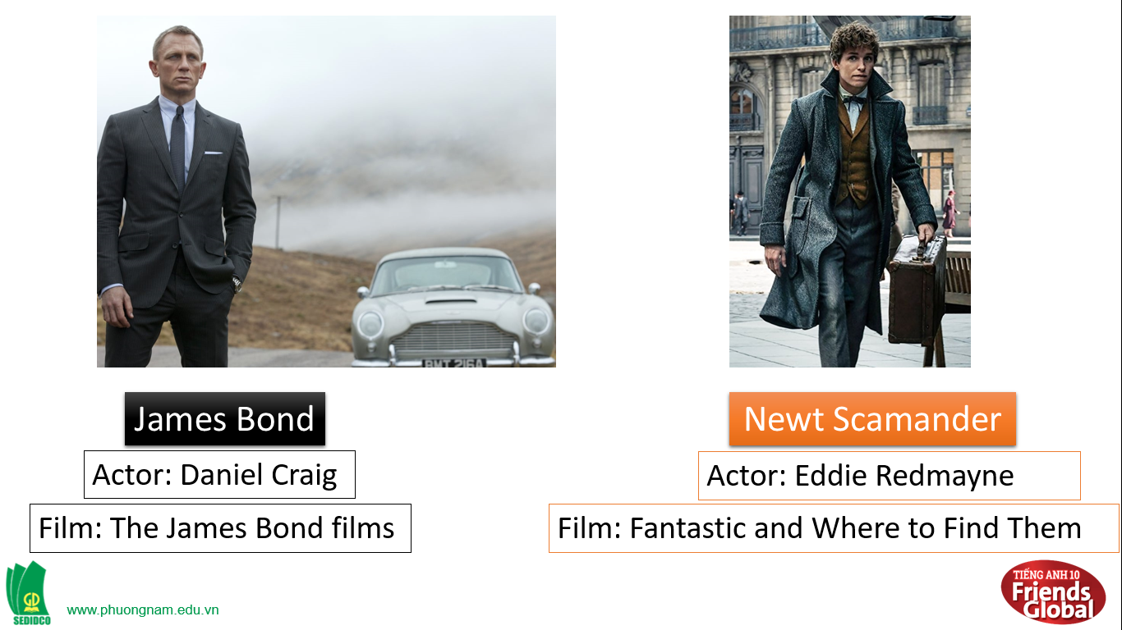  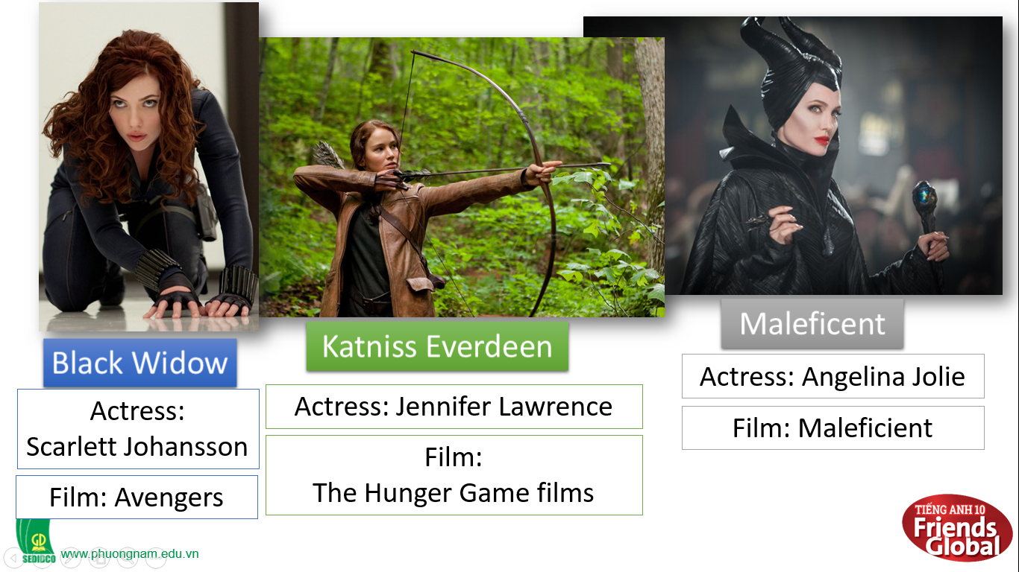

B. New lesson (35’)
- Activity 1: Vocabulary (8’)
a) Objective: Ss know more words about adjectives to describe hair
b) Content:
Vocabulary: wavy, curly, fair, trousers, waistcoat
Listening
c) Outcomes: Ss know how to pronounce the new words precisely and use them in appropriate contexts.
d) Competence: communication, drilling
e) Organisation of the activity:

TEACHER’S ACTIVITIES | STUDENT’S ACTIVITIES | CONTENTS
PRESENTATION. T -Ss- T/ Ss- Ss/ Individual  Set context:  - Call out some students to answer the question: “What is your favourite outfit? “What are you wearing today?”  - Teach new vocabulary:  - Use pictures and explanation to present new words.  - Have students practice their pronunciation drills.  New words:  wavy (a)  curly (a)  fair (a) picture +  trousers (n) meaning  waistcoat (n)  medium-length (a)  moustache (n) | - Some students will answer the question.  - Listen to the teacher.  - Look, listen, and repeat in chorus and individuals | Question:  - Who is your favourite characters?  - Why do you admire them?  - Can you describe them?  New words:  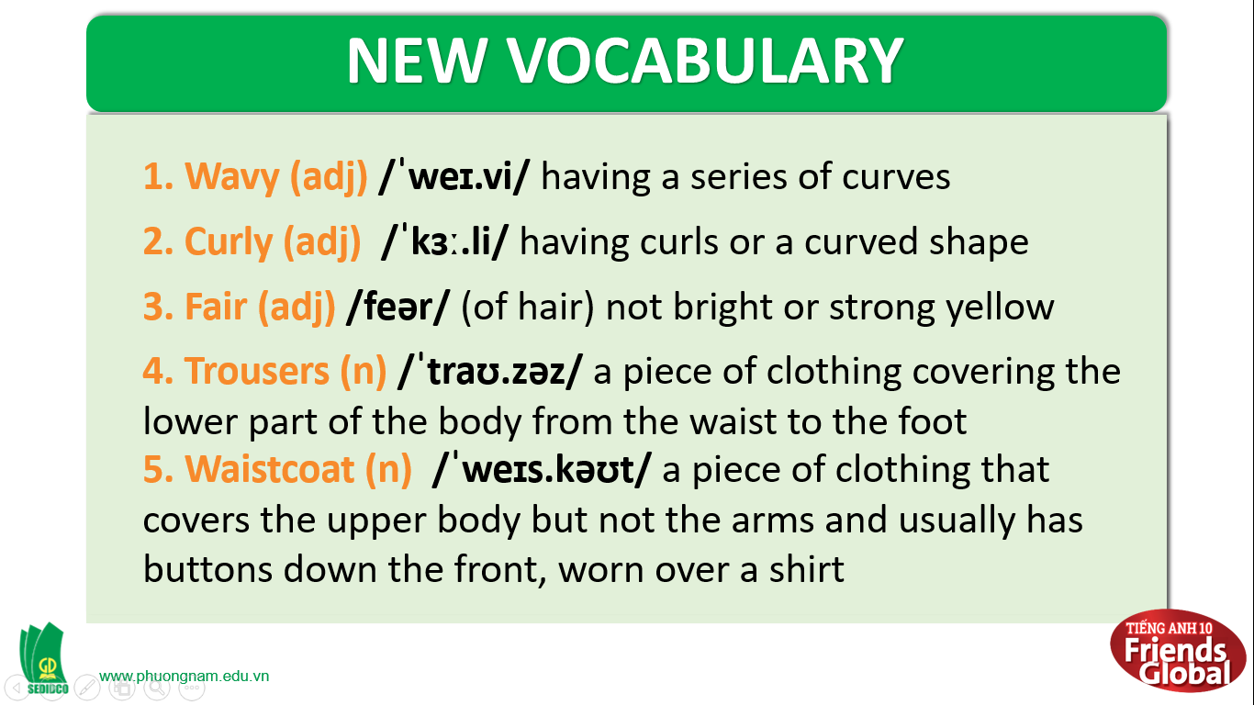
- Activity 2 Practice (22’)
a) Objective: Ss can answer the questions to critical thinking, and they can also finish the tasks in the textbook. Critical thinking skills (guessing/ reasoning) and communication can also be practiced.
b) Content: Students answer questions, classify words, choose the correct answer, read and complete, listen and match.
c) Outcomes: Ss read and listen, and they can apply the useful language in everyday listening and speaking.
d) Competence: collaboration, guessing, matching, communication
e) Organisation of the activity:
TEACHER’S ACTIVITIES | STUDENT’S ACTIVITIES | CONTENTS
PRACTICE. T-Ss- T/ S – S/ Indiv.  Activity 2 (4’) Match the sentence beginnings (1-4) with the endings (a-d). Then match the descriptions with four of the characters in exercise 1.  - Asks students to work in pairs  - Asks questions to check if students know how to do the exercise  - Shows the correct answers  Activity 3 (3’) VOCABULARY. Add the adjectives below to the table. Note the order of the adjectives.  - Asks students to work in groups  - Explains the exercise to students  - Shows students the correct answers  Activity 4 (4’) Work in pairs. How many different items of clothing can you write down? Include all the ones in exercise 2. Put them into groups A and B below.  - Asks students to work in pairs  - Explains the exercise to the students  - Shows students the correct answers  - Asks students to provide more items of clothing that they know  Activity 5 (6’) In your notebook, write a description of some of your classmates.  - Asks students to do the activity 5 in pairs  - Goes around the class and monitors, helping with vocabulary where necessary  - Elicits answers from students  - Provides suggested answers | - Work in pairs  - Do the exercise  - Check the answers with the teacher  - Write down the correct answers  - Work in groups  - Listen to the teacher’s explanations  - Check the answers with the teacher  - Write down the correct answers  - Work in pairs  - Listen to the teacher’s explanations  - Check the answers with the teacher  - Write down the correct answers  - Provide more items of clothing  - Do the activity 5 in pairs  - Ask teachers about the activity and vocabulary if needed  - Check answer with the teacher | Answers:  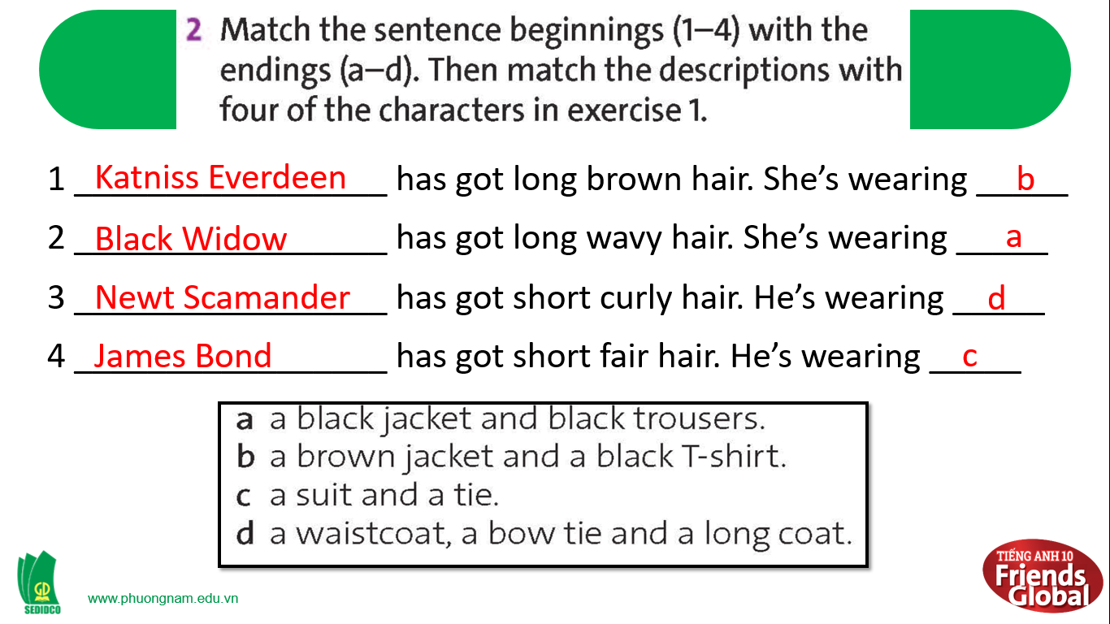  Answers:  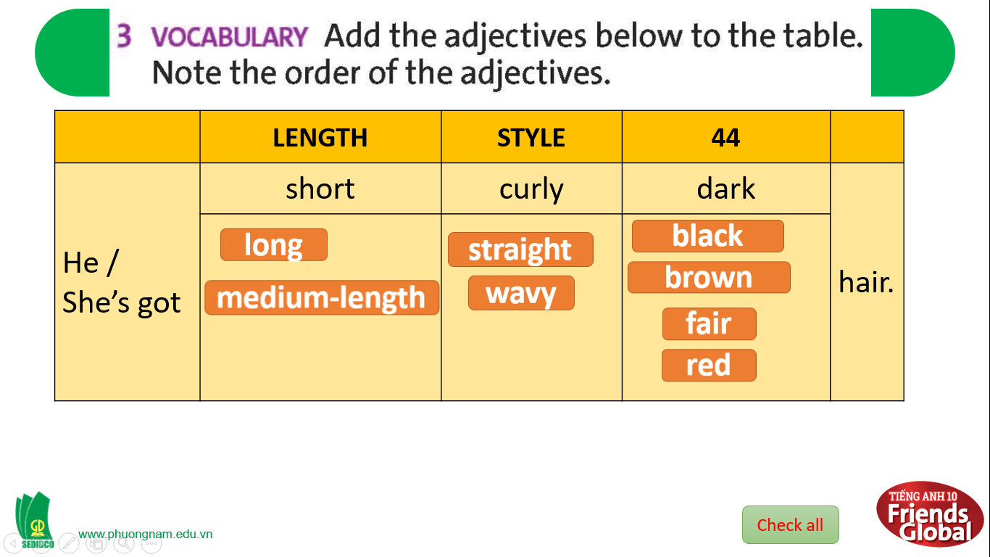  Suggested answers:  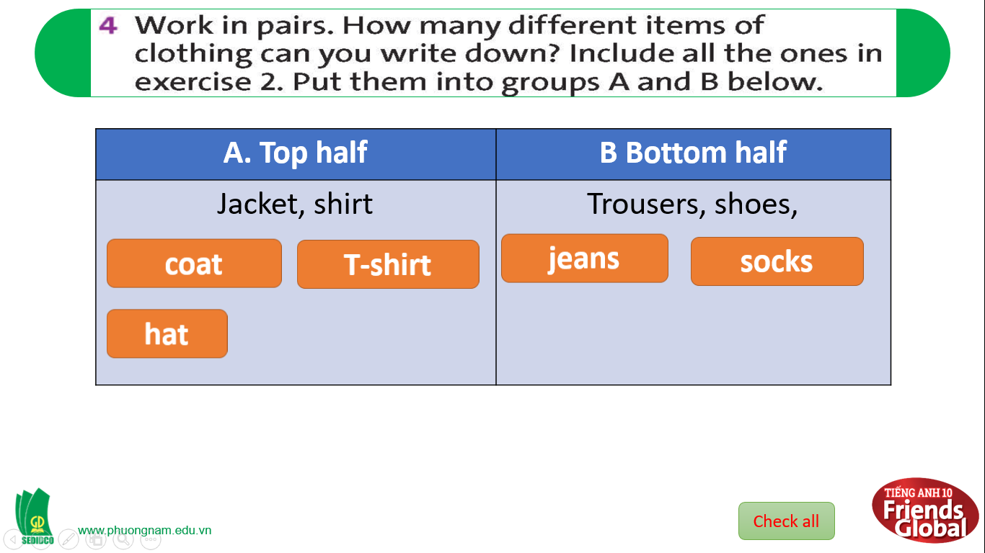  Possible answers:  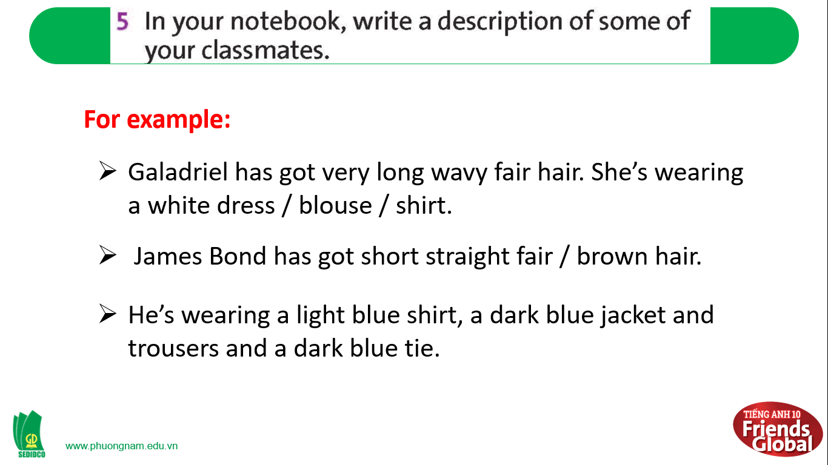

- Activity 3: Outcomes (5’)
a) Objective: Ss can answer the question to describe people’s appearance in some situations. Communication is also be practiced.
b) Content: Students work in pairs, speak and discuss
c) Outcomes: Ss speak and listen mutually, they can new words they have learnt in their conversation.
d) Competence: Collaboration, communication
e) Organisation of the activity:
TEACHER’S ACTIVITIES | STUDENT’S ACTIVITIES | CONTENTS
PRODUCT. S – S/ T – Ss  Activity 6 (5’) SPEAKING. Tell your partner what clothes you usually wear when:  - Asks students to work in pairs  - Goes around to help students when needed | - Work in pairs  - Take turns to ask and answer.  - Ask teacher for helps if needed  - Some can volunteer to present their ideas. | Questions: 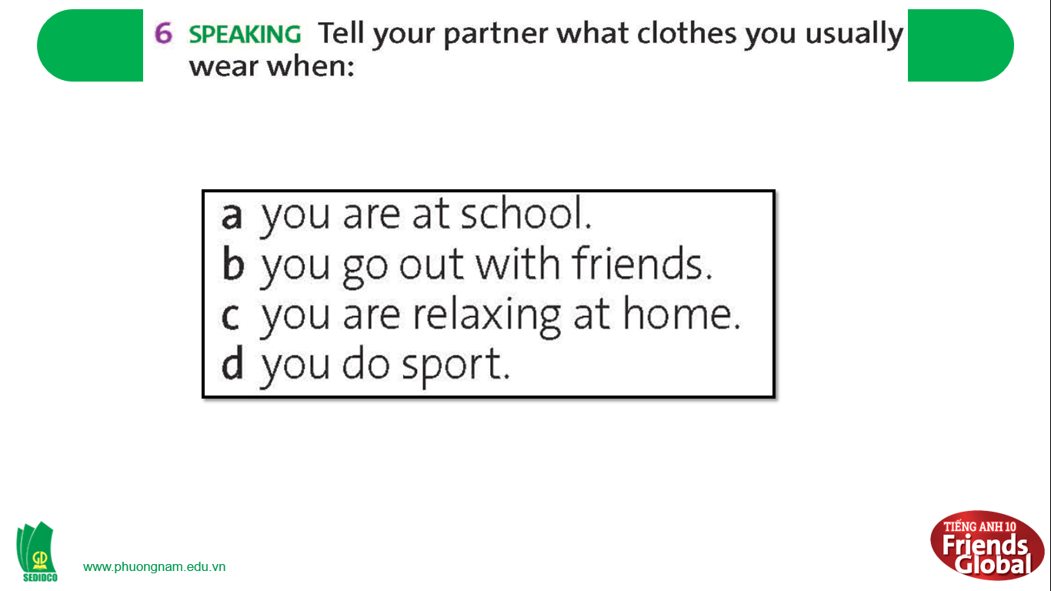  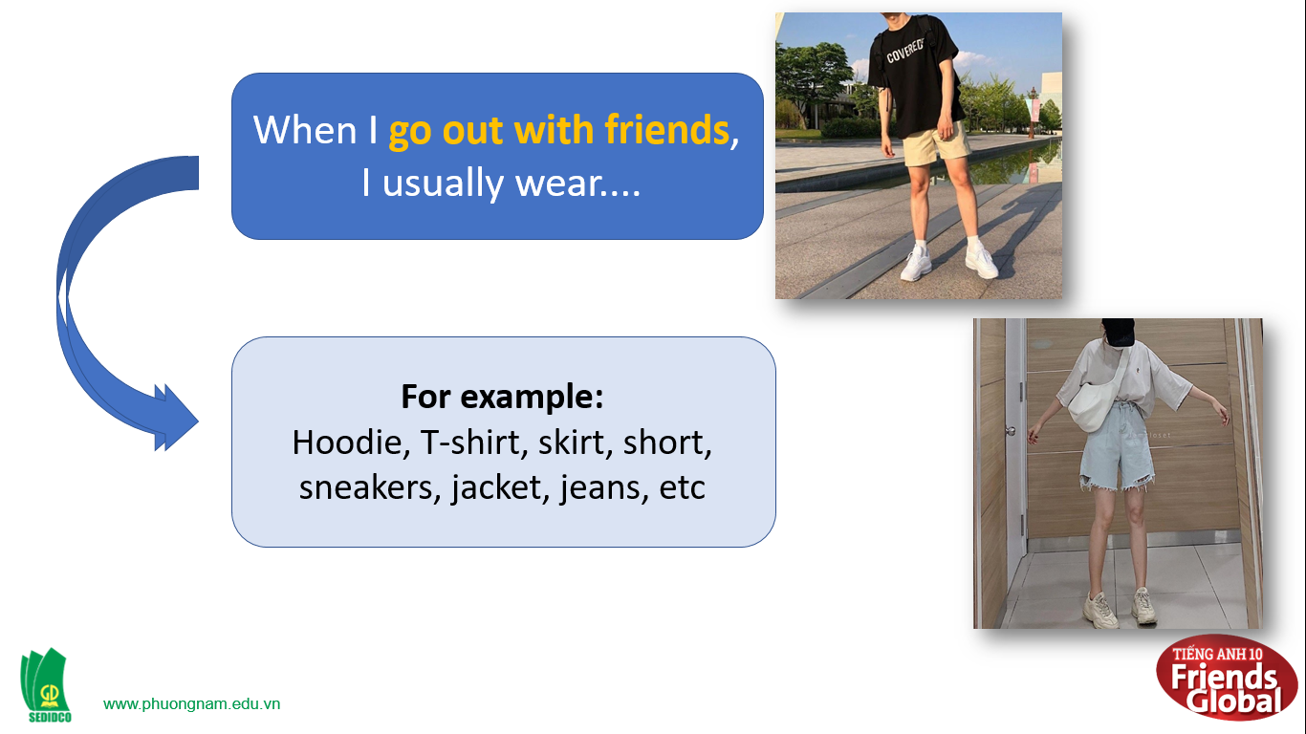  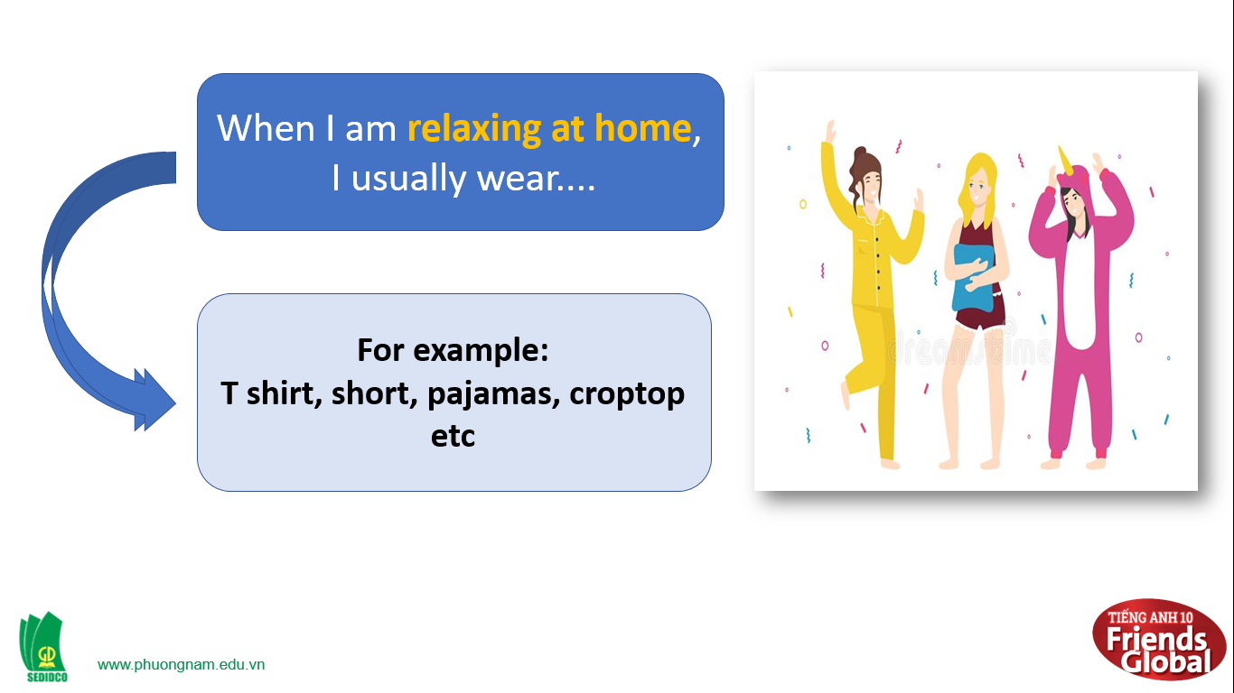  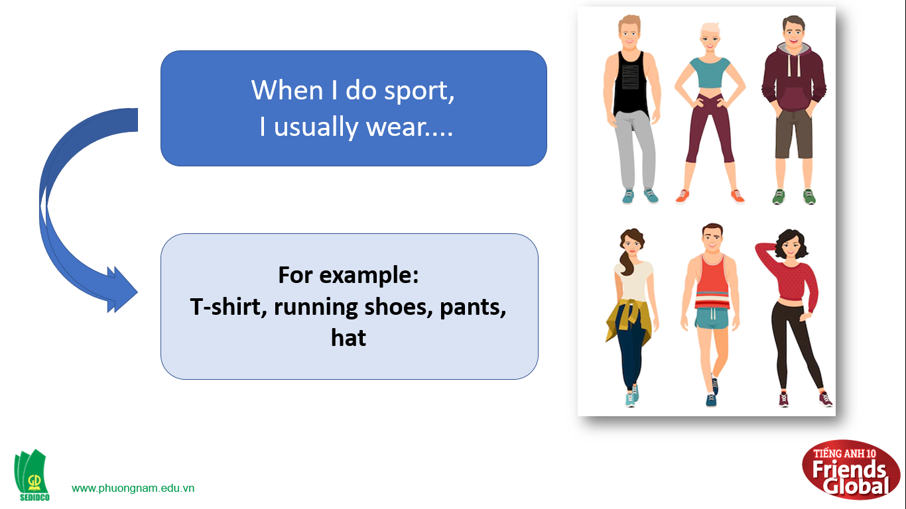
C. Consolidation (3’)
a) Vocabulary: wavy, curly, fair, trousers, waistcoat
b) Talking about people’s appearance especially people’s hair
D. Homework (2’)
- Learn by heart the vocabulary about people’s appearance
- Practice asking and answering about people’s appearance on specific occasions
- Do exercise in the workbook
- Prepare: Unit 0: Introduction – D-Grammar (page 7 – SB)

