Full name: ……………………………………………….  Class: …………………………………………………….  School: …………………………………………………... | Mark:

SPEAKING TEST 3 (UNITS 6 – 8)

TASK 1 |  |  | Let’s talk about how to become an independent student.  The following questions may help you.
 | 1. | What is an independent student?
 | 2. | Why do you want to become an independent student?
 | 3. | To become independent, what qualities do students have to own?
 | 4. | How can you solve your own learning problems without help?
 | 5. | What benefits do you gain when becoming an independent student?

TASK 2 | Work in pairs. Each of you receives a card. Use the clues on your card to make questions about your friend’s picture. Use the picture on your card to answer your friend’s questions.

CARD A
Trang An Scenic Landscape Complex
Ask your friends about his/ her picture. Listen to his/ her answers

1. | What/ the photo/ illustrate?
2. | What/ this heritage site/ famous?
3. | How/ tourists/ go sightseeing/ there?
4. | How/ the locals/ earn a living?
5. | What/ people/ do/ preserve/ it?
 |  | Answer your friend’s questions about this picture.

CARD B
Ha Long Bay
Ask your friends about his/ her picture. Listen to his/ her answers.

1. | What/ the photo/ illustrate? | 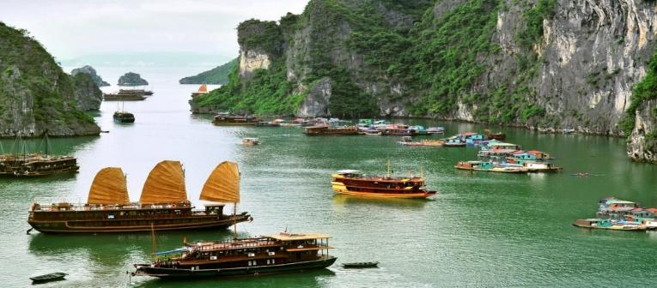
2. | What/ this heritage site/ famous?
3. | How/ tourists/ go sightseeing/ there?
4. | How/ the locals/ earn a living?
5. | What/ people/ do/ preserve/ it?
 |  | Answer your friend’s questions about this picture.

