School: ……………………………………….. | Date: …………………………………..
Class: ……………………………..................... | Period: ………………………….........

UNIT 4: COMMUNITY SERVICES
Lesson 1.2 - Grammar (Page 29)

I. OBJECTIVES
By the end of the lesson, Ss will be able to:
1.1. Language knowledge and skills
- listen to 2 people asking and answering about community fundraiser ideas.
- use “should”, “Let’s” and “How about” to make suggestions.
- talk about charity event.
1.2. Competences
- improve speaking, listening skills.
- improve the use of English.
1.3. Attributes
- be active to take part in social activities.
- help other people.

II. TEACHING AIDS AND LEARNING MATERIALS
1. Teacher’s aids: Student book and Teacher’s book, class CDs, Digital Book (DCR phần mềm tương tác SB, DHA (từ vựng/ cấu trúc) phần mềm trò chơi tương tác), projector/interactive whiteboard / TV (if any), PowerPoint slides, handouts.
2. Students’ aids: Student’s book, workbook, notebook, handouts.

III. ASSESSMENT EVIDENCE
Performance Tasks | Performance Products | Assessment Tools
- Listen and repeat. | - Ss’ performance. | - T’s feedback.
- Fill in the blanks with “should”, “Let’s” or “How about”. | - Ss’ answers. | - T’s feedback/Peers’ feedback.
- Circle the correct words. | - Ss’ answers. | - T’s feedback/Peers’ feedback.
- Ask and answer about charity event. | - Ss’ answers/ presentation. | - T’s observation, T’s feedback/Peers’ feedback.

IV. PROCEDURES
A. Warm up: (5’)
a) Objective: Introduce the new lesson and set the scene for Ss to acquire new language; get students' attention at the beginning of the class by enjoyable and short activities as well as to engage them in the follow-up steps.
b) Content: Review words about fundraising activities.
c) Expected outcomes: Ss review old vocabularies which are very useful for them in the new lesson.
d) Organization of the activity:
TEACHER’S ACTIVITIES | STUDENTS’ ACTIVITIES
- Option 1: Matching  - Have Ss work in pairs to match the words in A with those in B to make a right phrase about fundraising and charity activities.  - Call Ss to give answers.  - Check Ss’ answers, give feedback.  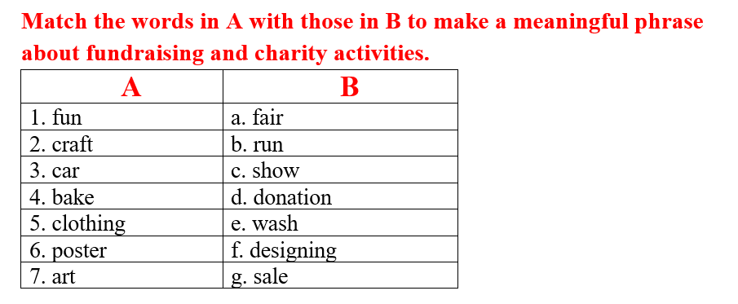  - Have Ss make sentences, using the phrases they have just made.  - Lead to the new lesson.  - Option 2: Game: WORD SQUARE  - Give the game: Word Square.  - Have Ss look at the word square and find phrases about fundraising and charity activities.  - Call Ss to give answers.  - Check Ss’ answers, give feedback.  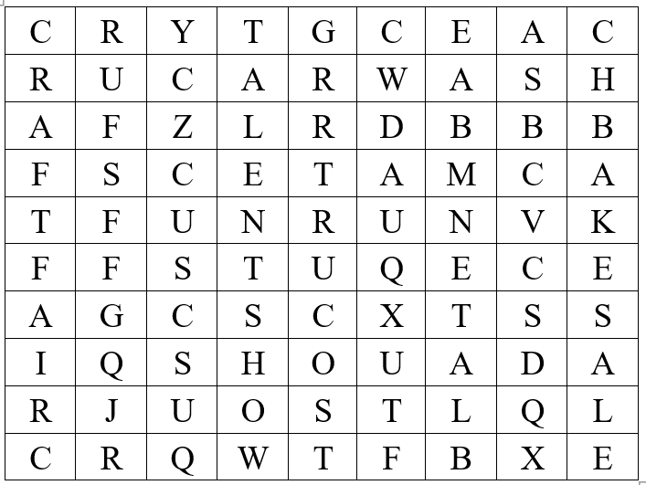  - Have Ss make sentences, using the phrases they have just found.  - Lead to the new lesson. | - Do the matching activity.  - Give answers.  Answers keys  1b  2a  33  4g  5d  6f  7c  - Read sentences.  - Take part in the game.  - Give answers.  Answers keys  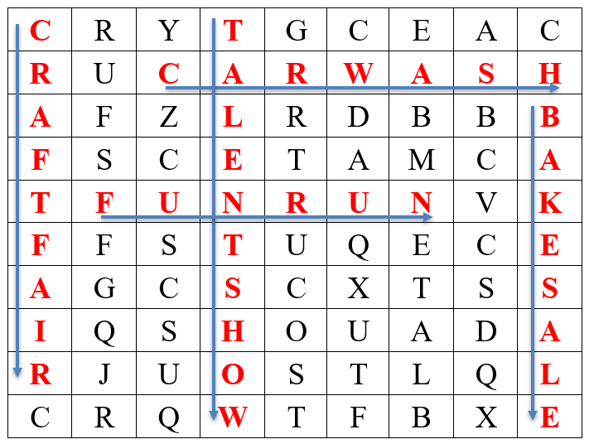  - Read sentences.  - Listen and write the new lesson.

B. New lesson (35’)
- Activity 1: Presentation (10’)
a) Objective: Introduce: “should”, “Let’s” and “How about” to make suggestions.
b) Content:
- Listen and repeat.
- Introduce the grammar points.
c) Expected outcomes: Ss know the new grammar points: “should”, “Let’s” and “How about” to make suggestions and use them in some exercises that follow.
d) Organization of the activity:
TEACHER’S ACTIVITIES | STUDENTS’ ACTIVITIES
Task a. Listen and repeat  - Have Ss look at the picture using DCR.  - Play audio (CD1 – Track 37) and have Ss listen and read the speech bubbles.  - Play the audio again and have Ss listen and repeat.  Grammar box  - Option 1:  - Have Ss look at the grammar explanation and read what to make suggestions for.  - Have Ss look at the box and read examples of different forms.  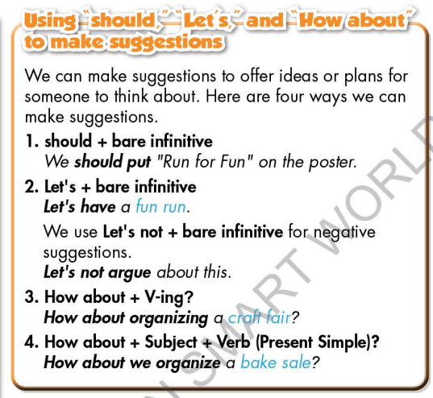  -Explain more about the way to use “should”, “Let’s” and “How about” to make suggestions.  - Ask Ss to make more sentences using “should”, “Let’s” and “How about” to make suggestions.  - Give feedback and evaluation.  - Option 2:  - Have Ss look at the sentences in the speech bubbles in Task a and read them again.  - Have Ss make comments on the types of verbs used after “should”, “How about” and “Let’s”.  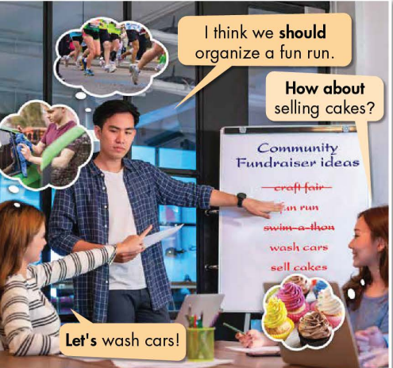  - Have Ss think and answer the question: What are the phrases “should”, “How about” and “Let’s” used for?  - Then, lead to the grammar box, briefly explain the way to use “should”, “How about” and “Let’s”.  - Have Ss read the grammar box again.  - Ask Ss to make more examples using “should”, “Let’s” and “How about” to make suggestions.  - Give feedback and evaluation. | - Look.  - Listen, then read.  - Listen and repeat.  - Look and read.  - Read examples of different forms.  - Listen.  - Give more examples.  - Look and read.  - Comment.  - Give answers.  Suggested answers  The phrases “should”, “How about” and “Let’s” are used for making suggestions.  - Listen.  - Read.  - Give more examples.  - Listen.
- Activity 2: Practice (19’)
a) Objective: Students can use “should”, “How about” and “Let’s” to do the given exercises.
b) Content:
- Fill in the blanks with “should”, “Let’s” or “How about”.
- Circle the correct words.
c) Expected outcomes: Students can get used to the form and usage of “should”, “Let’s” and “How about” and use them correctly.
d) Organization of the activity:

TEACHER’S ACTIVITIES | STUDENTS’ ACTIVITIES
Task b. Fill in the blanks with “should”, “Let’s” or “How about”.  - Demonstrate the activity on DCR, using the example.  - Have Ss read through the uncompleted sentences and fill in the blanks with “should”, “Let’s” or “How about”.  - Have Ss work in pairs to check each other’s work.  - Have some Ss share their answers with the whole class.  - Give feedback, correct Ss’ answers if necessary.  Task c. Circle the correct words.  - Demonstrate the activity, using the example.  - Have Ss read the sentences and circle the correct words  - Have Ss work in pairs to check each other’s work  - Have some Ss share their answers with the whole class  - Give feedback, correct Ss’ answers if necessary | - Look and listen.  - Work individually.  - Work in pairs.  - Read answers.  Answer keys  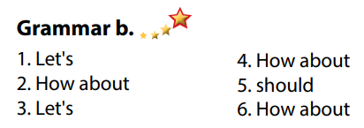  - Look and listen  - Work individually  - Work in pairs  - Read answers, explain  Answer keys  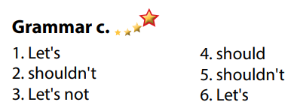

- Activity 3: Production (6’)
a) Objective: Students master the grammar point they study in the lesson.
b) Content: Speaking: Ask and answer about what kind of charity event they should organize
c) Expected outcomes: Ss produce the new language successfully, and they can use “should”, “Let’s” and “How about” to make suggestions in everyday speaking and writing.
d) Organization of the activity:
TEACHER’S ACTIVITIES | STUDENTS’ ACTIVITIES
Task d. In pairs: Ask and answer about what kind of charity event we should organize.  - Divide class into pairs.  - Have Ss take turns asking their partner about what kind of charity event they should organize.  - Have some pairs demonstrate the activity in front of the class.  - Give feedback and evaluation. | - Have conversation in pairs.  - Present.  - Listen.

C. Consolidation and homework assignments (5’)
* Consolidation:

* Homework:
- Make 3 sentences, use “should”, “Let’s” and “How about” to make suggestions.
- Do the exercises in WB: Lesson 1 - Grammar (page 21).
- Complete the grammar notes in Tiếng Anh 7 i-Learn Smart World Notebook (page 23).
- Play consolation games in Tiếng Anh 7 i-Learn Smart World DHA App on www.eduhome.com.vn
- Prepare: Lesson 1.3 – Pronunciation and Speaking (page 30 – SB).

D. Reflection
a. What I liked most about this lesson today:
…………………………………………………………………………………………
- What I learned from this lesson today:
…………………………………………………………………………………………
c. What I should improve for this lesson next time:
…………………………………………………………………………………………

