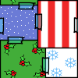

START HERE
1


2
LOSE A TURN!
3
4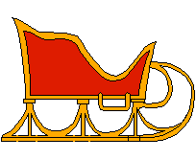
5
6 PLAY AGAIN
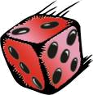
8
MOVE ONE STEP FORWARD

9

10
LOSE A TURN!
11

12

13
GO BACK TO START!
14

16

17


18 MOVE ONE STEP FORWARD
19

20

21 MOVE FIVE STEPS BACK!
23

22


24
LOSE A TURN!
26 PLAY AGAIN
25

27

28
LOSE
A
TURN
29

30
TAKE ONE STEP BACK!
31

32
FINISH

15 PLAY AGAIN

Rules:
- Throw the dice and say the name of the picture.
- Several players can be on the same square.
- Continue until someone reaches the finish.

7 



