UNIT 9: FESTIVALS AROUND THE WORLD
Lesson 4: Communication

I. OBEJECTIVES
By the end of this lesson, Ss will be able to:
- Express disappointment
- Understand the concept of festival symbols and their meanings
- Talk about the concept of festival symbols and their meanings
1. Knowledge:
a. Vocabulary: revise vocabulary on types of festivals and festival activities
b. Grammar: structures to express disappointment
2. Core competence:
- Develop communication skills and creativity
- Be collaborative and supportive in pair work and teamwork
- Actively join in class activities
3. Personal qualities
- Develop self-study skills
II. PREPARATIONS
1. Teacher
- Grade 7 textbook, laptop, TV/Projector/ pictures and cards, speakers, lesson plan, sachmem.vn…
2. Students
- Grade 7 textbook, notebooks, school things….
III. TEACHING PROCEDURES
Notes
In each activity, each step will be represented as following
* Deliver the task
** Implement the task
*** Discuss
 Giving comments or feedback
ACTIVITY 1 – WARM – UP & INTRODUCTION (5’)
a) Aims:
- To activate students’ knowledge and interest.
- To enhance students’ skills of cooperating with teammates
b) Contents: Play the game “Name the festivals”
c) Products: Ss’ answers
d) Teaching steps:
Teacher’s and students’ activities | Content
*Teacher divides the class into 2 teams. Teacher shows pictures of some festivals on the slides.  ** Ss give the correct names of the festivals as fast as possible. The one with more correct answers is the winner.  *** Students work in team mode    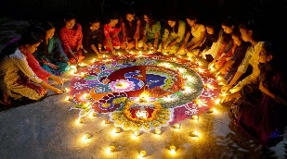   Teacher checks and gives feedback.   | Game: Name the festivals    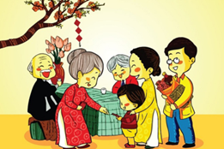
ACTIVITY 2 – PRESENTATION (15’)
a) Aims:
- To help students get to know the ways to express disappointment.
- To help students practise the ways to express disappointment.
b) Contents:
- Teach the way to express disappointment
- Listen and read the conversation. Pay attention to the highlighted sentences.
- Work in groups. Make a similar conversation for each situation below.
c) Products:
- Expressing disappointment
- Ss’ conversation
d) Teaching steps:
Teacher’s and students’ activities | Content
* Teacher lets students listen to the examples in Ex. 1 in the book.  ** Teacher draws their attention to the form of ways to express disappointment.  *** Teacher and students discuss the form of ways to express disappointment, and give some other expressions.   Teacher confirms the answers and gives feedback.  * Teacher has students work in groups to discuss and make similar conversation for each situation.  ** Students work in groups to discuss.  *** Teacher then asks students to exchange their answer among class.   Teacher moves around to observe, provides help and gives feedback. | I - EVERYDAY ENGLISH  Task 1: Listen and read the conversation. Pay attention to the highlighted sentences.  Expressing disappointment  * It was disappointing!  * It was a big disappointment.  Other expressions:  * That’s too bad!  * What a disaster!  * That’s so disappointing!  Task 2: Work in groups. Make a similar conversation for each situation below.  1. Your friend went to a film festival for teenagers, but there were not many films he / she liked.  2. Your friend went to the market to buy decorations for the Mid-Autumn Festival. But there were not many decorations to choose from.
ACTIVITY 3 – PRACTICE (15’)
a) Aims:
- To help Ss understand the concept of festival symbols.
- To provide Ss with some Christmas symbols and their meanings.
- To help Ss understand the symbols and meanings of other festivals.
- To let students practise talking about festival symbols and their meanings.
b) Contents:
- Listen to Mark talking about festival symbols. Fill in each blank with ONE word.
- Work in pairs. Match each festival with its symbol and meaning.
- Work in groups. Choose a festival and talk about its symbol(s) and meaning.
c) Products:
- Answer key
- Ss’ speakings
d) Teaching steps:
Teacher’s and students’ activities | Content
* Teacher asks Ss what they think of when they talk about Christmas, i.e. Christmas symbols. Elicit answers from students.  Have Ss read the sentences given. Ask them to predict what word to use to fill in each blank. Write their answers on the board.  ** Students work individually. Then listen to the recording and check the answers.  *** Teacher invites some Ss to share their answers.   Teacher gives feedback and correction (if needed)  * Teacher introduces some new words if necessary (prosperity, reunion).  ** Ss works in pairs to finish the task.  *** Teacher allows student to cross check first.   Teacher confirms the answers and gives feedback.  * Teacher lets students group up and spend 5 minutes on taking notes of a festival.  ** Students work in groups.  *** All group members choose a festival and talk about its symbols and meanings.   Teacher moves around to observe and offers help if needed. | II – FESTIVAL SYMBOLS  Task 3: Listen to Mark talking about festival symbols. Fill in each blank with ONE word.  Answer key:  1. think  2. meaning  3. life  4. happiness  Task 4: Work in pairs. Match each festival with its symbol and meaning.  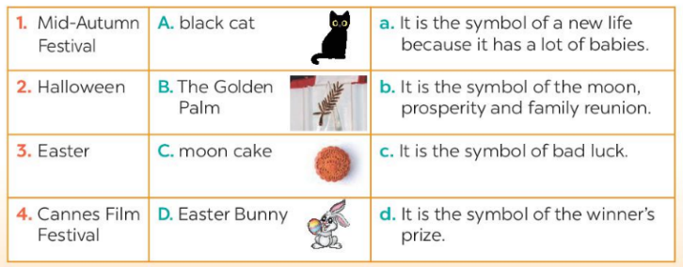  Answer key:  1. C-b  2. A-c  3. D-a  4. B-d  Task 5: Work in groups. Choose a festival and talk about its symbol(s) and meaning.  Example:  When we talk about Christmas, we think of the Christmas tree. It is the symbol of a long life.
ACTIVITY 4 – PRODUCTION (7’)
a) Aims:
- To let students practice talking about festival symbols and their meanings.
b) Contents:
- Work in groups. Interview two of you friends about their favourite food and drink. Write their answers in the table.
c) Products:
- Ss’ presentations
d) Teaching steps:
Teacher’s and students’ activities | Content
* Teacher invites some students to talk about festival symbols and their meanings.  ** Students share their group’s answer.  *** Teacher allows students to cross check first.   Teacher listens, gives comments or corrections if needed. | Task 6: Presentation
IV. WRAP-UP & HOMEWORK (7’)
- Teacher has Ss say what they have learnt in the lesson:
+ Vocabulary of the fesstivals
+ Yes/ No question
- Teacher asks Ss to prepare the next lesson “Unit 9 – Skills 1”

V. FEEDBACK

……………………….…, ngày………….tháng…………..năm 2022
Duyệt của Tổ chuyên môn

