|  |  |
| --- | --- |
|  |  |

**Họ tên thí sinh: .................................................................**

**Số báo danh: ......................................................................**

**Mã Đề: 024.**

**Câu 1.** How long is the flight to France?

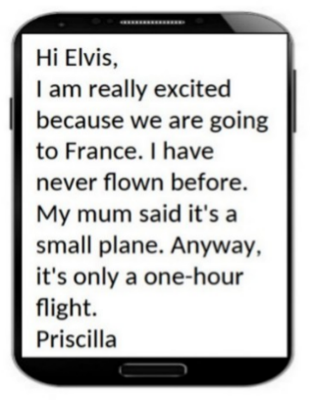

**A.** Two hours  **B.** One hour  **C.** Three hours  **D.** 30 minutes

**Câu 2.** What is true about this notice?

Library Opening Notice:

Book lovers rejoice! Our local library is finally opening its doors after months of renovation. Join us on Saturday, June 19th, for the grand opening celebration. We will have book signings, story readings, and a special surprise for our first 50 visitors. Don't miss out on this exciting event!

**A.** The first 100 visitors will receive a special surprise.

**B.** The local library is opening after months of being closed.

**C.** The grand opening celebration is on Sunday, June 19th.

**D.** There will be no book signings.

**Câu 3.** What is the main reason James cannot attend the concert?

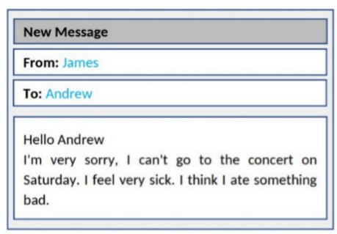

**A.** He has another commitment  **B.** He lost his ticket

**C.** He doesn't like the music  **D.** He is feeling unwell

**Câu 4.** **Look at the signs. Choose the best answer for the question.**

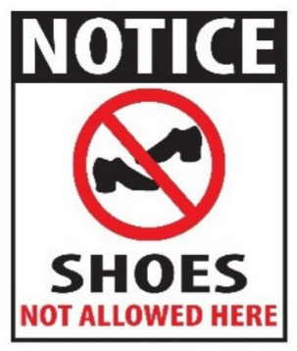

**A.** You can’t buy any shoes in this place.

**B.** Please take off your shoes when entering this place.

**C.** You don’t have to wear shoes in this place.

**D.** Please put on your shoes when entering this place.

**Câu 5.** **Look at the signs. Choose the best answer for the question.**



**A.** Chips and burgers are free - today only.

**B.** If you buy a burger today, you will get chips for free.

**C.** You can buy burgers and chips today only.

**D.** Every burger is served with chips in this restaurant.

**Câu 6.** **Look at the signs. Choose the best answer for the question.**

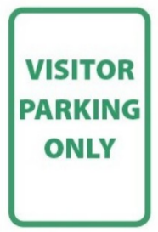

**A.** This parking space is only for visitors.

**B.** People can only park their car here after their visit.

**C.** You can park your car here unless you are visitors.

**D.** Anyone can park their car here.

**Câu 7.** Why has Jenna left a note for Marcus?

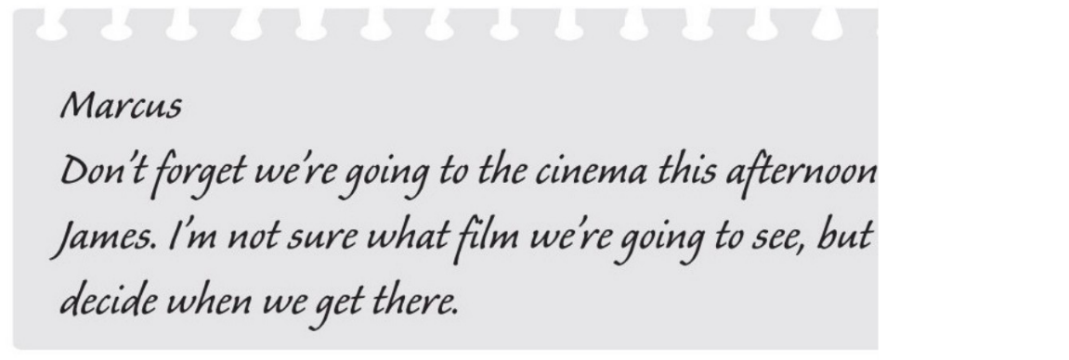

**A.** to invite him to the cinema  **B.** to choose the cinema

**C.** to suggest a film which they could see  **D.** to remind him about an arrangement

**Câu 8.** What is the offer for the swim class?

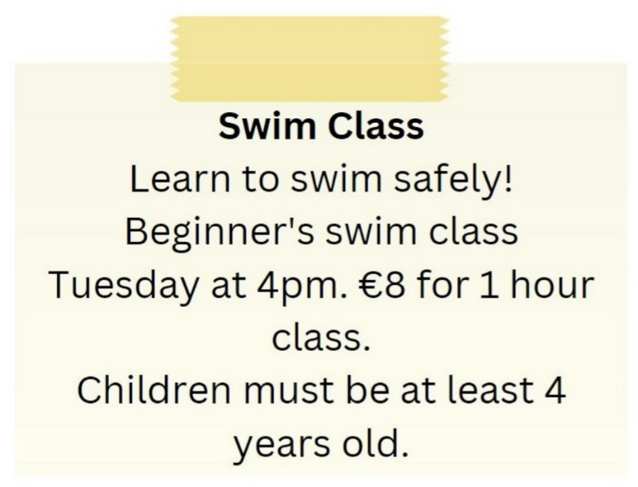

**A.** Advanced swim class on Tuesday at 4pm for €8

**B.** Beginner's swim class on Tuesday at 4pm for €8

**C.** Beginner's swim class on Tuesday at 5pm for €10

**D.** Beginner's swim class on Wednesday at 4pm for €8

**Câu 9.** **Look at the signs. Choose the best answer for the question.**

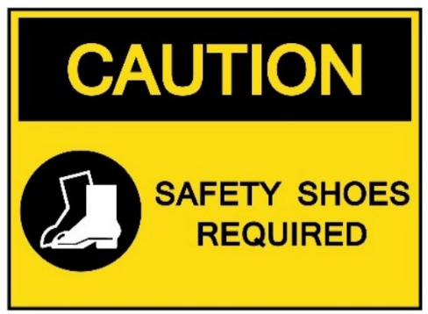

**A.** You should wear shoes in this area because of safety.

**B.** You are allowed to wear shoes in this area.

**C.** You have to wear shoes that can provide protection in this area.

**D.** You have to keep your shoes safe in this area.

**Câu 10.** **Look at the signs. Choose the best answer for the question.**

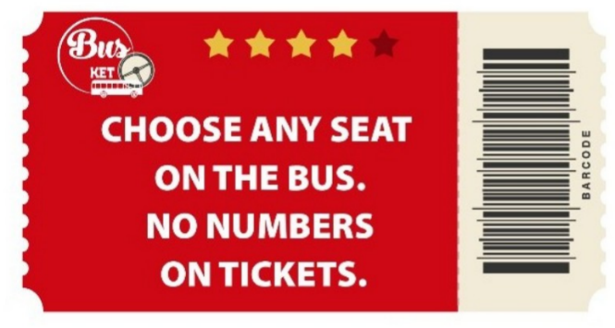

**A.** You may sit where you like.

**B.** The tickets don’t show bus numbers.

**C.** You have to choose your seat when you buy tickets.

**D.** There aren’t any numbers on the seats.

**----HẾT---**