UNIT 2: LIFE IN THE COUNTRYSIDE
I.Vocabulary:
Word | Meaning | Picture | Examples
Beehive(n)  /’bi:haiv/ | Tổ ong | 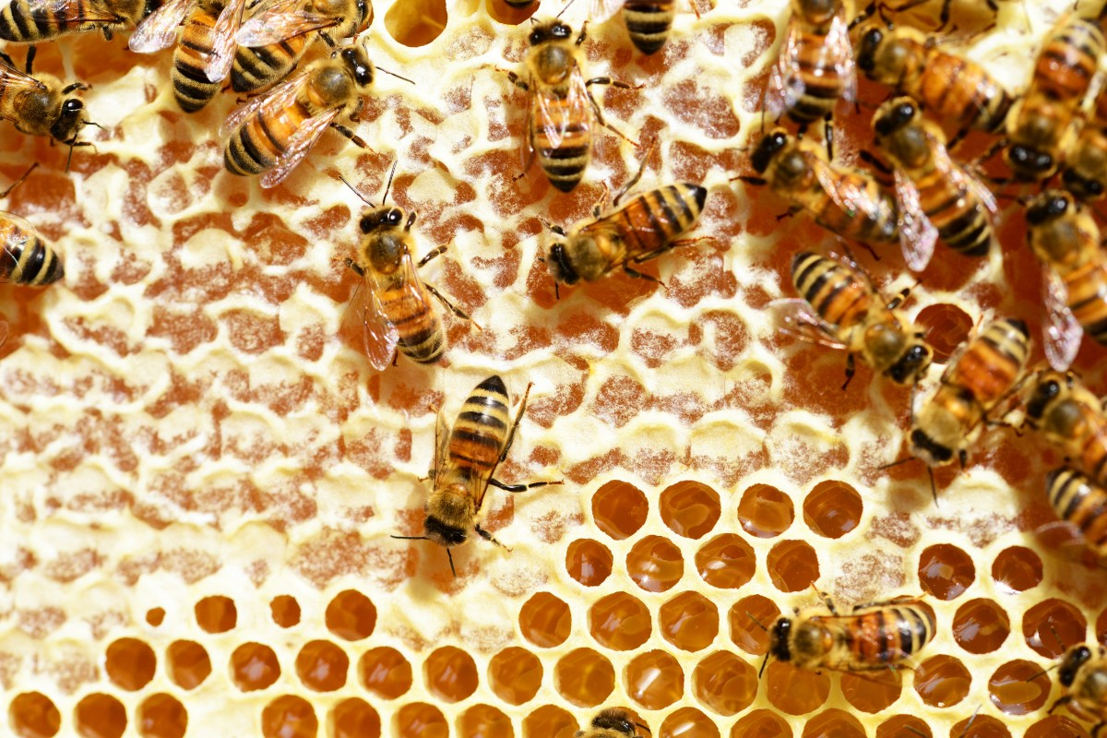 | Look! There is a beehive on the tree.
Cattle(n)  /ˈkætl/ | Gia súc | 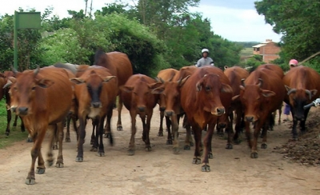  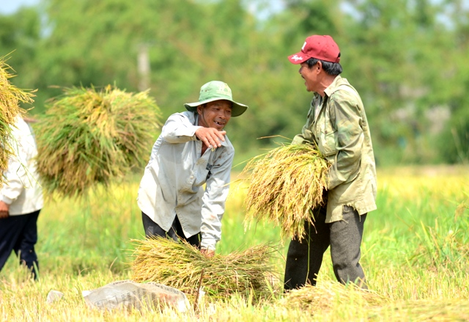 | There is a herd of cattle over there.
Crop(n) /krop/ | Vụ mùa |  | We are looking forword to  a bumper crop
Dairy product /ˈdeəri ˈprɒdʌkt/ | Sản phẩm từ sữa  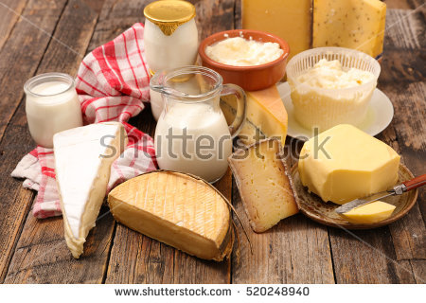 |  | The doctor advised me to eat more dairy products.
Densely(adv) /densli/ | Dày đặc  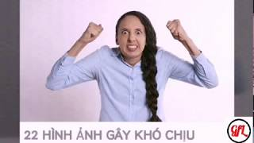 | 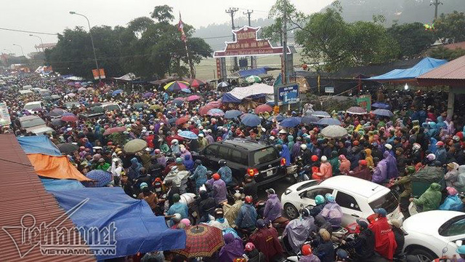 | I don’t want to live in a densely populated area.
Disturbing(adj) /dɪˈstɜːbɪŋ/ | Gây khó chịu  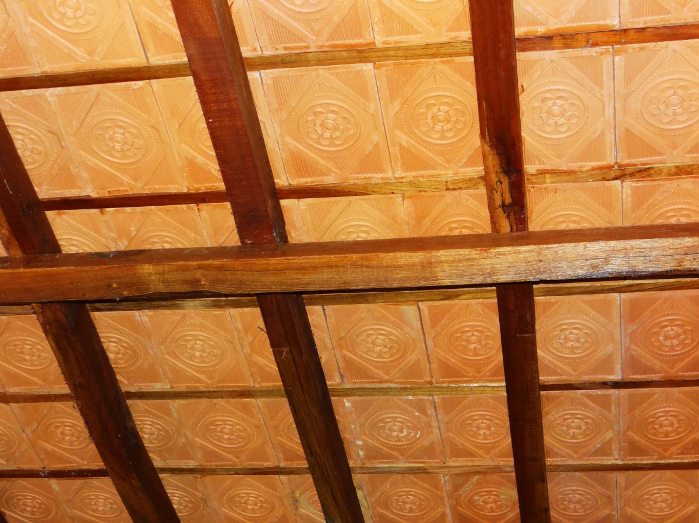 |  | Don’t make such disturbing noise
Earthen(adj) /ˈɜːθn/ | Bằng đất nung | 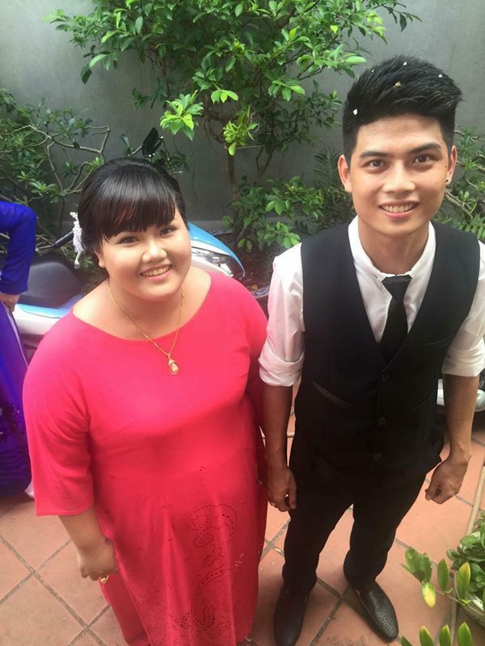 | The locals used to live in earthen houses
Envious(adj) /ˈenviəs/ | Ghen tị |  | Everyone is envious of him
Harvest(n) /ˈhɑːvɪst/ | Vụ thu hoạch  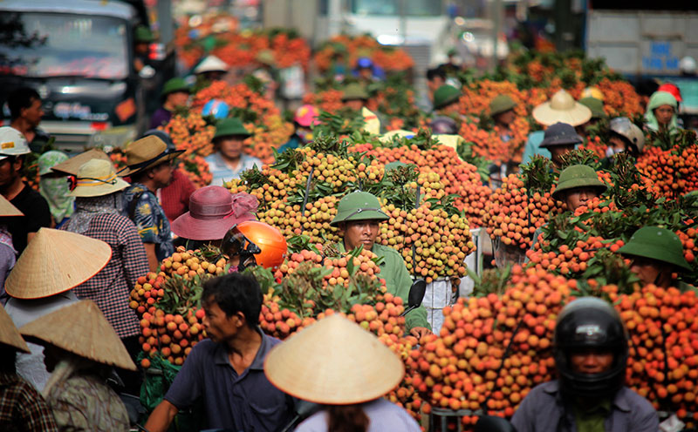  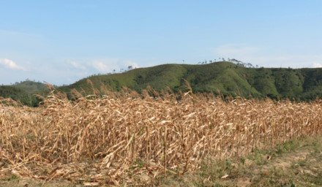 |  | Farmers often work very hard during  harvest time
Hay(n) /hei/ | Cỏ khô |  | These farm workers are making hay to feed the cattle in the winter
Herd(v) /hɜ:d/ | Chăn, dắt | 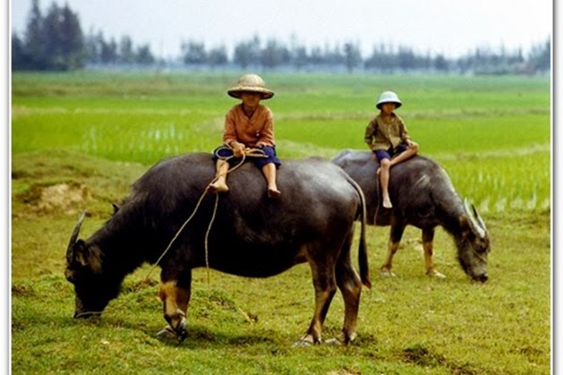 | I used to go herding buffaloes when I was  small.
Inconvenient  (adj)  /ˌɪnkənˈviːniənt/ | Bất tiện  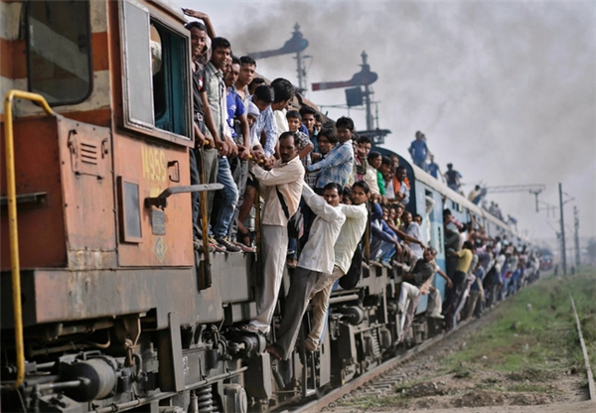 |  | This place is a bit inconvenient for  a formal meeting
Kite(n)  /kait/ | Con Diều  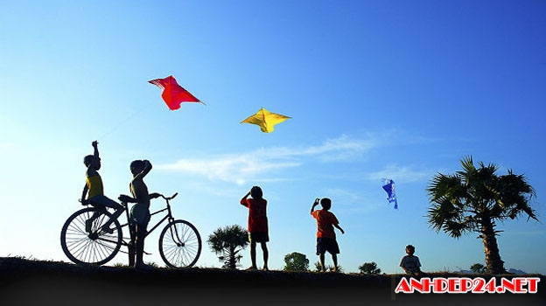  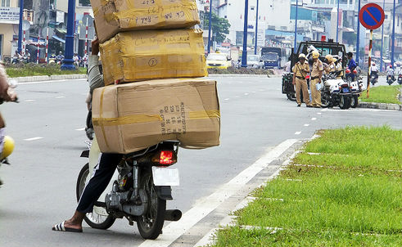 |  | My brother wants to fly his new kite
Load(v)  /ləʊd/ | Chất, chở |  | They loaded the boxes into the trucks
Nomadic(adj)  /nəʊˈmædɪk/ | Thuộc về du mục | 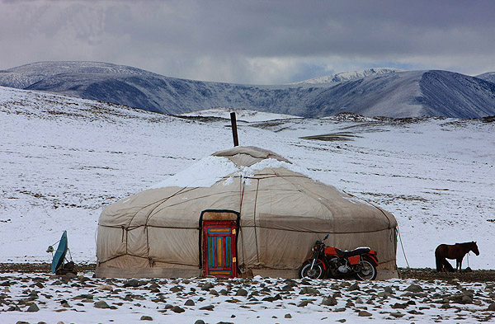  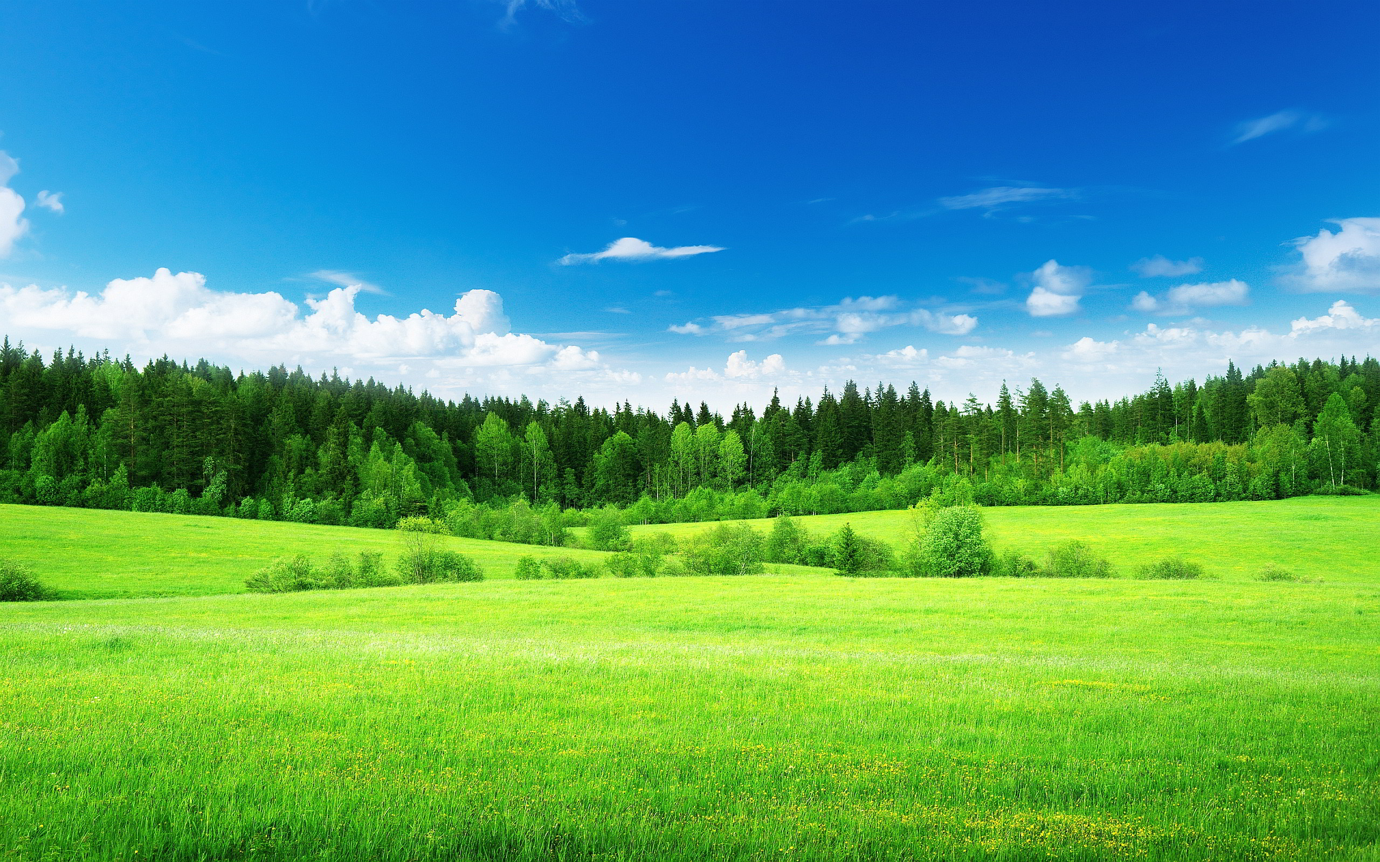 | Many groups of people gave up their nomadic life to settle down
Pasture(n) /ˈpɑːstʃə(r)/ | Đồng cỏ |  | People often raise cattle in areas of rich pasture

B. GRAMMAR:
I.Ôn tập so sánh hơn với tính từ( comparative forms of adjectives)
Ta sử dụng so sánh hơn của tính từ để so sánh giữa người(hoặc vật) này với người(hoặc vật) khác. Trong câu so sánh hơn, tính từ sẽ được chia làm 2 loại là tính từ dài và tính từ ngắn, trong đó:
- Tính từ ngắn là tính từ có 1 âm tiết : Ví dụ : tall, high, big………..
- Tính từ dài là tính từ có từ 2 âm tiết trở lên : Ví dụ : expensive, intelligent……..
II. Cấu trúc câu so sánh hơn:
Đối với tính từ ngắn | Đối với tính từ dài
S1 + to be + adj +er + than + S2
Với tính từ ngắn, thêm đuôi “er” vào sau tính từ | Với tính từ dài, thêm đuôi “more” vào trước tính từ
Ví dụ:  China is bigger than India  Lan is shorter than Nam  My house is bigger than your house  His pen is newer than my pen | Ví dụ:  Gold is more valuable than silver  Hanh is more beautiful than Hoa  Your book is more expensive than my book  Exercise 1 is more difficult than exercise 2
Lưu ý: Để nhấn mạnh ý trong câu so sánh hơn, ta thêm “much” hoặc “far” trước hình thức so sánh
Ví dụ: Her boyfriend is much/ far older than her
III. Cách sử dụng tính từ trong câu so sánh hơn:
1.Cách thêm đuôi –er vào tính từ ngắn
Tính từ kết thúc bởi 1 phụ âm →thêm đuôi -er | Old-older, near-nearer
Tính từ kết thúc bởi 1 nguyên âm “e” →thêm đuôi -r | Nice-nicer
Tính từ kết thúc bởi 1 nguyên âm(ueoai) +1 phụ âm → gấp đôi phụ âm cuối và thêm đuôi -er | Big-bigger, hot-hotter, fat-fatter
Tính từ kết thúc bởi “y” dù có 2 âm tiết vẫn là tính từ ngắn →bỏ “y” và thêm đuôi “ier” | Happy-happier,  Pretty-prettier

Lưu ý: Một số tính từ có hai âm tiết kết thúc bằng “et, ow, er, y” thì áp dụng như quy tắc thêm er ở tính từ ngắn
Ví dụ: quiet →quieter clever → cleverer
Simple → simpler narrow →narower
2.Một vài tính từ đặc biệt:
Với một số tính từ sau, dạng so sánh hơn của chúng không theo quy tắc trên.
Tính từ | Dạng so sánh hơn
Good | Better
Bad | Worse
Far | Farther/ further
Much/ many | More
Little | Less
Old | Older/ elder
BÀI TẬP VẬN DỤNG CƠ BẢN:
Bài 1: Cho dạng so sánh hơn của các tính từ trong bảng sau:
Tính từ | So sánh hơn | Tính từ | So sánh hơn
Bad | WORSE | Modern | MORE WONDERFUL
Clever | CLEVERER | Old | OLDER
Convenient | MORE CONVENIENT | Peaceful | MORE PEACEFUL
Far | FURTHER/ FARTHER | pretty | PRETTIER
Fresh | FRESHER | Quiet | QUIETER
Friendly | FRIENDLIER | Smart | SMARTER
Generous | MORE GENEROUS | Soon | SOONER
Good | BETTER | Strong | STRONGER
Happy | HAPPIER | Ugly | UGLIER
High | HIGHER | Warm | WARMER
Little | LESS | Wonderful | MORE WONDERFUL
Long | LONGER | Young | YOUNGER

Bài 2:Khoanh tròn vào đáp án đúng:
1.Living in this small town is (more peaceful/ peaceful more) than I expected.
2.Nowadays people are (more anxious/ anxious more) about pollution than before.
3.Today you look ( happier/ more happy) than usual.
4.This year I will move to a (bigger/ biggest) city.
5.This experience is (more exciting/ most exciting) than I expected.
6. Who is (more intelligent/ most intelligent) between two of them.
7. This song is (catchier/ more catchy) than that song.
8. The new sofa is (costlier/ more costly) than the old one
9.Our family will move to a (more comfortable/ more comfortable than) place next year.
10. I hope you will get (best/ better) the next time I see you.
11.James has (many/ more) books than Paul.
12.She is (more independent/ most independent) than the last time I saw her.
13. Today my sister (is more quiet/ quieter) than usual.
14.Jane is(more pretty/ prettier) than Ann.
15.The weather is (hotter/ hottest) than yesterday.

Bài 3 :Hoàn thành các câu sau với dạng so sánh hơn của tính từ trong ngoặc:
1.Living in the city is______MORE CONVENIENT__than living in the country(convenient).
2.Mrs.Smith is____YOUNGER_____than I thought.(young).
3.Houses in big cities are much_________than those in my hometown(tall).
4.No one in my class is_________TALLER __than Jim (smart).
5. The senior prom would be_____MORE EXCITING____than any other proms(exciting).
6. I have______LESS____courage than my brother(little).
7. His health condition is getting____WORSE______(bad).
8.You are_____CLEVERER____than you think(clever).
9.This computer is much___MORE EXPENSIVE______than mine(expensive)
10.I always dream of a____MORE MODERN______house to live in(modern).
11.They are______MORE SKILLFUL____than they used to be(skillful).
12.Life in this village is__ MORE PEACEFUL __than anywhere else.(peaceful).
13.I think people in the countryside are_____FRIENDLIER___than city dwellers.(friendly)
14.This year, the prize for the winner is__MORE VALUABLE____than last year.(valuable)
15.Which dress is_______MORE SUITABLE___for me?(suitable)
16.You should be_____MORE CONFIDENT_____and show your best.(confident).
17.They said that the conference was_____MORE INTERESTING___than usual(interesting).
18.Jane is so pretty but her sister is even______PRETTIER____(pretty).
19.They work hard to have____BETTER____life(good).
20.John is____MORE INTELLIGENT______than the rest of the class.(intelligent)

Bài 4: Biết câu so sánh hơn dùng từ gợi ý:
0.Bob / strong /Jim. →Bob is stronger than Jim.
1.My current job / demanding/ my last one.
MY CURRENT JOB IS MORE DEMANDING THAN MY LAST ONE
2.Today/ Jane/ beautiful/ usual.
TODAY JANE IS MORE BEAUTIFUL THAN USUAL
3.Yesterday / it/ cold/ today.
YESTERDAY IT WAS COLDER THAN TODAY
4.Fruits and vegetables / healthy / fast food.
FRUITS AND VEGETABLEA ARE HEALTHIER THAN FASTFOOD
5. Life in the countryside / peaceful/ life in the city.
LIFE IN THE COUNTRYSIDE IS MORE PEACEFUL THAN LIFE IN THE CITY.
6.Your sister/ good/ you think.
YOUR SISTER IS BETTER THAN YOU THINK
7.Who / intelligent/ you/ in your class?
WHO IS MORE INTELLIGENT THAN YOU IN YOUR CLASS?
8. Ann/ short / you?
IS ANN SHORTER THAN YOU?
9. Last year/ his salary / low/ this year.
LAST YEAR HIS SALARY WAS LOWER THAN THIS YEAR
10. Bob/ look / strong/ his brother.
BOB LOOKS STRONGER THAN HIS BROTHER

Bài 5: Sắp xếp các từ sau thành câu hoan chỉnh:
1.London /think/ is/ than/ more/ I/ New York/ expensive.
I THINK LONDON IS MORE EXPENSIVE THAN NEW YORK
2.Important/ is/ Health/ than/ money/ more.
HEALTH IS MORE IMPORTANT THAN MONEY
3.in / in/ city/ better/ the / is/ in /than / country/ convenient / than / is.
TRAVELLING IN THE CITY IS MORE CONVENIENT THAN IN THE COUNTRYSIDE
4.in / health care/ city/ better/ the / is/ in / than / countryside/ the service/ the.
THE HEALTH CARE SERVICE IN THE CITY IS BETTER THAN IN THE COUNTRYSIDE
5.living/ is/ than / in /rural/ more/ areas / living/ urban /in / comfortable/
LIVING IN RURAL AREAS IS MORE COMFORTABLE THAN LIVING IN URBAN AREAS
6.in/ pasture / this/ that/ area / richer / is / area.
PASTURE IN THIS AREAS IS RICHER THAN THAT AREA
7. Peter/ better / Math/ than / at/ is / Tom.
PETER IS BETTER AT MATH THAN JOHN
8.crowded/ cities/ often / than / more/ are/ the / countryside.
CITIES ARE OFTEN MORE CROWDED THAN THE COUNTRYSIDE
9.this /cake/ is /that/ more/ one/ delicious/ than?
IS THIS CAKE MORE DELICOUS THAN THAT ONE?
10.Who/ more/ than / Tom / can /in / intelligent / class/ his?
WHO CAN BE MORE INTELLIGENT THAN TOME IN HIS CLASS?
IV. SO SÁNH HƠN VỚI TRẠNG TỪ (COMPARATIVE FORMS OF ADVERBS)
Tương tự như với tính từ, trang từ chia thành 2 loại:
-.Trạng từ ngắn là những trạng từ có 1 âm tiết.
Ví dụ: hard, near, far, right, wrong…………
-Trạng từ dài là những từ có từ 2 âm tiết trở lên.
Ví dụ: slowly, responsibly, quickly, interestingly, tiredly……
1.Cấu trúc câu so sánh hơn với trạng từ:
Đối với trạng từ ngắn | Đối với trạng từ dài
S1 +V +adv +er +than+ S2 | S1 +V +more / less +adv +than+ S2
Với các trạng từ ngắn, thường là trạng từ chỉ cách thức có hình thức giống tính từ, ta thêm “er” vào sau trạng từ | -Với trạng từ dài, hầu hết là các trạng từ chỉ cách thức có đuôi “ly” ta thêm “mỏe”(nhiều hơn) hoặc “less”(ít hơn) vào các trước trang từ  -“Less” là từ phản nghĩa của “more” ,được dùng để diễn đạt sự không bằng nhau ở mức độ ít hơn.
Ví dụ:  They work harder than I do.  She runs faster than he does  My mother gets up earlier than me.  I go to school later than my friends do | Ví dụ:  My friend did the test more carefuly than I did.  My father talks more slowly than my mother does.  Hanh acts less resposibly than anyone

2.Một vài trạng từ có dạng từ đặc biệt:
Tính từ | Dạng so sánh hơn
well | Better
Badly | Worse
Far | Farther/ further
Early | Earlier

Ví dụ:
The little boy ran farther than his friends
You’re driving worse today than yesterday.

BÀI TẬP VẬN DỤNG CƠ BẢN:
Bài 6: Cho dạng so sánh hơn của các trạng từ trong bảng sau:

Trạng từ | So sánh hơn | Trạng từ | So sánh hơn
Badly | WORSE | Late | LATER
Conveniently | MORE CONVENIENTLY | Smartly | SMARTLY
Early | EARLIER | responsibly | MORE RESPONSIBLY
Far | FARTHER/FURTHER | Patiently | MORE PATIENTLY
Fast | FASTER | Generously | MORE GENEROUSLY
Fluently | MORE FLUENTLY | Cleverly | MORE CLEVERLY
Happily | MORE HAPPILY | Quickly | MORE QUICKLY
Hard | HADRER | Suitable | MORE SUITABLY
Slowly | SLOWER | Beautifully | MORE BEAUTIFULLY
well | BETTER | Strongly | MORE STRONGLY

Bài 7: Khoanh tròn vào đáp án đúng:

1.The teacher asked me to speak___________.
A.loud B.louder C.more loud
2.Today you looks________than usual.
A.more confident B.more confidently C. confidently
3.Your house is_______decorated than me.
A.more beautiful B.more beautifully C.beautifully.
4.No one in my class runs__________than Peter.
A.more fastly B.more better C.faster.
5.This time you did much________!
A.better B.more better C.more well
6.You have to work_________If you want to succeed.
A.more hardly B.hardlier C.harder
7.Today I come to class_________than usual
A.more early B.earlier C. early
8.You need to work___________, or you will make a lot of mistakes.
A.more careful B. more carefully C. carefully
9.She walks__________than other people.
A.slower B.slowlier C.more slowier
10.The blue skirt suits you_______than the black one.
A.better B.more better C.more well
Bài 8: Hoàn thành các câu sau với dạng so sánh hơn của các trạng từ trong ngoặc:
1.I speak English____ MORE FLUENTLY______now than last year.(fluently).
2.They smiled____ MORE HAPPILY____than before(happily).
3.Tom arrived___ EARLIER______than I expected(early).
4.We will meet __LATER______in the afternoon(late).
5.Mary dances____ MORE GRACEFULLY______than anyone else(gracefully)
6.Could you speak_____LOUDER____?(loud)
7.Jim could do the tast___BETTER___Jane(well).
8.We walked____ MORE SLOWLLY___than other people(slowly).
9.Planes can fly____HIGHER______than birds(high).
10.I can throw the ball______FARTHER____than anyone else in my team(far).
11.James drives___ MORE CAREFULLY____than his wife(carefully).
12.I visit my grandmother___ MORE OFTEN____than my brother.(often)
13.No one can run___FASTER____than John(fast).
14.My sister cooks____WORSE____than I(badly).
15. Everyone in the company is working____WORSE____than ever before(hard).

Bài 9:Hoàn thành các Câu sau với dạng so sánh hơn của các trang từ trong ngoặc:
1.I/ play/ tennis/ badly/ Tom.
I PLAY TENNIS WORSE THAN TOM
2.The Australian athlete/run/ slowly/ the Korean athlete.
THE AUSTRALIAN ATHELETIC RUNS MORE SLOWLY THAN THE KOREAN
3.Cats/ walk/ quiet/ dogs.
CATS WALK MORE QUIETLY THAN DOGS
4.James/ reply/ swiftly/ Peter.
JAMES REPLIED MORE SWIFTLY THAN PETER
5. The tiger/ hunt/ ferociously/ the wolf.
THE TIGER HUNTS MORE FEROCIOUSLY THAN THE WOLF
6.Your idea/ work/ well/ mine.
YOUR IDEA WORKS BETTER THAN MINE
7.I/ eat/ vegetables/ often/ I used / to.
I EAT VEGETABLES MORE OFTEN THAN I USED TO
8.Today/ you/ perform/ badly/ yesterday.
TODAY YOU PERFORM WORSE THAN YESTERDAY
Bài 10:Viết lại câu sau cho nghĩa không đổi, sử dụng cấu trúc so sánh hơn “more /less”
0.Ann speaks French more fluently than James.
→James speaks French less fluently than Ann.
1.Today the sun shines more brightly than yesterday.
YETSERDAY THE SUN SHONE LESS BRIGHTLY THAN TODAY
2.This cake is more freshlt made than that one.
THAT CAKE IS LESS FRESHLY MADE THAN THIS ONE
3.Jim behaves more politely than his younger brother.
JIM’S YOUNGER BROTHER BEHAVES LESS POLITELY THAN JIM
4.Teenagers act more violently these days than in the past.
TEENAGERS ACTED MORE VIOLENTLY IN THE PAST THAN THESE DAYS
5.The doctor treats his patiently than he should.
THE DOCTOR SHOULD TREAT HIS PATIENTS MORE PATIENTLY THAN HE DOES
6.My sister speaks more quickly than I.
I SPEAK LESS QUICKLY THAN MY SISTER.
7.Now Mary drives more carefully than she used to.
MARY USED TO DRIVE LESS CAREFULLY THAN SHE DRIVES NOW
8.This summer I go to the beach more often than the last summer.
THE LAST SUMMER I WENT TO THE BEACH LESS OFTEN THAN THIS SUMMER
BÀI TẬP TỔNG HỢP NÂNG CAO
Bài 11:Hoàn thành câu, sử dụng dạng so sánh hơn của các tính từ hoặc trạng từ cho sẵn
Angrily | large | soft | Cleverly | Warm
comfortably | hard | rich | costly | beautifully

1.Her voice is_____SOFTER____than mine.
2.James can sing____MORE BEAUTIFULLY____than many singer.
3.We can live____MORE COMFORTABLY_____in the countryside than in the city.
4.We hoped we would own a _____LARGER____apartment.
5.This mordern computer is_____COSTLIER____than that old-fashioned one.
6.My new house is_____MORE CLEVERLY____designed than my old one.
7.My father reacted____MORE ANGRILY_____to my misbehaviors than my mother.
8.John studies_____HARDER_____than anyone else in the class.
9.It is getting____WARMER_____today so we can go out.
10. People in the city are___RICHER____than people in the countryside.
Bài 12; Gạch chân lỗi sai trong mỗi câu sau và sửa lại cho đúng:
1.Their life has been more comfortably since they moved to the city.--> COMFORTABLE
2.She looks more pretty in this white dress. →PRETTIER
3.The manager wants us to work more hardly. →HARDER
4.This week you looks more healthily than last week. →HEALTHIER
5.Everyone in my town is looking for more better crop this year. →BETTER
6.Jim runs more fastly than his friends. →FASTER
7.I think a settle life is more better than a nomadic life. →BETTER
8.Today Jim performs less confident than usual. →CONFIDENTLY
9.The heavy rain makes it more difficultly to drive. →DIFFICULT
10.Their team preformed much more well than our team. →BETER
Bài 13; Viết lại câu bằng từ đã cho sao cho nghĩa câu không thay đổi theo mẫu:
0.This exercise is easier than that one.
→That exercise is more difficult than that one.
1.Mr Smith is wealthier than Mr.Brown.
→Mr Brown_IS POORER THAN MR.SMITH
2.My house is smaller than my parent’s house.
→My parent’s house__IS BIGGER THAN MY HOUSE
3.The black dress is more expensive than the red one.
→The red dress _IS CHEAPER THAN THE BLACK ONE
4.Today it is colder than yesterday.
→Yesterday__IT WAS WARMER THAN TODAY
5.I don’t think you are taller than me.
→I don’t think I___AM SHORTER THAN YOU
6.Is Jim worse at Math than John?
→Is John____BETTER AT MATH THAN JIM?
7. Jim looks much younger than his classmates.
→Jim’s classmates__LOOK MUCH OLDER THAN HIM
8.Your hair is longer than mine.
My hair__IS SHORTER THAN YOURS
Bài 14: Khoanh tròng vào đáp án đúng:
Benefit of living in the countryside.
While many people prefer city life, a lot of people want to send their life in a rural area. The countryside are often(1)_________than the city because there are not as many factories and traffic as in big cities. The country folk can be (2) _________and they often live(3) _________than city dwellers. Besides, life in the countryside is(4) _________and peaceful because the crime rate is much(5) _________. The rural areas are(6) _________populated than the urban area but the neighbors are(7) _________and more helpful. Life in the countryside is(8) _________for old people than the energetic youngsters.
1.A.less polluted B.more polluted C.less pollutedly D.more pollutedly
2.A.more healthy B.healthier C.more healthily D.helthily.
3.A.longly B.longer C.shortly D.shorter
4.A.more simple B.simpler C.simply D.more simply
5.A.higher B.highly C.lower D.lowly
6.A.more densely B.more dense C.less D.less dense
7.A.more friendly B.friendlier C.friendly D.less friendly
8.A.more suitable B.more suitbly C.less suitably D.suitably.
Bai15: Đọc đoạn văn sau và trả lời câu hỏi: The nomadic life of Mongolian
Mongololian people nowadays still maintain their tradition of a nomadic life. About half of mongolian population do not settle down but travel from place to place every season. When you think of Mongolian nomads, you think of animal farmers. Their most valuable possessions are their tents and cattle. Mongolian has severe weather. There are dramatic changed in weather condotions between seasons. That is the reason why Mongolian have to move location throughout the year to the most appropriate spots. In winter, they often move in front of a mountain for shelter. In spring, it’s closer to a river, in summer right next to a river for water supply, and in autumn up a hill to collect hay for winter time. Most nomads move at least four times a year but some might move up to 30 times in a year ,especially if they have a lot of animals that eat through the vaibable food quickly.
The number of namads has, however, significantly decreased over last years. More and more of its citizens move to Ulaanbaatar because they want to look for an education and a professional job.Mongolia is in a period of rapid change.
1.Is it true that about 50% of Mongolian population still lead a nomadic life?
YES IT IS
2.What are the most valuable possessions of Mongolian nomads?
TENTS AND CATTLE
3.Why do Mongolian have to move location throughout the year?
BECAUSE MONGOLIAN HAS SEVERE WEATHER AND THERE ARE DRAMATIC CHANGED IN WEATHER CONDITIONS BETWEEN SEASONS
4.Where do Mongolian nomads often move to in fall?
THEY MOVE UP A HILL
5.How often most nomads move their locations?
AT LEAST FOUR TIMES A YEAR
6.Why more and more Mongolian move to Ulaanbaatar?
MORE AND MORE OF ITS CITIZENS MOVE TO ULAANBAATAR BECAUSE THEY WANT TO LOOK FOR AN EDUCATION AND A PROFESSIONAL JOB.

END OF TERM TEST -ADVANCED
A.PHONETICS:
I.Find the word which has a different sound in the underlined part:
1.A.scientists B.bookworms C.deadlines D.flowers
2.A.nations B.speakers C.lessons D.students
3.A.continent B.alone C.combat D.control
4.A.delicate B.prefer C.reference D.schedule
5.A.southern B.courage C.encounter D.brother
II.Find the word which has a different stress pattern from the other:
1.A.scientist B.practical C.abondon D.furniture
2.A.remember B.influence C.convenient D.expressive
3.A.humorous B.arrangement C.attractive D.successful
4.A.bankruptcy B.phonetics C.piano D.seccessive
5.A.eventful B.announcement C.construction D.capital
B.VOCABULARY AND GRAMMAR:
III. Find a word/phrase for each definition below:

Definition | Word/Phrase
1.Any of the foods or substances that are combined to make a particular dish
2.to soak meat ,fish, or other food in a sauce for a period of time to add flavor to food
3.unable to be reached or to get into
4.the moment at which an aircraft’s wheels or part of a spacecraft make contact with the ground during landing
5.the language that a person has grown up speaking from early children
6.the physical state of astronauts in the condition of microgravity
7.a document attesting a level of achievement in a course of study or training.
8.officially register as a member of an institution or a student on a course.
IV. Fill in the gap with a suitable phrase or idiom given below:
Burn the midnight oil take into account make a bundle
Nine-to-five behind the scenes break the bank
Once in a blue moon over the moon out of this world
1._____________I go to the cinema, only when there’s a film really want to see.
2.Both my parents work___________in the state-owned companies. They go to work together everymorning.
3.Oh, this business seems really profitable. Do you think that you can_________by investing in it?
4.I asked my parents to allow me to join a five-day tour to Danang with my classmates this summer holiday ad they sais that they would__________my idea.
5. Oh, your chocolate cake is_________I have never tasted such a delicious cake. Can you tell me the recipe?
V. Choose the best answer (A,B, or D).
1. If you want to become a____________you need to know a lot about cultures and customs of different places.
A.tourist guide B.biologist C,businessman D.travel agent
2.When she opened this flower shop, she didn’t think that she could_______a bundle.
A.have B.earn C.make D.get
3.More and more women in developing countries are entering universities and getting higher education___________.
A.certificates B.diploma C.degrees D.achievements
4.__________the fact that becoming an astronaut is really challenging, my cousin has kept trying to following his dream.
A.Despite B.In spite of C.Although D.both A&B
5.On Sunday we decided to go to ________beach by_________train, but because of__________ threating weather, we went to___________cinema instead.
A.the-#-the-the B.a-a-the-the C.a-#-a-the D.the-the-a-#
6.The aim of the culture festival is__________friendship between the two countries.
A.promote B.promoting C.to promote D.being promoted
7.It’s no use________him. He never allows anybody_________advice.
A.advise-give B.to advise-to give C.advising-giving D.advising-to give
8.Without the money that you lent me, I _________buy this motorbike.
A.would B.wouldn’t C.could D.couldn’t
9.My grandfather,_________legs are suffering from arthritis, haven’t been able to travel as much as usual.
A.who B.whom C.whose D.that
10. The article about Rosetta, the latest ground-breaking space mission is extractly__________I need for one of my final-term project.
A.which B.whom C.whose D.that
VI. Provide the correct form of the verbs given in the brackets:
1.I can’t imagine Peter(go)___________by bike.
2.I look forward to(see)__________at the weenkend.
3.They had got all the Maths exercise(do)__________before the lunch time.
4.Do you know what(do)_____________if there’s a fire in the shop?
5.I don’t think that she can manage(complete)_____________the decoration work on time.
6.When I was doing shopping in the shop, I saw her(choose)_________some clothes in the opposite shop.
7.You’d better(take)_________an umbrella with you because it is going to rain.
8.I coulbn’t help(laugh)________when I saw him in that funny hat.
9.I think Jenny will consider(buy)_______a color printer because she needs one for her work.
10. We attempted so hard(persude)__________her, but we failed.
VII. Fill in the blank with the correct form of the given word:
1.This dish can’t be delicous without these___________(season).
2.In this new teaching approach, teachers become________to support students’ active learning (FACILITATE)
3.Although she was___________in marketing field, she still applied for that marketing company
(EXPERIENCE).
4.Besides specialized knowledge, what_________are interested in job applicants are their soft skills. (RECRUIT).
5.when the students learn about space travel, they are very curious about the state of being________ (WEIGHT)
VIII. Find one mistake in each sentence and correct it:
1.I had gone to the supermarket, then I cooked dinner and enjoyed it with some good music.
A B C D
2.If today is Sunday, staying in bed and watching a thriller would make me happier than anything
else. A B C D
3.Merlion Park where is a Singapore landmark and major tourist attraction is located at One
A B C D
Fullerton, Singapore, near the Central Business District.
4.Fish and chips, which is hot dish of English origin, consist of fried battered fish and hot potato chips. A B C D
5.Sashimi and sushi, which is served with a dipping sauce made from soy sause and wasabi, are
A B C D
well-known traditional food of Japan.
C.READING:
IX.Read the passage:
Five seconds on the floor
Urban legend says that if you pick up dropped food from the floor within five seconds, it’s safe to eat, because it is not enough time for(1)_________to take place. Dawson and his students(2)______ to understand the truth behind this food trope.
They spread salmonella bacteria on tile, carpet and wood.(3)_______five minutes, they put down bologna or bread and left it there for five,30 or 60 seconds. They did the same thing after bacteria had been(4)________the surface for two, four, eight and 24 hours. “There was enough bacterial transfer in five seconds; it’s not a really good idea to eat food from the floor, “Dawson said. He said he doesn’t think it’s time on the floor that(5)__________so much , but rether the type and amount of bacteria.
Donald Schffner, a food miccrobiologist at Rutgers University,(6)________the only other peer-reviewed five secod rule study. His findings, published last year, confirmed Dawson’s and showed that longer contact times with a contaminated floor(7)________in the transfer of more bacteria. Schaffner found that the type of food as well as the surface on which the food fell, also influenced the amount of bacteria transferred. Wet foods were more(8)________to pick up bacteria and surfaces such as carpets were less likely to transfer bacteria
1.Choose the most suitable word/ phrase to fill in the blank.
1.A.contaminant B.contamination C.contaminate D.conntaminated
2.A.set up B.set off C.set in D.set out
3.A. before B.during C.after D.since
4.A.on B.in C.over D.under
5.A. problems B.troubles C.issues D.matters
6.A.carried out B.conducted C.created D.both A &B
7.A.led B.caused C.resulted D.both A&C
8.A. like B.likely C.unlikely D.alike
2.Complete the following sentences with a suitable word/ phrse from the passage:
1.Dawson decided to do the investigation into the food matter with support of his __________
2.In the second time of testing, Dawson spread bacteria on the surface and left it for up to________
3.Dawson found out that it is the _________and _________of bacteria that decide whether dropped food can be still be safely eaten or not.
4.Schaffner supported Dawson’s findings and added that the amount of bacteria transferred to dropped food is strongly related to longer ar shorter__________
5.According to Schsffner, more bacteria will be transferred to_______than other foods.
X.Read the passage.Fill in the blank with one suitable word.
Anything good about natural disasters?
Training to(1)_________a veterinarian takes almost as much time as becoming a human doctor and it’s just as involved. You typically do four years of undergraduate and have to(2)________the prerequisites and required tests to get into veterinary school,(3)________is another four years of school. And then if you decide you want to specialize in a field , you do an internship for a year. And then if you decide you want to specialize in a field, you do an internship for a year and three more years(4)_______residentcy aftre you graduate. As a general practitioner, you’re not required to do a residency or internship.. But even if you ever only plan on practicing on household pets, your training encompasses all fields of veterinary medicine. So you go from seeing small animals, like dogs and cats, to(5)_________animals like birds and reptiles, to farm animals, like sheep, cows and goats. And there are rotations where you’re on-call in the middle of the night,(6)_________you work weekends and holidays. A lot of people sort of have this impression that you play with puppies and kittens all day, and that it’s inferior to human medicine. As a (7)_________, I need to know how to do dentistry, surgery, internal medicine, and X-rays, where in human medicine, you(8)________in one of those things.

D. SPEAKING:
XI. Tell about the differences between women’s life in today society and their life in the past;
You should base on some suggestions below.
You should think about the changes in terms of :
- Family responsibilities
- Career/ education
- Social life/ leisure and recreational activities.

XII. Some people say that women are not suitable to work in the field of space science. What do you think about that?
you should base on some suggestion below.
- Do you agree or disagree with the idea?
- Why do you think so?
- Do you know ant women working in this field?
- Do you think that more and more women will get involved in this field in the future? Why?

E : LISTENING:
XIII. Listen to a brief introduction to eating disorders. Decide if the statements are true(T) or False(F):
1._________Eating too little or too much are both symptoms of eating disorders.
2. _________Only females suffer from eating disorders.
3. _________Eating disorders only occur during the teen years or young childhood.
4. _________Eating disorders are simple disorders.
5. _________Treatment for eating should be done with support of support of specialists.
XIV: Listen again. Answer the question below.
1.Eating disorders might be caused by__________and being over-worried about body weight.
2.Eating disorders are classified as a__________
3. Eating disorders commonly coexist with other conditions, such as______substance abuse, or_____
4.The exact causes of Eating disorders are still______________
5.Treatment for an Eating disorders should be addressed with medical doctors,_______and therapists for complete care.
F. WRITING:
XV, Rewrite the following sentence based on the given words:
1.Tourist throw trash in the places they come to, which will make the places polluted.
→ If____________________________________________________________________
2.Working as a saleman for this company might give you a lot of chances to travel abroad.
→ If you__________________________________________________________________
3.She has experienced serious Eating disorders recently. It may possibly cause long-term effects to her health.
→Serious Eating disorders_______________________________________________________
4.Detox is the body’s natural, on-going process of neutralzing and eliminating toxins. Toxins can potentially harm body tissue.
→ Detox is___________________________________________________________________
5.Even though the ethlete is attempting to break her own record of the last year, she is unlikely to make it.
→Despite__________________________________________________________________
XVI: Make complete sentences based on the given words:
1.Today/ Mr.Dave/ work/ main chef/ five-star hetel/ nearly 10 years/ tell/ us/ recipes/ two amazing dishes.
____________________________________________________________________________________________________________________________________
2. If / it/ were not/ lack/ interpersonal skills/ he/ be/ competitive candidate/ job.
____________________________________________________________________________________________________________________________________
3.If/ transport system/ VietNam/ inprove, VietNam/ become/ more and more popular/ international visitors.
____________________________________________________________________________________________________________________________________
4.Although/ he/ not/ interested/ trave/ he/ just/ decide/ to go/ Bali island/ because/ extraordinary beauty.
____________________________________________________________________________________________________________________________________
5.Brother/ used/ drive/ car/ go/ work/ change/ use/ BRT buses/ save energy/ protect environment.
____________________________________________________________________________________________________________________________________
XVII.Write a paragraph(100-120 words) about the advantages and disadvantages of tourism development.
You should base on some suggestions below:
You should think about the development of tourism in relation to :
- National/ regional economy
- Employment
- Environment
________________________________________________________________________________________________________________________________________________________________________________________________________________________________________________________________________________________________________________________________________________________________________________________________________________________________________________________________________________________________________________________________________________

KEY -------------END OF TERM TEST -ADVANCED
A.PHONETICS:
I.Find the word which has a different sound in the underlined part:
1.A.scientists B.bookworms C.deadlines D.flowers
2.A.nations B.speakers C.lessons D.students
3.A.continent B.alone C.combat D.control
4.A.delicate B.prefer C.reference D.schedule
5.A.southern B.courage C.encounter D.brother
II.Find the word which has a different stress pattern from the other:
1.A.scientist B.practical C.abondon D.furniture
2.A.remember B.influence C.convenient D.expressive
3.A.humorous B.arrangement C.attractive D.successful
4.A.bankruptcy B.phonetics C.piano D.seccessive
5.A.eventful B.announcement C.construction D.capital
B.VOCABULARY AND GRAMMAR:
III. Find a word/phrase for each definition below:

Definition | Word/Phrase
1.Any of the foods or substances that are combined to make a particular dish | INGREDIENTS
2.to soak meat ,fish, or other food in a sauce for a period of time to add flavor to food | MARINATE
3.unable to be reached or to get into | INACCESSIBLE
4.the moment at which an aircraft’s wheels or part of a spacecraft make contact with the ground during landing | TOUCHDOWN
5.the language that a person has grown up speaking from early children | MOTHER TONGUE
6.the physical state of astronauts in the condition of microgravity | FLOATING
7.a document attesting a level of achievement in a course of study or training. | CERTIFICATE
8.officially register as a member of an institution or a student on a course. | ENROL
IV. Fill in the gap with a suitable phrase or idiom given below:
Burn the midnight oil take into account make a bundle
Nine-to-five behind the scenes break the bank
Once in a blue moon over the moon out of this world
1._ Once in a blue moon _I go to the cinema, only when there’s a film really want to see.
2.Both my parents work_ Nine-to-five in the state-owned companies. They go to work together everymorning.
3.Oh, this business seems really profitable. Do you think that you can make a bundle _by investing in it?
4.I asked my parents to allow me to join a five-day tour to Danang with my classmates this summer holiday ad they sais that they would_ take into account my idea.
5. Oh, your chocolate cake is_ out of this world I have never tasted such a delicious cake. Can you tell me the recipe?
V. Choose the best answer (A,B, or D).
1. If you want to become a____________you need to know a lot about cultures and customs of different places.
A.tourist guide B.biologist C,businessman D.travel agent
2.When she opened this flower shop, she didn’t think that she could_______a bundle.
A.have B.earn C.make D.get
3.More and more women in developing countries are entering universities and getting higher education___________.
A.certificates B.diploma C.degrees D.achievements
4.__________the fact that becoming an astronaut is really challenging, my cousin has kept trying to following his dream.
A.Despite B.In spite of C.Although D.both A&B
5.On Sunday we decided to go to ________beach by_________train, but because of__________ threating weather, we went to___________cinema instead.
A.the-#-the-the B.a-a-the-the C.a-#-a-the D.the-the-a-#
6.The aim of the culture festival is__________friendship between the two countries.
A.promote B.promoting C.to promote D.being promoted
7.It’s no use________him. He never allows anybody_________advice.
A.advise-give B.to advise-to give C.advising-giving D.advising-to give
8.Without the money that you lent me, I _________buy this motorbike.
A.would B.wouldn’t C.could D.couldn’t
9.My grandfather,_________legs are suffering from arthritis, haven’t been able to travel as much as usual.
A.who B.whom C.whose D.that
10. The article about Rosetta, the latest ground-breaking space mission is extractly__________I need for one of my final-term project.
A.which B.that C.what D.both A&B
VI. Provide the correct form of the verbs given in the brackets:
1.I can’t imagine Peter(go)_GOING_by bike.
2.I look forward to(see)__SEEING__at the weenkend.
3.They had got all the Maths exercise(do)__DONE__before the lunch time.
4.Do you know what(do)_TO DO_if there’s a fire in the shop?
5.I don’t think that she can manage(complete)_TO COMPLETE_the decoration work on time.
6.When I was doing shopping in the shop, I saw her(choose)_CHOOSING_some clothes in the opposite shop.
7.You’d better(take)_TO TAKE__an umbrella with you because it is going to rain.
8.I coulbn’t help(laugh)_LAUGHING_when I saw him in that funny hat.
9.I think Jenny will consider(buy)_BUYING_a color printer because she needs one for her work.
10. We attempted so hard(persude)_TO PERSUADE_her, but we failed.
VII. Fill in the blank with the correct form of the given word:
1.This dish can’t be delicous without these__SEASONINGS_(season).
2.In this new teaching approach, teachers become_ FACILITATORS_to support students’ active learning (FACILITATE)
3.Although she was_ INEXPERIENCED_in marketing field, she still applied for that marketing company
(EXPERIENCE).
4.Besides specialized knowledge, what RECRUITERS__are interested in job applicants are their soft skills. (RECRUIT).
5.when the students learn about space travel, they are very curious about the state of being WEIGHTLESS _______ (WEIGHT)
VIII. Find one mistake in each sentence and correct it:
1.I had gone to the supermarket, then I cooked dinner and enjoyed it with some good music.
A →WENT B C D
2.If today is Sunday, staying in bed and watching a thriller would make me happier than anything
else. A →WERE B C D
3.Merlion Park where is a Singapore landmark and major tourist attraction is located at One
A →WHICH B C D
Fullerton, Singapore, near the Central Business District.
4.Fish and chips, which is hot dish of English origin, consist of fried battered fish and hot potato chips. A B C→CONSISTS OF D
5.Sashimi and sushi, which is served with a dipping sauce made from soy sause and wasabi, are
A →WHICH ARE B C D
well-known traditional food of Japan.
C.READING:
IX.Read the passage:
Five seconds on the floor
Urban legend says that if you pick up dropped food from the floor within five seconds, it’s safe to eat, because it is not enough time for(1)_________to take place. Dawson and his students(2)______ to understand the truth behind this food trope.
They spread salmonella bacteria on tile, carpet and wood.(3)_______five minutes, they put down bologna or bread and left it there for five,30 or 60 seconds. They did the same thing after bacteria had been(4)________the surface for two, four, eight and 24 hours. “There was enough bacterial transfer in five seconds; it’s not a really good idea to eat food from the floor, “Dawson said. He said he doesn’t think it’s time on the floor that(5)__________so much , but rether the type and amount of bacteria.
Donald Schffner, a food miccrobiologist at Rutgers University,(6)________the only other peer-reviewed five secod rule study. His findings, published last year, confirmed Dawson’s and showed that longer contact times with a contaminated floor(7)________in the transfer of more bacteria. Schaffner found that the type of food as well as the surface on which the food fell, also influenced the amount of bacteria transferred. Wet foods were more(8)________to pick up bacteria and surfaces such as carpets were less likely to transfer bacteria
1.Choose the most suitable word/ phrase to fill in the blank.
1.A.contaminant B.contamination C.contaminate D.conntaminated
2.A.set up B.set off C.set in D.set out
3.A. before B.during C.after D.since
4.A.on B.in C.over D.under
5.A. problems B.troubles C.issues D.matters
6.A.carried out B.conducted C.created D.both A &B
7.A.led B.caused C.resulted D.both A&C
8.A. like B.likely C.unlikely D.alike
2.Complete the following sentences with a suitable word/ phrase from the passage:
1.Dawson decided to do the investigation into the food matter with support of his _STUDENTS
2.In the second time of testing, Dawson spread bacteria on the surface and left it for up to_
24 HOURS
3.Dawson found out that it is the _TYPE_and _AMOUNT_of bacteria that decide whether dropped food can be still be safely eaten or not.
4.Schaffner supported Dawson’s findings and added that the amount of bacteria transferred to dropped food is strongly related to longer ar shorterCONTACT TIMES
5.According to Schsffner, more bacteria will be transferred toWET FOODS_than other foods.
X.Read the passage.Fill in the blank with one suitable word.
Anything good about natural disasters?
Training to(1)_BECOME__a veterinarian takes almost as much time as becoming a human doctor and it’s just as involved. You typically do four years of undergraduate and have to(2)_COMPLETE the prerequisites and required tests to get into veterinary school,(3)WHICH is another four years of school. And then if you decide you want to specialize in a field , you do an internship for a year. And then if you decide you want to specialize in a field, you do an internship for a year and three more years(4)_OF_residentcy aftre you graduate. As a general practitioner, you’re not required to do a residency or internship.. But even if you ever only plan on practicing on household pets, your training encompasses all fields of veterinary medicine. So you go from seeing small animals, like dogs and cats, to(5)_EXOTIC_animals like birds and reptiles, to farm animals, like sheep, cows and goats. And there are rotations where you’re on-call in the middle of the night,(6)_WHERE_you work weekends and holidays. A lot of people sort of have this impression that you play with puppies and kittens all day, and that it’s inferior to human medicine. As a (7)VETERINARIAN_, I need to know how to do dentistry, surgery, internal medicine, and X-rays, where in human medicine, you(8)_SPECIALIZE in one of those things.

D. SPEAKING:
XI. Tell about the differences between women’s life in today society and their life in the past;
You should base on some suggestions below.
You should think about the changes in terms of :
- Family responsibilities
- Career/ education
- Social life/ leisure and recreational activities.

XII. Some people say that women are not suitable to work in the field of space science. What do you think about that?
you should base on some suggestion below.
- Do you agree or disagree with the idea?
- Why do you think so?
- Do you know ant women working in this field?
- Do you think that more and more women will get involved in this field in the future? Why?

LISTENING TRANSCRIPT:
Eating disorders means illness caused by irregualr eating habits and severe distress or concern about body weight or shape. It may include inadequate or excessive food intake which can ultimately damage an individual’s well-being. Eating disorders can happen to both men and women.
They can develop during any stages in life but typically appear during the teen years or young adulthood. Classified as a medical illness, appropriate treatment can be highly effectual for many of the specific types of eating disorders.
Although these conditions are treatable, the symptoms and consequences can be detrimental and deadly if not addressed. Eating disorders commonly coexist with other conditions, such as anxiety disorders, influenced by a facet of factors. Though the exact cause of eating disorders is unknown, it is generally believed that a combination of biological, psychological, and/or environmental abnormalities contribute too the development of these illnesses.
Therefore , treatment for an eating disorder should be addressed with medical doctors, nutritionists, and therapists for complete care.
E : LISTENING:
XIII. Listen to a brief introduction to eating disorders. Decide if the statements are true(T) or False(F):
1.___T______Eating too little or too much are both symptoms of eating disorders.
2. ____F_____Only females suffer from eating disorders.
3. ___F______Eating disorders only occur during the teen years or young childhood.
4. ___F______Eating disorders are simple disorders.
5. ____T_____Treatment for eating should be done with support of support of specialists.
XIV: Listen again. Answer the question below.
1.Eating disorders might be caused by_IRREGULAR EATING HABITS_and being over-worried about body weight.
2.Eating disorders are classified as a__MEDICAL ILLNESS
3. Eating disorders commonly coexist with other conditions, such as_ANXIETY DISORDERS substance abuse, or_DEPRESSION
4.The exact causes of Eating disorders are still__UNKNOWN
5.Treatment for an Eating disorders should be addressed with medical doctors,NUTRITIONISTS _and therapists for complete care.
F. WRITING:
XV, Rewrite the following sentence based on the given words:
1.Tourist throw trash in the places they come to, which will make the places polluted.
→ If_tourist throw trash in the places they come to, it will make the places polluted.
2.Working as a saleman for this company might give you a lot of chances to travel abroad.
→ If you work as a saleman for this company you might give you a lot of chances to travel abroad.
3.She has experienced serious Eating disorders recently. It may possibly cause long-term effects to her health.
→Serious Eating disorders which has experienced recently may possibly cause long-term effects to her health.
4.Detox is the body’s natural, on-going process of neutralzing and eliminating toxins. Toxins can potentially harm body tissue.
→ Detox is the body’s natural, on-going process of neutralzing and eliminating toxins which can potentially harm body tissue.

5.Even though the ethlete is attempting to break her own record of the last year, she is unlikely to make it.
→Despite the ethlete’s attempt to break her own record of the last year, she is unlikely to make it.

XVI: Make complete sentences based on the given words:
1.Today/ Mr.Dave/ work/ main chef/ five-star hetel/ nearly 10 years/ tell/ us/ recipes/ two amazing dishes.
→Today , Mr Dave , who has been working as a main chef in the five-satr hotel for nearly 10 years, will tell us the recipes of two amazing dishes.
2. If / it/ were not/ lack/ interpersonal skills/ he/ be/ competitive candidate/ job.
→If it were not for his lack of interpersonal skills, he would be a competitive candidate for this job.
3.If/ transport system/ VietNam/ inprove, VietNam/ become/ more and more popular/ international visitors.
→If the transport system in Vietna is improved, Vietnam will become more and more popular with international visitors.
4.Although/ he/ not/ interested/ trave/ he/ just/ decide/ to go/ Bali island/ because/ extraordinary beauty.
→ Although he is not interested in travelling, he has just decided to go to Bali island because of its extraordinary beauty.
5.Brother/ used/ drive/ car/ go/ work/ change/ use/ BRT buses/ save energy/ protect environment.
My brother, who used to drive his car to go to work , has changed to use BRT buses to save energy and protect environments
XVII.Write a paragraph(100-120 words) about the advantages and disadvantages of tourism development.
You should base on some suggestions below:
You should think about the development of tourism in relation to :
- National/ regional economy
- Employment
- Environment
________________________________________________________________________________________________________________________________________________________________________________________________________________________________________________________________________________________________________________________________________________________________________________________________________________________________________________________________________________________________________________________________________________

