Họ và tên: ....................................................  Lớp: ............................................................. | PHIẾU GHI BÀI CHUYÊN ĐỀ HÓA HỌC 11  Bài 3: PHÂN BÓN HỮU CƠ
MỞ ĐẦU
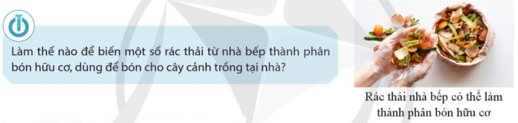
..........................................................................................................................................................................
..........................................................................................................................................................................

I. VAI TRÒ CỦA PHÂN BÓN HỮU CƠ
....................................................................................................................  ....................................................................................................................  ....................................................................................................................  ....................................................................................................................  ....................................................................................................................  ....................................................................................................................  ....................................................................................................................  ....................................................................................................................  ....................................................................................................................  ....................................................................................................................  ....................................................................................................................  .................................................................................................................... | 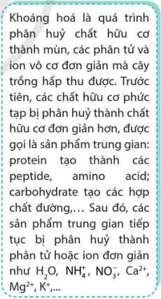
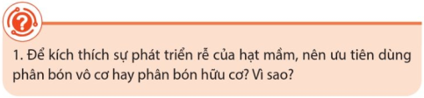
..........................................................................................................................................................................
..........................................................................................................................................................................
..........................................................................................................................................................................
..........................................................................................................................................................................
..........................................................................................................................................................................
..........................................................................................................................................................................

II. PHÂN LOẠI MỘT SỐ PHÂN BÓN HỮU CƠ
..........................................................................................................................................................................
..........................................................................................................................................................................
..........................................................................................................................................................................
..........................................................................................................................................................................
III. THÀNH PHẦN, QUY TRÌNH SẢN XUẤT VÀ CÁCH SỬ DỤNG MỘT SỐ LOẠI PHÂN BÓN HỮU CƠ
1) Phân hữu cơ truyền thống  a) Phân chuồng  ....................................................................................................................  ....................................................................................................................  ....................................................................................................................  ....................................................................................................................  ....................................................................................................................  ....................................................................................................................  ....................................................................................................................  ....................................................................................................................  ....................................................................................................................  ....................................................................................................................  ....................................................................................................................  ....................................................................................................................  ....................................................................................................................  ....................................................................................................................  ....................................................................................................................  ....................................................................................................................  ....................................................................................................................  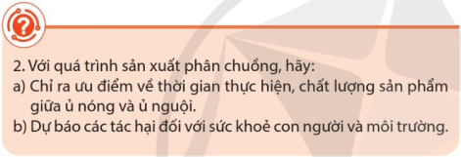  ....................................................................................................................  ....................................................................................................................  ....................................................................................................................  .................................................................................................................... | 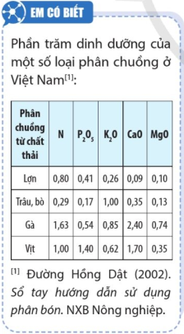  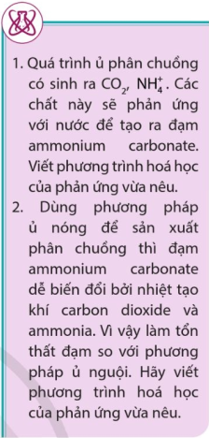
b) Phân xanh  ....................................................................................................................  ....................................................................................................................  ....................................................................................................................  ....................................................................................................................  ....................................................................................................................  ....................................................................................................................  c) Phân rác  ....................................................................................................................  ....................................................................................................................  ....................................................................................................................  ....................................................................................................................  ....................................................................................................................  ....................................................................................................................  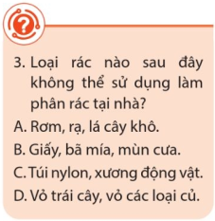 | 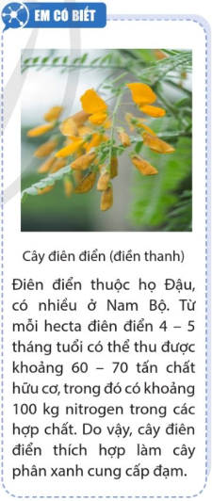
2) Phân hữu cơ sinh học
....................................................................................................................  ....................................................................................................................  ....................................................................................................................  ....................................................................................................................  ....................................................................................................................  ....................................................................................................................  .................................................................................................................... |  | 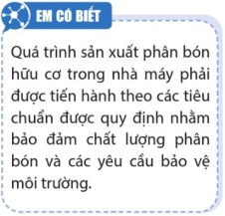
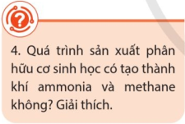 | ....................................................................................................................  ....................................................................................................................  ....................................................................................................................  ....................................................................................................................

3) Phân hữu cơ khoáng
...................................................................................................................  ...................................................................................................................  ...................................................................................................................  ...................................................................................................................  ...................................................................................................................  ................................................................................................................... | 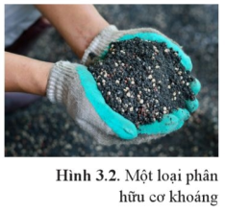
IV. ƯU NHƯỢC ĐIỂM CỦA PHÂN BÓN HỮU CƠ
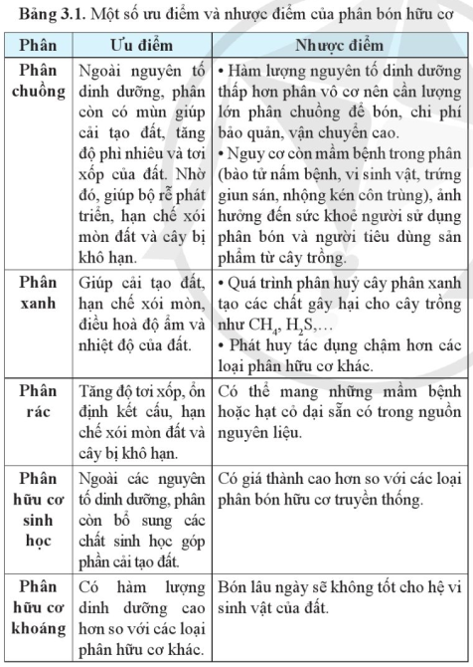 |  | 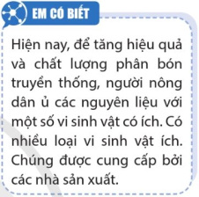  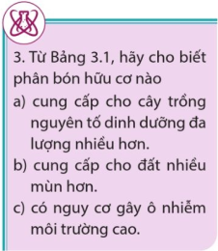  ................................................................  ................................................................  ................................................................  ................................................................
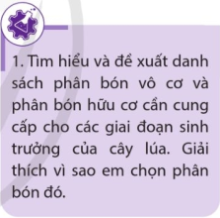 | ....................................................................................................................  ....................................................................................................................  ....................................................................................................................  ....................................................................................................................  ....................................................................................................................  ....................................................................................................................

V. BẢO QUẢN PHÂN BÓN HỮU CƠ
..........................................................................................................................................................................
..........................................................................................................................................................................
..........................................................................................................................................................................
..........................................................................................................................................................................
VI. TÁC ĐỘNG CỦA PHÂN BÓN ĐẾN MÔI TRƯỜNG  ..................................................................................................................  ..................................................................................................................  ..................................................................................................................  ..................................................................................................................  ..................................................................................................................  ..................................................................................................................  ..................................................................................................................  ..................................................................................................................  ..................................................................................................................  ..................................................................................................................  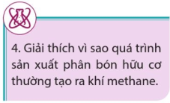  ..................................................................................................................  ..................................................................................................................  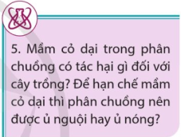  ..................................................................................................................  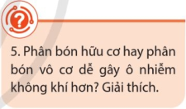  ..................................................................................................................  .................................................................................................................. | 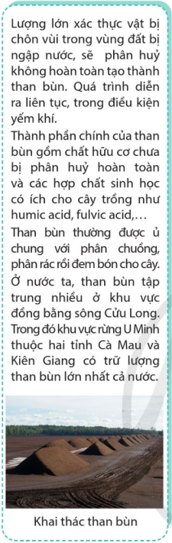  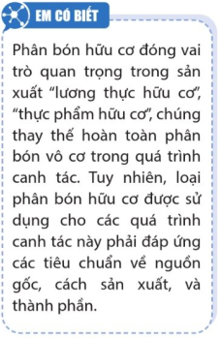
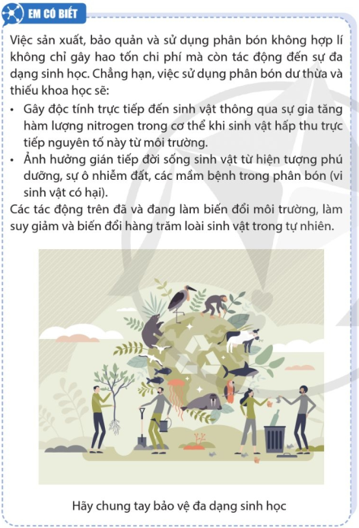 | 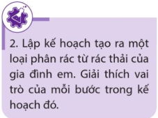

Tài liệu được chia sẻ bởi
https://www.vnteach.com
https://www.facebook.com/groups/thuvienvnteach/

