SỞ GIÁO DỤC VÀ ĐÀO TẠO  ĐỒNG NAI  ĐỀ CHÍNH THỨC  (Đề thi có 4 trang) | ĐỀ THI TUYỂN SINH VÀO LỚP 10 THPT  NĂM HỌC 2022-2023  Môn thi: Tiếng Anh  Ngày thi: 17.06.2022  Thời gian làm bài: 60 phút (Không kể thời gian giao đề)
I. PHONETICS (1.0 point)
Mark the letter A, B, C or D on your answer sheet to indicate the word that differs from the other three in the position of primary stress in each of the following questions.
1. A. humor B. parade C. describe D. prefer
2. A. benefit B. energy C. effective D. tropical

Mark the letter A, B, C or D on your answer sheet to indicate the word whose underlined part differs from the other three in pronunciation in each of the following questions.
3. A. close B. know C. cold D. lost
4. A. looked B. handed C. watched D. brushed

II. LEXICO-GRAMMAR AND COMMUNICATION (3.25 points)
Mark the letter A, B, C or D on your answer sheet to indicate the correct answer to each of the following questions.
5. Lan is always late for school, _________?
A. was it B. isn’t she C. isn’t it D. was she
6. If people _________ old items, they will save the environment.
A. reuse B. reused C. reusing D. to reuse
7. She came on Sunday morning and stayed here _________ 8.00 a.m. and 10.30 a.m.
A. on B. in C. between D. from

Mark the letter A, B, C or D on your answer sheet to indicate the word(s) OPPOSITE in meaning to the underlined word(s) in each of the following questions.
8. Hoi An is an ancient town in Central Vietnam. It was set up a long time ago.
A. comfortable B. boring C. modern D. local

Mark the letter A, B, C or D on your answer sheet to indicate the sentence that is closest in meaning to each of the following questions.
9. It’s a pity I don’t have anyone to share my troubles with.
A. I wish I have someone to share my troubles with.
B. I wish I have no one to share my troubles with.
C. I wish I had someone to share my troubles with.
D. I wish I had no one to share my troubles with.
10. Charlie said, “I don’t know what Fred is doing”.
A. Charlie said that he doesn’t know what Fred is doing.
B. Charlie said that he didn’t know what Fred is doing.
C. Charlie said that he doesn’t know what Fred was doing.
D. Charlie said that he didn’t know what Fred was doing.

Mark the letter A, B, C or D on your answer sheet to indicate the underlined part that needs correcting in each of the following questions.
11. Thank you for looking up my little cat while I was away.
A. for B. up C. little D. away
12. The car who he has just bought is very expensive.
A. who B. bought C. is D. expensive

Complete the conversation between two friends. What does Henry say to Alice? Choose
the correct letter (A - F). There is ONE extra letter you do not need to use.
Alice: Have you ever made a film using your smartphone?
Henry: (13) ___________________________________________________________.
Alice: What have you filmed before?
Henry: (14) ___________________________________________________________.
Alice: Did it turnout well?
Henry: (15) ___________________________________________________________.
Alice: How did you do that?
Henry: (16) ___________________________________________________________.
Alice: Can you show me how to use it?
Henry: (17) ___________________________________________________________.
Alice: Great! I want to make my own film!
A. I used a program for filmmaking. It’s great fun, actually.
B. Yes, I’ve made one or two films for fun.
C. No, I’ve never been in a film before.
D. Of course! I’d love to do that.
E. I filmed my family’s beach holiday last year.
F. Yes, it did. I used my computer to make changes.

III. READING (3.25 points)
Read the following passage and mark the letter A, B, C or D on your answer sheet to indicate the correct word or phrase that best fits each of the numbered blanks.
Department Stores
People who enjoy shopping like to find everything under one roof. Do you need some new clothes? Do you want (18) __________ the latest video game or just have a coffee? The department store in Festival Place has got everything including a restaurant if you need a break at lunchtime or after school. The store is open seven days (19) __________ week. The car park is free but it’s only a five-minute walk from the city center. During the week you can go to the cinema and the fantastic sports center which are (20) __________ the first floor. I asked my sister what she thought of the place. She said, “I never liked shopping before (21) __________ now I come here every weekend. It’s brilliant and the milkshakes in the café are (22) __________!”
18. A. buy B. buying C. to buy D. bought
19. A. a B. an C. the D. some
20. A. at B. on C. in D. for
21. A. if B. so C. or D. but
22. A. amaze B. amazing C. amazement D. amazingly

Read the following passage and mark the letter A, B, C or D on your answer sheet to indicate the correct answer to each of the questions.
School life is not easy for some Maasai people in Kenya. In some schools, there are 70
students in one classroom. These schools don’t always have books. Sometimes there aren’t
enough teachers, or there isn’t enough money.
This is especially true for Maasai girls. Not many Maasai girls in Kenya finish elementary
school. Many Maasai girls have to leave school early to get married. Kakenya Ntaiya has a
dream. She has a school for girls because she wants to help Maasai schoolgirls in her village.
Today, 200 girls go to Kakenya’s school, and they love it. They study English and Swahili
(an African language). They also study maths, science, geography, history, art, and P.E.
Kakenya wants her students to have better lives.
23. Which of the following is TRUE about some schools in paragraph 1?
A. There are 70 students in one classroom. B. Schools always have books.
C. There are always enough teachers. D. There is always enough money.
24. The phrase “especially true” in paragraph 2 means _______.
A. not true B. probably true C. only true D. even more true
25. Why do some Maasai girls not finish school?
A. They hate school. B. They leave Kenya.
C. They get married D. They move to another house
26. What can we learn about Kakenya from the article?
A. Only two subjects are taught at her school. B. She’s from Kenya.
C. Her students have good grades. D. Her school is free for girls.
27. What’s the best title for the article?
A. Life after School B. Kakenya’s dream
C. Living in Kenya D. Kakenya’s life

Read the texts and choose the letter A, B, C or D to indicate the correct answer to each of the following questions.
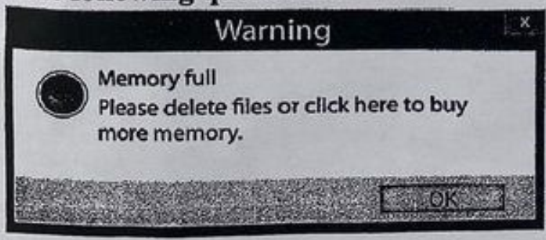 | 28. Where is this text mostly seen?  A. on the screen of a computer  B. on a blackboard  C. on a road sign  D. on the desk in a computer classroom
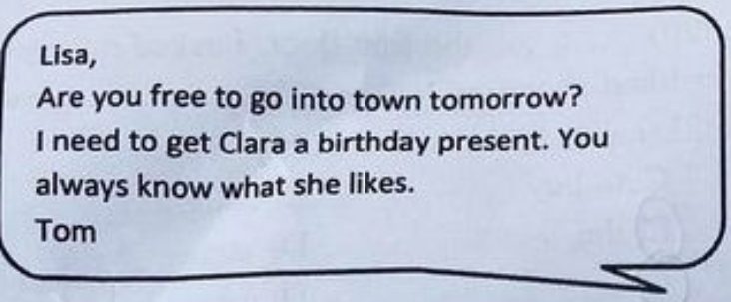 | 29. Tom is asking Lisa __________.  A. to go into town with Clara.  B. to come to Clara’s birthday party  C. to help choose a gift for Clara.  D. to give him a birthday gift.
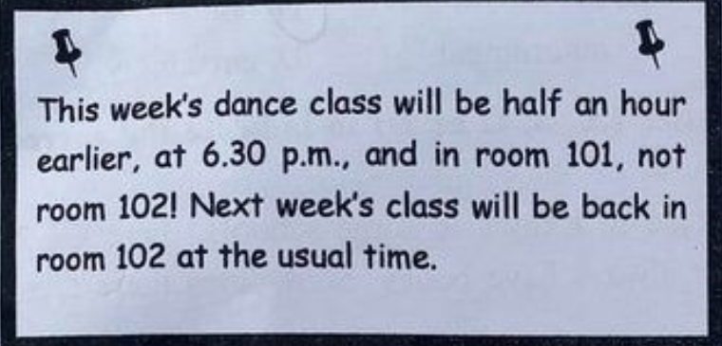 | 30. What does this notice say?  A. There won’t be a dance class next week.  B. The dance class will be somewhere different this week.  C. The dance class will only last for half an hour this week.  D. There will be a dance class in room 102 at 6.30 p.m. this week.

IV. WRITING (2.5 points)
Complete the second sentence so that it has a similar meaning to the original one, beginning with the given words.
31. His sister usually played hide and seek when she was a child.
His sister used to _______________________________________________________________.
32. They started listening to music 15 minutes ago.
They have ____________________________________________________________________.
33. I think we should take the train.
I suggest ______________________________________________________________________.

Order the words to make complete sentences.
34. got / this / late / up /I / morning.
________________________________________________________________________________.
35. learning / Tim / is / on / English. / keen
________________________________________________________________________________.
36. that /'is / Nam Cat Tien National Park / fascinating / of / most / destinations / can / be / in / the / Dong Nai. / one / experienced
________________________________________________________________________________.

Write a paragraph.
37. In about 100 words, write a paragraph about a place you would like to visit. Use the question cues below or create your own ideas.
- Which place would you like to visit?
- Where is it?
- Why would you like to go there?
- What would you like to do there?
- What is special about it?

