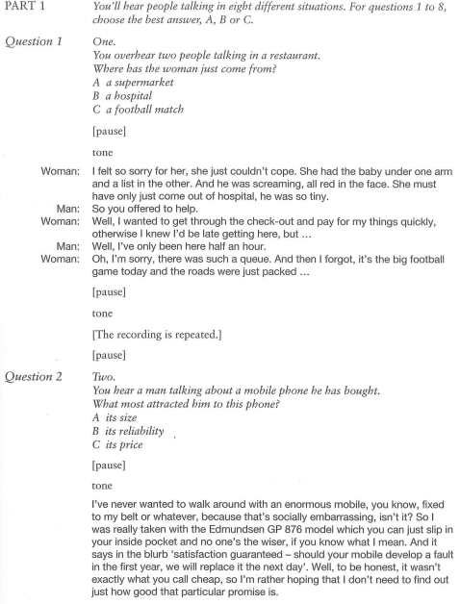





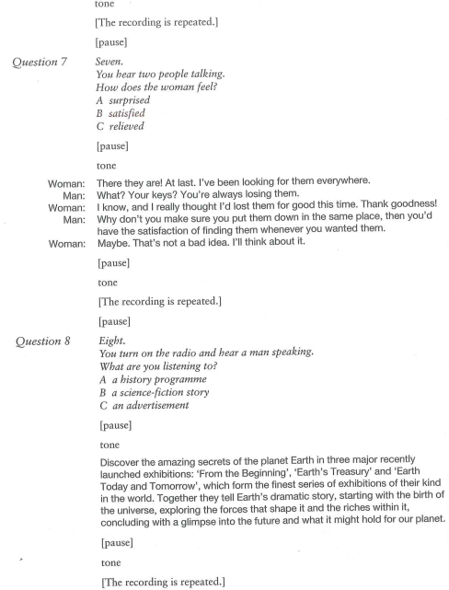

**PART 2.**

**Presenter:** The modern answer to the office worker’s sedentary lifestyle is to sign up at a gym. Such is the demand that 18% of us are members of a gym. With me tonight is Mark Stanwick, press officer of the National Fitness Association. Mark, welcome to the programme.

**Mark:** Thank you, Kate.

**Presenter:** Now, you were saying before that if someone is considering joining a gym they should first do some serious research rather than just choosing the one which is closest to their home. What is the reason for that?

**Mark:** Well, Kate, there are many different services gym can offer. Do you want a posers paradise in which to show off your muscles? Do you want a gym that hosts varied classes, such as aerobics and yoga? Are you looking for one that has vibrant social scene? Or do you want to keep your head down and just get on with losing some weight in peace? Perhaps you want staff to provide you with motivation and encouragement? All of these questions must be answered by your initial research. If you end up in the wrong kind of gym, you will lose motivation very quickly indeed and simply stop going and all your money and effort will go down the drain.

**Presenter:** I see. So what are the things I should be looking out for?

**Mark:** Well, before calling in on a gym, ring to see if you can book a good time for a walk round with one of the instructors. Gyms are normally busiest between 5pm and 7pm on weekdays. Although you do want to see the gym in action at a time when you might be attending, you will want to first view all the facilities without sweaty people constantly pushing past you. Also have a quick look at the car park to see how busy it is before stepping through the doors. Notice the general atmosphere of the gym. Do the instructors look extremely busy? Is there loud music playing? Does it smell fresh or stale? In a nutshell, is it the kind of place you want to visit regularly?

**Presenter:** I see. So suppose I’ve found my kind of gym – now it’s time to join?

**Mark: Not** just yet – there are a few things to talk about with them. You will probably already know what the monthly cost of being a member is, but what does that include? Does it include everything, or are services such as yoga classes and personal trainers going to cost more? Do you get a fresh towel each time you go or will that cost extra? Are lockers in the changing rooms free or are you going to have to remember to bring loose change every time you exercise?

**Presenter:** Right. What if I have to sign a contract?

**Mark:** It is best to take home any contract that you may have to sign and go through it carefully, looking for what happens if you leave or if the gym goes bust and moves. Be suspicious of a gym that is reluctant to let you take away a contract to look over and distrust it even if it is determined to secure your signature on your first visit. And avoid “life memberships”. You might move town at some point or, at least, want to change your gym.

**Presenter:**  Wow. All these things to think about. I think most people are a bit uncertain about joining when they think it’s simple. After today they may decide not to bother at all.

**Mark:** {laughs}. It’s not that bad, really. You know, joining a gym is a lifestyle change. If you do it right it can make a great difference – you’ll be healthier and happier every day. So don’t let small difficulties discourage you – it’s really worth it. Go for it, just make sure your gym is a place where you want to be, and not a place you’ll never want to see again after a few visits.