School: ……………………………………….. | Date: …………………………………..
Class: ……………………………..................... | Period: ……………………………........

UNIT 9: ENGLISH IN THE WORLD
Lesson 3.2 – Speaking and Writing (page 75)

I. OBJECTIVES
By the end of the lesson, Ss will be able to:
1.1. Language knowledge and skills
- know the format of a postcard.
- talk about a vacation in an English-speaking country (where to go, what to do, who to meet, what to eat).
- write a holiday postcard to a friend.
1.2. Competences
- improve communication, collaboration, writing and critical thinking skills.
1.3. Attributes
- love studying English, love travelling.
- have good preparation for any trip.

II. TEACHING AIDS AND LEARNING MATERIALS
1. Teacher’s aids: Student book and Teacher’s book, class CDs, Digital Book (DCR phần mềm tương tác SB, DHA (từ vựng/ cấu trúc) phần mềm trò chơi tương tác), projector/interactive whiteboard / TV (if any), PowerPoint slides, handouts.
2. Students’ aids: Student’s book, workbook, notebook.

III. ASSESSMENT EVIDENCE
Performance Tasks | Performance Products | Assessment Tools
- Speaking: Imagine you went to an English-speaking country on vacation. In pairs: Talk with your partner. Where did you go? Why? What did you do there? | - Ss’ answers / presentation. | - T’s feedback/Peers’ feedback.
- Make a list of ways you used English on your vacation. Use the table below and the examples to help you. Then, share with your friend. | - Ss’ answers / presentation. | - T’s feedback/Peers’ feedback.
- Writing: Read about writing postcards. Then, read An's postcard again and circle the examples she uses for each point in the Writing Skill box | - Ss’ answers. | - T’s feedback/Peers’ feedback.
- Underline and correct the mistakes. Then, rewrite the postcard in the correct order in your notebook. Use the skill box to help you, | - Ss’ answers. | - T’s feedback/Peers’ feedback.
- Now, write a postcard to your friend using two or three ideas from your notes in Speaking b. or your own ideas. Use the Feedback form to help you. Write 60 to 80 words. | - Ss’ answers. | - T’s observation and feedback.

IV. PROCEDURES
A. Warm up: (5’)
a) Objective: Introduce the new lesson and set the scene for Ss to acquire new language; get students' attention at the beginning of the class by enjoyable and short activities as well as to engage them in the follow-up steps.
b) Content: Review: English-speaking countries / Introduce: Postcard.
c) Expected outcomes: Ss know about the topic that they are going to talk and write about in new the lesson.
d) Organization of the activity:
TEACHER’S ACTIVITIES | STUDENTS’ ACTIVITIES
Option 1: Game: CROSS WORD  - Have Ss review names of some English-speaking countries by doing the cross word puzzle.  - Call Ss to choose lines and give answers.  - Encourage Ss to guess the keyword as soon as possible.  - Lead to the new lesson: Writing a vacation postcard.  *Illustration:  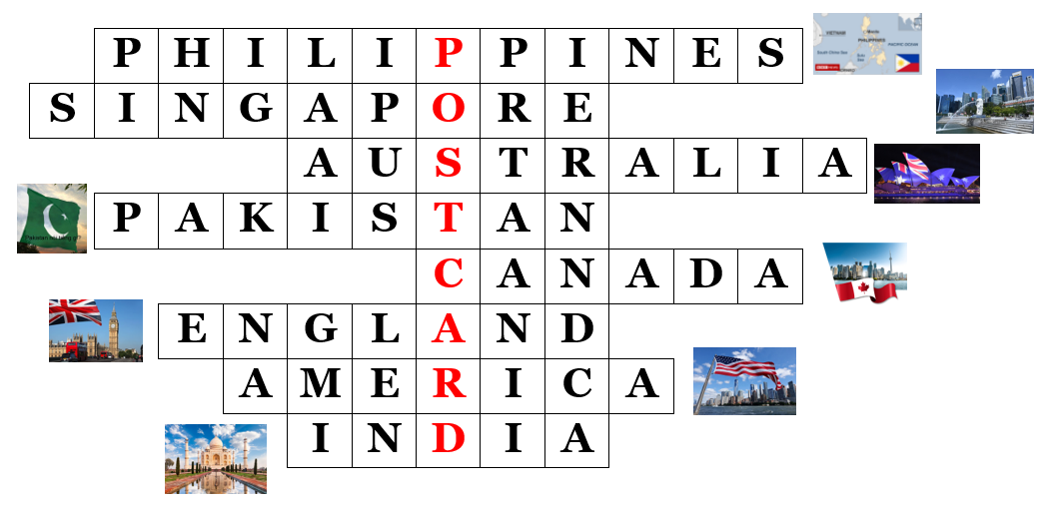  - Option 2: Kim’s Game  - Have Ss close books.  - Show some stamps of some English-speaking countries.  - Have Ss look at the pictures and try to remember the country names as many as possible.  - Hide the pictures one by one, have Ss tell the countries of the stamps again.  - Lead to the new lesson.  *Illustration:  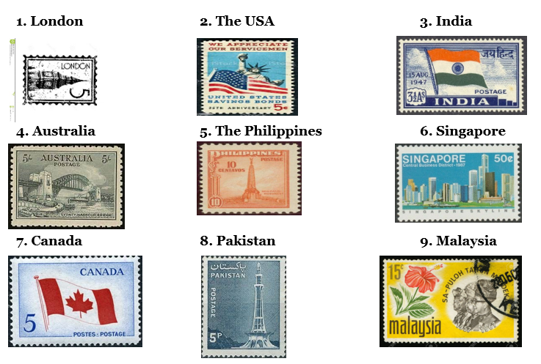 | - Take part in the game.  - Listen.  - Close books.  - Look at the pictures and try to remember the country names.  - Listen.

B. New lesson (35’)
- Activity 1: Pre-Writing (Speaking) (8’)
a) Objective: Ss prepare for what they are going to write about.
b) Content:
- Speaking: Imagine you went to an English-speaking country on vacation. In pairs: Talk with your partner. Where did you go? Why? What did you do there?
- Make a list of ways you used English on your vacation. Use the table below and the examples to help you. Then, share with your friend.
c) Expected outcomes: Ss have more ideas and language for their writing.
d) Organization of the activity:
TEACHER’S ACTIVITIES | STUDENTS’ ACTIVITIES
Task a. Imagine you went to an English-speaking country on vacation. In pairs: Talk with your partner. Where did you go? Why? What did you do there?  - Divide the class into pairs.  - Have Ss think of an English-speaking country, then ask each other the questions.  - Go round and support Ss if necessary.  - Have some students share their ideas with the class.  - Give feedback and evaluation.  Task b. Make a list of ways you used English on your vacation. Use the table below and the examples to help you. Then, share with your friend.  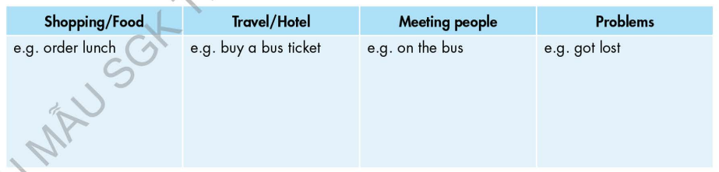  - Draw students' attention to the table and the example answers. Elicit one or two more answers from the whole class.  - Have the students come up with two or three examples for each column. Then, have students share their ideas with their partner.  - Have some students share some of their ideas with the class. | - Work in pairs.  - Present.  - Look and listen.  - Work in pairs.  - Present.
- Activity 2: While - Writing (22’)
a) Objective: Students can develop their writing skill.
b) Content: - Read about writing postcards. Then, read An's postcard again and circle the examples she uses for each point in the Writing Skill box.
- Underline and correct the mistakes. Then, rewrite the postcard in the correct order in your notebook. Use the skill box to help you.
- Now, write a postcard to your friend using two or three ideas from your notes in Speaking b. or your own ideas. Use the Feedback form to help you. Write 60 to 80 words.
c) Expected outcomes: Students can write a holiday postcard, using right format, structures and rich vocabulary.
d) Organization of the activity:
TEACHER’S ACTIVITIES | STUDENTS’ ACTIVITIES
Task a. Read about writing postcards. Then, read An's postcard again and circle the examples she uses for each point in the Writing Skill box.  -Briefly explain the Writing skill box using DCR and have some Ss read it aloud.  - Have Ss read about writing postcards. Then, read An's postcard again (page 74) and circle the examples she uses for each point in the Writing Skill box.  - Have Ss check their answers with a partner.  - Call Ss to give answers.  - Check answer as a whole class using DCR.  Task b. Underline and correct the mistakes. Then, rewrite the postcard in the correct order in your notebook. Use the skill box to help you.  - Have students read the sentences.  - Have students underline and correct the mistakes. Then, rewrite the postcard in the correct order in Ss’ notebook.  - Remind Ss to use information in the skill box.  - Have students check their answers with a partner.  - Check answer as a whole class using DCR.  *Let’s Write: Write a postcard to your friend using two or three ideas from your notes in Speaking b. or your own ideas. Use the Feedback form to help you. Write 60 to 80 words.  - Draw Ss’ attention to the feedback form.  - Have Ss use their notes in speaking part and the instruction in the Writing box to write a holiday postcard.  - Go round, observe and give help if necessary.  - Have some Ss write their postcard on the board. | - Listen and read.  -Work in pairs.  - Exchange their answers with a partner.  - Give answers.  Answer keys  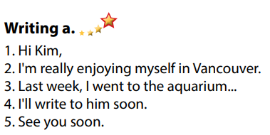  - Read the sentences, underline and correct the mistakes.  - Exchange answers.  - Read answers.  Answer keys  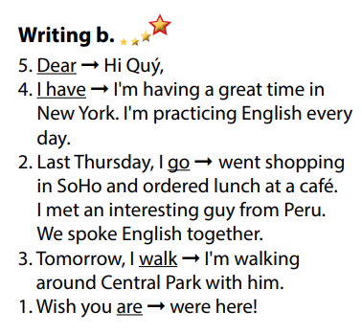  - Do the writing part.  -Write.
- Activity 3: Post - Writing (5’)
a) Objective: Help Ss realize their mistakes in writing and correct them.
b) Content: Correcting Ss’ writings.
c) Expected outcomes: Students know whether their writings follow the model and use the correct structures and language, whether their writings are interesting and understandable or not.
d) Organization of the activity:
TEACHER’S ACTIVITIES | STUDENTS’ ACTIVITIES
- Give feedback, correct Ss’ mistakes.  - Use the feedback form to give evaluation. Focus on:  + the format, the structures  + the understandability  + the coherence and cohesion  + the punctuation and the spelling | - Look, listen and correct mistakes.  Suggested writing  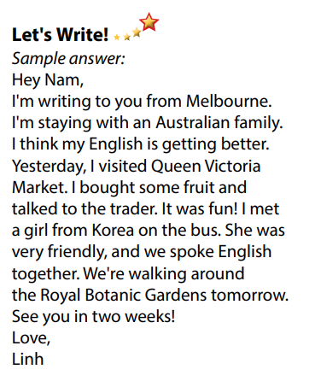

C. Consolidation and homework assignments (5’)
* Consolidation:
- Writing Skill:
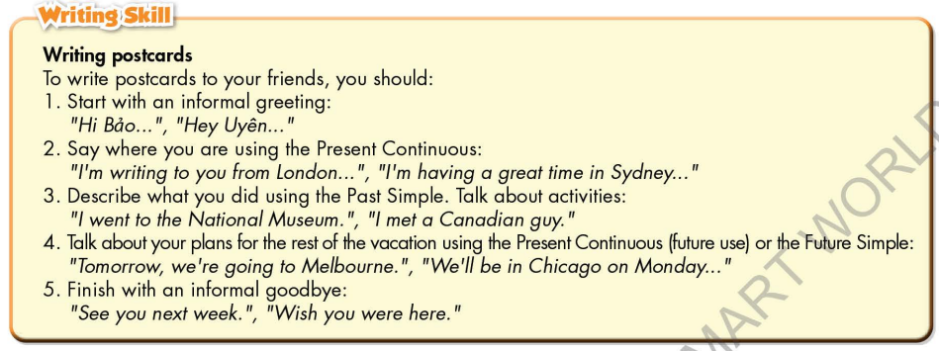

* Homework
- Remember how to write a holiday postcard.
- Finish the writing part.
- Do the exercises in WB: Writing, page 55.
- Complete grammar notes in Tiếng Anh 7 i-Learn Smart World Notebook (page 59).
- Play consolation games in Tiếng Anh 7 i-Learn Smart World DHA App on www.eduhome.com.vn
- Prepare: Unit 9 – Review, pages 108, 109.

D. Reflection
a. What I liked most about this lesson today:
…………………………………………………………………………………………
- What I learned from this lesson today:
…………………………………………………………………………………………
c. What I should improve for this lesson next time:
…………………………………………………………………………………………

