Period
LESSON PLAN
TIẾNG ANH 10 FRIENDS GLOBAL
UNIT 4: OUR PLANET
LESSON 4A: VOCABULARY – WEATHER
I. OBJECTIVES:
By the end of the lesson, students will be able to:
1. Knowledge:
- Understand and can describe the weather
- Vocabulary: sunny, rainy, windy, foggy, snow, hail, shower, lightning, rainbow, hurricane, hailstone, snowflake, misty, frostbite, thunder, etc.
2. Ability:
- main skills: listening and speaking skills
- sub skills: reading and writing skills
- Apply new words to describe the weather and make their own weather report
3. Quality:
- Have positive attitude in English language learning so that they can participate enthusiastically in all classroom activities, especially with the topic conducted by the teacher
- Can distinguish many types of weather
- Know how to share their opinion, describe the weather, and do a weather forecast
II. TEACHER AIDS AND LEARNING MATERIALS:
Lesson plan, PPT slides, student’s book, workbook, notebook, personal computer (if any), projector/TV. Speakers, IWB software.
III. PROCEDURES:
A. Warm-up (7’)
a) Objective: Introduce the new lesson and set the scene for students to acquire new language; get students' attention at the beginning of the class by means of enjoyable and short activities as well as to engage them in the steps that followed.
b) Content: Warm-up game
c) Outcomes: Students can gain more confidence and interest in the lesson
d) Competence: communication, guessing, collaboration
e) Organisation of the activity:

TEACHER’S ACTIVITIES | STUDENT’S ACTIVITIES | CONTENTS
Warm-up T-Ss- T/ Ss – Ss  Game “WEATHER QUIZ?”  (Task 1 page 46)  - Divide class into two large groups  - Give students about 30 seconds to think about the question and choose the correct answer  - Lead to the lesson: “Weather” | - Play game in groups and volunteer to answer  - With one correct answer, a whole group get one point. They also get bonus points if they can explain why they choose that answer.  - Open the book page 46 | 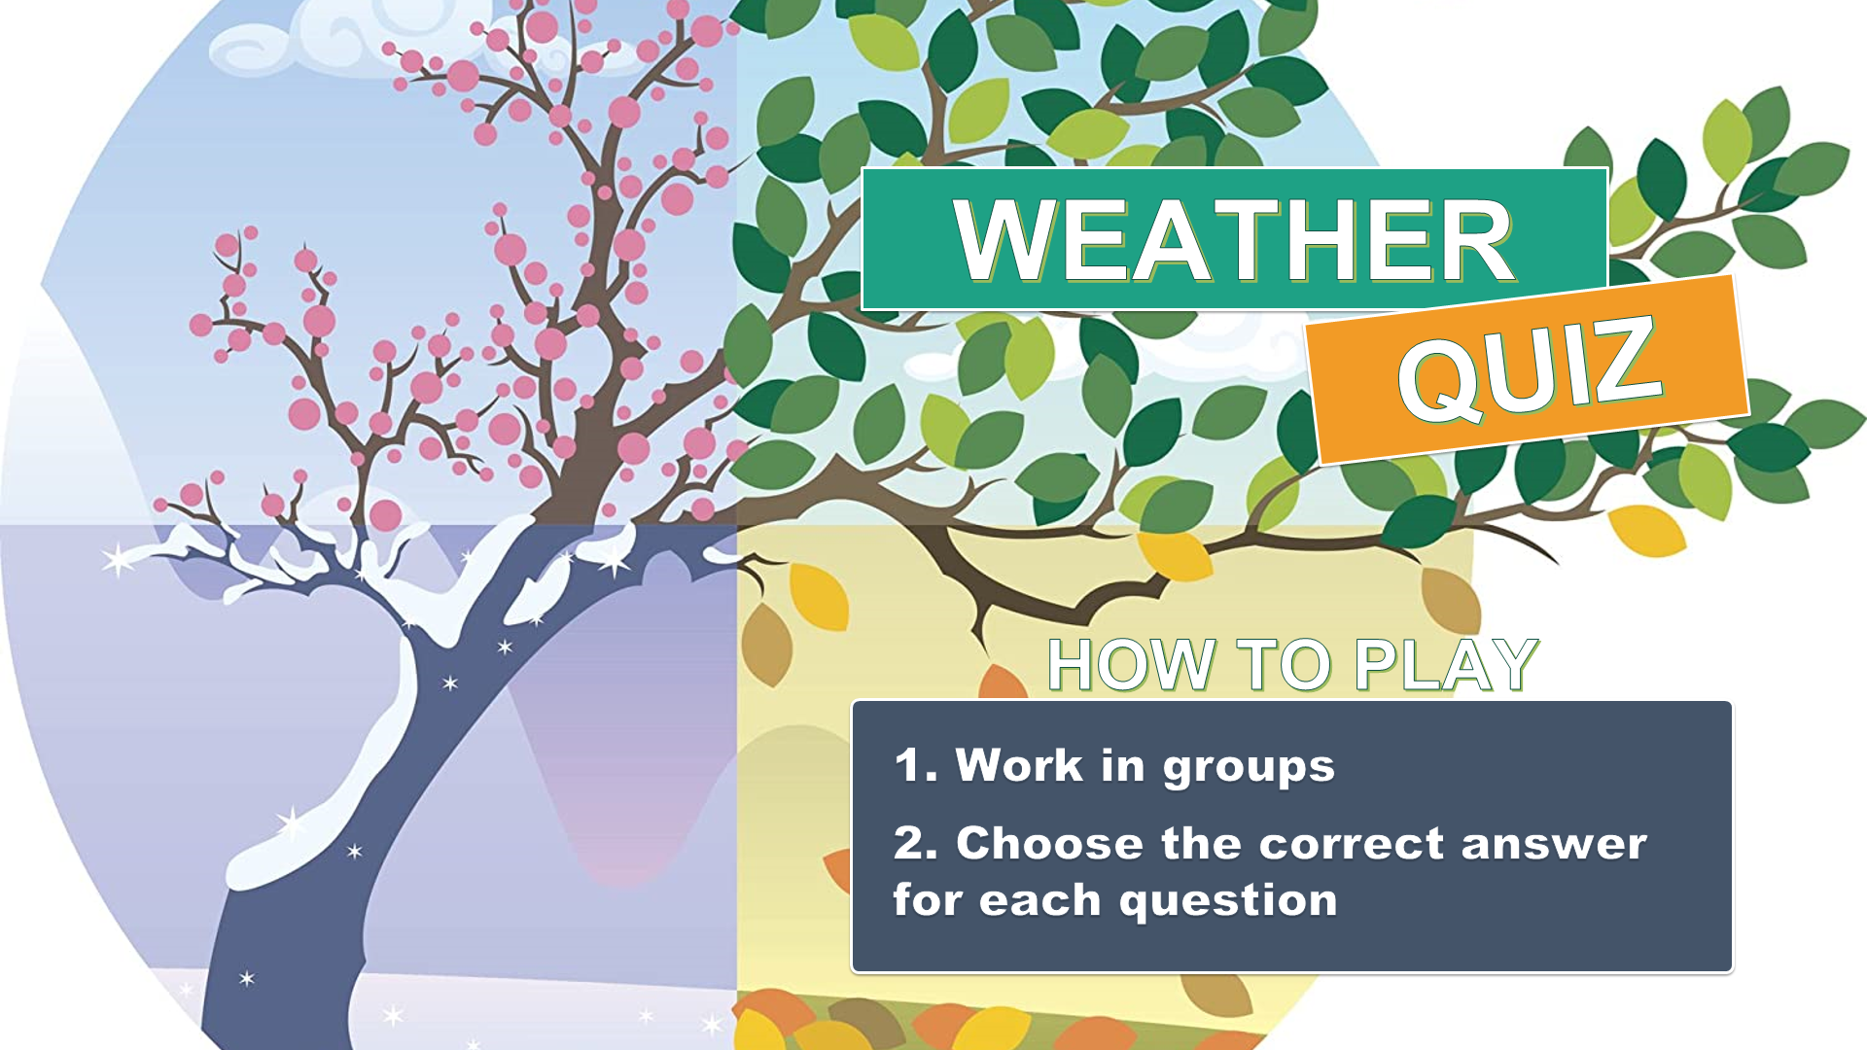  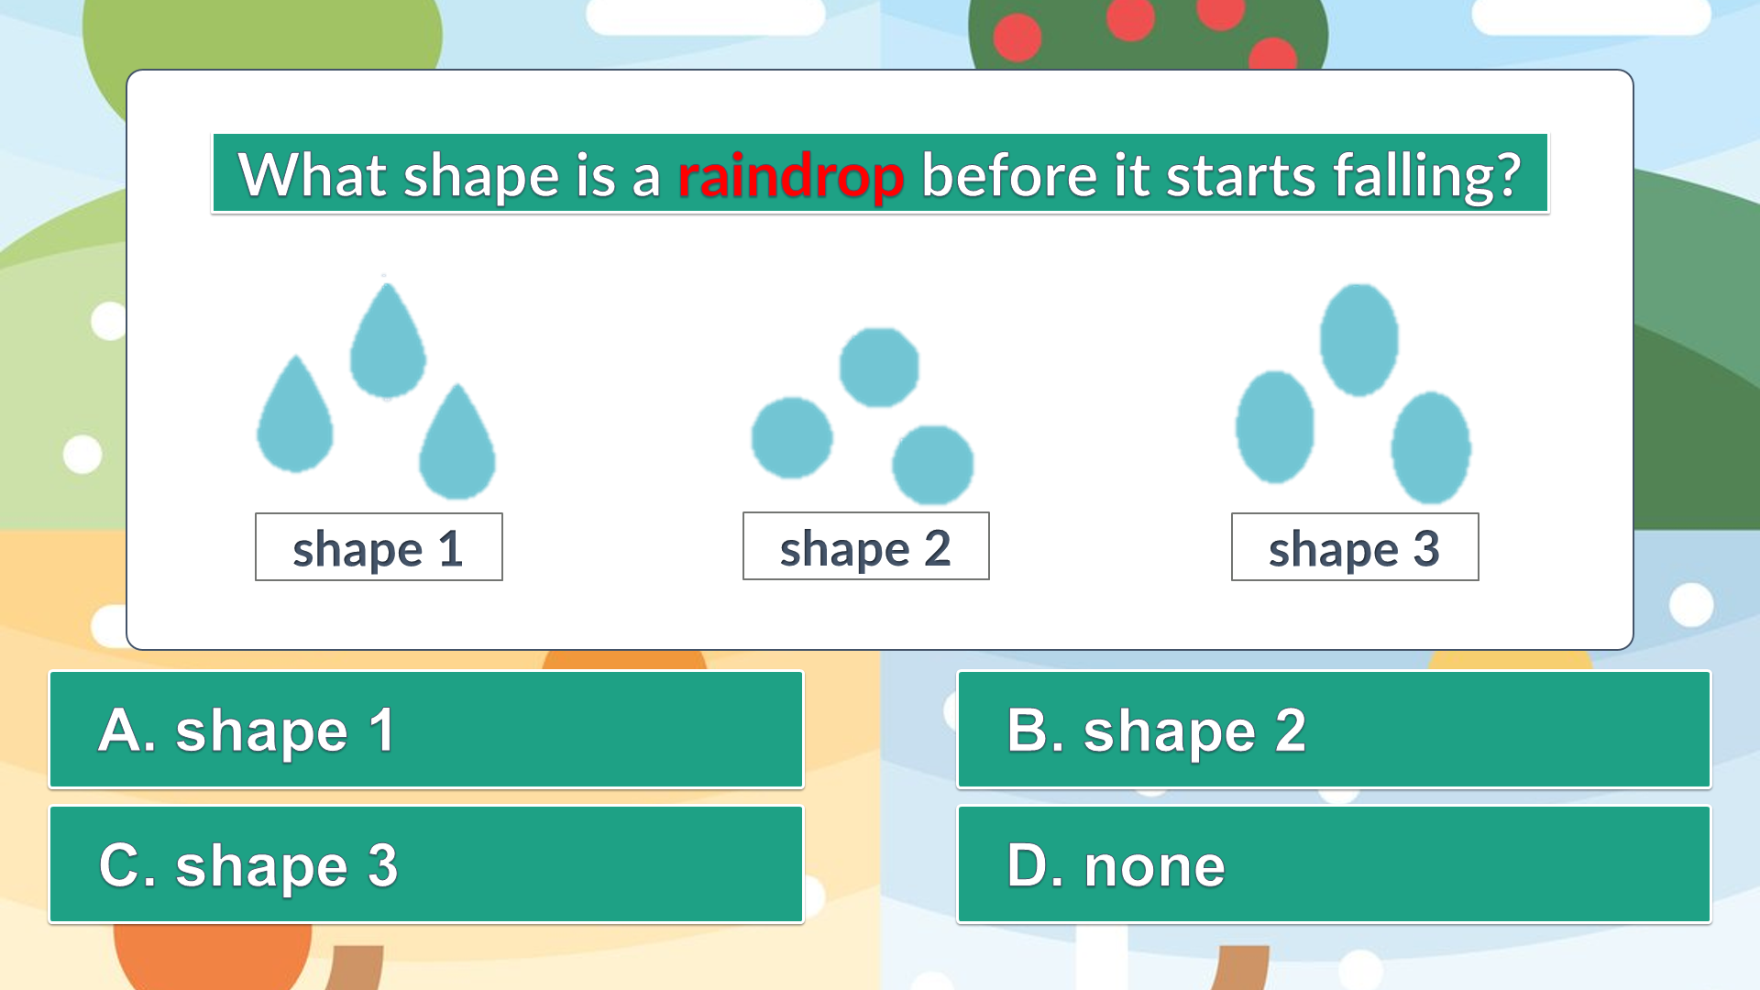  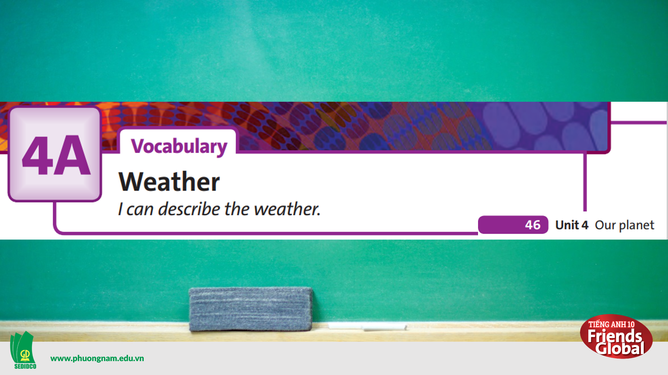

B. New lesson (33’)
- Activity 1: Vocabulary (8’)
a) Objective: Students know more words about types of weather.
b) Content:
Vocabulary
Listening
c) Outcomes: Students know how to pronounce the new words precisely and use them in appropriate contexts.
d) Competence: communication, collaboration, presentation
e) Organisation of the activity:
TEACHER’S ACTIVITIES | STUDENT’S ACTIVITIES | CONTENTS
PRESENTATION. T -Ss- T/ Ss- Ss/ Individual  Activity 1 (3’): Teach new vocabulary  - Use GIFs and short explanation to present new words  - Have students practice their pronunciation drills  New words:  foggy (adj)  hail (n)  hailstone (n)  snowflake (n)  misty (adj)  frostbite (n)  thunder (n)  Activity 2 (5’): Task 2 page 47  - Ask the students to complete the table with highlighted words in Ex1  - Give the answers to the class  - Have students practice their pronunciation drills | - Some students will answer the question in order to learn new words.  - Listen to the teacher and repeat in whole class and individuals  - Work in pairs and complete the task  - Check the answers with the teacher  - Look, listen, and repeat in chorus in whole class and individuals | New words:  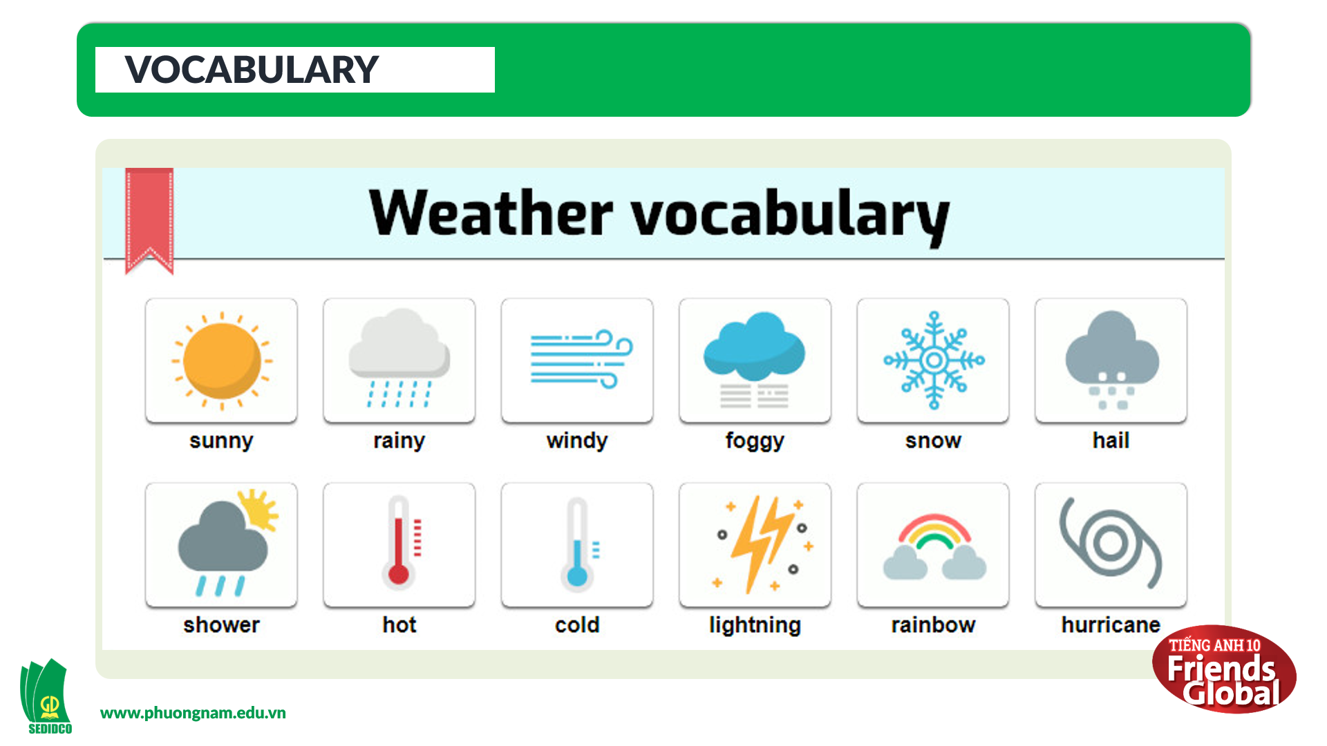  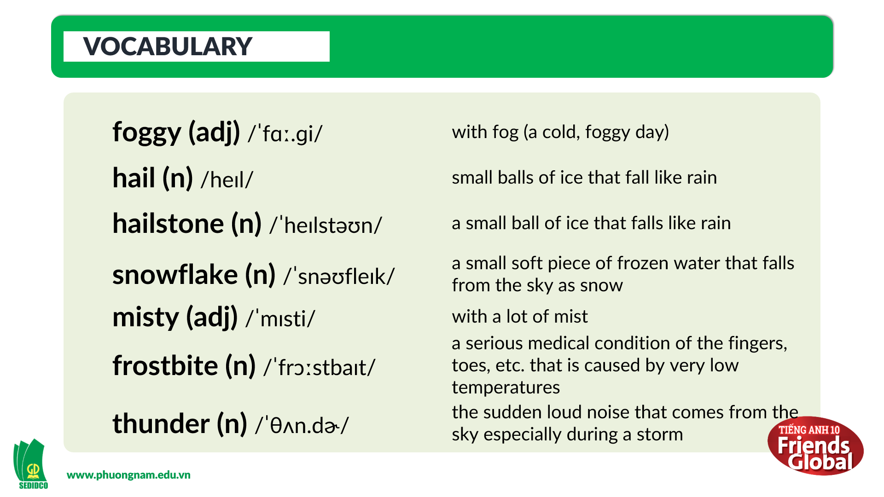  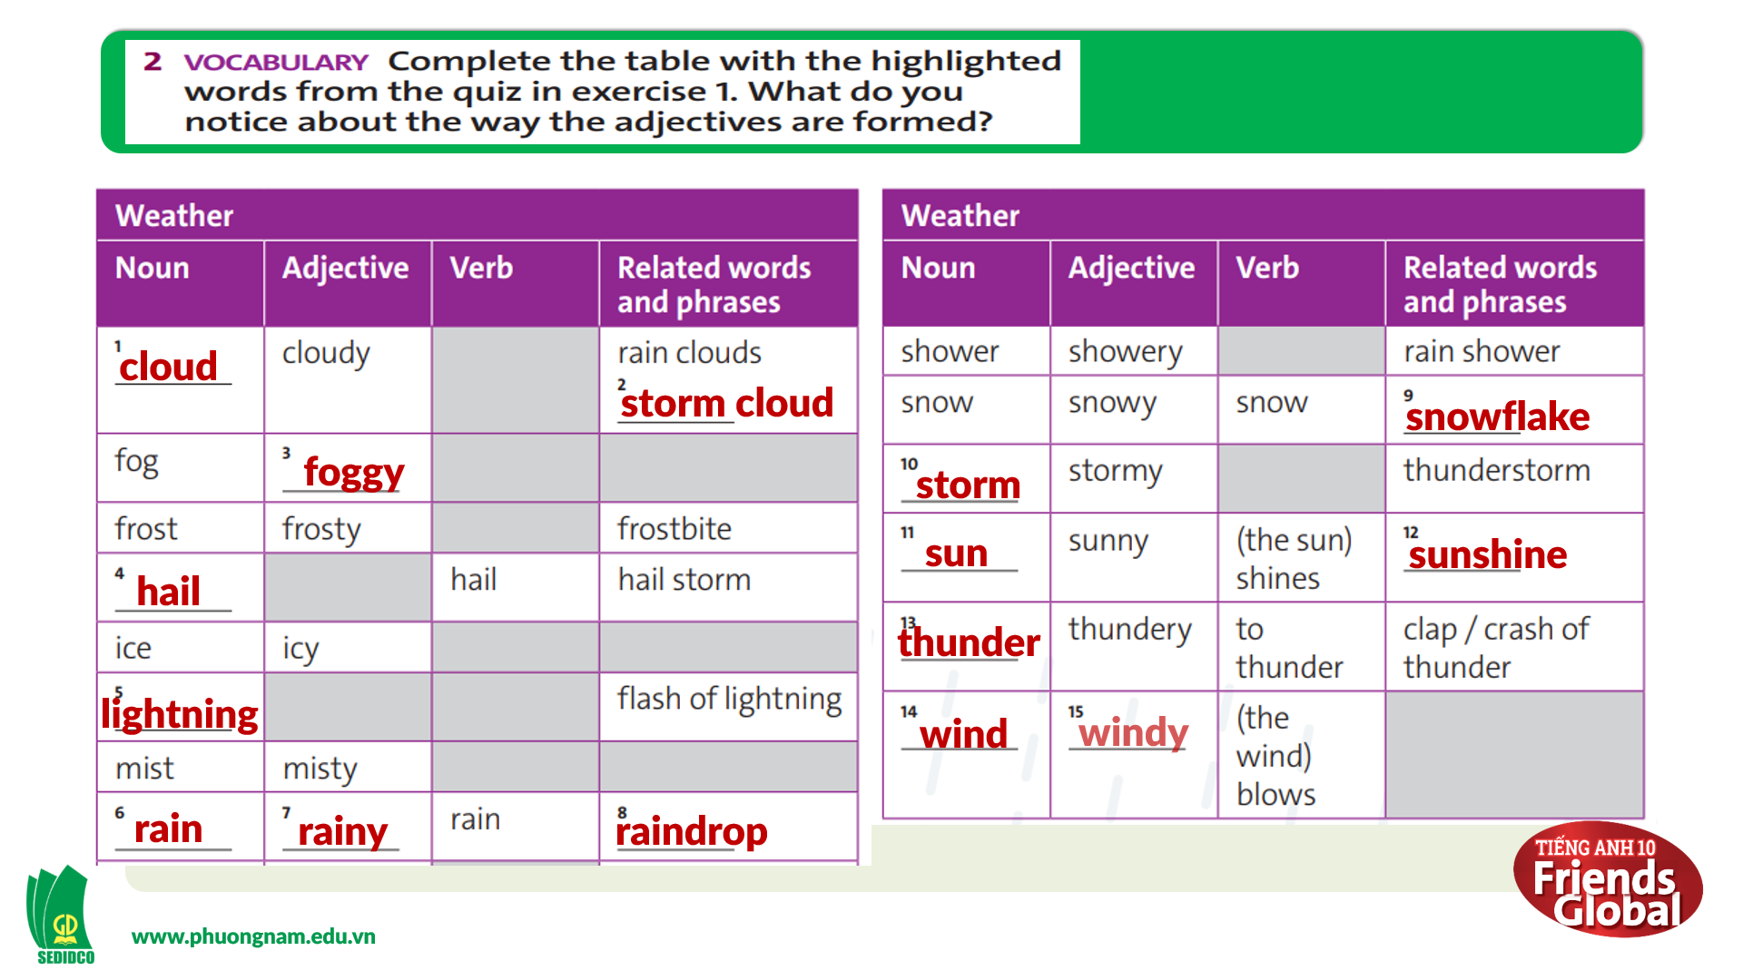  Answers:  1. cloud 2. storm cloud  3. foggy 4. hail 5. lightning  6. rainy 7. rainy 8. raindrop  9. snowflake 10. storm 11. sun  12. sunshine 13. thunder  14. wind 15. windy
- Activity 2 Practice (15’)
a) Objective: Students can answer the questions to critical thinking, and they can also finish the tasks in the textbook. Critical thinking skills (guessing/ reasoning) and communication can also be practiced.
b) Content: Students answer questions, classify words, choose the correct answer, listen and complete, listen and match.
c) Outcomes: Students read and listen, and they can apply the useful language in everyday listening and speaking.
d) Competence: collaboration, guessing, matching, communication
e) Organisation of the activity:
TEACHER’S ACTIVITIES | STUDENT’S ACTIVITIES | CONTENTS
PRACTICE. T-Ss- T/ S – S/ Individual  Activity 1 (5’): Task 3 page 47  - Ask students to discuss with their partners  - Monitor and help with grammar and vocabulary where necessary  Activity 2 (5’): Task 4 page 47  - Ask the students to listen to three weather reports and complete the task  - After students finish, play the audio of each picture for students to check their answers.  - Give the answers to the class  Activity 3 (5’): Task 5 page 47  - Go through the Recycle! box with students and highlight main ideas  - Ask the students to listen to three weather reports again and complete the task  - After students finish, play the audio of each picture for students to check their answers.  - Give the answers to the class | - Discuss with their partners about the given topic  - Try to use the language given by the teacher  - Listen to the audio and complete the task  - Listen again to check the answers  - Check the answers with the teacher  - Read the Recycle! box and highlight main ideas  - Listen to the audio again and complete the task  - Listen again to check the answers  - Check the answers with the teacher | 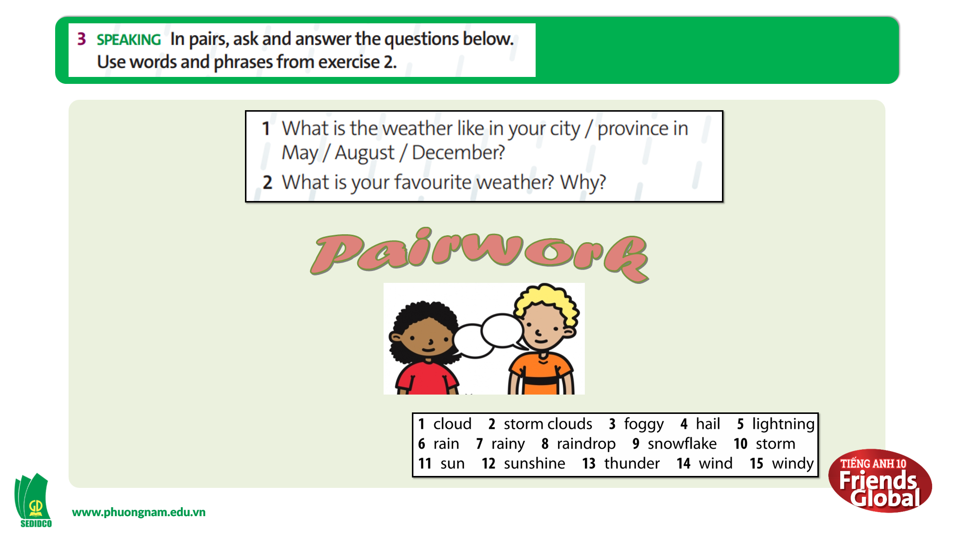  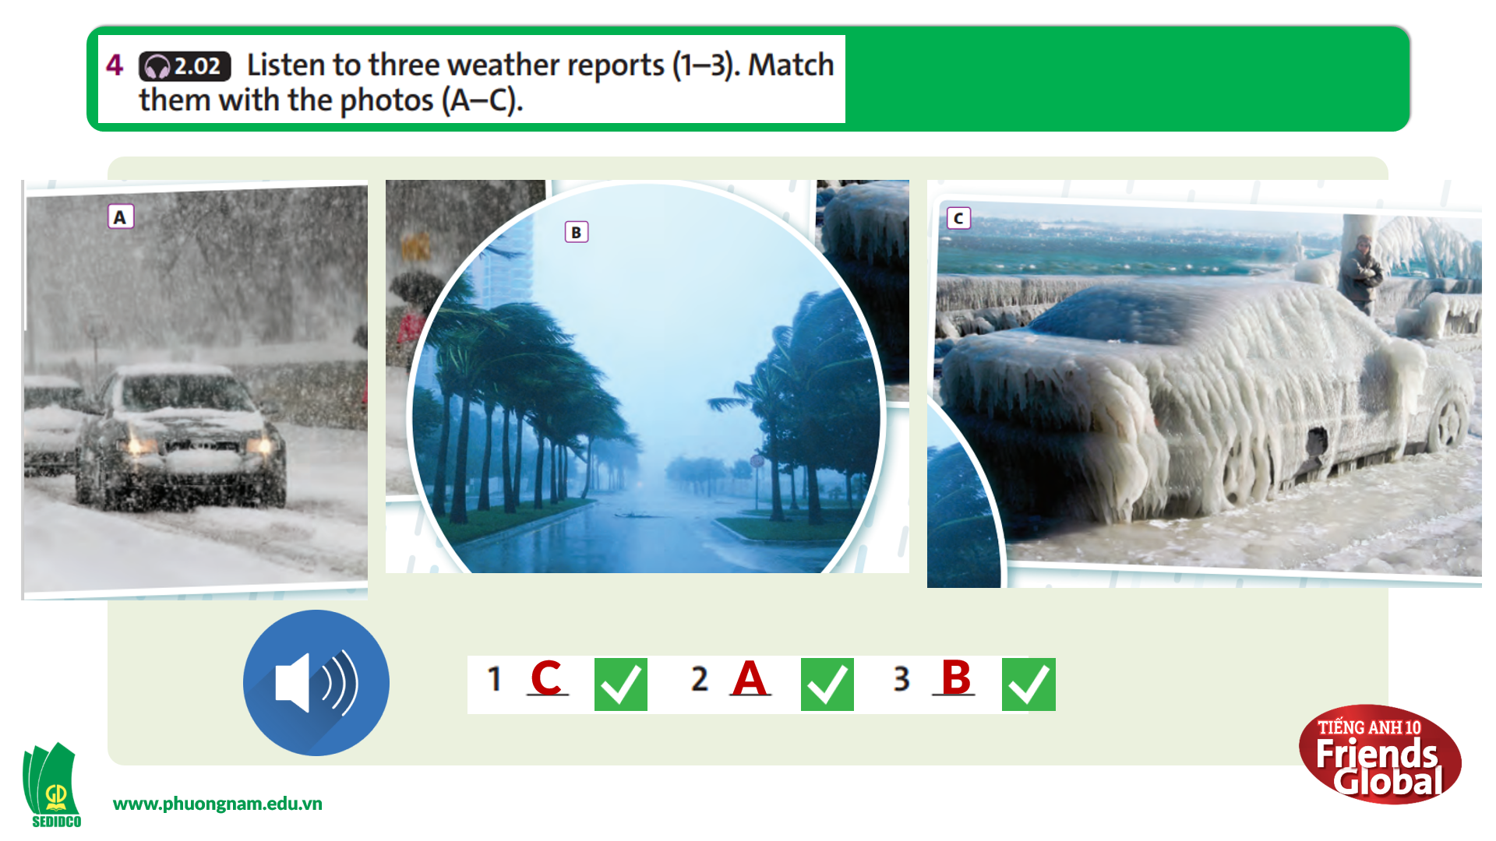  Answers:  1. C  2. A  3. B  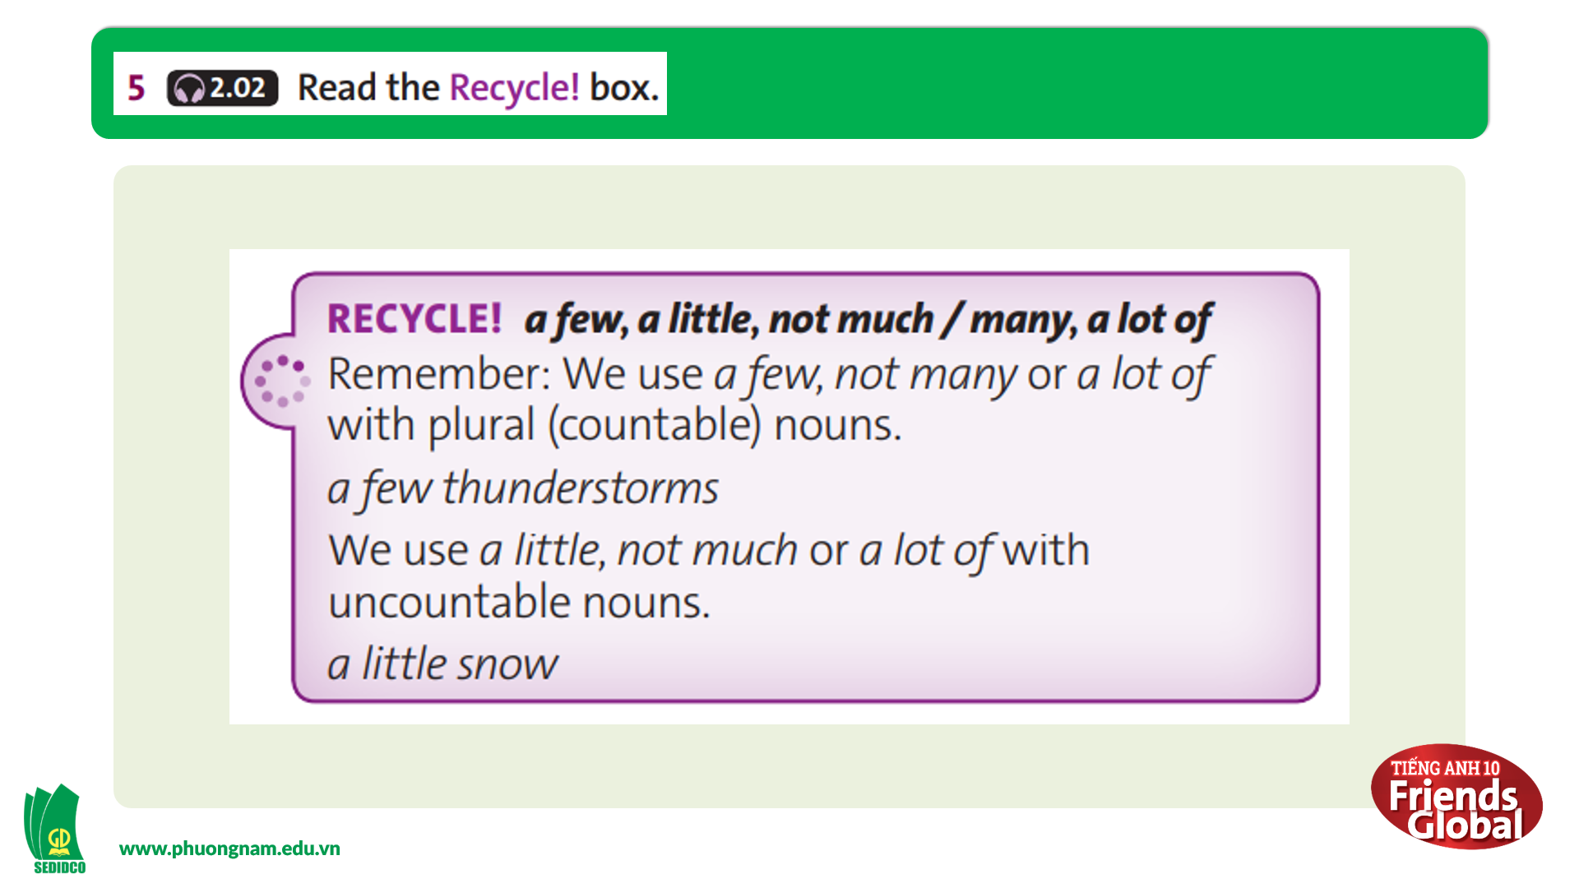  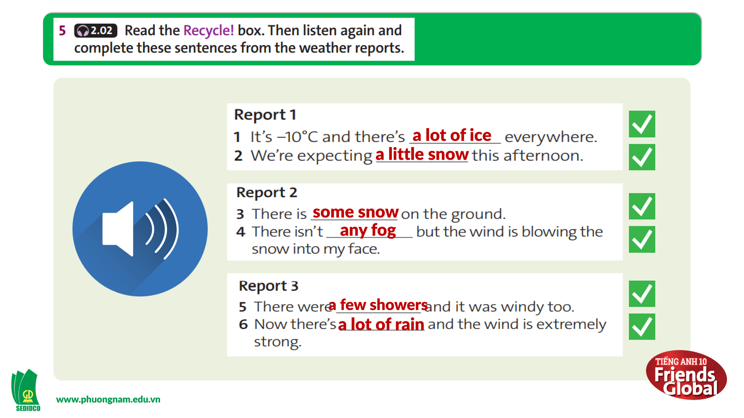  Answers:  1. a lot of ice 2. a little snow  3. some snow 4. any fog  5. a few showers 6. a lot of rain

- Activity 3: Outcomes (10’)
a) Objective: Students can write and perform their own weather forecast, express their opinion about their friends’ weather report and practice give feedback.
b) Content: Weather Reporter Game
c) Outcomes: Students speak and listen mutually, they can apply new words they have learnt in their conversation.
d) Competence: Collaboration, communication
e) Organisation of the activity:
TEACHER’S ACTIVITIES | STUDENT’S ACTIVITIES | CONTENTS
PRODUCT. S – S/ T – Ss  GAME: “WEATHER REPORTER GAME”  (Task 6 page 47)  - Go through the instructions together and make sure students understand what they have to do  - Give students some example sentences to use  - Monitor and help with grammar and vocabulary where necessary  - Invite each group to perform and encourage other students to listen and give feedback | - Discuss with their groups and write their own weather forecast  - Try to use the language given by the teacher  - Try to use the language they have learnt in the lesson  - Practice speaking and express their opinion about their friends’ weather report | 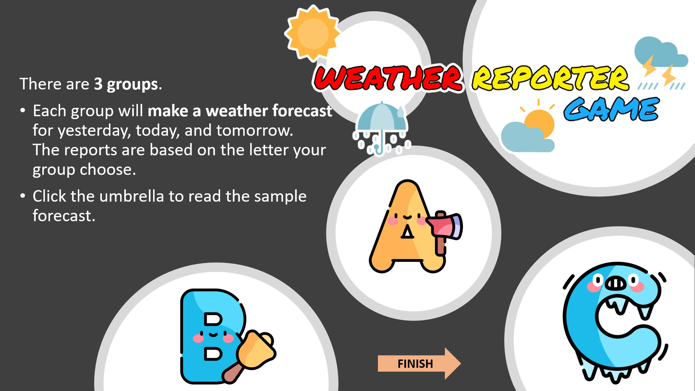  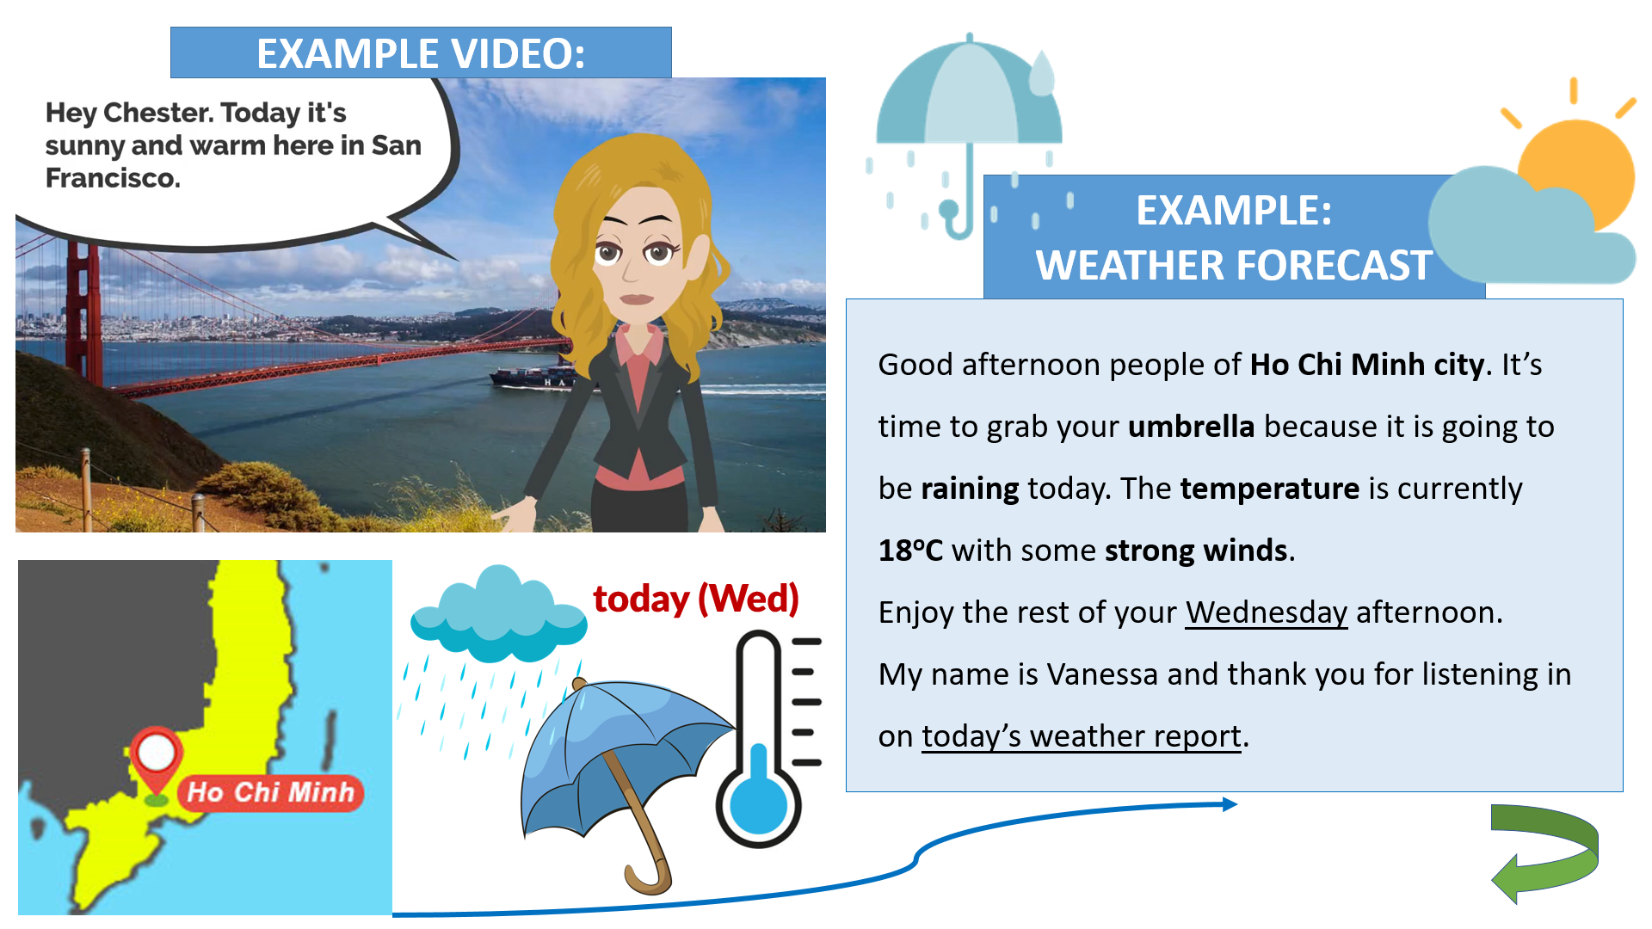  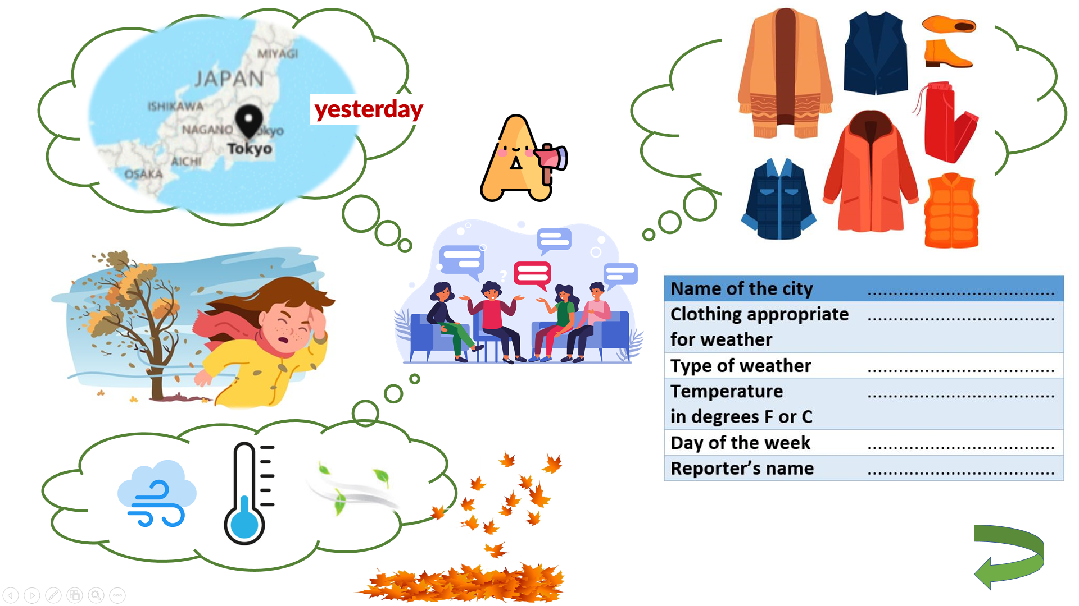

C. Consolidation (3’)
a) Vocabulary: sunny, rainy, windy, foggy, snow, hail, shower, lightning, rainbow, hurricane, hailstone, snowflake, misty, frostbite, thunder, etc.
b) Describe the weather, write and perform a weather forecast
D. Homework (2’)
- Learn by heart new words
- Practice write and perform a weather forecast
- Do exercises in the workbook
- Prepare: Unit 4 – B-Grammar (page 48 – SB)

