School: ……………………………………….. | Date: …………………………………..
Class: ……………………………..................... | Period: ………………………….........

UNIT 8: FESTIVALS AROUND THE WORLD
Lesson 1.1 – New words and Reading (page 60)

I. OBJECTIVES
By the end of the lesson, Ss will be able to:
1.1. Language knowledge and skills
- know some new words about festivals around the world. (bonfire, race, lantern, competition, sculpture, water fight, hot-air balloon).
- talk about festivals around the world and their activities.
- read an article about 2 festivals in Japan and Australia to understand general and specific information.
1.2. Competences
- improve communication, collaboration, analytical and critical thinking skills.
1.3. Attributes
- be active to take part in outdoor activities.
- respect cultures of other countries in the world.

II. TEACHING AIDS AND LEARNING MATERIALS
1. Teacher’s aids: Student book and Teacher’s book, class CDs, Digital Book (DCR phần mềm tương tác SB, DHA (từ vựng/ cấu trúc) phần mềm trò chơi tương tác), projector/interactive whiteboard / TV (if any), PowerPoint slides, pictures.
2. Students’ aids: Student’s book, workbook, notebook.

III. ASSESSMENT EVIDENCE
Performance Tasks | Performance Products | Assessment Tools
- Number the pictures. | - Ss’ answers. | - T’s feedback/Peers’ feedback.
- Listen and repeat. | - Ss’ answers/ presentation. | - T’s observation / feedback.
- Say which of these you'd like to see or try. | - Ss’ answers. | - T’s feedback/Peers’ feedback.
- Read the article and choose the best title. | - Ss’ answers. | - T’s feedback/Peers’ feedback.
- Read and answer the questions. | - Ss’ answers. | - T’s feedback/Peers’ feedback.
- Speak: Would you like to visit the Sapporo Snow Festival or the Melbourne Moomba Waterfest? Why? | - Ss’ answers/ presentation. | - T’s feedback/Peers’ feedback.

IV. PROCEDURES
A. Warm up: (5’)
a) Objective: Introduce the new lesson and set the scene for Ss to acquire new language; get students' attention at the beginning of the class by enjoyable and short activities as well as to engage them in the follow-up steps.
b) Content: Introduce words about festivals.
c) Expected outcomes: Ss have general ideas about the topic of the new lesson: Festivals around the world.
d) Organization of the activity:
TEACHER’S ACTIVITIES | STUDENTS’ ACTIVITIES
- Option 1: Number the pictures. Listen and repeat.  - Use the “New words” part a– page 60 for the warm-up activity.  - Show words and pictures using DCR, have Ss look and number the pictures (in pairs).  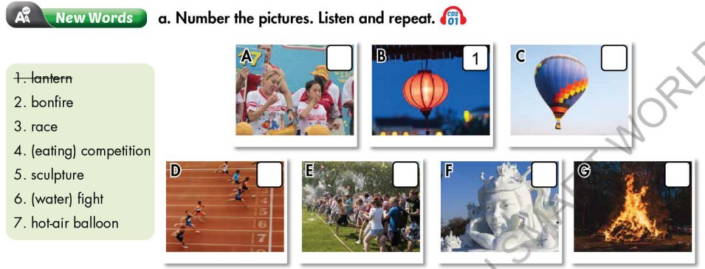  - Call Ss to give answers.  - Give feedback and show correct answers using DCR.  - Lead to the new lesson.  - Play the audio (CD2 – Track 01), have Ss listen and repeat  - Correct Ss’ pronunciation if necessary.  - Option 2: Sapporo Snow Festival, Japan  - Have Ss watch a video clip about Sapporo Snow Festival, Japan.  - Then, ask Ss some questions:  1 What can you see in the clip?  2 Are there many people in this festival?  3 What’s the weather like in Sapporo Snow Festival?  - Call Ss to give answers.  - Give feedback.  - Introduce the new lesson: Festivals around the word.  *Illustration:  Suggested link: https://www.youtube.com/watch?v=D7a5mUGSnLU  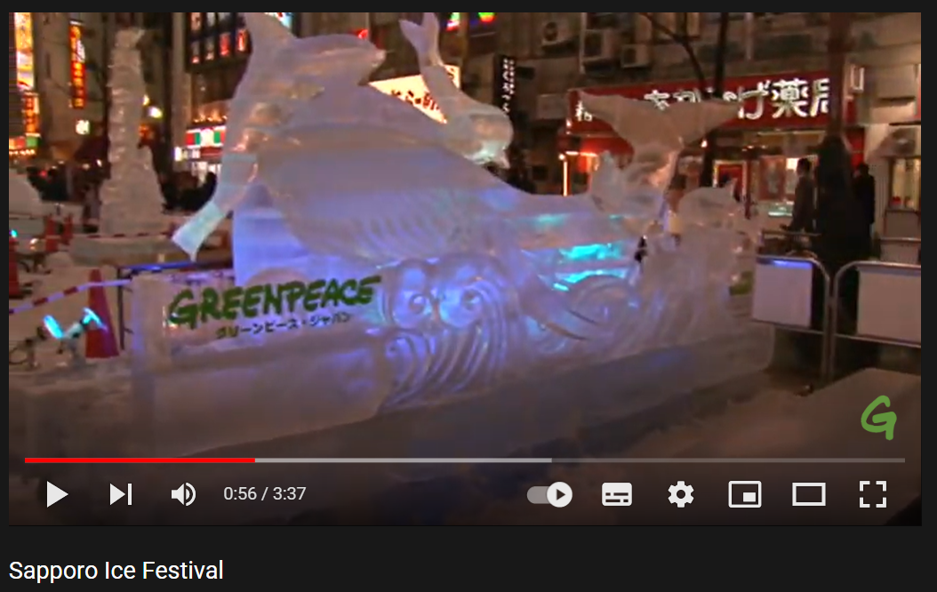 | - Work in pairs to number the pictures.  - Give answers.  - Listen.  - Listen and repeat.  Answer keys  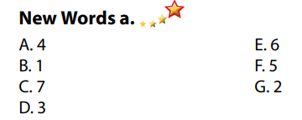  - Watch a video clip about Sapporo Snow Festival, Japan.  - Give answers.  - Listen.  Suggested answers  1. I can see the ice sculpture, much snow in the clip.  2. There are many people in this festival.  3. The weather is very cold with snow and ice.

B. New lesson (35’)
- Activity 1: Pre-Reading (Vocabulary) (12’)
a) Objective: Ss know some words about festivals around the world.
b) Content:
- Vocabulary study: bonfire, race, lantern, competition, sculpture, water fight, hot-air balloon, …
- Number the pictures. Listen and repeat.
- Speaking: Say which of these you'd like to see or try.
c) Expected outcomes: Ss know how to pronounce the new words correctly and use them in appropriate situations.
d) Organization of the activity:
TEACHER’S ACTIVITIES | STUDENTS’ ACTIVITIES
Task a. Number the pictures. Listen and repeat.  - Option 1 (If the teacher hasn’t used this part for the Warm-up activity.)  - Demonstrate the activity on DCR, using the example.  - Have Ss look at the pictures and phrases, then number the pictures.  - Divide class into pairs and have them check their answers with their partners.  - Call Ss to give answers (read or write).  - Check answers as a whole class using DCR.  - Play audio (CD2 – Track 01). Have Ss listen and repeat.  - Correct Ss’ pronunciation.  - Option 2: (If the teacher has used part a. for the Warm-up activity.)  - Have Ss review the words in they have known in the warmup activity by giving a matching exercise. (T uses different pictures from those in the text book.)  - Have Ss do the matching in pairs and give the meaning of the words.  - Call Ss to give answers (read or write).  - Check answers as a whole class.  - Call some Ss to read the words again.  - Play audio (CD2 – Track 01). Have Ss listen and repeat.  - Correct Ss’ pronunciation.  *Illustration:  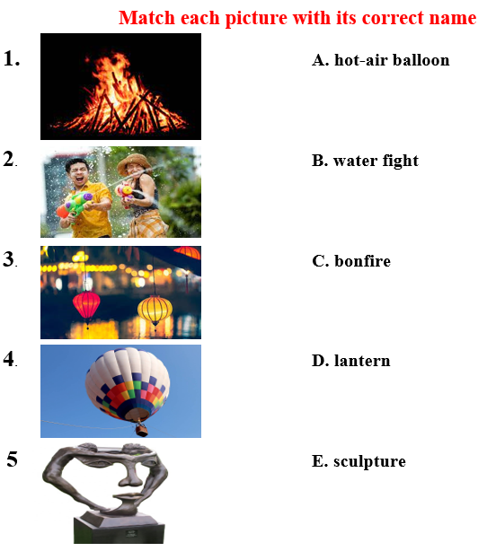  Task b. Say which of these you'd like to see or try.  - Have pairs discuss and say which of these they'd like to see or try.  - Remind Ss to use the phrase: I’d like to …  - Have Ss share their answers in front of the class.  - Give feedback and evaluation. | - Look and listen.  - Work individually.  - Work in pairs.  - Give answers.  - Listen and repeat.  Answer keys  - Work in pairs.  - Give answers.  - Read.  - Listen.  Matching: Answer keys  1C 2B 3D 4A 5E  - Work in pairs.  - Present.  Sample answers  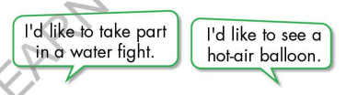
- Activity 2: While - Reading (18’)
a) Objective: Students can develop their reading skill.
b) Content:
- Read the article and choose the best title.
- Read and answer the questions.
c) Expected outcomes: Students can read an article and understand more about 2 famous festivals in the world.
d) Organization of the activity:

TEACHER’S ACTIVITIES | STUDENTS’ ACTIVITIES
Task a. Read the article and choose the best title.  - Ask Ss to scan the article, then choose the best title.  - Remind Ss to underline or highlight the keywords or supporting ideas for their answers.  - Have some Ss share their answers with the class (read), explain for their answers.  - Give feedback.  - Give feedback and correct Ss’ answers if necessary.  Task b. Read and answer the questions.  - Have Ss look at questions and underline the key words.  - Have Ss work in pairs to answer the questions. Remind Ss to use short answers for each question.  - Elicit answers from different pairs.  - Give feedback and evaluation. | - Work individually.  - Read answers, explain.  - Check answers.  Answer keys  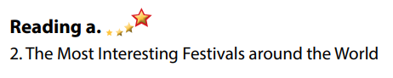  - Read, underline the key words.  - Work in pairs to answer the questions.  - Read answers.  Answer keys  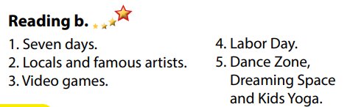

- Activity 3: Post - Reading (5’)
a) Objective: Students can use the vocabulary and ideas from the reading text to develop their speaking skill.
b) Content: Speaking: Would you like to visit the Sapporo Snow Festival or the Melbourne Moomba Waterfest? Why?
c) Expected outcomes: Students can talk about a festival they would like to visit.
d) Organization of the activity:
TEACHER’S ACTIVITIES | STUDENTS’ ACTIVITIES
Task c. In pairs: Would you like to visit the Sapporo Snow Festival or the Melbourne Moomba Waterfest? Why?  - Have Ss work in pairs to answer the questions.  - Go round and give help if necessary.  - Call some Ss to share their ideas with the whole class.  - Give feedback and evaluation. | - Discuss in pairs.  - Present.  - Listen.

C. Consolidation and homework assignments (5’)
* Consolidation:
- Words about festivals around the world (bonfire, race, lantern, competition, sculpture, water fight, hot-air balloon, …).
* Homework:
- Learn the new words by heart.
- Practice talking about your favorite festival.
- Do the exercises in WB: New words + Reading (pages 44 - 45).
- Do the vocabulary exercise in Tiếng Anh 7 i-Learn Smart World Notebook (page 48).
- Play consolation games in Tiếng Anh 7 i-Learn Smart World DHA App on www.eduhome.com.vn
- Prepare: Unit 8 - Lesson 1.2 – Grammar (page 61 – SB).

D. Reflection
a. What I liked most about this lesson today:
…………………………………………………………………………………………
- What I learned from this lesson today:
…………………………………………………………………………………………
c. What I should improve for this lesson next time:
…………………………………………………………………………………………

