SPEAKING ASSESSMENT ENGLISH 6
UNIT 10: OUR HOUSES IN THE FUTURE
- Introduction - 0.4 pt (~2 ideas):
Share something about your dream house, types of houses, appliances…. in the future.
- Topic Speaking (Cue pictures) – 1.0 pt (~4 questions):
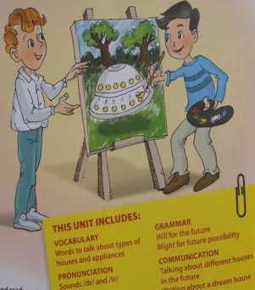  1 |   2 |   3
  8 | - - What is this?  - What do you see in the picture?  - - How do you spell it?  - - What are they doing?  - - It’s a type of house in the future.  8  7  - An activity helps you be healthy.  - An activity makes the environment clean.  - An appliance you will use in the future. |   4
  7 |   6 | 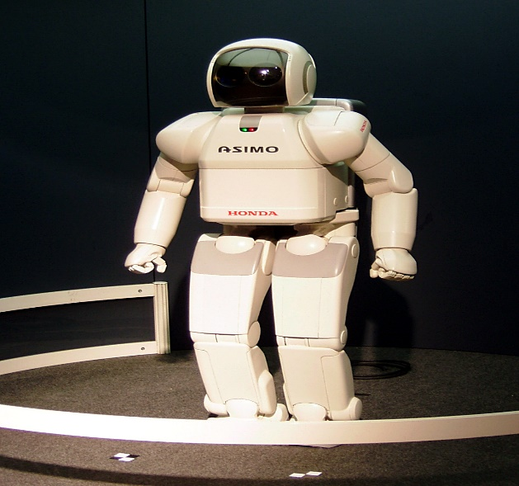  5

