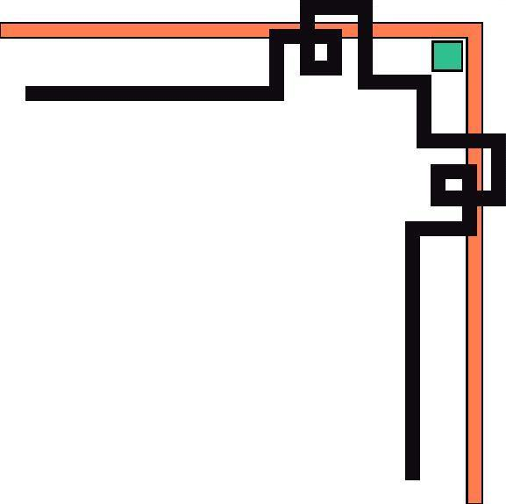

TAM DIEP DEPARTMENT OF EDUCATION AND TRAINING

**ĐONG GIAO LOWER SECONDARY SCHOOL**

**\***

**LESSON PLAN**

**Teacher: Dinh Thi Loan**

**School year: 2022- 2023**

*Preparing date: 06/11/2022*

*Teaching date: 08/11/2022*

**UNIT 4 : MY NEIGHBOURHOOD**

**Lesson 6 : SKILLS 2 ( Page 45)**

**STAGE I. DESIRED OBJECTIVES:**

|  |  |
| --- | --- |
|  |  |

1. **OBJECTIVES:**

*By the end of the lesson, students will be able to:*

**1. Cognition/Knowledge:**

- Identify and use some information and lexical items related to the topic “ My neighbourhood”:

**2. Competence:**

*General competences*: Develop communication, collaboration skills, self-study, problem-solving, critical thinking and creativity through group work activities to exchange ideas to put words in the right column and write about their neighbourhood.

*Specific competences*: Listen for specific information about what Vy likes and dislikes about Vy’s neighbourhood; write about what they like and dislike about their neighbourhood.

**3. Attributes/ personal qualities:**

**-** Show their love for the neighbourhood.

- Show their responsibility for improving their neighborhood to make it become a better place.

**B. LANGUAGE FOCUS**

**Key terms**/ **Vocabulary**

Use the words related to the topic *My neighbourhood:  
 near- far/faraway; clean- dirty; peaceful- noisy; modern-old; crowded; friendly; suburbs*

**Key grammatical structures:***- S+ be ( is/am/are)+ adjective  
- There is/are+ noun  
- S+ like (s)/dislike(s)*

**C.INSTRUCTIONAL RESOURCES**

*Grade 6 textbook, Unit 4, Skills 2; laptop; projector; handouts; sub-boards, a webcam*

**STAGE II. ASSESSMENT EVIDENCE.**

|  |  |  |
| --- | --- | --- |
| **Performance Tasks** | **Performance Products** | **Assessment Tools** |
| 1. Who is the fastest? | a table of opposite adjectives to describe neighbourhood | Peer correction.  T’s feedback |
| 2. Listen to the conversation between Khang and Vy and underline the correct answer | words related to Vy's neighbourhood | T’s observation.  Self-correction  T’s feedback |
| 3.Listen and tick the things Vy likes and dislikes. | selected sentences about Vy’s neighbourhood | T’s observation.  T’s feedback |
| 4. Tick (🗸) what you like or dislike about a neighbourhood. | Ss' answers | T’s observation.  T’s feedback |
| 5. Write a paragraph of about 50 words about your neighbourhood saying what you like and dislike about it. Use Khang’s blog as a model. | a paragraph of about 50 words about students’ neighbourhood. | T’s observation  T’s feedback. |

**STAGE III: TEACHING PROCEDURE/ LEARNING EXPERIENCES*:***

**Activity 1: Who is the fastest?** (7 minutes)

**Step 1:** T provides Ss with a set of adjectives and asks Ss to work in groups in 1 minute to stick them in the right column

**Step 2:** Ss do the task, T goes around to help .

**Step 3:** T asks SS to hang up their answers and asks the leader of each group to move to another group to check the answer

**Step 4:** T shows the keys and asks the leaders to report, then leads in the new lesson

* **Keys:**

|  |  |
| --- | --- |
|  |  |
| clean  near modern  peaceful  friendly  wide | dirty  far ( = faraway)  old  noisy  -  crowded  **-** |

**Activity 2: Listen to the conversation between Khang and Vy and underline the correct answer.** (10 minutes)1. Vy lives in the *suburbs/centre* of Ho Chi Minh City.  
2. The streets are *narrow/ wide.*

3. The schools are *faraway/near*

4. There *are/aren’t* some factories near her neighbourhood

**Step 1:** T asks Ss to listen and do the task individually.

**Step 2:** Ss do the task,T goes around to help.

- Ss exchange their answers with their partners.

**Step 3:** T asks some Ss to give their answers.

**Step 4:** T confirms and gives the answers key.

**Answer key:**

1. suburbs

2. wide

3. faraway

4. are

**Activity 3: Listen and tick the sentences that you hear** (8 minutes)

|  |  |
| --- | --- |
| **What Vy likes** |  |
| 1.There are also many, restaurants and art gallaries here |  |
| 2. The buildings are modern |  |
| 3. People are friendly |  |
| **What Vy dislikes** | |
| 4. The air is not very clean |  |
| 5. The rice field is beautiful |  |
| 6.The streets are noisy and crowded |  |

**Step 1:** T asks Ss to read through the sentences, find out key words, tick the sentences if they can and then listen and do the task individually.

**Step 2:** Ss do the task, T goes around to help.

- Ss correct themselves.

**Step 3:** T asks some Ss to answer what Vy likes and dislikes.

**Step 4:** T gives feedbacks

**Answer key:**

|  |  |
| --- | --- |
| **What Vy likes** |  |
| 1.There are also many, restaurants and art gallaries here | **🗸** |
| 2. The buildings are modern |  |
| 3. People are friendly | **🗸** |
| **What Vy dislikes** | |
| 4. The air is not very clean | **🗸** |
| 5. The rice field is beautiful |  |
| 6. the streets are noisy and crowded | **🗸** |

**Activity 4 : Tick (🗸) what you like or dislike about your neighbourhood and explain why** (5 minutes)

|  |  |  |  |  |
| --- | --- | --- | --- | --- |
|  |  | Like | Dislike | Why |
| 1. | The schools |  |  |  |
| 2. | The streets |  |  |  |
| 3. | The air |  |  |  |
| 4. | The people |  |  |  |
| 5. | The buildings |  |  |  |

**Step 1:** T gives students 2 example, one is about a good thing, one is about a bad thing, then asks Ss to do the task individually.

**Step 2:** Ss do the task, T goes around to help.

**Step 3:** T asks some Ss to answer what they like and dislike about their neighbourhood. Ss give their comments.

**Step 4:** T gives feedbacks

**Answer key:**

- Students' answers

**Activity 5: Write a paragraph of about 50 words about your neighbourhood saying what you like and dislike about it. Use Khang’s blog as a model.** (12 minutes)

|  |
| --- |
| I live in _______. There are some things I like about my neighbourhood.  ……………………………………………………………………………………………………………………………………………………………………………………  ……………………………………………………………………………………………………………………………………………………………………………………  However, there are some things I dislike about it.  ……………………………………………………………………………………………………………………………………………………………………………………  …………………………………………………………………………………………………………………………………………………………………………………… |

**Step 1:** T explains the requirements, and elicits how to write a paragraph about things they like or dislike about their neighbourhood, some structures to write about their neighbourhood  
*- S+ be ( is/am/are)+ adjective  
- There is/are+ noun  
- S+ like (s)/dislike(s)*

**Step 2:** T asks Ss to work individually.  
T reminds Ss to refer to what Khang / Vy likes and dislikes about his/her neighborhood.

Ss do the task,T goes around to help and finds out the common mistakes.

**Step 3:** T chooses a paragraph of a student to correct mistakes

**Step 4:** T gives feedbacks

**Answer key:**

- Students' answers

**Activity 6: Wrap up and Assignment** (3 minutes)

Ask students to answer the following question:

**1. What did you learn in the lesson today?**

*(*listening for specific information about what Vy likes and dislikes about Vy’s neighbourhood; writing about what they like and dislike about their neighbourhood)

**2. What are the core values of the lesson? / What do/ can you learn from the lesson?**

*- Do you love your neighbourhood ?*

*- What can you do to improve your neighbourhood to make it become a better place?*

**3. Homework:**

- Ask Ss to listen to the conversation between Khang and Vy again and do the exercises in the textbook

- Ask SS to rewrite their paragraph about their neighbourhood at home

- Ask students to practice talking about their neighbourhood at home

- Ask Ss to do the exercises 1,3 on page 32 in the workbook

|  |  |
| --- | --- |
| **THE PRINCIPAL’S SIGNATURE** | *Tam Diep, November 8th 2022*  ***Written by*** |
|  |  |